6.1 Architecture

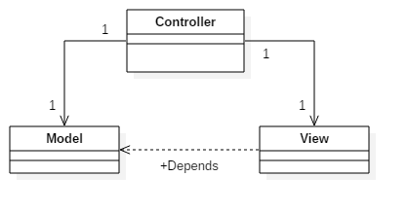

Time Turner’s architecture will follow a Model-View-Controller architecture (MVC). This MVC architecture is best suited for this project because it isolates our application to 3 different layers, data, logic and presentation. With these clear separation of concerns, changing any of these components might not affect the other two components. This is a prefered for team based environments since all 3 components can be coded at the same time.

**Controller**

This is the data of the MVC. This takes the user’s information, validated it with error processing and sends it to the model and view components.

**Model**

This is the logic of the MVC. With the user information given from the controller, and with the use of the underlying logical data structure, such as our domain model, processes such as generate sequence can be utilized.

**View**

This is the presentation of the MVC. With the proper session handling from the controller, this component can generate the proper interface for the user, giving a dynamic feeling with the help of Javascript, CSS and HTML. The viewer will also depend on information gathered from the modeller component.