|  |  |  |
| --- | --- | --- |
| Use Case ID: | UC7 | |
| Use Case Name: | View Saved Schedules | |
| Created By: | Erin Benderoff | Last Updated By: Claudia Della Serra |
| Date Created: | February 7, 2016 | Last Revision Date: February 14, 2016 |
| Actor(s): | Student | |
| Goal/Actor Goals: | The user wishes to view a previously saved schedule. | |
| Description/Summary: | The user selects a schedule from a list of their previously saved schedules. The system must display this schedule for the user to review. | |
| Preconditions: | * User is logged into the system. * User has previously generated one or more schedules * User has saved at least one generated schedule | |
| Post-conditions: | The system displays the saved schedule | |
| Minimum Guarantee: | Saved schedules remain in the system unchanged. | |
| Basic Flow: | 1. The user indicates their wish to view a saved schedule 2. The system prompts the user with a list of saved schedules 3. The user selects which semester’s schedule to view 4. The system displays the chosen schedule | |
| Risk assessment: | Medium | |
| Importance assessment: | 3/5 | |

5.7 Use Case 7 - View Saved Schedules

5.7.1 Fully Dressed Use Case

5.7.2 System Sequence Diagram

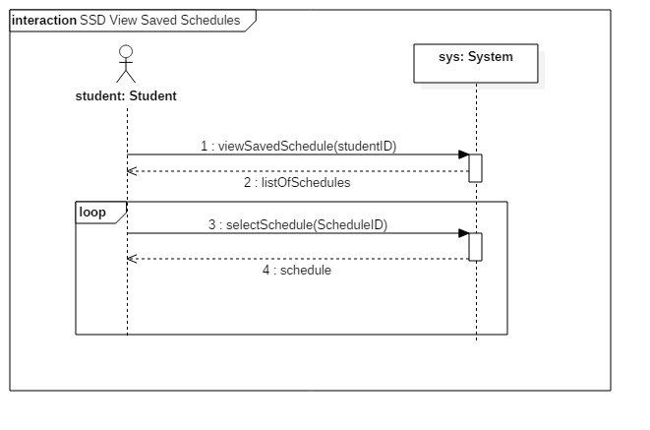

5.7.3 Operating Contract Diagrams

|  |  |  |
| --- | --- | --- |
| Contract 7.1 | viewSavedSchedules | |
| Created By: | Claudia Della Serra | Last Updated By: Claudia Della Serra |
| Date Created: | March 2, 2016 | Last Revision Date: March 2, 2016 |
| Operation: | viewSavedSchedules(studentID: long) | |
| Cross-reference: | UC7 | |
| Preconditions: | * User is logged into the system. * User has previously generated one or more schedules * User has saved at least one generated schedule | |
| Post-conditions: | * The system displays a list of saved schedules for various semesters | |
| Minimum Guarantee: | The user remains on the home page. | |

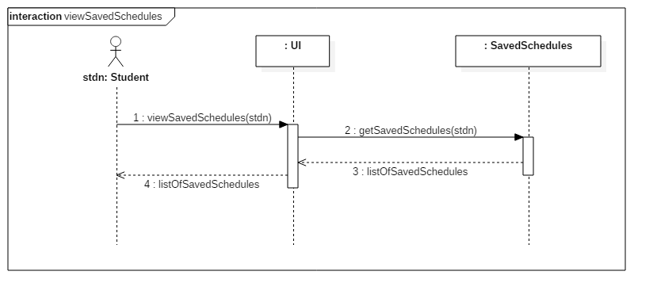

|  |  |  |
| --- | --- | --- |
| Contract 7.2 | selectSchedule | |
| Created By: | Claudia Della Serra | Last Updated By: Claudia Della Serra |
| Date Created: | March 2, 2016 | Last Revision Date: March 2, 2016 |
| Operation: | selectSchedule(scheduleID: long) | |
| Cross-reference: | UC7 | |
| Preconditions: | * User is logged into the system. * User has previously generated one or more schedules * User has saved at least one generated schedule | |
| Post-conditions: | * The system returns the selected schedule | |
| Minimum Guarantee: | The user remains on saved schedules list page. | |

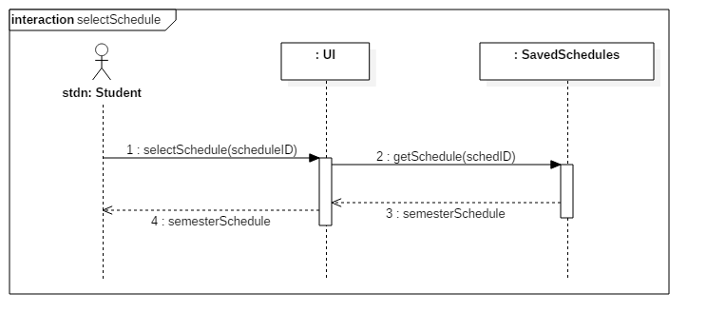

5.8 Use Case 8 – View Academic Record

5.8.1 Fully Dressed Use Case

|  |  |  |
| --- | --- | --- |
| Use Case ID: | UC8 | |
| Use Case Name: | View Academic Record | |
| Created By: | Erin Benderoff | Last Updated By: Claudia Della Serra |
| Date Created: | February 7, 2016 | Last Revision Date: February 14, 2016 |
| Actor(s): | Student | |
| Goal/Actor Goals: | The user wishes to view a list of his or her completed courses and grades for those courses. | |
| Description/Summary: | The system displays the user’s academic record, which includes completed courses and courses currently being taken. | |
| Preconditions: | * User is logged into the system. * User has completed at least one course and/or is presently enrolled in at least one course. | |
| Post-conditions: | The system displays the user’s academic record. | |
| Minimum Guarantee: | The academic record remains in the system unmodified. | |
| Basic Flow: | 1. The user requests to view their academic record 2. The system generates a list of the user’s completed courses, as well as courses in which the user is currently enrolled. | |
| Risk assessment: | Low | |
| Importance assessment: | 1/5 | |

5.8.2 System Sequence Diagram

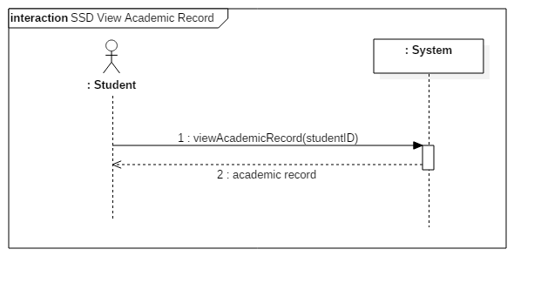

5.8.3 Operating Contract Diagrams

|  |  |  |
| --- | --- | --- |
| Contract 8.1 | viewAcademicRecord | |
| Created By: | Claudia Della Serra | Last Updated By: Claudia Della Serra |
| Date Created: | March 2, 2016 | Last Revision Date: March 2, 2016 |
| Operation: | viewAcademicRecord (studentID: long) | |
| Cross-reference: | UC8 | |
| Preconditions: | * User is logged into the system. * User has completed or is presently enrolled in at least one course | |
| Post-conditions: | * The system returns the student’s academic record | |
| Minimum Guarantee: | The user remains on the home page | |

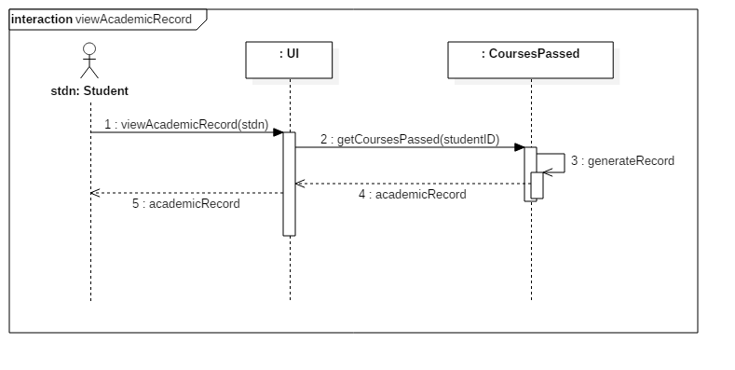

5.9 Use Case 9 – Drop Course

5.9.1 Fully Dressed Use Case

|  |  |  |
| --- | --- | --- |
| Use Case ID: | UC9 | |
| Use Case Name: | Drop Course | |
| Created By: | Erin Benderoff | Last Updated By: Claudia Della Serra |
| Date Created: | February 7, 2016 | Last Revision Date: February 14, 2016 |
| Actor(s): | Student | |
| Goal/Actor Goals: | The user wishes to remove a course from a generated schedule. | |
| Description/Summary: | The user selects which course he or she would like to remove from the schedule. The system must delete this course from the schedule. | |
| Preconditions: | * User is logged into the system. * User has generated a schedule containing at least one course. * User has chosen to view a saved schedule | |
| Post-conditions: | The chosen course has been removed from the user’s schedule. | |
| Minimum Guarantee: | The courses on the user’s schedule remain unchanged. | |
| Basic Flow: | 1. User selects a schedule they wish to view 2. System returns the desired Schedule 3. The user chooses a course from his or her schedule to view. 4. The system displays the course information 5. The user indicates they wish to remove the course from the schedule 6. The System prompts the user for confirmation. 7. The user confirms dropping of the course 8. The produces a modified schedule without the removed course. | |
| Risk assessment: | High | |
| Importance assessment: | 4/5 | |

5.9.2 System Sequence Diagram

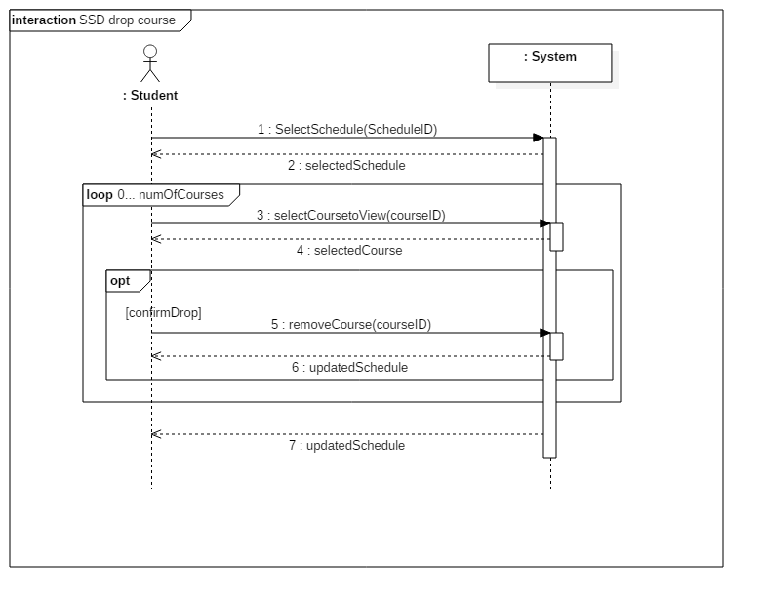

5.9.2 Operating Contract Diagrams

|  |  |  |
| --- | --- | --- |
| Contract 9.1 | selectSchedule | |
| Created By: | Claudia Della Serra | Last Updated By: Claudia Della Serra |
| Date Created: | March 2, 2016 | Last Revision Date: March 2, 2016 |
| Operation: | selectSchedule(scheduleID: long) | |
| Cross-reference: | UC9, UC7, Contract 7.2 | |
| Preconditions: | * User is logged into the system. * User has generated and saved a schedule * User has requested to view a list of saved schedules | |
| Post-conditions: | * The system will display a saved schedule | |
| Minimum Guarantee: | The user will remain on the home page | |



|  |  |  |
| --- | --- | --- |
| Contract 9.2 | viewCourse | |
| Created By: | Claudia Della Serra | Last Updated By: Claudia Della Serra |
| Date Created: | March 2, 2016 | Last Revision Date: March 2, 2016 |
| Operation: | viewCourse(courseID: long, sectionID: long) | |
| Cross-reference: | UC9 | |
| Preconditions: | * User is logged into the system. * User has generated and saved a schedule * User has requested to view a saved schedule | |
| Post-conditions: | * The system will display the selected course’s information | |
| Minimum Guarantee: | The user remains on the selected schedule’s page. | |

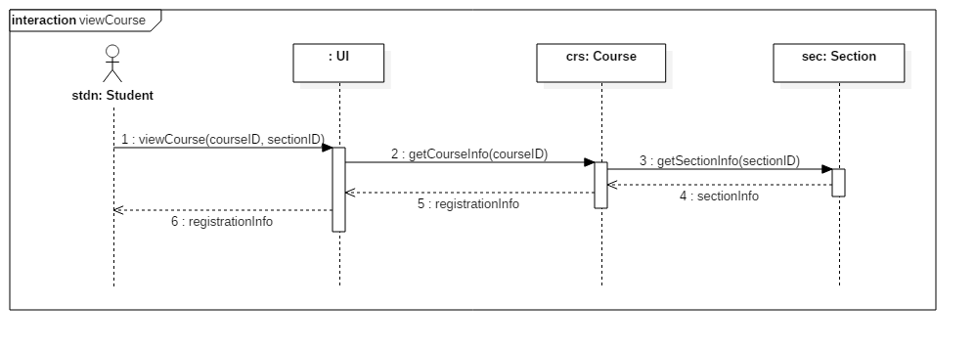

|  |  |  |
| --- | --- | --- |
| Contract 9.3 | removeCourse | |
| Created By: | Claudia Della Serra | Last Updated By: Claudia Della Serra |
| Date Created: | March 2, 2016 | Last Revision Date: March 2, 2016 |
| Operation: | removeCourse(courseID: long, sectionID: long) | |
| Cross-reference: | UC9 | |
| Preconditions: | * User is logged into the system. * User has generated and saved a schedule * User has requested to view a saved schedule * User has requested to view course registration info | |
| Post-conditions: | * The student will be removed from the course’s registration list * The student will be removed from the section’s registration list * The course will be removed from the student’s schedule * The student’s course sequence will be updated | |
| Minimum Guarantee: | The user’s schedule remains unaltered. | |

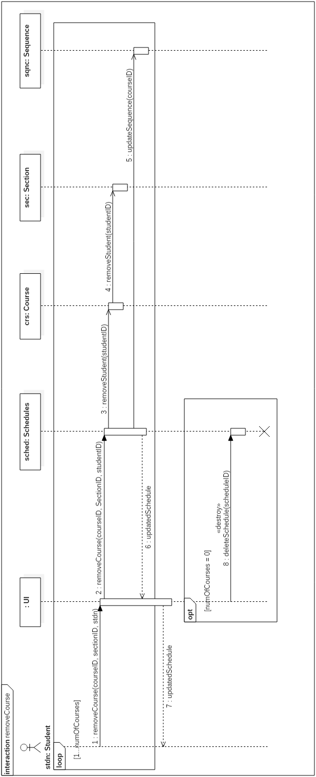

5.10 Use Case 10 – Add Course

5.10. 1 Fully Dressed Use Case

|  |  |  |
| --- | --- | --- |
| Use Case ID: | UC10 | |
| Use Case Name: | Add Course | |
| Created By: | Lori Dalkin | Last Updated By: Claudia Della Serra |
| Date Created: | February 7, 2016 | Last Revision Date: February 14, 2016 |
| Actor(s): | Student | |
| Goal/Actor Goals: | Add a course to a generated schedule. | |
| Description/Summary: | Specific courses can be added to a schedule generated by a user. The user must search for the course and manually add it to their schedule. | |
| Preconditions: | * The user is logged in to their account * A schedule has been generated | |
| Post-conditions: | The specified course is added to the schedule. | |
| Minimum Guarantee: | The user’s schedule remains unchanged and no new course is added | |
| Basic Flow: | 1. User requests to view schedule. 2. System displays the indicated schedule. 3. User indicates they wish to add a course 4. The system displays a search screen prompting the user to enter the name of the course 5. The user types in the name of the course they wish to add 6. The system displays a list of corresponding courses and sections 7. User selects the specific section of the course they wish to add. 8. The system prompts the user to confirm their selected course 9. The user confirms their wish to add the course 10. The system returns a modified schedule. | |
| Risk assessment: | Medium | |
| Importance assessment: | 3/5 | |

5.10.2 System sequence Diagram

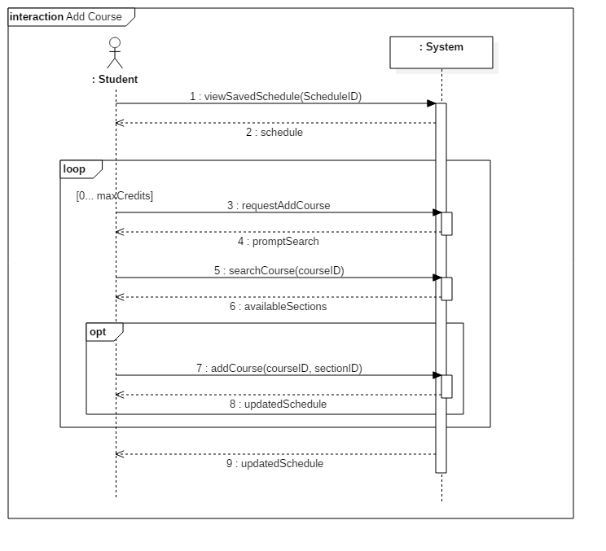

5.10.3 Operating Contract Diagrams



|  |  |  |
| --- | --- | --- |
| Contract 10.1 | viewSchedule | |
| Created By: | Claudia Della Serra | Last Updated By: Claudia Della Serra |
| Date Created: | March 2, 2016 | Last Revision Date: March 2, 2016 |
| Operation: | removeCourse(courseID: long, sectionID: long) | |
| Cross-reference: | UC10, UC7, Contract 7.2 | |
| Preconditions: | * User is logged into the system. * User has generated and saved a schedule * User has requested to view a saved schedule | |
| Post-conditions: | * The student will be shown the selected schedule | |
| Minimum Guarantee: | The user’s remains on the home page. | |

|  |  |  |
| --- | --- | --- |
| Contract 10.2 | requestAddCourse | |
| Created By: | Claudia Della Serra | Last Updated By: Claudia Della Serra |
| Date Created: | March 2, 2016 | Last Revision Date: March 2, 2016 |
| Operation: | requestAddCourse() | |
| Cross-reference: | UC10 | |
| Preconditions: | * User is logged into the system. * User has generated and saved a schedule * User has requested to view a saved schedule | |
| Post-conditions: | * The student will be prompted to search for a course to add | |
| Minimum Guarantee: | The user’s remains on the schedule view page. | |

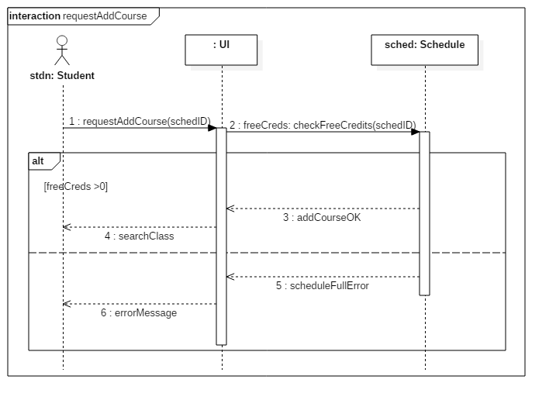

|  |  |  |
| --- | --- | --- |
| Contract 10.3 | searchCourse | |
| Created By: | Claudia Della Serra | Last Updated By: Claudia Della Serra |
| Date Created: | March 2, 2016 | Last Revision Date: March 2, 2016 |
| Operation: | searchCourse(courseID) | |
| Cross-reference: | UC10 | |
| Preconditions: | * User is logged into the system. * User has generated and saved a schedule * User has requested to view a saved schedule | |
| Post-conditions: | * The student will be prompted to search for a course to add | |
| Minimum Guarantee: | The user’s remains on the search page. | |

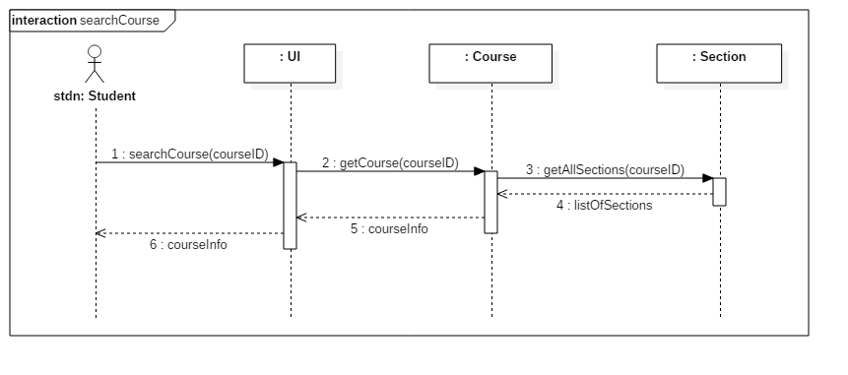

|  |  |  |
| --- | --- | --- |
| Contract 10.4 | addCourse | |
| Created By: | Claudia Della Serra | Last Updated By: Claudia Della Serra |
| Date Created: | March 2, 2016 | Last Revision Date: March 2, 2016 |
| Operation: | addCourse (courseID, sectionID) | |
| Cross-reference: | UC10 | |
| Preconditions: | * User is logged into the system. * User has generated and saved a schedule * User has requested to view a saved schedule * User has enough free credits to add a class * User has completed the required prerequisites | |
| Post-conditions: | * The class will be added to the student’s schedule | |
| Minimum Guarantee: | The user’s remains on the search page. | |

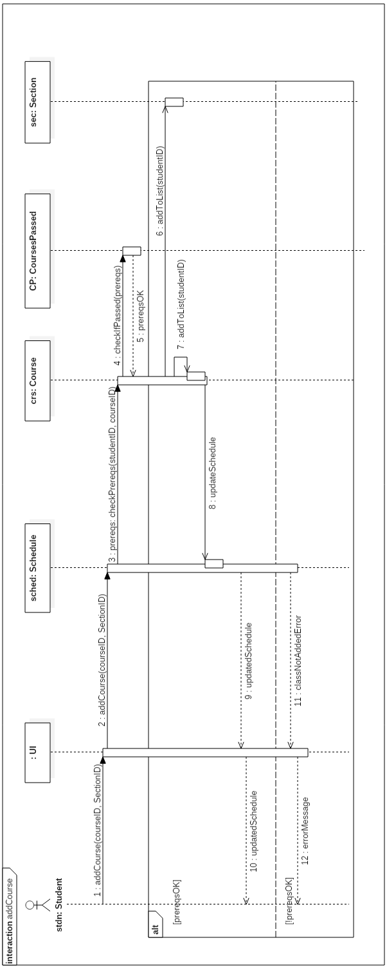

5.11 Use Case 11 – Save Generated Schedule

5.11.2 Fully Dressed Use Case

|  |  |  |
| --- | --- | --- |
| Use Case ID: | UC11 | |
| Use Case Name: | Save Generated Schedule | |
| Created By: | Lori Dalkin | Last Updated By: Claudia Della Serra |
| Date Created: | February 7, 2016 | Last Revision Date: February 14, 2016 |
| Actor(s): | Student | |
| Goal/Actor Goals: | The user wishes to save a schedule they have generated. | |
| Description/Summary: | A generated schedule can be saved in order to be accessed and viewed later on by the user. This schedule consists of courses the user is satisfied with and wishes to keep on their schedule. | |
| Preconditions: | * The user is logged on to their account * A schedule has been generated containing at least one course. | |
| Post-conditions: | The system saves the generated schedule to the user’s account. | |
| Minimum Guarantee: | The user’s account remains unchanged. | |
| Basic Flow: | 1. User indicated their wish to generate a schedule 2. The system prompts the user with a list of semesters for which they wish to generate a schedule 3. The user indicates which semester they wish to generate a schedule for 4. The system displays a generated schedule for the indicated semester 5. The user will indicates that they want to save the generated schedule. 6. The system will display a message telling the user that the schedule has been saved. | |
| Risk assessment: | Medium | |
| Importance assessment: | 4/5 | |

5.11.2 System Sequence Diagram

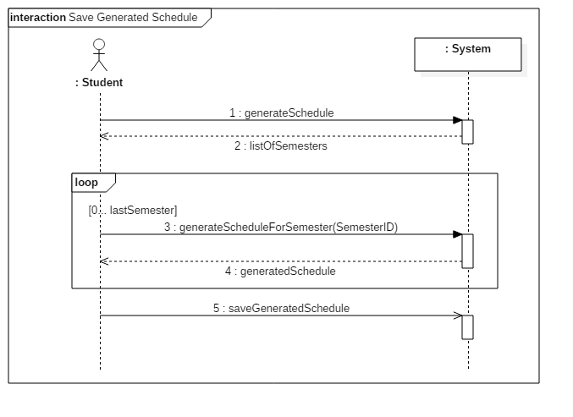

5.11.3 Operating Contract Diagrams

|  |  |  |
| --- | --- | --- |
| Contract 11.1 | generateSchedule | |
| Created By: | Claudia Della Serra | Last Updated By: Claudia Della Serra |
| Date Created: | March 2, 2016 | Last Revision Date: March 2, 2016 |
| Operation: | generateSchedule(studentID) | |
| Cross-reference: | UC11 | |
| Preconditions: | * User is logged into the system. * User is enrolled in a program | |
| Post-conditions: | * The user will be prompted to enter a semester | |
| Minimum Guarantee: | The user’s remains on the home page. | |

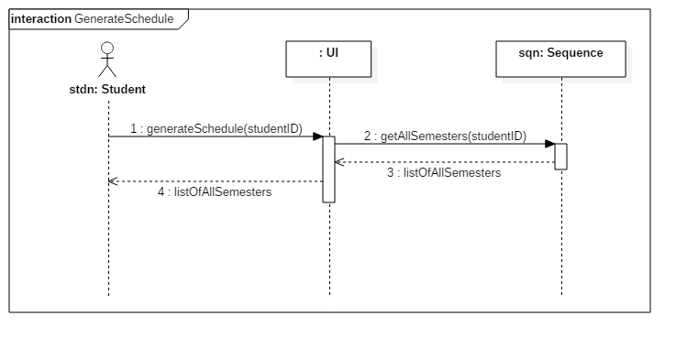

|  |  |  |
| --- | --- | --- |
| Contract 11.2 | generateScheduleForSemester | |
| Created By: | Claudia Della Serra | Last Updated By: Claudia Della Serra |
| Date Created: | March 2, 2016 | Last Revision Date: March 2, 2016 |
| Operation: | generateScheduleForSemester(semesterID) | |
| Cross-reference: | UC11 | |
| Preconditions: | * User is logged into the system. * User is enrolled in a program | |
| Post-conditions: | * All class lists for classes listed in the student’s sequence for the selected semester will be updated to include the student * All section lists for classes listed in the student’s sequence for the selected semester will be updated to include the student * A schedule for that semester will be generated based on the student’s sequence | |
| Minimum Guarantee: | The user remains on the home page. | |

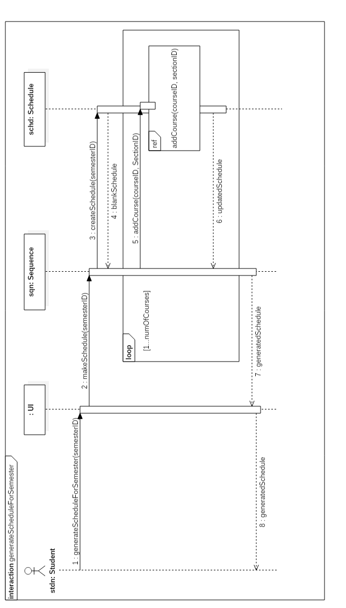

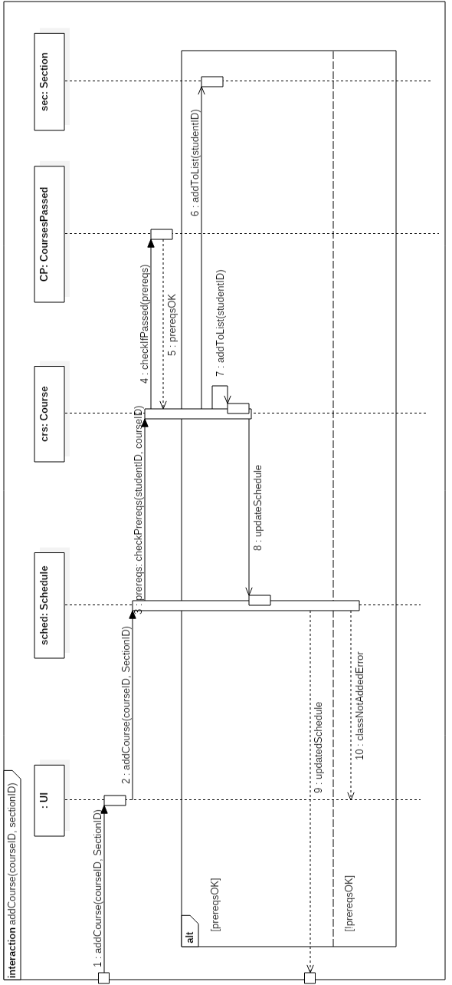

|  |  |  |
| --- | --- | --- |
| Contract 11.3 | saveGeneratedSchedule | |
| Created By: | Claudia Della Serra | Last Updated By: Claudia Della Serra |
| Date Created: | March 2, 2016 | Last Revision Date: March 2, 2016 |
| Operation: | saveGeneratedSchedule(scheduleID) | |
| Cross-reference: | UC11 | |
| Preconditions: | * User is logged into the system. * User is enrolled in a program * User has generated a schedule | |
| Post-conditions: | * A schedule for that semester will be saved to the student’s account | |
| Minimum Guarantee: | The user’s generated schedule remains unaltered. | |

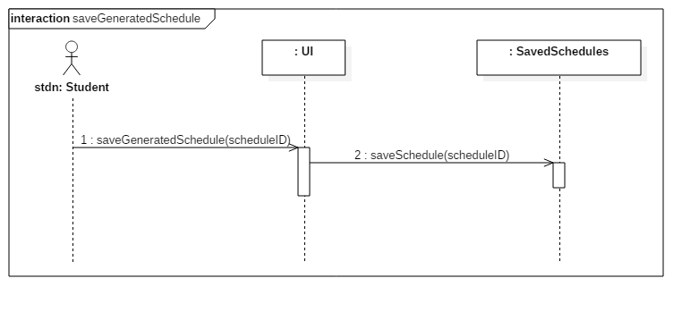

5.12 Use Case 12 – View Weekly Schedule

5.12.1 Fully Dressed Use Case

|  |  |  |
| --- | --- | --- |
| Use Case ID: | UC12 | |
| Use Case Name: | View Weekly Schedule | |
| Created By: | Bryce Drewery Schoeler | Last Updated By: Claudia Della Serra |
| Date Created: | February 7, 2016 | Last Revision Date: February 14, 2016 |
| Actor(s): | Student | |
| Goal/Actor Goals: | A student wants to view weekly schedule. | |
| Description/Summary: | The student wishes to see their class schedule for the current week. The student will specify a week to be displayed. The system must display the schedule for that week. | |
| Preconditions: | * The student has been authenticated * A schedule has been generated and saved | |
| Post-conditions: | The schedule is shown on screen. | |
| Minimum Guarantee: | The schedule fails to be displayed. | |
| Basic Flow: | 1. Student requests to see a saved schedule. 2. The system prompts the student to select a week. 3. Student selects a week 4. The systems display the schedule for that week | |
| Risk assessment: | Medium | |
| Importance assessment: | 3/5 | |

5.12.2 System Sequence Diagram

