## Prediktion på nya bilder

Starta cmd (med Docker running).

**Kopiera och klistra in nedanstående kommando (Byt ut user ”tobbe” till din egen)**

docker run --ipc=host --rm -it --name devtest --mount type=bind,source="C:/Users/tobbe/RV2/RV_CODE_DIR",target=/opt/src/code --mount type=bind,source="C:/Users/tobbe/RV2/RV_OUT_DIR",target=/opt/data/output --mount type=bind,source="C:/Users/tobbe/RV2/RV_DATA_INPUT_DIR",target=/opt/data/data_input quay.io/azavea/raster-vision:pytorch-**latest** /bin/bash

**Samla filerna på samma ställe**

Lägg “model-bundle.zip” från den körning du vill använda i mappen “RV_CODE_DIR”.

Lägg bilden du vill prediktera på i mappen “RV_CODE_DIR”.

**Kör koden**

rastervision predict --vector-label-uri /opt/src/code/test_tobias.json /opt/src/code/model-bundle.zip /opt/src/code/1.tif /opt/src/code/test_tobias.tif

**Handledning enligt manual**

>rastervision predict --help

Usage: rastervision predict [OPTIONS] MODEL_BUNDLE IMAGE_URI LABEL_URI

Make predictions on the images at IMAGE_URI using MODEL_BUNDLE and store

the prediction output at LABEL_URI.

Options:

--vector-label-uri TEXT URI to save vectorized labels for semantic segmentation model bundles that

support it

-a, --update-stats Run an analysis on this individual image, as opposed to using any analysis

like statistics that exist in the prediction package

--channel-order TEXT List of indices comprising channel_order. Example: 2 1 0

--help Show this message and exit.

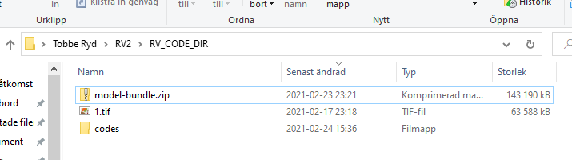**Filstruktur**

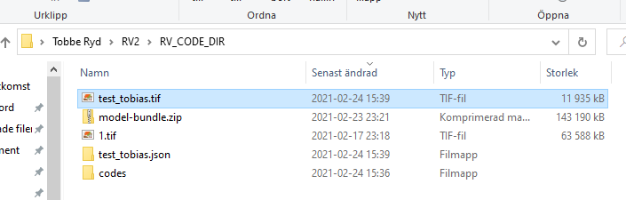

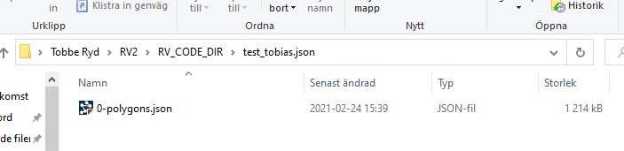

**Data i wgs84 format**