Zerobite: A Real-Time Food Donation and Waste Management System

Amrin Joshiga A

*Department of CSE*

*Panimalar Engineering College*

*Chennai, India*

*amrinjoshiga@gmail.com*

Alin Jebitha B

*Department of CSE*

*Panimalar Engineering College*

*Chennai, India*

*alinjebi@gmail.com*

***Abstract* - Food waste is considered one of the problems in today's society. We all know that there is much excess food available in the region while the community needs it. So, to create a bridge between them, we created the project called Zerobite, a website that helps to reduce the wastage of food by creating a connection between restaurants, non-governmental organizations like NGOs, volunteers, and individual users. This application mainly utilizes Django REST Framework for the backend, and the frontend is done by React with SCSS, delivering very understandable and excellent user performance. Zerobite included many functionalities, such as user registration, authentication, food donation, food request, expiry time of the food, checking the location of the donation via mapping, and donation confirmation process. This version also works with the MySQL for structuring the date and storing the values for efficient operational workflow.**

***Keywords - Django, React, SCSS, MySQL, Web Platform, Food Waste Reduction, Sustainability***

1. **INTRODUCTION**

Food wastage is one of the major challenges faced worldwide. Every day, restaurants, event organizers, and even households have an excess of edible food being wasted while millions of people are suffering from hunger and malnutrition. This shows how the imbalance between the high excess of food and the people who are in need of food can be connected so that they can even enjoy it. We can see there is a rapid development in the technology and also the increasing of many web platforms everywhere in the globe; there is a huge opportunity to create a website for them that will be more scalable and transparent. In this context, this type of website can be used by a large user base, which will be very easy to operate in the real world and have more support for the people who are in need of food.

In order to address this issue, we present a solution called Zerobite, a web application designed to streamline the process of redistributing surplus food from restaurant donors to non-profit organizations. The architecture takes advantage of the Django REST Framework for back-end processing, React and SCSS for front-end presentation, and MySQL for structured data storage. Zerobite utilizes role-based user management to allow restaurant users to donate food by providing details such as amount, expiration time, and pickup location while allowing non-profit users to search, request food, and acknowledge receipt once food is collected. Zerobite further provides a live map to monitor

donations in real-time and non-profit users with requests for pick-up prior to food expiration. By providing a strong back-end combined with an engaging front-end and live tracking capabilities and transaction logging, Zerobite offers an opportunity to minimize food waste, provide support to individuals in need, and engage in sustainable practices.

1. **LITERATURE REVIEW**

Food waste is a critical global issue for sustainability, food security, and resource management. Research has found that institutions based in schools, such as school canteens or cafeteria, generate a great deal of avoidable food waste due to lack of proper planning and monitoring [2], and household areas rank as some of the highest contributors of food waste across many nations [8]. The FAO has identified standard measurements and reductions as a priority for addressing waste [3]. Especially in periods of food crisis, food waste management systems are suggested that promote re-distribution rather than disposal of food [4], [19]. Mobile/digital food waste apps such as Helping Hand [1], FOOD FOR ALL [6], and smart and BYOD food waste apps [7] have the capacity to match donors and beneficiaries, suggesting that food re-distribution models can work via technology-based platforms. There is also evidence to suggest that users of the apps, in addition to food waste reduction, are also more conscious of nutritional issues [8], healthier eaters [9], and save money while eating with these apps [10]. Furthermore, food sharing/re-distribution through digital platform-based models permits social impacts at scale with networks driven by community participation [11].

Aside from the donation platforms, literature also acknowledges the importance of technology, collaboration, and circular economy principles to address food waste. Start-ups are crucial for changing food systems towards circular economies, which support reuse and redistribution of surplus food [10]. Digitalization of definitive supply chains can facilitate real-time coordination and collective stakeholder action and transparency to avoid waste [15]. The role of technology related directly to the prevention of food waste, as well as supply chain optimization, promotes sustainability [14]. Being able to measure and track food waste is also crucial for fair distribution and accountability regarding resources [11]. Ultimately, preventing food waste will contribute to a system becoming more resilient [16] as well as it lends lower environmental impact [17].

Social platforms promote community engagement and peer support in food sharing networks [18], alongside moral motivation in the form of willing individuals to donate time and resources to help others [20]. Additionally, recent studies highlight the importance of situational awareness of expiration and timely intervention to minimize spoilage [5], which is fully supported by the feature ZeroBite allows donors to assign food expiration time. ZeroBite builds off prior systems-- which have varying functionality in mobile applications-- by providing a web-based solution in the Django framework, integrating Google Maps API to provide live tracking, and coordinating donors, NGOs, and volunteers in real-time so that surplus food is collected, and bindings are delivered quickly. By addressing these existing gaps through a combination of digital accessibility, scheduling based on expiry, and location intelligence, ZeroBite improves scalability and transparency in existing food redistribution systems and increases social impact.

1. **PROPOSED WORKFLOW**

The Zerobite design was designed to provide a clear interaction between all necessary actors in food re-distribution which are donors, NGOs, needy individuals, the system. The flow of the process begins with the donor who has to register to or log into the platform to donate surplus food. The donor then submits a food donation with food information (e.g., food type, quantity, expiry length) and a GPS location so that the food will be visible on the live map. The process captures the food donation and gives real-life visibility for NGOs. In *fig 1.*, this is illustrated in the case where the donor adds food detail and relates it to a specific location through Zerobite. The NGO functions as the central link in the process, bridging the gap between donors and the needy. As represented in the diagram, NGOs log in to monitor food donations, assign or distribute them based on demand, and coordinate the collection process. They can view active donations mapped with locations, expiry times, and statuses, which allows them to prioritize food collection before expiration. NGOs also update the system once the donation is distributed, ensuring that a record of the activity is stored for accountability. Needy individuals, on the other hand, engage with the system by requesting food or searching available donations through the NGO channel. This ensures that the donated food reaches the right beneficiaries, minimizing wastage while maximizing social impact.

The MySQL database securely stores all necessary information - donation information, user records, and transaction logs. The auto-removal feature scans and removes expired donation postings, on a periodic basis, regardless of whether the food is picked up, rejected or still available for pick up. The live map provides NGOs with the ability to determine the current location of donors and shows real-time directions to go to pick up the food. Once the donation is marked as delivered, the donation's delivery status and history are updated automatically. This automated and modular framework provides the necessary infrastructure to facilitate future engagements with minimal duplicate data, the risk of missing information or human error, and a coordination role for the donor-NGO food delivery process.

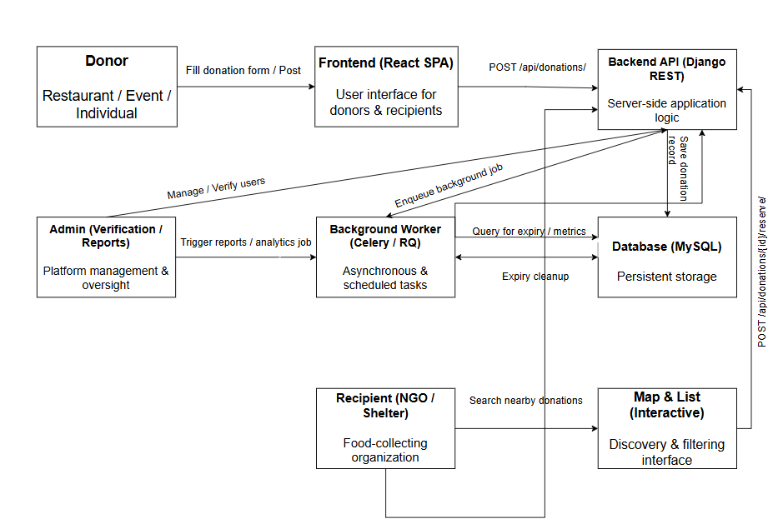

Fig.1 Proposed Workflow

1. **METHODLOGY**

The research adopts a **descriptive and developmental approach**, as the primary goal of this study is to design, implement, and evaluate an intelligent web-based food donation system that minimizes food wastage through real-time automation. The study describes the nature of food donation and redistribution while determining the **usability, functionality, reliability, and performance efficiency** of the proposed ZeroBite platform.

1. **Application Overview**

The **ZeroBite Food Redistribution Application** is a web-based system designed to connect food donors, NGOs, and needy individuals to reduce food wastage. As shown in ***Fig. 2***, the application allows donors to register, add food details with expiry time, and set their GPS location for easy identification. NGOs can log in, view available donations, assign or distribute food, and monitor ongoing donation activities. Needy individuals can browse and request available food items before their expiry. The system automatically manages data storage, removes expired donations, and maintains real-time updates in the database. This process ensures that food reaches NGOs quickly and safely, improving coordination and minimizing waste.

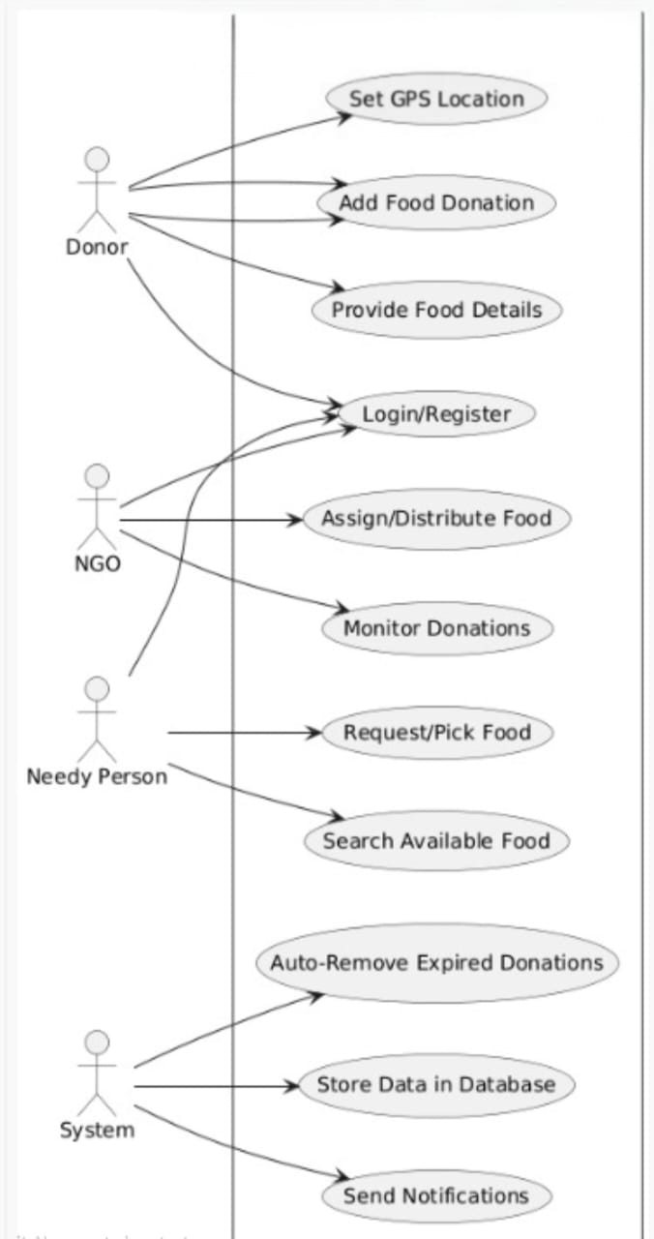

Fig.2 Use Case Diagram

1. **System Design**

The system design of ZeroBite, presented in Figure 4, describes the general flow and operation of the application from authentication of users to delivery of donations. The user can register or login, where they interact with their dashboard. The dashboard of a donor allows them to add food donations with GPS location and time of expiry, while the dashboard for an NGO allows users to browse the food available and request quantities of donated food. All information is securely stored within the MySQL database, and it is responsible for containing donation information, users, and transaction logs. The live map can assist NGOs to identify donors and access directions in real-time. When a donation is delivered, the system automatically updates both delivery and delivery history. Through its modular and self-operating design, it reduces the number of repetitive data, and allows coordinated exchanges of information between donors to NGOs.

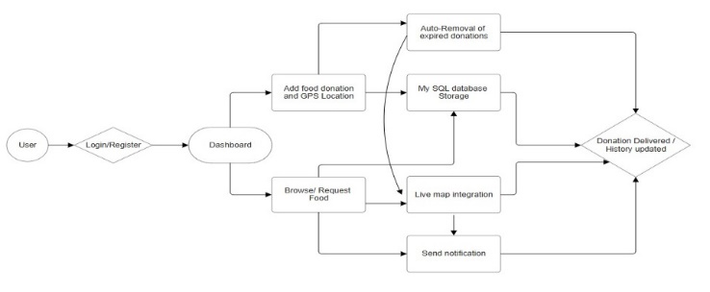

Fig.3 System Architecture Diagram

1. **Map Integration and Expiry Modules**

The Map Integration Module leverages the Google Maps API to provide NGO and donor real-time interaction based on their geographic location. When a donation is made, information about the donation is stored with a location parameter (latitude and longitude). The NGO can see all nearby donated food through an interactive map interface, and with the Get Directions button, the NGO can visualize a route for fast pickup.

The Expiry Management Module, ensures that the food can be eaten safely and automates the process of monitoring and managing expiry times. Each donation is continuously scanned to determine if the expiry time is equal to or has exceeded the current time. When that evaluation is true, the record is marked as expired and will be removed from the available donation list.

The following is the formula used in the system for calculating expiry times:

1. **System Testing**

Upon completion of all modules, we evaluated the full system for functionality, performance and reliability. Functionality and integrity of the data was verified through the use of Postman, Django test cases and manual verification through the interface. The functionality tests included:

* Functionality of API endpoints (POST, GET, PUT, DELETE) were verified
* Accuracy of expiry_time removal verified
* Data flow verified donor → back-end → NGO
* Verified routing can be displayed on a live map with markers

Performance testing verified the average time API requests and time to execute MySQL queries were recorded with a python time module.

TABLE I: SYSTEM TESTING RESULTS

|  |  |  |
| --- | --- | --- |
| **Module** | **Success Rate (%)** | **Average Response Time (s)** |
| Donation Management | 100 | 1.5 |
| NGO Request & Pickup | 100 | 1.8 |
| Map Integration | 100 | 2.0 |
| Expiry Management | 100 | 0.9 |
| **Overall System Average** | **100** | **1.55** |

1. **SYSTEM DEVELOPMENT**

The development of Zerobite was carried out through a structured approach involving requirement analysis, design, implementation, and testing. During the requirement analysis phase, both functional and non-functional requirements were identified, with the primary goal being the reduction of food wastage through a transparent and efficient redistribution platform. Functional requirements included user registration, secure login, posting of food donations, browsing and requesting available food, real-time tracking of donations, and notification delivery. Non-functional requirements emphasized system scalability, reliability, and data security. Once the requirements were clearly defined, the system design was planned using a client-server architecture. The frontend was developed using React combined with SCSS for modular styling and responsiveness, while the backend was implemented using Django REST Framework with JWT authentication for secure access. MySQL served as the database to store structured data such as user records, donation details, transaction history, and system logs. The overall design was modular, ensuring that the system could be extended with additional features such as AI-driven demand prediction and multilingual support in the future.

The implementation phase translated this design into a working platform. React components were used to create dashboards and forms tailored for different user roles, while SCSS provided a clean and consistent design across all modules. Django REST Framework was used to build secure APIs to handle requests from the frontend, including food posting, updates, requests, and confirmations. The live map integration allowed NGOs to locate donations in real time, while system-level automation ensured expired food items were removed promptly. Notifications were generated to update both donors and NGOs about pending or completed actions. MySQL stored all transactions, donation records, and activity logs, making it possible to maintain transparency and provide historical records of donations. Testing was conducted at multiple levels, including unit testing, integration testing, and user acceptance testing, to ensure smooth functionality across all modules.

The behavior of the system is further illustrated through the state diagram, which models the different stages of interaction within Zerobite. The state diagram begins with the user registering or logging into the system, after which they transition to their respective dashboards. For a restaurant donor, the next state involves posting a food donation with details such as type, quantity, and expiry, which then enters a “donation available” state. Automated states such as “expired donation” ensure that items are removed once their validity lapses. This state diagram highlights how user actions and system automation are synchronized to maintain a reliable and efficient food redistribution process.

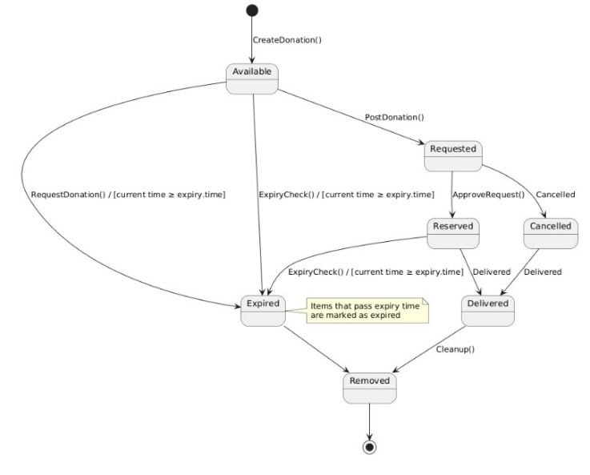

Fig.4 State Diagram

1. **RESULTS**

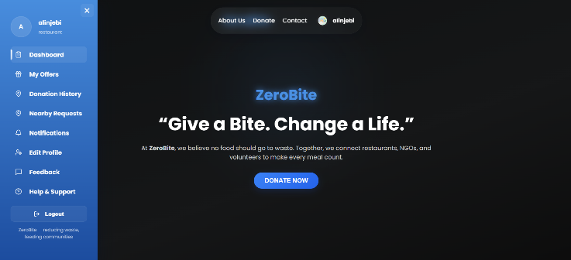

Fig.3 Launching Page

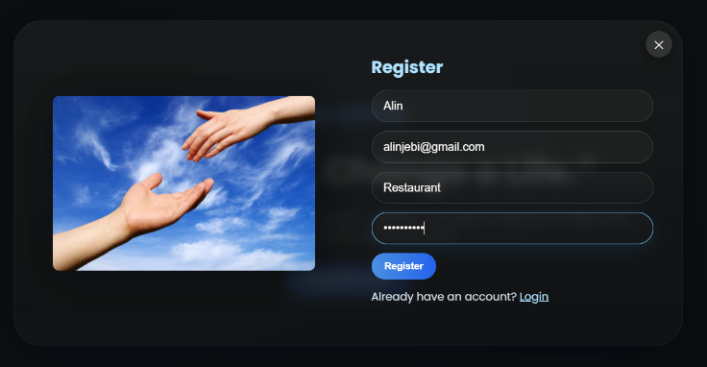

Fig.4 Registration Page

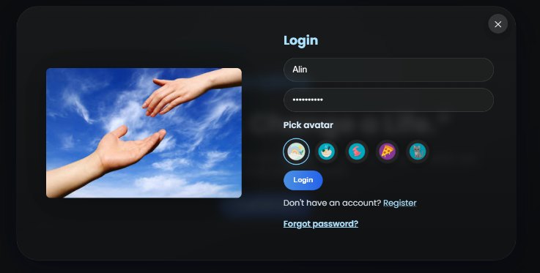

Fig.5 Login Page

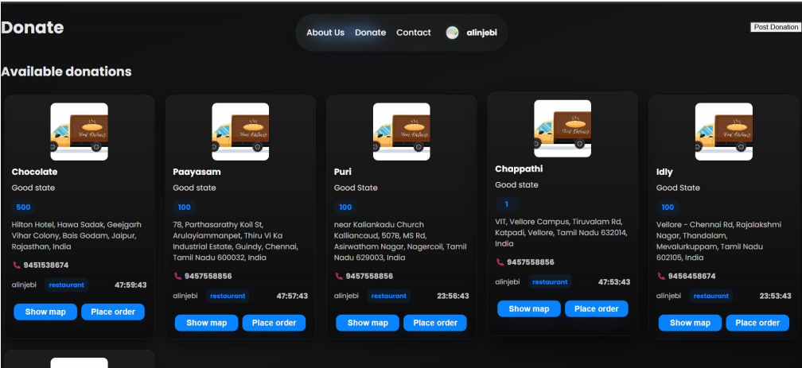

Fig.6 Donation Page

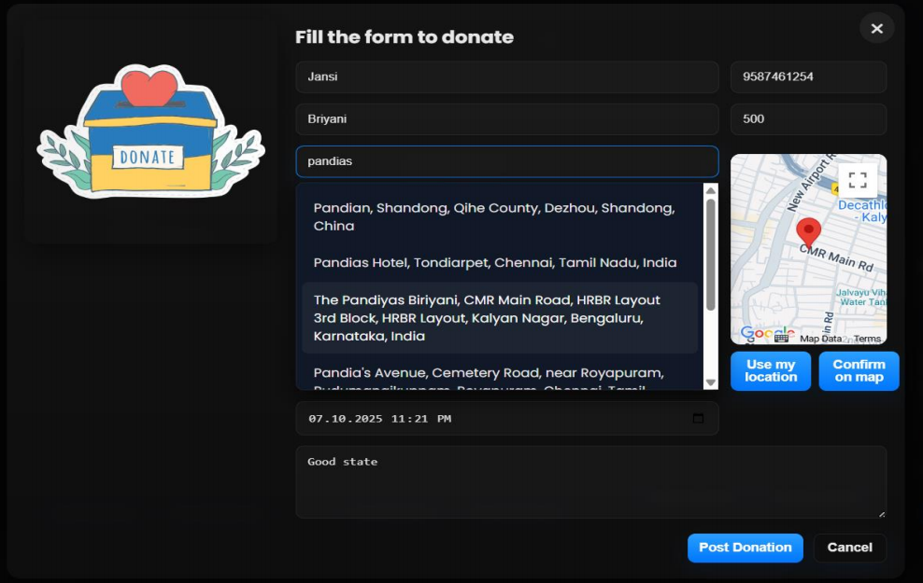

Fig.7 Donation Form

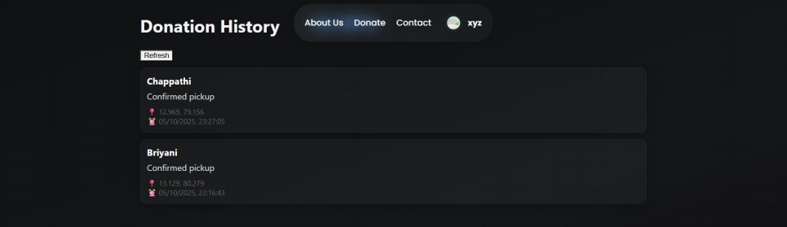

Fig.8 Donation History

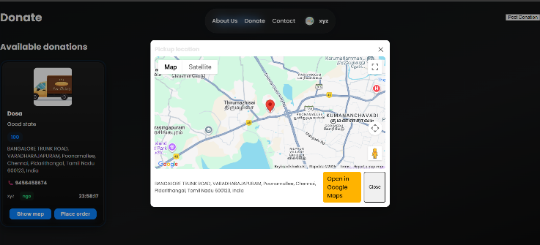

Fig.9 Map integration

1. **CONCLUSION**

The proposed ZeroBite Food Redistribution System was developed to reduce food waste and effectively channel surplus food to NGOS and those in need. The system includes an automated, easy to use software platform. Users can post all the food, details, expiry time and location, and NGOs can request foods and pick up soon after in real time. Food safety is a priority, with the backend services designed using Django REST Framework, the frontend using React.js and MySQL for the database, which ensures data will be processed securely, accurately and quickly. The Google Maps API is also included for NGOs to lookup the donors quickly and potentially get directions to their location. Expiry notification management, senses nutrients are expiring and automatically cancels this donation to keep food safe and reliability.

In testing, we found that ZeroBite can work correctly, with a 100% task completion rate across all modules, and an average processing time of 1.55 seconds. The system is able to manage users logging in, processing donation information management, syncing data confirming actions in real time. Future improvements may consist of an AI approximating food expiry prediction, IoT sensors that monitor food quality, or some sort of mobile version. Cloud server deployment would allow the platform to then be scaled for larger datasets and users. These future enhancements will strengthen ZeroBite’s potential to become a reliable, automated, and socially impactful food redistribution solution.

**VIII. REFERENCES**

[1] Chowdhury, Mahfuzulhoq and Ahmad, Alve. (2023) ‘Helping Hand: An Interactive Mobile Application Featuring Underprivileged People Assistance With Donation and Beneficiary Selection Facilities’, *Proc. 7th Int. Conf. on Computational Systems and Information Technology for Sustainable Solutions (CSITSS – 2023)*, Karnataka, India, Nov. 2–4, 2023, IEEE, pp.1–6.

[2] Lagorio, Alexandra, et al. "Food Waste Reduction in School Canteens: Evidence from an Italian Case." Journal of Cleaner Production, vol. 199, Oct. 2018, pp. 77-84,

[3] Food and Agriculture Organization of the United Nations (FAO), “Technical Platform on the Measurement and Reduction of Food Loss and Waste.”

[4] Kruthika V, Lavanya H.R, Mahalakshmi, Ranju P.S.R, Ms. H.L Priyanka, Ms. K.S Sindhu“FOOD WASTE MANAGEMENT SYSTEM IN THEMIDST OF A FOOD CRISIS” IRJMETS.(2023)

[5] Gallego-García, María, et al. "Recent advances on physical

technologies for the pretreatment of food waste and

lignocellulosic residues." Bioresource Technology 369 (2023):

128397.

[6] V. Panchal, K. Kuchekar and S. Tambe . “Availability of Food for NGO through Mobile Application: FOOD FOR ALL”. International Research Journal of Engineering and Technology (IRJET), Volume: 07, Issue: 03. Pages 2039-2042, 2021.

[7] Nawab, Naeem A., and Hamid Raza Malik. "Solving Food Wastage issues through BYOD application." 2022 Fifth

National Conference of Saudi Computers Colleges (NCCC).

IEEE, 2022.

[8] B. Raras, “Economist Intelligence Unit: Sektor Rumah Tangga jadi Penyumbang Sampah Makanan Terbesar di Indonesia.” Jul. 2022. [Online]. Available: https://goodstats.id/article/sektor-rumah-tangga-

penyumbang-sampah-makanan-terbesar-di-indonesia-vyZqy

[9] T. Mathisen and F. Johansen. “The Impact of Smartphone Apps Designed to Reduce Food Waste on Improving Healthy Eating, Financial Expenses and Personal Food Waste: Crossover Pilot Intervention Trial Studying Students' User

Experiences”. Journal of Medical Internet Research (JMIR) Formative Research, Volume: 06, Issue: 09, 2022.

[10] Närvänen, Elina, Malla Mattila, and Nina Mesiranta.

"Institutional work in food waste reduction: Start-ups' role in

moving towards a circular economy." Industrial Marketing

Management 93 (2021): 605-616.

[11] Amicarelli, Vera, and Christian Bux. "Food waste

measurement toward a fair, healthy and environmental-friendly

food system: A critical review." British Food Journal 123.8

(2021): 2907-2935.

[12] Mazzucchelli, Alice, et al. "How to fight against food waste in the digital era: Key factors for a successful food sharing platform." Journal of Business Research 124 (2021): 47-58.

[13] Aierzhati, Aersi, et al. "Development of a mobile, pilot

scale hydrothermal liquefaction reactor: Food waste conversion product analysis and techno-economic assessment." Energy Conversion and Management: X 10 (2021): 100076

[14] Ciccullo, Federica, et al. "Implementing the circular

economy paradigm in the agri-food supply chain: The role of

food waste prevention technologies." Resources, Conservation

and Recycling 164 (2021): 105114

[15] Annosi, Maria Carmela, et al. "Digitalization within food

supply chains to prevent food waste. Drivers, barriers and

collaboration practices." Industrial Marketing Management 93

(2021): 208-220

[16] Bajželj, Bojana, et al. "The role of reducing food waste for resilient food systems." Ecosystem services 45 (2020): 101140.[17] Read, Quentin D., et al. "Assessing the environmental impacts of halving food loss and waste along the food supply chain." Science of the Total Environment 712 (2020): 136255[18] Harvey, John, et al. "Food sharing, redistribution, and waste reduction via mobile applications: A social networkanalysis." Industrial Marketing Management 88 (2020): 437- 448.[19] Kruthika V, Lavanya H.R, Mahalakshmi, Ranju P.S.R, Ms. H.L Priyanka, Ms. K.S Sindhu“FOOD WASTE MANAGEMENT SYSTEM IN THE MIDST OF A FOOD CRISIS” IRJMETS.(2023)[20] Moral signalling through donations of money and time .(May -2022). Samuel G.B. Johnson a b c, Seo Young Park b