|  |  |
| --- | --- |
| MECHATRONICS INTL-PROGRAM | ASSIGNMENT COVERSHEET |

|  |  |  |
| --- | --- | --- |
| STUDENT DETAILS | | |
| STUDENT NAME | 于航 | |
| STUDENT NAME (PINYIN) | YU HANG | |
| STUDENT ID | 17222054 | |
| CLASS NUMBER | 1702 | |
| ASSIGNMENT DETAILS | | |
| COURSE NAME |  | |
| COURSE NUMBER |  | |
| ASSIGNMENT NAME |  | |
| LECTURER/TUTOR |  | |
| SUBMISSION DETAILS | | |
| DATE DUE | 06/09/2020 | |
| SUBMITTION DATE | 06/09/2020 | |
| STAFF ONLY | | |
| RECEIVED BY |  | DATE/TIME |
| MARKER |  | GRADE |

Declaration and Acknowledgement

By submitting this, I declare that:

1. This assignment meets all the requirements of the subject as student in the relevant subject outline, which I have read.
2. (a) This assessment item is entirely my own work, except where I have included fully-documented references to the work of others.

(b) The material contained in this assessment item has not previously been submitted for assessment.

1. I acknowledge that:

(a) The marker of this assessment item may, for the purpose of assessing this assignment, reproduce this assignment and provide a copy to another member of academic staff.

(b) If required to do so, I will provide an electronic copy of this assessment item to the marker.

1. I am aware that late submission without an authorized extension from the subject coordinator may incur a penalty.

Please note: Assignments are not to be submitted by fax and must be submitted during Lectures/tutorials/laboratories or directly to the academic. Only under special circumstances will the Administrative Staff collect assignments

Experiment 6:PWM signal

1. Object of experiment
   1. Be able to use the structure, function and working principle of the timer, timer/counter design PWM initialization program;
   2. Be able to use Atmeg128 timer pin working mode, design PWM program.
2. Experiment content
   1. basic experiment

Timer 1 is used to output three-way PWM signal, OCRIA,OCRIB and OCRIC values every certain time (for example, 150ms), but the difference between the two is 80, that is, the initial value is i, i+80, i +160. Three LEDs are used to display the three-way output signals respectively to observe the brightness changes.

* 1. extended experiment

Use timer 1 output PWM signal no.3, duty ratio were 25%, 50% and 75%, respectively with three LED display three PWM signals.

1. Experimental schematic diagram

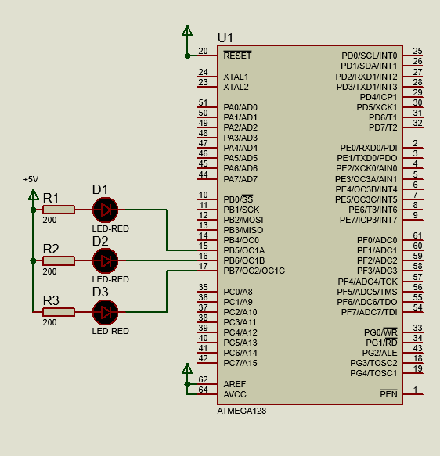

1. Code and flow diagram
   1. basic experiment
      1. flow diagram

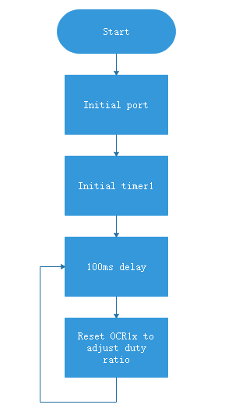

* + 1. code

|  |
| --- |
| 1. #include <iom128v.h> 2. #include <macros.h> 4. unsigned **char** i=0; 6. //to get 1us delay 7. **void** delay_us(unsigned **int** microsecond){ 8. **do**{ 9. microsecond--; 10. } 11. **while** (microsecond>1); 12. } 14. //to get 1ms delay 15. **void** delay_ms(unsigned **int** millisecond){ 16. **while** (millisecond--){ 17. delay_us(999); 18. } 19. } 21. **void** init_port(**void**){ 22. PORTB=0x00; 23. DDRB=0xFF;//PB as output 24. } 26. **void** init_timer1(**void**){ 27. TCCR1A=0XFD;// set on compare match clear on bottom 28. TCCR1B|=(1<<WGM12);//8-bie fast PWM 29. TCCR1B|=(0<<CS12)|(1<<CS11)|(0<<CS10);//8 prescale 30. OCR1A=i; 31. OCR1B=i+80; 32. OCR1C=i+160; 33. } 35. **void** main(**void**){ 36. init_port(); 37. init_timer1(); 38. **while**(1){ 39. delay_ms(100); 40. i++; 41. OCR1A=i; 42. OCR1B=i+80; 43. OCR1C=i+160; 44. } 45. } |

* 1. extended experiment
     1. flow diagram

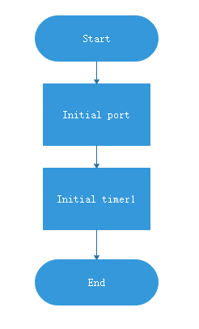

* + 1. code

|  |
| --- |
| 1. #include <iom128v.h> 2. #include <macros.h> 4. **void** init_port(**void**){ 5. PORTB=0x00; 6. DDRB=0xFF;//set PB as output 7. } 9. **void** init_timer1(**void**){ 10. TCCR1A=0XFD;//set on compare match clear on bottom 11. TCCR1B|=(1<<WGM12);//8-bit fast PWM 12. TCCR1B|=(0<<CS12)|(1<<CS11)|(0<<CS10);//8prescale 13. OCR1C=64;//75% 256-256*75% 14. OCR1B=128;//50% 256-256*50% 15. OCR1A=192;//25% 256-256*25% 16. } 18. **void** main(**void**){ 19. init_port(); 20. init_timer1(); 22. } |

1. Experiment Result
   1. Basic experiment

Turn on the power, three LEDs are turned on and the LED with OCR1A is the darkest while the LED with OCR1C is the brightest. With time going by, when the brightness of LED reach the maximum value, the light will be extinguished, and lighted gradually, and that cycle repeats.

* 1. Extended experiment

Turn on the power, three LEDs are turned on and the LED with 75% duty ratio PWM is the darkest while the LED with 25% duty ratio PWM is the brightest, since the LED lights are common anode.

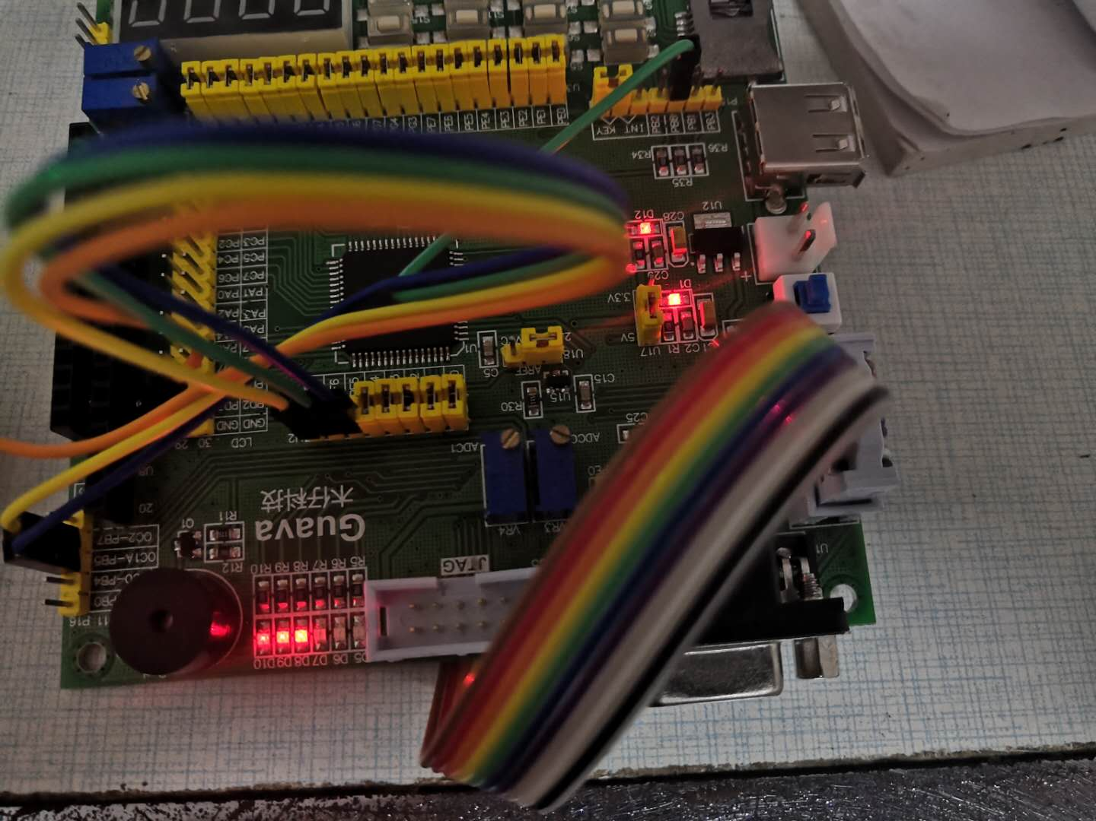

1. Reflection

Normal mode: the counter/timer continually counts from BOTTOM to TOP, and when TCNTn timer counts return to bottom Overflow flag will be set.

CTC mode: the counter/timer continually counts from 0x00 (BOTTOM) to OCRn, and when TCNTn timer counts to OCRn the Output Compare flag will be set.

Phase correct PWM mode: the counter/timer counts from BOTTOM to TOP and back down to bottom continually. When TCNTn of timer counts to OCRn the Output Compare flag will be set.

Fast PWM mode: the counter/timer counts from BOTTOM to TOP continually. When TCNTn of timer counts to OCRn the Output Compare flag will be set, it can also set timer overflow interrupt flag if it can count to top.

To calculate the initial value of timer/counter, we should definite the needed frequency. Then we use $TOP-\left(\frac{f_{clk}}{prescale×f_{needed}}\right)+1$ to get the initial value.

1. Experience

In this experiment, I learned four modes of timer/counter have the most intuitive understanding of the four Compare Match Output modes. Also, I mastered how to generate PWM signal with different duty ratio and frequency, writing and debugging the initialization program of PWM.