**<SimpleRelevance>**

***Version <1.0.1>***



Smarter emails drive more sales. Increase sales by sending #theperfectemail, personalized for your customers with the right products, sent at the right time.

**Table of Contents**

Summary

Component Overview

Functional Overview

Use Cases

Limitations, Constraints

Compatibility

Privacy, Payment

Setup

Verify Installation

Configuration

Setup schedule jobs

SimpleRelevance API credentials

Schedule jobs notification

Logging

Enable logging

Operations, Maintenance

Data Storage

Support

User Guide-

Roles, Responsibilities

Business Manager

Storefront Functionality

Release History

# 

# 

# Summary

The SimpleRelevance Business Manager extension provides functionality to export your store resources such as *Customers*, *Products*, *Orders* to your SimpleRelevance account via SimpleRelevanc API.

# Component Overview

## Functional Overview

In a nutshell the SimpleRelevance Demandware Business Manager Extension exports storefront data such as *Customers, Products, Orders* to your SimpleRelevance account via SimpleRelevance API. This process is done by running Schedule Jobs via your instance’s Business Manager.

Each time a Schedule Job runs, SimpleRelevance integration collects required data and sends them to the SimpleRelevance API in JSON.

If you set it up, this export process can log every step of the way. Also, Schedule Jobs can be set up to notify us or you about the job result.

## Use Cases

The SimpleRelevance Demandware Business Manager Extension can be configured to export storefront resources such as *Customers, Products, Orders* to your SimpleRelevance account via SimpleRelevance API.

## Limitations, Constraints

The SimpleRelevance Demandware Business Manager Extension requires your SimpleRelevance API credentials in order to make API calls.

Setup exporting Schedule Jobs to run when your Demandware instance is not under heavy load. Based on the size of data to export, and the size of your instance, running an export job might slow your instance.

## Compatibility

The SimpleRelevance Demandware Business Manager Extension has been implemented on Demandware version 13.4. This is the only requirement to have this integration technically working properly.

## Privacy, Payment

Please refer to the SimpleRelevance Privacy Policies page for more information on this topic:

<https://www.simplerelevance.com/policies/>

## Setup

Download the SimpleRelevance extension zip archive and import it to your instance via Demandware Studio.

Do the following to import the extension into Demandware Studio:

* In Demandware Studio click File->Import, General->Existing Projects into Workspace then click next.
* In the next window ensure Select archive file is checked and click on the Browse button on the right.
* Select the archive file containing the integration, then click Open->Finish.
* If you have an active Demandware server connection the Studio will ask you to link the cartridge to it. Click Yes.
* To manually assign and deploy the cartridge to a server connection, right-click on it and then Properties. Select Project References and check the project containing the integration. The cartridge should be automatically uploaded

To activate the integration in SiteGenesis, the cartridge has to be assigned to the site and Business Manager:

1. Login to Business Manager and click on Administration.
2. Click on Sites->Manage Sites.
3. Click on the site name followed by the Settings tab at the top.
4. In the Cartridges text field, add ***ext_simplerelevance:*** to the the beginning of the pre-existing text.
5. Go back to Manage Sites and click on Business Manager.
6. Click the Settings tab at the top.
7. In the Cartridges text field, add add ***ext_simplerelevance:*** to the beginning of the pre-existing text.
8. Repeat steps 3 and 4 for each Instance Type by selecting the appropriate type from the drop-down menu (Production, Staging, Sandbox / Development).

#### Verify Installation

Navigate to *Administration-*>*Organization-*>*Roles & Permissions*

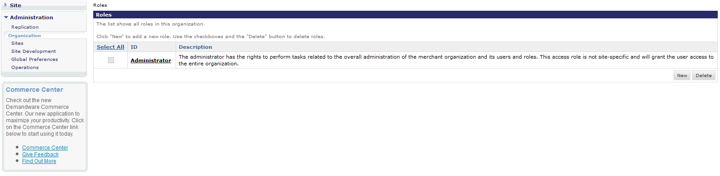

and select *Administrator* user or any other user which has rights to perform tasks related to the overall administration of the merchant organization and its users and roles. After selecting the admin user, select the *Business Manager Modules* tab. From the *Select Context:* dropdown, select the site instance that you wish to enable the SimpleRelevance extension for and click Apply. The *SimpleRelevance* module name and icon should be there:

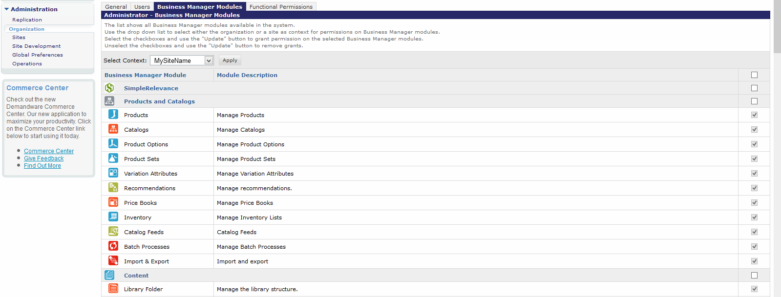

if you can see it then it means you've installed the extension successfully.

## Configuration

You can use the SimpleRelevance Business Manager extension by scheduling jobs, where you can define and customize them via the Demandware Business Manager.

#### Setup schedule jobs

Navigate to *Administration-*>*Operations-*>*Job Schedules*. You can see a list of currently scheduled jobs. Press the New button to define new schedule jobs. In the schedule job add page, you're on the *General* tab by default; to define the job fill out the required fields as follows:

* *Name*: You can input any name for this job. (ex. SimpleRelevance export)
* Check *Enable* in front of *Name* field.
* *Execution Scope*: Select the site instance you wish to run the job for
* *Pipelines*: **ExportResourceForSimpleRelevance**
* *Startnode*: **Start**

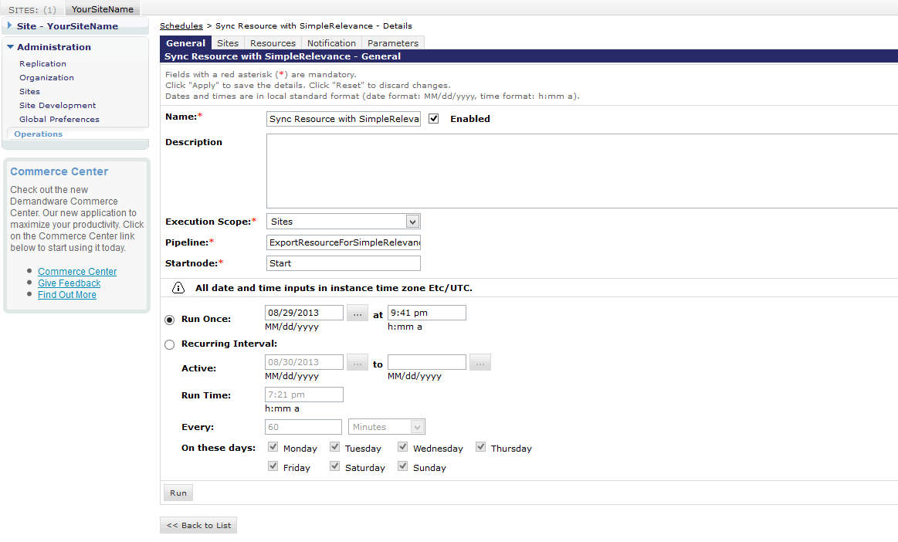

The rest of the form is for job schedule date-time settings. Fill them as you like - we recommend you set everything to recur nightly. After filling out the form press the Apply button to create/save the schedule job.

## *SimpleRelevance API credentials*

This cartridge requires your SimpleRelevance API credentials in order to make API calls. You need to provide these credentials. On the schedule job form page, select the Parameters tab and define these two parameters:

* APIKEY
* *BusinessName*

You can get the API key and Business name from you SimpleRelevance account setting page on your SimpleRelevance dashboard (simplerelevance.com/dashboard).

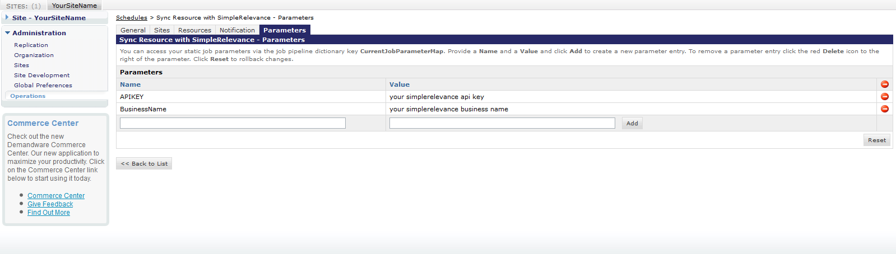

## *Schedule jobs notification*

In order to get notified about any SimpleRelevance schedule job result by email, you can set up a notification feature via the Business Manager. To do so, from the schedule job form select the *Notification* tab, and check all the below boxes on this page:

* *Enabled*
* *SUCCESS*
* *EXCEPTION*
* *ERROR*
* *HANG*
* *RETRY*

And fill the form fields as below:

* *To*: tech@simplerelevance.com
* *CC*: your email address (Optional, If you’d like to get notified too.)

That's all you need in order to get schedule job notification properly enabled and configured. Doing this allows us to troubleshoot any problems that come up, at any time.

#### Logging

SimpleRelevance Business Manager extension comes with logging functionality. Logging help us to find out what our extension does under the hood. We can fix extension bugs and issues more quickly if you have enabled logging for you instance.

#### Enable logging

Navigate to *Administration-*>*Operations-*>*Custom Log Settings*. You need to add *SimpleRelevanceLogger* log category to logging levels. In the **Warn** section add *SimpleRelevanceLogger* to its log levels. Repeat the same for the *Info* category. Remember to enable *logging message to File*, to do so press *Log Info To File*. Finally press the *Apply* button to save the settings.

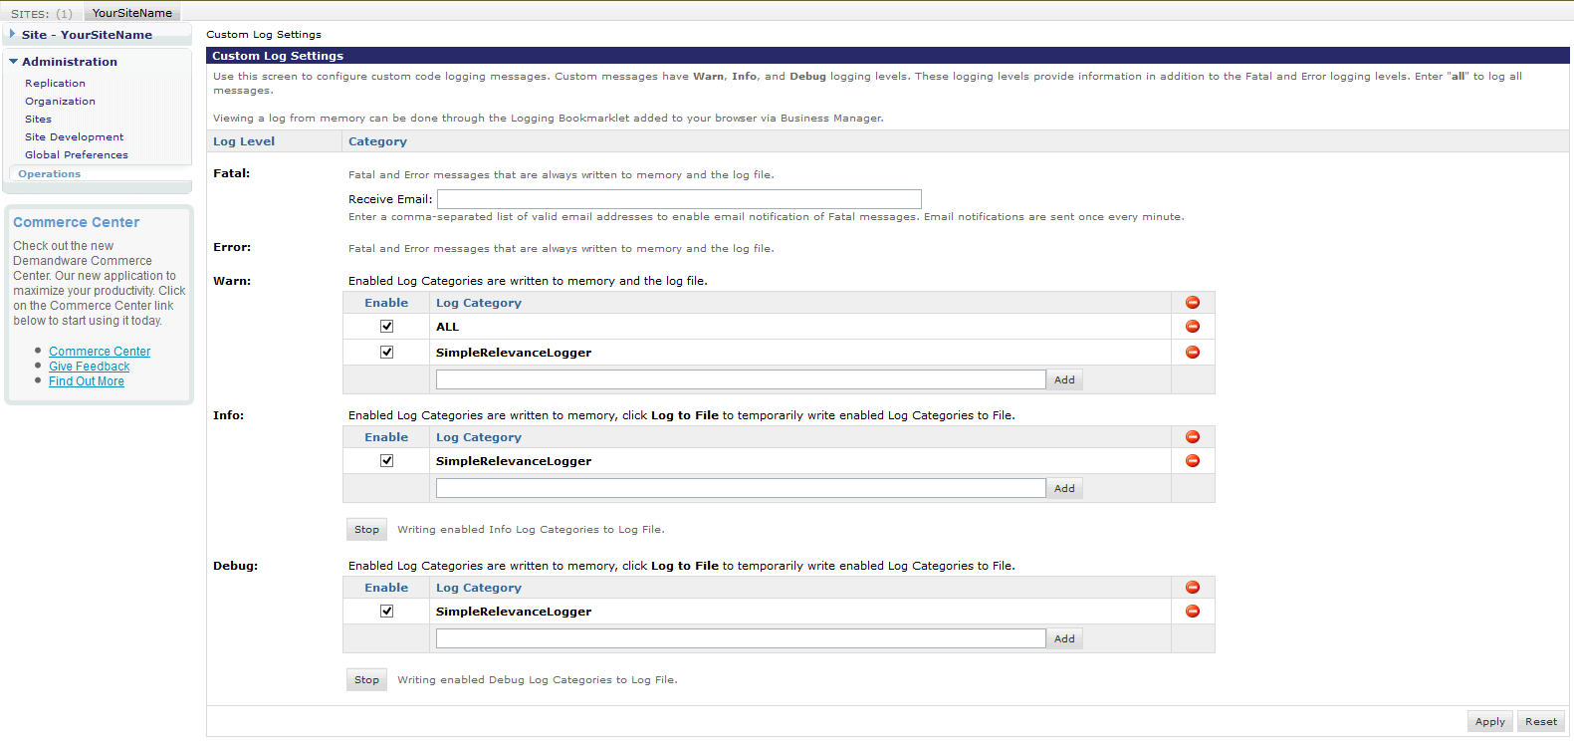

# Operations, Maintenance

## Data Storage

SimpleRelevance Demandware Business Manager Extension needs to have access to your store resources such as *Customers, Products, Orders* in order to perform the data export to your SimpleRelevance account.

## Support

To submit a bug or feature you can use SimpleRelevance Demandware Business Manager Extension issue tracker at github:

<https://github.com/SimpleRelevance/DemandwareSimpleRelevanceBusinessManagerExtension/issues>

Alternatively you can directly contact our tech team by:

[tech@simplerelevance.com](mailto:tech@simplerelevance.com)

User Guide

## Roles, Responsibilities

In order to use the SimpleRelevance integration, the client must setup and configure schedule jobs via the Business Manager. All the process has been described in previous chapters.

## Business Manager

SimpleRelevance Demandware Business Manager Extension doesn’t change or add any menu items to your instance business manager. All functionality is done by running schedule jobs as described in previous chapters.

## Storefront Functionality

SimpleRelevance Demandware Business Manager Extension doesn’t include any storefront functionality.

# Release History

|  |  |  |
| --- | --- | --- |
| **Version** | **Date** | **Changes** |
| 1.0.1 | 3/10/2013 | Fix a memory limitation on DW [Bug-Fix release] |
| 0.9.0 | 3/9/2013 | Initial release |