CPE301 –FALL 2019

Design Assignment 1A

Student Name: Alira Coffman

Student #: 5003236350

Student Email: coffma2@unlv.nevada.edu

Primary Github address: https://github.com/Alira-Coffman/submission-repo

Directory: https://github.com/Alira-Coffman/submission-repo/tree/master/ESD301/DA/LAB1A

Submit the following for all Labs:

1. In the document, for each task submit the modified or included code (only) with highlights and justifications of the modifications. Also, include the comments.
2. Use the previously create a Github repository with a random name (no CPE/301, Lastname, Firstname). Place all labs under the root folder ESD301/DA, sub-folder named LABXX, with one document and one video link file for each lab, place modified asm/c files named as LabXX-TYY.asm/c.
3. If multiple asm/c files or other libraries are used, create a folder LabXX-TYY and place these files inside the folder.
4. The folder should have a) Word document (see template), b) source code file(s) and other include files, c) text file with youtube video links (see template).

1. **COMPONENTS LIST AND CONNECTION BLOCK DIAGRAM w/ PINS**

No components were used.

1. **INITIAL/MODIFIED/DEVELOPED CODE OF TASK 1/A**

;

; AssemblerApplication1.asm

; Assignmetn 1A - inplementing 16 bit * 8bit multiplication without mul

; Created: 9/16/2019 4:38:37 PM

; Author : alira

;

; Replace with your application code

; **********NOTEWORTHY VARIABLES********************

; r25:r24 holds 16-bit multiplicand

; r23:r22 holds 16bit multiplier

; r20:r19:r18:r17 hold result

start:

;Zero Register;

clr r0

inc r1

;**Multiplicand**;

ldi r24,LOW(522)

ldi r25,HIGH(522)

;**Multiplier**;

ldi r23, HIGH(520)

ldi r22, LOW(520)

;**Result**;

clr r20

clr r19

clr r18

clr r17

inc r23

;add low, then add c to high, then addc with 0 to the next high, then add c the highest

top:

add r17, r24

adc r18, r25

adc r19, r0

adc r20, r0

cp r22, r0

breq moveReg

dec r22

brne top

moveReg:

cp r23, r0

breq STOP

dec r23

ldi r22, 255

brne top

STOP:

rjmp STOP

1. **SCREENSHOTS OF EACH TASK OUTPUT (ATMEL STUDIO OUTPUT)**

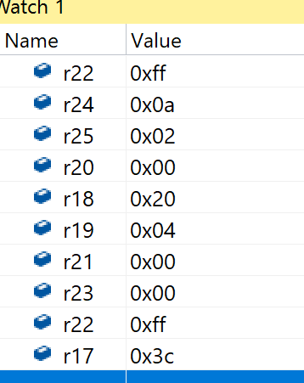

#include <stdio.h>

int main()

{

int sixteenbit = 522;

int sixteen2bit = 500;

int result = 0;

for(int i =1; i <= sixteen2bit; i++)

{

result += sixteenbit;

}

printf("Result is %d", result);

return;

}

1. **GITHUB LINK OF THIS DA**

https://github.com/Alira-Coffman/submission-repo/tree/master/ESD301/DA/LAB1A

“This assignment submission is my own, original work”.

Alira Coffman