CPE301 – FALL 2019

Midterm 1

Student Name: Alira Coffman

Student #: 5003236350­­



Student Email: coffma2@unlv.nevada.edu

Primary Github address: https://github.com/Alira-Coffman/submission-repo/

Directory: https://github.com/Alira-Coffman/submission-repo/tree/master/Midterm

Submit the following for all Labs:

1. In the document, for each task submit the modified or included code (only) with highlights and justifications of the modifications. Also, include the comments.
2. Use the previously create a Github repository with a random name (no CPE/301, Lastname, Firstname). Place all labs under the root folder ESD301/DA, sub-folder named LABXX, with one document and one video link file for each lab, place modified asm/c files named as LabXX-TYY.asm/c.
3. If multiple asm/c files or other libraries are used, create a folder LabXX-TYY and place these files inside the folder.
4. The folder should have a) Word document (see template), b) source code file(s) and other include files, c) text file with youtube video links (see template).

1. **COMPONENTS LIST AND CONNECTION BLOCK DIAGRAM w/ PINS**

Atmega328p

Arduino Shield

Used the APC220(pin out below)

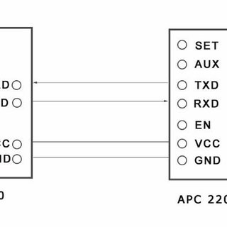

ESP8266:

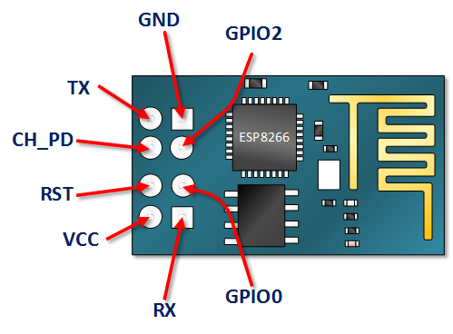https://i1.wp.com/henrysbench.capnfatz.com/wp-content/uploads/2016/12/ESP8266-PINOUT.png

LM35 temperature sensor:

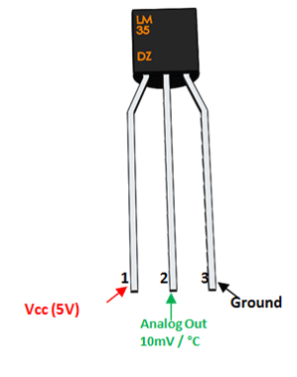

1. **INITIAL/MODIFIED/DEVELOPED CODE OF TASK 1/A**

#define *F_CPU* 16000000UL

#include <avr/io.h>

#include <stdlib.h>

#include <avr/interrupt.h>

#include <stdio.h>

#include <util/delay.h>

#include <math.h>

#define BAUDRATE 115200

#define BAUD_PRESCALLER (int)*round*(((((double)*F_CPU* / ((double)BAUDRATE * 8.0))) - 1.0))

void USART_init(void);

void USART_transmit(unsigned char data);

void USART_putstring(char* StringPtr);

void ADC_init (void); //function to initialize ADC

void ESP_init();

void UART_sendString(volatile unsigned char AT[]);

float readTemperatue();

//VARIABLES

volatile float myTemp; //holds temp

char * tempString[10];

volatile unsigned char AT[];

void UART_sendString(volatile unsigned char AT[])

{

volatile unsigned char len = 0;

volatile unsigned char i;

while(AT[len] != 0)

{

len++;

}

for(i = 0x00; i < len; i++){

// Wait for the transmitter to finish

while(!(UCSR0A & (1<<UDRE0)));

UDR0 = AT[i];

}

}

int main(void)

{

USART_init(); //initialize USART

ADC_init (); //initialize ADC

ESP_init();

TCCR0A = 0x00; //set normal operation

TCCR0B |= (1 << CS02); //set prescalar to 256

TCNT0 = 6;

TIMSK0 |= (1 << TOIE0);

sei(); //set interrupt

while (1)

{

}

}

/*INITALIZE FUNCTIONS*/

void USART_init(void)

{

UCSR0A = (1 << U2X0);

UBRR0H = (*uint8_t*)(BAUD_PRESCALLER >> 8);

UBRR0L = (*uint8_t*)(BAUD_PRESCALLER);

UCSR0B = (1 << RXEN0) | (1 << TXEN0);

UCSR0C = (3 << UCSZ00);

}

void ESP_init()

{

UART_sendString("AT\r\n");

USART_putstring("AT+CWMODE=1\r\n");

*_delay_ms*(20);

USART_putstring("AT+CWJAP=\"Alira\",\"Password\"\r\n");

*_delay_ms*(20);

// Enable connection

UART_sendString("AT+CIPMUX=0\r\n");

*_delay_ms*(50);

}

void ADC_init (void)

{

ADMUX = (0<<REFS1)|

(1<<REFS0)|

(0<<ADLAR)|

(1<<MUX2)|

(0<<MUX1)| // ADC5 PC4

(0<<MUX0);

ADCSRA = (1<<ADEN)|

(0<<ADSC)|

(0<<ADATE)|

(0<<ADIF)|

(0<<ADIE)|

(0<<ADPS2)| // ADC Prescaler

(1<<ADPS1)|

(1<<ADPS0);

}

/*END OF INITS*/

void USART_transmit(unsigned char data)

{

while(!(UCSR0A & (1 << UDRE0)));

UDR0 = data;

}

float readTemperatue()

{

ADCSRA |= (1<<ADSC);

if(ADCSRA & (1<<ADSC));

myTemp = ADC;

*_delay_ms*(50);

}

void USART_putstring(char *StringPtr)

{

while ((*StringPtr != '\0')){

while (!(UCSR0A & (1 << UDRE0)));

UDR0 = *StringPtr;

StringPtr++;

}

}

ISR(TIMER0_COMPA_vect)

{

*_delay_ms*(10);

UART_sendString("AT+CIPSTART=\"TCP\",\"api.thingspeak.com\",80\r\n");

*_delay_ms*(20);

UART_sendString("AT+CIPSEND=45\r\n");

*_delay_ms*(20);

// // Send temperature

UART_sendString("GET /update?key=IF6XQMA7HD4SUDOL&field1=");

readTemperatue();

*snprintf*(tempString, sizeof(tempString), "%f\r\n", myTemp);

UART_sendString(tempString);

UART_sendString("\r\n\r\n");

}

1. **SCHEMATICS**

3.3v

ATMEGA

Arduino shield

gnd

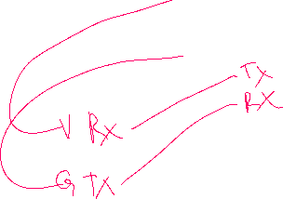

WIFI

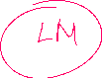

1. **SCREENSHOTS OF EACH TASK OUTPUT (ATMEL STUDIO OUTPUT)**

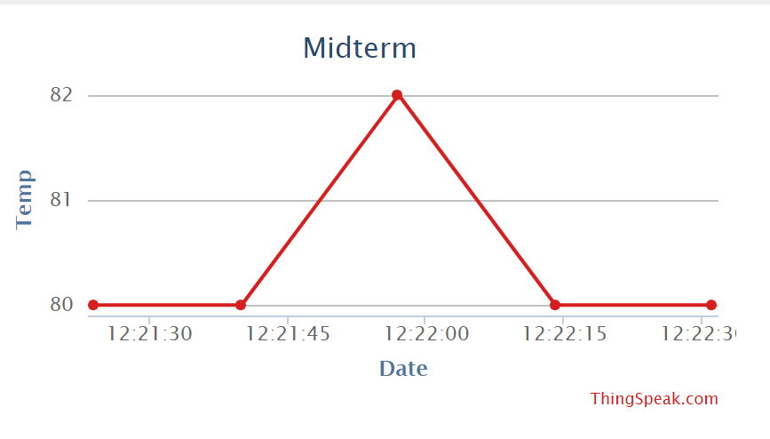

1. **SCREENSHOT OF EACH DEMO (BOARD SETUP)**

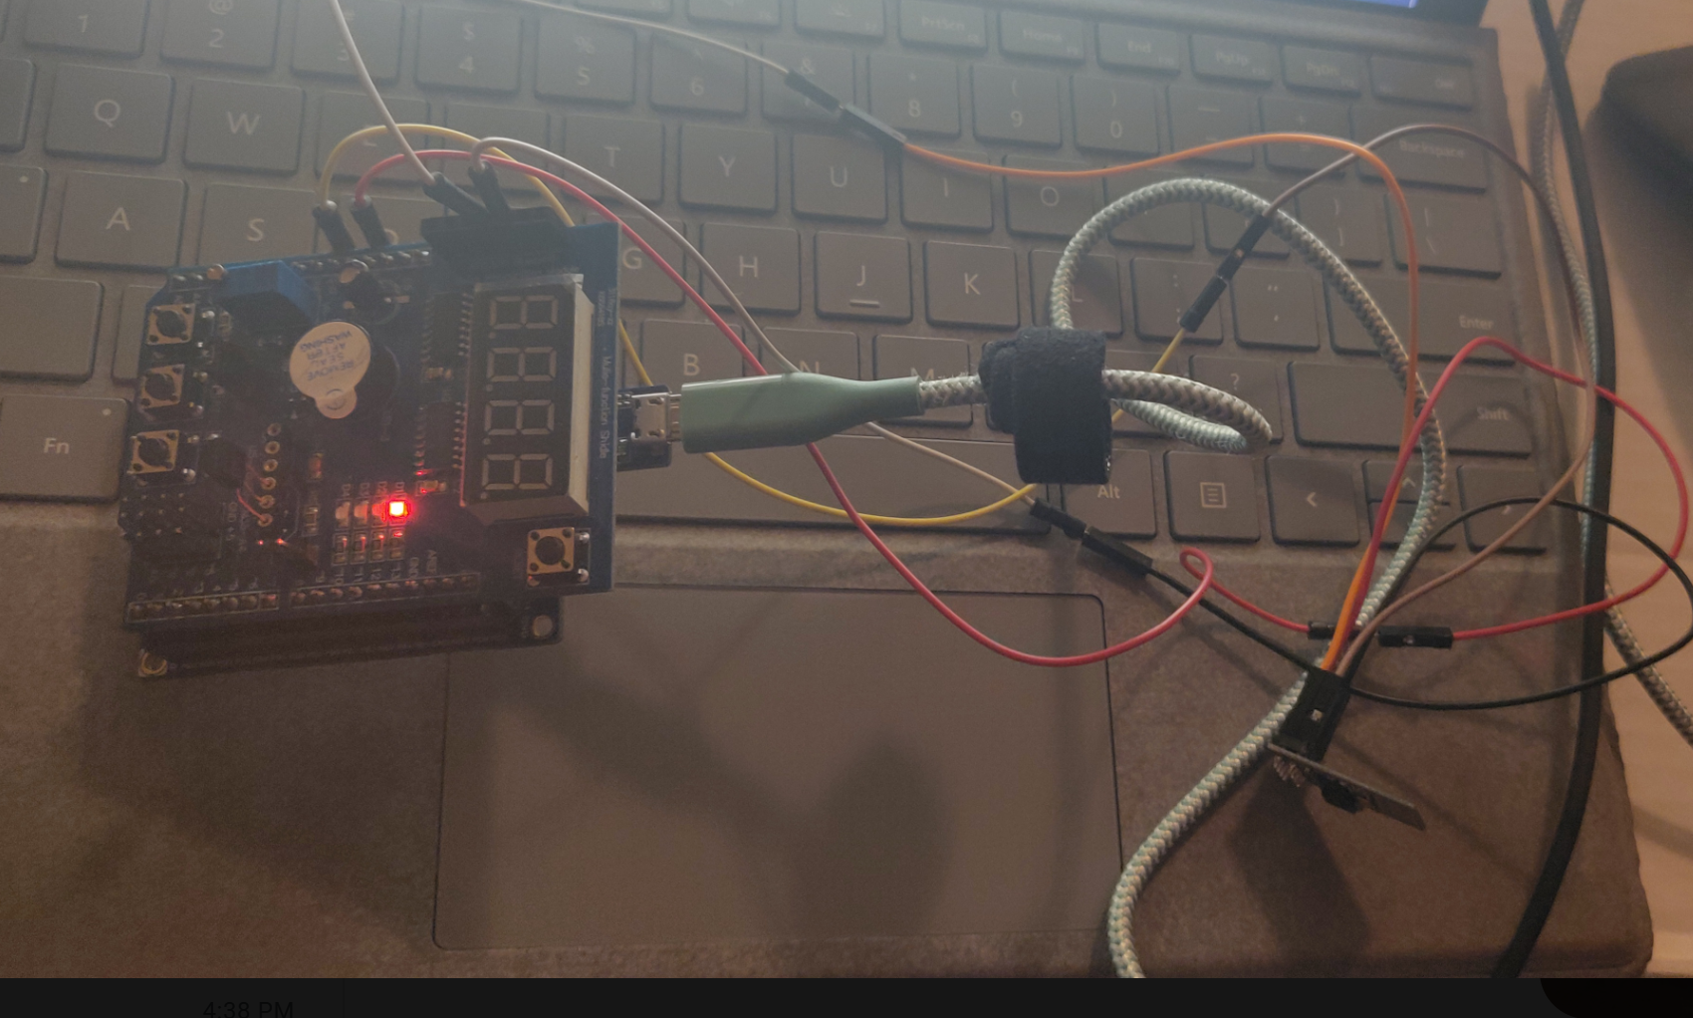

1. **Video links**

**https://www.youtube.com/watch?v=AM_zD48u9p0&feature=youtu.be**

1. **GITHUB LINK OF THIS DA**

**https://github.com/Alira-Coffman/submission-repo/tree/master/Midterm**

**Student Academic Misconduct Policy**

<http://studentconduct.unlv.edu/misconduct/policy.html>

“This assignment submission is my own, original work”.