

**NORMALIZATION**

UNF:

**ATTRIBUTES**

RoomID, RoomType, RoomRate, MaximumGuests, GuestID, FirstName, LastName, Email, PhoneNumber, Address, City, State, PostalCode, Country, ReservationID, Check-in-Date, Check-out-Date, TotalCost, PayID, PayDate, PayAmount, PayMethod.

1NF:

TABLE1: (RoomID, RoomType, RoomRate, MaximumGuests)

TABLE2: (GuestID, FirstName, LastName, Email, PhoneNumber, Address, City, State, PostalCode, Country)

TABLE 3: (ReservationID, Check-in-Date, Check-out-Date, TotalCost, PayID, PayDate, PayAmount, PayMethod)

2NF:

DEPENDENCIES:

RoomID RoomType

RoomID RoomRate

RoomID MaximumGuests

RoomType RoomRate

RoomType MaximumGuests

RoomRate MaximumGuests

GuestID FirstName

GuestID LastName

GuestID Email

GuestID PhoneNumber

GuestID Address

GuestID City

GuestID State

GuestID PostalCode

GuestID Country

ReservationID Check-in-Date

ReservationID Check-out-Date

ReservationID TotalCost

ReservationID PayID

PayID PayAmount

PayID PayDate

PayID PayMethod

3NF:

1. TABLE ROOM

ATTRIBUTES:

* RoomID INT PRIMARY KEY,
* RoomType VARCHAR(50),
* RoomRate DECIMAL(10, 2),
* MaximumGuests INT

1. TABLE2: GUEST

ATTRIBUTES:

* GuestID INT AUTO_INCREMENT PRIMARY KEY,
* FirstName VARCHAR(50),
* LastName VARCHAR(50),
* Email VARCHAR(100),
* PhoneNumber VARCHAR(20),
* Address VARCHAR(100),
* City VARCHAR(50),
* State VARCHAR(50),
* PostalCode VARCHAR(20),
* Country VARCHAR(50)

TABLE ReservationDetails

ATTRIBUTES:

* ReservationID
* GuestID INT
* RoomID INT

TABLE ReservationCost

ATTRIBUTES:

* ReservationID INT PRIMARY KEY,
* CheckInDate DATE,
* CheckOutDate DATE,
* TotalCost DECIMAL(10, 2)

TABLE PAYMENT

ATTRIBUTES:

* PaymentID INT PRIMARY KEY,
* ReservationID INT FOREIGN KEY
* PaymentDate DATE,
* PaymentAmount DECIMAL(10, 2),
* PaymentMethod VARCHAR(50)

Tables Screenshots

**Room Table**

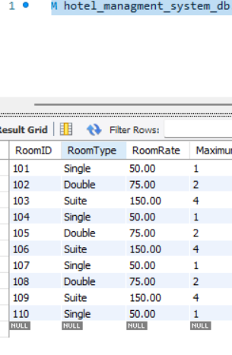

**Guest Table**

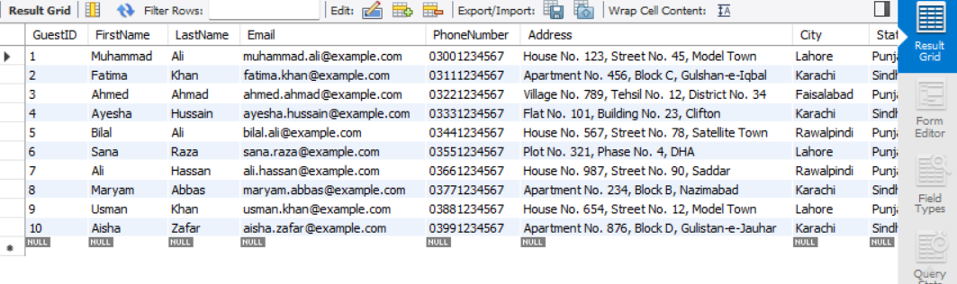

**Reservation Details Table**

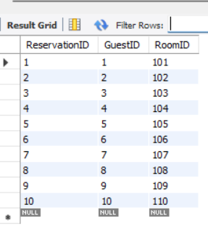

**ReservationCost Table**

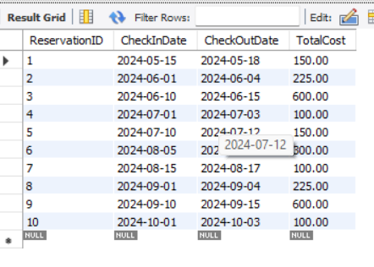

**Payment Table**

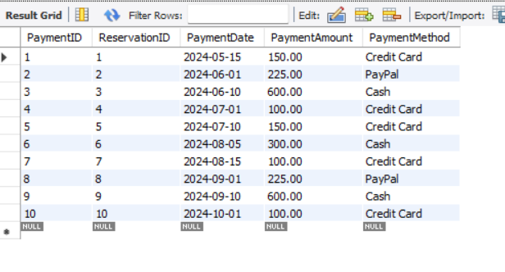

**ER diagram**

