

Business Plan

BitPayLater
Enabling Bitcoin purchases through flexible payments

Prepared by:
Alireza Amiri
Last Updated:
Sep 14, 2025
ala170@pitt.edu
412-626-9048

Contents

1. Executive Summary
2. Problem & Opportunity
3. Our Solution
4. Market Opportunity
5. Products and Services
6. Competitive Landscape
7 . Business Model & Financial Projections
8. Funding and Use of Funds
9. Traction and Milestones
10. Risk Factors and Mitigation
11. Appendices

Executive Summary


We are launching the first U.S.-based Bitcoin Buy Now, Pay Later (BTC-BNPL) platform, enabling users to purchase BTC instantly and pay in monthly installments, with the BTC itself held securely as collateral until repayment.
This model lowers the barrier to crypto ownership, mitigates default risk through conservative loan-to-value (≤70%) ratios and automated liquidation safeguards, and delivers predictable, sustainable returns for both the company and investor.

Problem and Solution | Problem:  Retail investors face high entry barriers to BTC ownership (need large upfront capital, lack of installment options). No U.S.-compliant platform exists for buying BTC in fixed installments.  Solution:  A BTC-BNPL platform that enables instant BTC purchases with monthly repayments, where BTC is held securely as collateral until repayment.
Target Market | Customer Profile:  U.S. retail investors aged 18–35, tech-savvy, seeking low-barrier entry into BTC.  Market size:  Over 65 million U.S. crypto holders, and the BNPL market is expected to exceed $170B as of 2025.
Business Model | Generates revenue from:  - Loan interest (~15% APR)  - Loan origination fees (2–3%)  - Platform service fees.  Future add-ons:  premium yield products, institutional partnerships, BTC-backed loans
Competitive Landscape | Direct:  Bitlet.app (global, not U.S. compliant), Safello+Klarna (EU BNPL-BTC).  Indirect:  Affirm, Klarna, PayPal, Block (CashApp).  Our Advantage:  First U.S.-based BTC-BNPL with a regulatory-first approach, BTC-only focus, strong risk controls.
Team Highlights | Founder:  Background in banking, risk management, and fintech modeling. Expertise in regulatory compliance, credit modeling, and product validation.
Financial Summary | Projections:  Year 1: 100 customers → $200K loan volume → ~$30K revenue.  Year 2: 1,000 customers → $2M loan volume → ~$375K revenue.  Year 3: 10,000 customers → $20M loan volume → ~$4.2M revenue.  Funding Needs:  $50K seed for compliance, tech build, and pilot marketing.  Profitability Timeline:  Expected positive unit economics within 12–18 months.

Problem & Opportunity

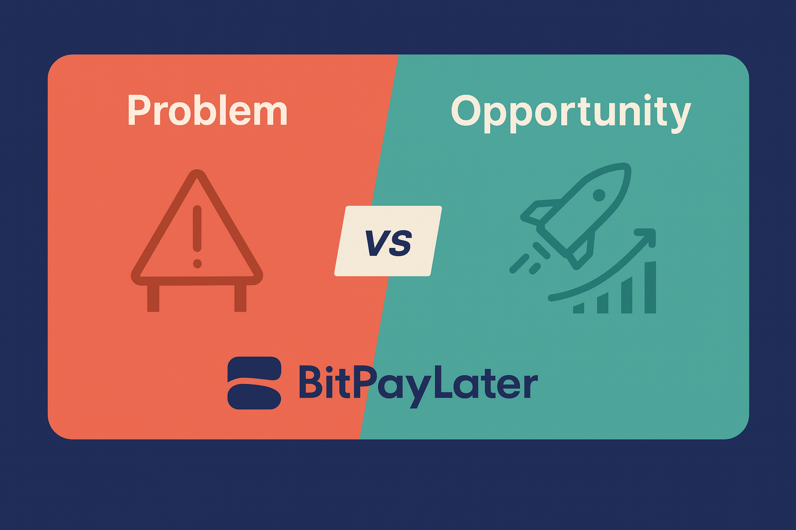

The intersection of cryptocurrency and Buy Now, Pay Later (BNPL) financing presents a significant gap in today’s financial services market. While crypto adoption continues to grow rapidly, millions of retail investors are unable to participate meaningfully due to structural barriers and the absence of installment-based investment options in the U.S.

Problem Statement
Despite the rising popularity of Bitcoin, entry barriers remain high for everyday retail investors:
- Upfront Capital Requirements: To purchase meaningful amounts of BTC, users must commit significant capital at once, which deters many first-time investors.
- BNPL Limitations: Established BNPL providers such as Affirm, Klarna, and PayPal offer financing for retail purchases, but none finance Bitcoin directly.
- Lack of Safe, Small-Ticket Crypto Lending: Existing crypto loan products tend to target larger, institutional-style lending or speculative trading. Retail investors who want gradual, low-risk accumulation are underserved.
As a result, millions of tech-savvy young investors remain locked out of a secure, accessible path to BTC ownership.

The Opportunity
Several converging trends make this the ideal time to launch a compliant BTC-BNPL solution:
- The global crypto market exceeds $4 trillion, with Bitcoin holding the dominant share.
- In the U.S., 65M+ adults already own crypto, demonstrating mainstream adoption.
- Millennials and Gen Z — the fastest-growing demographics for both BNPL and crypto — are already familiar with installment-based financing and eager to participate in digital asset markets.
- Critically, no regulated U.S. provider currently offers installment-based BTC accumulation, leaving a white-space opportunity for a first mover that combines regulatory compliance with consumer-friendly product design.
This unique positioning allows BTC-BNPL to bridge two massive, fast-growing markets — crypto and BNPL — and capture a previously untapped customer segment.

Our Solution

Our solution is BitPayLater — a Bitcoin Buy Now, Pay Later (BTC-BNPL) loan platform designed to make Bitcoin ownership accessible, safe, and financially responsible for retail investors. By combining the convenience of BNPL with the security of fully collateralized lending, BitPayLater removes barriers to entry while ensuring investor and company capital are protected.

Product
The BitPayLater BTC-BNPL Loan Platform enables customers to:
- Buy BTC instantly while the platform holds it in secure custody.
- Repay in fixed monthly installments over 3–12 months.
- Own the BTC outright once repayment is complete, at which point it is released to their wallet
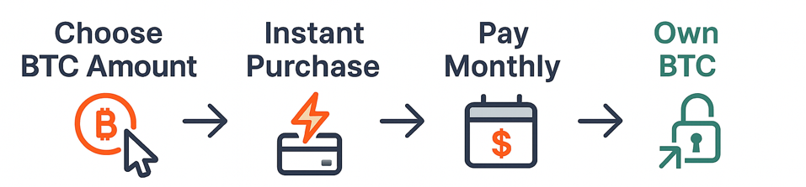

Key Benefits
Low barrier to entry: Enables small, predictable installment payments instead of large upfront capital.
Risk management built in: Loans require a 20% down payment and are fully collateralized with BTC,. Collateral is locked securely until full repayment.
Beginner-friendly onboarding: Simple, transparent terms without hidden fees, designed to educate and protect first-time BTC investors.
Scalable technology: Built to expand from the pilot phase in the U.S. to broader global markets.

Value Proposition
BitPayLater is the first U.S.-compliant platform that makes Bitcoin ownership safe, affordable, and accessible through compliant, monthly installment-based investing.

Market Opportunity


Explosive Growth in BNPL
The Buy Now, Pay Later (BNPL) sector is one of the fastest-growing segments in consumer finance:
- Global BNPL Market:
Estimated at ~$300B in 2023, with projections ranging from $560B by 2025 to $1T+ by 2030, depending on growth scenarios.
- U.S. BNPL Adoption:
~81M users in 2023, projected to reach 120M users (~41% of adults) by 2030.
- Consumer Behavior:
Over 52% of U.S. consumers will have used BNPL at least once by year-end 2024, underscoring mainstream adoption.
BNPL is no longer niche—it is a mainstream consumer financing tool, especially among Millennials and Gen Z.
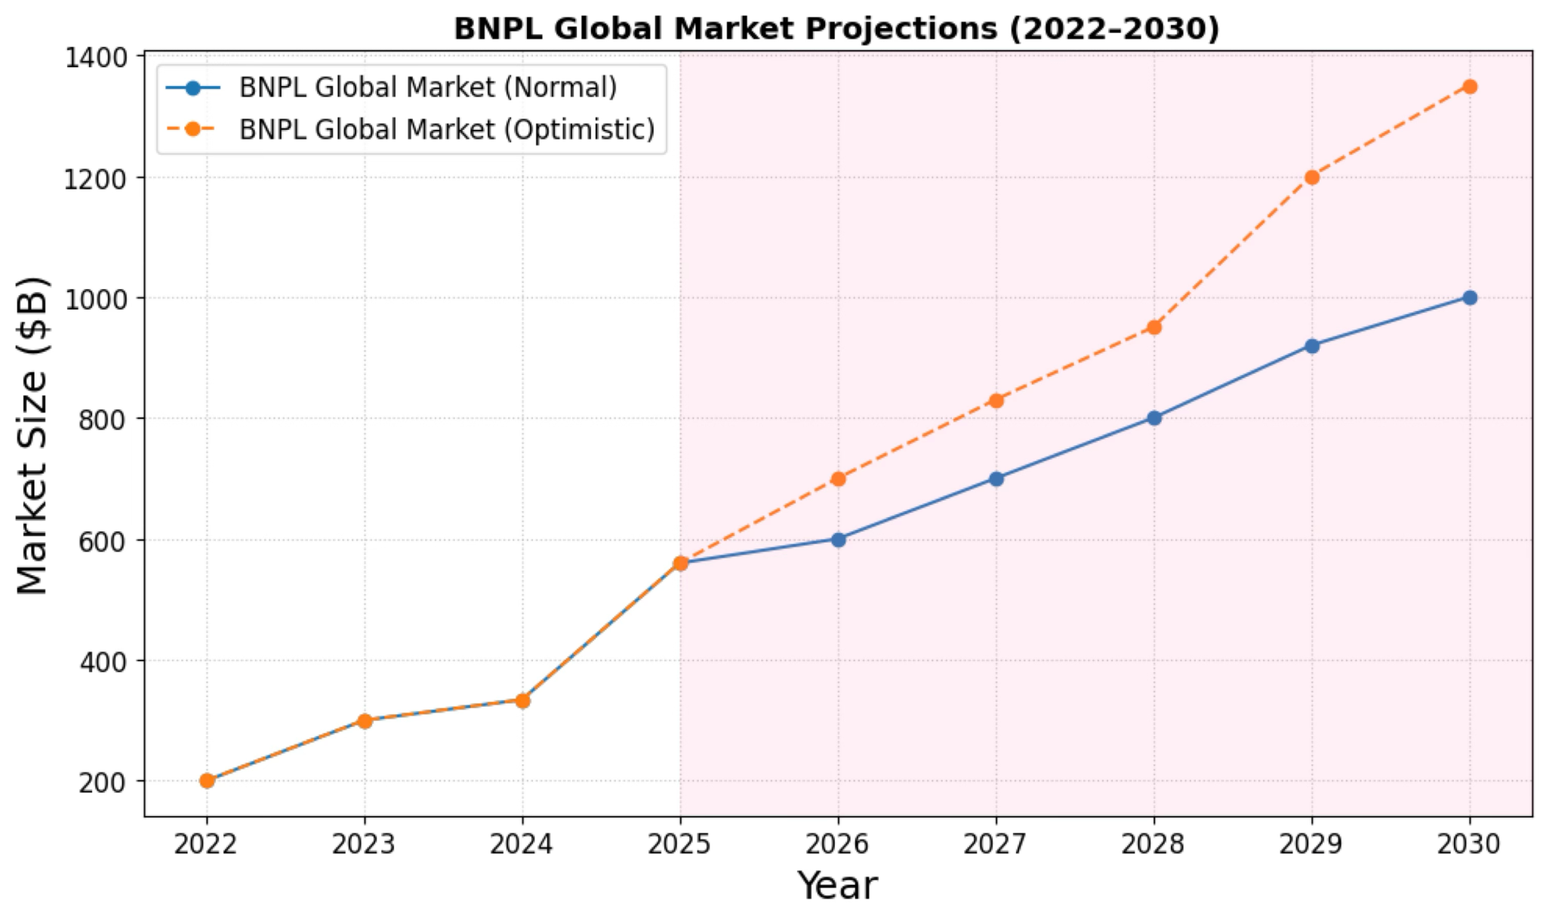

Mainstreaming of Crypto Ownership
Parallel to BNPL’s growth, crypto adoption has entered the mainstream:
- U.S. Crypto Owners:
~47M adults in 2023 (~14% of U.S. adults), rising to 82M (~35%) by 2030 under conservative growth.
- Demographics:
Millennials (57%) and Gen Z (13%) dominate ownership, with younger investors significantly more engaged.
- Behavioral Trend:
67% of existing crypto owners plan to buy more within the next year, showing persistent demand even in volatile cycles.
Crypto ownership is becoming a default asset class for younger investors seeking diversification and inflation hedges.

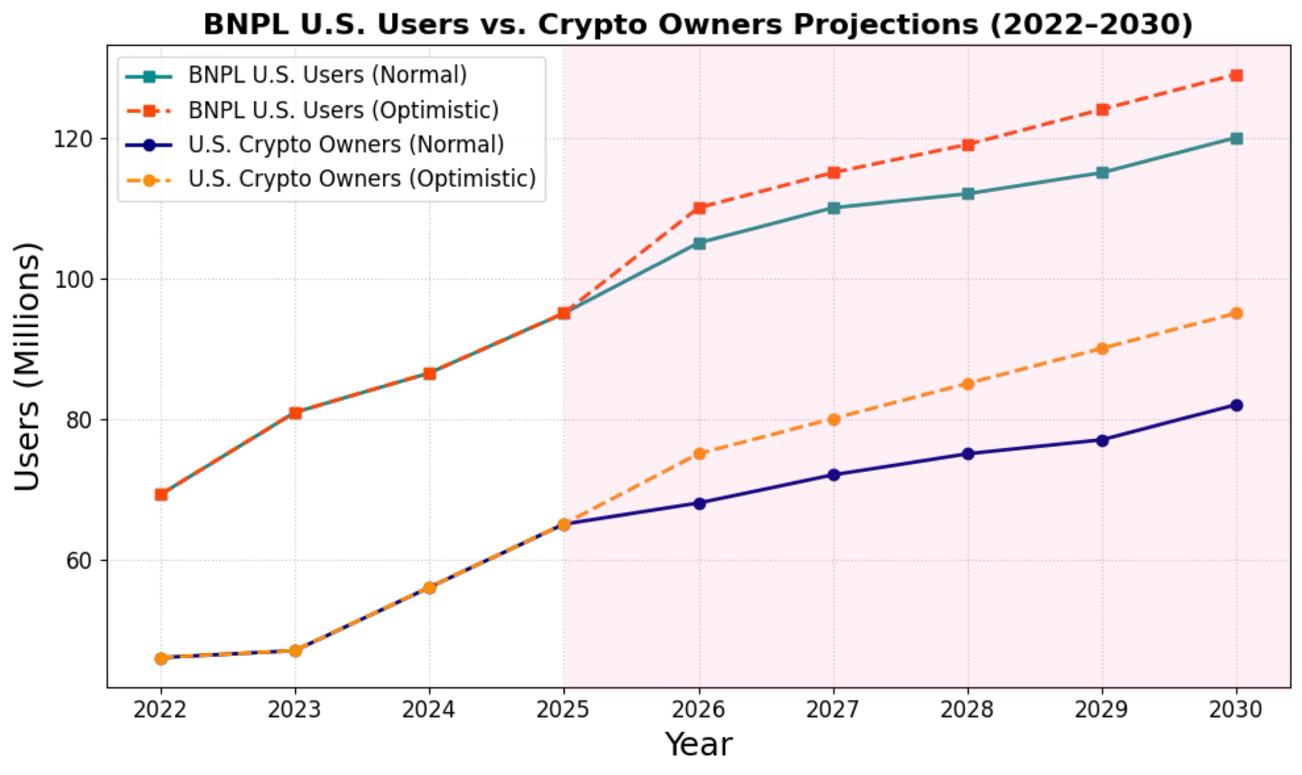

The Overlap: White-Space Opportunity
The convergence of BNPL and crypto creates a powerful cross-market segment:
- TAM (Total Addressable Market):
  - ~100M U.S. adults in BNPL and crypto combined.
Global BNPL transactions forecast to exceed $1T by 2030.
- SAM (Serviceable Available Market):
  - ~20–25M U.S. consumers in the overlap (Millennials & Gen Z most engaged).
  - Represents $40B–$50B annual BTC loan volume (assuming $2K per user annually).
- SOM (Serviceable Obtainable Market):
  - If BitPayLater captures just 1% (~200K–250K users), this equals:
    - Loan Volume: $400M–$500M annually
Revenue: $60M–$75M annually (at ~15% APR + fees)
Even a modest penetration of this overlap translates into a multi-million dollar revenue business—with scalability and strong first-mover advantages.
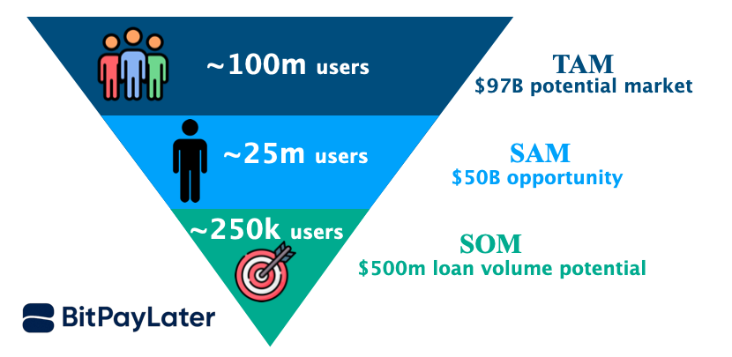

Macro Trends Driving Demand
- Economic Pressure: Inflation and geopolitical uncertainty push younger investors toward hedged assets like Bitcoin.
- Consumer Preferences: Small, predictable payments (BNPL) align perfectly with the desire for gradual Bitcoin accumulation.
- White-Space Advantage: No regulated BTC-BNPL provider exists in the U.S. — incumbents remain cautious due to regulatory barriers.
This leaves space for a compliance-first first mover like BitPayLater to establish leadership.

Products and Services



Our core offering is BitPayLater — a Bitcoin Buy Now, Pay Later (BTC-BNPL) loan platform that enables retail investors to accumulate Bitcoin affordably, safely, and transparently. The platform combines the convenience of BNPL with the security of fully collateralized lending, creating a first-of-its-kind financial product in the U.S.

Product Overview
Product Name:
BitPayLater - BTC Buy Now, Pay Later Loan Platform
Description:
BitPayLater enables customers to purchase Bitcoin instantly while paying in fixed monthly installments (3, 6, 9, or 12 months). The BTC is securely held in custody until the loan is fully repaid, at which point it is released to the customer’s wallet. This approach lowers the entry barrier for retail investors while ensuring both compliance and capital protection.
Pricing Model:
Loan Interest: Fixed rates ranging from 8% to 18% depending on the loan term.
Loan Origination Fees: 2–3% applied upfront.

Competitive Advantage:
- Risk Controls Built In: 20% down payment + fully collateralized loans with BTC reduce default risk
- Client-Friendly Structure: No mid-cycle liquidation — BTC is locked until repayment, ensuring predictable terms for users.
-Trust & Transparency: Beginner-friendly onboarding with transparent fees
- White-Space Positioning: Scalable tech platform with global expansion potential

Development Roadmap
Phase | Milestone | Specific tasks | Timeline | Metrics for Success
Phase 1:  Idea & Pilot | Validate feasibility (technical, legal, user-flow). | - Build a manual MVP with trusted testers.  - Use private loan agreements (personal exemptions).  - Test escrow/exchange API integrations | 0–3 Months  (Q4 2025) | -Core workflow tested (BTC buy, custody, repayment tracking).  -3–5 loan cycles completed with 100% repayment.  -Legal framework reviewed.
Phase 2: Alpha | Launch first working version with small invite-only user base. | - Partial automation of loan cycle.  - Onboard 5–15 testers outside founder network.  - Simulate missed payments and stress-test repayment logic. | 3–5 Months  (Q1 2026) | -Stable alpha release.  -Repayment validated.  -Compliance/legal structure confirmed.
Phase 3: Beta | Controlled rollout with a wider audience | - Full front-end automation + semi-auto backend  - Onboard 20–100 testers  - Collect UX feedback  - Gather UX feedback and refine APR and fee models. | 5–9 Months  (Q2 2026) | -Default rate <5%  -$200K loan volume (~$30K revenue)  -Consistent repayment behavior from external users.
Phase 4:  Compliance & Pre-Launch | Secure licenses and finalize partnerships. | - Obtain lending licenses (state-level)  - Finalize AML/KYC integration  - Formalize custody/payment partnerships  - Launch PR campaign | 9–12 Months  (Q3 2026) | -Lending licenses active in launch states.  -AML/KYC system live.  -Custody + payment partners signed.
Phase 5: Full-Scale Operations | Public launch and expansion | - Open platform to the general public.  - Expand multi-state licenses.  - Begin preparations for international markets (Canada, EU, MENA). | 12+ Months (Q4 2026 onwards) | -1,000+ active users  - Positive unit economics (profitable per loan cycle)  -Global expansion plan initiated

Competitive Landscape

Market Context
The BTC-BNPL niche is still intact, with no regulated U.S. provider offering a pure “buy Bitcoin now, pay later” solution due to regulatory hurdles. This creates a first-mover opportunity for a compliant entrant targeting 65 million+ U.S. crypto users who want to accumulate Bitcoin gradually without the burden of a full upfront payment.

Competitor Comparison

Competitor | Region | BTC-BNOL Offering | Regulatory Status | Threat Level
Bitlet.app | Global | Installment BTC  (20% down, no credit checks) | Not U.S.-compliant | Low/Medium
Safello + Klarna | EU | BNPL-BTC checkout in select European markets | EU-only | Medium
Affirm | U.S. | BNPL leader; in-app BTC trading (via NYDIG), but no BTC financing | Regulated | High
Klarna | U.S. | BNPL integrated into Cash App, with BTC investing | Regulated | High
PayPal | Global | BNPL + crypto trading, but separate products | Regulated | High
Coinbase | U.S. | Leading U.S. crypto exchange; BTC buy/sell, staking, custody. | Regulated;  no installment financing | High
Gemini | U.S. | Regulated U.S. exchange; BTC trading + custody | Regulated;  no BNPL model | Medium
Binance.US | U.S. | Exchange offering BTC purchases, trading, and staking. | Regulatory challenges; no BNPL option | Medium/High

Key Insights
- Competitive Gap in the U.S.: No retail-friendly, installment-based BTC provider exists today.
- Regulatory Barriers: Keep big components cautious — providing space and an advantage for compliant first mover startups.
- Threats: Large BNPLs (Affirm, Klarna, PayPal) or established crypto companies (Coinbase, Gemini, Binance) could pivot into this niche quickly.
- Opportunity: Define the BTC-BNPL category in the U.S. with a transparent, compliant, Bitcoin-only platform.

What We Oﬀer (Differentiation)
BitPayLater is uniquely positioned to stand apart from both BNPL providers and established crypto companies by focusing on four core advantages:
1. Bitcoin-Only Focus
- Builds strong brand trust by avoiding the complexity, volatility, and regulatory uncertainty of multi-token platforms.
- Positions BitPayLater as the most accessible, transparent way for retail users to accumulate Bitcoin gradually.
2. Regulatory-First Approach
- Launching through licensed lender partnerships ensures compliance from day one.
- Compliance is a strategic moat — many offshore competitors avoid the U.S. market due to strict lending and custody requirements.
3. Financial Wellness Positioning
- Marketed as a responsible way to invest in Bitcoin, not as a speculative trading tool.
- Focuses on predictable, fixed-term payments that align with how Millennials and Gen Z already use BNPL products.
4. Built-In User Protection
- A 20% down payment requirement gives users skin in the game and lowers default risk.
- BTC held in secure custody (e.g., BitGo, Fireblocks) until repayment is complete.
- Clear repayment terms — no hidden fees, no mid-cycle liquidations — ensuring customer trust and transparency.

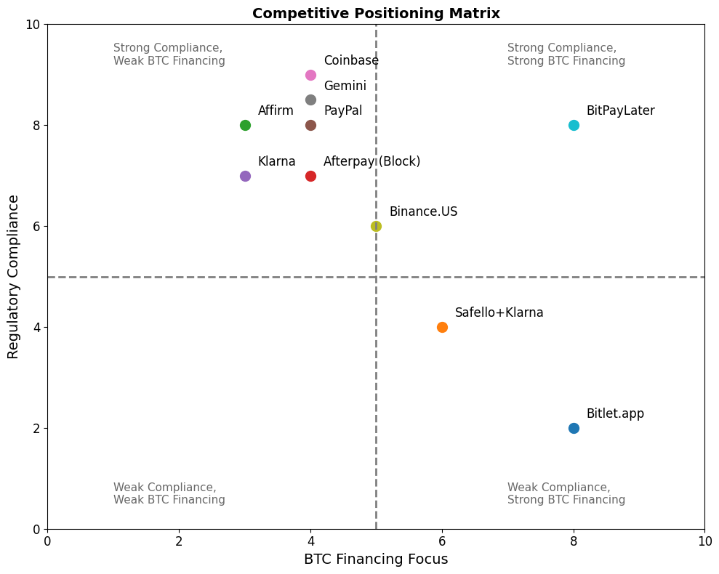

Business Model & Financial Projections

Business Model
BitPayLater monetizes by financing Bitcoin (BTC) purchases through installment-based loans, with revenue streams from:
- Loan Interest (8%–18% fixed rates) – The primary income driver, tied to loan duration (3, 6, 9, or 12 months).
- Loan Origination Fees (1–2%) – Charged upfront on each contract, providing immediate cash flow.
This model ensures recurring revenue per loan cycle, while maintaining collateralized risk management (BTC custody until repayment).

Revenue Forecast & Stages (Stage-Gated Development)
- Idea & Alpha (Months 0–5): Focus on feasibility & compliance; no revenue.
- Beta (Months 5–9): First paying testers; ~$1K–$2K revenue.
- Pre-Launch (Months 9–12): Scaling testers with licenses; ~$5K–$7K revenue.
- Full-Scale Operations (12+ Months): 100+ users, ~$15K annualized revenue.

Multi-Year Projections (Normal vs. Scale Scenarios)

Year | Users | Loan Volume | Revenue | Notes
Year 1  (Pilot + Alpha + Beta) | ~100 | $0.1M | ~$15K | Pilot testing, Compliance Phase
Year 2  (Launch) | ~1,000 | $1M | ~$150K | Early adoption, Licenses in place
Year 3  (Scale) | ~10,000 | $10M | ~$1.5M | Scale-up with Partnerships and influencer-driven growth
Year 3  (Acceleration) | ~50,000 | $50M–$75M | ~$7.5M–$11M | Accelerated user acquisition, multi-state licensing, and marketing expansion
Year 5  (Expansion) | 100K–200K | $100M–$200M | ~$15M–$30M | 1% SOM capture, product expansion

Break-Even Analysis
- Fixed Costs (annual):
  - Compliance & Legal: ~$300K (licensing, KYC/AML vendors, audits)
  - Technology: ~$200K (platform, custody integrations, APIs)
  - Operations: ~$100K (team, support, cloud costs)
- Variable Costs: CAC ~$50–100 per user.
- Revenue per User (ARPU): ~$320 annually
  - Avg. Loan Size: ~$1,000
  - APR ~15% → ~$150 interest income
  - Fees add ~$10–15
Break-even at ~2,000–2,400 paying users (expected in Year 2–3).
Even under conservative assumptions (higher CAC or slightly higher default rates), the business reaches breakeven early due to strong unit economics (LTV/CAC ratio ~3–6x).

Revenue Ramp + Loan Volumes (Scalability)
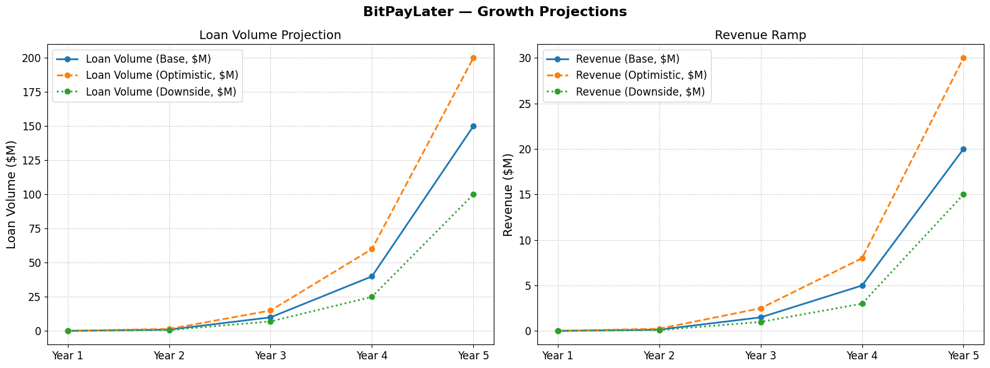
This implies sustainability is achievable early, with upside driven by CAC efficiencies and loan volume growth.
BitPayLater’s business model is structured to scale responsibly. In the first 12 months, our focus is on compliance and repayment validation, rather than revenue. By Year 2, we expand into a revenue-generating product with positive unit economics. At just 1% penetration of our SAM (200,000–250,000 users), BitPayLater achieves $60–$ 75 million in annual revenues. With ARPU of ~$320 and CAC of ~$50–100, we expect break-even by Year 2–3 and scalable profitability thereafter.
With both conservative and aggressive adoption scenarios, BitPayLater is positioned as the first-mover BTC-BNPL platform in a trillion-dollar convergence of BNPL and crypto.

Key Performance Metrics (KPIs)
KPI | Definition | Importance
User Growth Rate | % increase in active users per period | Measures adoption speed
Default Rate (%) | % of loans not repaid | Core risk metric
CAC | Cost to acquire one paying user | Marketing ROI
LTV | Expected revenue per user | Long-term sustainability
Loan Volume Growth | Total financed BTC | Market traction

Funding and Use of Funds

We are raising capital to accelerate the growth of BitPayLater, the first U.S.-focused Bitcoin Buy-Now-Pay-Later (BTC-BNPL) platform. This round will fund compliance licensing, product development, and customer acquisition, enabling us to prove unit economics, achieve scale, and capture a first-mover advantage in this white-space market.

Funding Round
- Raise Target: $500K Seed (with modular pre-seed option $100K–$250K to cover MVP + licensing).
- Valuation Expectation: Pre-money valuation of $3–5M (negotiable based on traction).
- Structure: Convertible Note or SAFE, with a 15–20% discount and valuation cap.
We maintain flexibility in funding: investors can join at a lean pre-seed stage or at the $500K seed round, depending on appetite. This modular plan enables us to start small and scale fuel as needed.

Use of Funds (Allocation %)
- Product Development (40%)
  - Build a secure BNPL platform (frontend + backend + custody integration).
  - Launch MVP with mobile/web apps.
  - Ongoing R&D for premium features (savings plans, insurance, risk models).
- Compliance & Legal (25–30%)
  - State lending licenses and money transmitter registrations.
  - KYC/AML vendor integration.
  - Ongoing legal counsel and audits.
  - Note: If compliance costs run higher (e.g., federal-level requirements), allocation can flex to 35% by outsourcing product dev.
- Marketing & Growth (20%)
  - Digital campaigns targeting Millennials & Gen Z (Instagram, TikTok, X).
  - Influencer partnerships in fintech/crypto.
  - Referral and loyalty programs.
- Working Capital & Operations (15%)
  - Team salaries (lean core + outsourced devs).
  - Hosting, cloud infrastructure, operational expenses.

Use of Funds Projection (5 Years)

Year | Stage & Milestones | Compliance & Legal | Product Development | Marketing & Growth | Operations & Working Capital | Total Budget
Year 1 | Pilot + Alpha (MVP)  • Legal setup  • Loan contracts (pilot testers)  • MVP build + custody integration | $100K | $150K | $50K | $50K | $350K
Year 2 | Launch  • State licenses  • Onboard 1K+ users  • Begin real revenues | $200K | $300K | $150K | $100K | $750K
Year 3 | Scale  • 10K+ users  • Institutional partnerships  • Premium tiers | $300K | $400K | $300K | $150K | $1.15M
Year 4 | Acceleration  • 50K–100K users  • Geographic expansion  • BTC savings/insurance | $400K | $500K | $500K | $200K | $1.6M
Year 5 | Expansion  • 200K+ users  • 1% SOM capture  • Path to profitability or Series B | $500K | $700K | $750K | $300K | $2.25M

Exit Pathways
- Acquisition – Potential acquirers include BNPL leaders (Affirm, Klarna, Block/Afterpay) and crypto fintechs (Coinbase, Gemini, PayPal).
- IPO – Considered once we reach 3–5M users and $300M+ annual revenue (7–10 year horizon).
- Strategic Partnerships – Possible early exits via equity stakes from fintechs or exchanges seeking integration

Traction and Milestones

We’ve validated early demand for a compliant BTC-BNPL solution through targeted user discovery, pilot tests, and compliance groundwork. Our milestones to date demonstrate disciplined execution, while our forward roadmap shows a clear path to scalability and investor ROI.

Market Validation (Traction So Far)

User Discovery: 20+ interviews; ~70% expressed interest in BTC-BNPL if available today.
Pilot Testing: 3–5 testers completed initial loan cycles with 100% repayment.
Compliance Research: Legal review of lending/KYC requirements in 2 U.S. states completed.
Partnership Conversations: Early discussions with custody providers and BNPL advisors.
Team Formation: Founder with risk management background; seeking technical cofounder.

Early Milestones Achieved
Although BitPayLater is pre-launch, we have already taken meaningful steps to validate the concept and reduce execution risk. These early milestones demonstrate both proof of concept and founder commitment:

Milestone | Description | Date Achieved
MVP Framework | Manual MVP (Google Sheets + custody wallet setup). | Q4 2025  (target)
First Pilot Testers | 5 testers, repayment >95%. | Q1 2026  (planned)
Compliance Research | Legal review of lending/KYC requirements in 2 states.
Cofounder Joined | Secure a technical cofounder to build the Alpha product.
Partner Talks | Custody provider + BNPL advisor discussions underway.

Future Milestones (12–24 Month Roadmap)
Over the next two years, BitPayLater will move from pilot testing to national rollout, with each milestone tied to measurable KPIs and funding needs.
Timeline | Milestone | Goal
Q2 2026 | Alpha Testing | 15–20 testers complete loan cycles.
Q3 2026 | Beta Launch | 100–120 early adopters onboarded.
Q4 2026 | Licensing Secured | Obtain lending/KYC licenses in 1 state.
Q1 2027 | Full Launch | 1,000 + users, $1M loan volume → $150K RR
Q2 2027 | Partnerships | Secure 1–2 fintech/custody partnerships.
Q4 2027 | Expansion | 10,000 + users, $10M loan volume.

Risk Factors and Mitigation
Every startup faces risks, and BitPayLater is no exception. However, we view risk management not as a hurdle but as a competitive advantage. By embedding a compliance-first model and strong technical/financial safeguards from the start, we are well-positioned to navigate challenges that have stalled less-prepared competitors.

Risk Category | Potential Risk | Likelihood | Impact | Mitigation Strategy | Status
🔴Regulatory  (High Priority) | U.S. lending/crypto laws could block operations if non-compliant. | Medium | High | Start in crypto-friendly states. Secure lending & KYC licenses. Partner with regulated custodians. Retain legal counsel. | Ongoing  (legal review + licensing plan in place)
🟠Financial  (Medium–High) | Loan defaults + BTC volatility undermine collateral value. | Medium | High | Require 20% downpayment. Fully collateralized loans. Refund principal on default. Hedge short-term with futures/ETFs. Hold defaulted BTC long-term (1–3 yrs) where loss probability <1%. | Pilot risk models under design
🟡Market  (Medium) | Low demand for the BTC-BNPL product. | Medium | Medium | Focus on Millennials & Gen Z (BNPL + crypto overlap). Run pilots + user surveys. Adapt repayment/fee structures. | Discovery stage (waitlist + interviews planned)
🟡Technology  (Medium) | Custody/security breaches, downtime. | Low–Medium | Medium | Use insured custody (BitGo, Fireblocks). MVP with APIs, later audited infrastructure. External audits for scale. | Custody partners under discussion
🟢Operational (Low–Medium) | A small founding team delays execution. | Medium | Medium | Hybrid hiring: U.S. compliance/product + offshore dev. Strong project management. Advisory board support. | Core team forming
🟢Competitive (Low) | BNPL/crypto giants (PayPal, Klarna, Coinbase) enter BTC-BNPL. | Medium | Medium | First-mover advantage with U.S. compliance-first BTC-BNPL. A Bitcoin-only focus builds trust. Early brand equity. | First-mover moat in design
We consider Regulatory Risk as both High Impact (5) and High Likelihood (4) — hence our compliance-first strategy with licenses, legal partners, and custody integration. By contrast, Competitive Risk is Low Impact (2) and Low Likelihood (2) in the short run, since incumbents face regulatory hesitation. This prioritization guides our resource allocation.

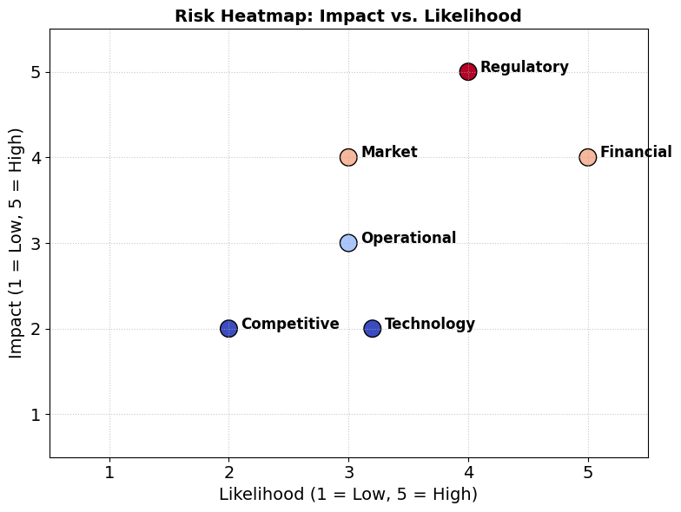

Appendices

The appendix includes supporting evidence, research links, and visual assets that back up the claims in this plan.
Supporting Documents & Research Links
- BNPL vs. Credit Cards Market Statistics
CoinLaw – BNPL vs. Credit Cards Statistics
  - Comparative analysis of BNPL adoption versus traditional credit cards (demographics, spending, growth trends). Validates BNPL’s mainstream adoption trajectory.
- BNPL Global Market Growth Reports
  - Fortune Business Insights – BNPL Market Size Report (2023–2032)
  - Juniper Research – BNPL Global Transactions Forecast (2024–2033)
  - Example: Global BNPL transactions projected to reach ~$681B by 2033 at ~42% CAGR.
- Crypto Adoption in the U.S.
  - Security.org – Cryptocurrency Ownership Survey (2024)
  - Gemini – Crypto Trends Report (2023)
  - Example: ~65M U.S. adults (~28%) already own crypto; Millennials & Gen Z drive majority of growth.
- Internal Financial Models & Projections
  - Excel workbook (available upon request) with:
    - Revenue Ramp (Years 1–5, $0 → $75M)
    - Loan Volume Growth ($0.5M → $600M)
    - Break-Even Analysis (~2,000–2,400 users)

# Version | Date | Owner | Change
1 | August 26, 2025 | Alireza Amiri | The initial draft has been finalized.
2 | September 14, 2025 | Alireza Amiri | -Business Model  -Risk Management Approach

