**StudentID: 9731009 Name:سید علیرضا اعزاز**

**Activity 2:**

**Single table queries**

Create the “**product”** table, which we talked in the class (please refer to ch3).

create database Company;  
create table Product  
(  
 PName varchar(255) primary key,  
 Price float default 0.0 check ( Price >= 0 ),  
 Category varchar(255) not null,  
 Manufacturer varchar(255) not null  
);  
insert into Product values ('Gizmo',19.99,'Gadgets','GizmoWorks');  
insert into Product values ('Powergizmo',29.99,'Gadgets','GizmoWorks');  
insert into Product values ('SingleTouch',149.99,'Photography','Canon');  
insert into Product values ('MultiTouch',203.99,'Household','Hitachi');

Show all records of the products table:

Write your query here:

In [1]:

select * from Product;

Show the output here:

Out [1]:

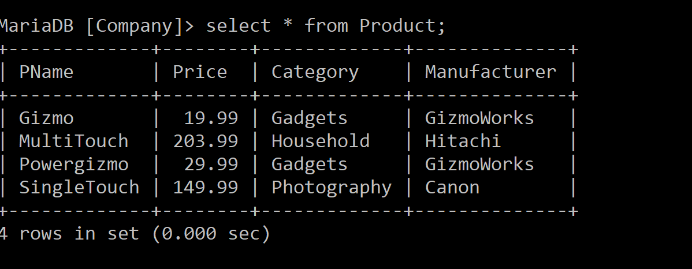

**Exercise #1**

Try writing a query to get an output table of all the products with "Touch" in the name, showing just their name and price, and sorted alphabetically by manufacturer.

Write your query here:

In [2]:

select PName, Price  
from Product  
where PName like '%Touch%'  
order by Manufacturer;

Out [2]:

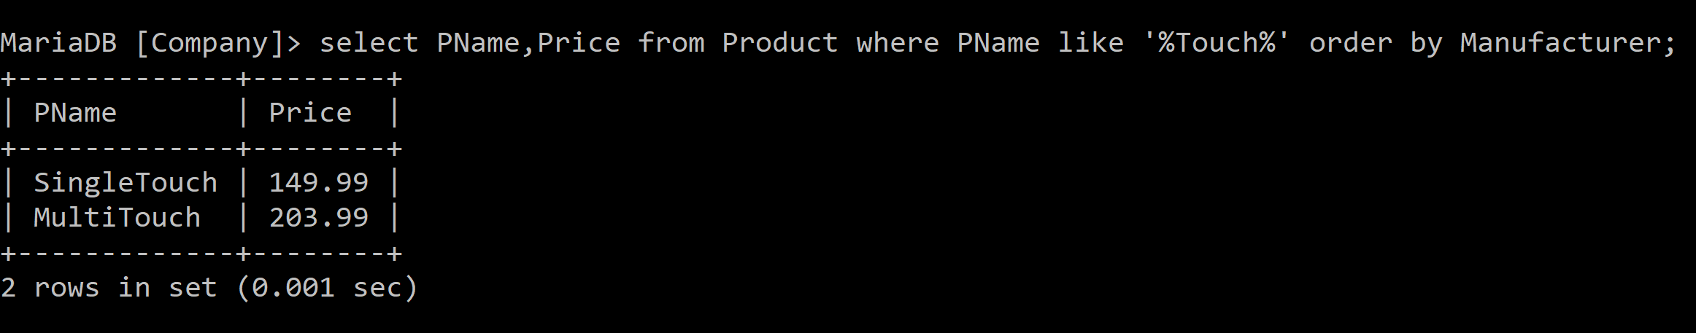

Next, write a query that returns the *distinct* names of manufacturers that make products with "Gizmo" in the name:

In [3]:

select distinct Manufacturer  
from Product  
where PName like '%Gizmo%';

Out [3]:

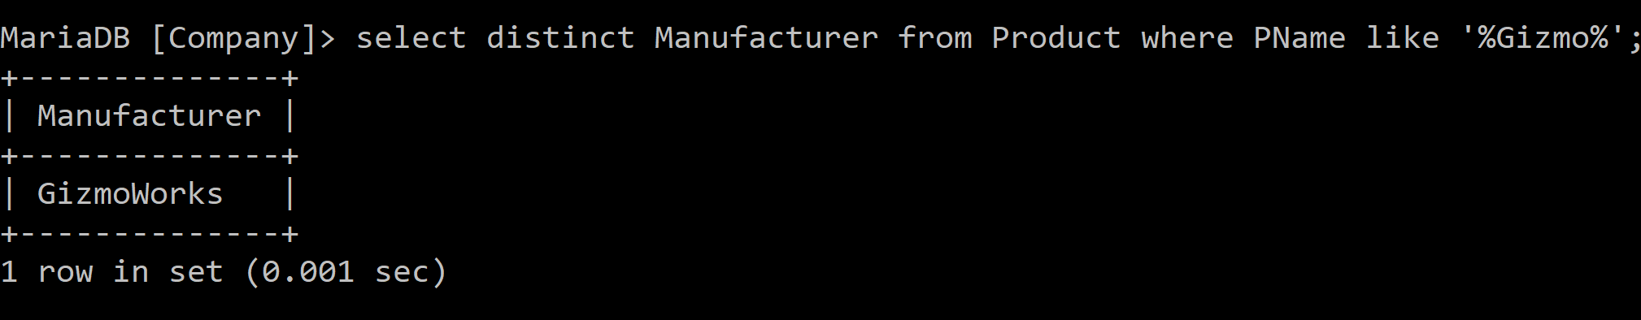

**Exercise #2:**

Try these queries but first guess what they return.

In [4]:

%sql SELECT DISTINCT category FROM product ORDER BY category;

Out [4]:

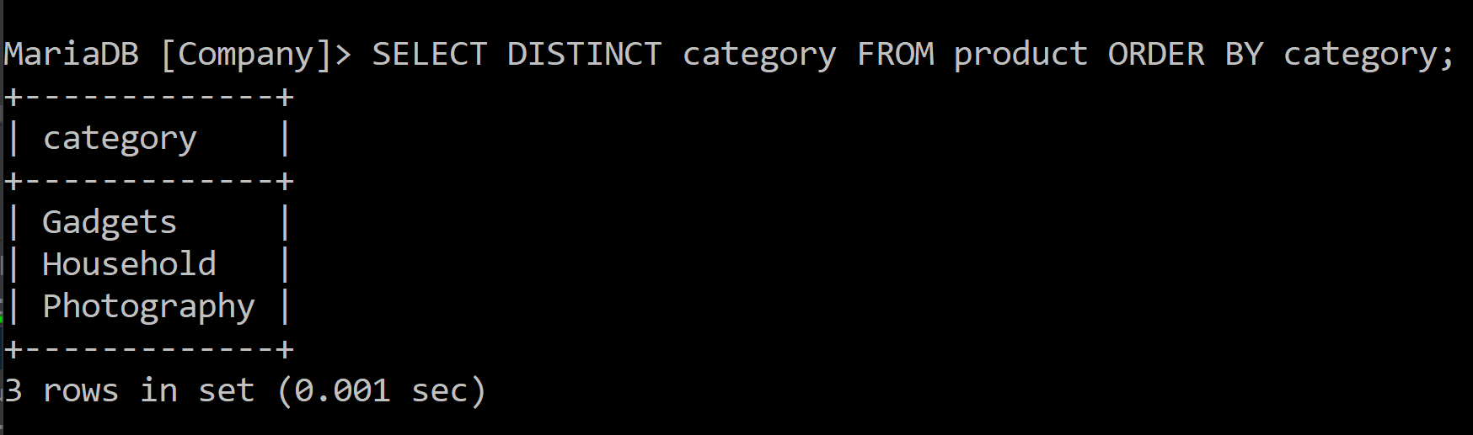

In [5]:

%sql SELECT category FROM product ORDER BY pname;

Out[5]:

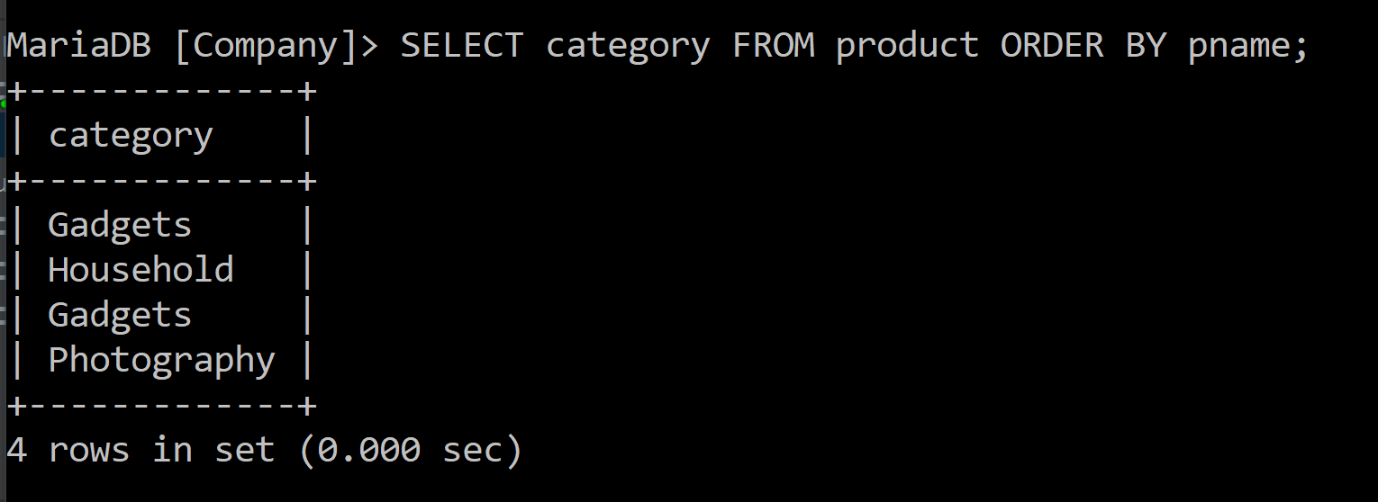

In [6]:

%sql SELECT DISTINCT category FROM product ORDER BY pname;

Out [6]:

