**StudentID: 9731009 Name:سید علیرضا اعزاز**

**Activity 3:**

**Multi-table queries**

**Exercise #1:**

For three tables $R, S,T$ that only have one attribute $A$:

* R = {1,2,3,4,5}
* S = {1,3,5,7,9}
* T = {1,4,7,10}
* create database Exercise2;  
  create table R(A int primary key );  
  create table S(A int primary key );  
  create table T(A int primary key );  
    
  insert into R values (1);  
  insert into R values (2);  
  insert into R values (3);  
  insert into R values (4);  
  insert into R values (5);  
    
  insert into S values (1);  
  insert into S values (3);  
  insert into S values (5);  
  insert into S values (7);  
  insert into S values (9);  
    
  insert into T values (1);  
  insert into T values (4);  
  insert into T values (7);  
  insert into T values (10);

Write a query to select $R∩\left(S∪T\right)$- in other words elements that are in $R$ and either $S$ or $T$?

Write your query here:

**In [1]:**

select distinct R.A  
from R,S,T  
where R.A = S.A or R.A = T.A;

**Out [1]:**

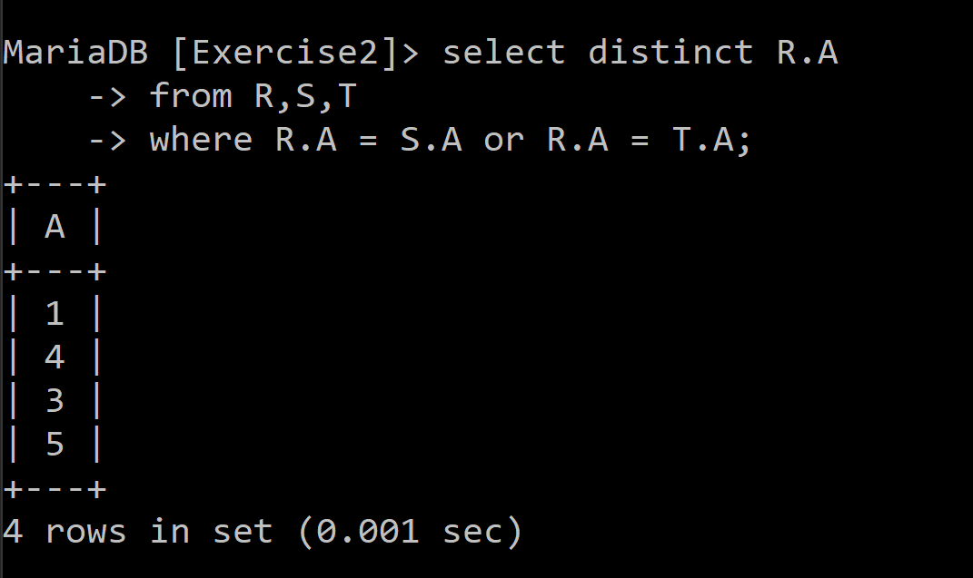

* Now test your query above for the case where $S=∅$- what happens and why?

با توجه به اینکه مجموعه s تهی است ،ضرب دکارتی هر مجموعه دیگر در آن تهی می شود پس خروجی مجموعه تهی خواهد بود.

* Execute the below, then re-run your query above

**In [2]:**

%%sql

delete from S;

**Out [2]:**

**Empty set**

Write a query to select $R∪\left(S∩T\right)$?

Write your query here:

**In [1]:**

select distinct A  
from R  
union  
select distinct S.A  
from R,S,T  
where S.A = T.A ;

**Out [1]:**

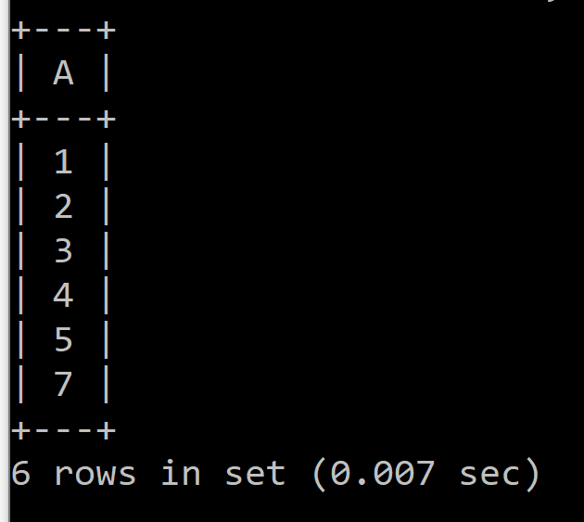

**Exercise #2**

* Schema is same as before

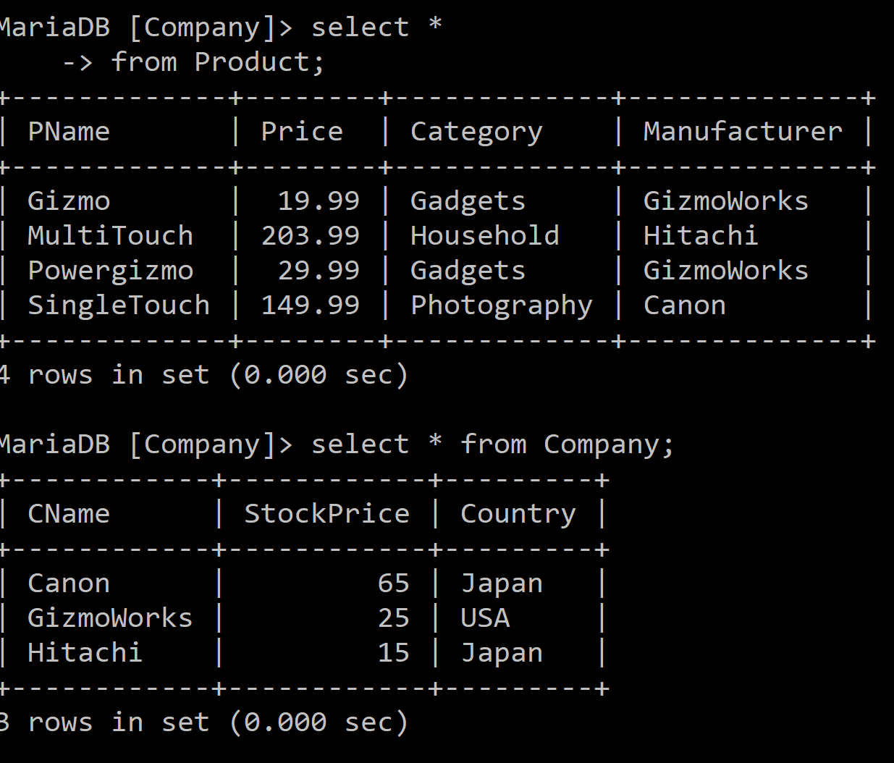

Product (PName, price, category, manufacturer)  
Company (Cname, stockPrice, country)

* Our goal is to answer the following question:

Find all categories of products that are made by Chinese companies

Write your query here:

In [3]:

select Category  
from Company,Product  
where Manufacturer = CName and Country ='China';

Out [3]: 