**Abstract**

EZ Gas is a crowdsourcing service which aim is to help users to locate gas stations in an area, along with the price they offer and support the process of collection of fuel prices in different gas stations from its users. This document contains the system requirements, the system design, the software requirements and the software design for the EZ Gas application.

**Stakeholders**

Gas station Administrator - Uses the application to collect fee for the gas from users and generate receipt. (5-10 people).

Customer – Uses the app to locate the gas stations nearby, compare the prices they offer, to register for the gas and optionally, do payment online.

**Context diagram and interfaces**

The context diagram specifies the EZGas application and what are its interfaces with the external world. See System design to know what is inside the application.

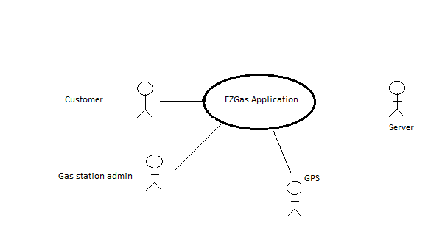

**Interfaces-**

|  |  |  |
| --- | --- | --- |
| **With object** | **Physical** | **Logical** |
| Customer | Touch Screen | Screen and buttons |
| Gas station Admin | Touch Screen | Screen and buttons |
| GPS | Touch Screen | Touch Screen |
| Server | Wi-Fi, LAN | http request to server for the desired service. |

**Functional Requirements**

|  |  |
| --- | --- |
| **FR ID** | **Requirement’s description** |
| FR 1 | The user shall be able to register to the application as a customer or as a gas-station user. |
| FR 2 | The customer shall be able to login and locate the gas stations near him. |
| FR 3 | The customer shall be able to compare the offered price of the gas stations near him. |
| FR 4 | The customer shall be able to select the gas station and make it reservations for the gas. |
| FR 5 | The gas station must be notified of the reservation made by the customer. |
| FR 6 | The customer should get the success/failure notification against his reservation. |
| FR 7 | Optionally, the customer shall be able to pay online through app. |
| FR 8 | Gas station should be able to generate receipt of the payment made by customer |

**Table 1**

**Non-functional Requirements**

The system should complain also with the following requirements

|  |  |  |
| --- | --- | --- |
| **NFR** | |  | | --- | | **Requirement’s description** | |
| NFR 1 | The application should be responsive and easy to use |

**Table 2**

**Use Case Diagram**

