**# Official Requirements Document**

Author : Giovanni Tangredi

Date: 24/03/2020

Version: 1

Changes:

**#Contents**

* Abstract
* Stakeholders
* Context Diagram and Interfaces
* Context Diagram
* Interfaces
* Stories and personas
* Functional and Nonfunctional requirements
* Functional requirements
* Nonfunctional requirements
* Use case diagram and use cases
* Use case diagram
* Use cases
* Relevant scenarios
* Glossary
* System design
* Deployment diagram

**Abstract**

EZgas‘ developers want to make it easier for thousands of people to find and compare the fuel prices of the numerous gas stations in their area.

Ezgas is a web app that locates the gas stations in the area of the user, shows them and displays the current fuel prices.

Visitors can only see the location of the gas stations and corresponding prices, Registered Users can also modify prices of the gas station so that the app has always the most updated and correct prices.

The Users can insert and update fuel prices of the gas stations they find very simply from the web app, the app uses an internal database for maintaining the list of gas stations and updates the prices.

For not wasting too many resources and time the app’s developers decided to use a pre-exist Map Services (Ex. Google Maps) without developing one on their own.

The developers update the app regularly and they take care of problems and faults in the database/app and of the communication between the app and the Map Service. They can also delete/ban users.

**Stakeholders**

|  |  |
| --- | --- |
| Stakeholder Name | Description |
| Developer | Create and update the app, can delete/ban users. |
| User | Uses the app, can update fuel prices of a gas station |
| Visitor | Use the app, can only locate the gas station and see the prices. |
| Map Service | Used to get a user or visitor position and to locate close gas stations. |

**Context diagram and interface**

**Context Diagram**

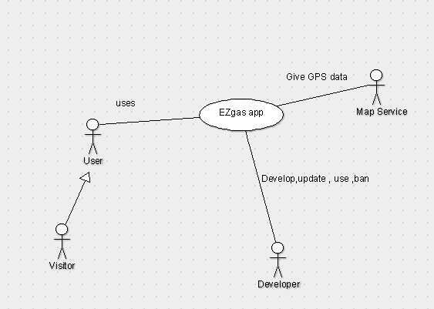

**Interfaces**

|  |  |  |
| --- | --- | --- |
| Actor | Logical Interface | Physical Interface |
| Map Service | REST API | Internet Connection |
| User | GUI | TouchScreen,Monitor, Keyboard |
| Visitor | GUI | TouchScreen,Monitor, Keyboard |
| Developer | GUI,IDE | TMonitor, Keyboard |