OFFICIAL REQUIREMENTS DOCUMENT

Authors: Francesco Xia

version: 1.0

ABSTRACT

Ezgas is an application that provide the end-user a list of all gas station in a specific geographic area along the prices they practice for their fuel. The app has an additional functionality to display the list on a built-in map, finding the nearest gas stations from your current position (e.g. by setting the radius filter).

The prices are kept up to date by updates made by verified users and/or directly from the owners of the gas stations.

Ezgas is a web application accessible both via an smartphone app or a website.

STAKEHOLDER

* USER
  + end-user

direct user of the web application

* verified users (profile 1)

can send updates related to the prices of a gas station

* unverified users (profile 2)

are not allowed to send updates to the ezgas app. Can use all the main functionality of the web application

* business user (profile 3)

owner of a gas station

* CUSTOMER SUPPORT

responsible of the daily to daily operations

* DEVELOPER

responsible in building and writing the web application

CONTEXT DIAGRAM

The following diagram defines and clarifies what we consider part of the system and what it is outside.

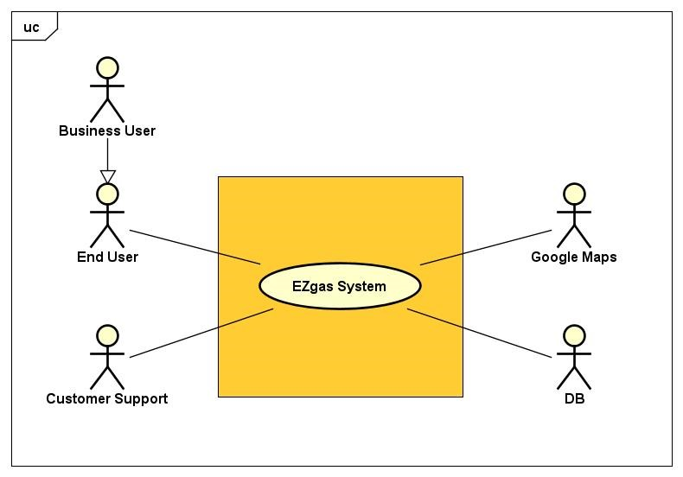

INTERFACES

|  |  |  |
| --- | --- | --- |
| Actor | Physical interface | Logical interface |
| end-user | screen, keyboard | GUI |
| owner | screen, keyboard | GUI |
| google map | internet connection | google maps API |
| developer | screen, keyboard | source code |
| customer support | screen, keyboard | GUI |

STORIES AND PERSONAS

Mark is a graduate student that just transferred in a new neighborhood. During the week, he goes back and forth to the university using the car, spending too much money, in his opinion, on fuel. He would love to find the cheapest gas station in his neighborhood but he has little or no time to look around.

Evan is the owner of a gas station which it is situated far away from the main road. Although there is only an another gas station in the radius of 10km, he has not many customers since not many people know of its whereabouts. Thus, he would like to advertise his gas station on the web hoping to attract new customers.

SCENARIOS

SCENARIO id: SC1

"User wants to update the price of a gas station"

precondition:

* gas station must exist in the system
* the user must be authenticated

post condition:

* the system updated the price of that particular gas station

STEPS

NOMINAL

1. log in to the system with the user's credentials
2. fills in the form
3. receive a visual confirmation

EXCEPTIONS

1. the price is invalid, e.g. price out of range

SCENARIO id: SC2

"Search for a gas station"

precondition:

* gas station must exist in the system

postcondition:

* show a list of gas station in a specific area along the prices of each gas station

STEPS  
NOMINAL

1. fills in the form and optionally apply a set of filters
2. show to the user the filtered results

EXTENSION

* show the result on a map

EXCEPTIONS

1. the list is empty

USE CASES

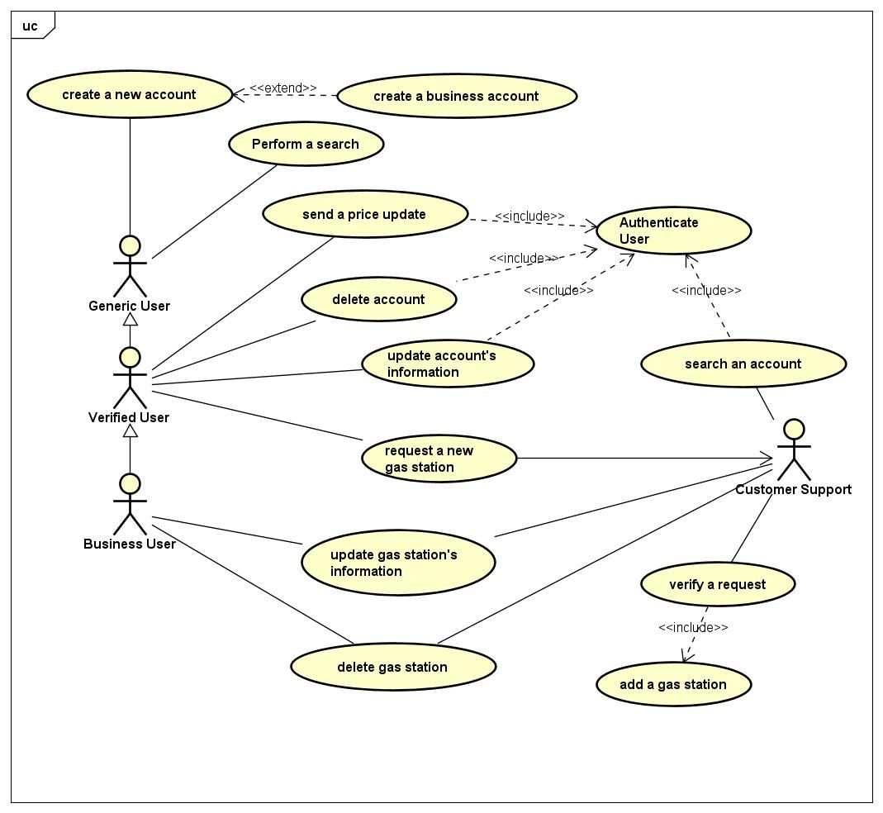

USE CASE id: UC1 (related to FR3)

GOAL: send a price update

precondition:

* user must be authenticated before he/she can access this functionality

Main Success Scenario:

1. user fills in the form with all the relevant information, i.e. gas station id, price
2. system confirms the request with an alert

Extension:

2a: the gas station doesn't exist in the system

.1: send an error message to the user

Optional:

* initially the user may perform a search to find the gas station id (see UC2)

USE CASE id: UC2 (related to FR4)

GOAL: perform a search

Main Success Scenario:

1. user fills in the address information and optionally can filter the results (see "filters" in NOTE)
2. system presents full list of gas station that satisfy the requirements

Extension:

2a: there aren't any gas station with those characteristics

2b: show the list of gas stations on a map

Optional:

* the search functionality may be preceded by an authentication phase

USE CASE id: UC3 (related to F5.1a, F5.1b)

GOAL: create a new basic account

Main Success Scenario:

1. user fills in the minimum required information (see NOTE)
2. system confirms the successful creation of the account

Extension:

1a: username already taken and/or password too weak and/or email address is invalid

.1 user may retry, return to MSS at step 1

1b: user decide to create a business account

.1 user fills in the minimum required information for a basic account

precondition: the gas station is already in the system

.2a request to link this account to the gas station and return to MSS at step 2

NOTE: to find out if the gas station is already in the system, the user may perform a search

precondition: the gas station is not present in the system

.2b follow the steps described in UC7

.3 if the previous step has been successful link the gas station to the new account

.4 system confirms the creation of the account

USE CASE id: UC4 (related to FR5.2)

GOAL: update account information

precondition:

* user must be signed into the system, he/she can modify only the information related to his/her account

postcondition:

* the new information must be recorded in the system

Main Success Scenario:

1. user updates his personal information (see NOTE for more information)
2. system confirms the update

Extension:

1a: user decides to update his/her password, but new one is not compliant with the minimum requirements

.1 user may reenter a new password

USE CASE id: UC5 (related to FR5.3)

GOAL: delete an account

precondition:

* user must be signed into the system, he/she can modify only the information related to his/her account

postcondition:

* the account has been deleted from the system

Main Success Scenario:

1. user sends a request to delete his account
2. system confirms the account was successfully deleted

USE CASE id: UC6 (related to FR5.4)

GOAL: search an account in the system

precondition: accessible only to customer support

Main Success Scenario:

1. search an account using an account id
2. system prints the result

Extension:

2.a the account doesn't exist

USE CASE id: UC7 (related to FR6.1a, FR6.1b)

GOAL: add a new gas station into the system

Main Success Scenario:

1. user fills in the minimum information required for a gas station (see NOTE)
2. system accepts the request
3. customer support verifies and validates the information
4. customer support adds the gas station into the system
5. system sends a confirmation email to the user

Extension:

3b: the gas station already exist in the system

.1 sends an email to the user saying the gas station already exist in the system

USE CASE id: UC8 (related to 6.2)

GOAL: updates the information related to a gas station

precondition:

* user must be signed into the system (either a customer support or the associated business account)

Main Success Scenario:

1. user updates the information related to the gas station (see NOTE for more information)
2. system confirms the update

USE CASE id: UC9 (related to 6.3)

GOAL: delete a gas station from the system

precondition:

* user must be signed into the system (either a customer support or the associated business account)

Main Success Scenario:

1. user sends a request to delete his account
2. system confirms the delete

NOTE:

* filters available: "radius", "price range", "brand", and "charging station" (boolean)
* *minimum information* required for a *basic account* to be considered valid: username, password, email address
* *minimum information* required for a *business account* to be considered valid: all the information of a basic account + ID gas station.
* *minimum information* required for a *gas station* to be considered valid: gas station name, city and address
* *optional account* properties: full name, address, city, phone number
* *optional gas station* properties: price, charging station (boolean), brand, opening hours, phone number. If not supplied, they will be set to default values.

A gas station is useful only if the price property is set.

* Every gas station in the system is uniquely identified through an ID.
* Every user account in the system is uniquely identified through an ID.
* FOR SENDING UPDATES: minimum information required is the gas station ID and the price

FUNCTIONAL REQUIREMENTS

|  |  |
| --- | --- |
| UNIQUE ID | DESCRIPTION |
| FR1 | Authenticate a user |
| FR1.1 | log in to the system with username and password |
| FR1.2 | log out from the system.  NOTE: available only to signed in users |
| FR3 | send a price update corresponding to a gas station |
| FR4 | perform a search based on a set of filters. Return the result in the form of a list, or directly showing on a map  See section Note for more information about "filters" |
| FR5 | manage new and existing accounts: create, show, modify or delete an existing account from the system.  NOTE: he/she can access/modify information related only to his/her account |
| FR5.1a | create a normal account |
| FR5.1b | create a business account, i.e. the account of the owner of a gas station |
| FR5.2 | modify the information related to an account |
| FR5.3 | delete an existing account |
| FR5.4 | search an account inside the system |
| FR6 | manage new and existing gas station |
| FR6.1a | send a request to add a new gas station  NOTE: allowed only for signed in users |
| FR6.1b | add a new gas station to the system  NOTE: allowed only if the corresponding request has been filed and accepted |
| FR6.2 | update the information related to a gas station  NOTE: available only to business accounts |
| FR6.3 | delete a gas station from the system NOTE: available only to business accounts |

NON FUNCTIONAL REQUIREMENTS

|  |  |  |  |
| --- | --- | --- | --- |
| UNIQUE ID | TYPE | DESCRIPTION | REFERS TO |
| NFR1 | Usability | application should be user-friendly with no training time required | ALL FR |
| NFR2 | Efficiency | the system should give an answer to any user request in < 1 sec | ALL FR |
| NFR3 | Portability | the web application should be accessible by any type of browser and should be available on the most popular mobile operating systems | ALL FR |
| NFR4 | Reliability | the system should be available all the time with backup servers ready in case of failure of the main system |  |
| NFR5 | Localization | the price are shown in euro |  |