# ABSTRACT

Some drivers want to know the prices and the position of the gas stations localized in their area. Exploiting these informations users can choose the best solution for their needs.

According to this a group of developer may want to build an application. The application allows the user to find the gas station that better fits their necessities by submitting just few parameters like position, maximum distance and price, and the specific fuel.

Gas station’s owners can update and loading the informations regarding prices, locations and other things concerning the gas station.

# STAKEHOLDERS

|  |  |
| --- | --- |
| Stakeholder name | Description |
| Developers | Are interested to provide a useful service for the drivers and specially they are worried about an economic return. |
| Drivers | People that are using the application for satisfy a specific need. |
| Gas Station’s owners | People that can use the application for reach more clients. |

# CONTEXT DIAGRAM AND INTERFACES

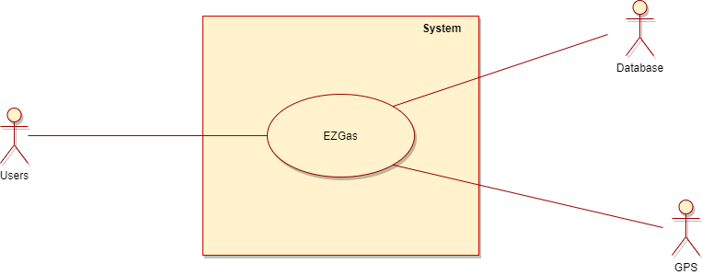## CONTEXT DIAGRAM

## INTERFACES

|  |  |  |
| --- | --- | --- |
| With object | Physical | Logical |
| Driver | Touch Screen | GUI |
| Gas Station’s Owners | Screen, keyboard | GUI |
| Database | EM fields | Communication protocol [HTTP request – JSON query |
| GPS | GPS’ smartphone system | GPS API |

# STORIES AND PERSONAS

Kevin is a very busy person. He wakes up at 8 am and after a quickly breakfast and shower, he’s ready to go work. On the way to the office he realizes that the fuel in the tank is almost finished, “Oh, no!” says Kevin.

Luckily there is a group of developers that made available an interesting application called **EZGas**. Kevin, for not losing more time, uses the application in order to find the nearest Gas Station.

Now Kevin is happy and in time for work, he will not be fired!

Bob is Gas Station’s owner and it means that he needs clients to pay bills and food. But he doesn’t want to spend too much for advertising.

He is a very smart person and decides to adopt 2.0 marketing. Like Kevin, he knows the potential of **EZGas** application, so he decides to use this tool for let drivers know about his Gas Station.

He can set up a lot of things like prices, types of fuel, position, a little description and so on.

Bob is now satisfied of the large number of clients he has achieved and now he have an house, a family and a beautiful dog.

Johanna is away for work. She doesn’t know about the fuel prices in Italy (too much expensive anyway), so she decides to install **EZGas** because she doesn't want to waste all her money on fuel. Thanks to the tool she finally finds the Gas Station that perfectly fits her needs.

Johanna is very happy of her choice and will always use the application in future!

# FUNCTIONAL AND NON-FUNCTIONAL REQUIREMENTS

## FUNCTIONAL REQUIREMENTS

|  |  |
| --- | --- |
| Requirement ID | Description |
| FR1 | The driver shall be able to set the fuel type |
| FR2 | The driver shall be able to set the maximum price of the fuel |
| FR3 | The driver can exploit the GPS system to allow the app to know about his position |
| FR4 | The driver shall be able to set the maximum distance from the Gas Station |
| FR5 | The driver can contact the Gas Station’s Owners to receive informations |
| FR6 | The Gas Station’s Owners can submit their activity in the application’s database |
| FR7 | The Gas Station’s Owners shall be able to send photo of their activity |
| FR8 | The Gas Station’s Owners shall be able to update some parameters like prices, positions, description and opening/closing time |
| FR9 | The Gas Station’s Owners shall be able to pay a fee in order to have more visibility |
| FR10 | Both types of users have the possibility to login and logout in order to use the application wherever they want |
| FR11 | Both types of users have the possibility to delete their account and delete every informations about them |
| FR12 | Both types of users shall use a GUI for doing all the previous activity |
| FR13 | Users can report bugs |

## NON-FUNCTIONAL REQUIREMENTS

|  |  |  |  |
| --- | --- | --- | --- |
| Requirement ID | Type | Description |  |
| NFR1 | Usability | Application should be used with no training by anyone | |
| NFR2 | Performance | All function should be complete in < 2 sec | |
| NFR3 | Portability | The application should be able to run on the most popular web Browsers | |
| NFR4 | Portability | The application should be able to run on Android | |
| NFR5 | Privacy | The application must be JDPI complied | |

# USE CASE DIAGRAM AND USE CASE

## USE CASE DIAGRAM

1. Gas Station Search

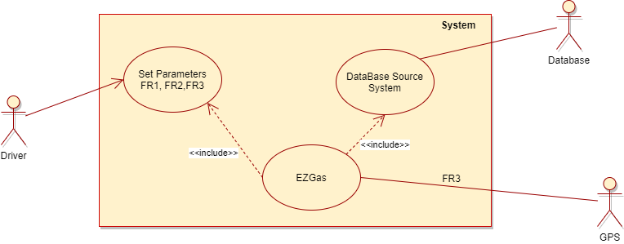

1. Gas Station setup

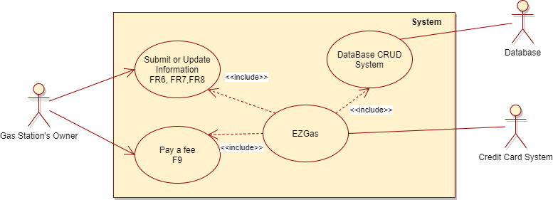

## USE CASE

### USE CASE 1, Driver search for a Gas Station

|  |  |
| --- | --- |
| Actors Involved | Administration |
| Precondition | The driver has a smartphone and an Internet connection |
| Post condition | The tank of the car is full |
| Nominal Scenario | The driver set up the parameters for search a gas station, the system returns the result and the driver choose the best solution for him |
| Variants | No Gas Station fit the driver’s need, he has to fit the parameters |

### USE CASE 2, Gas Station’s Owner sets up their activity

|  |  |
| --- | --- |
| Actors Involved | Administration |
| Precondition | The Gas Station’s Owner must have a Gas Station, a smartphone or a computer and an Internet connection |
| Post condition | The Gas Station is available on the application |
| Nominal Scenario | The Gas Station’s Owner submit or update the information about his activity |
| Variants | The Gas Station’s Owner pay a fee to get more visibility |

# RELEVANT SCENARIOS

## Scenario 1

|  |  |
| --- | --- |
| Scenario ID: SC1 | Corresponds to UC1 |
| Description | A driver uses EZGas to find a solution that fit his needs |
| Precondition | EZGas doesn’t find any Gas Station that fits the driver needs |
| Postcondition | EZGas finds an alternative solution |

|  |  |
| --- | --- |
| Step# | Description |
| 1 | The driver must change the searching parameter |
| 2 | EZGas performs another research |
| 3 | EZGas returns the new results |

## Scenario 2

|  |  |
| --- | --- |
| Scenario ID: SC2 | Corresponds to UC2 |
| Description | A Gas Station’s owner wants to increase his visibility |
| Precondition | The Gas Station’s owner has a bank account |
| Postcondition | The specific Gas Station appears in a special section |

|  |  |
| --- | --- |
| Step# | Description |
| 1 | The Gas Station’s owner has to verify his identity by sending docs |
| 2 | The Gas Station’s owner has to enable the application to access the bank account |
| 3 | The Gas Station’s owner has to choose the plan for his advertisement |
| 4 | The Gas Station’s owner has to confirm the previous point |
| 5 | EZGas reserves a special section for the Gas Station |

# GLOSSARY (CONCEPTUAL DIAGRAM)

