**Abstract**

Some drivers may want to know the prices and the positions of the gas stations localized in their area. Because exploiting these informations they can choose the best solution for their needs.

Knowing this, a group of developers may want to build an application, the application allows the users to find the proper gas station that better fit in their necessities. By submit just few parameters like position, maximum distance and prices and the specific fuel.

Gas stations owners can update and load informations concerning their activities, prices and positions.

**Stakeholders**

|  |  |
| --- | --- |
| **Stakeholder name** | **Description** |
| **Developers** | Are interested to provide a useful service for the drivers, and especially they are worried about their economic returns. |
| **Drivers** | People that are using the application for satisfy a specific need. |
| **Gas Station Owners** | People that can use the application for reach more clients. |

**Context Diagram and Interfaces**

**Context Diagram**

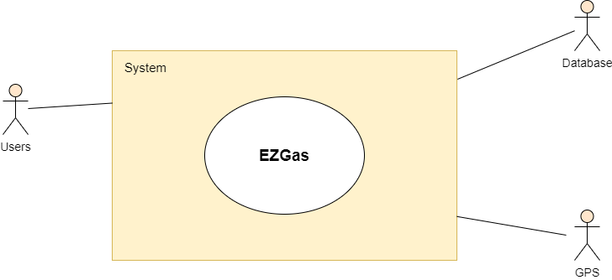

**Interfaces**

|  |  |  |
| --- | --- | --- |
| With Object | Physical | Logical |
| Users | Touch Screen | Screens and buttons |
| GPS | GPS Phone’s system | API GPS system – Application  (depending on the OS) |
| Database | EM fields, phone’s antenna | Wireless Communication protocol (http request / API RESTful / json query) |

**Stories and Personas**

Mario wakes up at 8 AM after a quickly breakfast and a quickly wash (because he is a very busy person) is ready to go work (in non-quarantine period hopefully).

On the way to the office he realizes that the fuel in the tank is almost finished “Oh perbacco” says Mario “I have to refill my tank, otherwise I have to go to work walking”.

Luckly, there is a groups of developers (very smart developers) that made available the **EZGas** application. Mario for no loosing more time (because he is late and risk to be fired out) uses the application in order to find the nearest gas station.

Now Mario is happy and in time for work. He will not be fired.

Bob, casually, is a gas station owner this involves that he need clients to pay bills and survive. But he doesn’t spend to much for advertise. So, because is a very smart person, he decides to adopt a 2.0 marketing.

Like Mario, he knows the strength of the **EZGas** application, so he decides to use this tool for let the drivers know about his gas station.

Bob can set up a lot of things:

-prices

-position

-types of fuel

-a little description

Bob is now satisfied of the large number of clients that he reached, now he have an house, a family and a beautiful dog (and he is thinking about to emigrate in New Mexico).

Karla, is away for work (or holiday, you choose), she doesn’t know about the fuel’s prices in Italy (to much expensive anyway). So, because she don’t want to spend all her moneys, she decides, because is a very smart person, to install EZGas application.

Thanks to the tool she find the right prices for her needs, now she is happy, she find the love in the gas station and married him (Spoiler the husband is Mario).

**Functional Requirements**

|  |  |
| --- | --- |
| **Requirement Id** | **Description** |
| FR 1 | The driver shall be able to set *FuelType* in the app. |
| FR 2 | The driver shall be able to set the *MaximumPrice* of the fuel. |
| FR 3 | The driver shall be able to set the *MaximumDistance* from the gas station |
| FR 4 | The driver can exploit the GPS to allow the application to know his position |
| FR 5 | The driver shall be able to contact the gas station owner |
| FR 6 | The gas stations owners can submit their activity in the application databases. |
| FR 7 | The gas stations owners shall be able to send photos of the gas station. |
| FR 8 | The gas stations owners shall be able to update the parameters like: prices, positions, descriptions and opening/closing time. |
| FR 9 | The gas stations owners shall be able to pay a fee in order to have more visibility (like the subito.it advertising system). |
| FR 10 | Both types of users have the possibility to do a log in and a log out in the application. |
| FR 11 | Both types of users have the possibility to delete their accounts and informations about them. |
| FR 12 | Both types of users shall be able to use a GUI for doing all the previous FRs. |
| FR 13 | Both types of users shall be able to report a bug via a bug system reporting. |

**Non-Functional Requirements**

|  |  |  |
| --- | --- | --- |
| **Requirement Id** | **Type** | **Description** |
| NFR 1 | Usability | Application should be used with no training by any colleague in the office |
| NFR 2 | Performance | All functions should complete in < 1 sec |
| NFR 3 | Portability | The application runs on the most popular web browsers. |
| NFR 4 | Portability | The application runs on Android and iOs. |
| NFR 5 | Privacy | The application must be GDPR compliant. |

**Use Case and Use Case Diagram**

**Use case diagram of a gas station search**

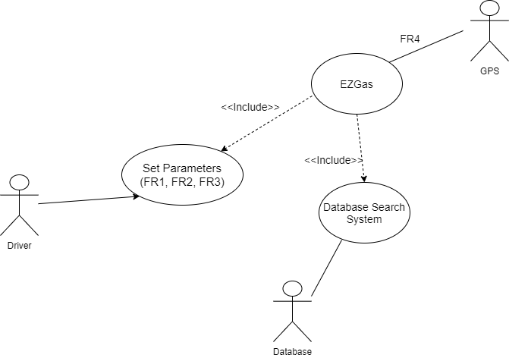

**Use case diagram of add/update a gas station informations**

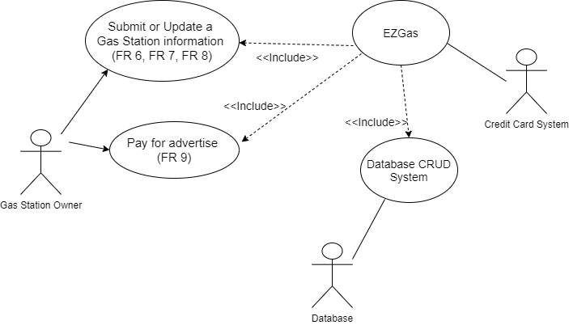

**Use Case 1 (showed in the first diagram)**

|  |  |
| --- | --- |
| **Actors involved** | Driver |
| **Pre-Condition** | The driver has a smartphone, an internet connection and way to interact with the smartphone |
| **Post-Condition** | The tank of the driver’s car is full. |
| **Nominal Scenario** | The driver set up the parameters for search a gas station, the EZGase return the results, the driver choose the best solution for him. |
| **Variants** | No gas station fit in the driver needs, he has to update the parameters. |

**Use Case 2 (showed in the second diagram)**

|  |  |
| --- | --- |
| **Actors involved** | Gas station owner |
| **Pre-Condition** | Have a gas station, have an internet connection, have a smartphone or a computer. |
| **Post-Condition** | The gas station is reachable in the application. |
| **Nominal Scenario** | The gas station owner submit or update the informations about his gas station on the EZGas application. |
| **Variants** | The gas station owner pays an additional fee to get more visibility on the application. |

**Scenarios**

**Scenario 1**

|  |  |
| --- | --- |
| Scenario 1: SC1 | Correspond to UC1 |
| Description | One driver use EZGas to find a solution that fit his need. |
| Pre-condition | EZGas doesn’t find a gas station that fits the driver needs. |
| Post-condition | EZGas find an alternative solution. |
| STEP | Step Description |
| 1 | The drive has to change the searching parameters |
| 2 | EZGas perform another search |
| 3 | EZGas returns new results. |

**Scenario 2**

|  |  |
| --- | --- |
| Scenario 2: SC2 | Correspond to UC2 |
| Description | A gas station owner wants to upgrade the visibility of his gas station. |
| Pre-condition | The gas station owner has a bank account. |
| Post-condition | The specific gas station appears in a special section. |
| STEP | Step Description |
| 1 | The gas station owner has to verify his identity (by sending a document). |
| 2 | The gas station owner has to enable the application to access the bank account. |
| 3 | The gas station owner has to choose the plan for his advertise. |
| 4 | The gas station owner has to confirm previous point. |
| 5 | EZGas reserve a special section for that specific gas station. |

**Conceptual Diagram (Glossary)**

