**Official Requirements Document**

Author: Santa Panduri

Date: 5/04/2020

Version: 1

**Contents**

* Abstract
* Stakeholders
* Context Diagram and Interfaces
  + Context Diagram
  + Interfaces
* Stories and personas
* Functional and non Functional Requirements
  + Functional Requirements
  + Non Functional Requirements
* Use case diagram and use cases
  + Use case diagram
  + Use cases
  + Relevant scenarios
* Glossary

**Abstract**

EZGas is a crowdsourcing services that allows users to collect prices of fuels in different gas station and locate gas stations in area along with the prices they practice.

**Stakeholders**

|  |  |
| --- | --- |
| **Stakeholder name** | **Description** |
| Driver | Is the main user of the application, he is interested in collect and compare prices between gas stations |
| Gas station owner | Uses this application to insert his gas station and provide a list of prices related to types of fuel |
| Administrator | Uses the application to manage, retrieve accounts and change password |
| Google LLC company | Do not use the application directly. They only provide map to the application |

**Context diagram and interfaces**

**Context diagram**

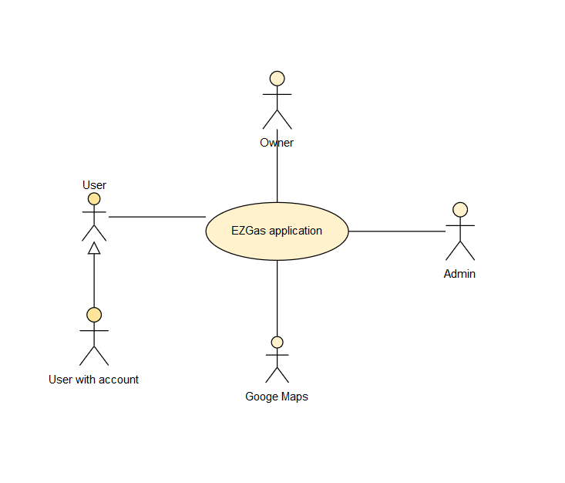

**Interfaces**

|  |  |  |
| --- | --- | --- |
| Actor | Logical interface | Physical Interface |
| User | GUI | touchscreen |
| Owner | GUI | touchscreen |
| Administrator | GUI | touchscreen, keyboard |
| Google Maps | APIs | internet connection |

**Stories and personas**

Vittorio is a student, he uses to travel a lot and he wants to save money so he use the application to find gas stations along his way and stock up to the nearest station with the cheapest price.

Ludovica is a lawyer. She discovered this app randomly and she appreciate it. She wants to contribute to his development so every time she gets gas want to notify other users about the service she received.

**Functional Requirements and non Functional Requirements**

**Functional Requirements**

|  |  |
| --- | --- |
| **ID** | **Description** |
| F1 | Create new accounts |
| F2 | Login |
| F3 | Logout |
| F4 | Manage accounts |
| F5 | Insert a new gas station |
| F6 | Record the price and the kind of fuel provided by a certain gas station |
| F7 | Update a price related to a certain type of fuel |
| F8 | Locate the user and show closer gas stations and their prices |
| F9 | Write a review on the reliability of prices |
| F10 | Select an area on the map and show the cheaper gas station |

**Non Functional Requirements**

|  |  |  |  |
| --- | --- | --- | --- |
| **ID** | **Type** | **Description** | **Refers to** |
| NF1 | Usability | Ensure user to perform tasks efficiently while enjoying the experience | All FR |
| NF2 | Efficiency | All functions should be completed in less than 1 sec | All FR |
| NF3 | Domain | Currency is Euro | All FR |
| NF4 | Easy of use | The system should be easy to use, in total autonomy | All FR |

**Use case diagram and use cases**

**Use case diagram**

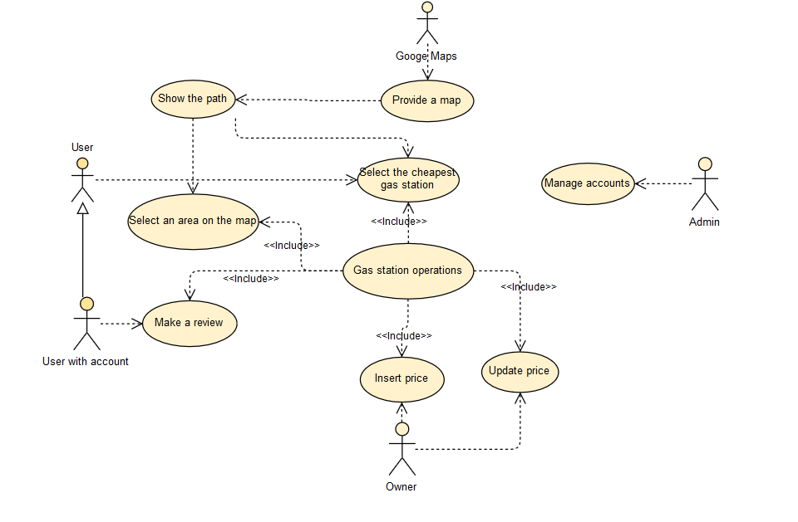

**Use cases**

**Use case 1, UC1-FR5 Insert a gas station**

|  |  |
| --- | --- |
| **Actors Involved** | **Owner** |
| Precondition | Owner O has an account, List of stations L defined in the app |
| Post condition | L.number_of_stations_pos t > L.number_of_stations_pre |
| Nominal scenario | The owner O inserts his station in the list L in order to be visible to users |

**Use case 2, UC2-FR6-FR7 Record/ Update price**

|  |  |
| --- | --- |
| **Actors Involved** | **Owner** |
| Precondition | Owner O has an account, station S already present in the list of station L, type of fuel F |
| Post condition | F.price_pre != F.price_post |
| Nominal scenario | The owner O can set or update the price of the fuel F |

**Use case 3, UC3-FR8 Locate a user and show gas stations**

|  |  |
| --- | --- |
| Actors Involved | User |
| Precondition | User U actives geolocation |
| Post condition | Path between User U and station S is shown on the map |
| Nominal scenario | User U wants to know where stations S are displaced, he selects them to see prices of fuel F |

**Use case 4, UC4-FR9 Write a review on the reliability of prices**

|  |  |
| --- | --- |
| **Actors Involved** | **User with account** |
| Precondition | User U has an account, station S exists within the list L |
| Post condition | A new review related to station S is inserted |
| Nominal scenario | User U can provide a review to confirm or deny the reliability of prices of station S |

**Use case 5, UC5-FR10 Select an area on the map and show the cheapest gas station**

|  |  |
| --- | --- |
| **Actors Involved** | **User** |
| Precondition | User U explore the app, station S exists within the list L |
| Post condition | The path between user U and the cheapest gas station S is shown |
| Nominal scenario | User U can select an area on the map to find the cheapest gas station |

**Relevant scenarios**

**Scenario 1**

|  |  |
| --- | --- |
| **Scenario ID: ID1** | **Corresponds to UC2** |
| Description | Owner O wants to update a price of a type of fuel F |
| Precondition | Owner O has an account |
| Post condition | Price of F updated |
| Step# | Step description |
| 1 | Owner O logs in into his account |
| 2 | Select the station S |
| 3 | Select the type of fuel F |
| 4 | Write the new price |

**Scenario 2**

|  |  |
| --- | --- |
| **Scenario ID: ID2** | **Corresponds to UC5** |
| Description | User wants to reach the cheapest gas station |
| Precondition | User U has activated geolocalization |
| Postcondition | path between user U and station S is shown |
| Step# | Step description |
| 1 | User select an area in the map |
| 2 | Select the type of fuel |
| 3 | The cheapest station S appears on the map |
| 4 | User U select the station S |
| 5 | Path is shown |

**Glossary**

