Assignment 2

Author: Alireza Aleali

Affiliation: Dalhousie University

Course: PSYR 6003: Advanced Topics in Psychology

Instructor: Dr. Igor Yakovenko

Date: 6th of Apr 2024

**Statistical description**

Initially, sex values (male, female, and other) were transformed into numerical values (0, 1, and 2, respectively). Subsequently, subscale scores for socially prescribed perfectionism (SPP), conscientiousness, and negative affect were computed (refer to Table 1 for means, SDs, and bivariate correlations). Moreover, based on the bivariate correlation analysis, it was observed that negative affect displayed a moderate negative correlation with conscientiousness and a moderate positive correlation with SPP. Additionally, a weak positive correlation was noted between SPP and conscientiousness.

**Visualization of Data and Assessment of Assumptions**

Data was initially visualized through univariate plots (Fig.1). It was observed that only one participant identified their gender as 'other' instead of male or female. Sensitivity analyses revealed that the model fit remained unchanged upon removal of this individual; hence, their data was retained for final analyses (Table 2). Furthermore, there was no differential impact on meeting model assumptions when this participant was included or excluded (Fig.2). Additionally, it was noted that there were limited instances of males with high conscientiousness. However, visual examination did not suggest any outliers of concern (Fig.3).

Our visualization of the model indicated differing relationships between Conscientiousness and Negative Affect across genders. Among females, a negative association between Conscientiousness and Negative Affect was observed, which varied across levels of SPP, showing a stronger relationship with higher SPP. Conversely, among males, a negative relationship was also evident, with a more pronounced association at lower levels of SPP. In females, SPP exhibited a positive correlation with Negative Affect, generally consistent across levels of Conscientiousness. However, among males, SPP displayed a negative relationship with Negative Affect at low Conscientiousness levels but a positive relationship at mid-levels. In light of these observed patterns, a sensitivity analysis was conducted to explore whether incorporating interaction terms within our model would enhance model fit (Table 3). However, the results of this analysis indicated no improvement in model performance with the inclusion of such terms.

Our model assumptions were predominantly fulfilled. The data is independent, as they are not longitudinal, and there are no clusters or groups of related individuals. The histogram of residuals displays a reasonably normal distribution. Additionally, the scale-location plot demonstrates a satisfactory level of homoskedasticity, as indicated by the relatively horizontal line. However, the residual dependence plot exhibits curvature, suggesting a violation of linearity (Fig.4). In response to this visual observation, we conducted a sensitivity analysis to assess whether the inclusion of a polynomial term in our model would enhance its fit (Table 4). Since the addition of this term did not significantly improve the model fit, it was not incorporated into our final model.

**Analysis of Model 1**

In our first analysis, we assessed the fit of our complete proposed model, which includes predictors for Negative Affect, namely, Sex, Conscientiousness, and Socially Prescribed Perfectionism (SPP), represented by the equation: Negative Affect = b0 + b1(Sex) + b2(Conscientiousness) + b3(SPP) + e. This comprehensive model was compared against a reduced model, where only the intercept term (b0) is included, as depicted by the equation: Negative Affect = b0. The aim was to evaluate the performance of the full model in explaining variations in Negative Affect against a simpler model with no predictor variables. Model fit indices were scrutinized to discern the adequacy of the proposed model (Table 5).

The results derived from our model fit indices suggest that our full model exhibits superior fit compared to our reduced model. This is evidenced by lower AIC/BIC values, high level of Bayes Factor, a very small p-value, and a substantially higher percentage of explained variance in the outcome. Estimates obtained from our model suggest that our full model has the capacity to predict an approximate difference of up to 1.5 points in negative affect.

In total, our selected model explains 27% of the variance in the outcome variable. Conscientiousness contributes the most to this explanation, accounting for 15.9% of the variance, and displaying a negative relationship with Negative Affect. Sex and SPP contribute 2.7% and 8.4% of the explained variance, respectively. Notably, SPP exhibits a positive relationship with Negative Affect.

Our hypothesis was validated by our findings, as both gender, conscientiousness, and socially prescribed perfectionism (SPP) emerged as predictors of negative affect. Specifically, conscientiousness exhibited a negative association with negative affect. Additionally, male gender showed a negative relationship with negative affect when compared to female gender, indicating that females tend to experience higher levels of negative affect than males.

**Analysis of Model 2**

In our second analysis, the objective was to ascertain whether socially prescribed perfectionism (SPP) significantly forecasts negative affect, while adjusting for the effects of gender and conscientiousness. To achieve this, we initially generated an added variable plot to visually examine the interrelationships among the variables (refer to Fig.5).

After controlling for conscientiousness and sex, there emerges a positive association between SPP and negative affect. Following this adjustment, we compared our proposed full model (negative affect = b0 + b1(sex) + b2(conscientiousness) + b3(SPP) + e) with a reduced model (negative affect = b0 + b1(sex) + b2(conscientiousness) + e) to determine the model that offers a superior fit (Table 4).

Our findings indicate that our full model has the capability to explain a predicted variance in negative affect of up to 0.64 points. Furthermore, the full model demonstrates a superior fit compared to the reduced model, as evidenced by lower AIC/BIC values, a Bayes Factor exceeding 100, and a significant p-value. Additionally, the full model accounts for 27% of the variance in the outcome, whereas the reduced model explains only 18.6% of the variance. Consequently, our second hypothesis was not supported; SPP does not forecast unique variance in negative affect beyond the influences of sex and conscientiousness. This is further reinforced by our initial model analysis, which revealed that the majority of the variance explained by our model stemmed from conscientiousness rather than SPP.

**Table 1**

*Means, standard deviations, and correlations with confidence intervals*

|  |  |  |  |  |
| --- | --- | --- | --- | --- |
| Variable | *M* | *SD* | 1 | 2 |
|  |  |  |  |  |
| 1. aff_sc | 2.44 | 0.97 |  |  |
|  |  |  |  |  |
| 2. conc_sc | 5.01 | 1.31 | -.37** |  |
|  |  |  | [-.51, -.22] |  |
|  |  |  |  |  |
| 3. perf_sc | 4.38 | 1.42 | .36** | -.19* |
|  |  |  | [.20, .50] | [-.35, -.02] |
|  |  |  |  |  |

*Note.* *M* and *SD* are used to represent mean and standard deviation, respectively. Values in square brackets indicate the 95% confidence interval for each correlation. The confidence interval is a plausible range of population correlations that could have caused the sample correlation (Cumming, 2014). * indicates *p* < .05. ** indicates *p* < .01.

**Fig1.**

*Univariate visualization of interested variables. aff_subsc = Negative Affect, conc_subsc = Conscientiousness, perf_subsc = SPP.*

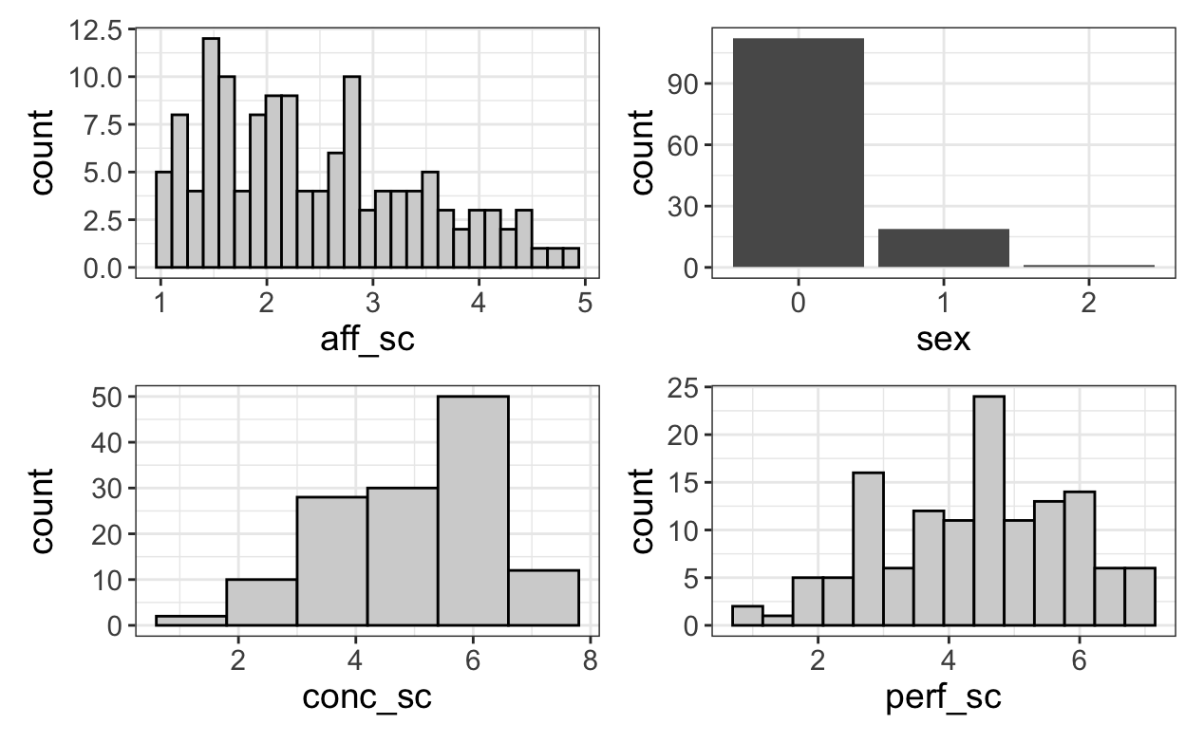

Fig1.

**Table 2**

*Sensitivity analysis: Comparison of model fit indices between models with and without one individual categorized as 'other' in terms of sex.*

|  |  |  |  |  |
| --- | --- | --- | --- | --- |
|  | AIC | BIC | Bayes Factor | R2 |
| Model with | 333.257 | 347.633 | 1 | 0.269 |
| Model without | 333.257 | 347.633 | 1 | 0.269 |
| % Predicted differences: 0% 25% 50% 75% 100%  0 0 0 0 0 | | | | |

**Fig2.**

*Visual examination of data and associated residual plots subsequent to the exclusion of one participant categorized as 'other' in terms of sex.*

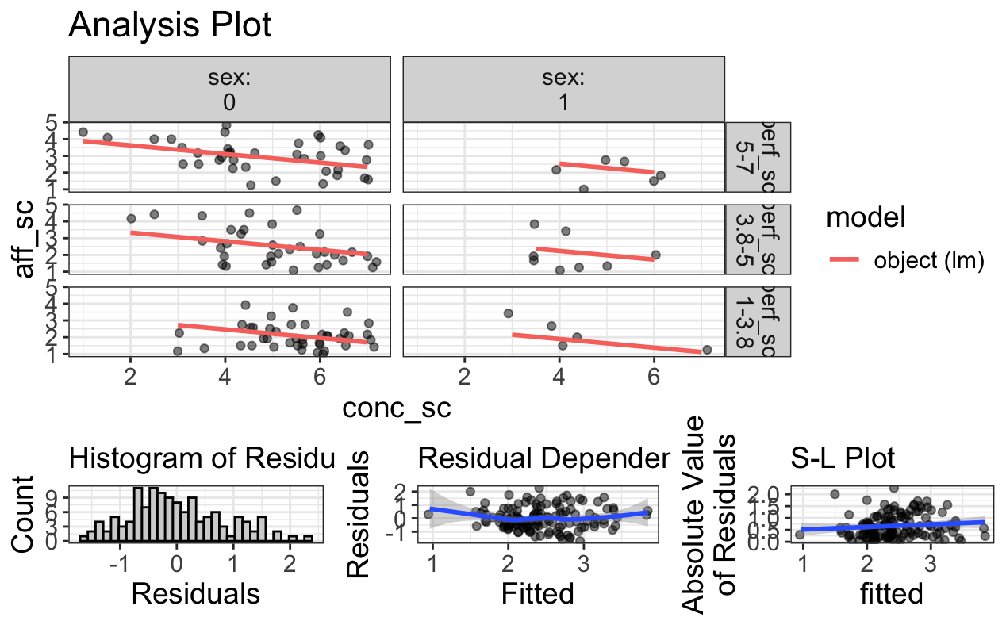

Fig2.

**Fig3.**

Visualization of the association between conscientiousness and negative affect specifically among males.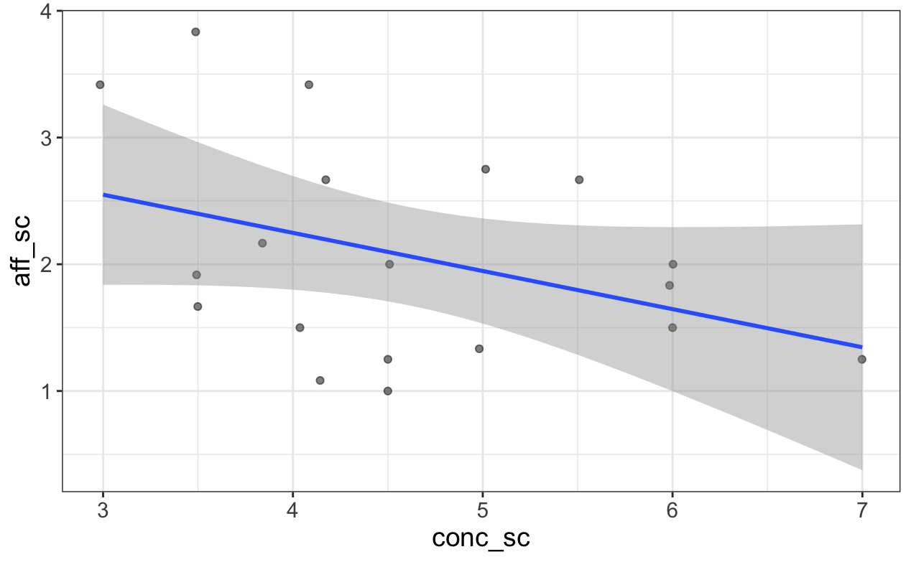

Fig3.

**Table 3**

*Sensitivity analysis: Comparison of model fit indices between models with and without the interaction effect (sex x Conscientiousness x SPP).*

|  |  |  |  |  |  |  |
| --- | --- | --- | --- | --- | --- | --- |
|  | AIC | | BIC | Bayes Factor | p-value | R2 |
| Model with | 336.721 | | 354.018 | 4657.351 | 0.648 | 0.270 |
| Model without | 342.082 | | 370.910 | 0 |  | 0.285 |
| % Predicted differences: | | 0% 25% 50% 75% 100%  0.000 0.020 0.038 0.110 0.401 | | | | |

**Fig. 4**

**Data visualization for our model.**

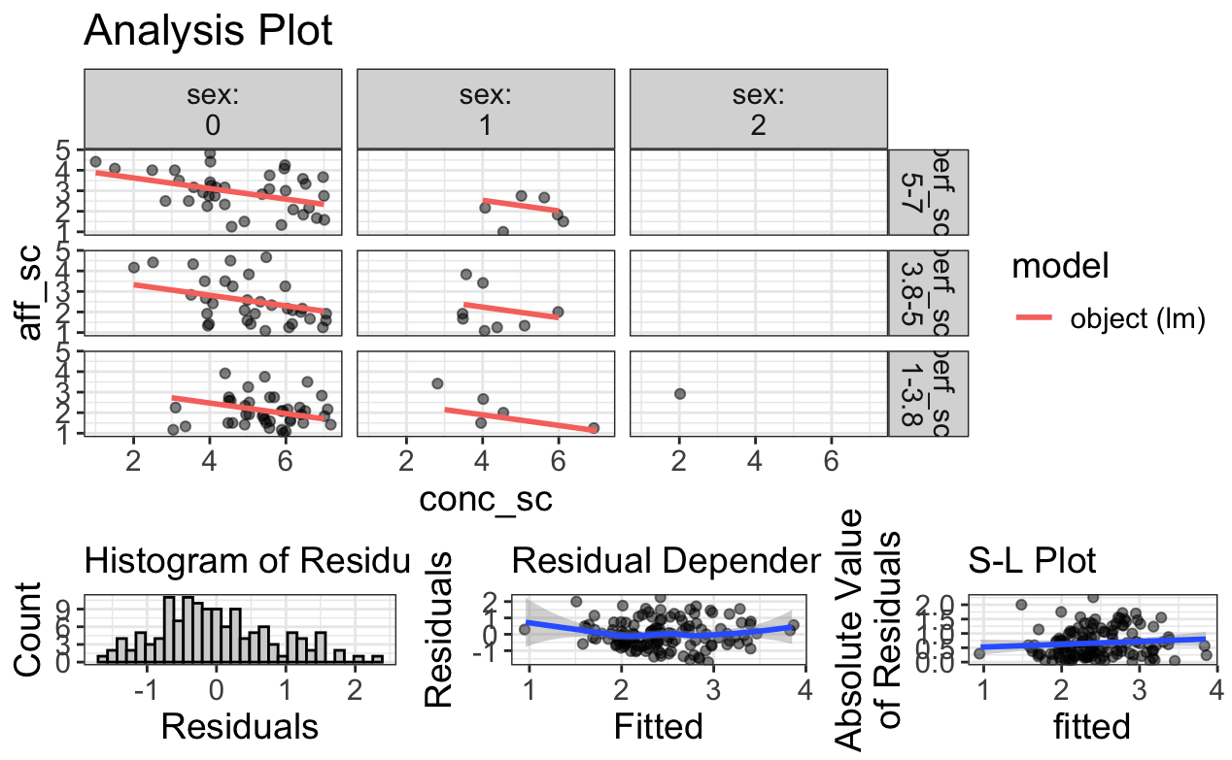

Fig.4

**Table 4a**

*Sensitivity assessment: Comparison of model fit indicators between models with and without a polynomial term (for Conscientiousness polynomial term)*

|  |  |  |  |  |  |  |
| --- | --- | --- | --- | --- | --- | --- |
|  | AIC | | BIC | Bayes Factor | p-value | R2 |
| Model with | 336.721 | | 354.018 | 3.57 | 0.136 | 0.270 |
| Model without | 336.384 | | 356.563 | 0.28 |  | 0.283 |
| % Predicted differences: | | 0% 25% 50% 75% 100%  0.000 0.033 0.069 0.089 0.633 | | | | |

**Table 4b**

*Sensitivity assessment: Comparison of model fit indicators between models with and without a polynomial term (for SPP polynomial term)*

|  |  |  |  |  |  |  |
| --- | --- | --- | --- | --- | --- | --- |
|  | AIC | | BIC | Bayes Factor | p-value | R2 |
| Model with | 336.721 | | 354.018 | 2.136 | 0.074 | 0.270 |
| Model without | 335.357 | | 355.536 | 0.468 |  | 0.289 |
| % Predicted differences: | | 0% 25% 50% 75% 100%  0.000 0.038. 0.089 0.119 0.477 | | | | |

**Table 5**

*Comparison of model fit indicators between full and reduced models.*

|  |  |  |  |  |  |  |
| --- | --- | --- | --- | --- | --- | --- |
|  | AIC | | BIC | Bayes Factor | p-value | R2 |
| Full model | 336.721 | | 354.018 | 61624.36 | <2e-16 | 0.27 |
| Reduced model | 370.310 | | 376.076 | 0.00 |  | 0.00 |
| % Predicted differences: | | 0% 25% 50% 75% 100%  0.010 0.164 0.335 0.545 1.487 | | | | |

**Fig 5.**

*Added variable plot (AVP) illustrating the association between SPP and Negative Affect while adjusting for sex and conscientiousness.*

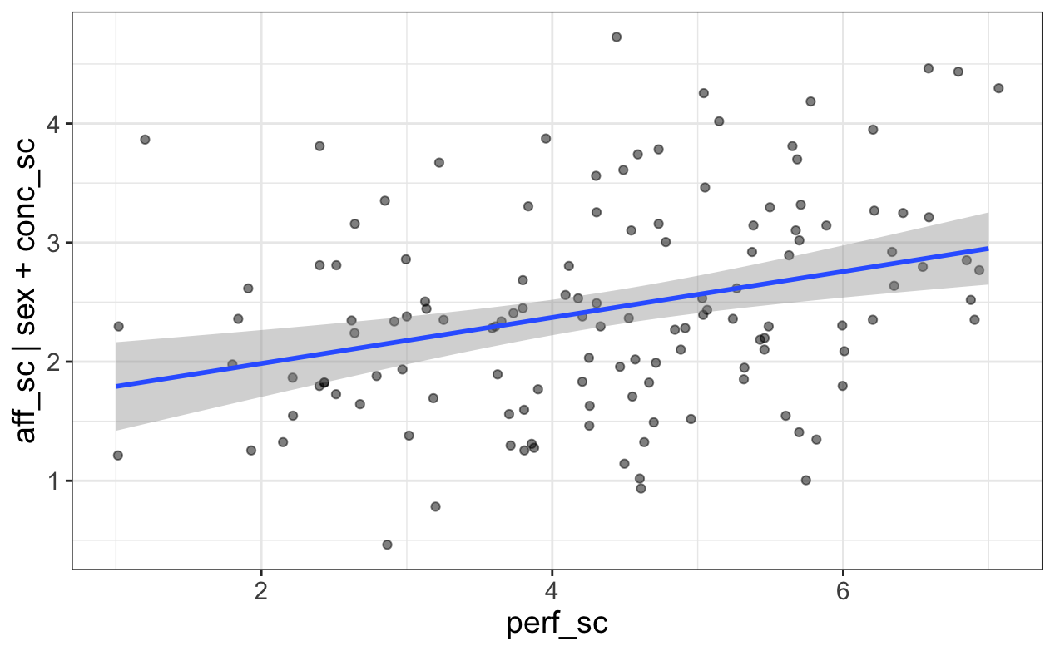

Fig. 5

**Table 6**

*Comparison of model fit indicators between full and reduced models, while controlling for sex and conscientiousness.*

|  |  |  |  |  |  |  |
| --- | --- | --- | --- | --- | --- | --- |
|  | AIC | | BIC | Bayes Factor | p-value | R2 |
| Full model | 336.721 | | 354.018 | 117.238 | <2e-16 | 0.27 |
| Reduced model | 349.132 | | 363.546 | 0.009 |  | 0.186 |
| % Predicted differences: | | 0% 25% 50% 75% 100%  0.000 0.071 0.229 0.357 0.644 | | | | |

**Table 7**

*Regression results using aff_sc as the criterion for the full model*

|  |  |  |  |  |  |
| --- | --- | --- | --- | --- | --- |
| Predictor | *b* | *b*  95% CI  [LL, UL] | *sr2* | *sr2*  95% CI  [LL, UL] | Fit |
| (Intercept) | 2.93** | [2.08, 3.77] |  |  |  |
| Male sex | -0.58** | [-0.99, -0.16] | .04 | [-.02, .10] |  |
| Other sex | -0.15 | [-1.87, 1.58] | .00 | [-.00, .00] |  |
| conc_sc | -0.26** | [-0.37, -0.14] | .11 | [.02, .20] |  |
| perf_sc | 0.20** | [0.10, 0.31] | .08 | [.00, .17] |  |
|  |  |  |  |  | *R2*  = .270** |
|  |  |  |  |  | 95% CI [.13,.37] |
|  |  |  |  |  |  |

*Note.* A significant *b*-weight indicates the semi-partial correlation is also significant. *b* represents unstandardized regression weights. *sr2* represents the semi-partial correlation squared. *LL* and *UL* indicate the lower and upper limits of a confidence interval, respectively.  
* indicates p < .05. ** indicates p < .01.