Assignment 4

Author: Alireza Aleali

Affiliation: Dalhousie University

Course: PSYR 6003: Advanced Topics in Psychology

Instructor: Dr. Igor Yakovenko

Date: 26th of Apr 2024

**Descriptive Statistics**

Means, standard deviations, and bivariate correlations among the study variables were computed (Table 1). Across the entire sample, extraversion showed a moderate positive correlation with life satisfaction and a moderate negative correlation with neuroticism. Additionally, neuroticism was found to have a moderate to strong negative correlation with life satisfaction.

Table 1

*Means, standard deviations, and correlations with confidence intervals*

|  |  |  |  |  |
| --- | --- | --- | --- | --- |
| Variable | *M* | *SD* | 1 | 2 |
|  |  |  |  |  |
| 1. Satisfaction with Life | 4.43 | 1.61 |  |  |
|  |  |  |  |  |
| 2. Extraversion | 4.18 | 1.52 | .38** |  |
|  |  |  | [.35, .41] |  |
|  |  |  |  |  |
| 3. Neuroticism | 3.49 | 1.54 | -.45** | -.33** |
|  |  |  | [-.47, -.43] | [-.36, -.31] |
|  |  |  |  |  |

*Note.* *M* and *SD* are used to represent mean and standard deviation, respectively. Values in square brackets indicate the 95% confidence interval for each correlation. The confidence interval is a plausible range of population correlations that could have caused the sample correlation (Cumming, 2014). * indicates *p* < .05. ** indicates *p* < .01.

**Initial Data Exploration with Univariate Plots**

Initially, the data were depicted using univariate plots (refer to Figure 1), which included satisfaction with life (swl), extraversion (tipm.E), and neuroticism (tipm.N). It was observed that the distribution of satisfaction with life was not normal. Both extraversion and neuroticism, being based on Likert-scale measures, exhibited a limited range of values; extraversion displayed a relatively normal bell curve, while neuroticism showed a mild rightward skew. None of the three variables presented outliers of significant concern.

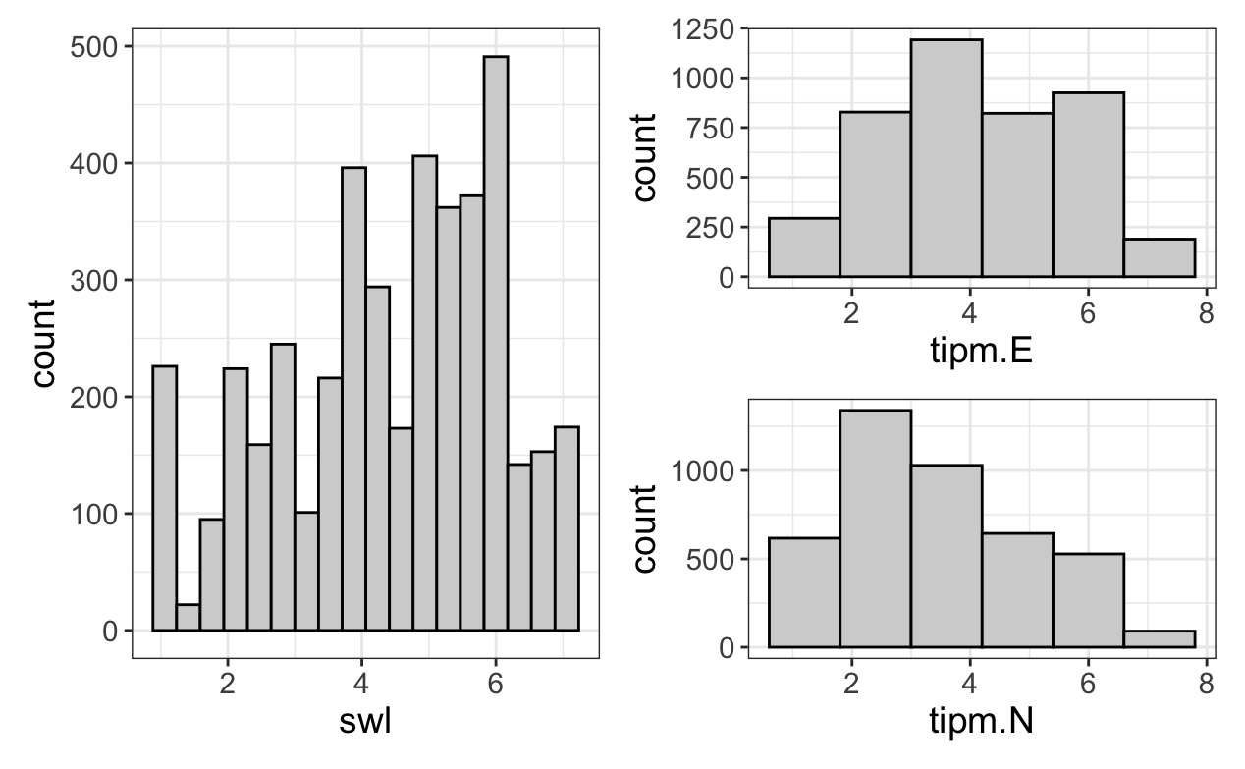

Figure 1 Univariate visualization for each interested variable in the assignment

**Model Fitting**

Based on our formulated hypotheses, we proceeded with fitting a model where extraversion and neuroticism served as predictors, and the dependent variable was satisfaction with life. The hypotheses were as follows:

1.Extraversion will positively correlate with satisfaction with life.

2.Neuroticism will negatively correlate with satisfaction with life.

3.The impacts will remain consistent across level 1 (within participants over time) and level 2 (between participants).

Initially, we fitted a baseline linear mixed-effects model for our dependent variable using only a random intercept (by participant ID) and excluding our specific predictors; the intra-class coefficient was calculated at 0.74, with a design effect of 12.3, suggesting the necessity of a mixed-effects model for our data.

Subsequently, we evaluated nested models using maximum likelihood (ML) analysis—restricted maximum likelihood (REML) was not employed as it doesn't permit such comparisons—to assess model fit. We incrementally introduced our predictor variables into our mixed effects models, initially as fixed effects and subsequently as random effects (i.e., initially with fixed slopes, then with random slopes and intercepts). From a theoretical perspective, the relationships between both extraversion and neuroticism with satisfaction with life were considered suitable for modeling with random intercepts and slopes, when grouped by individuals. These relationships, both at baseline and as they fluctuate over time, were likely to show significant individual variability. The indices of model fit favored our comprehensive linear mixed-effects model (Equation 1), where both extraversion and neuroticism were modeled using random effects, demonstrating consistent improvements with each model refinement, reflected in lower AIC and BIC scores, larger Bayes Factors, and p-values below the established thresholds.

**Equation 1***Full linear mixed effects model.*

$$S_{ij}= β_{0}+β_{1}E_{ij}+ β_{2}N_{ij}+b_{0i}+b_{1i}E_{ij}+b_{2i}N_{ij}+ϵ_{ij}$$

Where:

* $i$ represents each individual
* $j$ represents each measurement time point, within each individual
* $S$ represents satisfaction with life (outcome measure)
* $β$ are fixed effects terms ( $β_{0}$ is intercept term, $β_{1}$ and $β_{2}$ represent fixed effects coefficients for predictors)
* $E$ represents extraversion (predictor)
* $N$ represents neuroticism (predictor)
* $b$ are random effects terms ( $b_{0i}$ is the random intercept for each person – as it deviates from the overall average intercept; $b_{1i}$ and $b_{2i}$ represent random slopes for each person for the predictors – as the slopes deviate from the overall average slopes, which are captured by fixed effects)
* $ϵ_{ij}$ is the error in the model

**Model Visualization and Assumptions Checking**

We conducted several visual examinations of various iterations of the model to identify any potential non-linear relationships or interaction effects; none were found. We next visually assessed the model's residuals to check its assumptions (see Figure 2). The residuals' histogram appeared bell-shaped but potentially leptokurtic. The calculated kurtosis value of 4.15 confirmed leptokurtosis. Additionally, the residual-dependence plot displayed a zero slope, supporting the linearity assumption. The scale-location (S-L) plot showed only a slight negative slope, suggesting a mild degree of heteroskedasticity, which was not considered concerning.

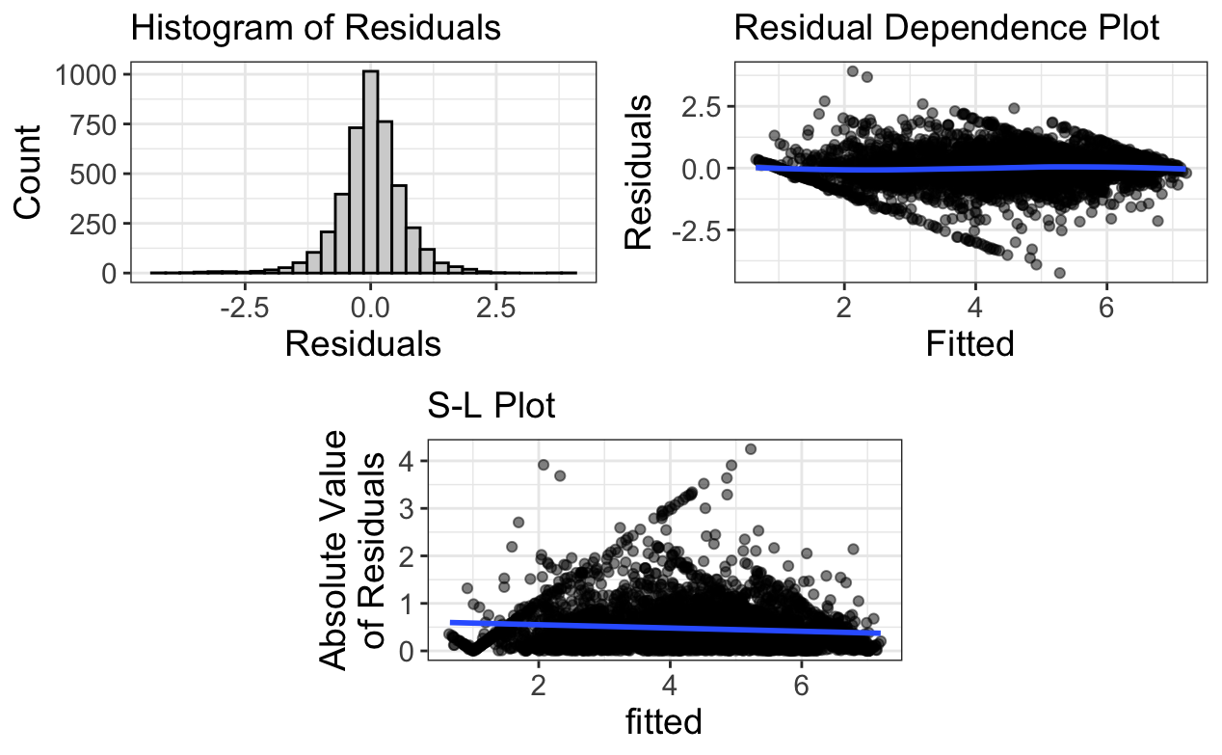

Figure 2 residual plots of our full model.

**Model Estimates**

Model estimates for our full model were computed using REML as outlined in Table 2. Since the focus was on calculating estimates rather than comparing nested models, the use of REML was appropriate as it offers less biased variance estimates compared to other methods.

The results showed that for every one unit increase in extraversion, there was a 0.16 increase in satisfaction with life, accounting for neuroticism. Conversely, each one unit increase in neuroticism led to a 0.21 decrease in satisfaction with life, accounting for extraversion. These outcomes corroborate Hypotheses 1 and 2. However, when calculating R2, it was evident that our model did not significantly explain the variance in satisfaction with life among individuals (R2 Intercept of 0%), indicating that extraversion and neuroticism did not substantially account for differences between individuals in our model. Nonetheless, the model did account for a considerable amount of variance over time (R2 Residual of 26%), suggesting that both extraversion and neuroticism significantly explained variations in our outcome within individuals across time. Therefore, Hypothesis 3 was not supported.

The overall variance explained by both fixed and random effects (Conditional R2) was 78.8% (0.788), and the variance explained solely by fixed effects (Marginal R2) was 9.4% (0.094).

**Table 2**

*Estimates, intra-class correlation (ICC), and calculated R2 values for our full model*

|  |  |  |  |  |  |
| --- | --- | --- | --- | --- | --- |
| **Fixed Effect Term** | **Estimate** | **SE** | **Statistic** | **95 % CI** | |
| (Intercept) | 4.51 | 0.12 | 38.11 | [4.27, 4.734] | |
| Extraversion | 0.16 | 0.02 | 10.55 | [0.13, 0.19] | |
| Neuroticism | -0.21 | 0.02 | -12.33 | [-0.24, -0.18] | |
|  |  |  |  |  |  |
| **ICC** | 0.74 |  |  |  |  |
|  |  |  |  |  |  |
| **R2** |  |  |  |  |  |
| (Intercept) | -0.06 |  |  |  |  |
| Residual | 0.26 |  |  |  |  |