الف

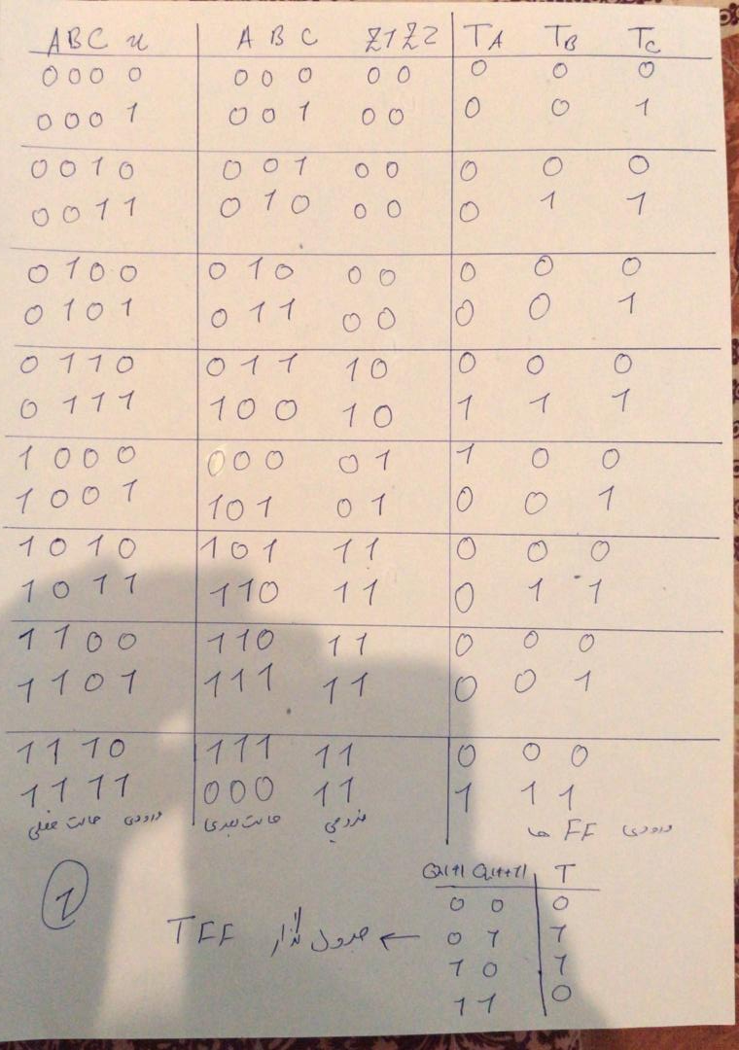

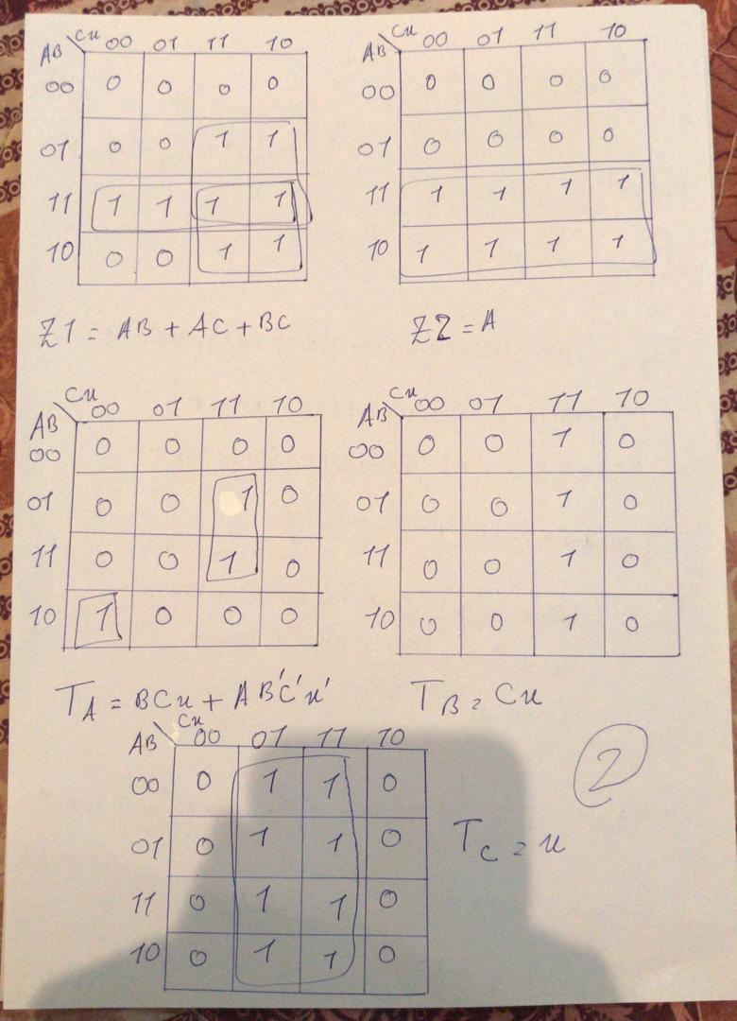

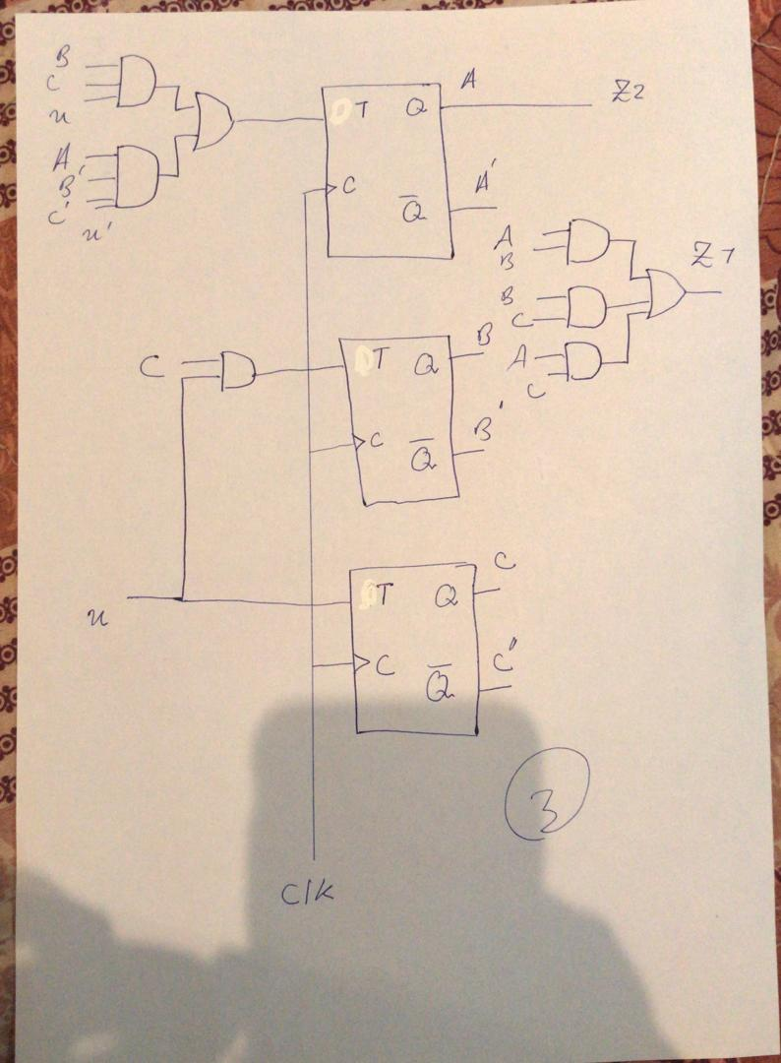

ب-

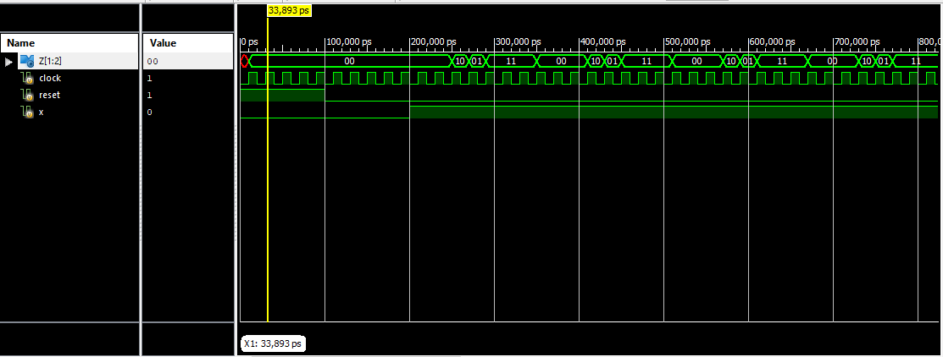

ج-

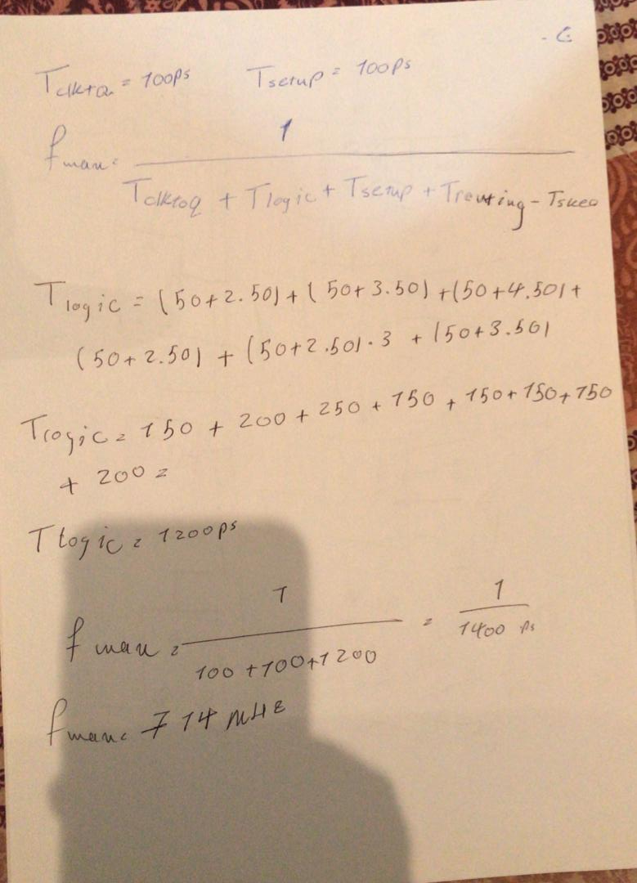

و-

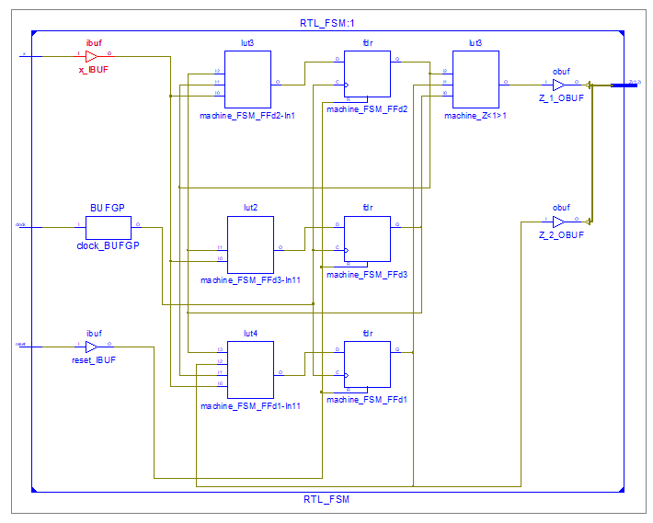

ط-

NET "clock" LOC = A8;

NET "reset" LOC = A9;

NET "x" LOC = A12;

NET "Z[1]" LOC = AB12;

NET "Z[2]" LOC = AB11;