**——— E-commerce Market Analysis Using EDA ———**

**1 - How was the sales trend over the months?**

According to Fig 4. the sales trend in the year 2019 starts in January with total money of 3.6M, and it keeps increasing until it reaches its peak in December with total money of 7.7M. Afterwards, the sales fell dramatically to their minimum with a value of just about 2M by the end of December.

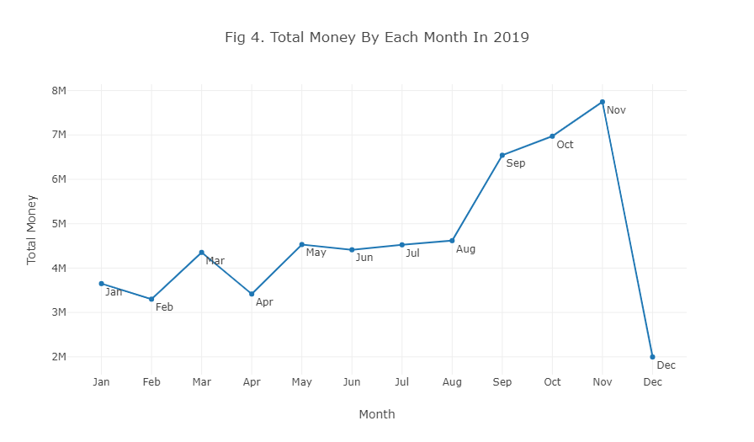

**2 - What are the most frequently purchased products?**

- Popcorn Holder: 580K

- World War 2 Gliders Asstd Designs: 550K

- Paper Craft Little Birdie: 500K

- Cream Hanging Heart T-Light Holder: 450K

- Assorted Color Bird Ornament: 420K

- Pack Of 72 Retrospot Cake Cases: 388K

- Rabbit Night Light: 327K

- Jumbo Bag Red Retrospot: 290K

- Regency Cakestand 3 Tier: 289K

- Mini Paint Set Vintage: 284K*

However, this analysis is based on the product price & quantity. For further analysis, the product profitability must be taken into account.

**3 - How many products does the customer purchase in each transaction?**

According to Fig 12. the number of quantities varies in each transaction. However, the average number of quantities in each transaction (including canceled orders) is 241, omitting the canceled transaction the average number of quantities in each transaction is 229.

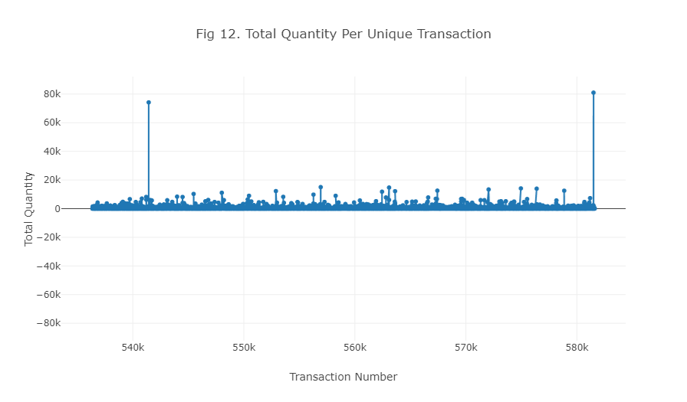

**4 - What are the most profitable segment customers?**

Based on Fig 2. the top 10 customers of the company represent only 0.002% of the company's consumers but contribute about 15% of the total sales revenue.

Moreover based on Fig 7. the most profitable customers are those who buy the products listed in Fig 7.

More generally, according to Fig 3. the most profitable segment customers are from the countries listed in Fig 3.

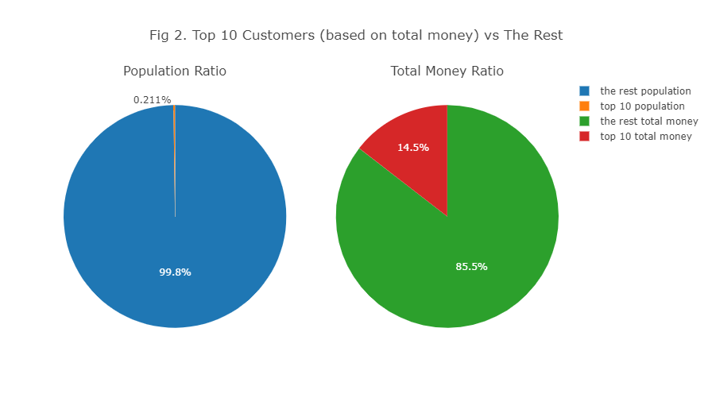

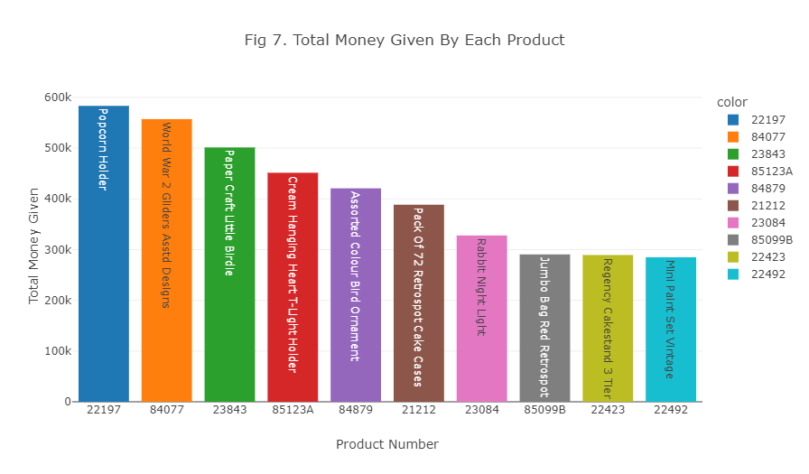

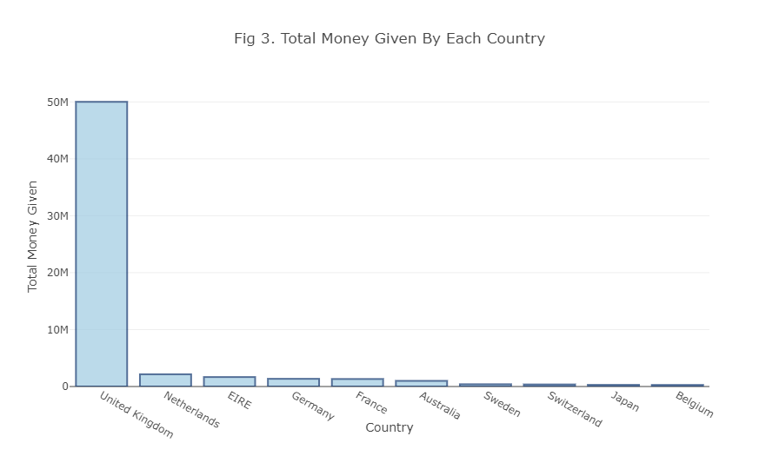

**5 - Based on your findings, what strategy could you recommend to the business to gain more profit?**

Based on the findings, below is the list of several recommended strategies to help the company grow sales:

- The trend in Fig 4. and Fig 6.1 shows that the total sales trend of the company has a strong correlation with the total sales in the UK. This is an indication that the buyers from the UK are crucial to the company. Therefore the company could target this market segment with different marketing strategies.

- Based on Fig 8. the top 10 products of the company bring massive sales for the company. Conceivably the company could use various marketing techniques to maneuver these items.

- According to Fig 4. the sales revenue drops significantly in December. The company could offer various promotions and deals to grow sales this month. According to Fig 5. and Fig 6. the biggest customers of the company are from European countries, which makes sense why the sales drop by the end of the year. The company could target other countries at this time of the year when there are no holidays(Eastern / Middle Eastern countries).

- There are a number of countries such as Lebanon, Brazil, RSA, Bahrain and Saudi Arabia, which bring the least amount of total money to the company. Therefore either the firm could re-calculate its business with these countries (cost vs profit) or it could conduct market research in these countries to promote commodities in favor of the forenamed countries to boost sales.

- Fig 5.1. and Fig 5.2. show the top countries that have the most total money. The company could use various marketing strategies, or announce new items in favor of these countries in order to dominate their market.

- Based on Fig 1. and Fig 2. the top 10 customers of the company contribute about 15% of the total sales of the company. The company could perhaps create a customer loyalty program to incentivize its loyal customers. This could include providing member discounts, outstanding offers or VIP events.

