**——— Fake News Classification ———**

False information is news, reports or hoaxes designed to influence people’s perceptions of real facts, events, and statements. Usually, these stories are created to either manipulate people’s opinions, push a political agenda or cause confusion and can often be a promising business for online publishers. False information can mislead individuals by looking like authorized websites or utilizing similar terms and web addresses to reputable news institutions.

Fake news classification on social media has gained a lot of awareness in the last decade due to the ease of adding fake content through social media. Therefore detecting false information quickly is crucial more than ever.

To tackle the issues of spreading fake news, automated detection approaches have been studied building on artificial intelligence and machine learning. The recent accomplishments of deep learning techniques in complex natural language processing tasks, make them a promising solution for fake news detection.

This project classifies fake news with textual content into 2 categories (0: reliable, 1:unreliable) using deep learning.

The model used in this system is a 5-layer LSTM model with about 1.4M parameters to train. The proposed model involves sequential processing of the data for learning. This sequential process is justified by its ability to retain a memory of what came before the current sequence being processed.

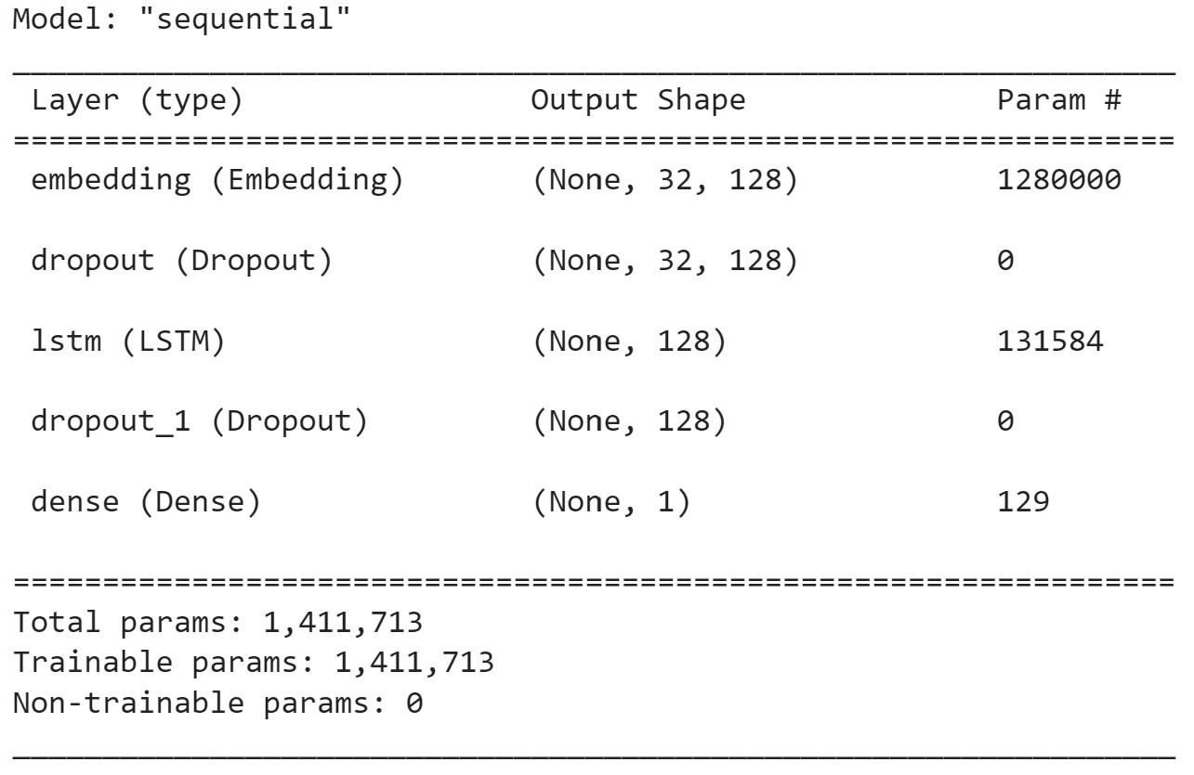

The dataset consists of about 18,000 news articles, almost equally distributed to the true and fake categories.

In order to train the network, for each article only the headline text (article title) is evaluated.

The model is assessed based on various evaluation metrics and achieved an accuracy score of 92%. The classification report is listed below.

