Task to do:

1. our variable(x) might be different datatype like

1. Int

2. Float

3. bool

4. another variable with char+num like "var22"

2. Get input as SMT Solver

3. output must be in SMT-lib format (using to_smt2() )

4. mutation count

Order of mutation also matter

num. conflicts (less better)

"num. conflicts" is useful for estimating the size of the search space traversed by Z3. We may say an axiomatisation is "better" if the size of the search space is smaller.

conflicts indicate assignments that happen in the theory subsolvers and that did not make the formula true. If the formula can be satisfied and the number of conflicts is high, it basically means that the prover tried lots of assignments that did not satisfy the formula,

quant-instantiations indicates the number of instantiated quantifiers. The fewer instantiations the better, but you of course don't want to make your patterns/triggers too strict because Z3 then won't be able to prove anything

challenge: z3 automatically convert int to real toReal() on asserts

We are using depth first

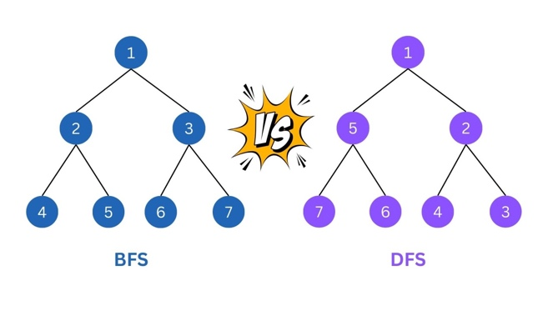

A formula/constraint F is **valid** if F always evaluates to true for any assignment of appropriate values to its uninterpreted symbols. A formula/constraint F is **satisfiable** if there is some assignment of appropriate values to its uninterpreted symbols under which F evaluates to true. Validity is about finding a proof of a statement; satisfiability is about finding a solution to a set of constraints

<https://stackoverflow.com/questions/23064533/statistics-in-z3>

Different type of operators

Arithmetic Operators:

* Addition (+): 3 + 5 evaluates to 8.
* Subtraction (-): 7 - 2 evaluates to 5.
* Multiplication (*): 4 * 6 evaluates to 24.
* Division (/): 10 / 2 evaluates to 5.0.
* Modulus (%): 10 % 3 evaluates to 1 (remainder of division).

Comparison Operators:

* Equal to (==): 5 == 5 evaluates to True.
* Not equal to (!=): 3 != 5 evaluates to True.
* Greater than (>): 8 > 5 evaluates to True.
* Less than (<): 2 < 7 evaluates to True.
* Greater than or equal to (>=): 6 >= 6 evaluates to True.
* Less than or equal to (<=): 4 <= 3 evaluates to False.

Logical Operators:

* AND (and): True and False evaluates to False.
* OR (or): True or False evaluates to True.
* NOT (not): not True evaluates to False.

Assignment Operators:

* Assignment (=): x = 5 assigns the value 5 to variable x.
* Addition assignment (+=): x += 3 is shorthand for x = x + 3.
* Subtraction assignment (-=): x -= 2 is shorthand for x = x - 2.
* Multiplication assignment (*=): x *= 4 is shorthand for x = x * 4.
* Division assignment (/=): x /= 2 is shorthand for x = x / 2.

Bitwise Operators (for integers):

* Bitwise AND (&): 5 & 3 evaluates to 1.
* Bitwise OR (|): 5 | 3 evaluates to 7.
* Bitwise XOR (^): 5 ^ 3 evaluates to 6.
* Bitwise NOT (~): ~5 evaluates to -6.
* Left shift (<<): 5 << 1 evaluates to 10.
* Right shift (>>): 5 >> 1 evaluates to 2.

Membership Operators:

* In (in): 3 in [1, 2, 3] evaluates to True.
* Not in (not in): 4 not in [1, 2, 3] evaluates to True.

Identity Operators:

* is: x is y evaluates to True if x and y refer to the same object.
* is not: x is not y evaluates to True if x and y refer to different objects.