4-4. Verification
The present numerical solution is verified through five independent checks, each against either an exact analytical solution, published results, or a commercial finite-element solution. In every check, besides the quantitative error, the present result is plotted against the corresponding reference so that the coincidence of the curves can be seen. Table 4-6 gives the overview of all five checks, and the subsections that follow treat each one separately.
Table 4-6. Summary of the solver verification tests.
# | test | reference | result
1 | static spatial assembly | independent static solver | agreement 2.20×10⁻¹¹
2 | dynamic mechanical response | reference [31] + ANSYS | error 0.1–0.2 %; σ_rr exact
3 | transient heat conduction | exact Bessel-series solution | relative error 10⁻⁵–10⁻⁷
4 | time integration | adaptive stiff solver (independent) | max difference 0.0034 K
5 | coupled Lord–Shulman waves | exact Fourier–Bessel solution | pointwise error 0.32 %; L₂ 0.065 %

4-4-1. Test 1 — assembly of the static matrices
The static limit of the dynamic solver is checked against an independent static solver. That independent solver is a separate code with its own assembly, which carries no time term at all and solves the two algebraic systems of steady conduction and elastostatic equilibrium directly; the loading is internal pressure only and the ends are free. Figure 4-5 shows the two mid-span radial-displacement curves lying on top of one another, and their maximum difference across the whole wall thickness, given in Table 4-7, is at machine-precision level. The test confirms both the numerical equivalence of the two implementations and the correctness of the system assembly.
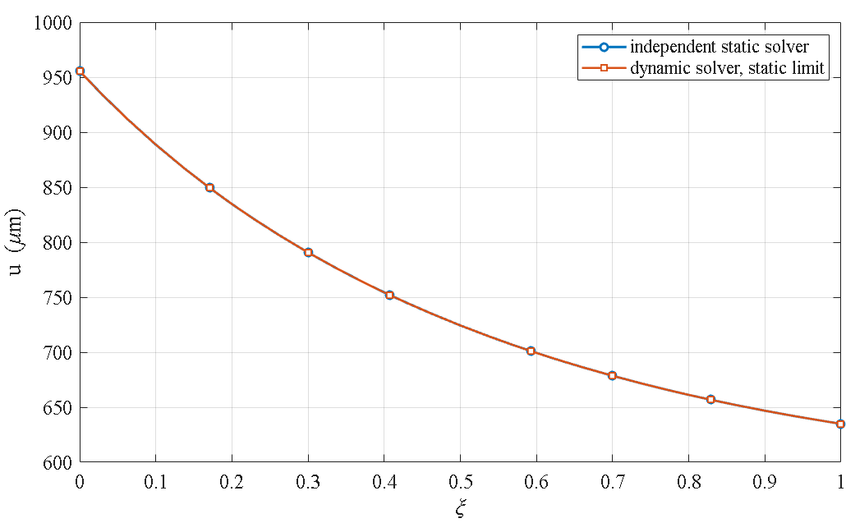
Figure 4-5. Test 1 — mid-span radial displacement from the independent static solver against the static limit of the dynamic solver.
Table 4-7. Test 1 — static limit against the independent static solver.
quantity | value
radial points compared | 45
max u, independent static solver | 9.555556×10⁻⁴ m
max u, static limit of the dynamic solver | 9.555556×10⁻⁴ m
maximum absolute difference | 2.103667×10⁻¹⁴ m
maximum relative difference | 2.201512×10⁻¹¹

4-4-2. Test 2 — dynamic mechanical response
The mechanical part of the problem is compared with the results of Malekzadeh (Table 6 of reference [31]) and with an independent ANSYS finite-element solution. The dimensionless radial displacement is reproduced with a relative difference of 0.1 to 0.2 percent, and the dimensionless inner-surface radial stress is obtained exactly as the negative of the applied pressure, in full agreement with the loading boundary condition.
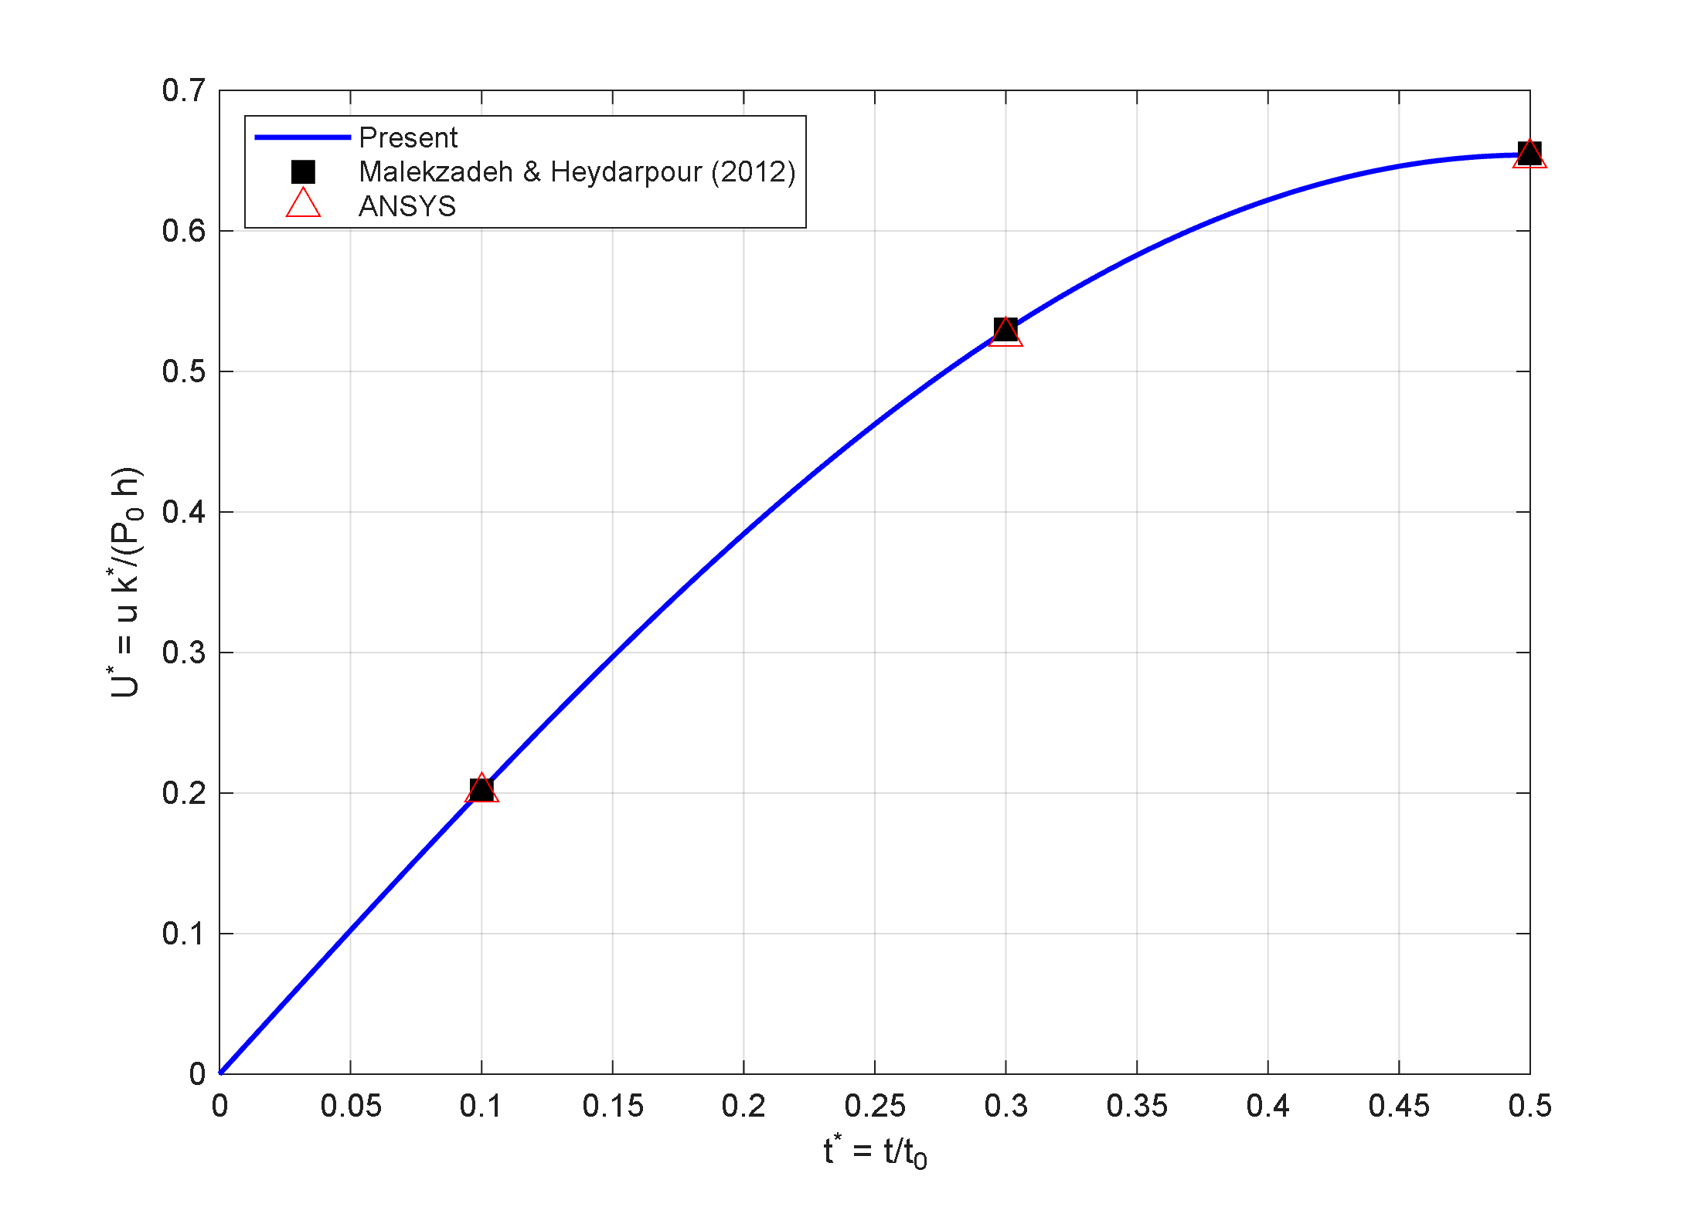
Figure 4-6. Test 2 — dimensionless inner-surface radial displacement at mid-span against dimensionless time: the present solution compared with the published values of reference [31] and the ANSYS solution.

4-4-3. Test 3 — transient heat conduction
The transient conduction problem is checked against the exact Bessel-series solution. The dimensionless temperature distribution at several times lies on the exact curve, with a relative error between 10⁻⁵ and 10⁻⁷; that is, the differential quadrature spatial discretization reproduces the transient thermal field to several significant digits.
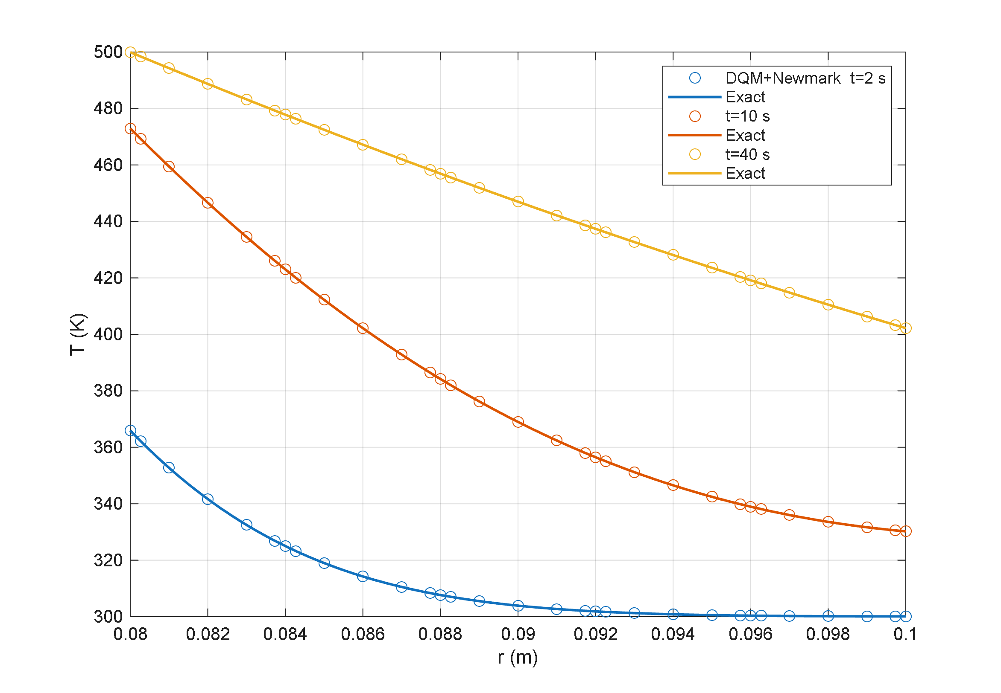
Figure 4-7. Test 3 — radial temperature profiles at several times: the present solution (markers) against the exact Bessel-series solution (solid line).

4-4-4. Test 4 — time-integration scheme
The Newmark scheme is checked against MATLAB’s adaptive stiff solver on the same spatial system. Figure 4-8 shows all three curves — the exact solution, Newmark, and the adaptive solver — coinciding over the whole time interval. The quantitative size of the difference between the two schemes is given in Table 4-8: the maximum Newmark error is about one order of magnitude larger than that of the adaptive solver, but its computational cost is roughly one tenth. It is this accuracy-to-cost ratio that justifies the choice of Newmark for all production runs.
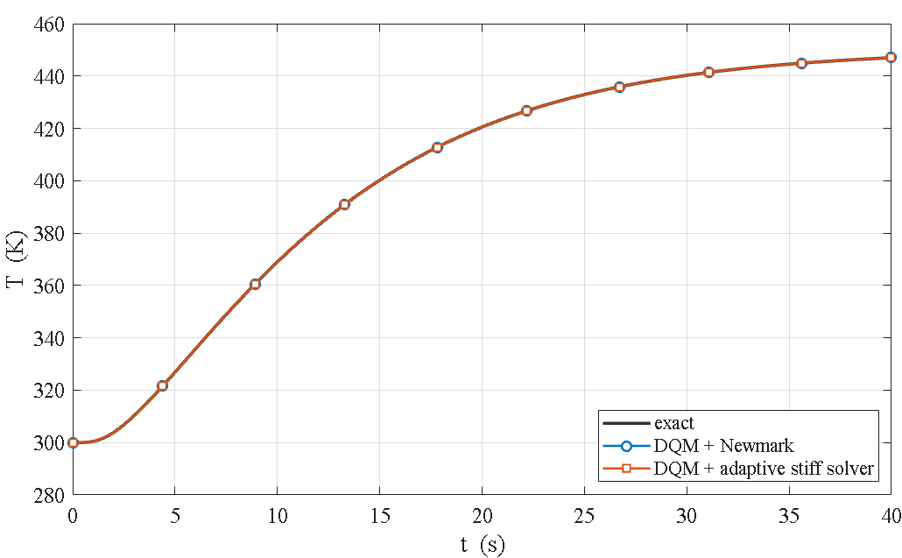
Figure 4-8. Test 4 — mid-point temperature history for the exact solution, the Newmark scheme and the adaptive stiff solver; all three curves coincide.
Table 4-8. Test 4 — comparison of time integrators on the identical spatial system.
method | max error vs exact (K) | CPU time (s)
differential quadrature + Newmark | 0.00319 | 0.18
differential quadrature + adaptive stiff solver | 0.00026 | 1.74
difference between Newmark and the adaptive solver | 0.00337 | —

4-4-5. Test 5 — the Lord–Shulman second-sound wave
The wave-propagation behaviour is checked against an exact Fourier–Bessel solution derived for the solver’s own geometry. That reference was itself verified independently before use: the steady-state limit to 1.9×10⁻¹⁶, strict hyperbolic causality ahead of the front to 4×10⁻⁶, and the front-jump ratios against the analytic ray law to 0.16 percent. The present solver matches it with a maximum pointwise error of 0.32 percent and an L₂ error of 0.065 percent on the finest mesh, and according to Table 4-9 the error falls monotonically under mesh refinement. That monotone decrease simultaneously establishes that the oscillations trailing the sharp front are a Gibbs effect of the spectral discretization and not a numerical instability.
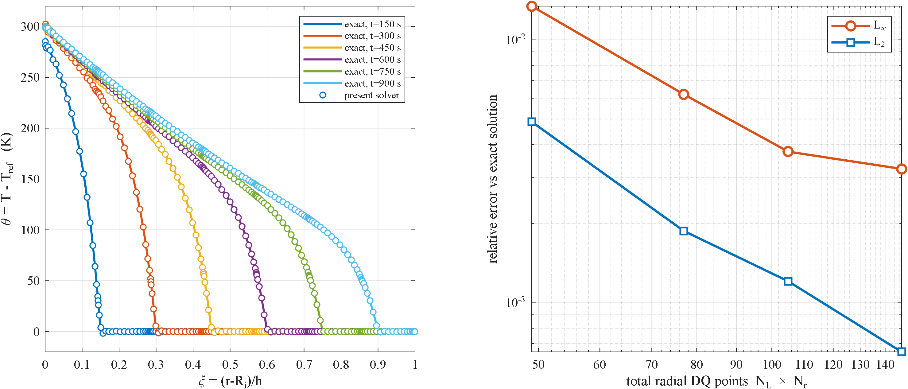
Figure 4-9. Test 5 — radial temperature profiles at several times: the present solver against the exact Fourier–Bessel second-sound solution, with the sharp wave front present in both.
Table 4-9. Test 5 — mesh convergence against the exact Fourier–Bessel solution.
N_r | radial points | L∞ relative error | L₂ relative error
7 | 49 | 1.343×10⁻² | 4.881×10⁻³
11 | 77 | 6.204×10⁻³ | 1.876×10⁻³
15 | 105 | 3.756×10⁻³ | 1.207×10⁻³
21 | 147 | 3.230×10⁻³ | 6.507×10⁻⁴

4-4-6. Summary
Taken together, these five checks confirm the validity of the present solution in both the static and the transient regimes and in the coupled and uncoupled cases: test 1 covers the system assembly, tests 2 and 3 the mechanical and thermal parts separately, test 4 the time-marching scheme, and test 5 the Lord–Shulman wave phenomenon itself, which is the central novelty of this research.

Implementation notes (not part of the thesis text)
- End condition in test 1. The comparison uses free ends, as recorded in the original documentation. Running the same comparison with simply supported ends gives a relative difference of about 8.0×10⁻², because the two codes do not impose the axial simple-support condition identically; that discrepancy is a genuine physical difference, not an assembly error. The new data were produced with Static_Baseline_R3 (the free-end revision) and LSTE_solver_R11.
- Change relative to the previous summary table. Row 5 previously cited Bagri and Eslami as the reference and “wave speeds and reflections matched” as the result, i.e. a qualitative comparison. Following the addition of the exact Fourier–Bessel solution, that row is now quantitative. Row 4 has likewise been updated to the measured difference between Newmark and the adaptive solver (0.0034 K).
- Figure and table numbering. The numbers 4-5 to 4-9 for figures and 4-7 to 4-9 for tables are provisional and must be reconciled with the chapter’s global numbering at final assembly; the summary table keeps its existing number 4-6.
- Image paths. The image paths are written relative to the claude/ folder (the CHAPTER3_formulation convention), so pandoc must be run from that folder to build the docx — running it elsewhere drops the images silently. Black-and-white versions of the two new figures exist in the same folder with the _bw suffix.

