Results Chapter — English original

4.1 Problem definition of the reference case and dimensionless presentation
The results of this chapter concern the multilayer porous GPL-reinforced hollow cylinder described in Chapters 2–3, with inner radius R_i = 0.1 m, outer radius R_o = 0.2 m (thick-walled, R_o/R_i = 2), length L = 0.5 m and N_L = 5 layers. The reference (base) case is: uniform GPL distribution (UD) with total weight fraction W_GPL = 4 %, uniform porosity (UD) with mass coefficient e_m3 = 0.8980, Lord–Shulman theory with relaxation time τ0 = 50 s, full thermo-mechanical coupling, simply supported ends, and the following loading: the inner surface temperature rises smoothly from 300 K to 600 K (ramp time constant t0 = 0.5 s) together with an internal pressure P_i = 1 MPa; the outer surface exchanges heat by convection (h_c = 10 W/m²K) with the 300 K environment. The grid is N_r = 9 points per layer and N_z = 11 axial points; the time step is Δt = 0.1 s up to t_end = 100 s. The Newmark parameters are δ = 1/2, β = 1/4 (no numerical damping); the small oscillations visible behind sharp wave fronts are the expected Gibbs effect of the spectral discretization and are left unfiltered.
All results are reported in dimensionless form (Table 4.1). The reference diffusivity ᾱ = k̄/(ρ̄c̄) = 3.50×10⁻⁴ m²/s is that of the homogenized base material.
Table 4.1 — Dimensionless quantities used in this chapter.
quantity | definition | value/range
Fourier number (time) | Fo = ᾱ t / R_o² | Fo(100 s) = 0.875
dimensionless relaxation | τ* = ᾱ τ0 / R_o² | 0.44 (base)
temperature | T* = (T − T∞)/(T_in − T∞) | 0 → ~1.4
radial coordinate | ξ = (r − R_i)/(R_o − R_i) | 0 … 1
radial displacement | u* = u(λ̄+2μ̄)/(β̄ ΔT h) | O(1)
stress | σ* = σ/(β̄ ΔT) | O(0.1)

The Lord–Shulman thermal wave speed of the base material is v = √(ᾱ/τ0) = 2.65×10⁻³ m/s; crossing half the wall takes ≈19 s (Fo ≈ 0.17), which is exactly where the first wave arrival appears in the histories below.

4.2 Validation (صحت‌سنجی)
Six independent verifications support the solver (details and figures in the Validation section/appendix):
Table 4.2 — Validation summary.
# | test | reference | result
1 | static spatial assembly | independent static solver | agree to 2×10⁻¹¹
2 | dynamic mechanics | Malekzadeh & Heydarpour, IJPVP 98 (2012), Table 6 + ANSYS | U* within 0.1–0.2 %; σ_rr = −1.000 exact
3 | transient conduction | exact Bessel-series solution | rel. error 10⁻⁵–10⁻⁷
4 | time integration | MATLAB ode15s (independent scheme) | max diff. 0.003 K
5 | LS coupled wave propagation | Bagri & Eslami, IJMS 49 (2007) | both wave speeds and reflection times reproduced
6 | layer convergence | N_L = 5/10/20 refinement | monotone, extrapolates onto published values

4.3 Effect of the GPL distribution pattern (study A)
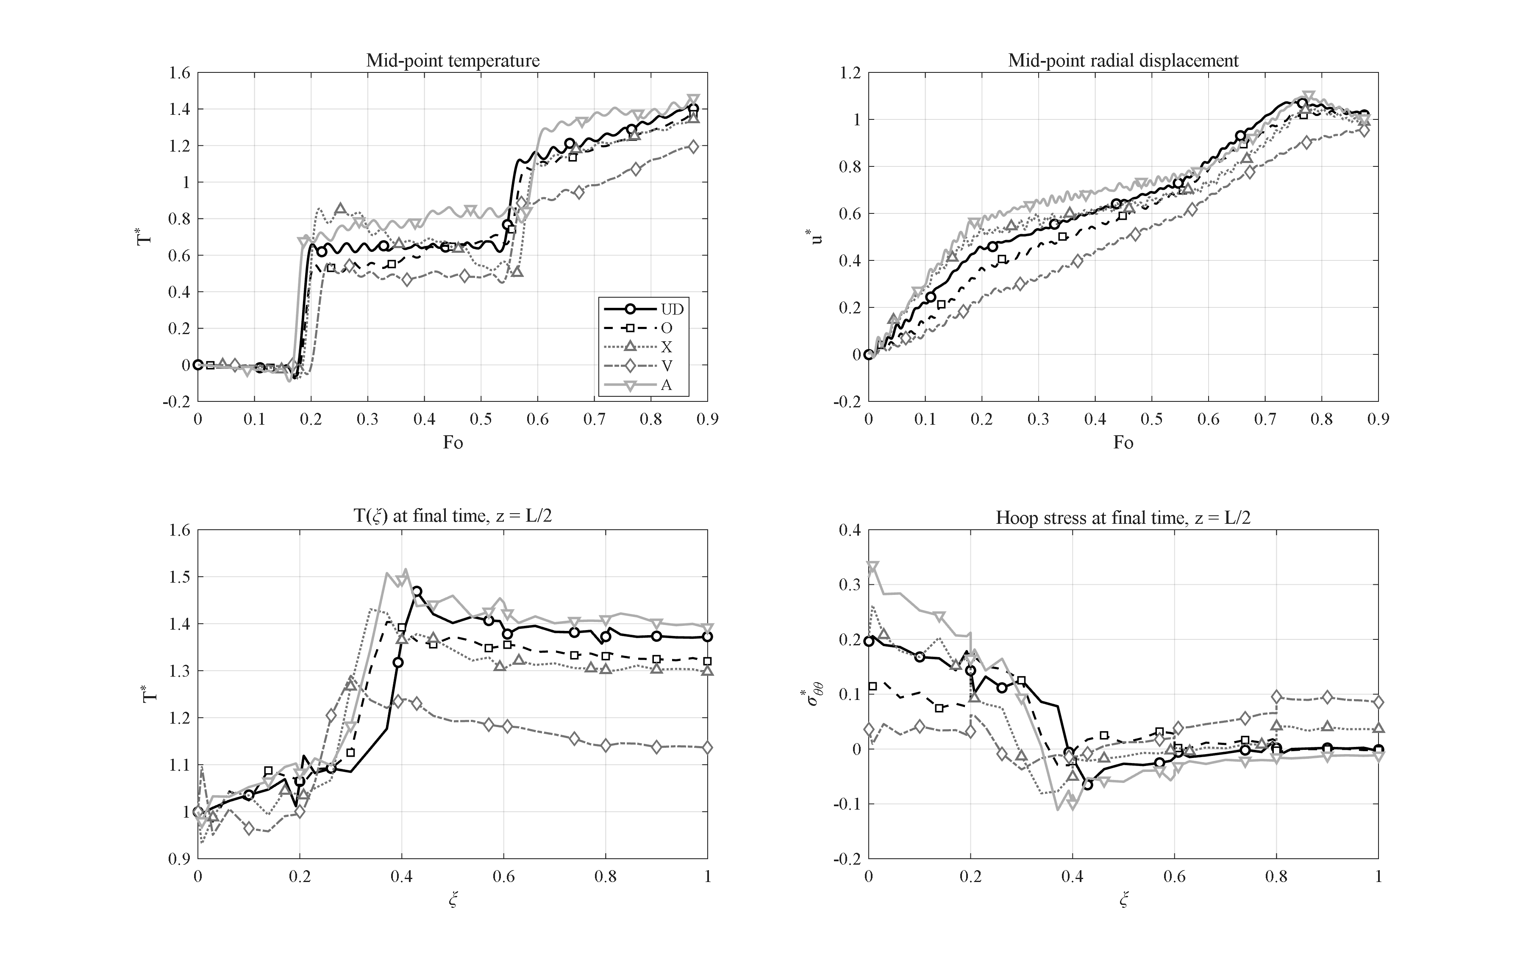
Figure 4-x: Effect of the GPL distribution pattern (UD, O, X, V, A) on the transient response of the base cylinder: (a) mid-point temperature history, (b) mid-point radial displacement history, (c) radial temperature profile at the final time, (d) hoop-stress profile at the final time (z = L/2).
With the porosity fixed (UD), the five GPL patterns change both how fast heat crosses the wall and how the wall carries the thermal stress. The peak mid-thickness temperature reads T*_max = 1.41 (UD), 1.37 (O), 1.34 (X), 1.19 (V) and 1.46 (A). Pattern V — GPL-rich at the inner surface — is the most favorable: the highly conductive inner region spreads the incoming heat and its peak temperature is 16 % below UD; simultaneously its final inner hoop stress is σ*_θθ = 0.036, i.e. 5.5 times smaller than UD (0.196) and 8.8 times smaller than pattern A (0.313). Pattern A (GPL-rich at the outer, insulating epoxy-rich material facing the cavity) is the worst on both counts. The radial displacement follows the same ordering (u*_max = 0.95 V … 1.11 A). Physically, placing the stiff, conductive phase where the temperature gradient is steepest (the heated inner wall) both relieves the gradient and reinforces the region of largest hoop stress.

4.4 Effect of the porosity pattern and porosity level (studies B and E)
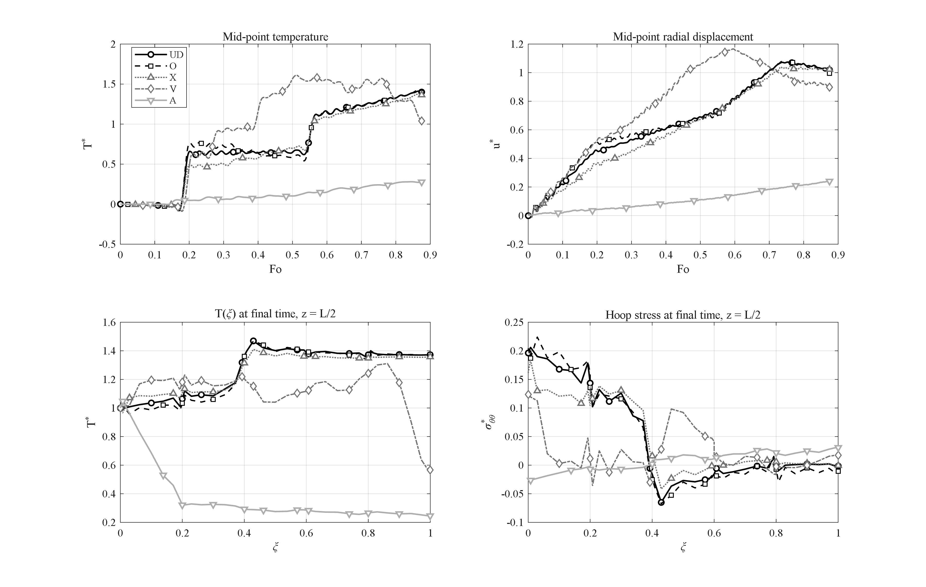
Figure 4-x: Effect of the porosity pattern (UD, O, X, V, A) at fixed UD GPL distribution; pattern A acts as a thermal barrier, pattern V produces the largest transient trapping peak.
The porosity pattern acts primarily on the conduction path. Patterns UD, O and X behave similarly (T*_max = 1.41, 1.42, 1.37). The two asymmetric patterns are extreme opposites:
• Pattern V (pores concentrated at the inner surface) initially traps the heat next to the cavity — the mid-point shows the largest transient peak of the whole campaign group, T*_max = 1.61 at Fo = 0.51 — but the porous inner band then throttles further inflow, so by the end of the process the mid-point has fallen back to T* = 1.04 and the outer surface to 0.57.
• Pattern A (pores concentrated at the outer surface) is a genuine thermal barrier: the porous outer band blocks conduction outward, and the mid-point never exceeds T* = 0.28 while the outer surface stays at 0.25 — a 5.6-fold reduction of the outer temperature compared with UD (1.37). The price is paid elsewhere: with the load carried by the low-temperature region, displacements collapse (u*_max = 0.24) and the final hoop stress at the inner surface even changes sign (−0.025).
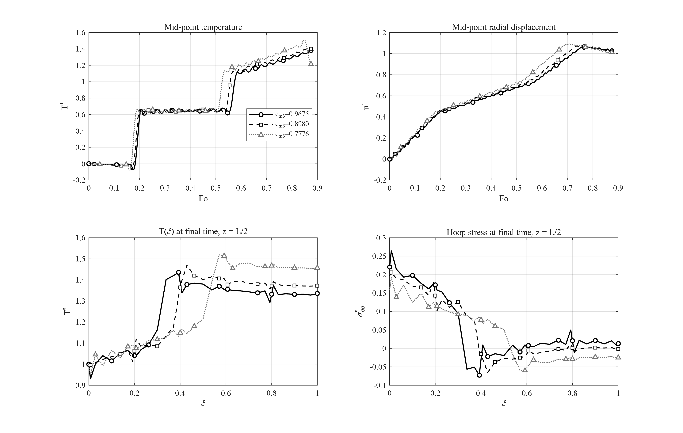
Figure 4-x: Effect of the porosity level (e_m3 = 0.9675, 0.8980, 0.7776): heavier porosity raises the peak temperature and slows the through-wall transient.
Raising the overall porosity (e_m3 = 0.9675 → 0.8980 → 0.7776, i.e. light → heavy porosity) lowers conductivity and stiffness together: the peak temperature grows mildly (1.38 → 1.41 → 1.51) while the process slows (final mid-point value drops from 1.38 to 1.21 because the wall is still filling with heat at t_end).

4.5 Effect of the GPL weight fraction (study D)
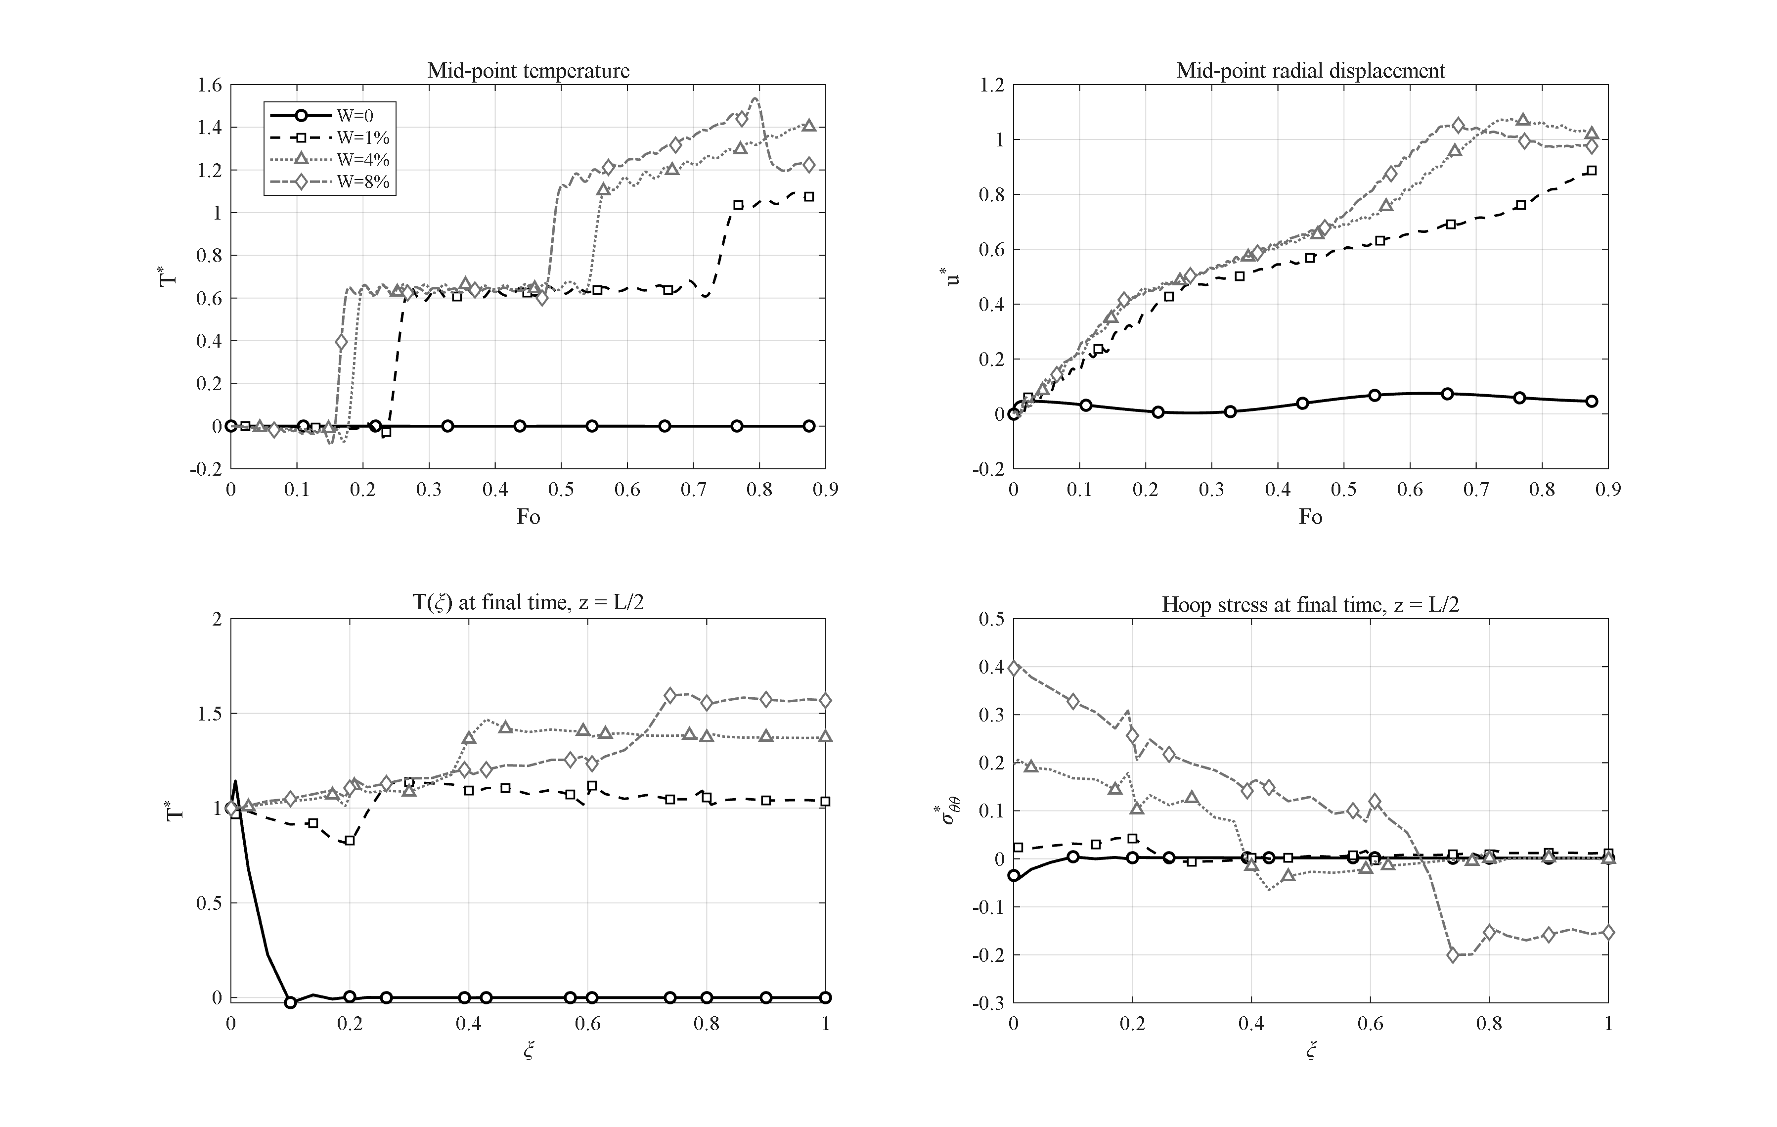
Figure 4-x: Effect of the GPL weight fraction (W = 0, 1 %, 4 %, 8 %): the percolated GPL network switches the wall from thermally insulating (W = 0) to conducting behavior.
The percolation character of the conductivity model makes W_GPL the strongest material lever in the problem. With no GPLs (W = 0) the wall is pure porous epoxy (k ≈ 0.25 W/mK, ᾱ ≈ 1.9×10⁻⁷ m²/s): within the whole 100 s window the heat wave does not even reach mid-thickness (T* ≈ 0 throughout; the small displacement u* = 0.075 is the pressure response). Already at W = 1 % the percolated GPL network raises the conductivity by three orders of magnitude and the familiar transient establishes itself (T*_max = 1.09); W = 4 % (base) gives 1.41 and W = 8 % gives 1.54 with a much stiffer wall — the final inner hoop stress doubles (0.397 vs 0.196). The practical reading: a small GPL fraction is enough to switch the structure from "thermal insulator" to "thermal conductor", after which additional GPLs mainly raise the thermally induced stresses.

4.6 Effect of the relaxation time — Lord–Shulman vs Fourier (study C)
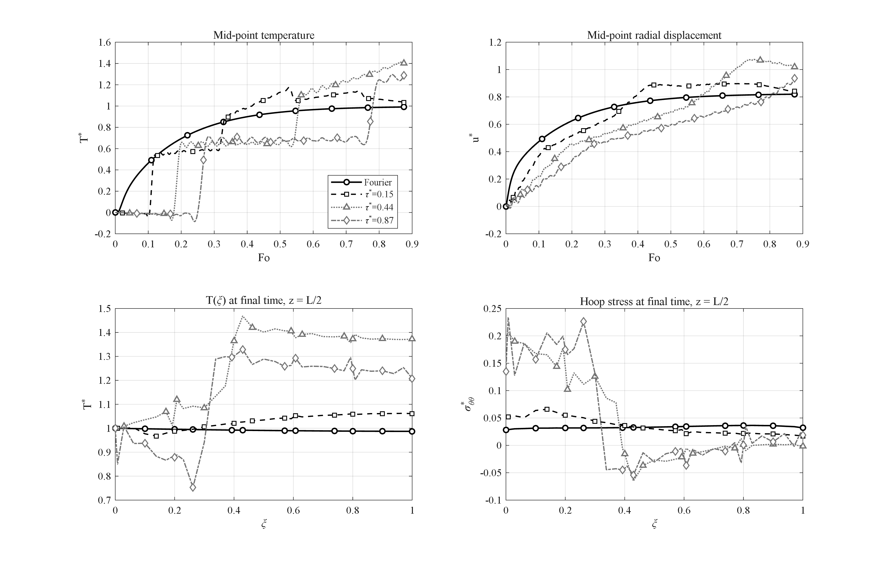
Figure 4-x: Effect of the dimensionless relaxation time τ* on the response (Fourier, τ* = 0.15, 0.44, 0.87). Wave arrivals at Fo ≈ 0.17 and 0.55 and the hyperbolic overshoot T* > 1 are visible; mild oscillations behind the fronts are the unfiltered Gibbs effect (δ = ½).
Under Fourier conduction (τ* = 0) the mid-point temperature rises monotonically and never exceeds the driving value (T*_max = 0.99): classical diffusion cannot overshoot. With the Lord–Shulman relaxation active, heat propagates as a wave of speed √(ᾱ/τ0): the first arrival at mid-thickness appears at Fo ≈ 0.17 for τ* = 0.44, followed by a second front (reflection from the outer surface) at Fo ≈ 0.55. Because the cylindrical geometry focuses the reflected wave, the temperature overshoots the cavity value — a purely hyperbolic effect impossible in the parabolic theory: T*_max = 1.17 (τ* = 0.15), 1.41 (τ* = 0.44), 1.30 at t_end and still rising (τ* = 0.87; the slower wave has completed fewer passes within the window). The relaxation time thus controls both the arrival times (∝ 1/√τ0 in speed) and the overshoot amplitude, and its clear signature in the histories is the central physical argument for using generalized thermoelasticity in short-time analyses of this structure.

4.7 Effect of the end supports (study F)
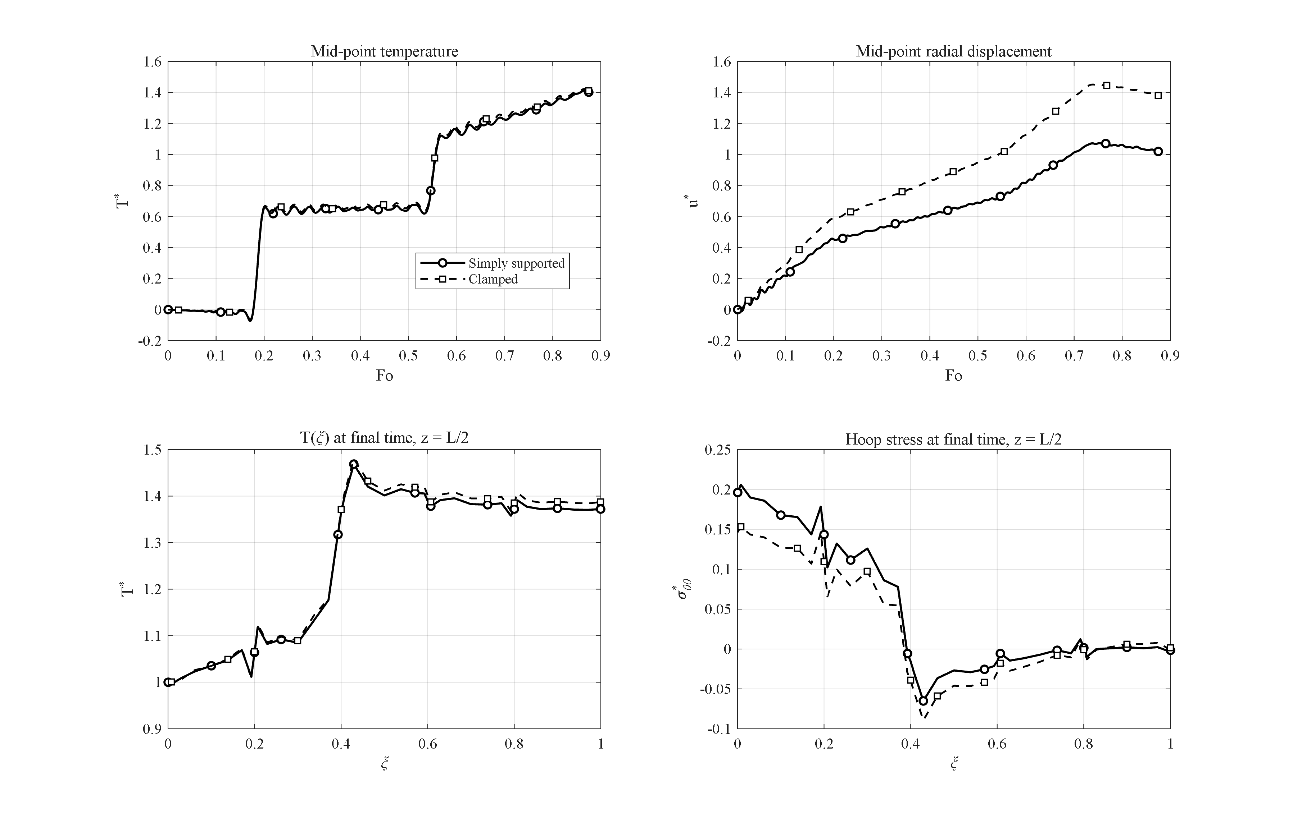
Figure 4-x: Effect of the end supports (simply supported vs clamped): the temperature field is unchanged while blocked axial expansion raises the mid-span radial displacement by 35 %.
Changing the ends from simply supported to clamped leaves the temperature field essentially untouched (T*_max changes by 0.8 %) — the thermal problem does not see the mechanical supports. The mechanical response, however, changes character: with clamped ends the axial thermal expansion of the wall is blocked, and by the Poisson effect the blocked axial strain is diverted into the radial direction — the mid-span radial displacement rises by 35 % (u*_max = 1.45 vs 1.07), while the final inner hoop stress *decreases* from 0.196 to 0.146 as part of the load is transferred to the end restraints. Both supports produce end-localized disturbances that decay within roughly one wall thickness of the ends, so mid-span histories are support-independent to within a few percent — the justification for reporting mid-span quantities as the characteristic response.

4.8 Effect of the internal pressure — step and harmonic (studies G and N)
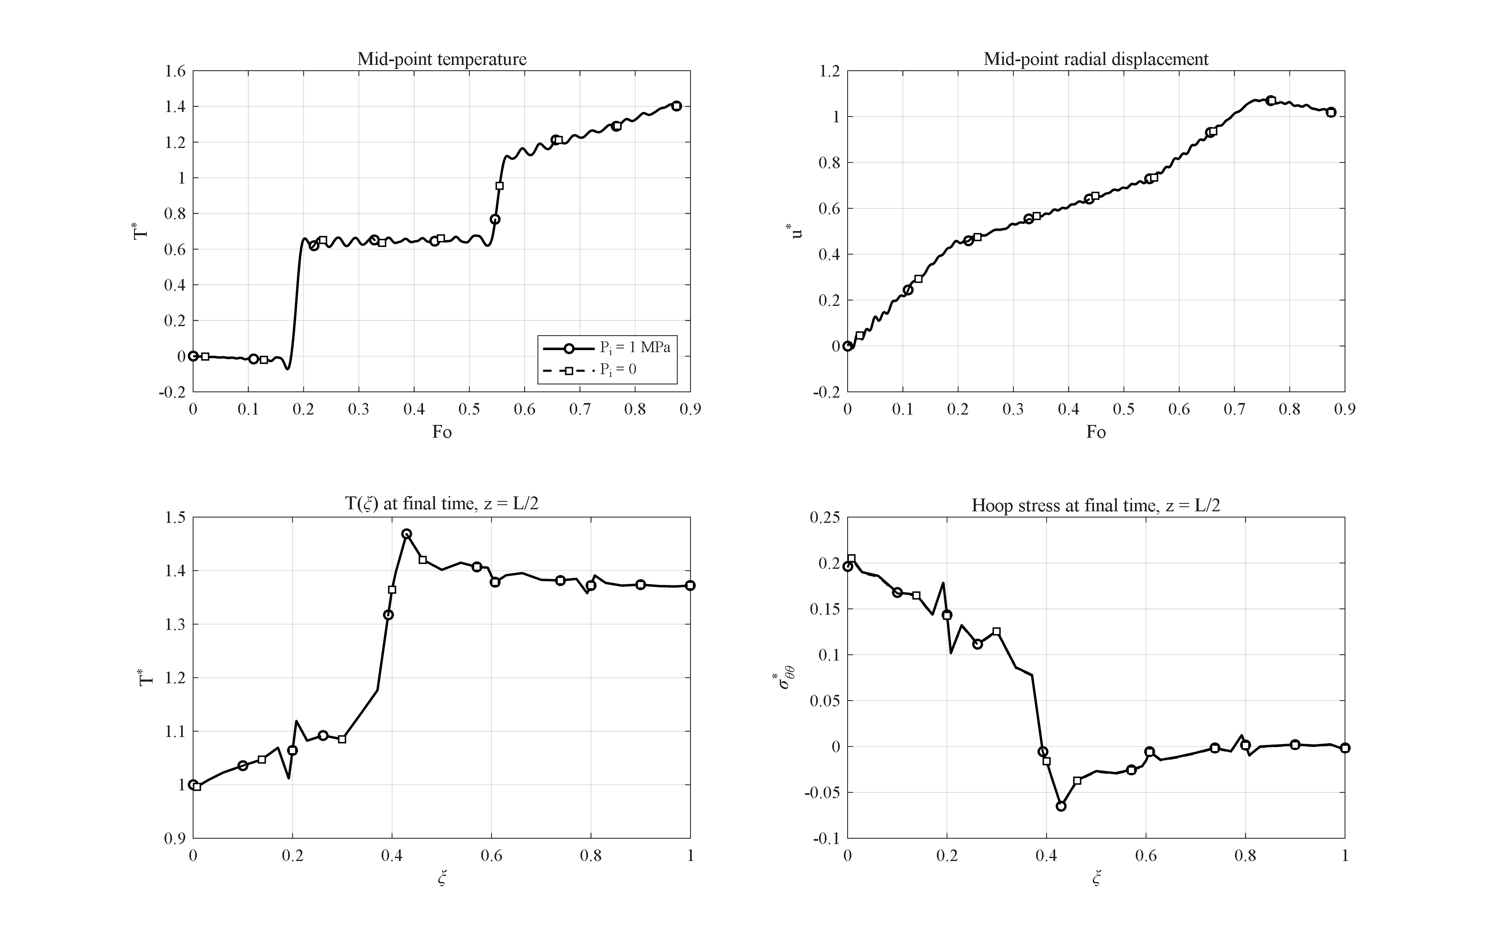
Figure 4-x: Effect of removing the internal pressure (P_i = 1 MPa vs 0): the response is thermally dominated and changes by less than 1 %.
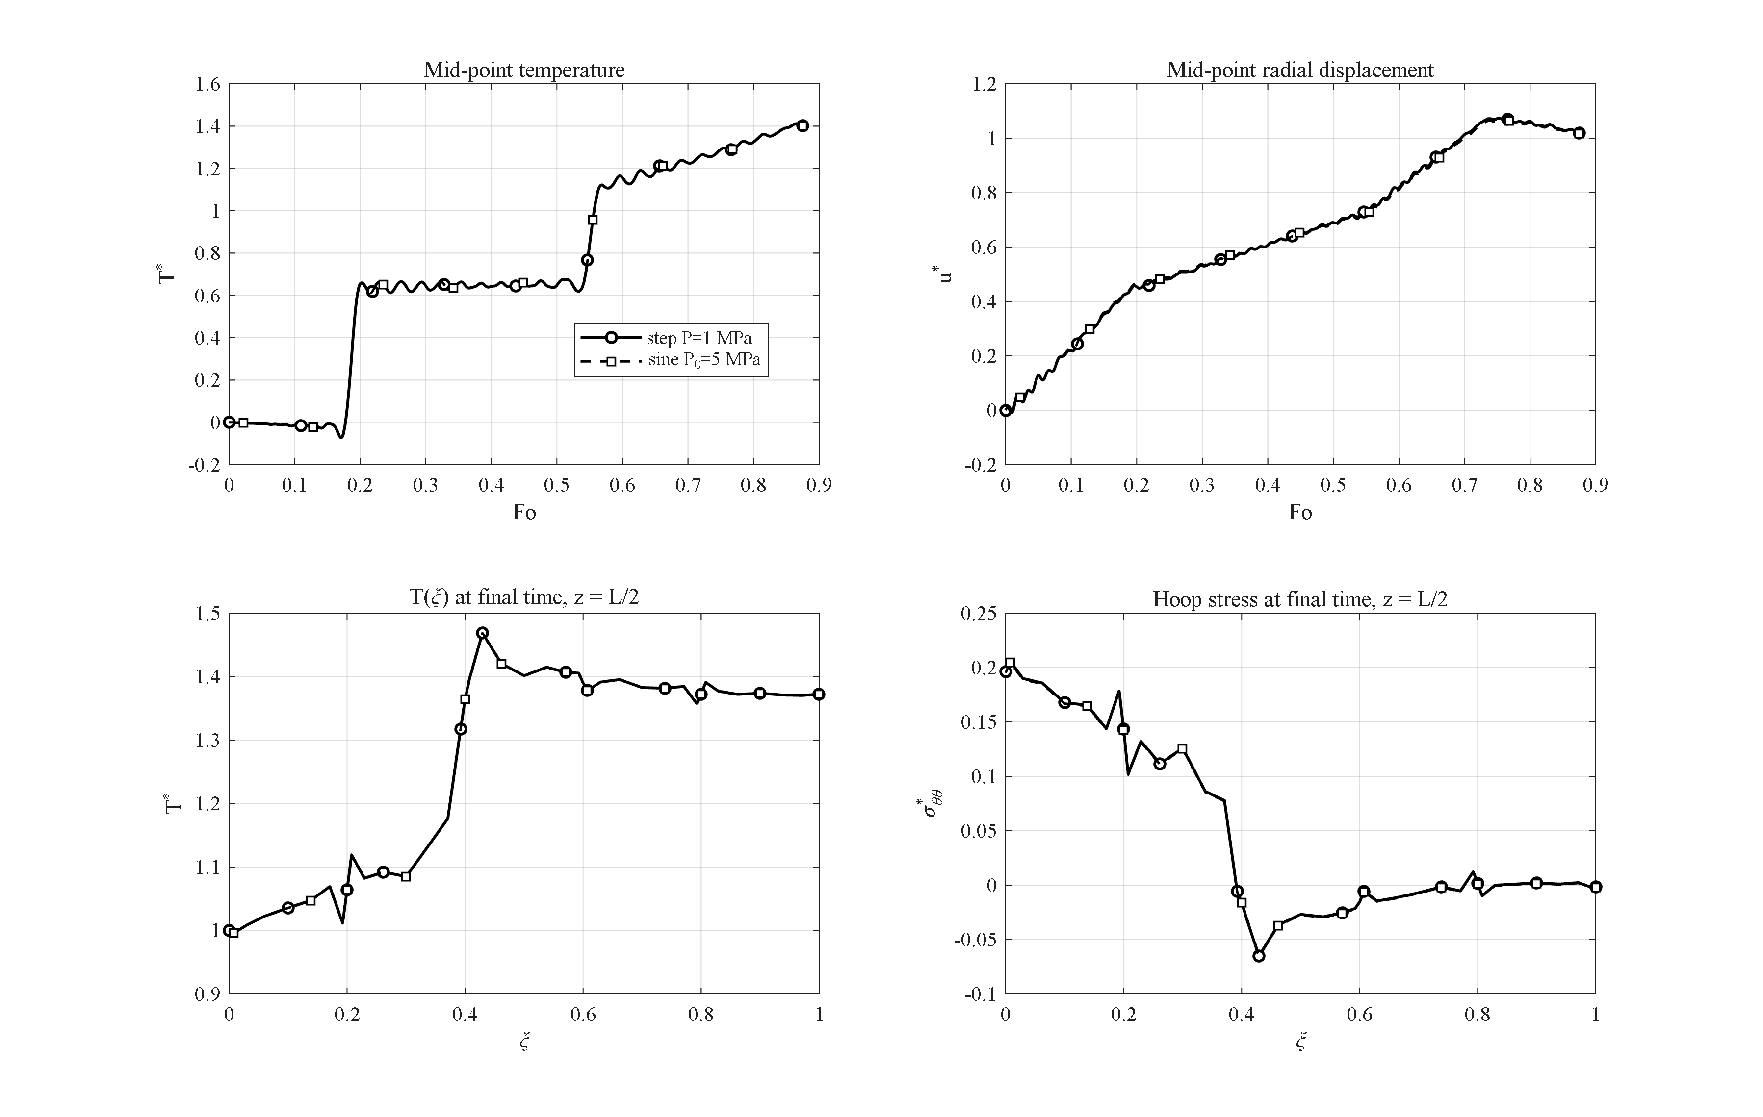
Figure 4-x: Effect of a harmonic internal pressure (P_0 = 5 MPa) versus the step pressure: a small ripple on the displacement without change of the thermal solution.
At the load levels of interest the response is thermally dominated: removing the 1 MPa internal pressure changes the displacement and stress histories by well under 1 % (e.g. u*_max 1.0735 → 1.0721), because the thermal stress scale β̄ΔT is two orders of magnitude larger than P_i. Even a harmonic pressure of amplitude 5 MPa (study N) superposes only a small visible ripple on the displacement history without altering the temperature solution (T*_max identical to base within 10⁻⁵). The engineering conclusion — in rapid heating events of this magnitude the pressure term is a second-order correction — also justifies the common literature practice of studying the thermal shock alone.

4.9 Interaction of GPL and porosity patterns (study H)
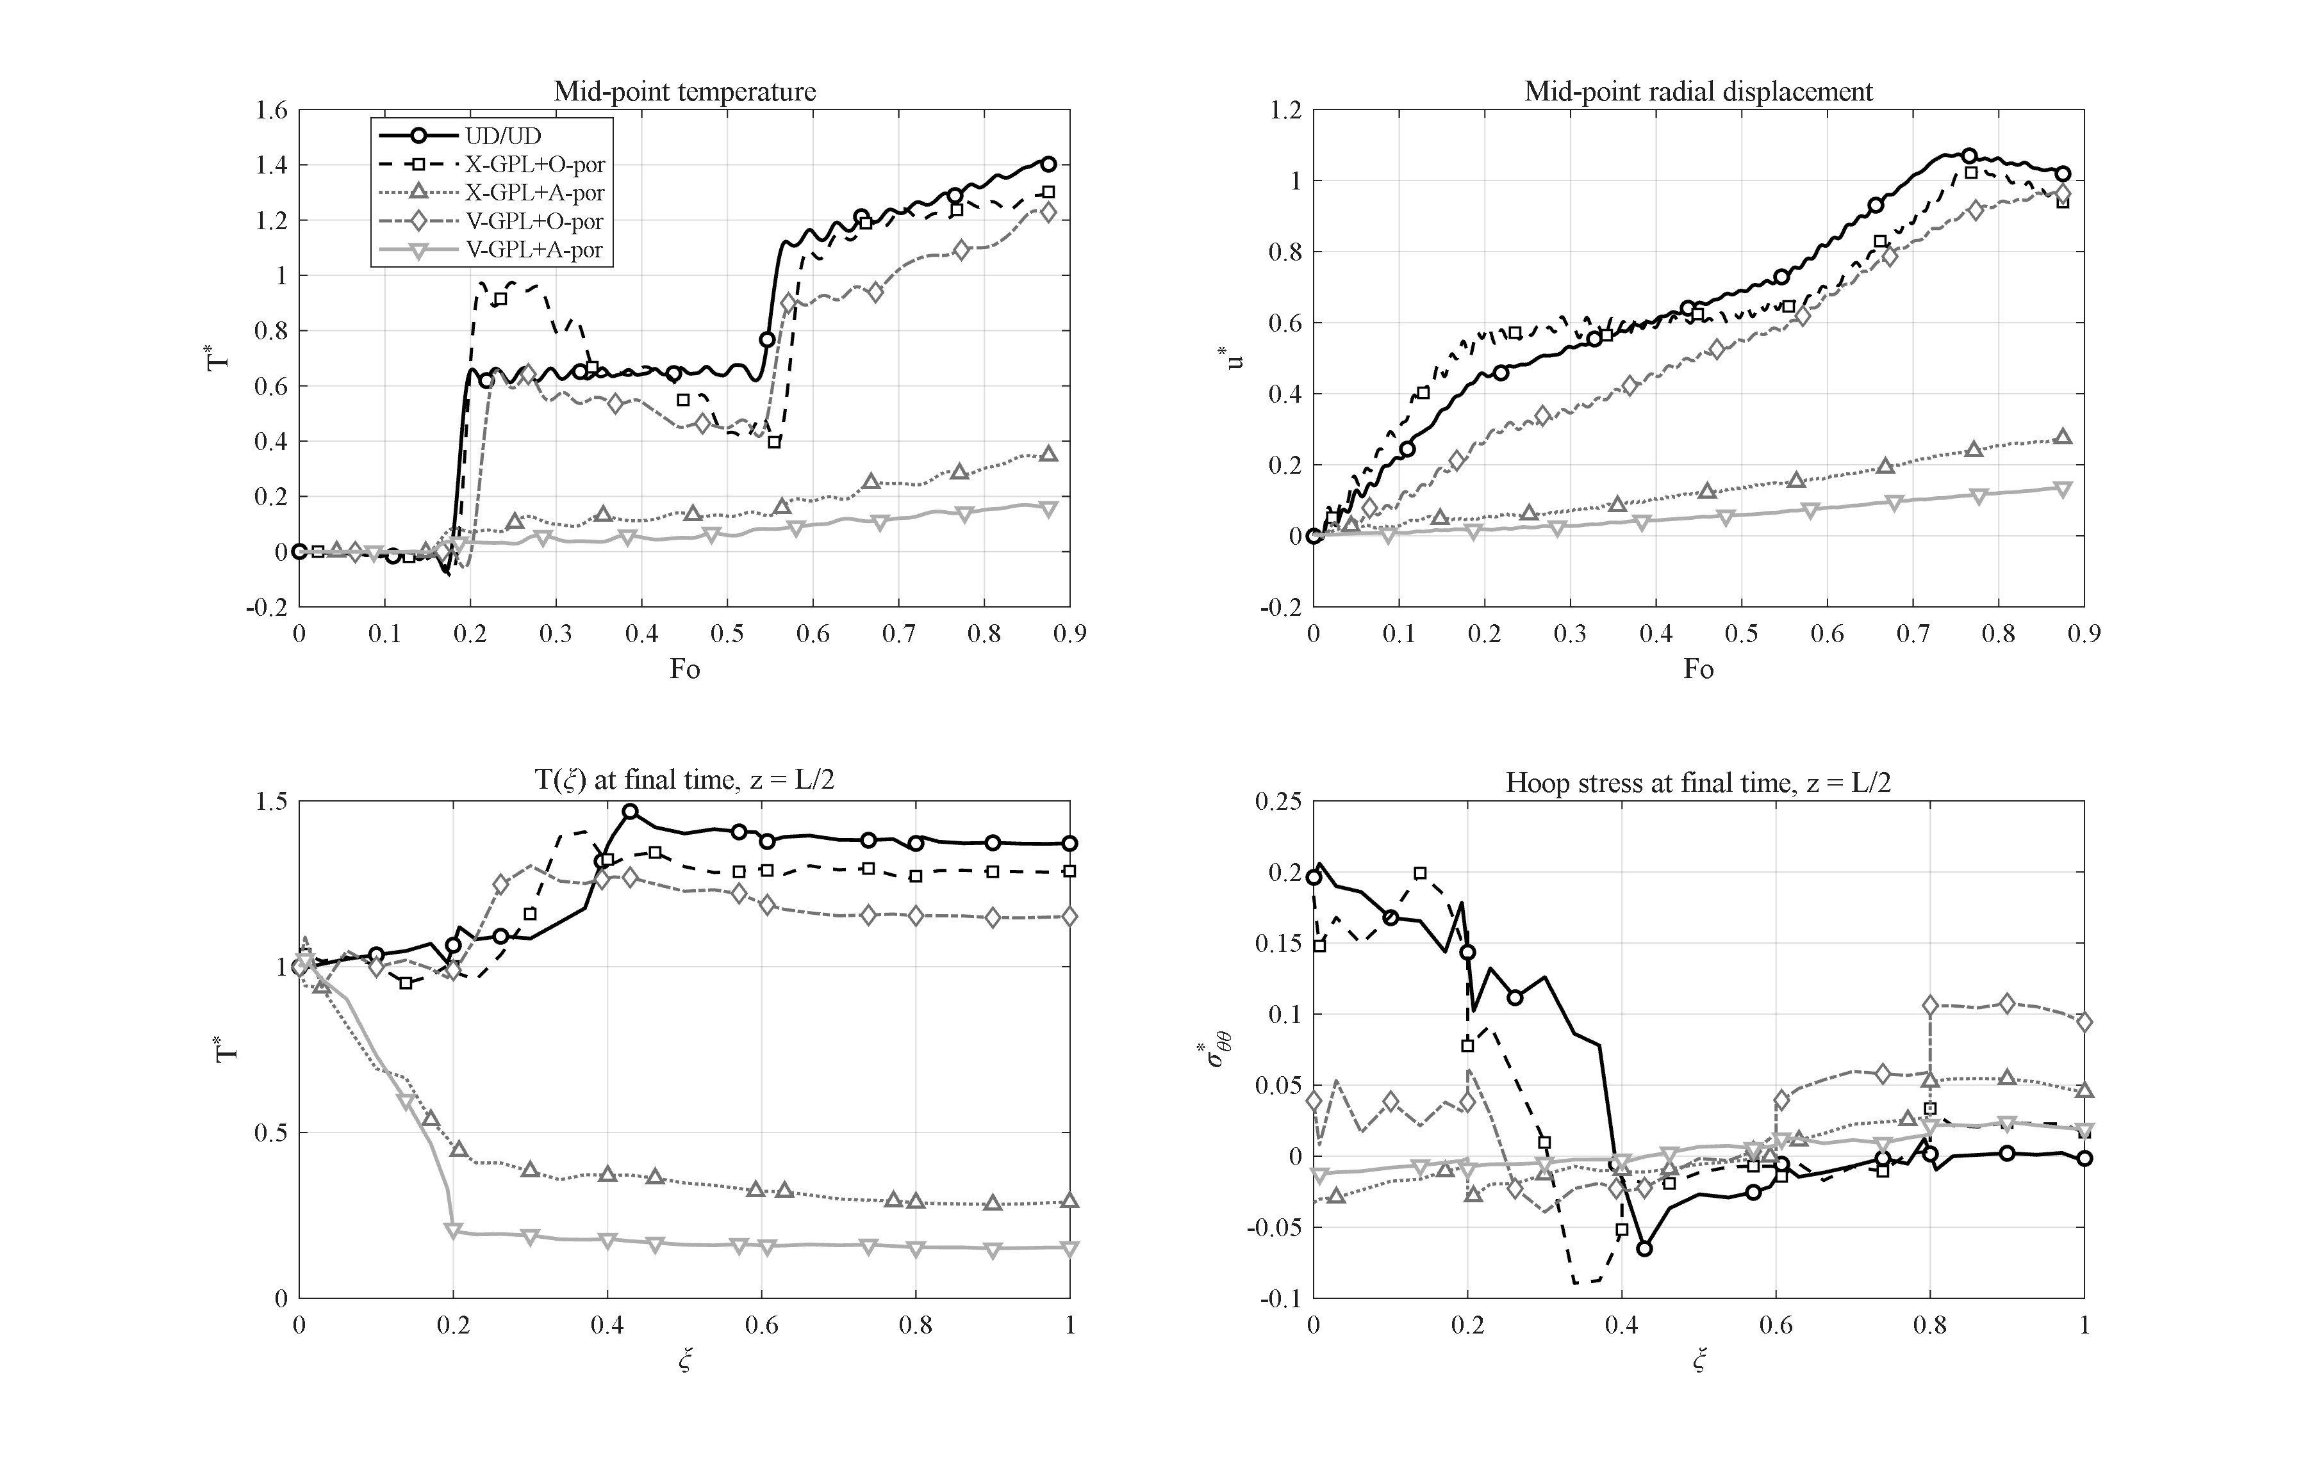
Figure 4-x: Interaction of GPL and porosity patterns (UD/UD, X+O, X+A, V+O, V+A): the V-GPL + A-porosity combination reduces the outer-surface temperature 9-fold — the thermal-protection design of this work.
Combining the best GPL pattern (V, §4.3) with the barrier porosity pattern (A, §4.4) tests whether the two mechanisms cooperate. They do, and the porosity barrier dominates the pairing: with X-GPL the switch of porosity from O to A drops the mid-point peak from 1.30 to 0.35; with V-GPL from 1.23 to 0.17. The best combination, V-GPL + A-porosity, keeps the outer surface at T* = 0.15 — a 9.0-fold reduction with respect to the base case (1.37) — while its stress state remains benign (|σ*_θθ| ≤ 0.024). This combination — conductive GPLs facing the heat source, insulating pores facing the environment — is the design recommendation of this thesis for thermal protection, and the interaction study that identifies it has no counterpart in the reference works.

4.10 Effect of the thermo-mechanical coupling (study I)
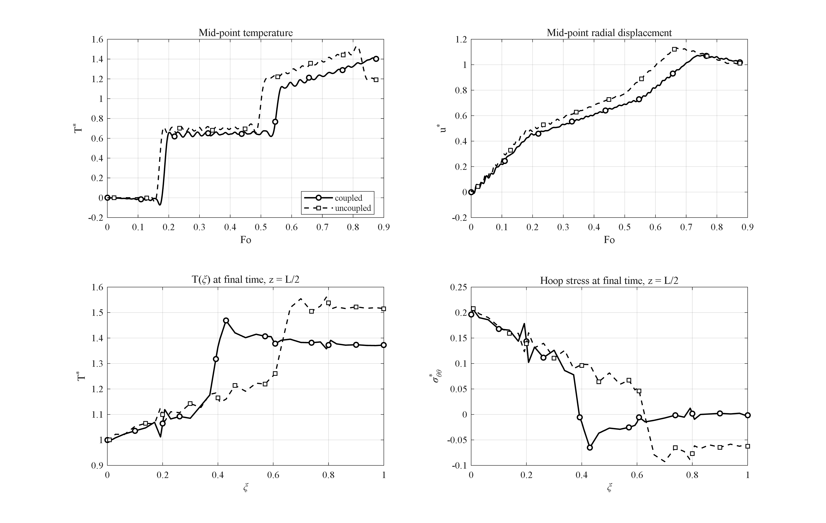
Figure 4-x: Effect of the thermo-mechanical coupling: the uncoupled model overestimates the temperature peak by 8.4 % (missing thermoelastic damping of the wave).
Deactivating the coupling term (the dilatation-rate source in the energy equation) leaves a pure conduction problem driving an elastic one. The uncoupled model overestimates the temperature peak by 8.4 % (T*_max = 1.53 vs 1.41) and the displacement peak by 5.5 %, because coupling continuously converts part of the thermal energy into mechanical work — thermoelastic damping of the thermal wave. The difference is largest exactly at the wave fronts, i.e. in the quantities a short-time analysis cares about, which justifies carrying the fully coupled system despite its cost.

4.11 Effect of the outer convection — Biot number (study J)
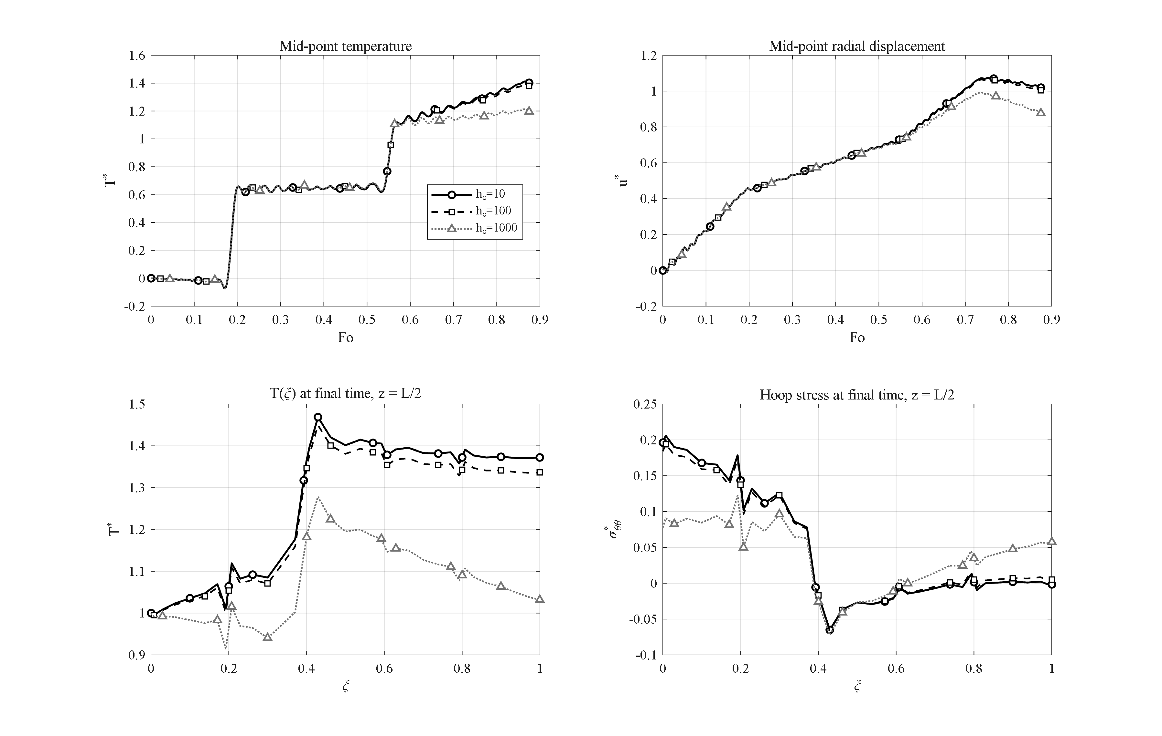
Figure 4-x: Effect of the outer convection coefficient h_c = 10, 100, 1000 W/m²K (Bi ≈ 0.004–0.4) on the transient response.
Increasing h_c from 10 to 100 to 1000 W/m²K (Biot number Bi = h_c h/k̄ from 4×10⁻³ to 0.4) turns the outer surface from nearly adiabatic into an efficient heat sink: the outer-surface final temperature drops from T* = 1.37 to 1.34 to 1.03, the mid-point peak from 1.41 to 1.39 to 1.21, and the final inner hoop stress relaxes from 0.196 to 0.078 as the through-wall temperature difference, not the absolute level, sets the thermal stress. The response is insensitive below Bi ≈ 10⁻² and strongly convection- controlled above Bi ≈ 0.1, bracketing the regimes a designer must distinguish.

4.12 Effect of the wall thickness (study K)
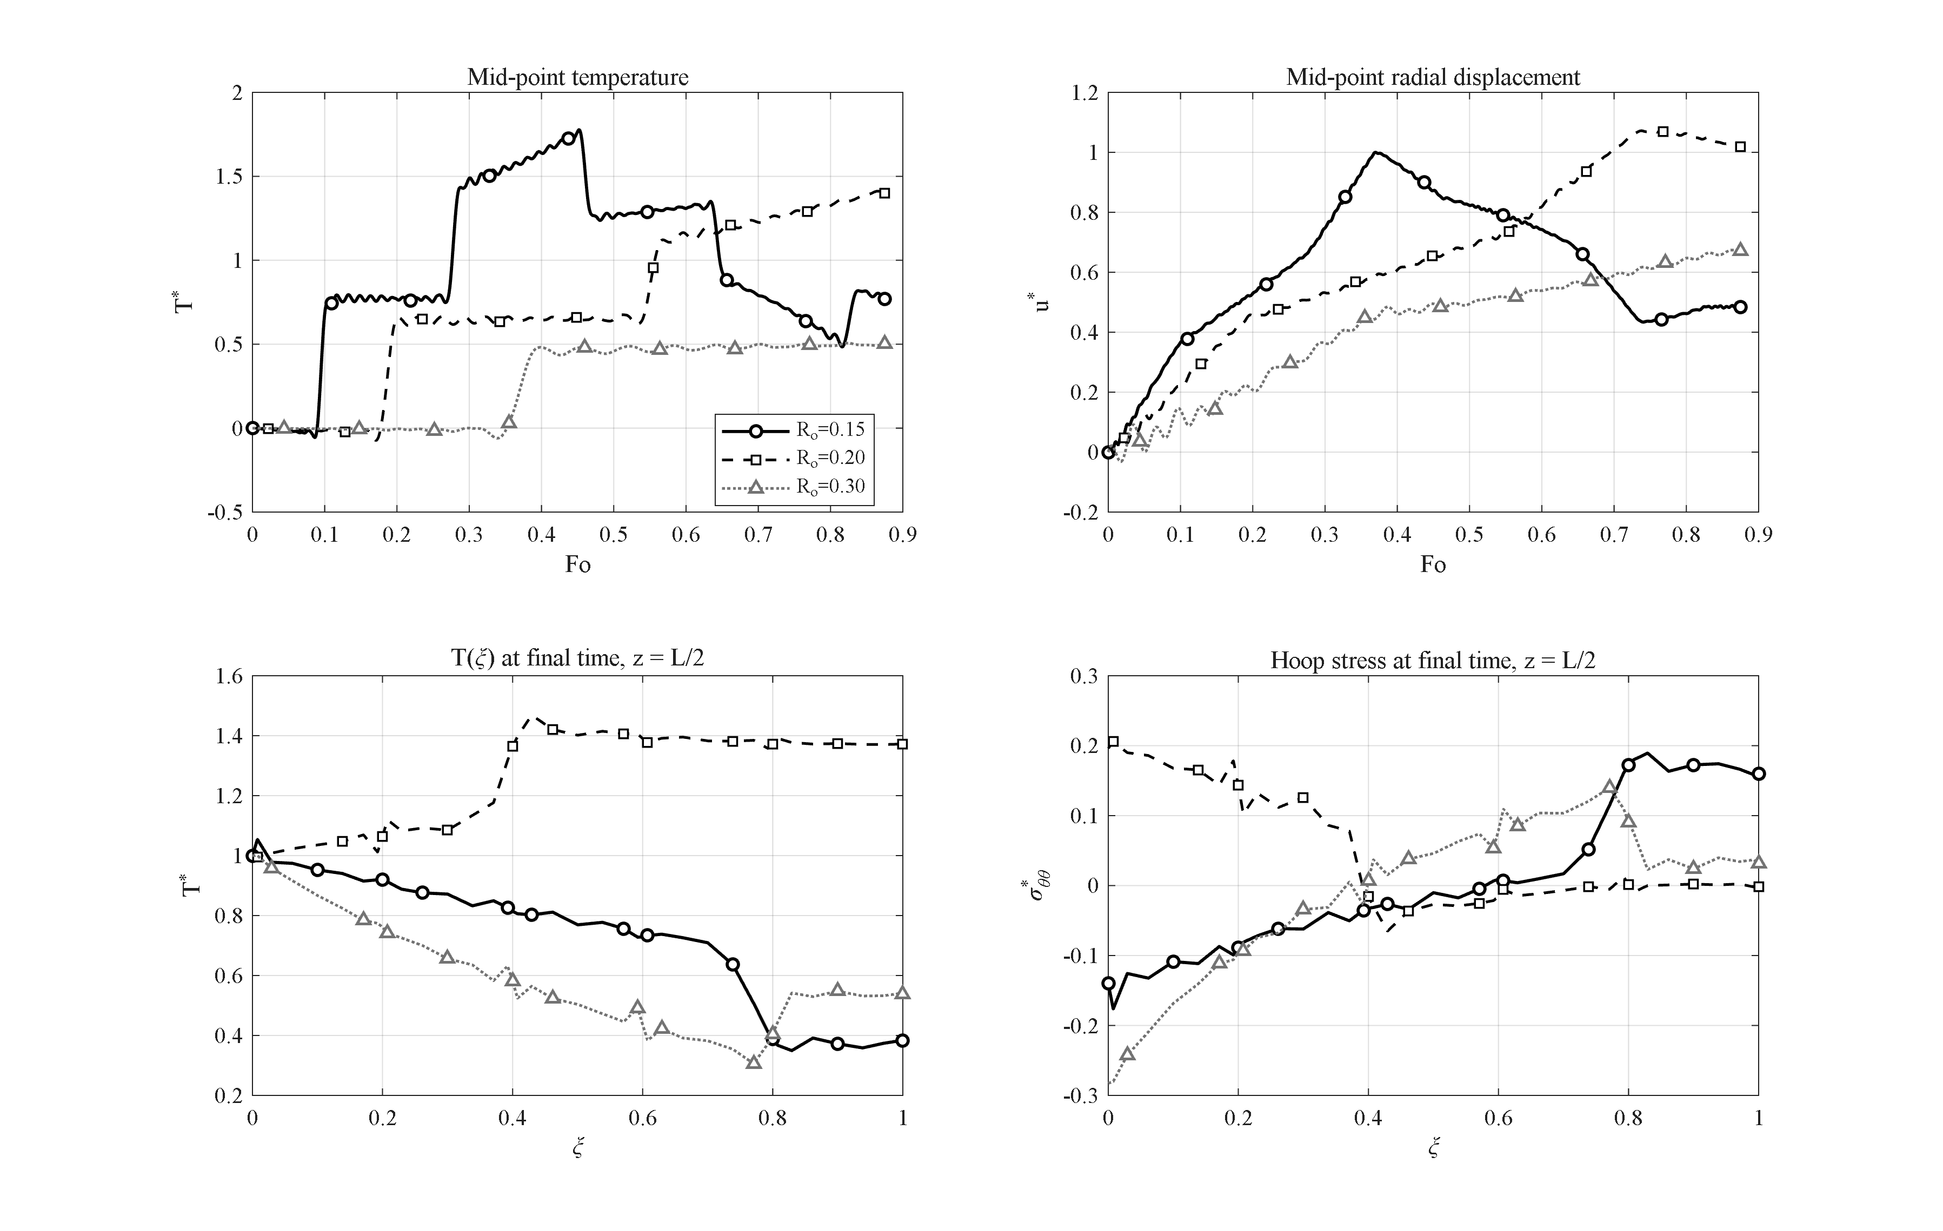
Figure 4-x: Effect of the wall thickness (R_o = 0.15, 0.20, 0.30 m at fixed R_i = 0.1 m): the thin wall maximizes the wave overshoot, the thick wall the compressive inner hoop stress.
With R_i fixed, walls of h = 0.05, 0.10 and 0.20 m are compared (all times scaled with the base R_o = 0.2). The thin wall is crossed quickly and repeatedly by the thermal wave: its mid-point sees the largest overshoot of the whole campaign (T*_max = 1.78 at Fo = 0.45) but also drains fastest (final mid-point 0.77). The thick wall is the opposite: within the window the wave completes less than one crossing (T*_max = 0.51) and the outer region stays cold, while the final inner hoop stress becomes strongly compressive at the inner surface (σ*_θθ,min = −0.28) because the heated inner band pushes against a cold, stiff outer mass. Thickness is thus the geometric knob that trades peak overshoot (thin) against stress severity (thick).

4.13 Effect of the number of layers (study L)
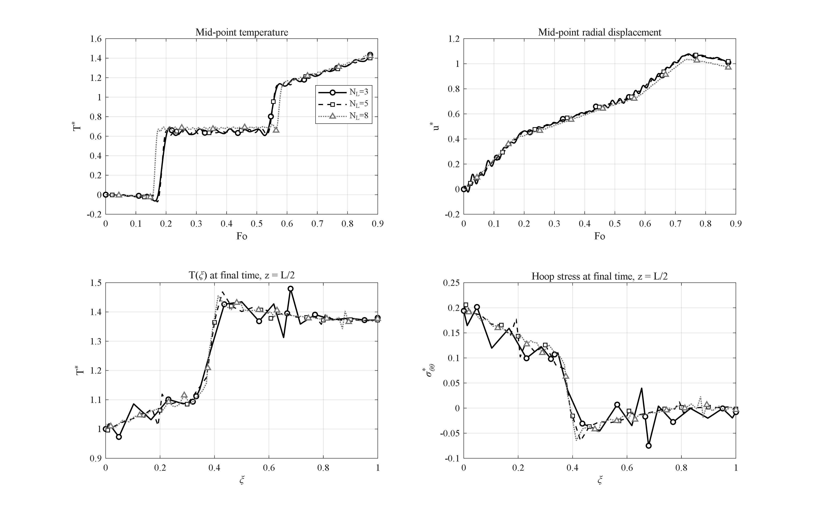
Figure 4-x: Effect of the number of layers N_L = 3, 5, 8: global histories are converged (≤1.6 % change); the layer count refines the interface staircase of the stress profile.
Rebuilding the same graded wall with N_L = 3, 5 and 8 layers changes the mid-point peak by at most 1.6 % (1.435 / 1.412 / 1.428) and leaves the histories visually indistinguishable; the layer count mainly sharpens the staircase of the hoop-stress profile at the interfaces (§4.4 figure, lower right panels). N_L = 5 is retained as the standard compromise between fidelity of the grading and cost, consistent with the convergence study of the validation section.

4.14 Response to a Gaussian thermal shock (study M)
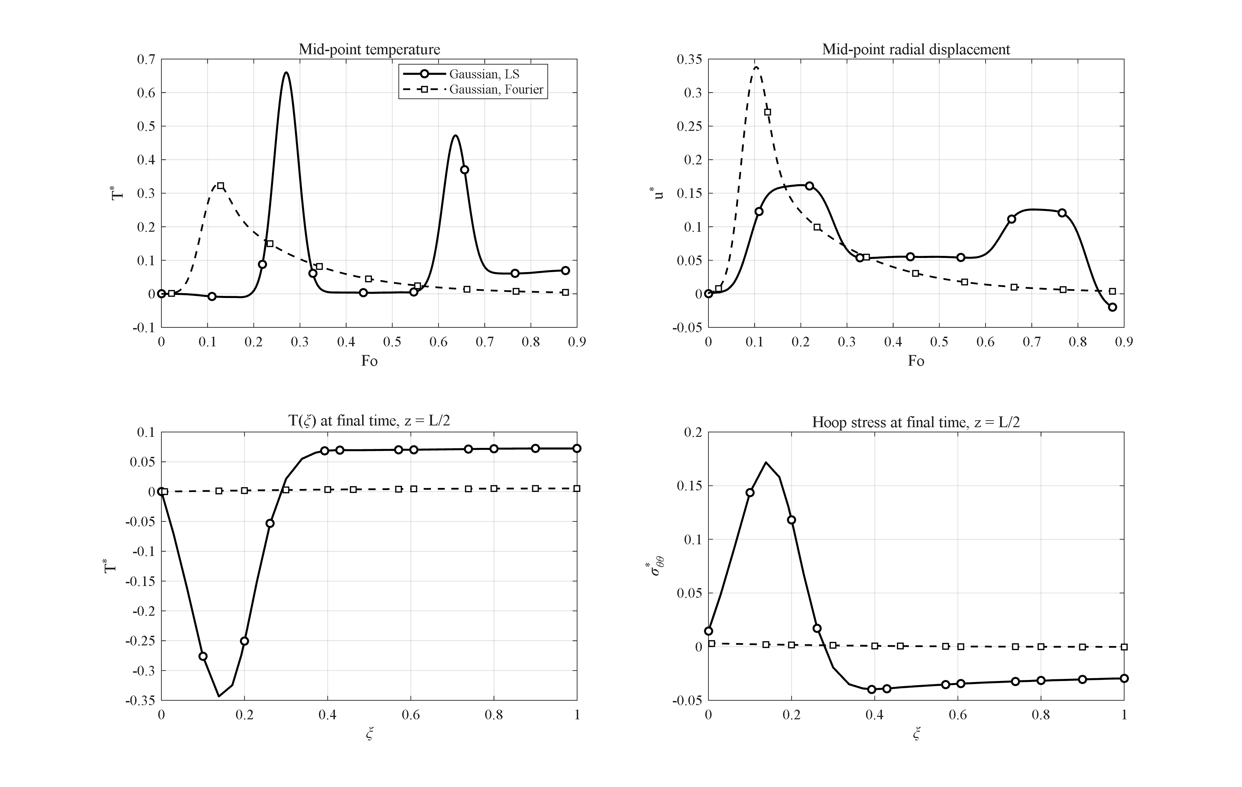
Figure 4-x: Response to a Gaussian thermal pulse under LS and Fourier conduction: the LS wave packet arrives later, twice as strong, with a ~50× larger stress excursion.
Replacing the sustained ramp by a short Gaussian pulse of the inner temperature isolates the difference between wave-like and diffusive transport. Under Fourier conduction the pulse arrives at mid- thickness smeared and weak (T*_max = 0.33 at Fo = 0.12) and is essentially gone by the end (T* = 0.004). Under Lord–Shulman the pulse travels as a coherent wave packet: it arrives later (Fo = 0.27), twice as strong (T*_max = 0.66), and leaves behind persistent oscillations (final T* = 0.070). The stress response differs even more: the LS hoop-stress excursion (σ*: −0.040 … +0.172) is roughly 50 times the Fourier one — under impulsive loads the classical theory underestimates the mechanical consequences of the shock by more than an order of magnitude, the strongest single argument in this thesis for the generalized theory.

4.15 Extension — comparison of time-integration methods (T1)
To place the Newmark scheme of this thesis, five alternative integrators were run on the identical semi-discrete conduction benchmark (exact solution known; error = max temperature error at t = 10 s):
Table 4.15 — Time integrators on the same spatial system.
method | max error (K) | CPU (s)
Newmark (δ=½, β=¼) | 0.0032 | 0.33
Wilson-θ (θ=1.4) | 0.0164 | 0.19
Houbolt | 0.0025 | 0.24
HHT-α (α=−0.1) | 0.0033 | 0.29
ode15s (adaptive BDF) | 0.0003 | 2.57
Laplace–Durbin (thermal subsystem) | 0.137 | 193

Newmark, Houbolt and HHT-α are equivalent in accuracy at equal step; Wilson-θ trades a 5× larger error for its extra dissipation; the adaptive stiff solver is 10× more accurate but 8× more expensive; and the Laplace-transform route is three orders of magnitude slower while being *inapplicable to the full coupled system* — the undamped elastic poles of the coupled operator lie on the inversion contour, which is why the literature applies transform methods to thermal subsystems only. This measured comparison motivates the choice of Newmark for all production runs.

4.16 Extension — comparison of spatial discretizations (T2)
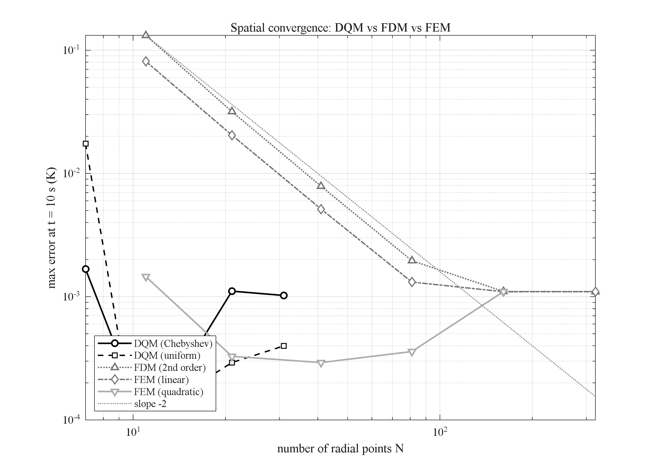
Figure 4-x: Spatial convergence of DQM (Chebyshev/uniform), FDM (2nd order) and FEM (linear/quadratic) on the transient-conduction benchmark: points needed to reach the time-step error floor: N ≈ 9–11 (DQM), 21 (FEM-quad), 161 (FEM-lin/FDM).
On a transient conduction problem with exact Bessel-series solution, four discretizations were driven to the time-step error floor with identical Newmark marching. The number of radial points needed to reach that floor is: DQM (Chebyshev or uniform) N ≈ 9–11; quadratic FEM N ≈ 21; linear FEM and 2nd-order FDM N ≈ 161. The linear-FEM and FDM curves coincide at slope −2, quadratic (Bubnov–Galerkin, consistent matrices) FEM gains roughly one order per refinement step, and the DQM error falls quasi-exponentially until the temporal floor. At equal accuracy the DQM system is 15× smaller in one dimension — squared in the (r,z) plane — which is the quantitative justification of the layerwise-DQM choice of this thesis.

4.17 Extension — comparison of thermoelasticity theories (T3)
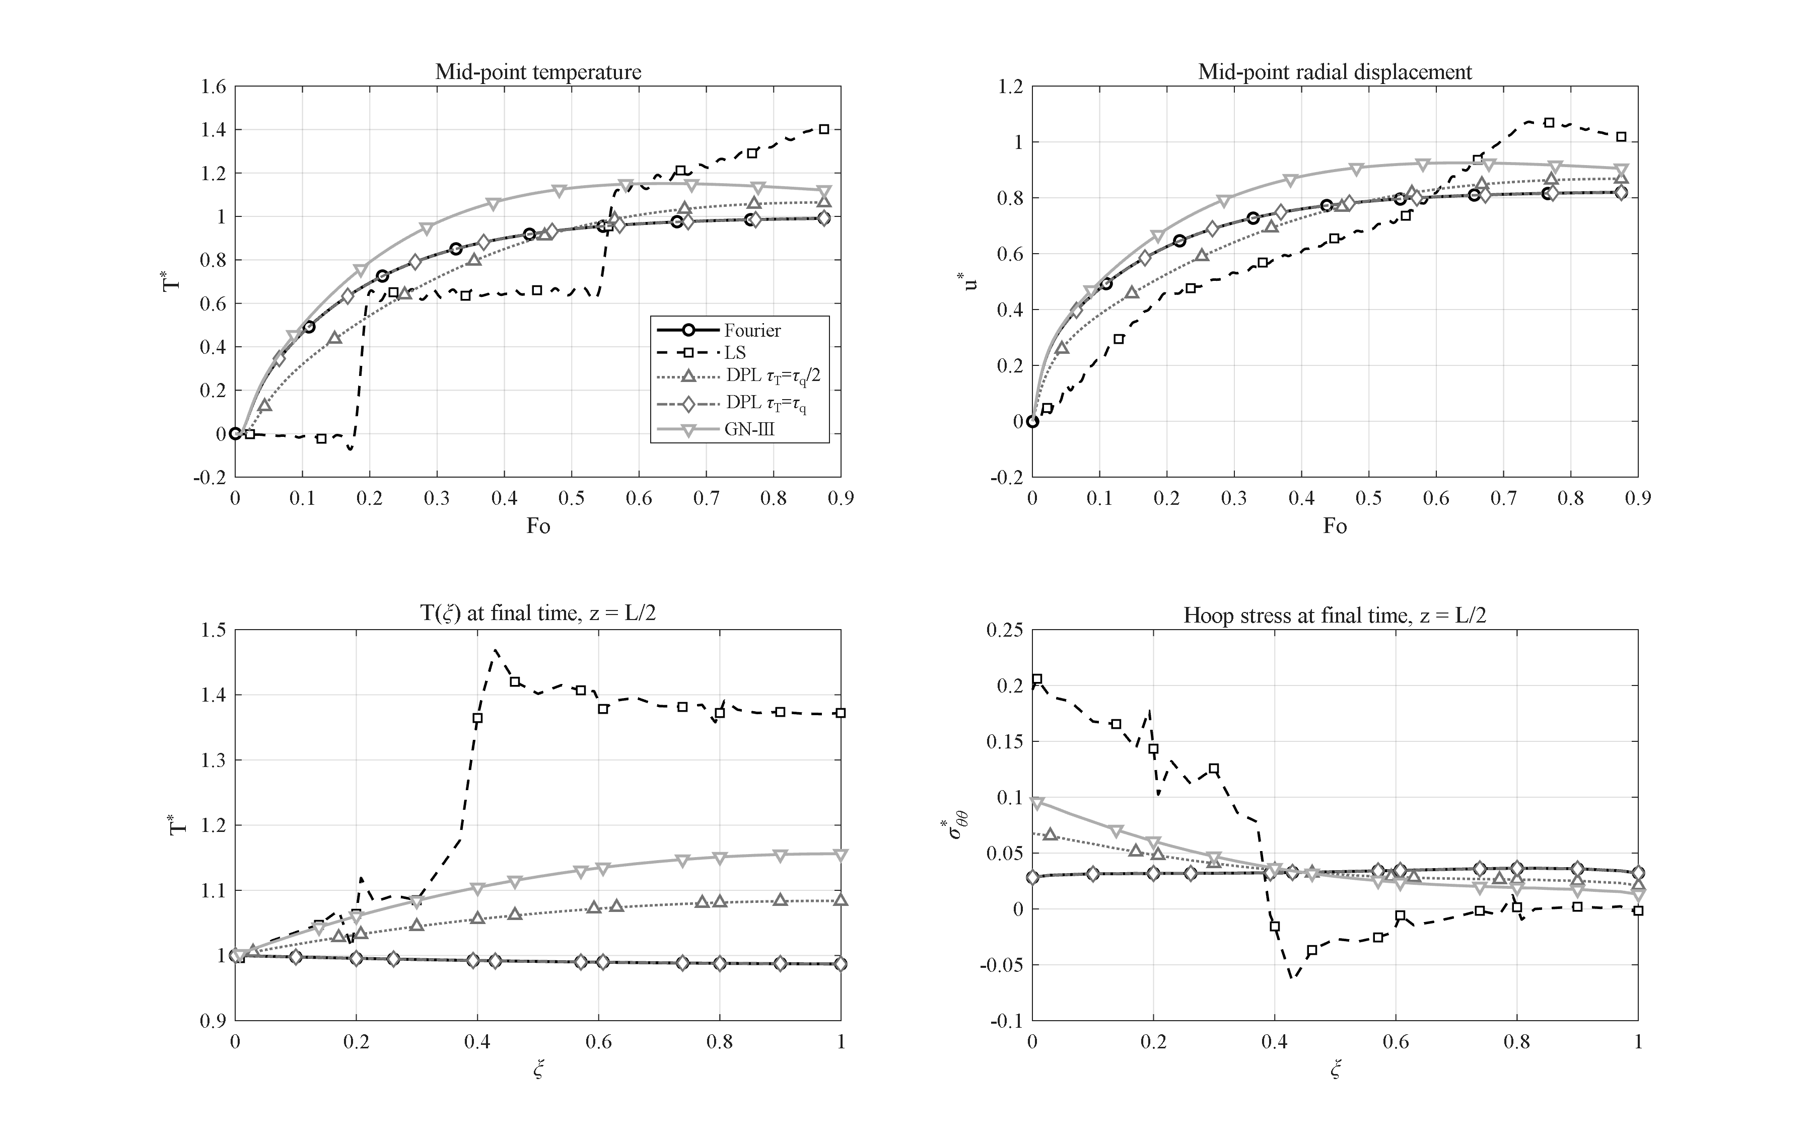
Figure 4-x: Comparison of thermoelasticity theories (Fourier, LS, DPL τ_T = τ_q/2, DPL τ_T = τ_q, GN-III) with matched parameters: DPL(τ_T=τ_q) collapses onto Fourier; GN-III shows a persistent overshoot; LS carries the strongest wave.
The same base problem was solved under four theories with matched parameters (DPL with τ_q = τ0; GN-III with k* = k/τ0 so that its wave speed equals the LS one). The peak mid-point temperatures order as: Fourier 0.991 = DPL(τ_T=τ_q) 0.991 < DPL(τ_T=τ_q/2) 1.065 < GN-III 1.151 < LS 1.412. Two observations carry the section: (i) for τ_T = τ_q the DPL solution collapses onto Fourier to nine significant digits — the numerical confirmation of the known analytical degeneracy — so DPL is meaningful only with τ_T < τ_q, interpolating between Fourier and LS; (ii) GN-III shows an earlier, weaker front (arrival Fo ≈ 0.64 at the peak) and a *persistent* overshoot (T* = 1.12 at t_end) because its energy equation lacks the damping k∇²θ̇-term's dissipation of the wave — qualitatively different long-time behavior. For the porous GPL-reinforced cylinder such a four-theory map does not exist in the literature and constitutes one of the contributions of this work.

4.18 Summary of the chapter
1. The LS thermal wave produces mid-wall temperature overshoot up to T* = 1.41 (base) and 1.78 (thin wall) — impossible under Fourier conduction and decisive for short-time design.
2. Placing GPLs at the heated surface (V) and pores at the cooled surface (A) is synergetic: outer temperature reduced 9.0-fold at benign stress levels — the design recommendation of this thesis.
3. A percolation threshold near W_GPL ≈ 1 % switches the wall from insulator to conductor; further GPL mainly raises thermal stresses.
4. Full coupling damps the thermal wave (−8 % peak); uncoupled models are non-conservative exactly at the fronts.
5. Pressure of engineering magnitude is a second-order effect against β̄ΔT.
6. Clamped ends convert blocked axial expansion into +35 % mid-span radial displacement; support effects stay end-localized.
7. Under impulsive (Gaussian) heating the classical theory underestimates the stress response by a factor ≈ 50.
8. Methodological: Newmark is the best accuracy/cost integrator of the six tested; DQM needs ~15× fewer points per direction than FDM/linear FEM; the four-theory comparison (Fourier/LS/DPL/GN-III) maps where the theories diverge for this class of structures.

