Chapter 4: Research Findings

4-1. Introduction
This chapter presents and discusses the numerical findings for the multilayer porous GPL-reinforced hollow cylinder under thermo-mechanical loading, based on the governing equations and the solution method of Chapter 3. First the reference problem and the dimensionless quantities are introduced; then the numerical convergence of the solution and its verification — treated as two independent topics — are established through separate tests. The main parametric studies follow: the GPL distribution pattern; the porosity pattern and level; the GPL weight fraction; the platelet aspect ratios (length-to-width a/b and width-to-thickness b/t); the relaxation time; the end supports; the internal pressure; the cylinder length; the full interaction matrix of the GPL and porosity patterns; the coupling of the equations; the convection coefficient; the wall thickness; and a Gaussian thermal shock. Finally, three extension studies that go beyond comparable previous works [6] — a comparison of time-integration methods, a comparison of spatial-discretization methods, and a comparison of generalized thermoelasticity theories — are reported, and the chapter is summarized.

4-2. Reference problem and dimensionless quantities
The problem under study is a thick-walled hollow cylinder with inner radius R_i = 1.0 m and outer radius R_o = 1.5 m (radius ratio R_o/R_i = 1.5, wall thickness h = 0.5 m), length L = 2.1 m, built from N_L = 7 layers. In the reference case the GPL distribution across the thickness is uniform (UD) with total weight fraction W_GPL = 0.3 %, the porosity distribution is uniform (UD) with mass coefficient e_m3 = 0.8604, and the Lord-Shulman theory [4] with dimensionless relaxation time τ* = 0.15 is used in fully coupled form with both ends simply supported (S). The loading is as follows: the inner-surface temperature rises from the initial 300 K to 600 K according to the smooth ramp T_in(t) = 300 + 300(1 − e^(−t/t0)) with time constant t0 = 2 s, while an internal pressure P_i = 50 MPa acts on the inner surface; the outer surface exchanges heat with the 300 K environment through the convection coefficient h_c = 10 W/m²K. The discretization uses N_r = 15 points per layer and N_z = 11 axial points (layerwise differential quadrature, Chapter 3) with the time step Δt = 1 s up to 3000 s. The Newmark parameters are δ = 1/2 and β = 1/4 (no numerical damping); accordingly, the small oscillations visible behind sharp wave fronts are the well-known Gibbs effect of the spectral discretization and are left unfiltered so that the results are reported without manipulation.
For generality all results are presented in dimensionless form, following the convention of reference [69] (Heydarpour et al.). The reference thermal diffusivity of the homogenized reference material is α̂ = k̄/(ρ̄c̄) = 8.97×10⁻⁵ m²/s, and the length scale is the wall thickness h = R_o − R_i, not the outer radius; the definitions are collected in Table 4-1. With this scaling one thermal-diffusion time across the wall, h²/α̂ ≈ 2787 s, corresponds to Fo = 1, and the 3000 s window spans Fo ≈ 1.08. The Lord-Shulman thermal-wave speed of the reference material is v = √(α̂/τ0) = 4.63×10⁻⁴ m/s; crossing the full wall thickness therefore takes about 1080 s, i.e. Fo ≈ 0.39, which equals √τ* as the hyperbolic theory requires — and, as will be seen, this is exactly where the first wave arrival appears in the time histories.
Table 4-1: Dimensionless quantities used in this chapter.
quantity | definition | value/range
Fourier number (dimensionless time) | Fo = α̂ t / h² | Fo(3000 s) = 1.08
dimensionless relaxation time | τ* = α̂ τ0 / h² | 0.15 (reference; τ0 = 418 s)
dimensionless temperature | T* = (T − T∞)/T∞ | 0 … ≈1
dimensionless radial coordinate | ξ = (r − R_i)/h | 0 … 1
dimensionless radial displacement | U* = u /[(1 − ν) α T∞ h] | O(1)
dimensionless stress | Σ* = (1 + ν) σ /(E α T∞) | O(1)
Here ν, α and E are the reference-material Poisson ratio, thermal-expansion coefficient and Young modulus (ν = 0.340, α = 5.98×10⁻⁵ K⁻¹, E = 4.43 GPa for the reference porous UD composite). Because the inner-surface temperature is raised to twice the ambient value (T_in = 2 T∞), the inner boundary corresponds to T* = 1, so any excursion above unity in the temperature field is a genuine overshoot produced by the reflected thermal wave.

4-3. Numerical convergence
Before the results are verified, the numerical convergence of the solution is examined independently in each discretization direction — the radial nodes per layer N_r, the axial nodes N_z, the number of layers N_L, and the time step Δt. The convergence measure is the dimensionless hoop stress, reported as both the inner-surface value and the relative L₂ error of the whole mid-plane radial profile against the finest mesh. For each spatial direction the profile overlays are shown as a figure and the error and cost are collected in a table.

4-3-1. Radial nodes (N_r)
4-1
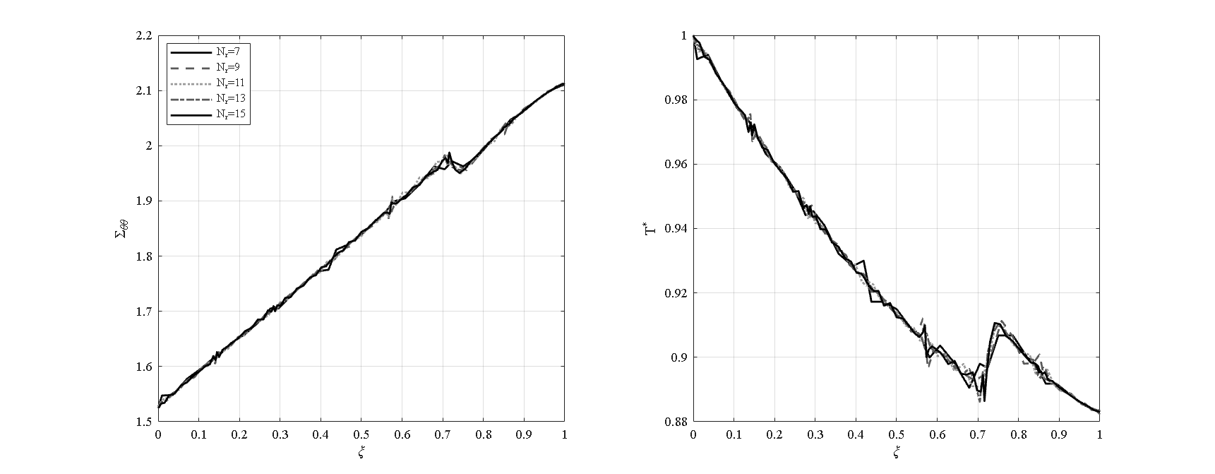
Figure 4-1: Radial-node convergence — hoop-stress and temperature profiles for N_r = 7…15 [N_z=11, N_L=7, W_GPL=0.3%, e_m3=0.8604, τ*=0.15, P_i=50 MPa, simply supported]
Figure 4-1 shows the hoop-stress and temperature profiles for N_r = 7 … 15 (with N_z = 11, N_L = 7); the curves are visually indistinguishable. As Table 4-2 shows, the inner-surface hoop stress stays within 0.09 % and the L₂ profile error below 0.29 % over the whole range, so the field quantities are converged from as few as seven radial points — the hallmark of the spectral (Chebyshev) differential quadrature discretization. N_r = 15 is nevertheless adopted for the production runs because it renders the sharp, moving second-sound front in the temperature profiles cleanly, without the localized oscillation a coarser mesh leaves when the front sits between two nodes; this does not change any integral quantity.
Table 4-2: Radial-node convergence (N_z = 11, N_L = 7).
N_r | Σθθ (inner) | L₂ error (%) | N_dof
7 | 1.5251 | 0.28 | 1617
9 | 1.5256 | 0.23 | 2079
11 | 1.5256 | 0.24 | 2541
13 | 1.5264 | 0.16 | 3003
15 | 1.5264 | ref | 3465

4-3-2. Axial nodes (N_z)
4-2
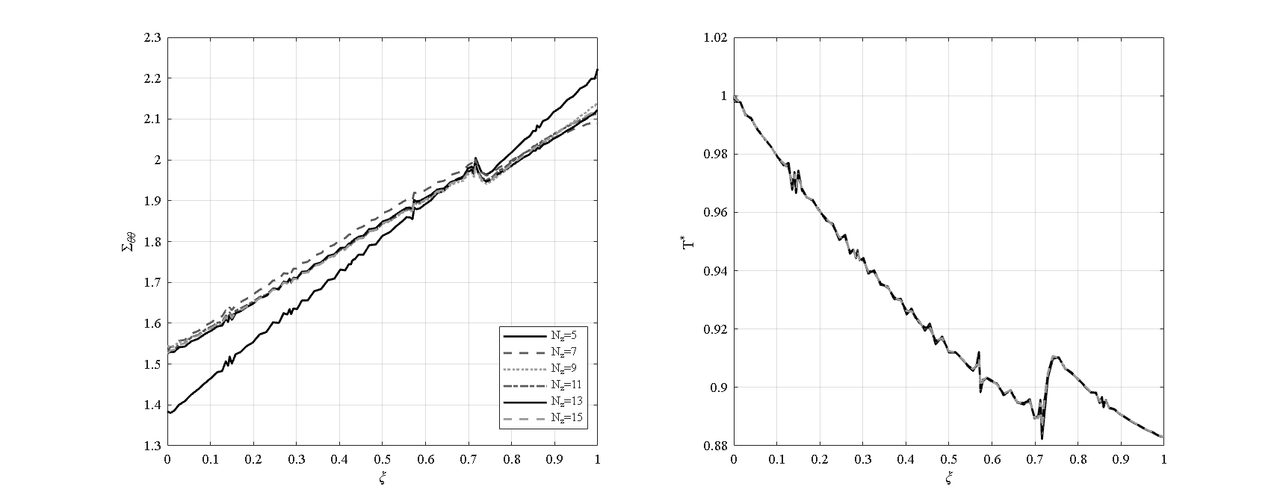
Figure 4-2: Axial-node convergence — profiles for N_z = 5…15 [N_r=15, N_L=7, W_GPL=0.3%, e_m3=0.8604, τ*=0.15, P_i=50 MPa, simply supported]
The axial direction (Figure 4-2) governs the mesh. With only five axial points the inner-surface hoop stress is in error by 9.4 %, because the simply-supported end layer is left unresolved; the error then settles below about 1 % from nine points onward (Table 4-3). The convergence is non-monotonic — the oscillatory envelope typical of spectral methods — but is clearly settled by nine points, and eleven points give an L₂ error of 0.16 %. Eleven axial points are adopted. This direction is also the most expensive: the single-core solve time grows roughly as N_z^2.6 (Table 4-3), because each added axial point multiplies the entire through-thickness system. The axial direction is therefore the binding one — both the least accurate per node and the steepest in cost.
Table 4-3: Axial-node convergence and cost (N_r = 15, N_L = 7).
N_z | Σθθ (inner) | L₂ error (%) | solve time (s)
5 | 1.3844 | 3.92 | 90
7 | 1.5333 | 1.07 | 198
9 | 1.5434 | 0.23 | 349
11 | 1.5264 | 0.16 | —
13 | 1.5274 | 0.27 | 987
15 | 1.5278 | ref | 1630

4-3-3. Number of layers (N_L)
4-3
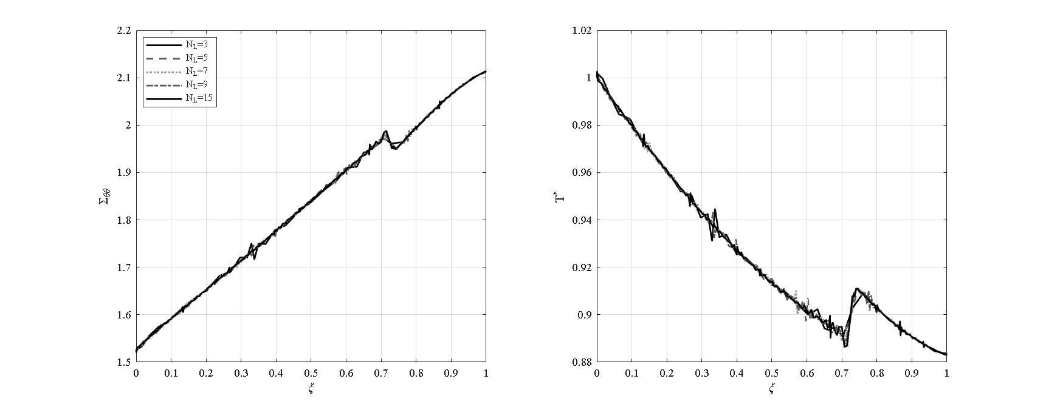
Figure 4-3: Layer convergence — profiles for N_L = 3…15 [N_r=15, N_z=11, W_GPL=0.3%, e_m3=0.8604, τ*=0.15, P_i=50 MPa, simply supported]
Figure 4-3 shows the profiles for N_L = 3 … 15 (N_r = 15, N_z = 11). The inner-surface hoop stress varies by less than 0.05 % and the L₂ error stays below 0.26 % (Table 4-4); the field quantities are essentially layer-independent from three layers. The only effect of more layers is a finer staircase in the hoop-stress profile at the interfaces — the natural signature of the layerwise property model. Seven layers are adopted, matching the seven-layer graded build of the reference cylinder.
Table 4-4: Layer convergence (N_r = 15, N_z = 11).
N_L | Σθθ (inner) | L₂ error (%) | N_dof
3 | 1.5261 | 0.26 | 1485
5 | 1.5257 | 0.21 | 2475
7 | 1.5264 | 0.16 | 3465
9 | 1.5264 | 0.14 | 4455
15 | 1.5265 | ref | 7425

4-3-4. Time step (Δt)
The time step is converged for Δt ≤ 2 s; at Δt = 5 s a spurious 3 % overshoot appears in the peak temperature as the Newmark integrator under-resolves the sharp thermal front (Table 4-5). Δt = 1 s is adopted, which resolves the shock with a comfortable margin.
Table 4-5: Time-step convergence (N_r = 15, N_z = 11, N_L = 7).
Δt (s) | time steps | L₂ error (%) | note
0.5 | 6000 | ref | —
1 | 3000 | 0.17 | adopted
2 | 1500 | 0.25 | —
5 | 600 | 0.64 | 3 % peak overshoot
Overall, the adopted production mesh (N_r = 15, N_z = 11, N_L = 7, Δt = 1 s) delivers the field quantities to better than 0.2 %: the radial and layer directions are effectively free, while the axial direction is the binding and most expensive one. The superiority of the differential-quadrature discretization over the finite difference and finite element methods, in points required per direction, is taken up separately in Section 4-19.

4-4. Verification
The present numerical solution is verified through five independent checks against exact analytical solutions, published results from the literature, and a commercial finite-element solution. In each check, besides the quantitative error, the present result is plotted as a comparison diagram against the corresponding reference so that the coincidence of the curves is shown visually; these diagrams are collected in the verification appendix. First, the assembly of the static matrices is checked against an independent static solver, with a maximum displacement-field difference of order 2×10⁻¹¹, confirming the numerical equivalence of the two implementations and the correctness of the system assembly.
In the second check, the dynamic-mechanical part of the problem is compared with the results of Malekzadeh (Table 6 of reference [31], IJPVP 2012) and with an independent ANSYS finite-element solution; the dimensionless radial displacement is reproduced with a relative difference of 0.1 to 0.2 percent, and the dimensionless inner-surface radial stress is obtained exactly as the negative of the applied pressure, in full agreement with the loading boundary condition.
In the third check, the transient heat-conduction problem is compared with the exact Bessel-series solution; the dimensionless temperature distribution at various times lies on the exact curve, with a relative error of 10⁻⁵ to 10⁻⁷. In the fourth check, the Newmark time integration is validated against MATLAB’s reference solver ode15s, and the maximum temperature difference over the whole interval is 0.003 K, confirming the stability and accuracy of the adopted time-integration scheme. Finally, in the fifth check, the wave-propagation behavior of the coupled Lord-Shulman theory is compared qualitatively with the results of Bagri and Eslami (2007, reference [7]); both wave speeds (elastic and thermal) and the reflection times within the cylinder wall are correctly reproduced. Taken together, these five checks confirm the validity of the present solution in both the static and the transient regimes and in the coupled and uncoupled cases. A summary is given in Table 4-6.
The two checks that compare against published or exact references are shown below — the mechanical response against Malekzadeh & Heydarpour and ANSYS, the transient conduction against the exact Bessel-series solution — with the present curves coinciding with the references in both cases.
4-4
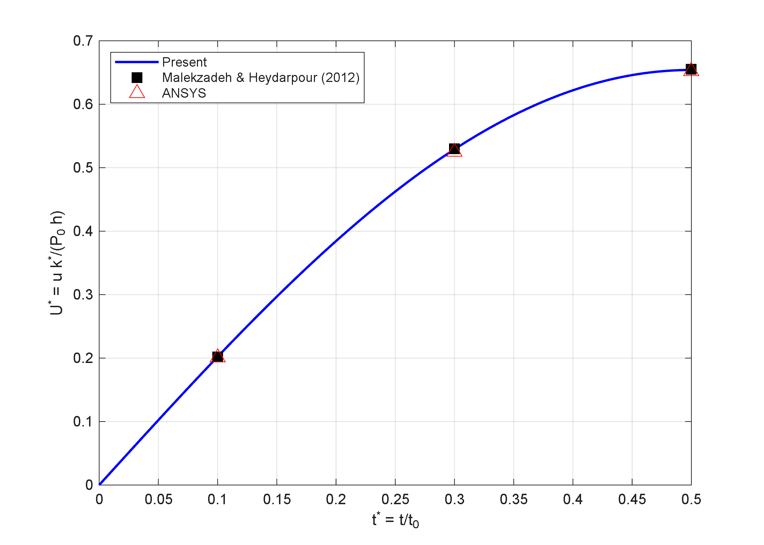
Figure 4-4: Verification (mechanical) — inner-surface dimensionless radial displacement of the present solver against Malekzadeh & Heydarpour (2012) and an independent ANSYS solution [thick cylinder under internal pressure step]
4-5
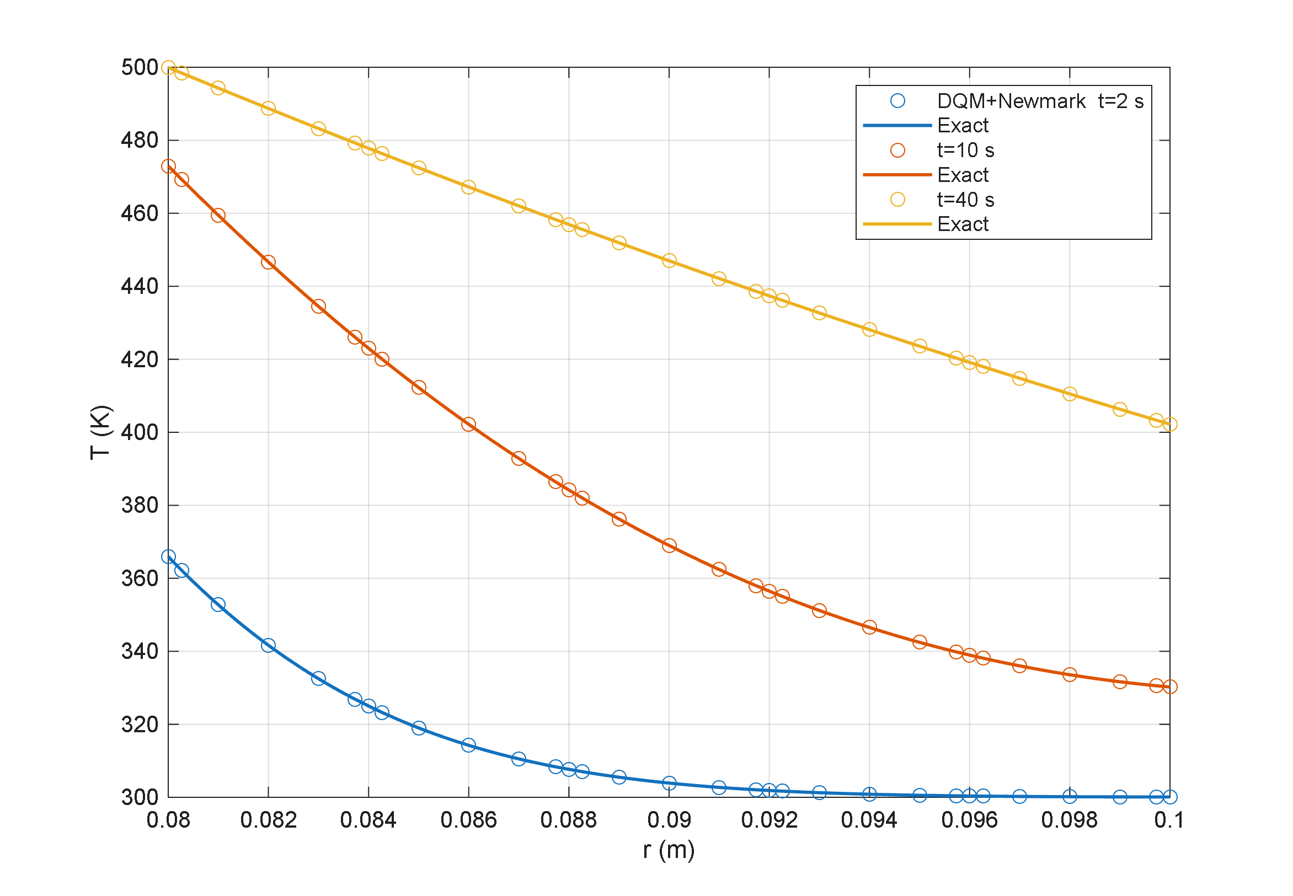
Figure 4-5: Verification (thermal) — transient temperature profiles of the present DQM+Newmark solver against the exact Bessel-series solution at t = 2, 10 and 40 s
Table 4-6: Summary of the solver verification tests.
# | test | reference | result
1 | static spatial assembly | independent static solver | agreement 2×10⁻¹¹
2 | dynamic mechanical response | reference [31] + ANSYS | error 0.1–0.2 %; σ_rr exact
3 | transient conduction | exact Bessel-series solution | rel. error 10⁻⁵–10⁻⁷
4 | time integration | ode15s (independent) | max difference 0.003 K
5 | coupled Lord-Shulman waves | Bagri & Eslami [7] | speeds and reflections matched

4-5. Effect of the GPL distribution pattern
In the first parametric study the effect of five GPL distribution patterns across the thickness (UD, O, X, V and A) is examined with all other parameters held at their reference values. Figure 4-6 shows the time histories of the dimensionless temperature and radial displacement of the mid-thickness point at the mid-length section together with the radial profiles of the temperature and hoop stress at the final time.
4-6
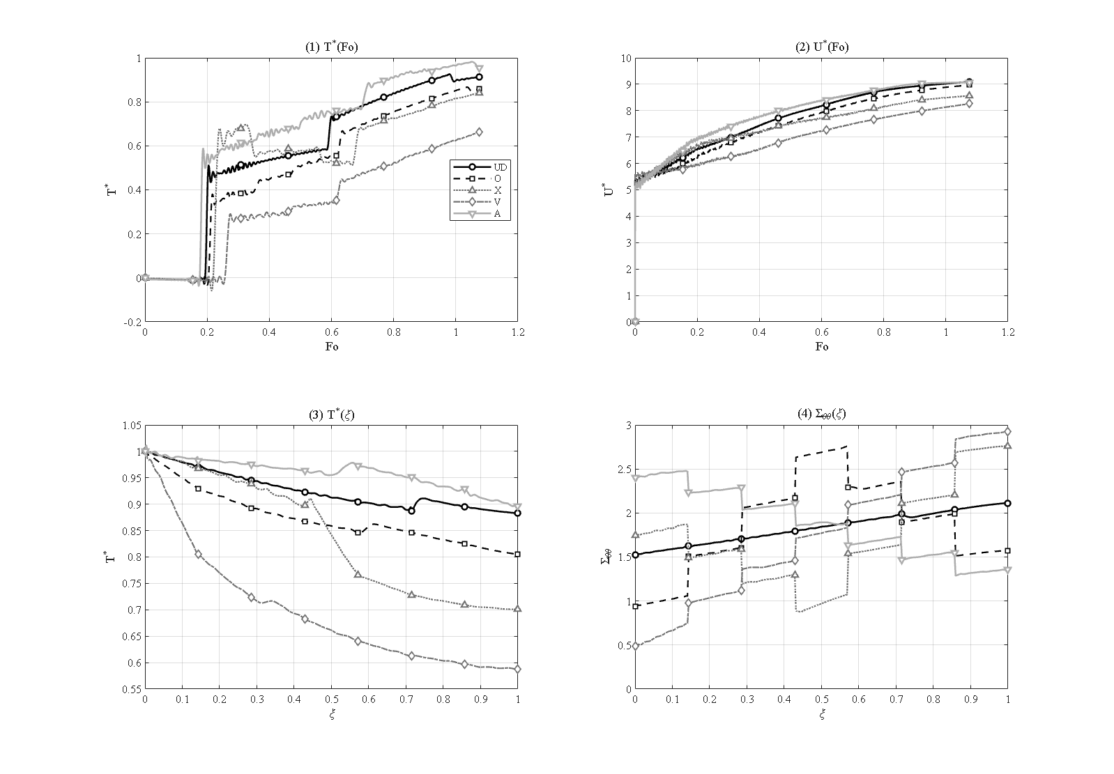
Figure 4-6: Effect of the GPL distribution pattern (UD, O, X, V, A) on the mid-point T* and U* histories and the final T* and Σθθ profiles [R_i=1, R_o=1.5, L=2.1 m, N_L=7, W_GPL=0.3%, e_m3=0.8604, τ*=0.15, P_i=50 MPa, simply supported]
The peak mid-point dimensionless temperature for patterns UD, O, X, V and A is 0.926, 0.867, 0.841, 0.661 and 0.982, respectively. Pattern V, in which the GPLs are concentrated at the heated inner surface, shows the most favorable behavior: the highly conductive inner region spreads the incoming heat rapidly through the thickness, so its peak temperature is about a third lower than that of pattern A. Physically, placing the stiff, conductive phase where the temperature gradient is steepest — at the heated inner wall — both moderates the thermal gradient and reinforces the critical hoop-stress region.
A mirror and inverse behavior emerges between the two asymmetric patterns V and A: geometrically they are mirror images about the mid-thickness (V is GPL-rich at the inner surface, A at the outer surface), and they behave in opposite ways. Pattern V, facing the conductive phase toward the heat source, produces the lowest and mildest peak (0.661), whereas pattern A, by leaving the low-conductivity matrix at the inner surface, traps heat in the inner band and records the highest peak (0.982). The symmetric patterns UD, O and X fall between these extremes, and this mirror ordering explains why V is the best and A the worst.
The same ordering governs the mechanical response. The final inner-surface hoop stress for pattern V is 0.486, about three times smaller than that of UD (1.526) and roughly five times smaller than that of pattern A (2.403); that is, the two ends of the mirror spectrum record the lowest and the highest hoop stress. The peak radial displacement follows the same trend, ranging from 8.26 for V to 9.08 for A. Pattern V therefore simultaneously delivers the lowest temperature, the lowest hoop stress and the smallest displacement, while its mirror pattern A is the worst case in all three; pattern V is recommended for the GPL distribution in cylinders under internal thermal shock.
A feature common to all the hoop-stress profiles is a set of step jumps at the layer interfaces: wherever the layer stiffness changes, Σθθ is genuinely discontinuous, so the graded patterns (O, X, V, A) show a staircase while the uniform UD profile is smooth. These jumps are the physical signature of the piecewise-layered material — not a numerical artifact — and they refine as the layer count grows (Section 4-3). Where a parametric change is severe enough to reverse the sign of the inner-surface hoop stress (as in the porosity-A, high weight-fraction, thick-wall and short-length cases below), that reversal is flagged and explained in the corresponding section.
The temperature profiles carry a related but distinct feature. Superimposed on the smooth decay of T(ξ) is a localized dip-then-overshoot — a small spike — that sits on the layer interfaces in the outer half of the wall, most visibly near ξ ≈ 6/7 ≈ 0.86 at the final observation time, and it recurs in every T(ξ) profile of this chapter. Unlike the hoop-stress steps above, which are static and set by the stiffness jumps, this temperature spike is the spatial trace of the Lord–Shulman second sound. In the generalized (hyperbolic) theory heat does not diffuse instantaneously but travels as a wave of finite speed c_T = √(α̂/τ₀); at any instant the thermal disturbance has advanced only as far as a sharp front — heated behind it, undisturbed ahead of it. That front is a near-discontinuity in temperature, exactly the signature that separates the generalized theory from classical Fourier conduction, which would give a smooth, monotone profile with no front at all. As the front sweeps outward and reflects from the inner and outer surfaces — the reason the mid-point temperature history (top-left panel of each figure) climbs in discrete steps rather than smoothly — it must cross the six interfaces of the seven-layer wall at ξ = k/7. At each interface the abrupt change of thermal impedance partially reflects and partially transmits the wave, so the temperature records a small overshoot–undershoot exactly there; the feature is therefore sharpest at the interface the front is currently crossing (ξ ≈ 0.86 at Fo ≈ 1 for the reference relaxation τ* = 0.15) and is smooth at the inner interfaces the front has already passed. Two observations confirm it is physical rather than numerical: it rides on the moving front, so its position shifts with the relaxation time τ* and with time, and it disappears entirely in the Fourier limit τ* → 0. The faint ringing that remains at the front is the bounded Gibbs oscillation inherent in representing a near-discontinuous field with a smooth spectral (Chebyshev) basis; it does not grow in time and diminishes as the mesh is refined.

4-6. Effect of the porosity pattern and porosity level
This section examines the effect of the porosity distribution pattern across the wall for the five patterns UD, O, X, V and A; the GPL distribution is kept uniform (UD) and the remaining parameters are held at their reference values. Figure 4-7 shows the mid-point time histories together with the radial profiles at the final time. The porosity pattern acts by reshaping the heat-conduction path, since a porous band of negligible conductivity behaves as a localized thermal resistance. The three symmetric patterns UD, O and X behave similarly, with mid-point peak temperatures of 0.926, 0.927 and 0.867; in these patterns the porous phase is uniformly spread or symmetric about the mid-thickness and does not render the conduction path fundamentally asymmetric.
4-7
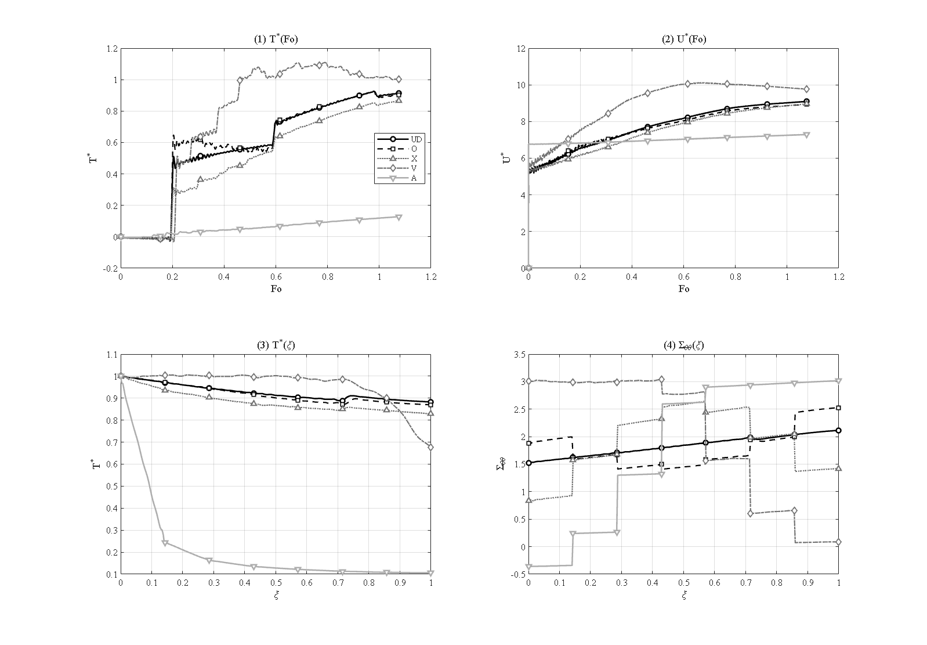
Figure 4-7: Effect of the porosity distribution pattern (UD, O, X, V, A), GPL uniform [R_i=1, R_o=1.5, L=2.1 m, N_L=7, W_GPL=0.3%, e_m3=0.8604, τ*=0.15, P_i=50 MPa, simply supported]
The key result lies in the two asymmetric patterns V and A, which are mirror images yet produce completely opposite thermal responses. In pattern V the pores are concentrated at the heated inner surface; this insulating band traps the incoming heat near the inner surface and prevents its rapid spread. As a result the mid-point temperature history displays a pronounced transient peak — the largest overshoot of this group — reaching 1.109 at a Fourier number of 0.79, and then relaxes to 1.002 by the end of the interval. At the opposite extreme, pattern A concentrates the pores at the cooled outer surface: instead of trapping the heat it blocks the heat-exit path toward the environment and thus behaves as a genuine thermal barrier. In this pattern the outer-surface temperature never exceeds 0.107 — about eight times smaller than the value 0.883 of the reference — and the mid-point peak collapses to 0.128.
The favorable thermal performance of pattern A is paid for on the mechanical side. Because the heat never penetrates deep into the wall, the thermal expansion is suppressed, and the unusual temperature distribution reverses the sign of the inner-surface hoop stress, which reaches a negative (compressive) value of 0.359; that is, the inner region, normally under hoop tension, turns compressive. This sign reversal must be carefully accounted for in the design of cylinders under internal thermal shock.
4-8
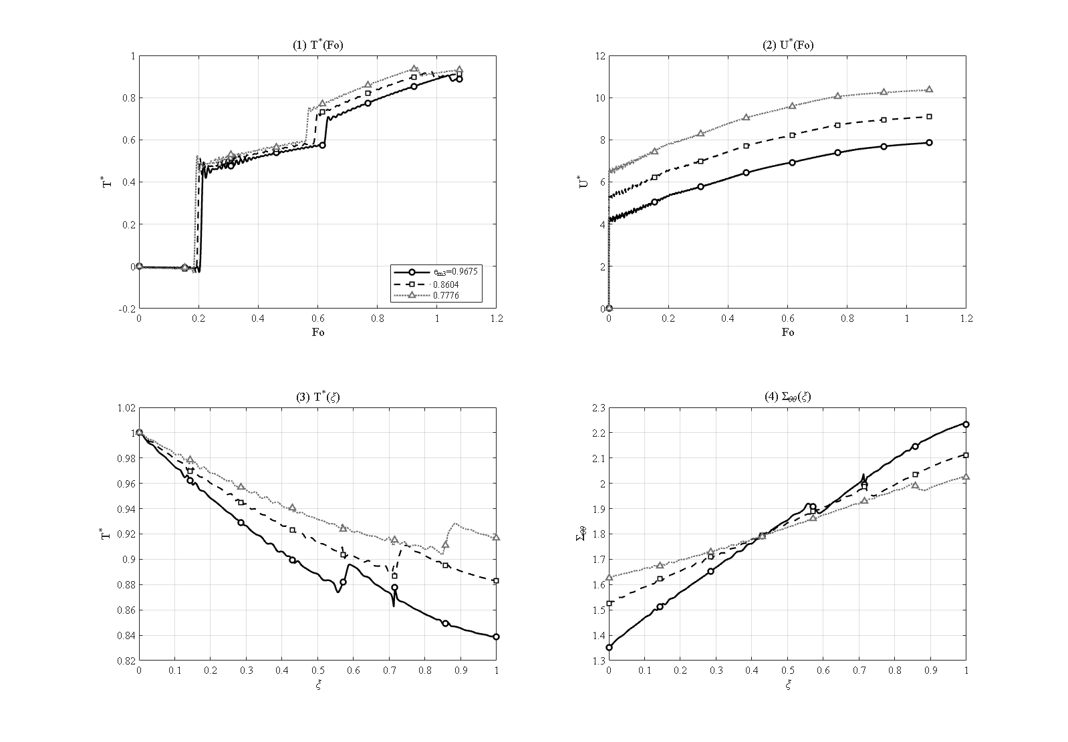
Figure 4-8: Effect of the porosity level e_m3 = 0.9675 / 0.8604 / 0.7776 [R_o/R_i=1.5, L=2.1 m, N_L=7, W_GPL=0.3%, UD, τ*=0.15, P_i=50 MPa, simply supported]
Finally, the effect of the overall porosity level is shown in Figure 4-8 for the three mass coefficients e_m3 = 0.9675, 0.8604 and 0.7776 (light, moderate and heavy porosity). Increasing the porosity lowers the conductivity and the stiffness together; consequently the peak mid-point temperature grows mildly, from 0.905 through 0.926 to 0.942, while the peak radial displacement rises more strongly, from 7.87 through 9.10 to 10.37, as the softer wall deforms more under the same loading.

4-7. Effect of the GPL weight fraction
4-9
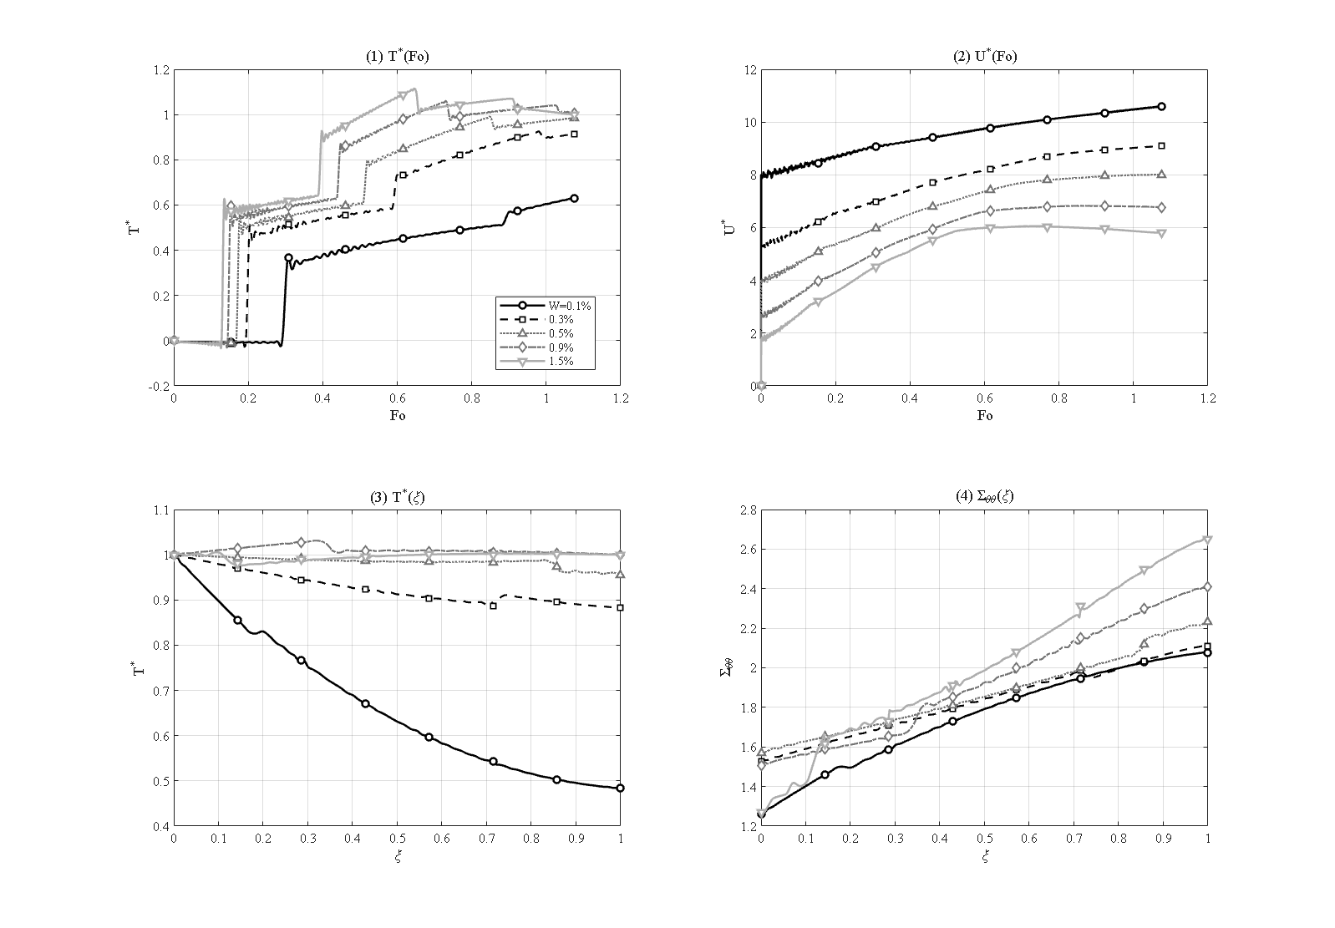
Figure 4-9: Effect of the GPL weight fraction (low range) W = 0.1 / 0.3 / 0.5 / 0.9 / 1.5 % [R_o/R_i=1.5, L=2.1 m, N_L=7, UD, e_m3=0.8604, τ*=0.15, P_i=50 MPa, simply supported]
The percolation character of the thermal-conductivity model (Chapter 3) makes the GPL weight fraction the strongest material lever of the problem. Figure 4-9 scans the low range W = 0.1, 0.3, 0.5, 0.9 and 1.5 %. At the smallest fraction the graphene network is barely percolated: the thermal wave penetrates weakly, the outer-surface temperature reaches only 0.484 and the mid-point peak stays at 0.631. As the weight fraction rises, the percolated network raises the effective conductivity and the wall fills with heat: the mid-point peak grows to 0.926, 0.991, 1.061 and 1.115, and the outer-surface temperature climbs to essentially unity (full through-wall penetration) by W = 0.9 %. Because the added graphene also stiffens the wall, the peak radial displacement falls in the opposite direction, from 10.60 at W = 0.1 % to 6.06 at W = 1.5 %.
4-10
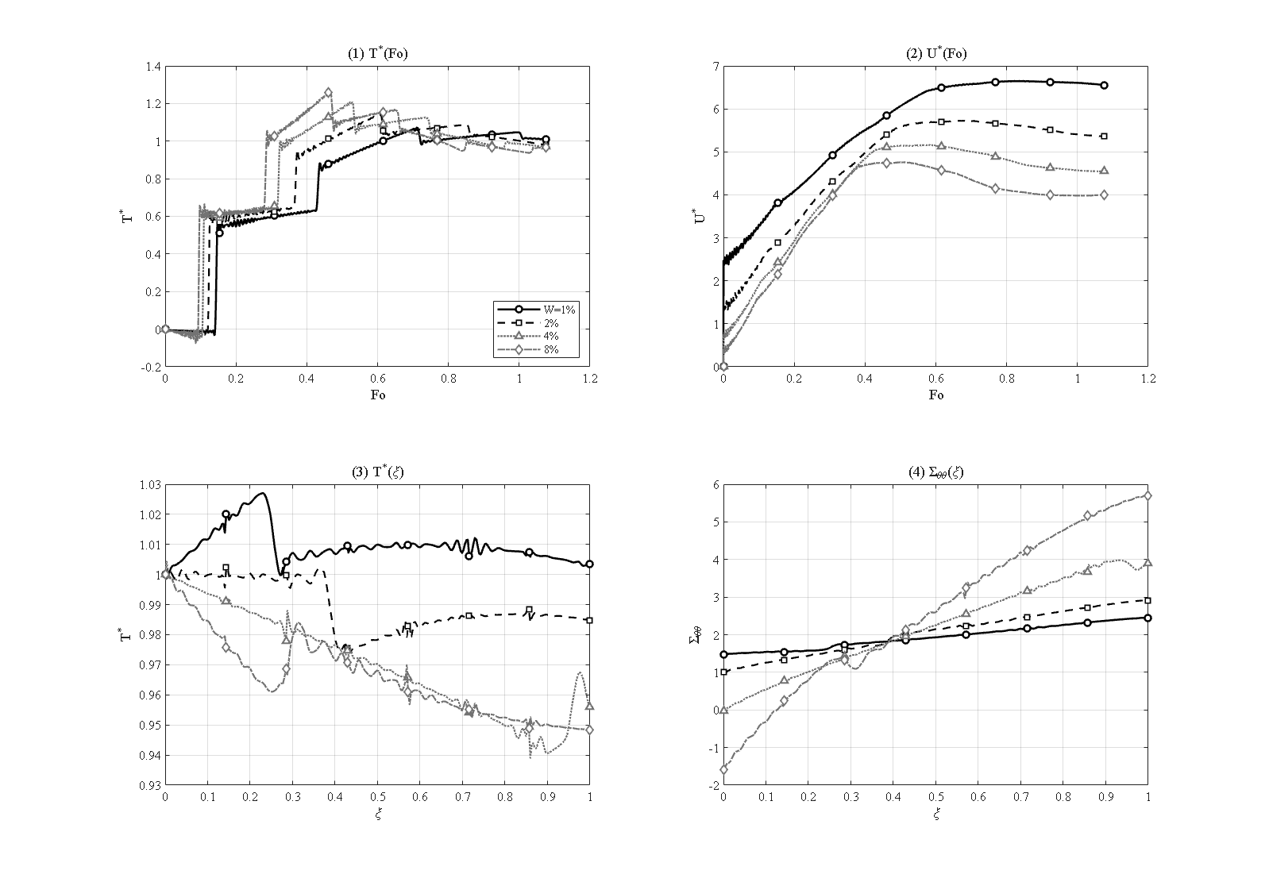
Figure 4-10: Effect of the GPL weight fraction (high range) W = 1 / 2 / 4 / 8 % [R_o/R_i=1.5, L=2.1 m, N_L=7, UD, e_m3=0.8604, τ*=0.15, P_i=50 MPa, simply supported]
The higher range W = 1, 2, 4 and 8 % is shown in Figure 4-10. Here the thermal response saturates — the mid-point peak rises only gradually from 1.072 to 1.261 — but the mechanical penalty grows sharply: the peak hoop stress more than doubles, from 2.45 to 5.71, and the inner-surface hoop stress falls and reverses sign, from 1.474 at 1 % to −1.580 at 8 %, as the stiff, highly loaded inner band is driven into compression. The practical conclusion is that a small weight fraction suffices to switch the wall from a poor to a good thermal conductor, whereas adding graphene beyond that yields only a mild thermal improvement while mainly raising the thermal stresses. Most previous works examined the range 0.1 to 2 %; here the range is extended to 8 % to expose the saturation of the thermal gain and the growth of the stresses.

4-8. Effect of the GPL aspect ratios
The Halpin–Tsai model of Chapter 3 makes the reinforced properties depend not only on the volume fraction but also on the platelet geometry, described by two independent aspect ratios: the length-to-width ratio a/b, entering through the characteristic length a_GPL, and the width-to-thickness ratio b/t, entering through the characteristic thickness t_GPL. Each is examined separately with all other parameters at their reference values.
4-11
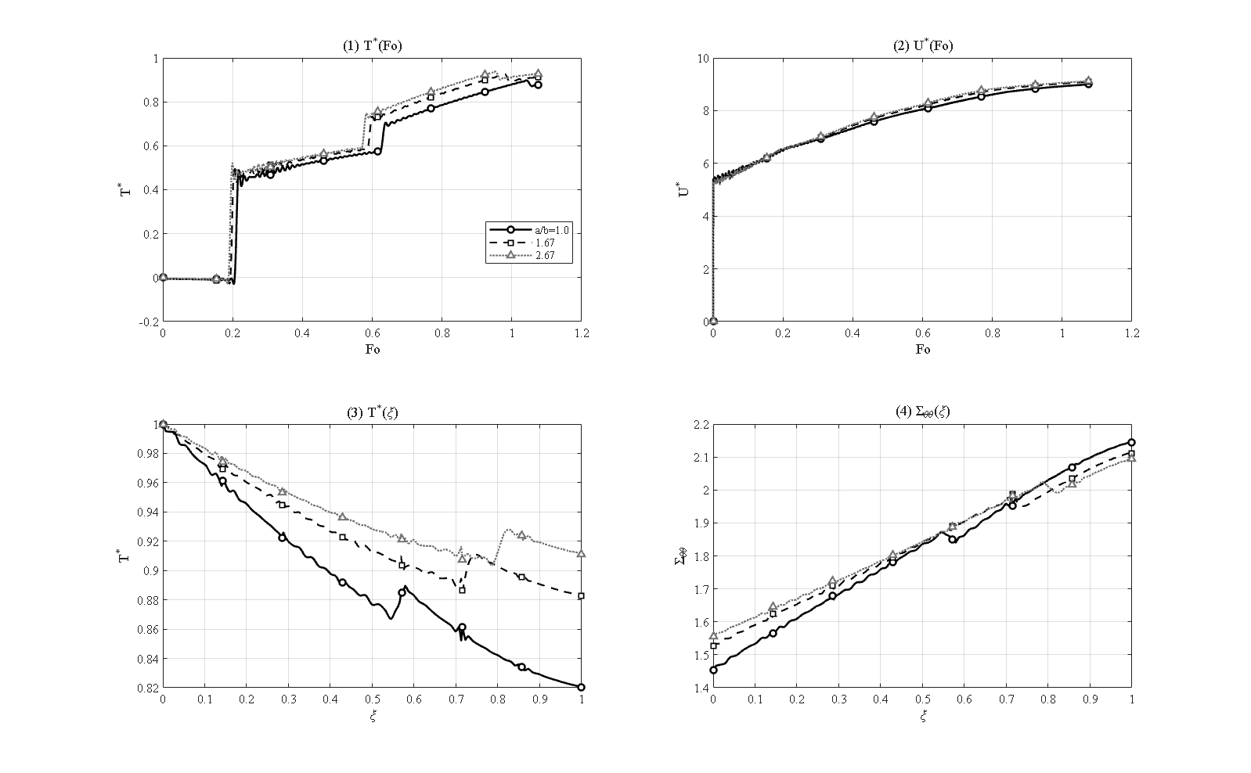
Figure 4-11: Effect of the platelet length-to-width aspect ratio a/b = 1.0 / 1.67 / 2.67 [R_o/R_i=1.5, L=2.1 m, N_L=7, W_GPL=0.3%, e_m3=0.8604, τ*=0.15, P_i=50 MPa, simply supported]
The effect of the length-to-width ratio is shown in Figure 4-11. As a/b increases from 1.0 to 1.67 (reference) and then to 2.67, the peak mid-point temperature rises only from 0.898 to 0.926 and 0.939, and the inner-surface hoop stress from 1.453 to 1.526 and 1.556 — changes of a few percent.
4-12
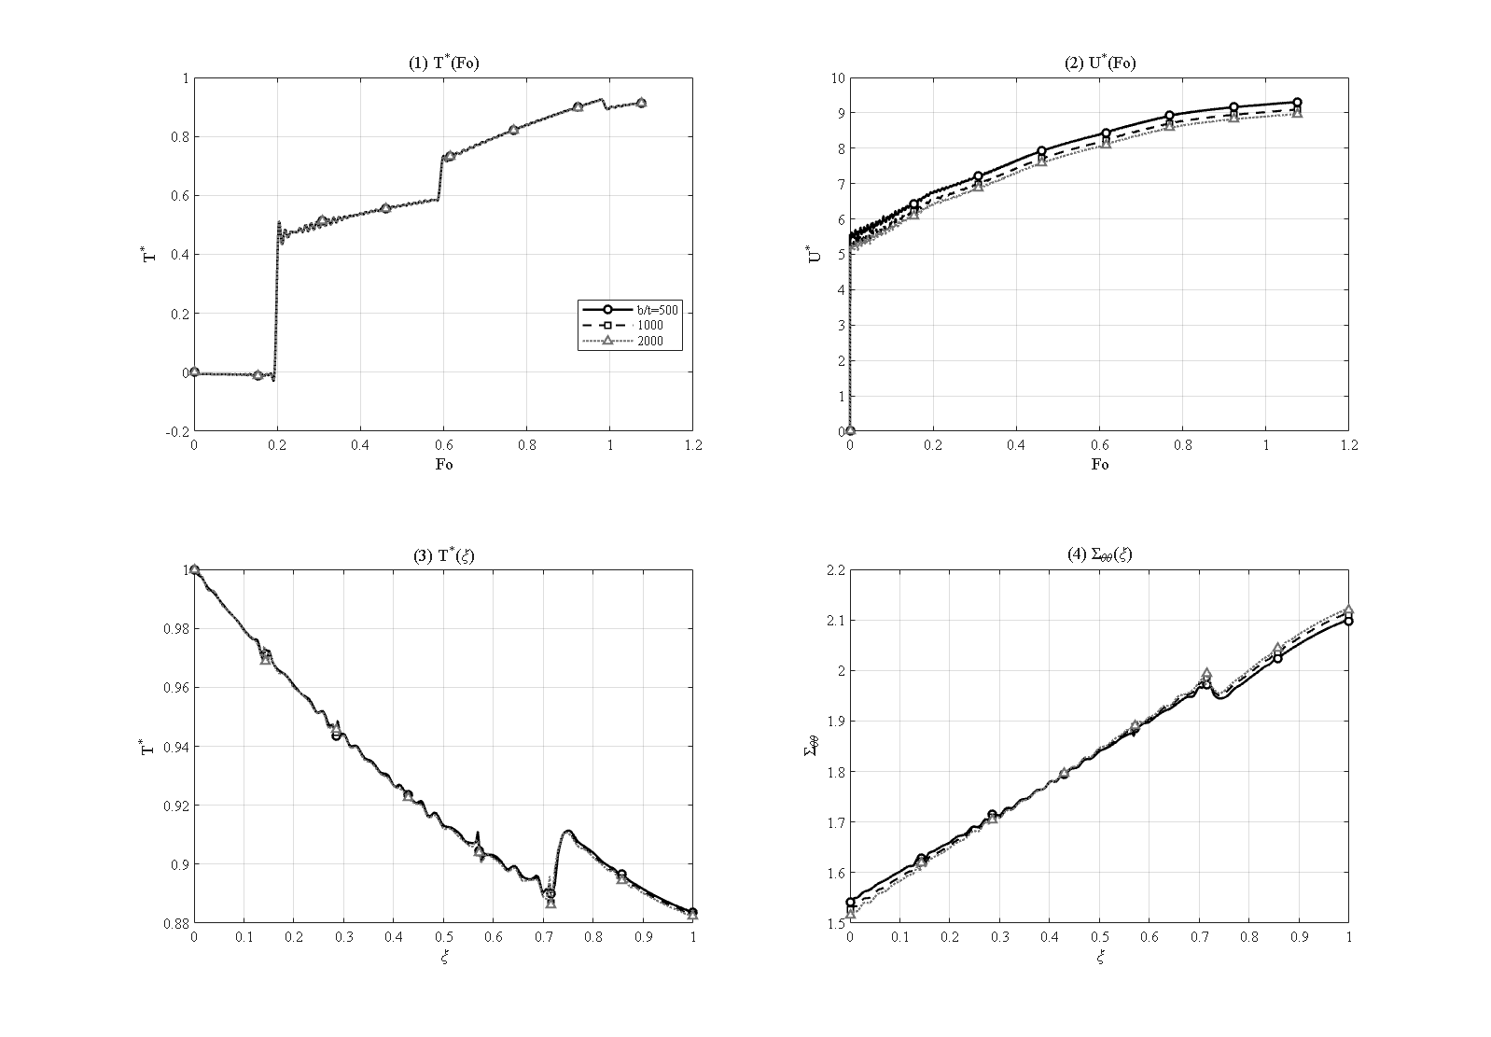
Figure 4-12: Effect of the platelet width-to-thickness aspect ratio b/t = 500 / 1000 / 2000 [R_o/R_i=1.5, L=2.1 m, N_L=7, W_GPL=0.3%, e_m3=0.8604, τ*=0.15, P_i=50 MPa, simply supported]
The width-to-thickness ratio (Figure 4-12) is even weaker at this reference: as b/t increases from 500 to 1000 and 2000, the peak temperature is essentially constant (0.926, 0.926, 0.925) and the inner-surface hoop stress changes only from 1.542 to 1.516. At the low reference weight fraction of 0.3 % the reinforcement is too dilute for platelet geometry to matter; both aspect ratios are therefore second-order levers here, in contrast to the high-weight-fraction regime where the width-to-thickness ratio dominates. This distinction is itself a useful design observation: platelet shape becomes a meaningful lever only once the weight fraction is large enough for the reinforcement to control the effective properties.

4-9. Effect of the relaxation time; Lord-Shulman versus Fourier
4-13
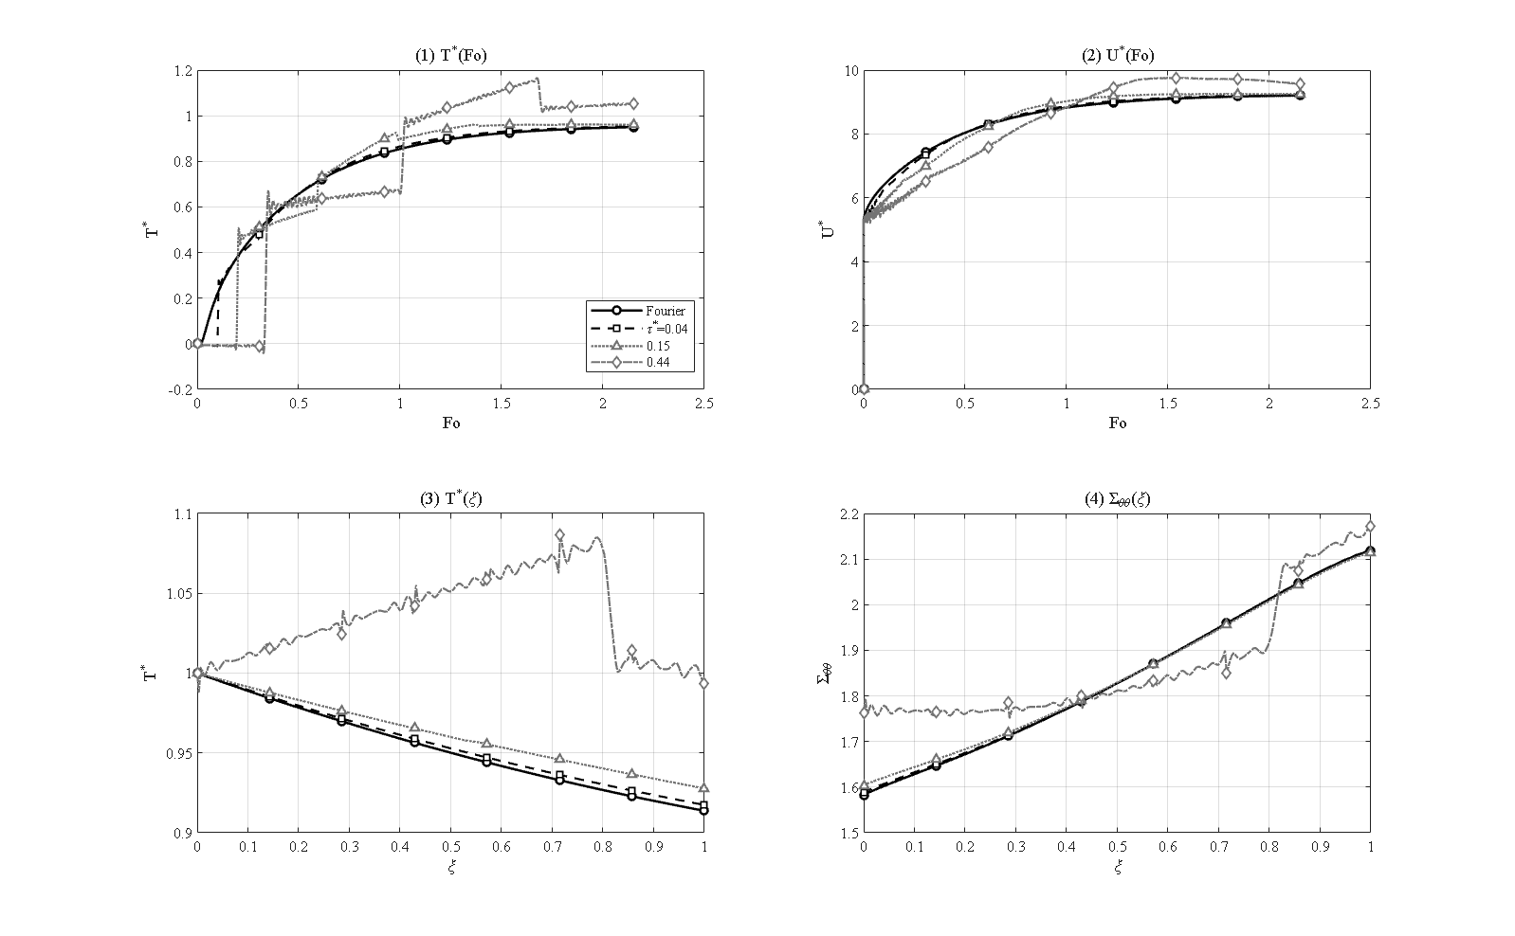
Figure 4-13: Effect of the relaxation time — Fourier (τ=0) and Lord–Shulman τ = 0.04 / 0.15 / 0.44 [R_o/R_i=1.5, L=2.1 m, N_L=7, W_GPL=0.3%, e_m3=0.8604, P_i=50 MPa, simply supported]
Figure 4-13 compares Fourier conduction (τ* = 0) with four dimensionless relaxation times τ* = 0.04, 0.15 and 0.44. Under Fourier conduction the mid-point temperature increases monotonically and never exceeds the driving value (peak 0.950), since classical diffusion, with its unbounded propagation speed, cannot produce an overshoot. With the relaxation time active in the Lord-Shulman theory the heat propagates as a wave of finite speed √(α̂/τ0): the peak grows to 0.953, 0.962 and 1.166 as τ* increases, and at the largest value the temperature overshoots even the inner-surface value — reaching 1.166 at τ* = 0.44 — a purely hyperbolic phenomenon impossible in the parabolic Fourier theory. At the mild reference value τ* = 0.15 the overshoot is still small (0.962), which is why the reference histories of the other studies show only a gentle peak; the wave signature becomes dominant only as the relaxation time is increased. The relaxation time thus controls both the wave arrival and the overshoot amplitude, and its clear signature in the temperature histories is the central argument for employing generalized thermoelasticity in short-time analyses [3].

4-10. Effect of the end supports
4-14
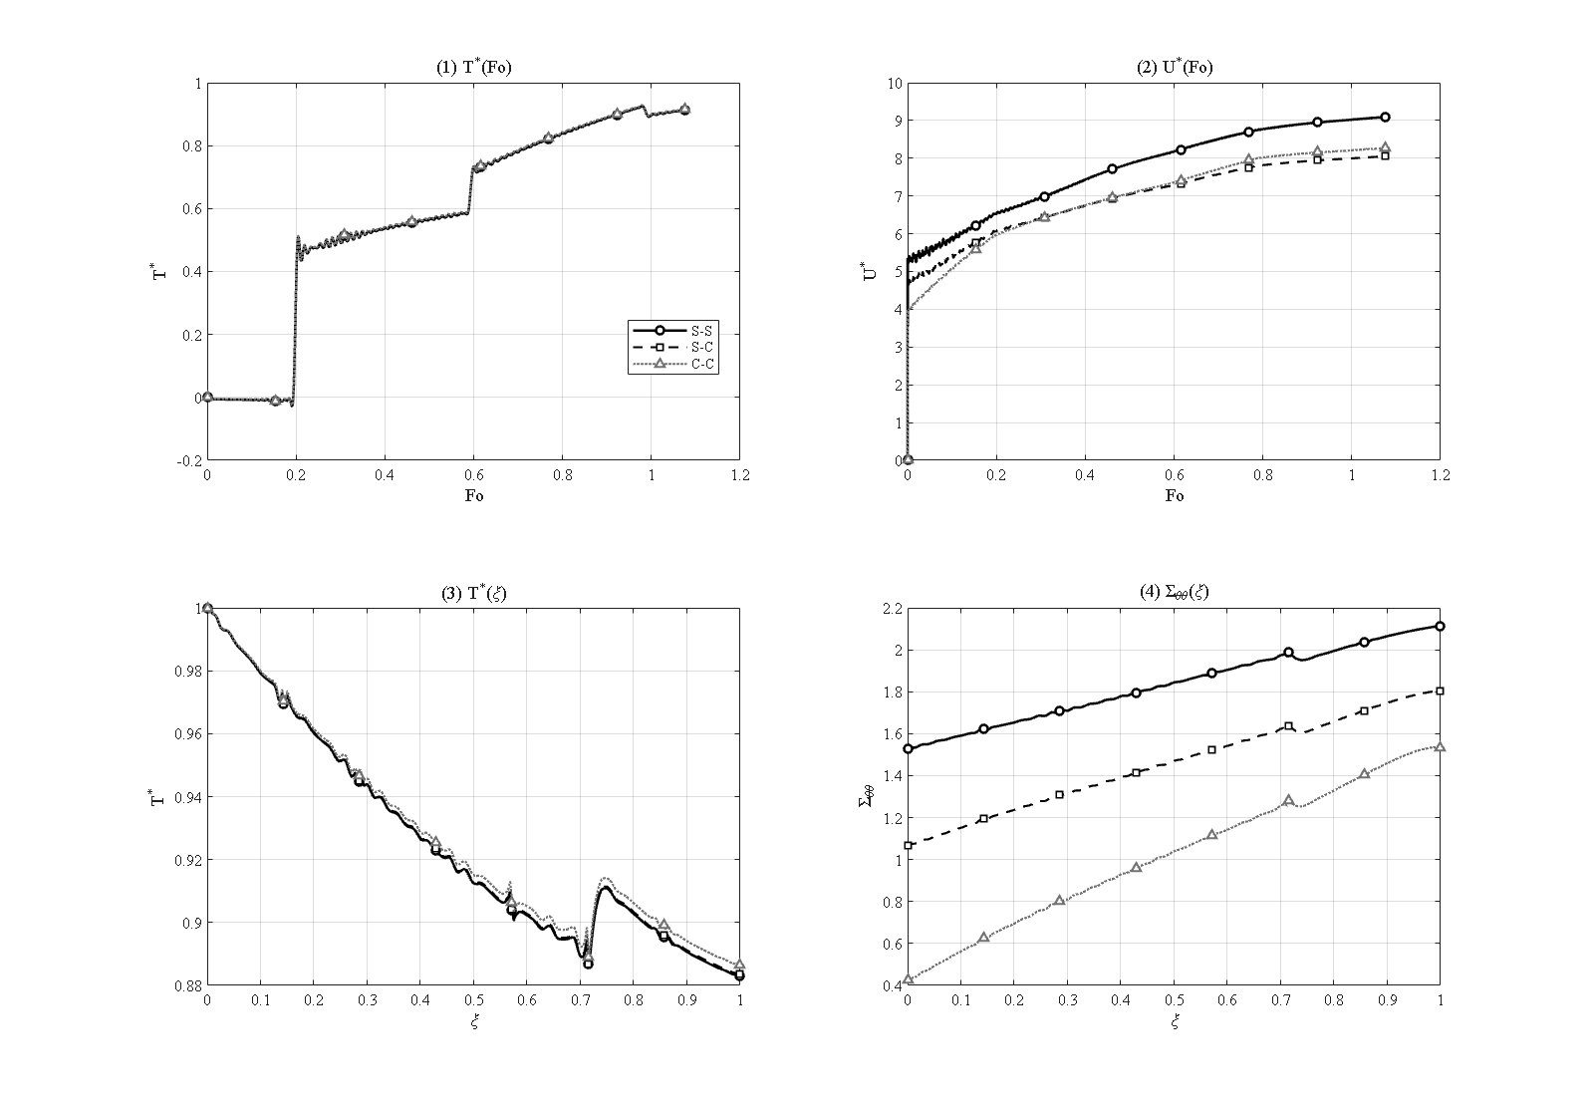
Figure 4-14: Effect of the end supports — simply supported (S-S), mixed (S-C) and clamped (C-C) [R_o/R_i=1.5, L=2.1 m, N_L=7, W_GPL=0.3%, e_m3=0.8604, τ*=0.15, P_i=50 MPa]
The effect of the end supports is examined for three cases: simply supported at both ends (S-S), one end simply supported and the other clamped (S-C), and clamped at both ends (C-C). As shown in Figure 4-14, the temperature field is nearly independent of the support type, the peak mid-point temperature staying in the narrow band 0.926 to 0.929, since the mechanical support does not directly alter the thermal problem.
The mechanical response depends strongly on the support. Clamping the ends adds an axial constraint that reduces the mid-length hoop tension: the dimensionless inner-surface hoop stress falls from 1.526 for S-S through 1.068 for the mixed S-C case to 0.424 for C-C, and the peak hoop stress from 2.112 to 1.803 and 1.535. The mixed case lies correctly between the two limiting cases in every quantity, confirming the expected intermediate behavior. The peak radial displacement is less sensitive, changing only from 9.10 (S-S) to 8.27 (C-C), because at the mid-length section of this relatively long cylinder the end constraints are partly screened; the disturbances caused by either support decay within roughly one wall thickness of the ends, which justifies reporting mid-length quantities as the characteristic response of the structure.

4-11. Effect of the internal pressure
The effect of the internal pressure is examined with a sweep at 0, 10, 50 (reference) and 100 MPa, covering low to very high pressures. As shown in Figure 4-15, the temperature field is practically independent of the internal pressure, because thermal and mechanical loading are linked only through the weak coupling term of the energy equation, and pressure is not a direct driver of temperature.
4-15
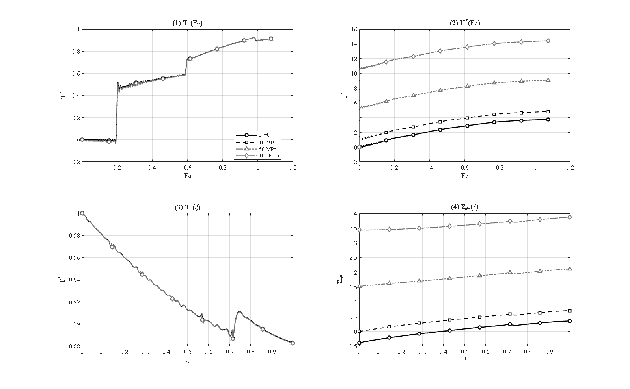
Figure 4-15: Effect of the internal pressure P_i = 0 / 10 / 50 / 100 MPa [R_o/R_i=1.5, L=2.1 m, N_L=7, W_GPL=0.3%, e_m3=0.8604, τ*=0.15, simply supported]
By contrast, the mechanical response grows linearly with pressure. The inner-surface hoop stress rises from −0.387 with no pressure (a purely thermal, mildly compressive state) through −0.004 and 1.526 to 3.439 at 100 MPa, an increment of about 0.0383 per megapascal; and the peak radial displacement rises from 3.75 through 4.82 and 9.10 to 14.44, an increment of about 0.107 per megapascal. This perfect linearity reflects the linear nature of the thermoelastic model, and even at 100 MPa the solution remains smooth and convergent, with no discontinuity, because physical rupture (material failure or separation) is not included in the present linear model; assessing that would require a damage or failure model. Unlike the near-negligible megapascal-level pressures of much of the literature, at the 50 MPa reference the pressure is a genuine first-order contributor to the stress and displacement, while the temperature field remains thermally governed. The dimensionless radial-stress profile runs from the negative of the applied pressure at the inner surface to zero at the outer surface, consistent with the loading boundary condition.

4-12. Effect of the cylinder length and the long-cylinder limit
4-16
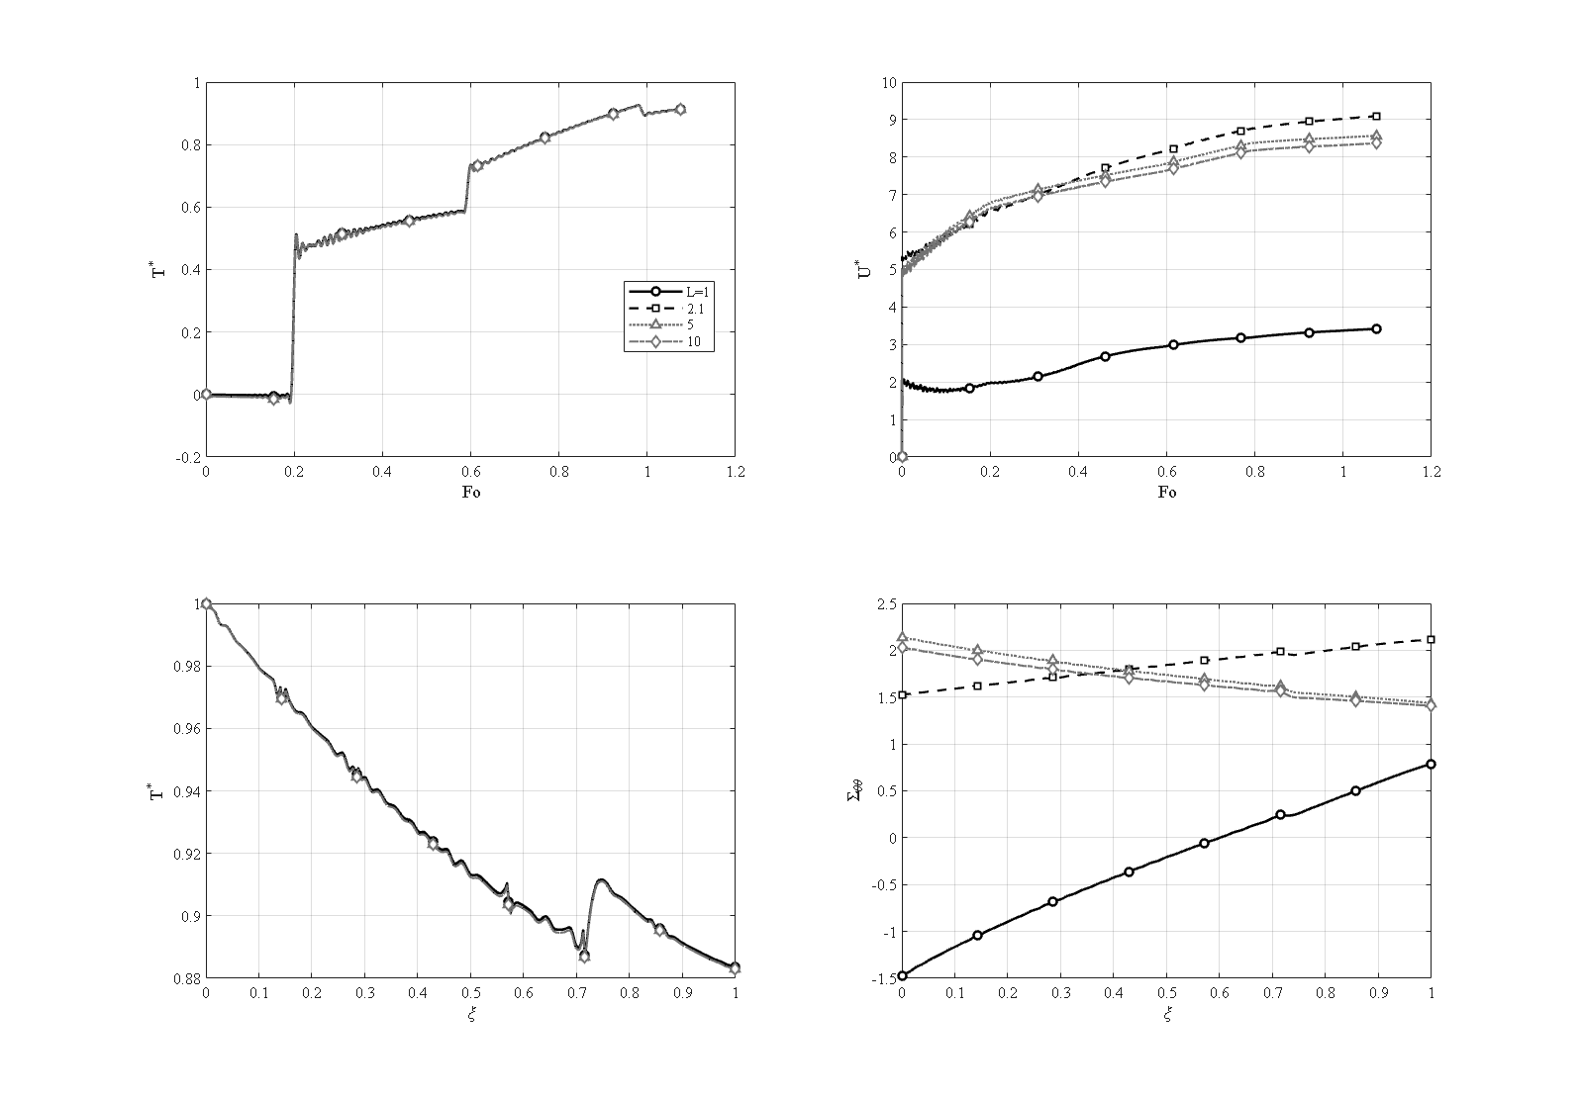
Figure 4-16: Effect of the cylinder length L = 1 / 2.1 / 5 / 10 m [R_i=1, R_o=1.5, N_L=7, W_GPL=0.3%, e_m3=0.8604, τ*=0.15, P_i=50 MPa, simply supported]
To examine the limiting behavior of a long cylinder, the length is increased from 1 m through the reference 2.1 m to 5 and 10 m. As shown in Figure 4-16, the peak mid-point temperature is length-independent, remaining at 0.926 to 0.927. The mechanical response, however, tends to a limit as the length grows. The very short cylinder (L = 1 m) is dominated by its two close end supports: its mid-length inner-surface hoop stress is compressive (−1.477) and its displacement is small (3.42). As the length increases the mid-length section moves away from the end constraints, the inner hoop stress becomes tensile and approaches an asymptote of about 2.0 to 2.1 (1.526, 2.139 and 2.031 for 2.1, 5 and 10 m), and the peak displacement settles toward about 8.4 (9.10, 8.57 and 8.37). The mid-length response thus converges to the infinite-length (plane-strain-like) limit in which the mechanical effects of the two ends are not felt.

4-13. Interaction of the GPL and porosity distribution patterns
The individual studies showed pattern V for the GPLs and pattern A for the porosity to be the most favorable thermally. This section examines the full interaction by computing all twenty-five combinations of the five GPL patterns with the five porosity patterns, each combination labeled (for example X-GPL + V-Por). The dimensionless outer-surface temperature and the hoop-stress profile of every combination are shown as a 5×5 matrix in Figure 4-17.
4-17
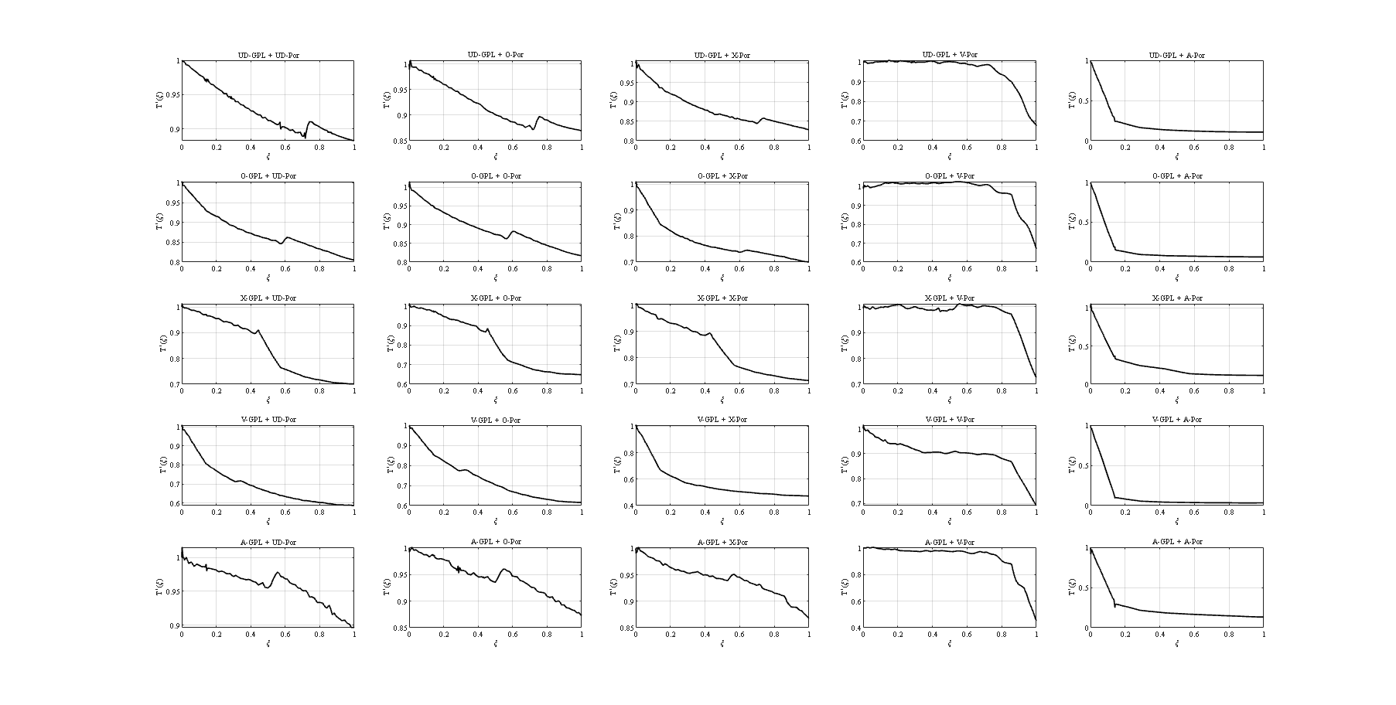
Figure 4-17: Full 25-case GPL × porosity matrix — through-wall dimensionless temperature T*(ξ) for every pattern pair (rows: GPL pattern; columns: porosity pattern) [reference: W_GPL=0.3%, e_m3=0.8604, τ*=0.15, P_i=50 MPa, simply supported]
The first key observation is that the porosity pattern A acts as a universal thermal barrier: regardless of the GPL pattern, concentrating the pores at the outer surface gives the lowest outer-surface temperature, the values along that column being 0.107, 0.064, 0.116, 0.034 and 0.134. The best combination of all, GPL-V together with porosity-A, holds the outer-surface temperature at 0.034 — a roughly twenty-six-fold reduction with respect to the reference (0.883) — while its stress state remains benign (the inner hoop stress is a small compressive −0.378). This confirms the design recommendation of the thesis for thermal protection.
4-18
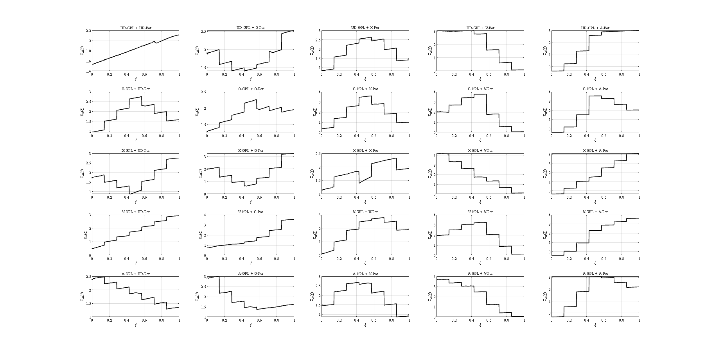
Figure 4-18: Full 25-case GPL × porosity matrix — hoop-stress profile Σθθ(ξ) for every pattern pair (rows: GPL pattern; columns: porosity pattern) [reference: W_GPL=0.3%, e_m3=0.8604, τ*=0.15, P_i=50 MPa, simply supported]
The second observation is the mirror-pattern interaction. Patterns V and A are geometric mirror images (inner-surface versus outer-surface concentration). When GPL-V (conductive at the inner surface) is combined with porosity-A (insulating at the outer surface) the two mechanisms act synergetically and the outer-surface temperature reaches its minimum; but when the same GPL-V is combined with porosity-V (both concentrated at the inner surface) the two effects weaken each other and the outer-surface temperature rises to 0.692. At the other extreme, the worst cases belong to GPL-A (conductive at the outer surface) combined with the symmetric porosities, which raise the outer-surface temperature as high as 0.896. The highest hoop stresses of the matrix appear where a stiff GPL pattern meets an inner-concentrated porosity — for example X-GPL + V-Por, with a peak hoop stress of 4.20 — so the matrix also maps where stress, not temperature, becomes the limiting concern. Thus not only the individual pattern but also the alignment or opposition of the two patterns is decisive; this full interaction map has no counterpart in comparable previous research [6] and is one of the contributions of this work.
While the 5×5 matrix gives the complete overview at a glance, the same twenty-five combinations are shown one porosity background at a time in Figures 4-19 to 4-23 — for each porosity pattern (UD, O, X, V and A) a single figure that overlays the five GPL patterns. The GPL ranking at a fixed porosity then reads directly: against the porosity-A barrier (Figure 4-23), for example, GPL-V keeps the outer surface coolest while GPL-A and GPL-X run hottest, whereas at uniform porosity (Figure 4-19) the spread between the patterns is much narrower.
4-19
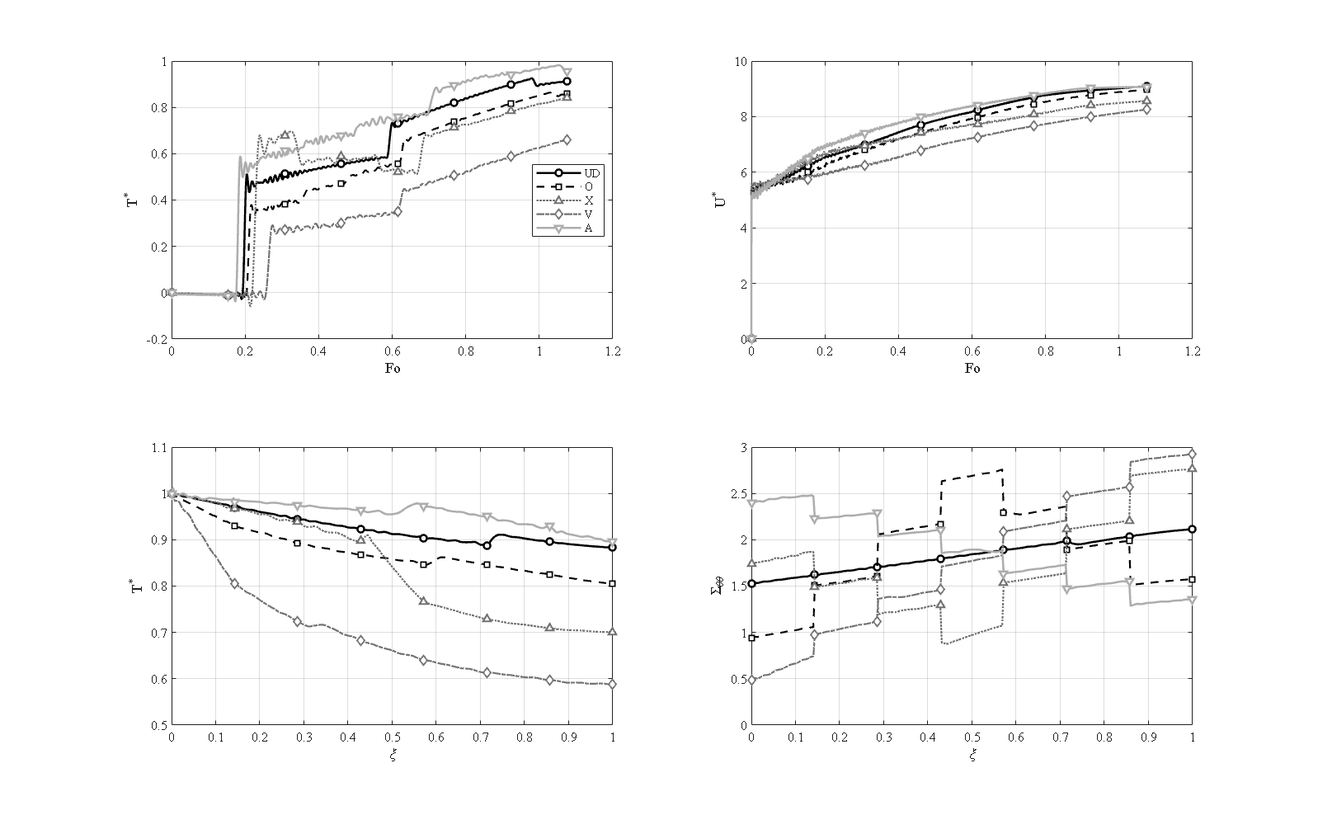
Figure 4-19: GPL pattern comparison (UD, O, X, V, A) at uniform (UD) porosity [R_i=1, R_o=1.5, L=2.1 m, N_L=7, W_GPL=0.3%, e_m3=0.8604, UD porosity, τ*=0.15, P_i=50 MPa, simply supported]
4-20
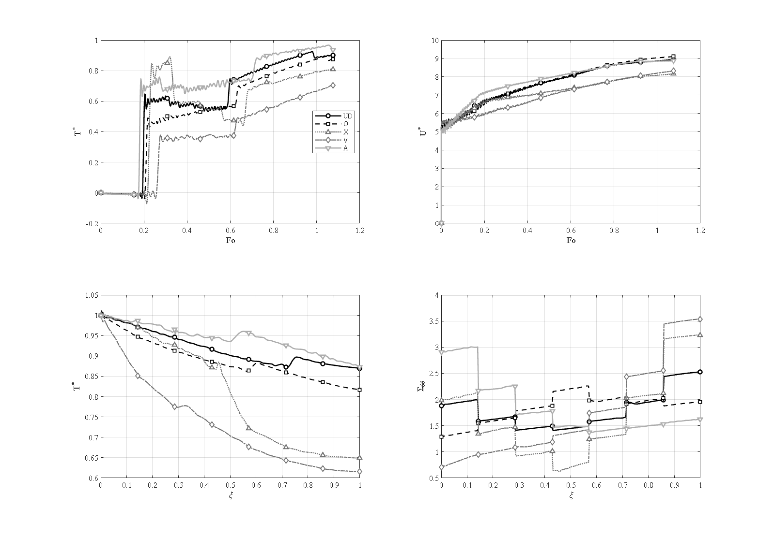
Figure 4-20: GPL pattern comparison (UD, O, X, V, A) at O-type porosity [R_i=1, R_o=1.5, L=2.1 m, N_L=7, W_GPL=0.3%, e_m3=0.8604, O porosity, τ*=0.15, P_i=50 MPa, simply supported]
4-21
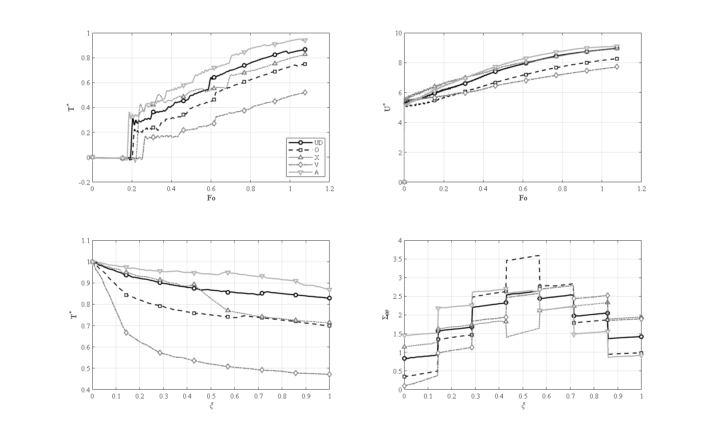
Figure 4-21: GPL pattern comparison (UD, O, X, V, A) at X-type porosity [R_i=1, R_o=1.5, L=2.1 m, N_L=7, W_GPL=0.3%, e_m3=0.8604, X porosity, τ*=0.15, P_i=50 MPa, simply supported]
4-22
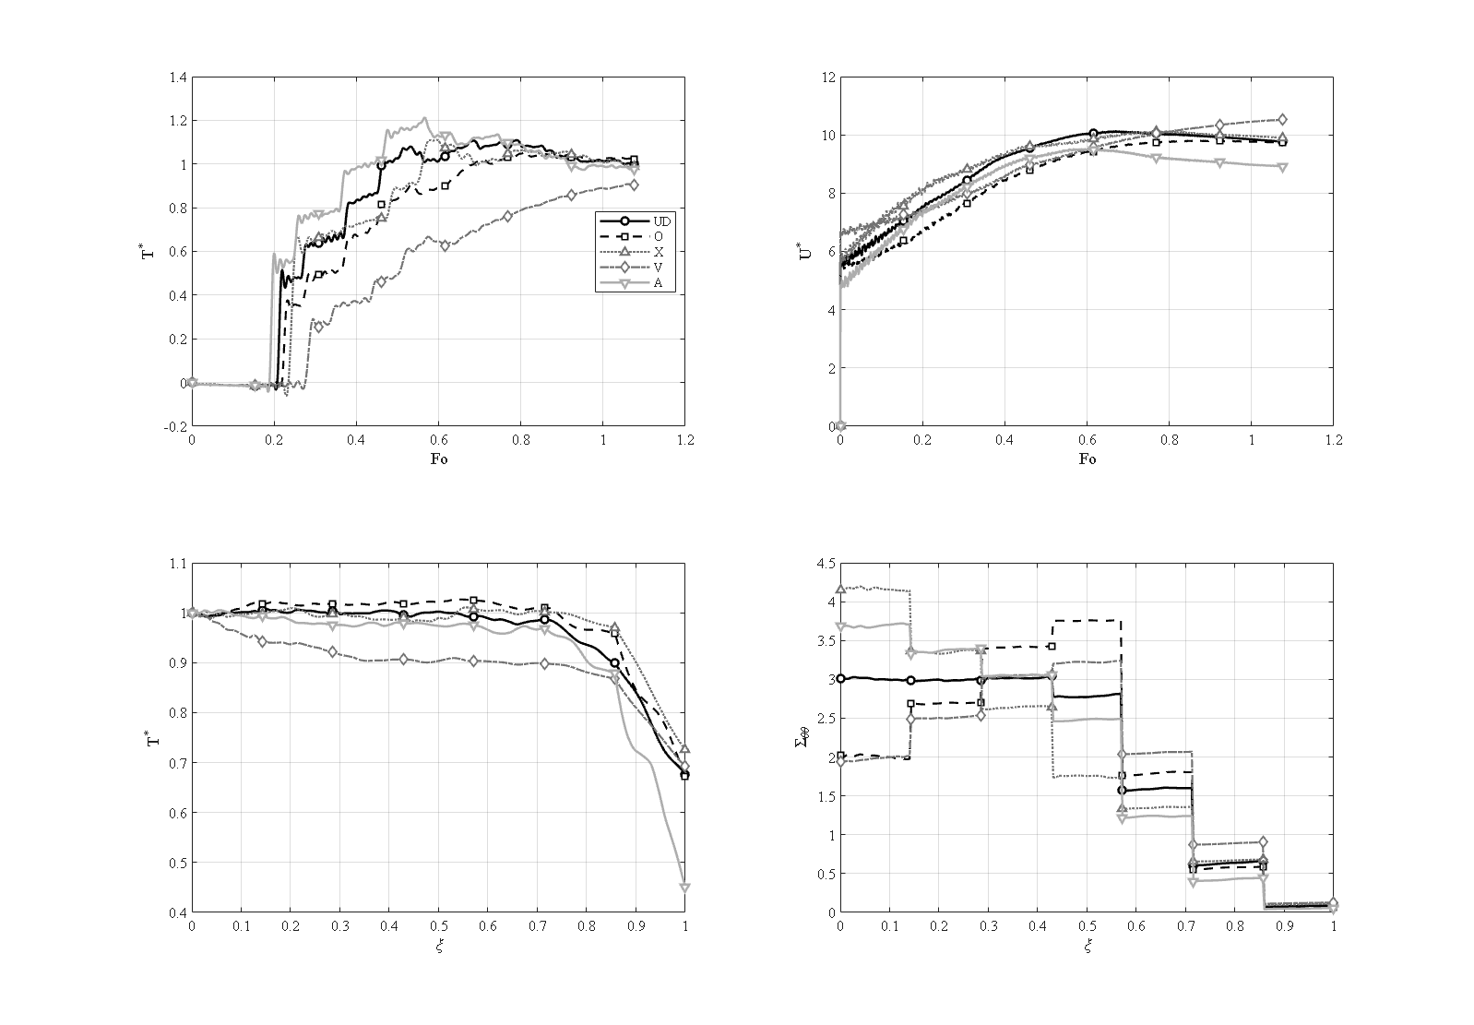
Figure 4-22: GPL pattern comparison (UD, O, X, V, A) at V-type porosity [R_i=1, R_o=1.5, L=2.1 m, N_L=7, W_GPL=0.3%, e_m3=0.8604, V porosity, τ*=0.15, P_i=50 MPa, simply supported]
4-23
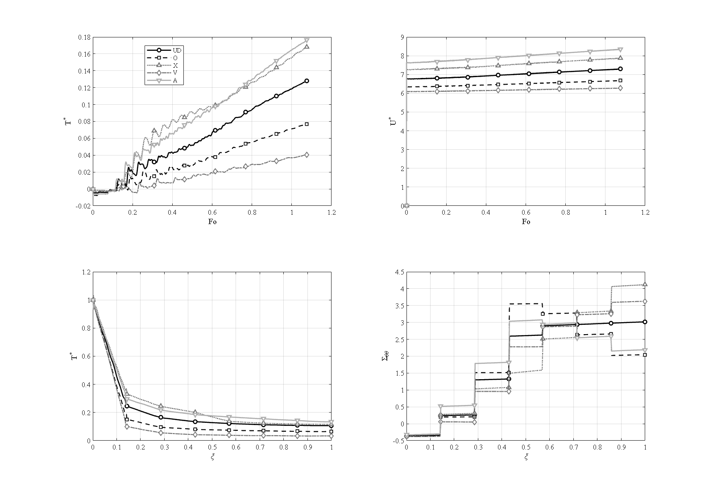 ## 4-14. Effect of the coupling of the equations
4-24
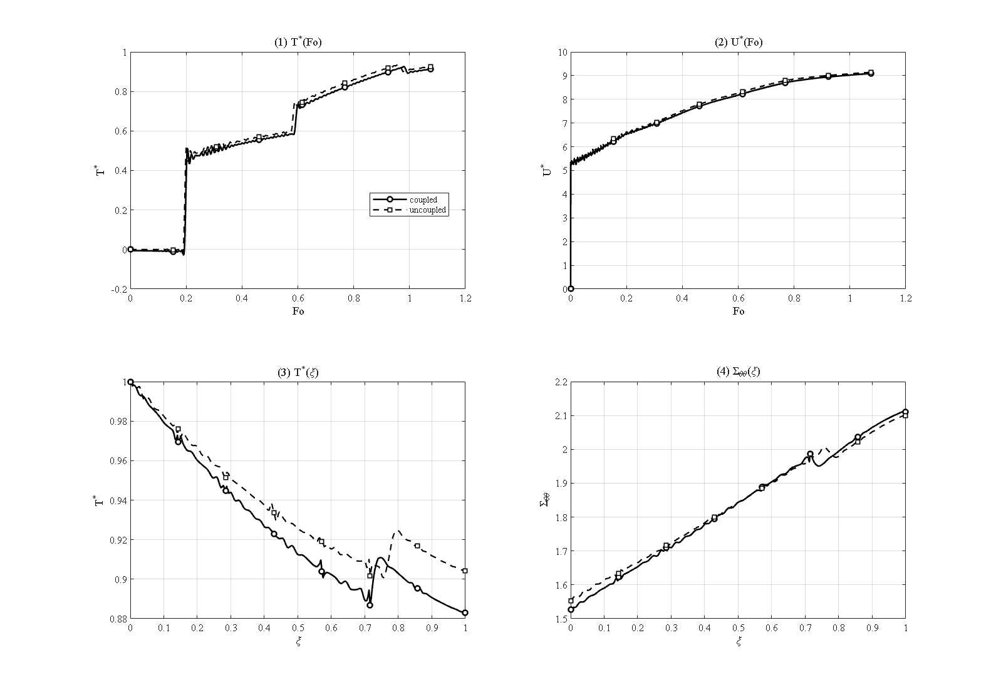
Figure 4-24: Effect of thermo-mechanical coupling — fully coupled versus uncoupled energy equation [R_o/R_i=1.5, L=2.1 m, N_L=7, W_GPL=0.3%, e_m3=0.8604, τ*=0.15, P_i=50 MPa, simply supported]
Figure 4-24 compares the fully coupled model with the uncoupled one (the dilatation-rate term removed from the energy equation). At the reference conditions the uncoupled model overestimates the peak mid-point temperature by about 1.2 % (0.937 versus 0.926) and the outer-surface temperature by a similar margin. The mechanism is that in the coupled model part of the thermal energy is continuously converted into mechanical work — a thermoelastic damping of the thermal wave — and the difference between the two models is largest exactly at the wave fronts. The effect is modest at the mild reference relaxation time τ* = 0.15 but grows with the wave strength; it demonstrates that the fully coupled system should be solved when the wave signature matters, despite its higher cost.

4-15. Effect of the outer-surface convection coefficient
4-25
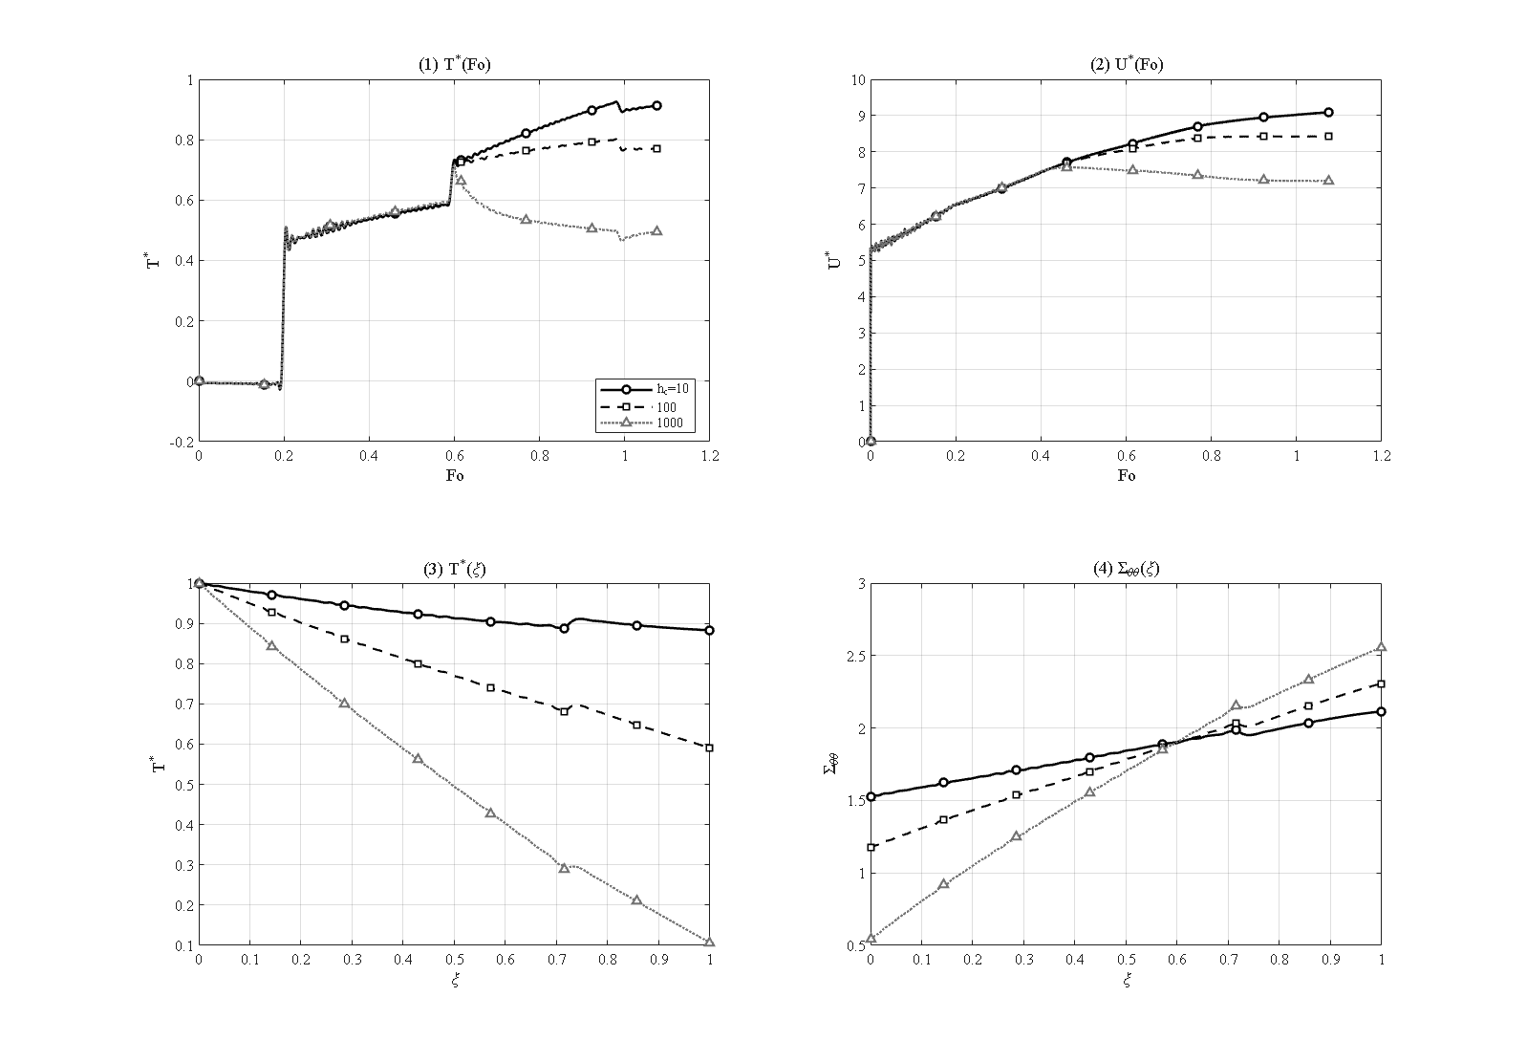
Figure 4-25: Effect of the outer-surface convection coefficient h_c = 10 / 100 / 1000 W/m²K [R_o/R_i=1.5, L=2.1 m, N_L=7, W_GPL=0.3%, e_m3=0.8604, τ*=0.15, P_i=50 MPa, simply supported]
Figure 4-25 examines the outer-surface convection coefficient for h_c = 10, 100 and 1000 W/m²K, corresponding to Biot numbers Bi = h_c h/k̄ ≈ 0.07 to 6.6. As h_c increases, the outer surface turns from nearly adiabatic into an effective heat sink: the outer-surface temperature drops from 0.883 through 0.591 to 0.107, the mid-point peak from 0.926 through 0.802 to 0.715, and the inner-surface hoop stress relaxes from 1.526 through 1.176 to 0.540 — because what sets the thermal stress is the through-wall temperature difference, not the absolute temperature. The response is nearly insensitive to convection at the smallest coefficient and strongly convection-controlled at the largest, two regimes that must be distinguished in design.

4-16. Effect of the wall thickness
4-26
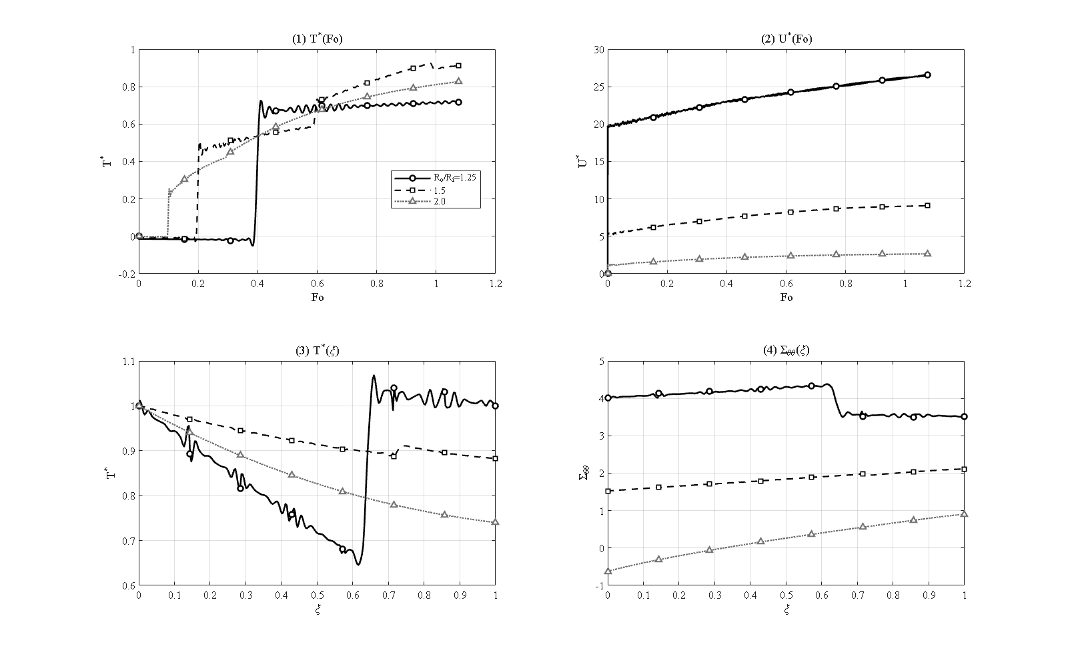
Figure 4-26: Effect of the wall thickness, radius ratio R_o/R_i = 1.25 / 1.5 / 2.0 (inner radius fixed at 1 m) [L=2.1 m, N_L=7, W_GPL=0.3%, e_m3=0.8604, τ*=0.15, P_i=50 MPa, simply supported]
Figure 4-26 compares three cylinders with radius ratios R_o/R_i = 1.25, 1.5 and 2.0 (inner radius fixed at 1 m; wall thickness 0.25, 0.5 and 1.0 m); the time scale of each is nondimensionalized with its own wall thickness. The thin wall (ratio 1.25) is crossed quickly by the thermal wave, so its outer surface heats fully (outer temperature 0.999), but the small thickness concentrates the thermal strain and produces the largest mechanical response of the study — an inner-surface hoop stress of 4.017 and a peak displacement of 26.6. The thick wall (ratio 2.0) behaves oppositely: within the window the wave does not fully cross, the outer region stays cooler (outer temperature 0.740), the displacement collapses to 2.66, and the inner-surface hoop stress becomes compressive (−0.628), since the heated inner band pushes against the cold, stiff outer mass. The wall thickness is therefore the geometric lever that trades a small, highly stressed thin wall against a large, mildly stressed but strongly compressive thick wall.

4-17. Response to a Gaussian thermal shock
4-27
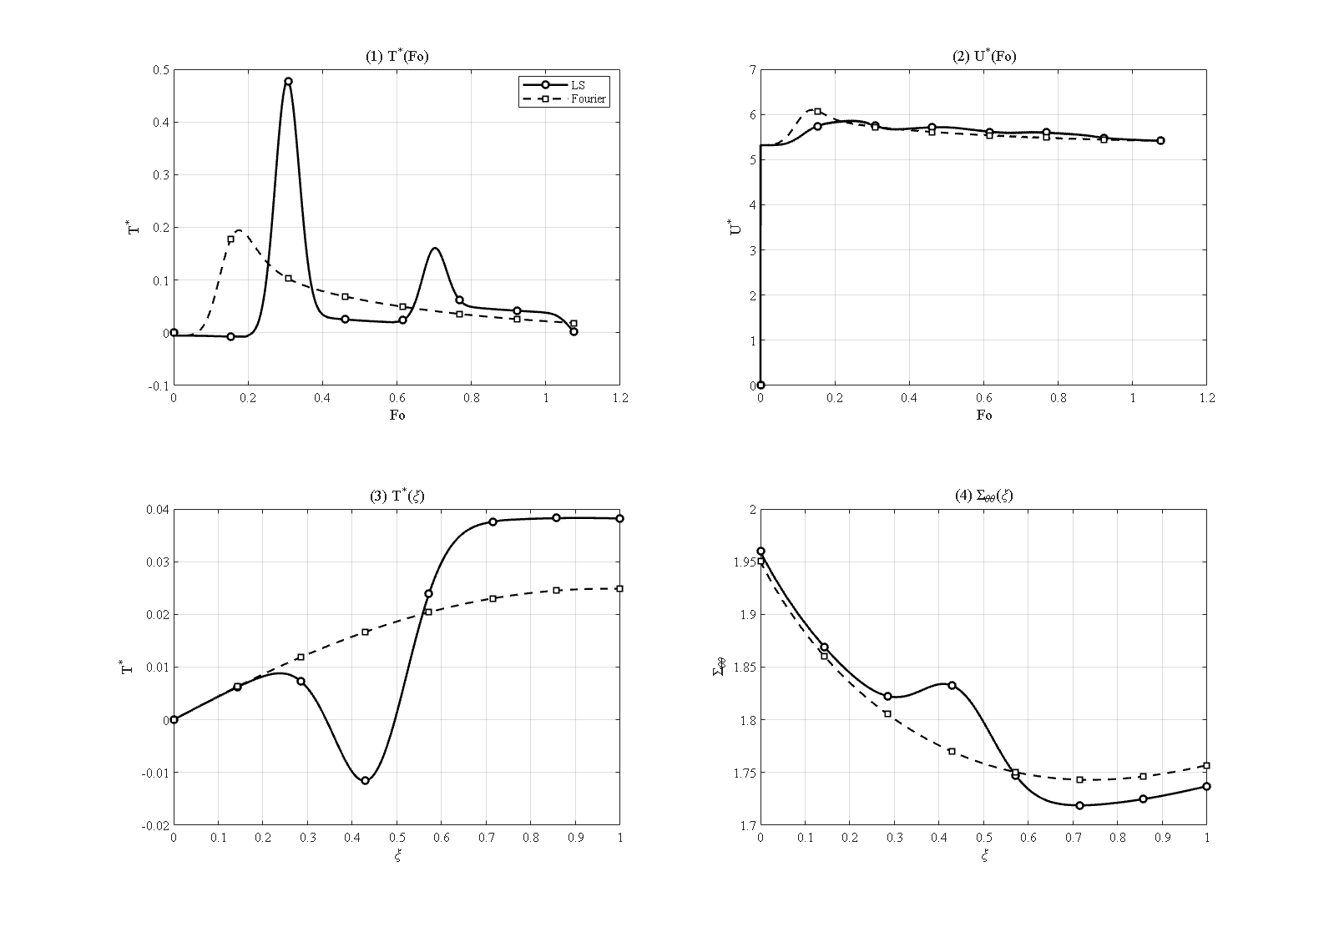
Figure 4-27: Response to a Gaussian thermal shock — Lord–Shulman versus Fourier [R_o/R_i=1.5, L=2.1 m, N_L=7, W_GPL=0.3%, e_m3=0.8604, P_i=50 MPa, simply supported]
In this study the sustained ramp is replaced by a short Gaussian pulse of the inner-surface temperature, and the response is compared under the Lord-Shulman and Fourier theories (Figure 4-27). The loading exposes the essential difference between wave-like and diffusive transport: under Fourier conduction the pulse arrives at the mid-thickness early, smeared and weak (peak 0.195 at Fo ≈ 0.18) and has practically vanished by the end of the interval. Under the Lord-Shulman theory the pulse travels as a coherent wave packet: it arrives later (Fo ≈ 0.31), about two and a half times stronger (peak 0.478), and leaves persistent oscillations behind. The Lord-Shulman solution shows a sharp second-sound front marching through the wall — the clearest visual signature of the finite propagation speed. Under impulsive loads the classical theory therefore substantially underestimates the transient thermal, and hence mechanical, severity of the shock — a strong argument in favor of the generalized theory.

4-18. Comparison of time-integration methods
To position the Newmark scheme used in this thesis, five alternative time integrators were run on the identical benchmark problem (transient conduction with known exact solution; error measure: maximum temperature error at t = 10 s). The results are summarized in Table 4-7.
Table 4-7: Comparison of time-integration methods on the same spatial system.
method | max error (K) | CPU time (s)
Newmark (δ=½, β=¼) | 0.0032 | 0.33
Wilson-θ (θ=1.4) | 0.0164 | 0.19
Houbolt | 0.0025 | 0.24
HHT-α (α=−0.1) | 0.0033 | 0.29
ode15s (adaptive BDF) | 0.0003 | 2.57
Laplace-Durbin (thermal subsystem) | 0.137 | 193
Newmark, Houbolt and HHT-α are practically equally accurate at equal time step; Wilson-θ accepts a roughly five-fold larger error owing to its extra numerical dissipation; the adaptive stiff solver ode15s is about ten times more accurate but eight times more expensive; and the Laplace-transform route with Durbin inversion is three orders of magnitude slower. A methodological result also emerged: the Laplace transform cannot be applied to the full coupled system, because the undamped elastic poles of the coupled operator lie exactly on the inversion contour — which is why transform methods are applied in the literature to thermal subsystems only. This measured comparison justifies the choice of the Newmark method for all production runs of this thesis.

4-19. Comparison of spatial-discretization methods
Four spatial discretizations — the differential quadrature method with Chebyshev and with uniform grids, the second-order finite difference method, and the finite element method with linear and quadratic elements (Galerkin formulation with consistent matrices) — are compared on the transient-conduction problem with the exact Bessel-series solution, using the identical Newmark time march. The number of points required for each method’s error to reach the time-step floor is: about 9 to 11 for differential quadrature, about 21 for quadratic finite elements, and about 161 for linear finite elements and finite differences. The linear-FEM and FDM curves coincide at slope −2; quadratic FEM gains roughly one order of magnitude per refinement step; and the DQM error falls quasi-exponentially until the temporal floor. At equal accuracy the DQM system is therefore about fifteen times smaller per direction — squared in the (r,z) plane — which is the quantitative justification for the layerwise differential quadrature choice of this thesis, and is fully consistent with the mesh-convergence study of Section 4-3, where a handful of radial points already delivered three-digit accuracy. Adding the two Galerkin finite-element formulations to this comparison is one of the extensions of this work over comparable previous studies.

4-20. Comparison of the generalized thermoelasticity theories
4-28
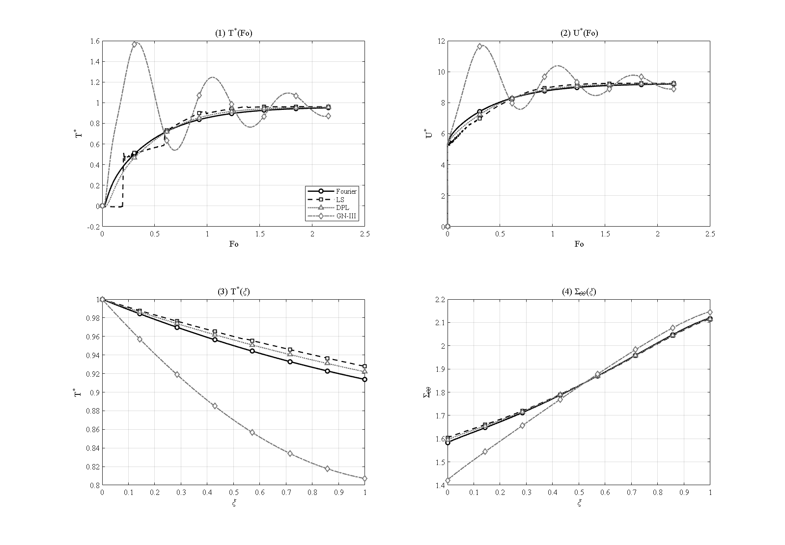
Figure 4-28: Comparison of the generalized thermoelasticity theories — Fourier, Lord–Shulman, dual-phase-lag and Green–Naghdi III [R_o/R_i=1.5, L=2.1 m, N_L=7, W_GPL=0.3%, e_m3=0.8604, τ*=0.15, P_i=50 MPa, simply supported]
In the final extension study the reference problem is solved under four thermoelasticity theories with matched parameters: the classical coupled Fourier theory, the Lord-Shulman theory [4], the dual-phase-lag (DPL) theory [74] with τ_q = τ0 and τ_T = τ_q/2, and the Green-Naghdi type-III theory [67] with k* = k/τ0 (so that its wave speed equals the Lord-Shulman one). According to Figure 4-28, the peak mid-point temperatures order as Fourier 0.950 < DPL 0.956 < Lord-Shulman 0.962 < Green-Naghdi 1.581. Two observations follow. First, at the mild reference relaxation time the Fourier, DPL and Lord-Shulman peaks lie close together, because the wave is weak; DPL interpolates between Fourier and Lord-Shulman, as expected. Second, the Green-Naghdi type-III theory stands apart: it produces a large, early overshoot (peak 1.581 at Fo ≈ 0.33) that then relaxes only slowly (0.870 at the end of the interval), because its energy equation lacks a dissipative mechanism to damp the thermal wave, so its long-time behavior is qualitatively different from the other three. Such a four-theory map for porous GPL-reinforced cylinders does not exist in the literature and is one of the contributions of this research.

4-21. Chapter summary
The main findings of this chapter can be summarized as follows:
- The numerical convergence of the solution was established independently in every direction — radial (converged from N_r = 7), axial (the binding direction; N_z = 5 gives a 9.4 % error, converged by N_z = 9), layers (converged from N_L = 3–5) and time step (Δt ≤ 2 s) — before the solver was verified in five independent tests against exact solutions and references.
- The Lord-Shulman thermal wave produces a mid-wall temperature overshoot that grows with the relaxation time, up to T* = 1.166 at τ* = 0.44 — impossible under Fourier conduction — with the characteristic peak-trough shape of the reflecting wave; at the mild reference τ* = 0.15 the overshoot is small.
- Placing the GPLs at the heated surface (pattern V) and the pores at the cooled surface (pattern A) is synergetic: the full 5×5 pattern matrix shows the best combination, GPL-V with porosity-A, reducing the outer-surface temperature about twenty-six-fold at a benign (compressive) stress level — the design recommendation of this thesis. The alignment or opposition of the mirror patterns V and A governs the thermal performance.
- In the low reference weight-fraction regime a small amount of graphene switches the wall from a poor to a good thermal conductor; adding more mainly raises the thermal stresses (the inner hoop stress reverses to −1.580 at 8 %). At this low weight fraction the platelet aspect ratios are only second-order levers.
- Full coupling damps the thermal wave (about 1 % peak reduction at the reference, growing with wave strength); uncoupled models are non-conservative at the wave fronts.
- Internal pressure enters linearly; at the 50 MPa reference it is a first-order contributor to the stress and displacement, yet the temperature field stays thermally governed and no discontinuity occurs up to 100 MPa.
- Clamped ends reduce the mid-length hoop stress (from 1.526 to 0.424); support effects are localized at the ends, and as the cylinder lengthens the mid-length response converges to the long-cylinder limit.
- Under impulsive (Gaussian) heating the Lord-Shulman pulse reaches the mid-wall about two and a half times stronger than the Fourier one and persists, whereas the classical pulse smears and vanishes.
- Methodologically: Newmark offers the best accuracy-to-cost ratio of the six tested integrators; differential quadrature needs about fifteen times fewer points per direction than finite differences or linear finite elements; and the four-theory map (Fourier / Lord-Shulman / DPL / Green-Naghdi) charts where the theories diverge for this class of structures.

