Chapter 4: Research Findings

4-1. Introduction
This chapter presents and discusses the numerical findings of the research for the multilayer porous GPL-reinforced hollow cylinder under thermo-mechanical loading, based on the governing equations and solution method described in Chapter 3. First, the reference problem and the dimensionless quantities are introduced; then the numerical convergence of the solution and its verification — treated as two independent topics — are established through separate tests. The main parametric studies follow: the GPL distribution pattern, the porosity pattern and level, the GPL weight fraction, the platelet aspect ratio, the relaxation time, the end supports, the internal pressure, the cylinder length, the interaction of the distribution patterns, the coupling of the equations, the convection coefficient, the wall thickness, and a Gaussian thermal shock. Finally, three extension studies that go beyond comparable previous works [6] — a comparison of time-integration methods, a comparison of spatial discretization methods, and a comparison of generalized thermoelasticity theories — are reported, and the chapter is summarized.

4-2. Reference problem and dimensionless quantities
The problem under study is a thick-walled hollow cylinder with inner radius R_i = 0.1 m, outer radius R_o = 0.2 m (R_o/R_i = 2, wall thickness l = 0.1 m), length h = 0.5 m and N_L = 5 layers. In the reference case the GPL distribution across the thickness is uniform (UD) with total weight fraction W_GPL = 4 %, the porosity distribution is uniform (UD) with mass coefficient e_m3 = 0.8980, the Lord-Shulman theory [4] with relaxation time τ0 = 50 s is used in fully coupled form, and both ends are simply supported (S). The loading is as follows: the inner-surface temperature rises from the initial 300 K to 600 K according to the smooth ramp T_in(t) = 300 + 300(1 − e^(−t/t0)) with time constant t0 = 0.5 s, while an internal pressure P_i = 1 MPa acts on the inner surface; the outer surface exchanges heat with the 300 K environment through the convection coefficient h_c = 10 W/m²K. The discretization uses N_r = 9 points per layer and N_z = 11 axial points (layerwise differential quadrature, Chapter 3) with the time step Δt = 0.1 s up to 100 s. The Newmark parameters are δ = 1/2 and β = 1/4 (no numerical damping); accordingly, the small oscillations visible behind sharp wave fronts are the well-known Gibbs effect of the spectral discretization and are deliberately left unfiltered so that the results are reported without manipulation.
For generality, all results are presented in dimensionless form. The reference thermal diffusivity ᾱ = k̄/(ρ̄c̄) = 3.50×10⁻⁴ m²/s belongs to the homogenized reference material, and the definitions are collected in Table 4-1. The Lord-Shulman thermal wave speed of the reference material is v = √(ᾱ/τ0) = 2.65×10⁻³ m/s; crossing half the wall thickness therefore takes about 19 s (Fo ≈ 0.17), which — as will be seen — is exactly where the first wave arrival appears in the time histories.
Table 4-1: Dimensionless quantities used in this chapter.
quantity | definition | value/range
Fourier number (dimensionless time) | Fo = ᾱ t / R_o² | Fo(100 s) = 0.875
dimensionless relaxation time | τ* = ᾱ τ0 / R_o² | 0.44 (reference)
dimensionless temperature | T* = (T − T∞)/(T_in − T∞) | 0 … ≈1.4
dimensionless radial coordinate | ξ = (r − R_i)/l | 0 … 1
dimensionless radial displacement | u* = u(λ̄+2μ̄)/(β̄ ΔT l) | O(1)
dimensionless stress | σ* = σ/(β̄ ΔT) | O(0.1)

4-3. Numerical convergence
Before validating the results, the numerical convergence of the solution must be examined at two independent levels: first, convergence with respect to the number of layers used in the layerwise discretization through the wall thickness, and second, convergence with respect to the spatial discretization method and the number of points it employs. Only after both levels are established can one be confident that any discrepancy with the reference results stems from physical differences rather than residual numerical error.
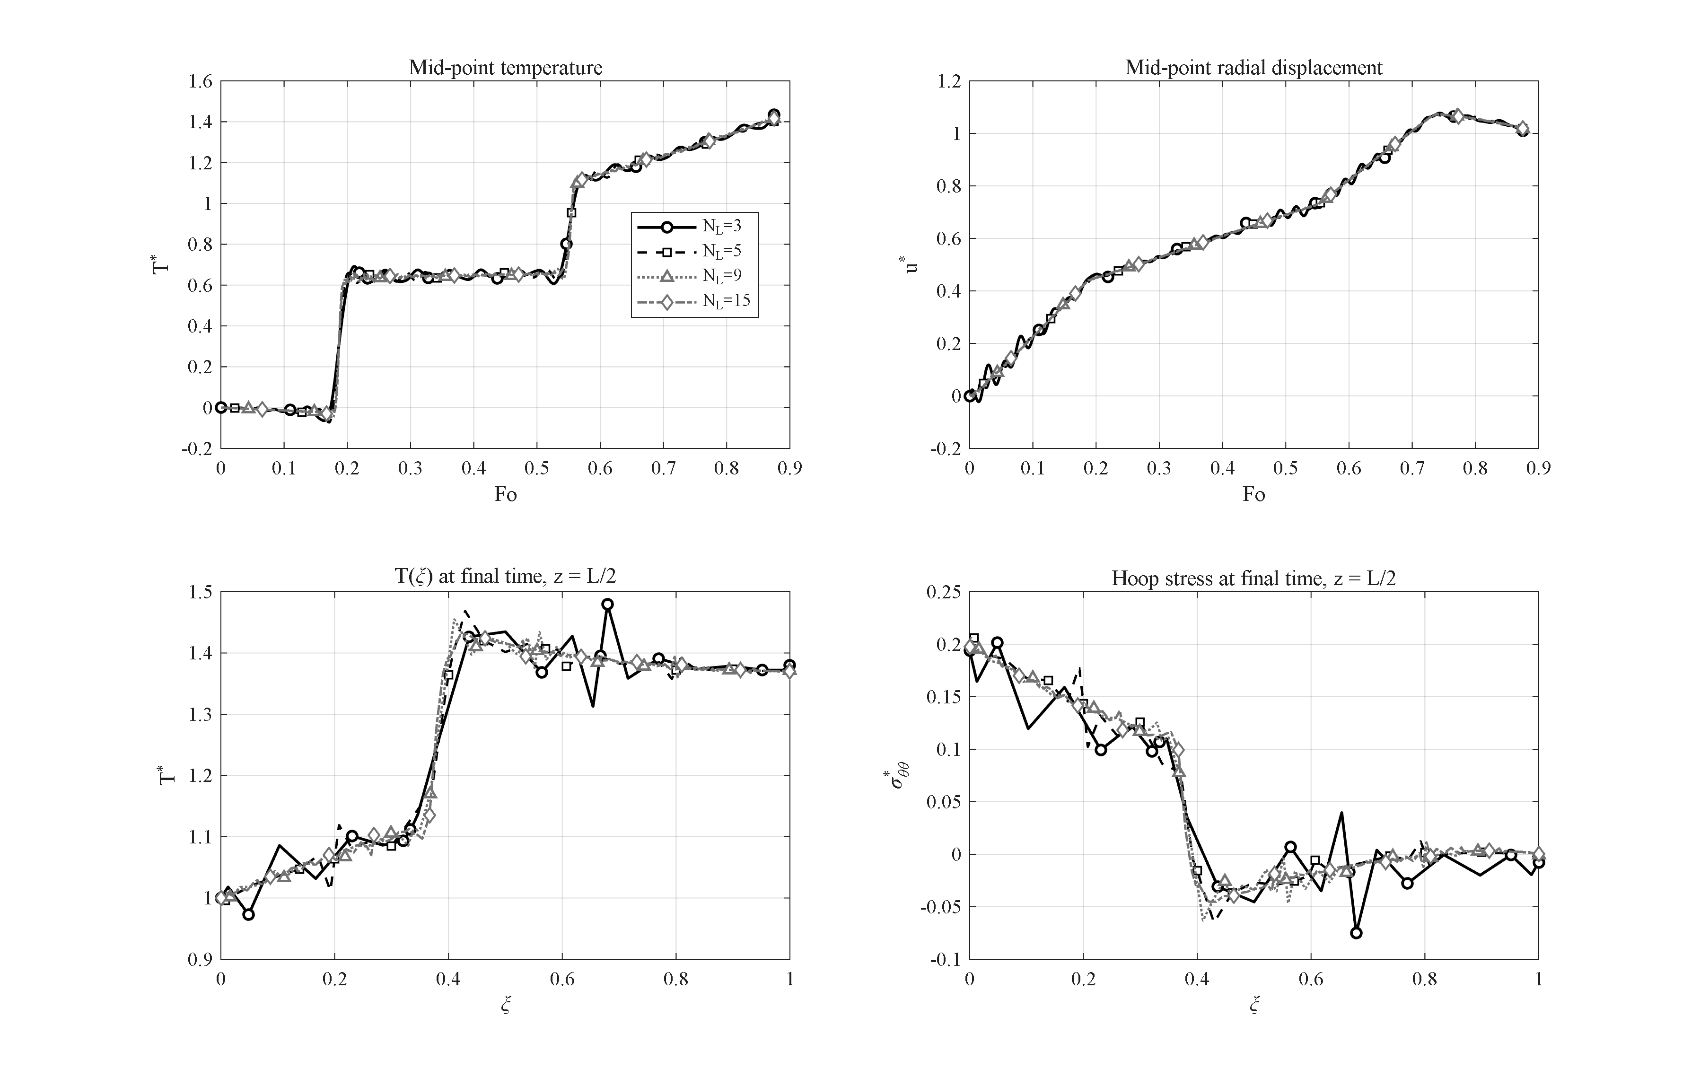
Figure 4-1: Layer convergence — peak mid-point dimensionless temperature versus the number of layers (N_L = 3, 5, 8, 9, 15); the response is converged from N_L = 9 and N_L = 5 is adopted (<1 % from converged).
To assess layer convergence, the peak dimensionless temperature at the mid-point of the wall was computed for different numbers of layers and is shown in Figure 4-1. With three layers the peak dimensionless temperature is 1.435, and as the number of layers is increased to five, eight, nine, and fifteen it tends to 1.412, 1.428, 1.416, and 1.416, respectively. From nine layers onward the dimensionless temperature remains essentially unchanged and convergence has been achieved. Since five layers differ only negligibly (below 1 %) from the converged state while imposing a considerably lower computational cost, five layers are adopted in what follows as a compromise between accuracy and cost; the main effect of a larger layer count is a refinement of the staircase pattern of the hoop-stress profile at the layer interfaces, which is the natural signature of the layerwise property model. Within each layer a mesh of nine radial and eleven axial points is used, with a time step of 0.1 s.
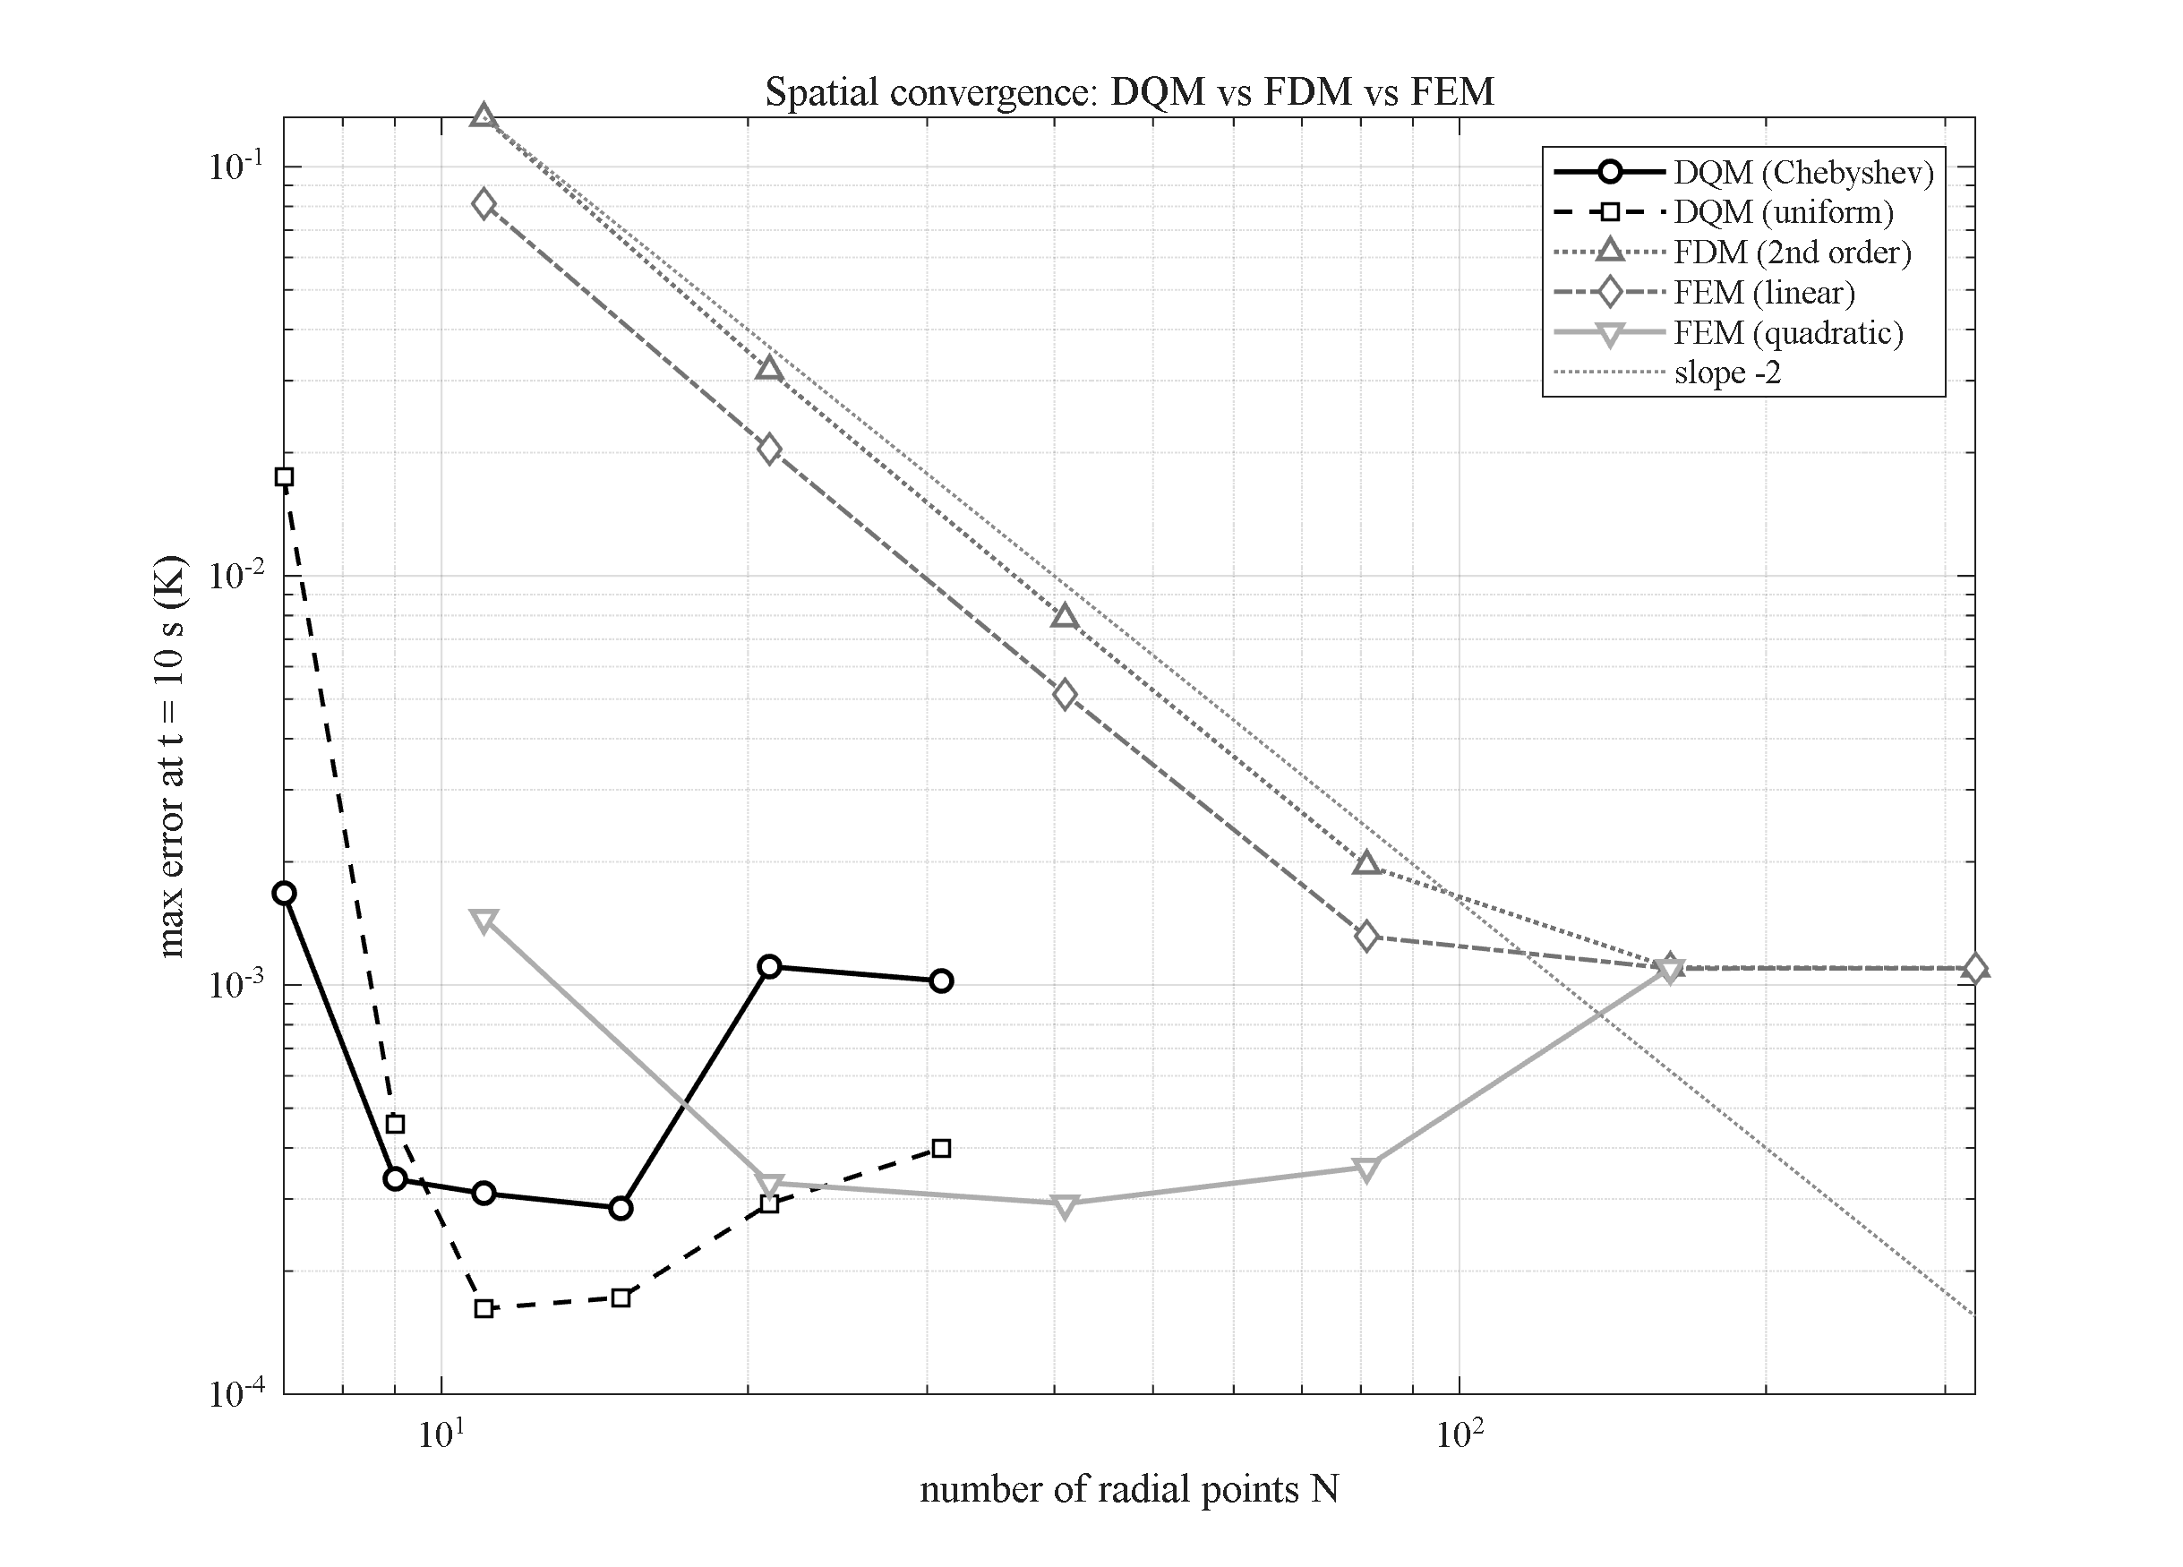
Figure 4-2: Spatial convergence of DQM (Chebyshev/uniform), 2nd-order FDM and FEM (linear/quadratic) on the transient-conduction benchmark; points to reach the time-step error floor are N ≈ 9–11 (DQM), 21 (quadratic FEM), 161 (linear FEM/FDM). Legend moved to the top-right corner.
The superiority of the layerwise differential quadrature method for spatial discretization is also evaluated against the finite difference and finite element methods. A transient heat conduction problem with an exact Bessel-function solution is taken as the benchmark, and the number of points required for the error of each method to reach the time-step error floor is compared; the results are presented in Figure 4-2, whose legend is now located at the top-right corner. The differential quadrature method with a Chebyshev or uniform distribution reaches the error floor with only about nine to eleven points, whereas quadratic finite elements require about twenty-one points, and linear finite elements and the second-order finite difference method require about one hundred and sixty-one points. The differential quadrature system is therefore, per direction, about fifteen times smaller than the corresponding finite difference or linear finite element system. The full methodological comparison, together with the Galerkin finite-element formulation, is reported as an extension study in Section 4-19. In this way the numerical convergence of the solution — both in the number of layers and in the spatial discretization — is fully established before proceeding to the verification of the results.

4-4. Verification
The present numerical solution is verified through five independent checks, based on comparison with exact analytical solutions, published results from the literature, and a commercial finite-element solution. In each check, in addition to the quantitative error, the present result is plotted as a comparison diagram against the corresponding reference so that the coincidence of the curves is demonstrated visually; these diagrams are collected in the verification appendix. First, the assembly of the static matrices is checked against an independent static solver, with a maximum displacement-field difference of order 2×10⁻¹¹, confirming the numerical equivalence of the two implementations and the correctness of the system assembly.
In the second check, the dynamic-mechanics part of the problem is compared with the results of Malekzadeh (Table 6 of reference [31], IJPVP 2012) and with an independent ANSYS finite-element solution. The dimensionless radial displacement is reproduced with a relative difference of 0.1 to 0.2 percent, and the dimensionless inner-surface radial stress is obtained exactly as −1.000, in full agreement with the unit-pressure loading boundary condition.
In the third check, the transient heat-conduction problem is compared with the exact Bessel-series solution; the dimensionless temperature distribution at various time steps lies on the exact curve, with a relative error of 10⁻⁵ to 10⁻⁷. In the fourth check, the Newmark time integration is validated against MATLAB's reference solver ode15s, and the maximum temperature difference over the whole interval is 0.003 K, confirming the stability and accuracy of the adopted time-integration scheme.
Finally, in the fifth check, the wave-propagation behavior of the coupled Lord-Shulman theory is compared with the results of Bagri and Eslami (2007, reference [7]); both wave speeds (elastic and thermal) and the reflection times within the cylinder wall are correctly reproduced, and the present wave fronts coincide with those of the reference. Taken together, these five checks confirm the validity of the present numerical solution in both the static and transient regimes and in the coupled and uncoupled cases. A summary is given in Table 4-2.
Table 4-2: Summary of the solver verification tests.
# | test | reference | result
1 | static spatial assembly | independent static solver | agreement 2×10⁻¹¹
2 | dynamic mechanical response | reference [31] + ANSYS | error 0.1–0.2 %; σ_rr exact
3 | transient conduction | exact Bessel-series solution | rel. error 10⁻⁵–10⁻⁷
4 | time integration | ode15s (independent) | max difference 0.003 K
5 | coupled Lord-Shulman waves | Bagri & Eslami [7] | speeds and reflections matched

4-5. Effect of the GPL distribution pattern
In the first parametric study, the effect of five GPL distribution patterns across the thickness (UD, O, X, V and A) is examined with all other parameters held at their reference values. Figure 4-3 shows the time histories of the dimensionless temperature and radial displacement of the mid-thickness point at the mid-length section (panels a and b) and the radial profiles of the dimensionless temperature and hoop stress at the final time (panels c and d).
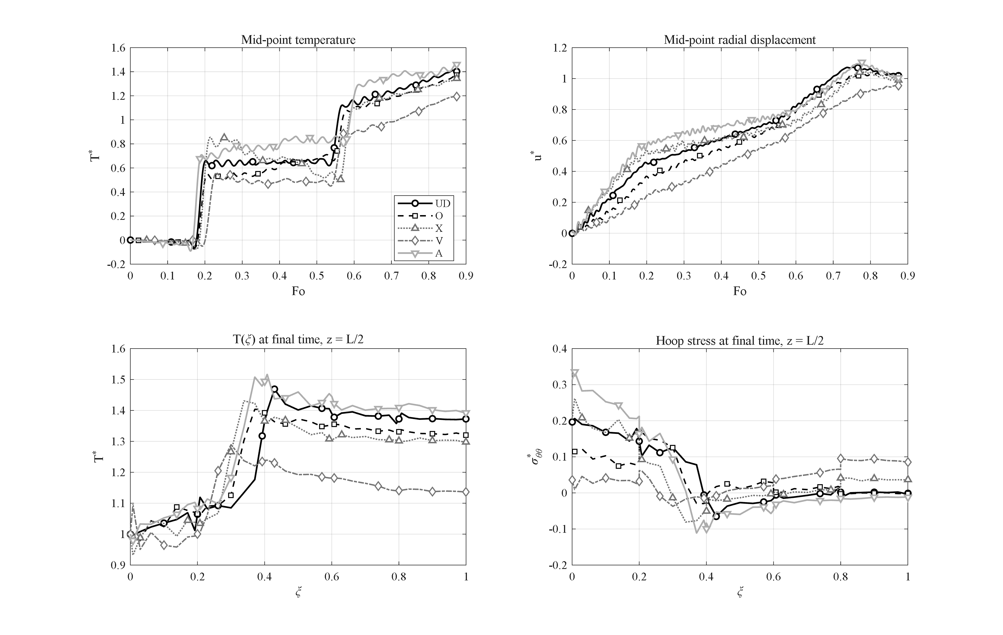
Figure 4-3: Effect of the GPL distribution pattern (UD, O, X, V, A): (a) mid-point temperature history; (b) mid-point radial displacement history; (c) radial temperature profile and (d) hoop-stress profile at the final time (z = h/2).
As observed, the peak mid-point temperature for patterns UD, O, X, V and A is 1.41, 1.37, 1.34, 1.19 and 1.46, respectively. Pattern V, in which the GPLs are concentrated at the inner surface, shows the most favorable behavior, because the highly conductive inner region spreads the incoming heat rapidly through the thickness, so its peak temperature is about 16 percent lower than UD. Physically, placing the stiff, conductive phase where the temperature gradient is steepest — the heated inner wall — both moderates the thermal gradient and reinforces the critical hoop-stress region.
The key feature of this study is the peak-trough shape of the dimensionless temperature histories, which stems directly from the wave-like nature of heat conduction in the Lord-Shulman theory: as the thermal wave front reaches the mid-point, the temperature rises rapidly to a peak and then, after the front passes and before the reflected wave returns from the outer surface, drops into a transient trough. The depth of this peak and trough depends strongly on the distribution pattern. Against this background, a mirror and inverse behavior emerges between the two asymmetric patterns V and A: geometrically they are mirror images about the mid-thickness (V is GPL-rich at the inner surface while A is GPL-rich at the outer surface), and they behave in exactly opposite ways. Pattern V, placing the conductive phase facing the heat source, produces a low, mild peak (1.19) with the smallest oscillation amplitude, whereas pattern A, by placing the low-conductivity epoxy matrix at the inner surface, traps heat within the inner band and experiences the sharpest and highest peak (1.46). The symmetric patterns UD, O and X fall between these extremes, and this mirror ordering clearly explains why V is the best and A the worst.
This inverse behavior is also reflected in the mechanical response, all three quantities following the same ordering. The final inner-surface hoop stress for pattern V is 0.036, about 5.5 times smaller than UD (0.196) and 8.8 times smaller than pattern A (0.313); that is, the two ends of the mirror spectrum record the lowest and highest stress. The radial displacement follows the same trend, its maximum ranging from 0.95 for V to 1.11 for A. Pattern V therefore simultaneously delivers the lowest temperature, the lowest hoop stress and the smallest displacement, while its mirror pattern A is the worst case in all three; pattern V is therefore recommended for the GPL distribution in cylinders under internal thermal shock.

4-6. Effect of the porosity pattern and porosity level
This section examines the effect of the porosity distribution pattern across the wall thickness for the five patterns UD, O, X, V and A; in all cases the GPL distribution is kept uniform (UD) and the remaining parameters are held at their reference values. Figure 4-4 shows the time histories of the dimensionless temperature and radial displacement of the mid-point together with the radial profiles of the temperature and hoop stress at the final time. The porosity pattern acts essentially by reshaping the heat-conduction path, since a porous band of negligible conductivity behaves as a localized thermal resistance. The three symmetric patterns UD, O and X behave similarly, with mid-point peak temperatures of 1.41, 1.42 and 1.37; in these patterns the porous phase is either uniformly spread or placed symmetrically about the mid-thickness and therefore does not render the conduction path fundamentally asymmetric.
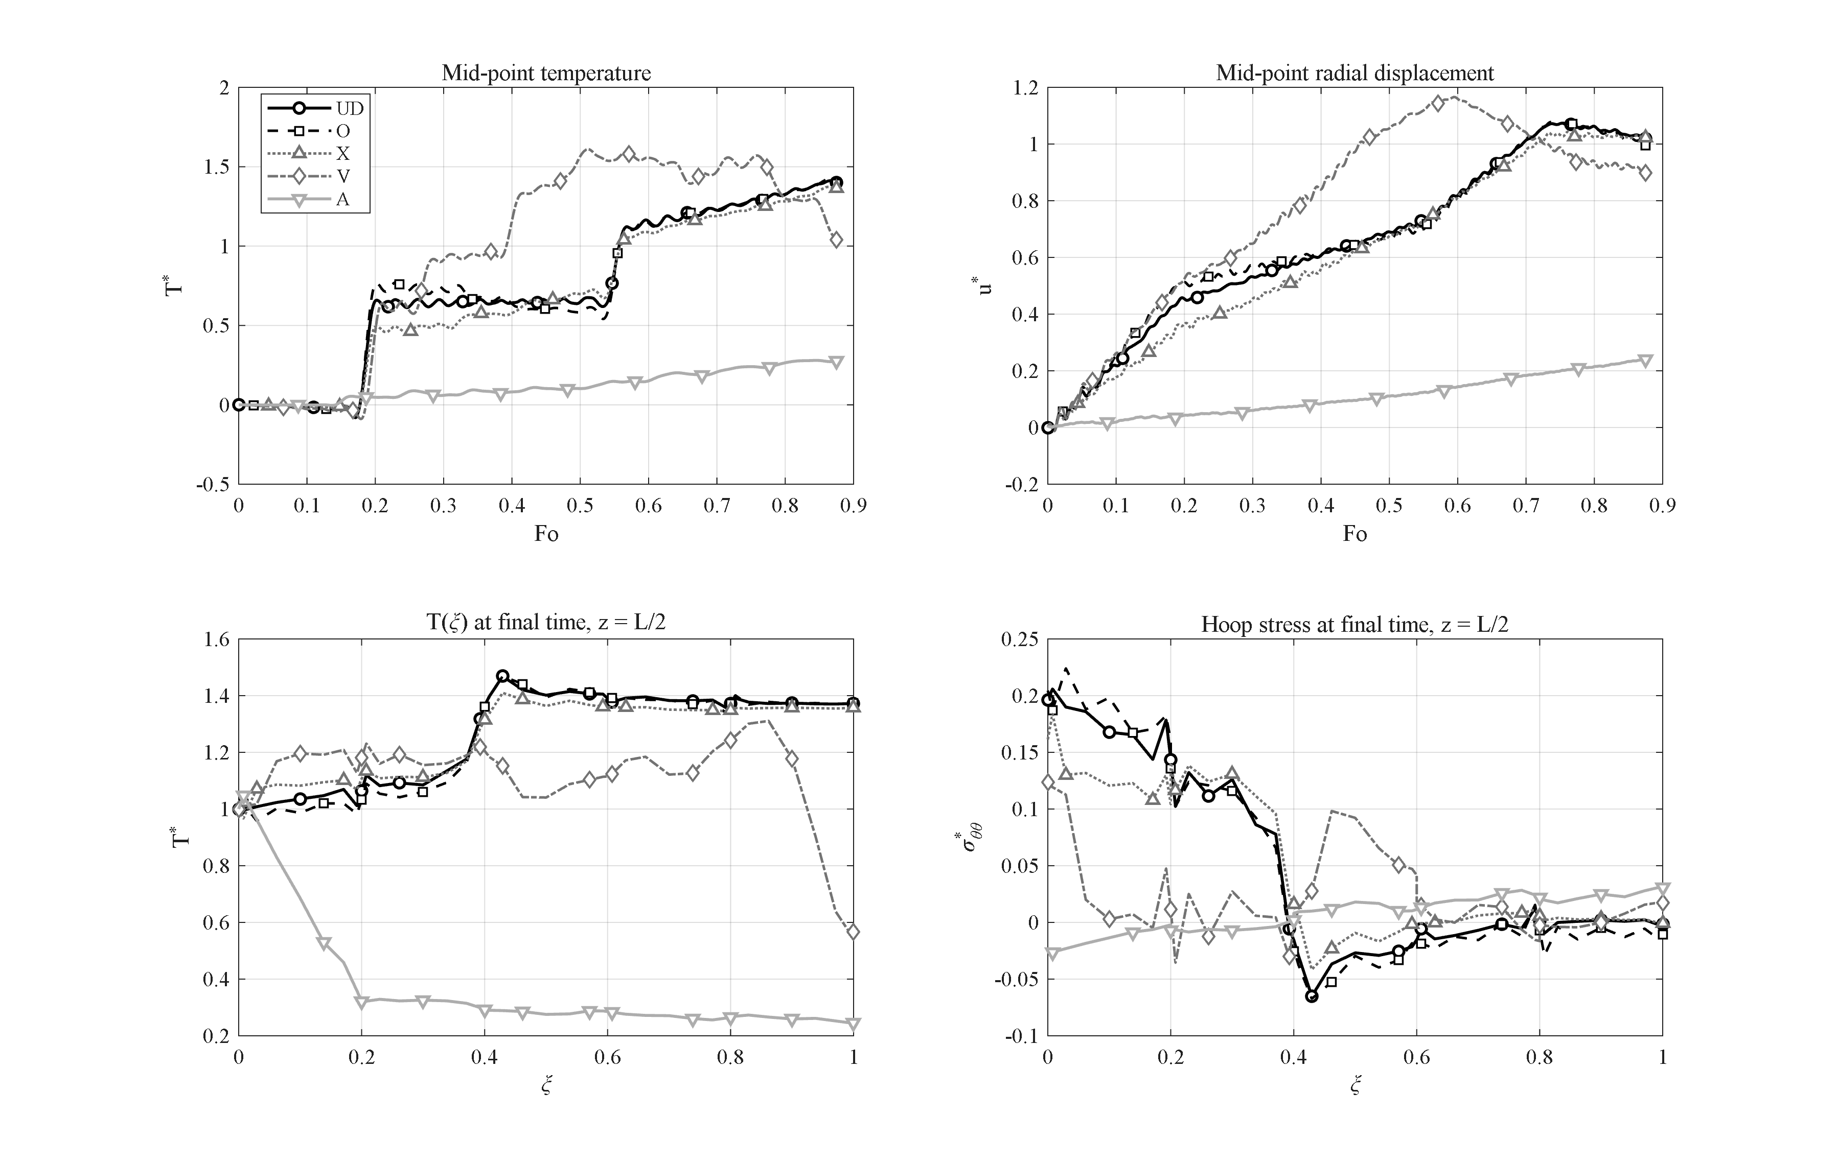
Figure 4-4: Effect of the porosity distribution pattern (UD, O, X, V, A) at uniform GPL distribution; pattern A acts as a thermal barrier and pattern V shows the largest transient trapping peak.
The key result lies in the two asymmetric patterns V and A, which are mirror images of each other yet produce completely opposite thermal responses. In pattern V the pores are concentrated at the heated inner surface; this insulating band traps the incoming heat near the inner surface at the very outset and prevents its rapid spread through the thickness. As a result the mid-point temperature history displays a pronounced transient peak — the largest overshoot of this group — reaching 1.61 at a Fourier number of 0.51; the same inner porous band then acts as a barrier against further heat inflow, and the curve falls until the mid-point temperature returns to 1.04 by the end of the interval. At the opposite extreme, pattern A concentrates the pores at the cooled outer surface, so that instead of trapping the heat it blocks the heat-exit path toward the environment and thus behaves as a genuine thermal barrier. In this pattern the mid-point temperature never exceeds 0.28 and the outer-surface temperature remains at 0.25 — a 5.6-fold reduction with respect to the value 1.37 of pattern UD. Shifting the porous band from the inner to the outer surface therefore transforms the thermal response from a tall, deeply relaxing transient peak (pattern V) into a smooth, suppressed curve (pattern A); the mirror symmetry of the geometry leads to a mirror contrast of performance.
The favorable thermal performance of pattern A is paid for on the mechanical side. Because the heat never penetrates deep into the wall, the thermal expansion and hence the radial displacement drop sharply, and the peak dimensionless displacement collapses to 0.24. Moreover, the unusual resulting temperature distribution reverses the sign of the inner-surface dimensionless hoop stress, which reaches a negative value of 0.025; that is, the inner region, normally under hoop tension, turns compressive in this pattern. This sign reversal must be carefully accounted for in the design of cylinders under internal thermal shock.
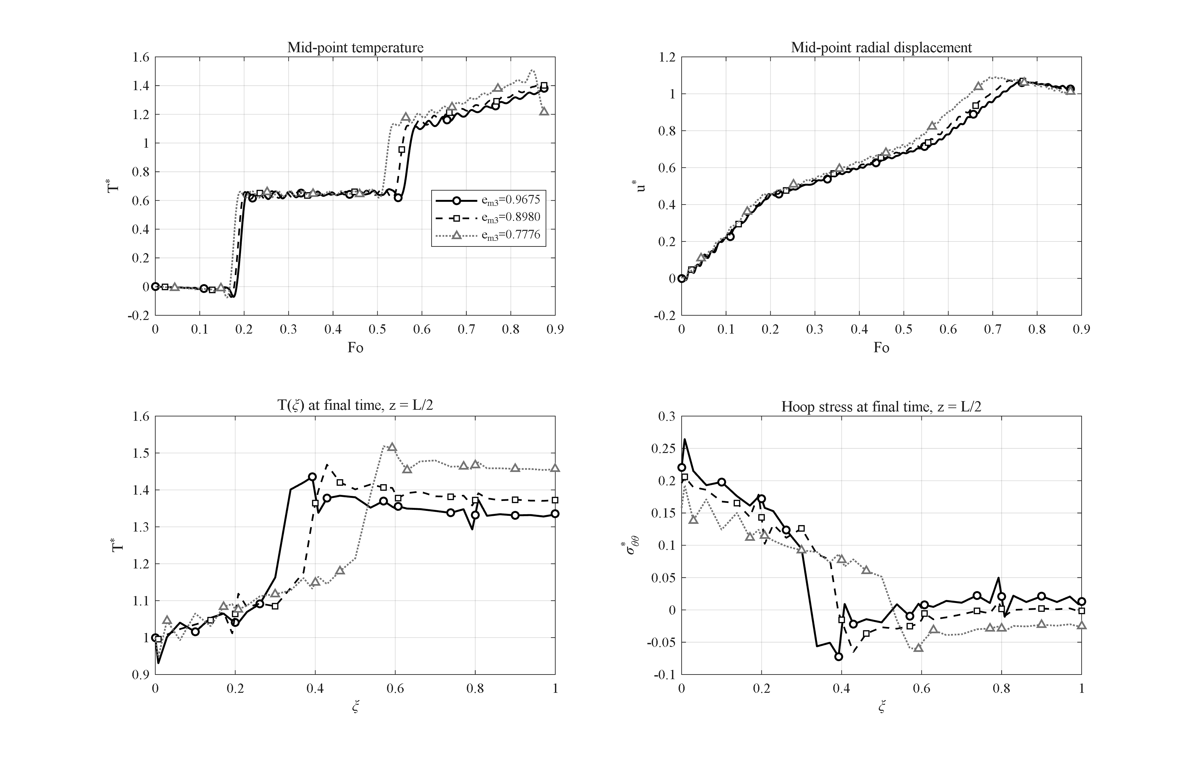
Figure 4-5: Effect of the porosity level (e_m3 = 0.9675, 0.8980, 0.7776) on the transient thermoelastic response.
Finally, the effect of the overall porosity level is shown in Figure 4-5 for the three mass coefficients e_m3 = 0.9675, 0.8980 and 0.7776 (light, moderate and heavy porosity). Increasing the porosity reduces the conductivity and the stiffness simultaneously; consequently the peak temperature grows mildly (from 1.38 to 1.41 and 1.51) while the diffusion process slows down, so that the final mid-point value for the heavy porosity drops to 1.21 — at the end of the time window the wall is still filling with heat.

4-7. Effect of the GPL weight fraction
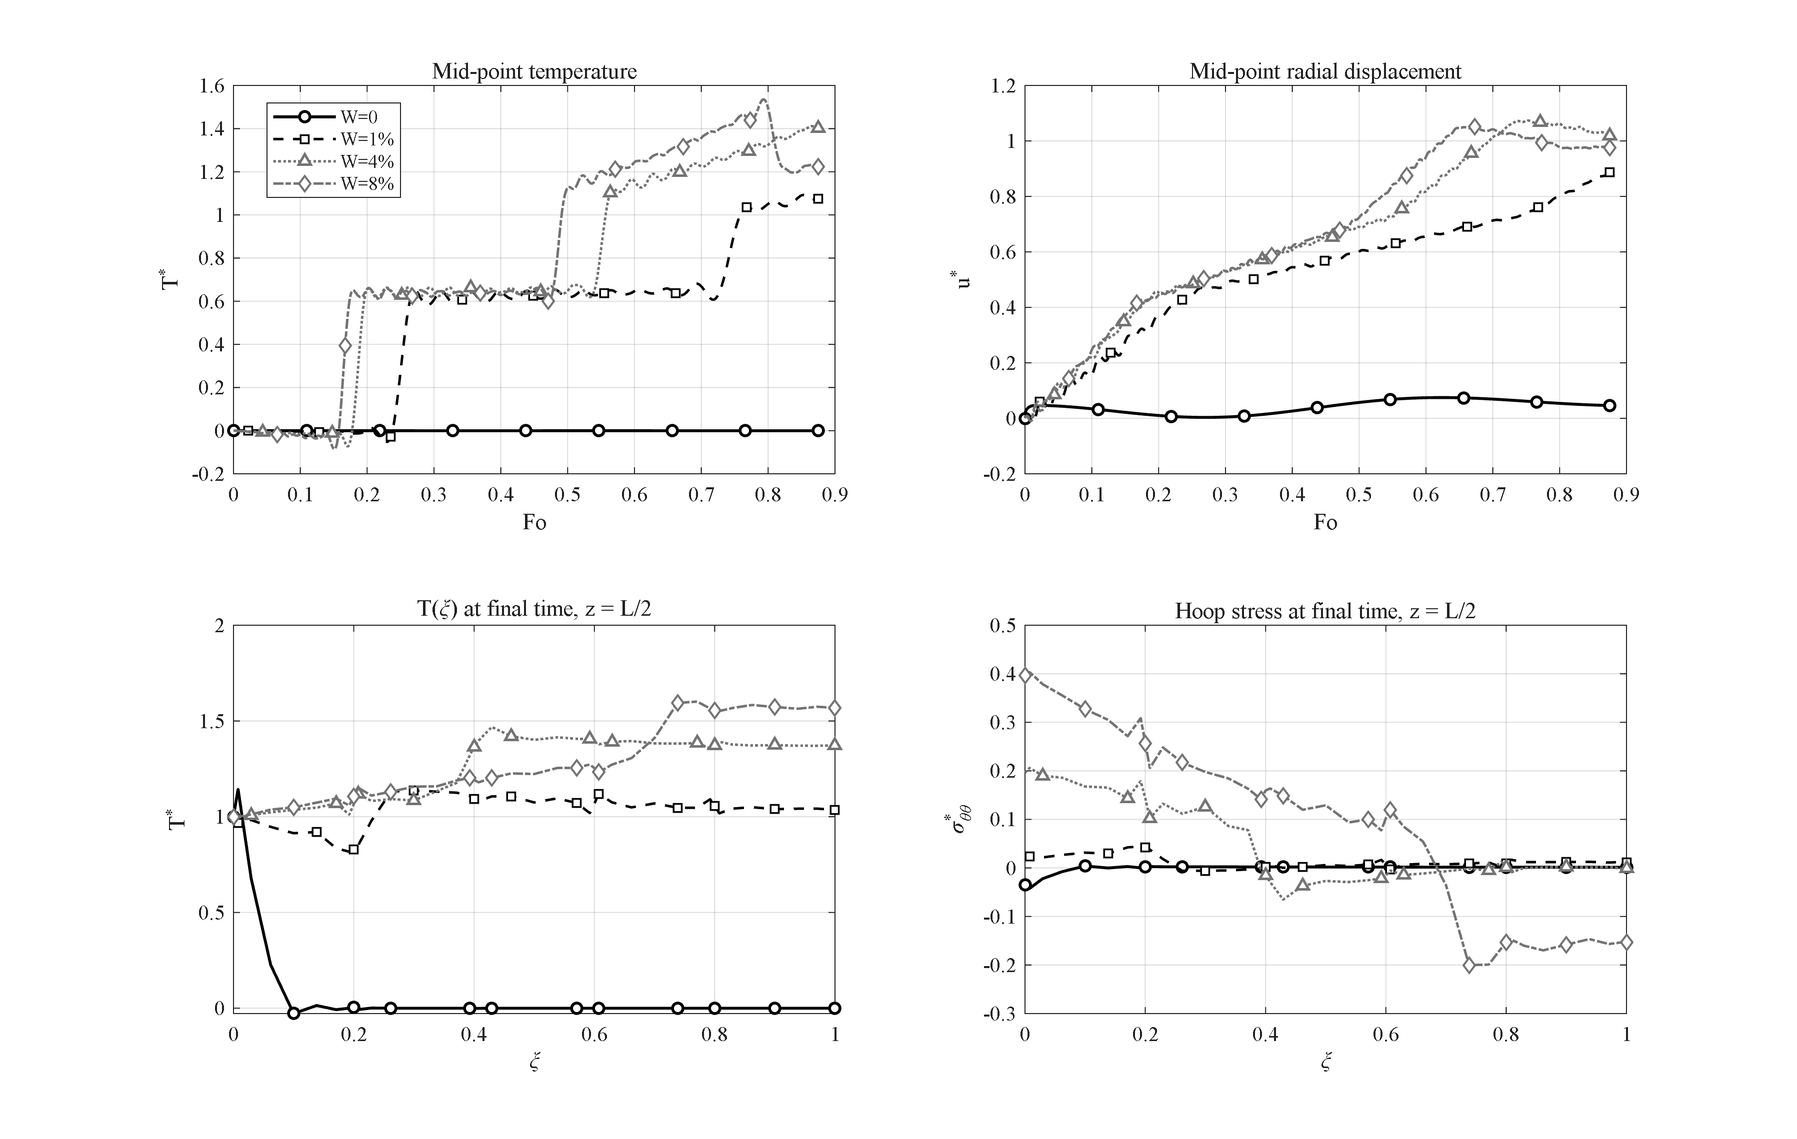
Figure 4-6: Effect of the GPL weight fraction (W = 0, 1 %, 4 %, 8 %): the percolated GPL network switches the wall from thermally insulating to conducting behavior.
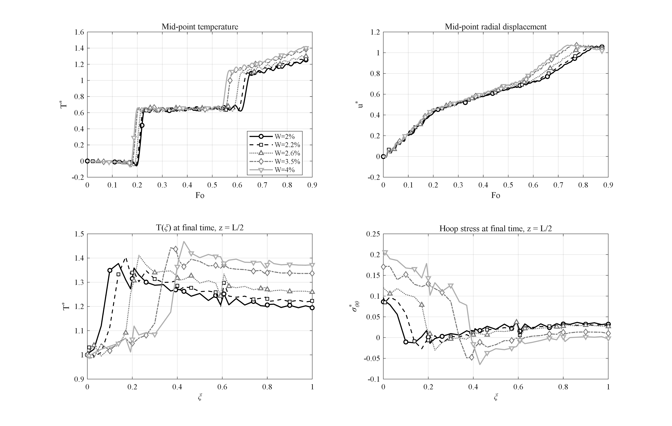
Figure 4-7: Zoom of the transition band (W = 2, 2.2, 2.6, 3.5, 4 %) above the percolation threshold: the peak temperature rises smoothly and monotonically with no further jump.
The percolation character of the thermal-conductivity model (Chapter 3) makes the GPL weight fraction the strongest material lever of the problem. According to Figure 4-6, without GPLs (zero weight fraction) the wall consists of pure porous epoxy with a thermal conductivity of about 0.25 W/mK and a thermal diffusivity of about 1.9×10⁻⁷ m²/s; within the whole 100-second window the thermal wave does not even reach the mid-thickness and the dimensionless temperature remains close to zero throughout, while the small observed radial displacement of about 0.075 is merely the response to the internal pressure.
Adding only 1 % of GPLs by weight, the percolated graphene network raises the thermal conductivity by about three orders of magnitude and the familiar transient behavior is established; at this point the peak dimensionless mid-point temperature reaches 1.09. This jump reveals the percolation threshold of the graphene network at a weight fraction of about 1 %: below this level the wall stays effectively an insulator, and slightly above it a continuous conductive heat path is opened. To resolve the behavior just above the threshold, the transition range of 2 to 4 % is scanned finely in Figure 4-7 (a zoom of the same range): the peak mid-point temperature for the weight fractions 2, 2.2, 2.6, 3.5 and 4 % is 1.254, 1.262, 1.303, 1.386 and 1.412, respectively. Once the percolated network is active the temperature rises smoothly and monotonically with increasing weight fraction and no further abrupt jump occurs; the main transition is concentrated only near the 1 % threshold, and the subsequent increases are gradual corrections interpolating between the reference values.
Increasing the weight fraction further to 8 % raises the peak mid-point temperature to 1.535; at the same time, however, the wall stiffness increases strongly and the final inner-surface hoop stress doubles relative to the reference case (0.397 versus 0.196). The practical conclusion is that a small GPL weight fraction — around the same 1 % threshold — suffices to switch the structure from a "thermal insulator" to a "thermal conductor", and adding graphene beyond that, while producing only a mild and smooth improvement in heat diffusion, mainly raises the thermal stresses. It is worth noting that most previous works examined GPL weight fractions in the range 0.1 to 2 %; in this work the range is extended up to 4 % (reference) and 8 % in order to fully expose the upper reinforcement limit and the saturation behavior beyond the percolation threshold.

4-8. Effect of the GPL aspect ratio
The Halpin–Tsai model employed in Chapter 3 to estimate the effective modulus and thermal conductivity of the nanocomposite makes the reinforced properties depend not only on the volume fraction but also on the geometry of the graphene platelets. This geometry is described by two independent aspect ratios: the length-to-width ratio, entering through the characteristic length a_GPL, and the width-to-thickness ratio, appearing through the characteristic thickness t_GPL. In this section the effect of each ratio is examined separately while all other parameters are held at their reference-case values.
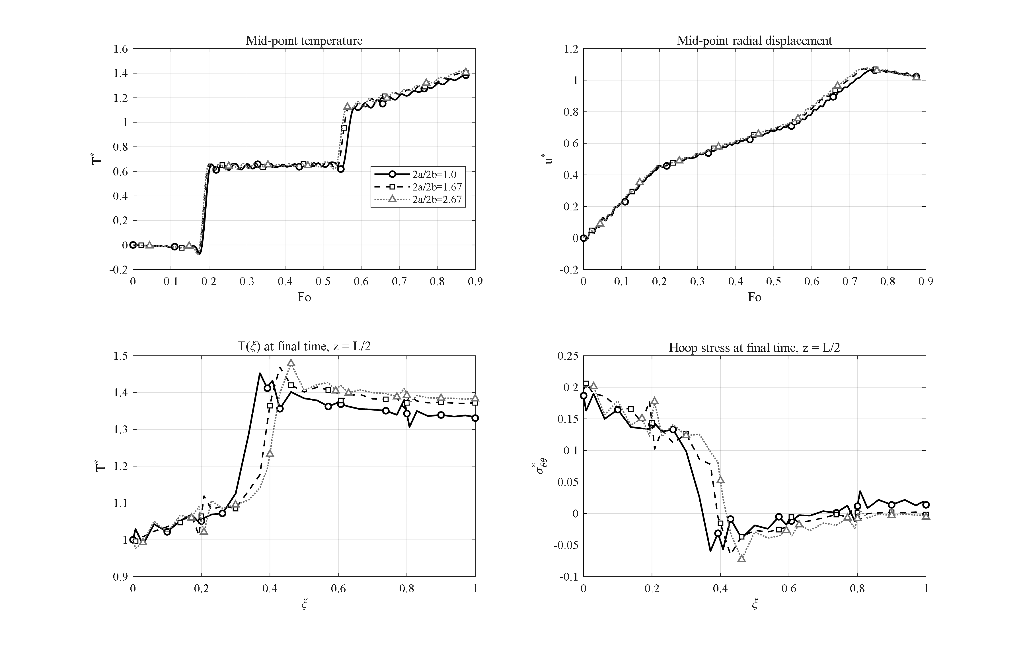
Figure 4-8: Effect of the GPL length-to-width aspect ratio (via a_GPL, ratio 1 → 1.67 → 2.67): the response is weakly sensitive (~3 % change in peak temperature).
The effect of the length-to-width ratio is shown in Figure 4-8. As this ratio increases from unity to 1.67 (reference) and then to 2.67, the maximum dimensionless temperature rises from 1.384 to 1.412 and 1.416, while the inner-surface hoop stress increases from 0.187 to 0.196 and 0.202. The structural response is only weakly sensitive to this ratio: a substantial increase produces a change of only about three percent in the peak temperature, because in the Halpin–Tsai coefficients the geometric factor associated with the platelet length plays a subordinate role relative to that of the thickness.
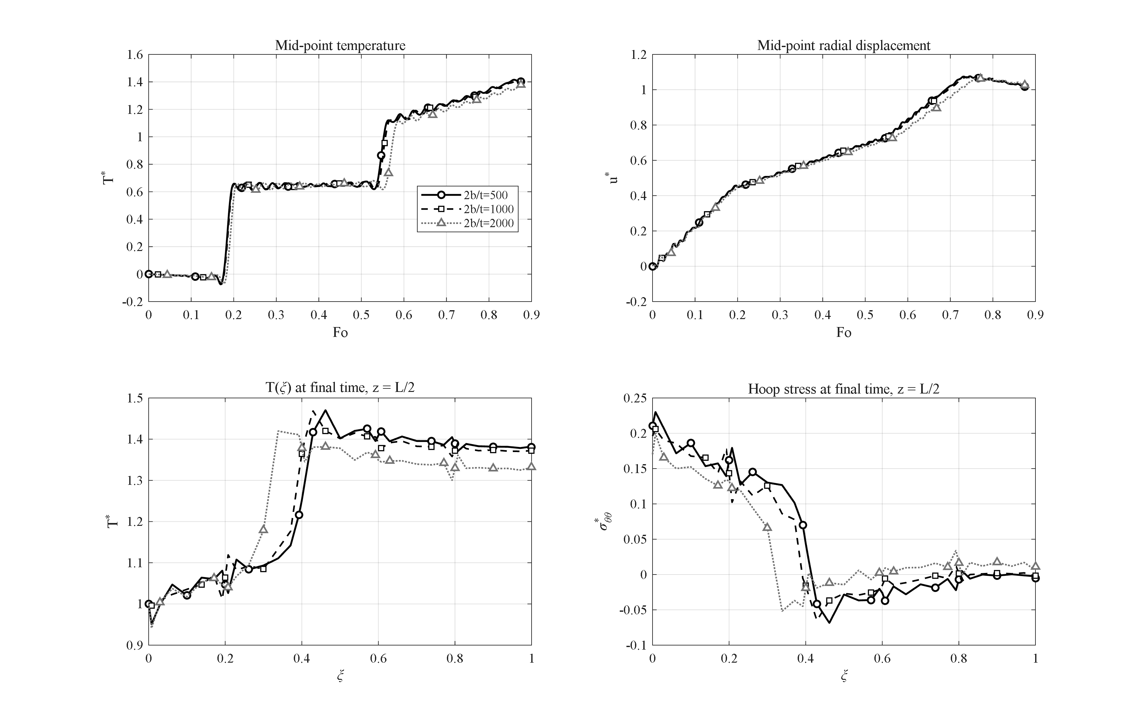
Figure 4-9: Effect of the GPL width-to-thickness aspect ratio (via t_GPL, ratio 500 → 1000 → 2000): the dominant reinforcement lever — inner hoop stress changes by ~20 %.
By contrast, the effect of the width-to-thickness ratio (Figure 4-9) is far more pronounced. As this ratio increases from 500 to 1000 (reference) and then to 2000, the maximum dimensionless temperature rises from 1.378 to 1.412 and 1.415; however, the inner-surface hoop stress increases from 0.170 to 0.196 and 0.210, a change of about twenty percent. The factor ξ_T, which sets the reinforcement weight along the platelet width, scales with the width-to-thickness ratio, so this ratio becomes the dominant reinforcement lever. Thinner platelets with a higher aspect ratio impart a greater effective modulus and thermal conductivity to the wall, thereby raising both the thermal penetration and the thermal stress.
The overall conclusion is that, among the two aspect ratios, the width-to-thickness ratio is the governing reinforcement lever, whereas the length-to-width ratio plays a second-order role. From a design standpoint, thinner platelets provide more effective reinforcement, but this is accompanied by a comparatively larger increase in thermal stresses (about twenty percent) against a modest rise in the peak temperature (about three percent), a trade-off that must be accounted for when selecting the platelet geometry.

4-9. Effect of the relaxation time; Lord-Shulman versus Fourier
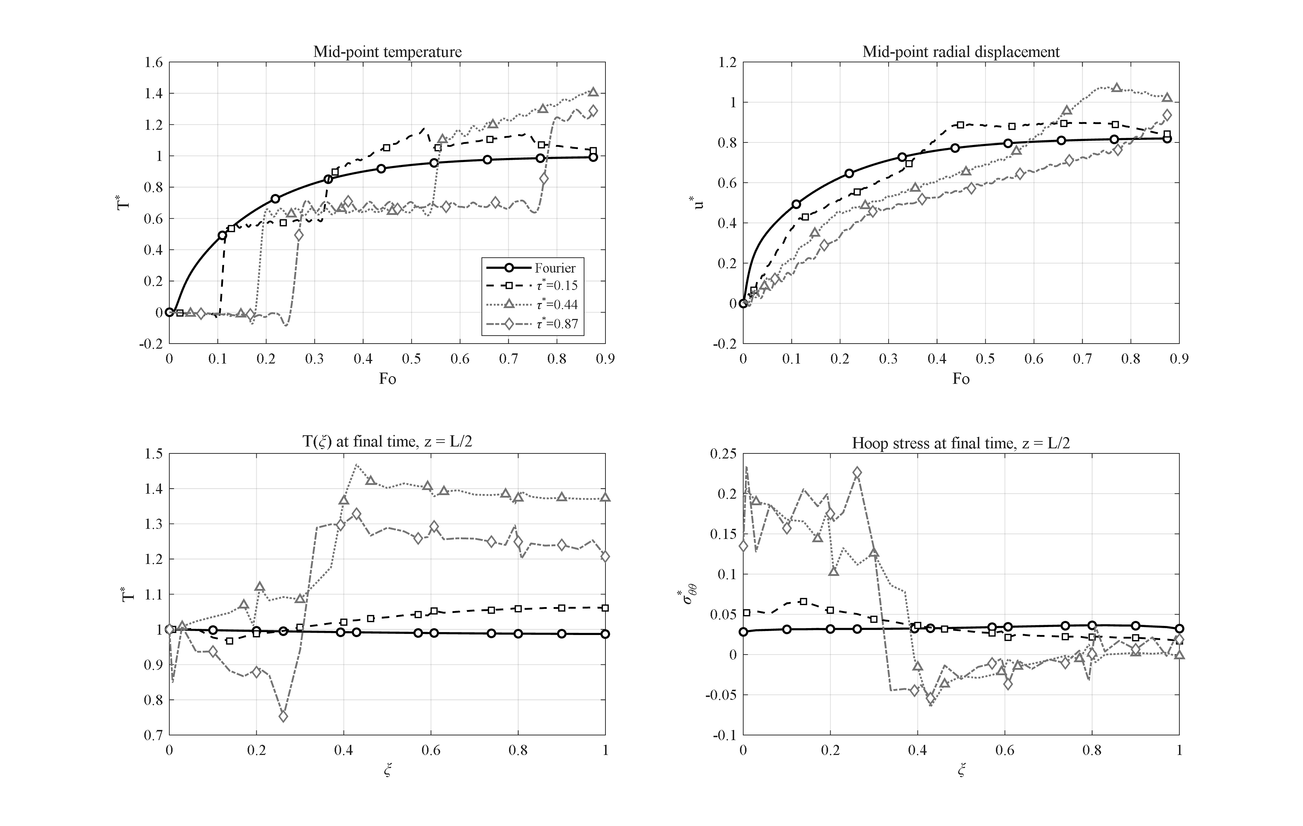
Figure 4-10: Effect of the dimensionless relaxation time (Fourier and τ* = 0.15, 0.44, 0.87): wave arrivals at Fo ≈ 0.17 and 0.55 and the hyperbolic overshoot T* > 1; the mild oscillations behind the fronts are the unfiltered Gibbs effect (δ = 1/2).
Figure 4-10 compares the response for Fourier conduction (τ* = 0) and for three values of the dimensionless relaxation time, τ* = 0.15, 0.44 and 0.87. Under Fourier conduction the mid-point temperature increases monotonically and never exceeds the driving value (T*_max = 0.99), since classical diffusion, with its unbounded propagation speed, cannot produce any overshoot. With the relaxation time active in the Lord-Shulman theory, the heat propagates as a wave with the finite speed √(ᾱ/τ0): the first wave arrival at the mid-thickness for τ* = 0.44 is clearly visible at Fo ≈ 0.17, followed by a second front — the reflection from the outer surface — at Fo ≈ 0.55. Remarkably, owing to the cylindrical geometry and the superposition of the reflected wave, the temperature overshoots even the inner-surface value; a purely hyperbolic phenomenon impossible in the parabolic Fourier theory. The peak temperatures are 1.17 for τ* = 0.15, 1.41 for τ* = 0.44 and 1.30 for τ* = 0.87 (at the end of the interval and still rising — the slower wave completes fewer passes within the window). The relaxation time thus controls both the wave arrival times and the overshoot amplitude, and its clear signature in the temperature histories is the central physical argument for employing generalized thermoelasticity in short-time analyses of such structures [3].

4-10. Effect of the end supports
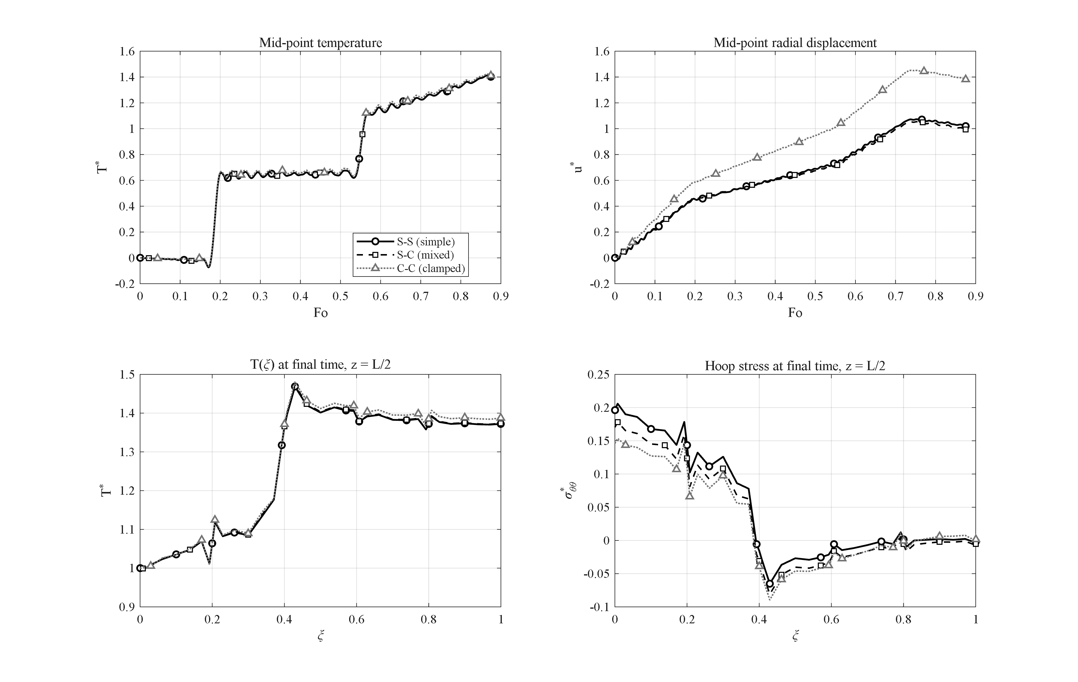
Figure 4-11: Effect of the end supports (S-S, mixed S-C, C-C): the temperature field is unchanged while the blocked axial expansion raises the mid-length radial displacement by about 35 %.
The effect of the end supports is examined for three cases: simply supported at both ends (S-S), one end simply supported and the other clamped (S-C) as a mixed case, and clamped at both ends (C-C). As shown in Figure 4-11, the temperature field is nearly independent of the support type, and the peak dimensionless temperature for all three cases lies in the narrow range 1.412 to 1.423; this is natural, since the mechanical support does not directly alter the thermal problem.
The mechanical response, however, depends strongly on the support. With both ends clamped, the axial thermal expansion of the wall is blocked and, by the Poisson effect, redirected radially; consequently the peak dimensionless radial displacement rises from 1.073 in the simply supported case to 1.451 in the clamped case, an increase of about 35 %. The mixed case shows intermediate behavior for the inner hoop stress: the dimensionless inner-surface hoop stress for the S-S, mixed, and C-C cases is 0.196, 0.170, and 0.146, respectively, and the mixed value lies correctly between the two limiting cases.
It is noteworthy that the peak displacement of the mixed case (1.054) is close to the simply supported case rather than the clamped case, because at the mid-length section the simply supported end governs the radial freedom and the effect of the clamped end remains confined to the half nearer to it. Furthermore, the disturbances caused by either support decay within a distance of roughly one wall thickness from the ends; reporting mid-length quantities as the characteristic response of the structure is therefore justified.

4-11. Effect of the internal pressure
The effect of the internal pressure is examined with a full pressure sweep at six values 0, 10, 30, 50, 70, and 100 MPa, so that the behavior is covered from low pressures to very high pressures. As shown in Figure 4-12, the temperature field remains practically independent of the internal pressure, because thermal and mechanical loading are linked only through the weak coupling term in the energy equation, and pressure is not a direct driver of temperature. By contrast, the mechanical response grows linearly with pressure: the peak dimensionless radial displacement rises from 1.073 with no pressure to 1.086, 1.115, 1.143, 1.171, and 1.214, respectively, with an increment of exactly 0.0283 per 20 MPa; this perfect linearity reflects the linear nature of the thermoelastic model employed.
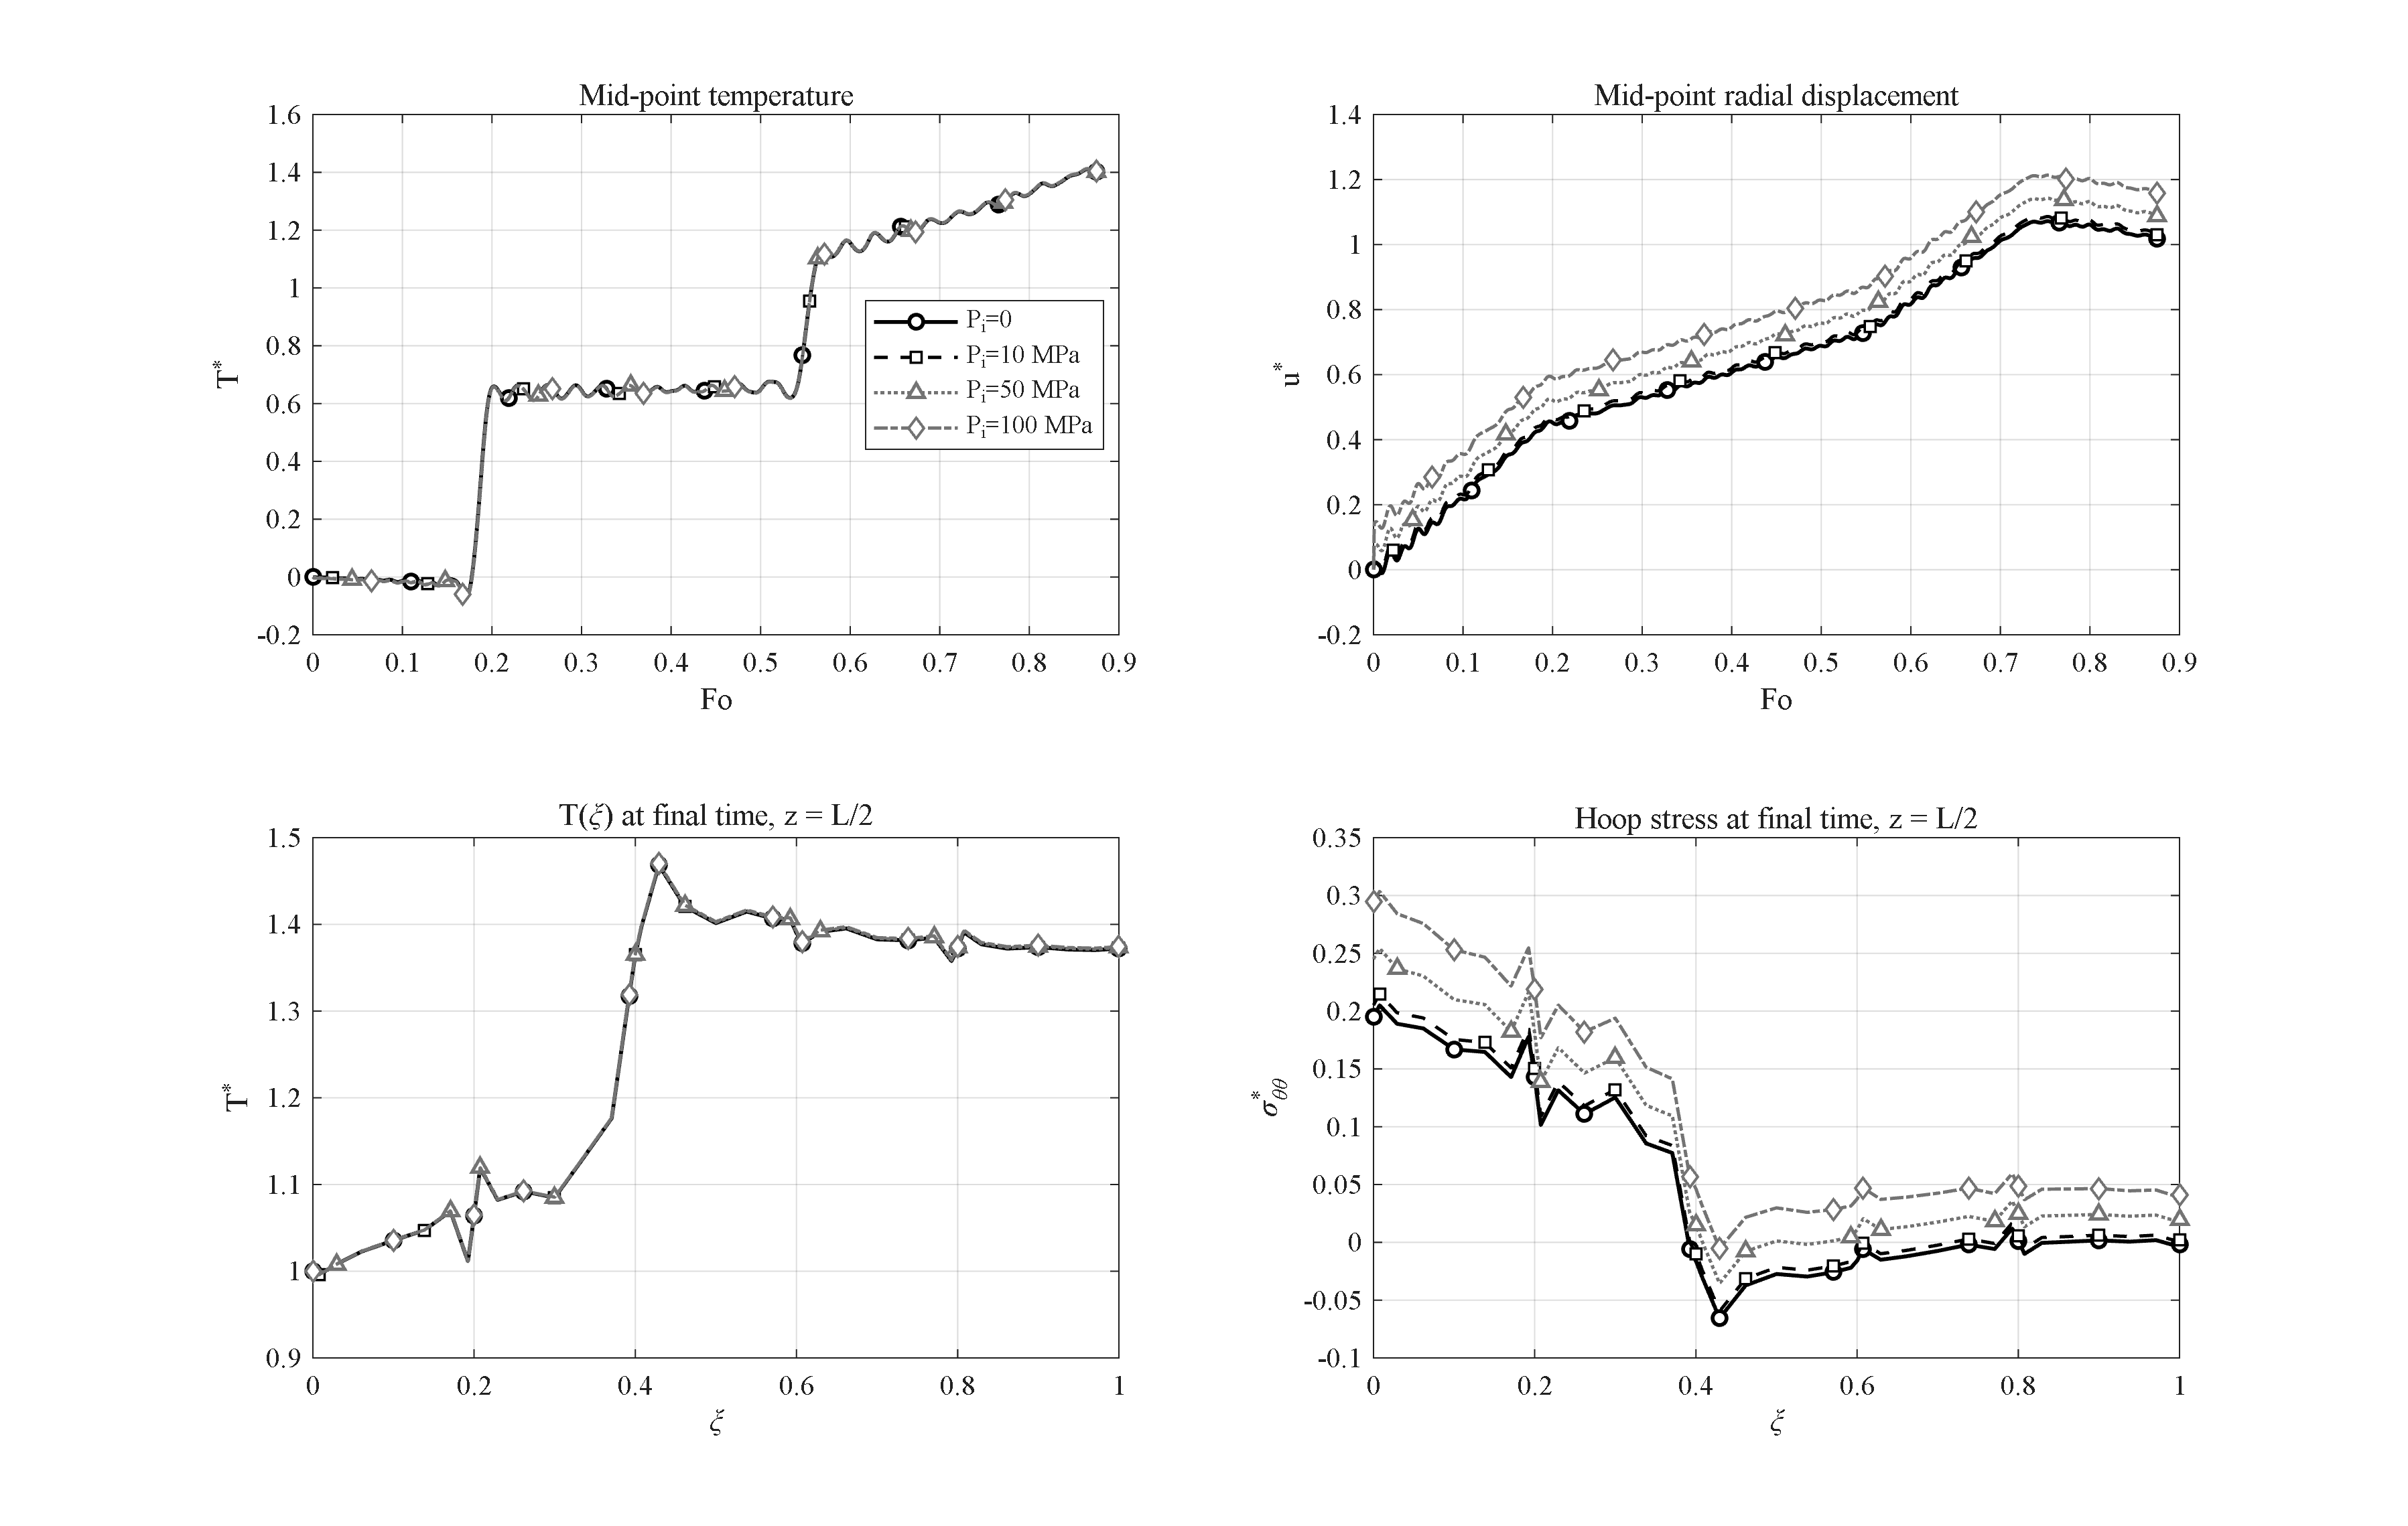
Figure 4-12: Pressure sweep (P_i = 0, 10, 30, 50, 70, 100 MPa): the temperature field is unchanged while the mechanical response grows exactly linearly (0.0283 per 20 MPa); no discontinuity even at 100 MPa.
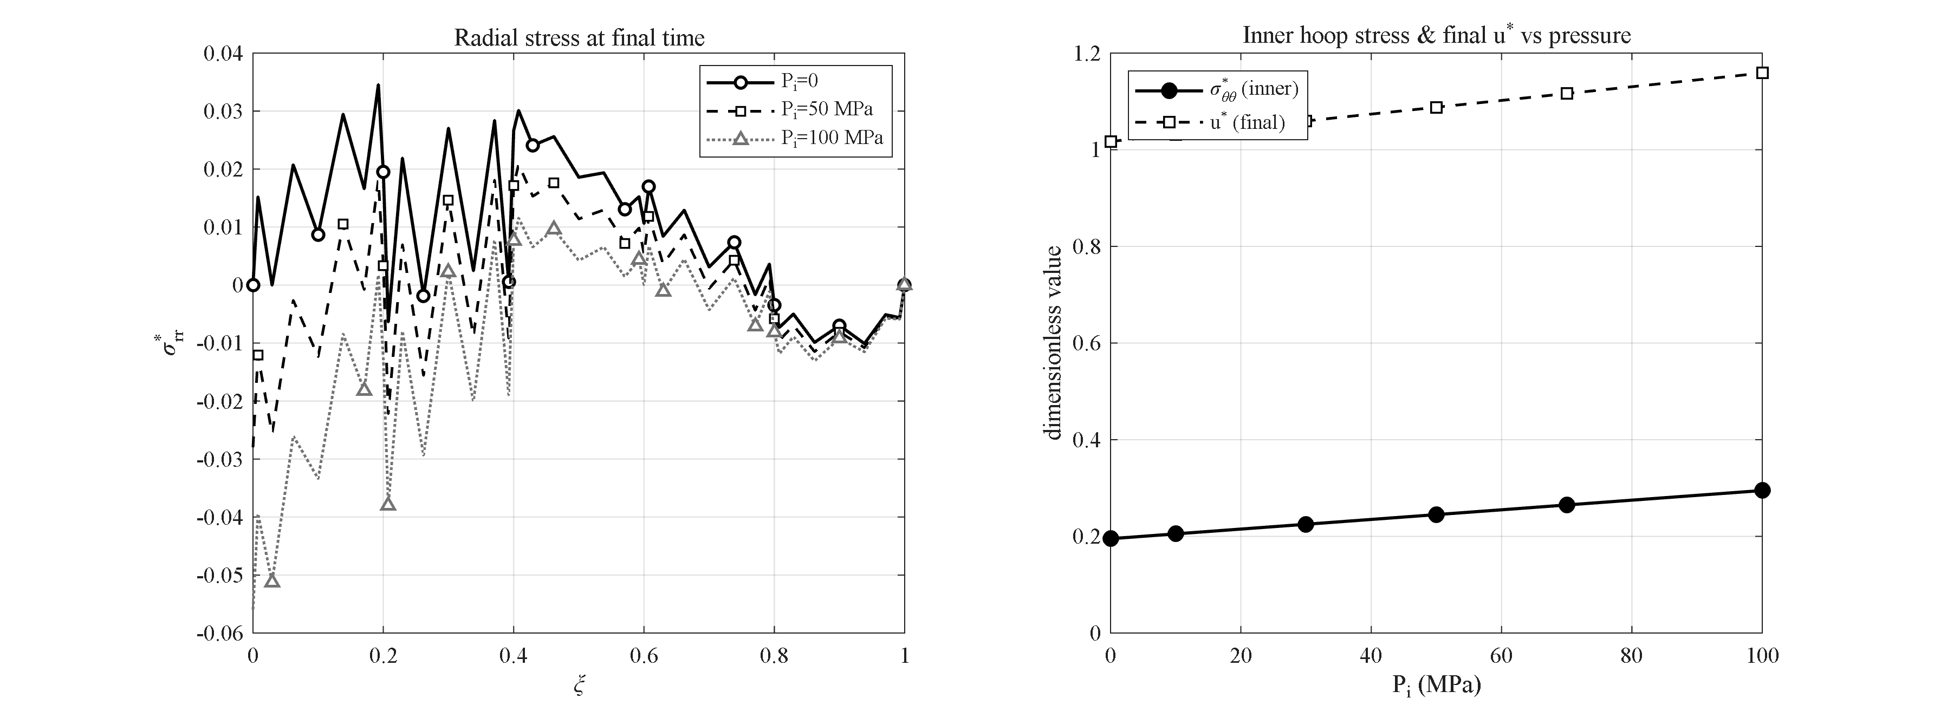
Figure 4-13: Dimensionless radial-stress profile through the wall for the pressure sweep: σ*_rr runs from the negative of the applied pressure at the inner surface to zero at the outer surface, consistent with the loading boundary condition.
Importantly, even at 100 MPa no discontinuity occurs in the numerical response, and the solution remains smooth and convergent, because the present model is a linear thermoelastic model in which physical rupture (material failure or separation) is not included; assessing that would require a damage or failure model beyond the present linear analysis. The dimensionless inner-surface hoop stress rises from 0.195 with no pressure to 0.295 at 100 MPa, an increase of about 51 %. The dimensionless radial-stress profile (Figure 4-13) runs from the negative of the applied pressure at the inner surface to zero at the outer surface, consistent with the loading boundary condition.
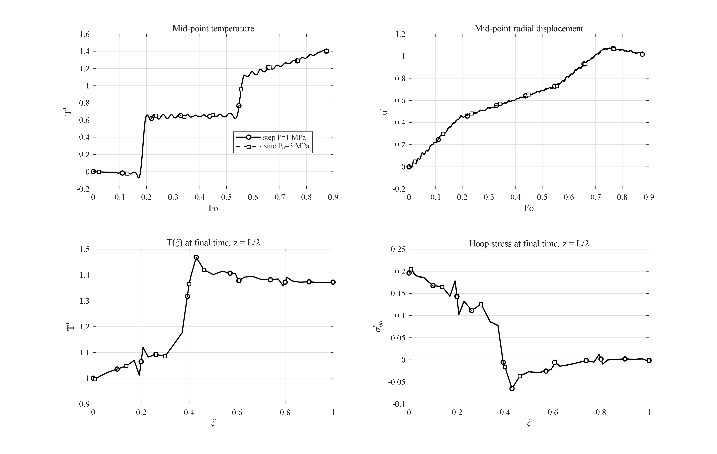
Figure 4-14: Effect of a harmonic internal pressure (amplitude 5 MPa) versus the step pressure: a small ripple on the displacement history without change of the thermal solution.
This study refines the common literature result more precisely: at the base pressure of 1 MPa the pressure contribution is below one percent and hence second-order; but as the pressure rises into the 70–100 MPa range, pressure becomes a genuine secondary effect that accounts for up to about 50 % of the inner hoop stress and about 13 % of the displacement, although the response is still thermally dominated. In addition, a harmonic internal pressure of 5 MPa amplitude superposes only a small ripple on the displacement history and leaves the temperature field unchanged (Figure 4-14).

4-12. Effect of the cylinder length and the infinite-length limit
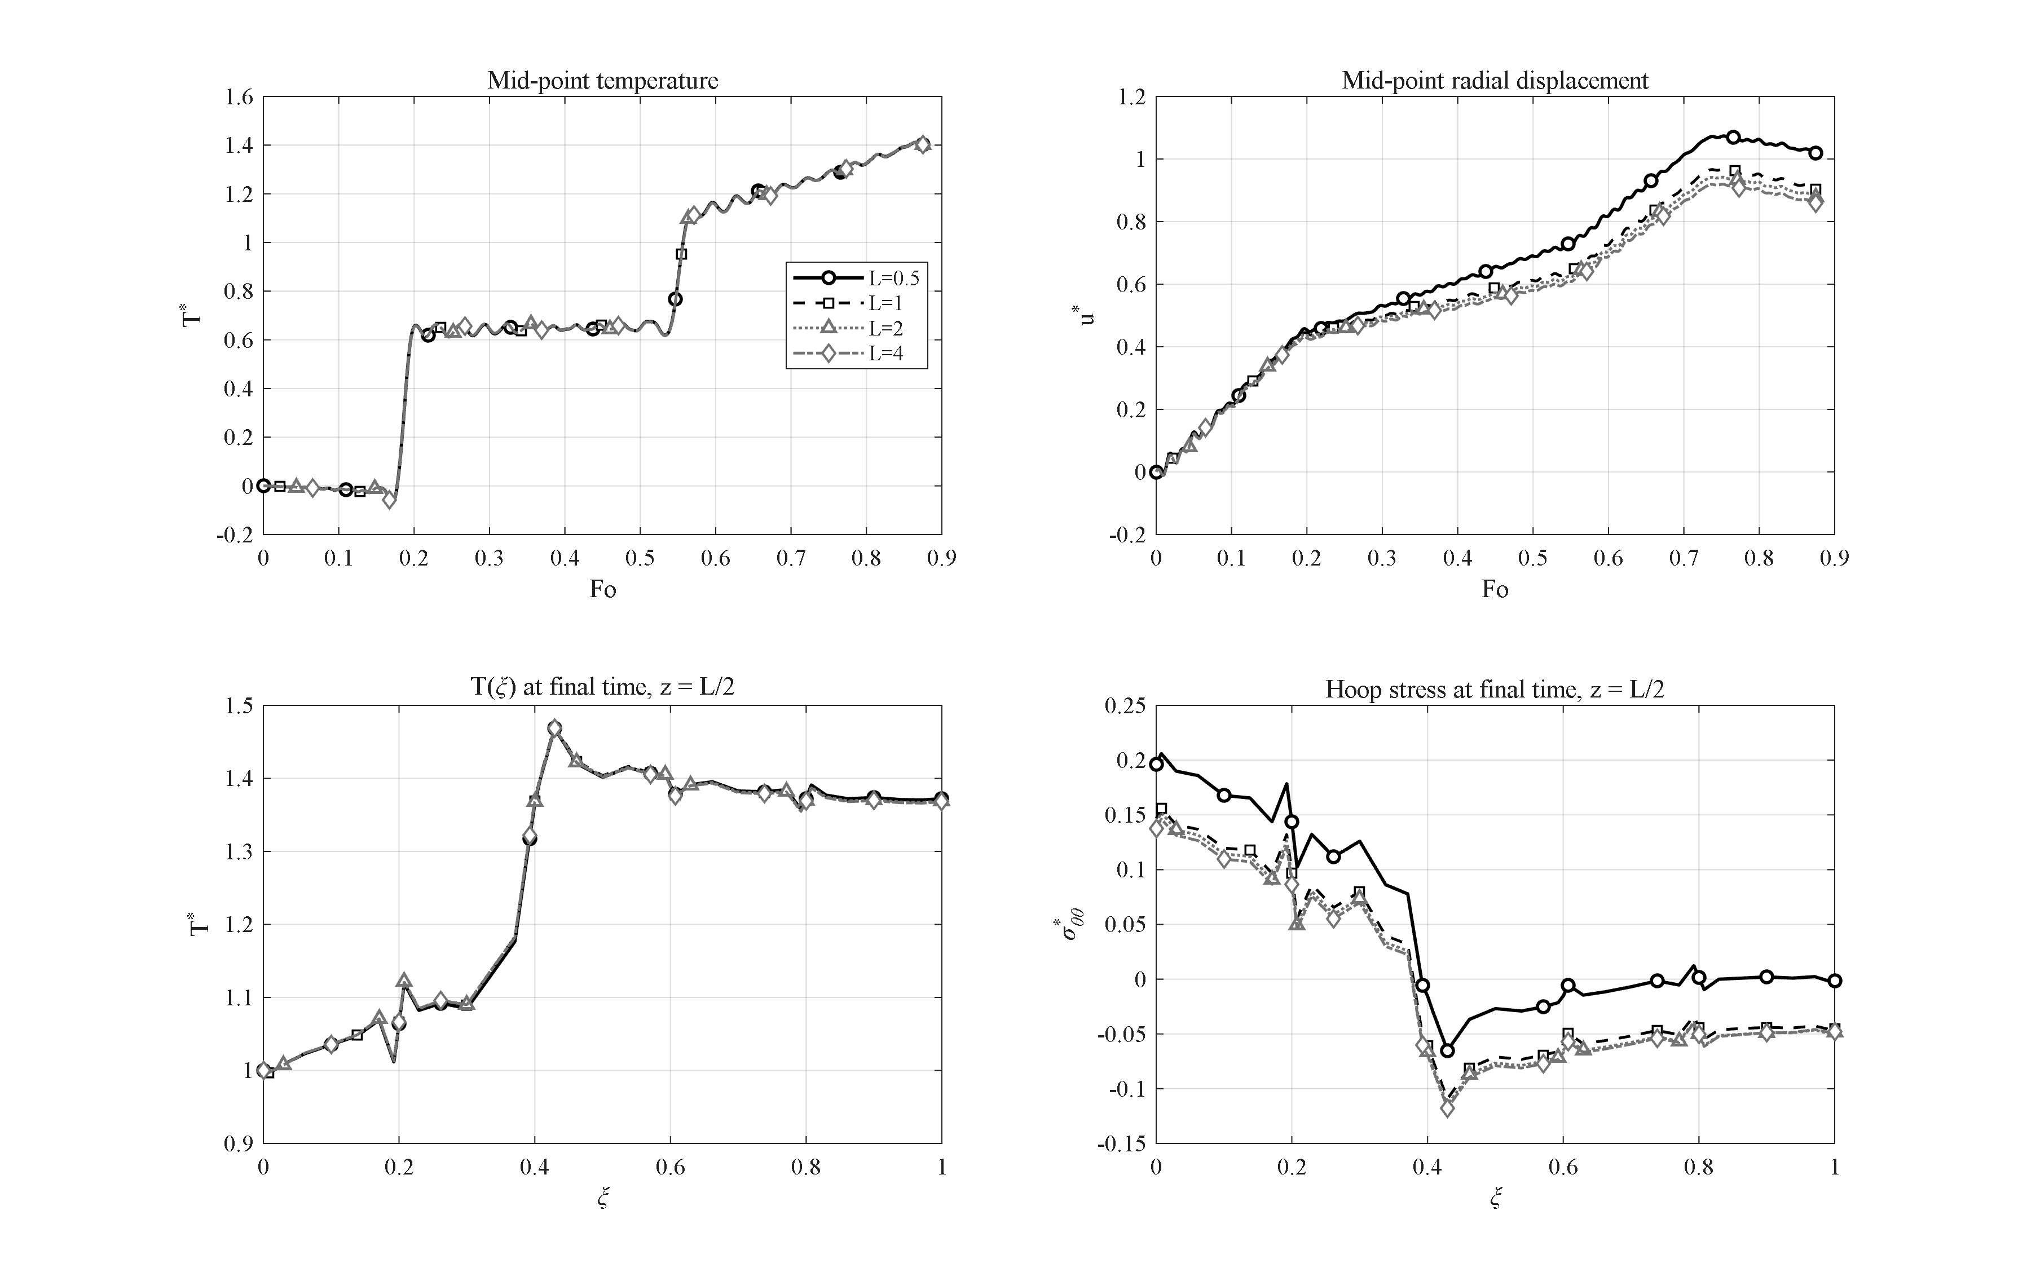
Figure 4-15: Effect of the cylinder length (h = 0.5, 1, 2, 4 m): the mid-length mechanical response converges to the infinite-length (plane-strain-like) limit (u* → 0.85, σ*_in → 0.138) while the temperature field is length-independent.
To examine the limiting behavior of a long cylinder, the length is gradually increased from the base value of 0.5 m to 1, 2, and 4 m so that the effect of the two ends on the mid-length section vanishes. As shown in Figure 4-15, the peak dimensionless temperature at the mid-length section is practically constant, remaining in the range 1.412 to 1.414; the temperature field is length-independent.
By contrast, the mechanical response of the mid-length section tends to a limiting value as the length increases. The final dimensionless radial displacement decreases from 1.019 for a length of 0.5 m to 0.904, 0.879, and 0.858 for lengths of 1, 2, and 4 m, respectively, approaching an asymptote of about 0.85. Likewise the dimensionless inner-surface hoop stress decreases from 0.196 to 0.147, 0.143, and 0.138, approaching an asymptote of about 0.138.
This behavior shows that as the cylinder becomes longer, the mid-length response converges to the infinite-length (plane-strain-like) limit, in which the mechanical and thermal effects of the two ends are not felt. The base cylinder of length 0.5 m, owing to the proximity of the two ends, experiences a slightly larger displacement and stress than the limiting case, and this boundary effect is progressively removed as the length increases.

4-13. Interaction of the GPL and porosity distribution patterns
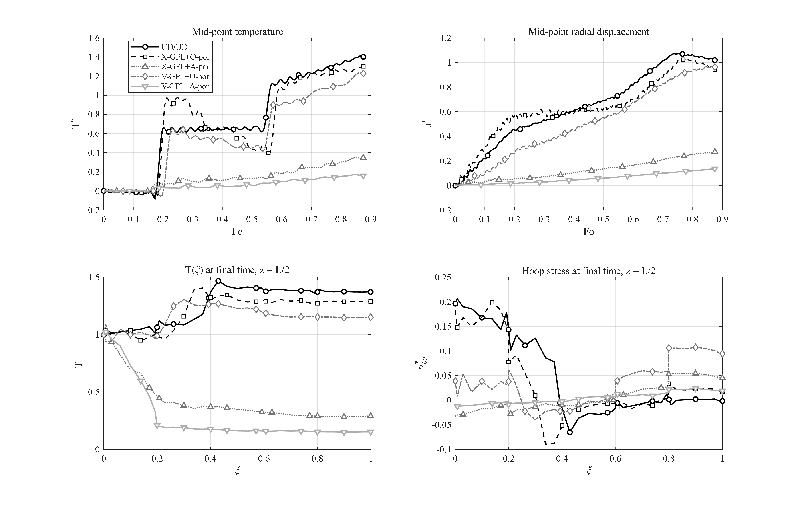
Figure 4-16: Interaction of the GPL and porosity patterns (UD/UD, X+O, X+A, V+O, V+A): the V-GPL + A-porosity combination reduces the outer-surface temperature 9-fold at benign stress levels.
The studies of Sections 4-5 and 4-6 showed that pattern V for the GPLs and pattern A for the porosity are individually the most favorable thermally. This section first examines their interaction for the four combinations X-GPL+O-por, X-GPL+A-por, V-GPL+O-por and V-GPL+A-por alongside the UD/UD reference (Figure 4-16). The two mechanisms are synergetic, with the porosity barrier dominant: with the X distribution of graphene, switching the porosity pattern from O to A lowers the mid-point peak from 1.30 to 0.35, and with the V distribution from 1.23 to 0.17.
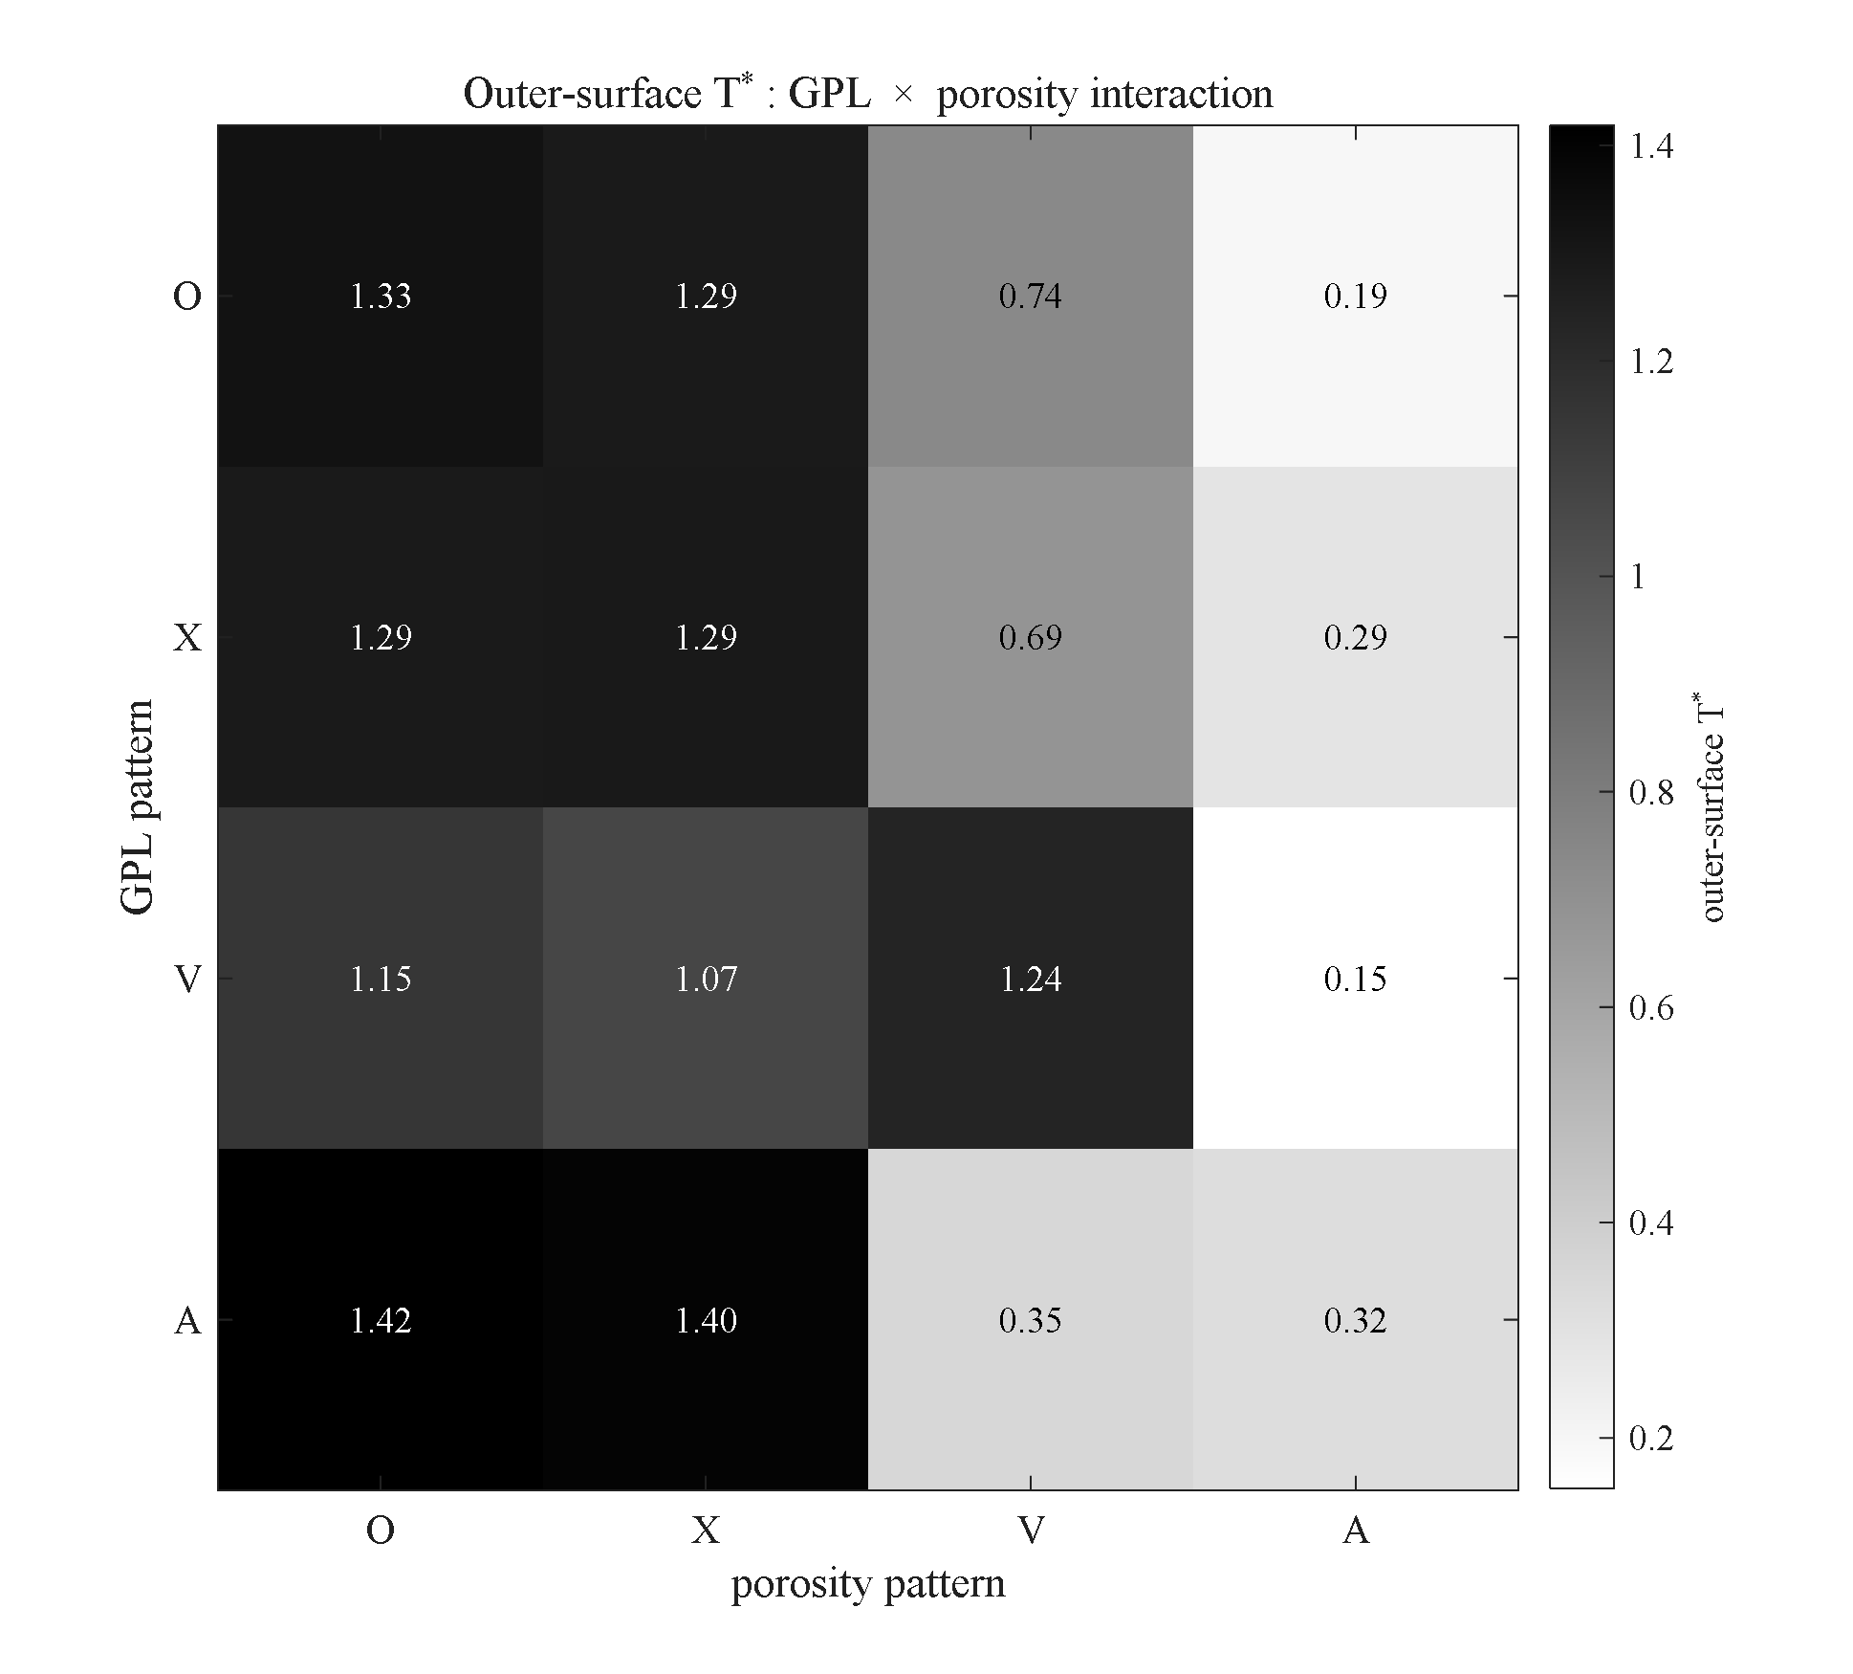
Figure 4-17: Complete 4×4 GPL×porosity interaction matrix — dimensionless outer-surface temperature (heatmap) for all sixteen combinations; porosity-A is a universal barrier and the mirror pair V/A governs synergy vs cancellation.
To examine this interaction fully, all sixteen combinations formed by the four GPL patterns (O, X, V, A) and the four porosity patterns (O, X, V, A) are computed, and the dimensionless outer-surface temperature for each combination is presented as a heatmap (Figure 4-17). The first key observation is that porosity pattern A (pores concentrated at the outer surface) acts as a universal thermal barrier and, regardless of the GPL pattern, gives the lowest outer-surface temperature; the values for this column are 0.19, 0.29, 0.15, and 0.32. The best combination, GPL-V together with porosity-A, holds the outer-surface temperature at T* = 0.15 — a roughly ninefold reduction with respect to the reference case (about 1.37) — confirming this work's design recommendation for thermal protection, while its stress state remains benign (|σ*_θθ| ≤ 0.024).
The second observation is the mirror-pattern interaction. Patterns V and A are geometric mirror images (inner-surface versus outer-surface concentration). When GPL-V (conductive at the inner surface) is combined with porosity-A (insulating at the outer surface), the two mechanisms act synergetically and the outer-surface temperature reaches 0.15; but when the same GPL-V is combined with porosity-V (both concentrated at the inner surface), the two effects weaken each other and the outer-surface temperature rises to 1.24. At the other extreme, the worst cases belong to GPL-A (conductive at the outer surface) combined with porosity-O or X, which raise the outer-surface temperature to as high as 1.42 and 1.40. Thus not only the individual pattern but also the alignment or opposition of the two patterns is decisive. This interaction study has no counterpart in comparable previous research [6] and is one of the contributions of this work.

4-14. Effect of the coupling of the equations
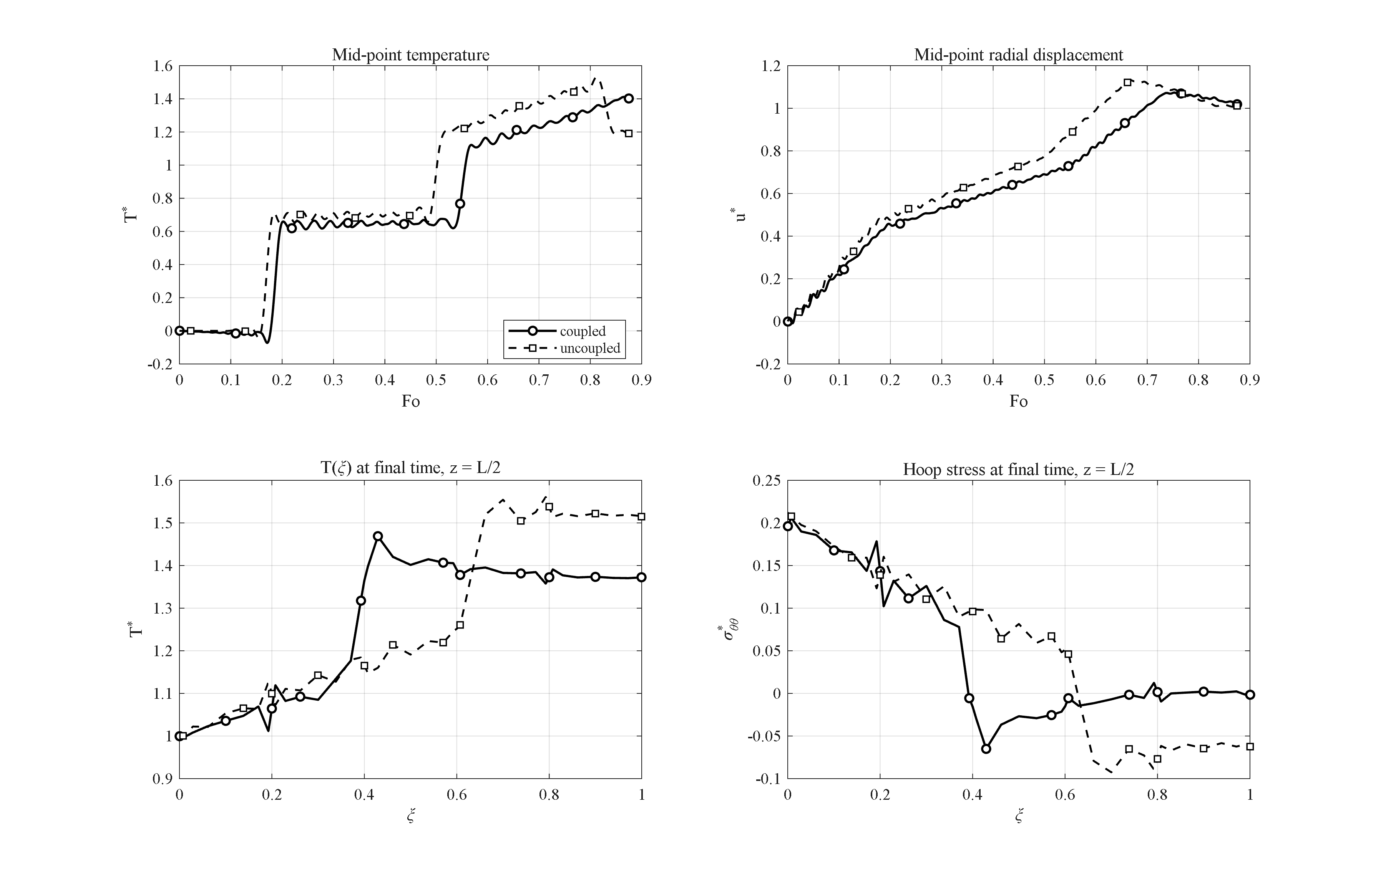
Figure 4-18: Effect of the thermo-mechanical coupling: the uncoupled model overestimates the temperature peak by 8.4 % (absence of the thermoelastic damping of the wave).
Figure 4-18 compares the fully coupled model with the uncoupled one (the dilatation-rate term removed from the energy conservation equation). The uncoupled model overestimates the peak temperature by 8.4 % (1.53 versus 1.41) and the peak displacement by 5.5 %. The reason is that in the coupled model a part of the thermal energy is continuously converted into mechanical work — a mechanism that may be called the thermoelastic damping of the thermal wave. The largest difference between the two models occurs exactly at the wave fronts, i.e. in the very quantities that matter in short-time analyses. This result demonstrates the necessity of solving the fully coupled system despite its higher computational cost.

4-15. Effect of the outer-surface convection coefficient
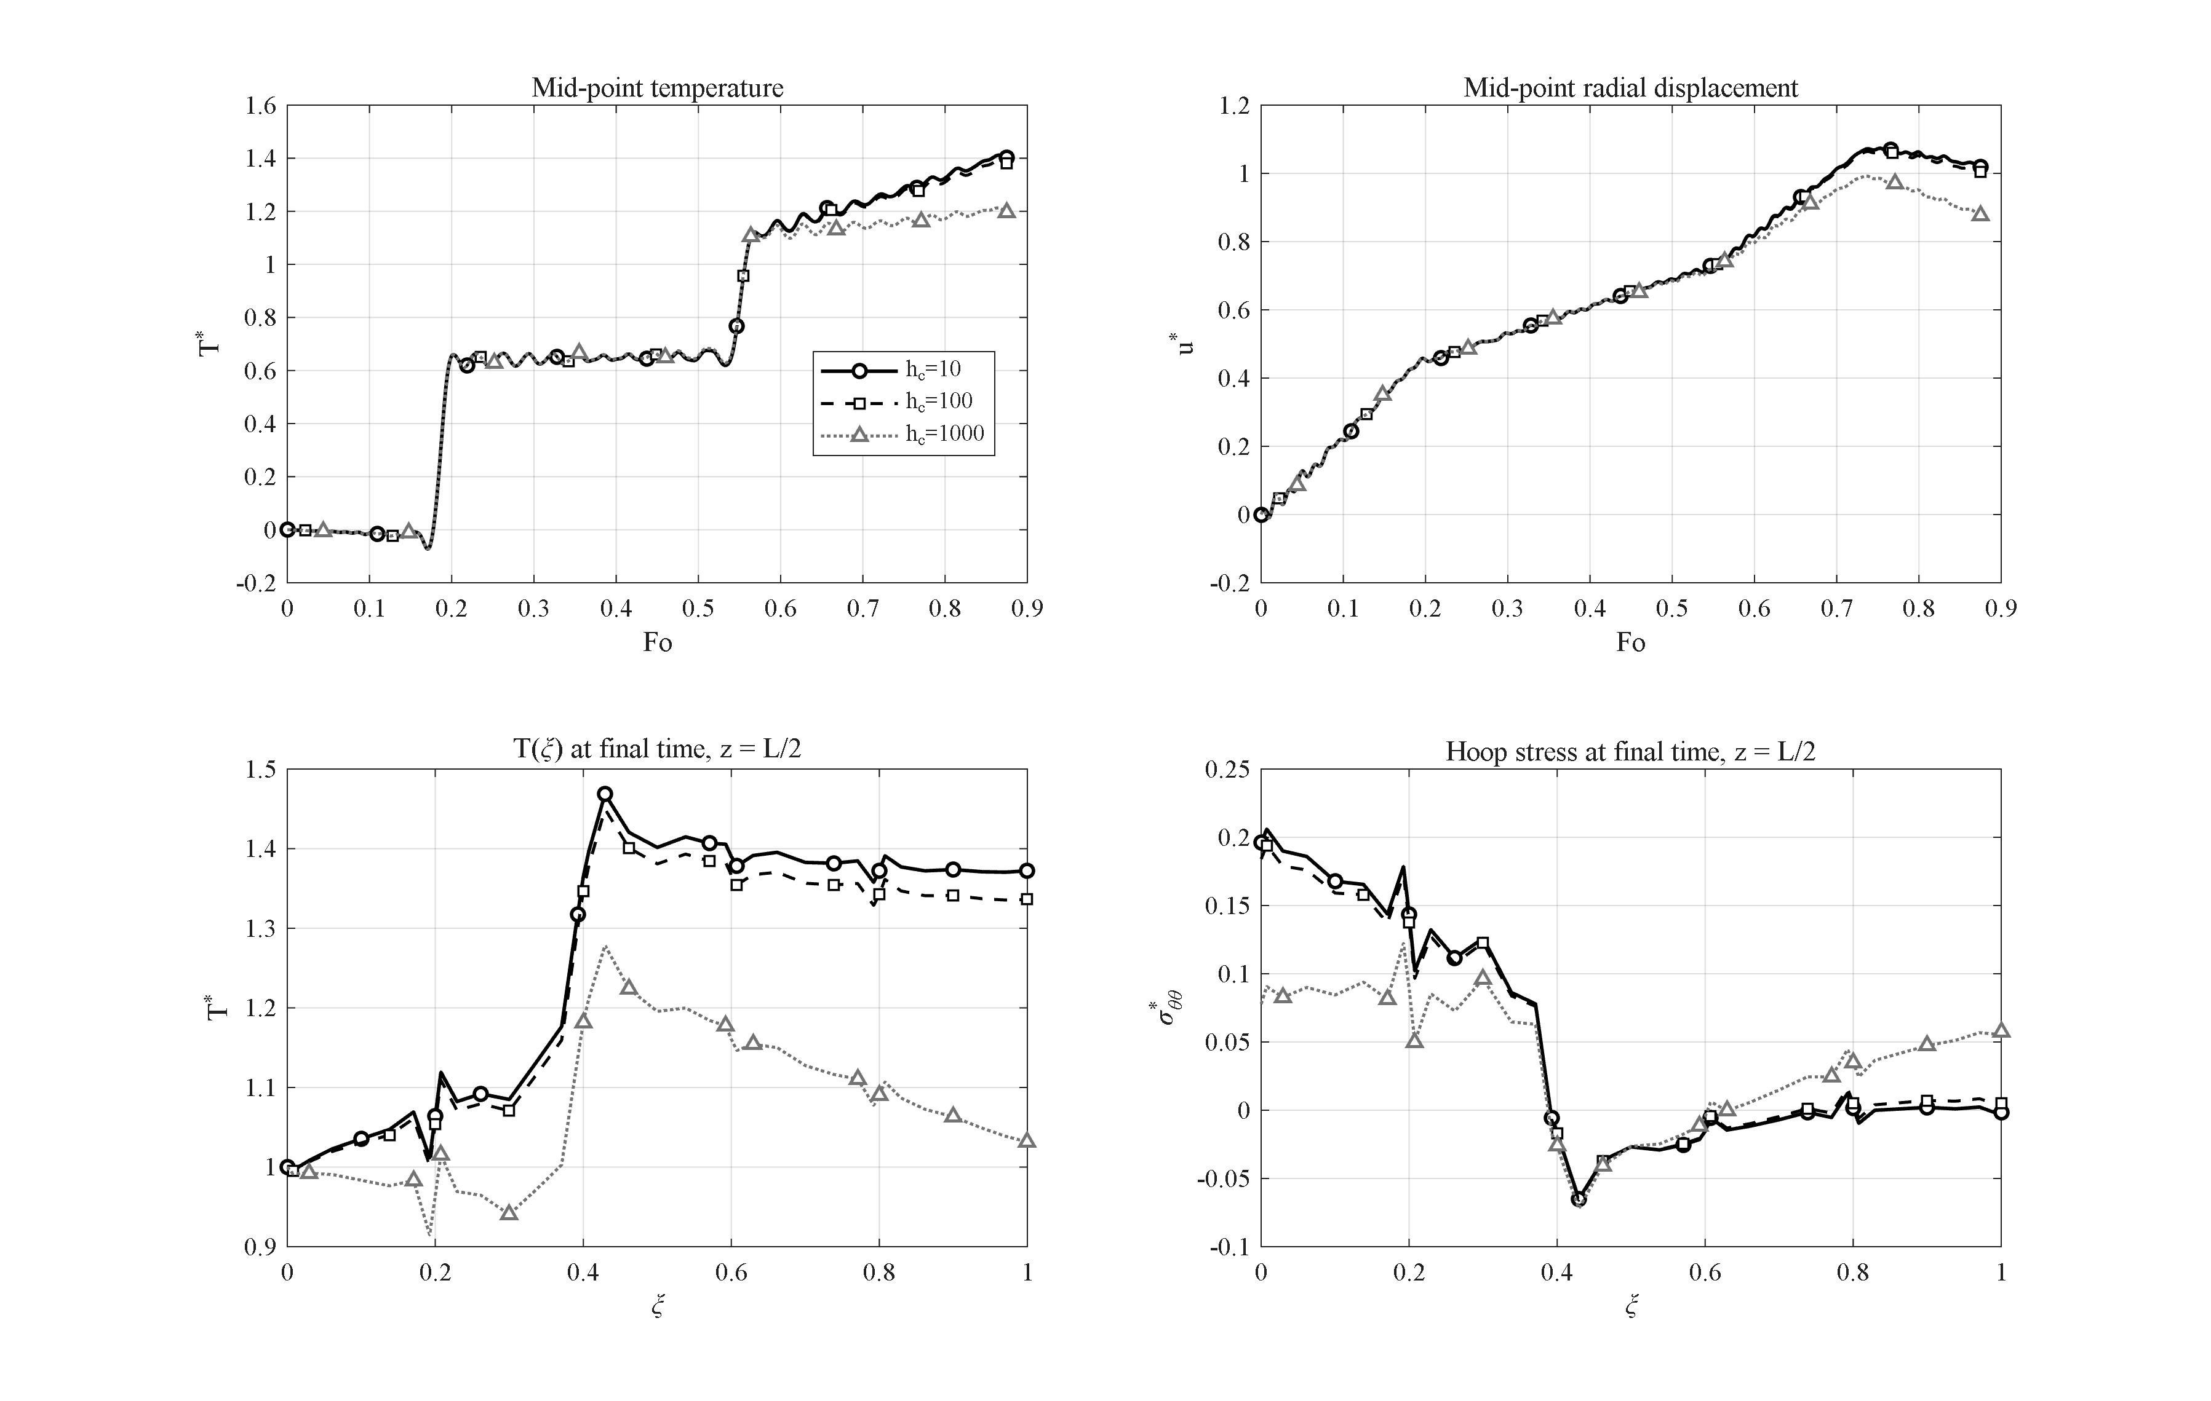
Figure 4-19: Effect of the outer-surface convection coefficient (h_c = 10, 100, 1000 W/m²K; Bi ≈ 0.004–0.4) on the transient response.
Figure 4-19 examines the effect of the outer-surface convection coefficient for h_c = 10, 100 and 1000 W/m²K, corresponding to Biot numbers Bi = h_c l/k̄ ≈ 0.004 to 0.4. With increasing h_c the outer surface turns from nearly adiabatic into an effective heat sink: the final outer-surface temperature drops from T* = 1.37 to 1.34 and 1.03, the mid-point peak from 1.41 to 1.39 and 1.21, and the final inner-surface hoop stress relaxes from 0.196 to 0.078 — because what determines the thermal stress is the through-wall temperature difference, not the absolute temperature level. The response is insensitive to convection for Bi below about 10⁻² and strongly convection-controlled for Bi above about 0.1 — two regimes that must be distinguished in design.

4-16. Effect of the wall thickness
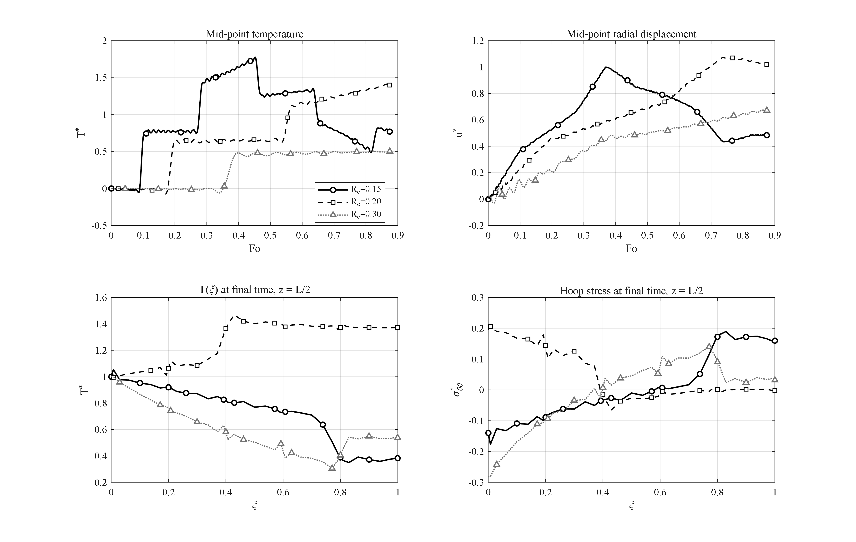
Figure 4-20: Effect of the wall thickness (l = 0.05, 0.10, 0.20 m at fixed R_i = 0.1 m): the thin wall maximizes the wave overshoot and the thick wall the compressive inner hoop stress.
Figure 4-20 compares three cylinders with wall thicknesses l = 0.05, 0.10 and 0.20 m (R_i = 0.1 m fixed); for comparability the time scale of all cases is nondimensionalized with the reference R_o = 0.2 m. The thin wall is crossed quickly and repeatedly by the thermal wave, and its mid-point experiences the largest overshoot of all studies in this chapter (T*_max = 1.78 at Fo = 0.45); equally quickly, however, it drains (final temperature 0.77). The thick wall behaves oppositely: within the examined window the wave does not even complete one full crossing (T*_max = 0.51) and the outer region stays cold; instead the inner-surface hoop stress becomes strongly compressive (σ*_θθ,min = −0.28), since the heated inner band pushes against the cold, stiff outer mass. The wall thickness is therefore the geometric lever trading "temperature overshoot in thin walls" against "stress severity in thick walls".

4-17. Response to a Gaussian thermal shock
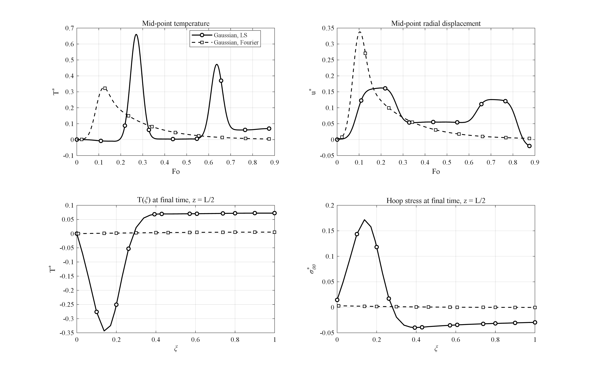
Figure 4-21: Response to a Gaussian thermal pulse under the Lord-Shulman and Fourier theories: the LS wave packet arrives later and twice as strong, with a ~50× larger hoop-stress excursion.
In this study the sustained ramp is replaced by a short Gaussian pulse of the inner-surface temperature, and the response is compared under the Lord-Shulman and Fourier theories (Figure 4-21). This loading exposes the essential difference between wave-like and diffusive transport: under Fourier conduction the pulse arrives at the mid-thickness smeared and weak (T*_max = 0.33 at Fo = 0.12) and has practically vanished by the end of the interval (T* = 0.004). Under the Lord-Shulman theory the pulse travels as a coherent wave packet: it arrives later (Fo = 0.27), about twice as strong (T*_max = 0.66), and leaves persistent oscillations behind (final temperature 0.070). The difference in the stress response is even more striking: the hoop-stress excursion under Lord-Shulman (from −0.040 to +0.172) is about 50 times that of Fourier conduction. In other words, under impulsive loads the classical theory underestimates the mechanical consequences of the shock by more than an order of magnitude — the strongest single argument of this thesis in favor of the generalized theory.

4-18. Comparison of time-integration methods
To position the Newmark scheme used in this thesis, five alternative time integrators were run on the identical benchmark problem (transient conduction with known exact solution; error measure: maximum temperature error at t = 10 s). The results are summarized in Table 4-3.
Table 4-3: Comparison of time-integration methods on the same spatial system.
method | max error (K) | CPU time (s)
Newmark (δ=½, β=¼) | 0.0032 | 0.33
Wilson-θ (θ=1.4) | 0.0164 | 0.19
Houbolt | 0.0025 | 0.24
HHT-α (α=−0.1) | 0.0033 | 0.29
ode15s (adaptive BDF) | 0.0003 | 2.57
Laplace-Durbin (thermal subsystem) | 0.137 | 193

Newmark, Houbolt and HHT-α are practically equally accurate at equal time step; Wilson-θ accepts a roughly 5-fold larger error due to its extra numerical dissipation; the adaptive stiff solver ode15s is about 10 times more accurate but 8 times more expensive; and the Laplace-transform route with Durbin's numerical inversion is three orders of magnitude slower. In addition, a methodological result emerged: the Laplace transform cannot be applied to the full coupled system of this problem, because the undamped elastic poles of the coupled operator lie exactly on the inversion contour — which is why transform methods are applied in the literature to thermal subsystems only. This measured comparison justifies the choice of the Newmark method for all production runs of this thesis.

4-19. Comparison of spatial discretization methods
In this extension study four spatial discretizations — the differential quadrature method with Chebyshev and with uniform grids, the second-order finite difference method, and the finite element method with linear and quadratic elements (Galerkin formulation with consistent matrices) — are compared on the transient-conduction problem with the exact Bessel-series solution, using the identical Newmark time march. The error convergence versus the number of radial points was presented earlier in Figure 4-2 (Section 4-3). The number of points required to reach the time-step error floor is: N ≈ 9–11 for differential quadrature, N ≈ 21 for quadratic finite elements, and N ≈ 161 for linear finite elements and finite differences. The linear-FEM and FDM curves coincide at slope −2; quadratic FEM gains roughly one order of magnitude per refinement step; and the DQM error falls quasi-exponentially until the temporal floor. At equal accuracy the DQM equation system is about 15 times smaller per direction — squared in the (r,z) plane — which is the quantitative justification for the layerwise differential quadrature choice of this thesis. Adding the two Galerkin finite-element formulations (linear and quadratic) to this comparison is one of the extensions of this work over comparable previous studies.

4-20. Comparison of the generalized thermoelasticity theories
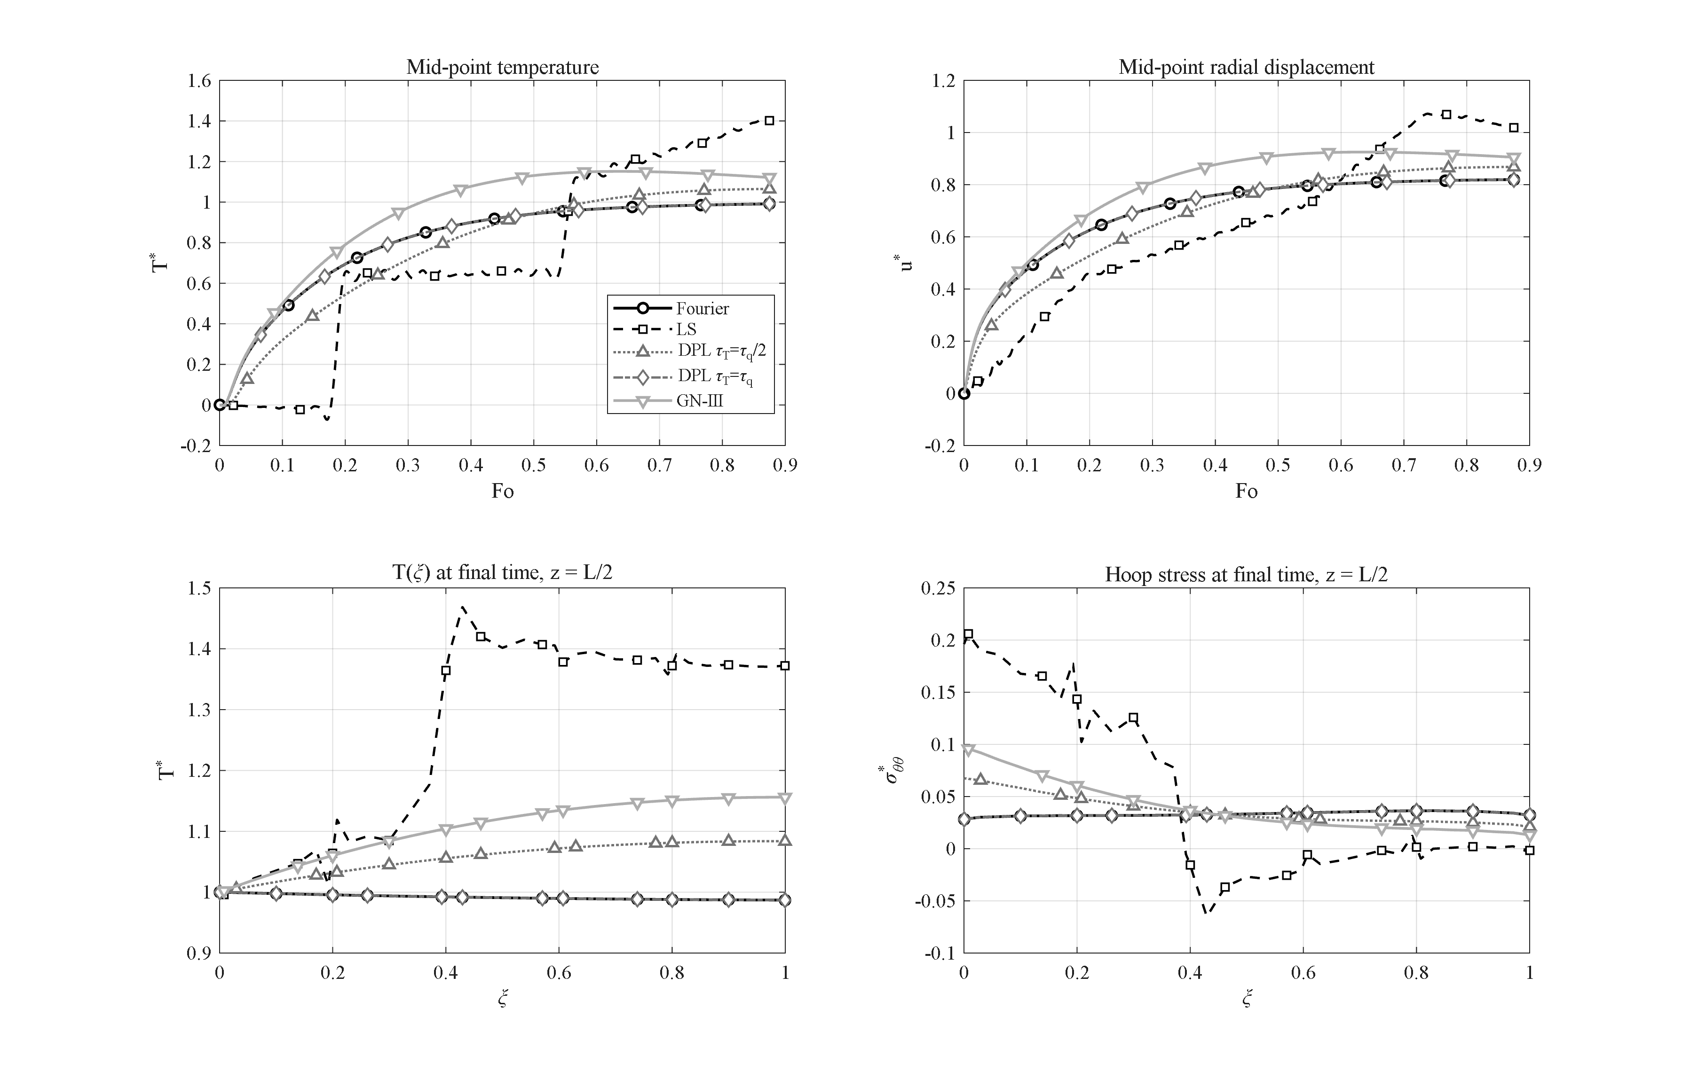
Figure 4-22: Comparison of the thermoelasticity theories (Fourier, Lord-Shulman, DPL with τ_T = τ_q/2 and τ_T = τ_q, Green-Naghdi III) with matched parameters: DPL(τ_T=τ_q) collapses onto Fourier; GN-III shows a persistent overshoot; LS carries the strongest wave.
In the final extension study the reference problem is solved under four thermoelasticity theories with matched parameters: the classical coupled Fourier theory, the Lord-Shulman theory [4], the dual-phase-lag (DPL) theory [74] with τ_q = τ0 and the two values τ_T = τ_q/2 and τ_T = τ_q, and the Green-Naghdi type-III theory [67] with k* = k/τ0 (so that its wave speed equals the Lord-Shulman one). According to Figure 4-22, the peak mid-point temperatures order as: Fourier 0.991 = DPL(τ_T=τ_q) 0.991 < DPL(τ_T=τ_q/2) 1.065 < Green-Naghdi 1.151 < Lord-Shulman 1.412. Two main observations follow. First, for τ_T = τ_q the DPL solution collapses onto the Fourier solution to nine significant digits — the numerical confirmation of the known analytical degeneracy of this theory — showing that DPL is meaningful only for τ_T < τ_q, in which case it interpolates between Fourier and Lord-Shulman. Second, the Green-Naghdi theory exhibits an earlier but weaker front (peak at Fo ≈ 0.64) and a persistent overshoot (T* = 1.12 at the end of the interval), because its energy equation lacks a dissipative mechanism to damp the thermal wave; its long-time behavior is therefore qualitatively different. Such a four-theory map for porous GPL-reinforced cylinders does not exist in the literature and constitutes one of the contributions of this research.

4-21. Chapter summary
The main findings of this chapter can be summarized as follows:
1. The numerical convergence of the solution was established — in the number of layers (converged from N_L = 9) and in the spatial discretization (DQM with 9–11 points) — before verification, and the solver was validated in five independent tests against exact solutions and references.
2. The Lord-Shulman thermal wave produces mid-wall temperature overshoot up to T* = 1.41 (reference case) and 1.78 (thin wall) — impossible under Fourier conduction — and the temperature histories show the characteristic peak-trough shape of the reflecting wave.
3. Placing the GPLs at the heated surface (pattern V) and the pores at the cooled surface (pattern A) is synergetic: a 9-fold reduction of the outer-surface temperature at benign stress levels — the design recommendation of this thesis. Patterns V and A are mirror images, and the full 4×4 matrix shows that the alignment or opposition of the two patterns governs the thermal performance.
4. A percolation threshold near 1 % weight fraction switches the wall from an insulator to a conductor; graphene beyond that mainly raises the thermal stresses. Of the two platelet aspect ratios, the width-to-thickness ratio is the dominant reinforcement lever.
5. Full coupling damps the thermal wave (about 8 % peak reduction); uncoupled models are non-conservative exactly at the wave fronts.
6. Internal pressure is a second-order effect at the base pressure, but in the 70–100 MPa range it becomes a genuine secondary effect (up to about 50 % of the inner hoop stress); the response nonetheless remains thermally dominated and no discontinuity occurs up to 100 MPa.
7. Clamped ends convert the blocked axial expansion into a ~35 % increase of the mid-length radial displacement; support effects are localized at the ends, and as the cylinder lengthens the mid-length response converges to the infinite-length limit.
8. Under impulsive (Gaussian) heating the classical theory underestimates the stress response by a factor of about 50.
9. Methodologically: Newmark offers the best accuracy-to-cost ratio of the six tested integrators; differential quadrature needs about 15 times fewer points per direction than finite differences or linear finite elements; and the four-theory map (Fourier / Lord-Shulman / DPL / Green-Naghdi) charts where the theories diverge for this class of structures.

