4-4. Verification
The present numerical solution is verified through five independent checks, each against either an exact analytical solution, published results, or a commercial finite-element solution. In every check, besides the quantitative error, the present result is plotted against the corresponding reference so that the coincidence of the curves can be seen. Table 4-6 gives the overview of all five checks, and the subsections that follow treat each one separately.
Table 4-6. Summary of the solver verification tests.
# | test | reference | result
1 | static spatial assembly | independent static solver | agreement 2.20×10⁻¹¹
2 | dynamic mechanical response | reference [31] + ANSYS | error 0.1–0.2 %; σ_rr exact
3 | transient heat conduction | exact Bessel-series solution | relative error 10⁻⁵–10⁻⁷
4 | time integration | adaptive stiff solver (independent) | max difference 0.0034 K
5 | coupled Lord–Shulman waves | exact Fourier–Bessel solution | pointwise error 0.32 %; L₂ 0.065 %

4-4-1. Test 1 — assembly of the static matrices
The static limit of the dynamic solver is checked against an independent static solver. That independent solver is a separate code with its own assembly, which carries no time term at all and solves the two algebraic systems of steady conduction and elastostatic equilibrium directly; the loading is internal pressure only and the ends are free. The displacement panel of Figure 4-5 shows the two mid-span radial-displacement curves lying on top of one another, while the difference panel keeps their discrepancy at machine-precision level across the whole wall thickness. The test confirms both the numerical equivalence of the two implementations and the correctness of the system assembly.
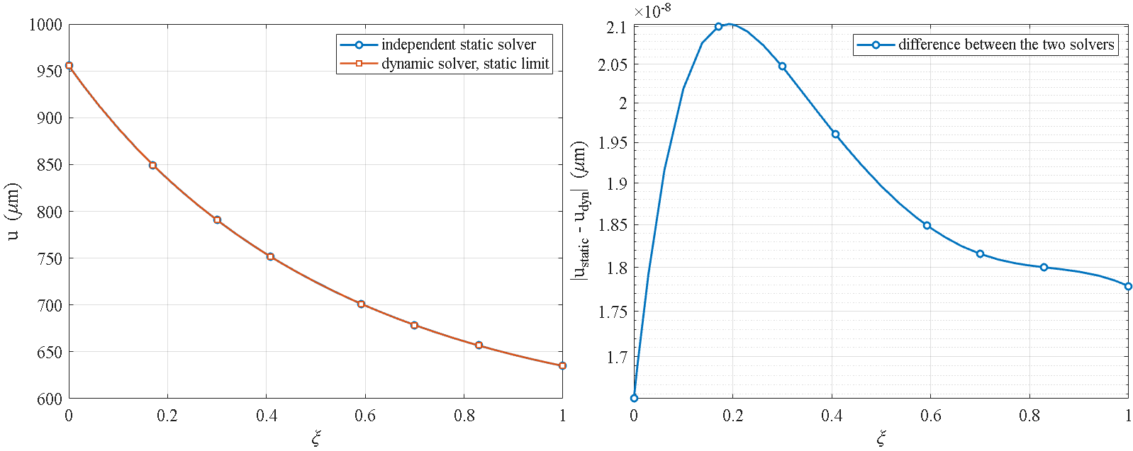
Figure 4-5. Test 1 — mid-span radial displacement from the independent static solver against the static limit of the dynamic solver (displacement panel), and the absolute difference between the two solutions across the wall thickness on a logarithmic axis (difference panel).
Table 4-7. Test 1 — static limit against the independent static solver.
quantity | value
radial points compared | 45
max u, independent static solver | 9.555556×10⁻⁴ m
max u, static limit of the dynamic solver | 9.555556×10⁻⁴ m
maximum absolute difference | 2.103667×10⁻¹⁴ m
maximum relative difference | 2.201512×10⁻¹¹

4-4-2. Test 2 — dynamic mechanical response
The mechanical part of the problem is compared with the results of Malekzadeh (Table 6 of reference [31]) and with an independent ANSYS finite-element solution. The dimensionless radial displacement is reproduced with a relative difference of 0.1 to 0.2 percent, and the dimensionless inner-surface radial stress is obtained exactly as the negative of the applied pressure, in full agreement with the loading boundary condition.
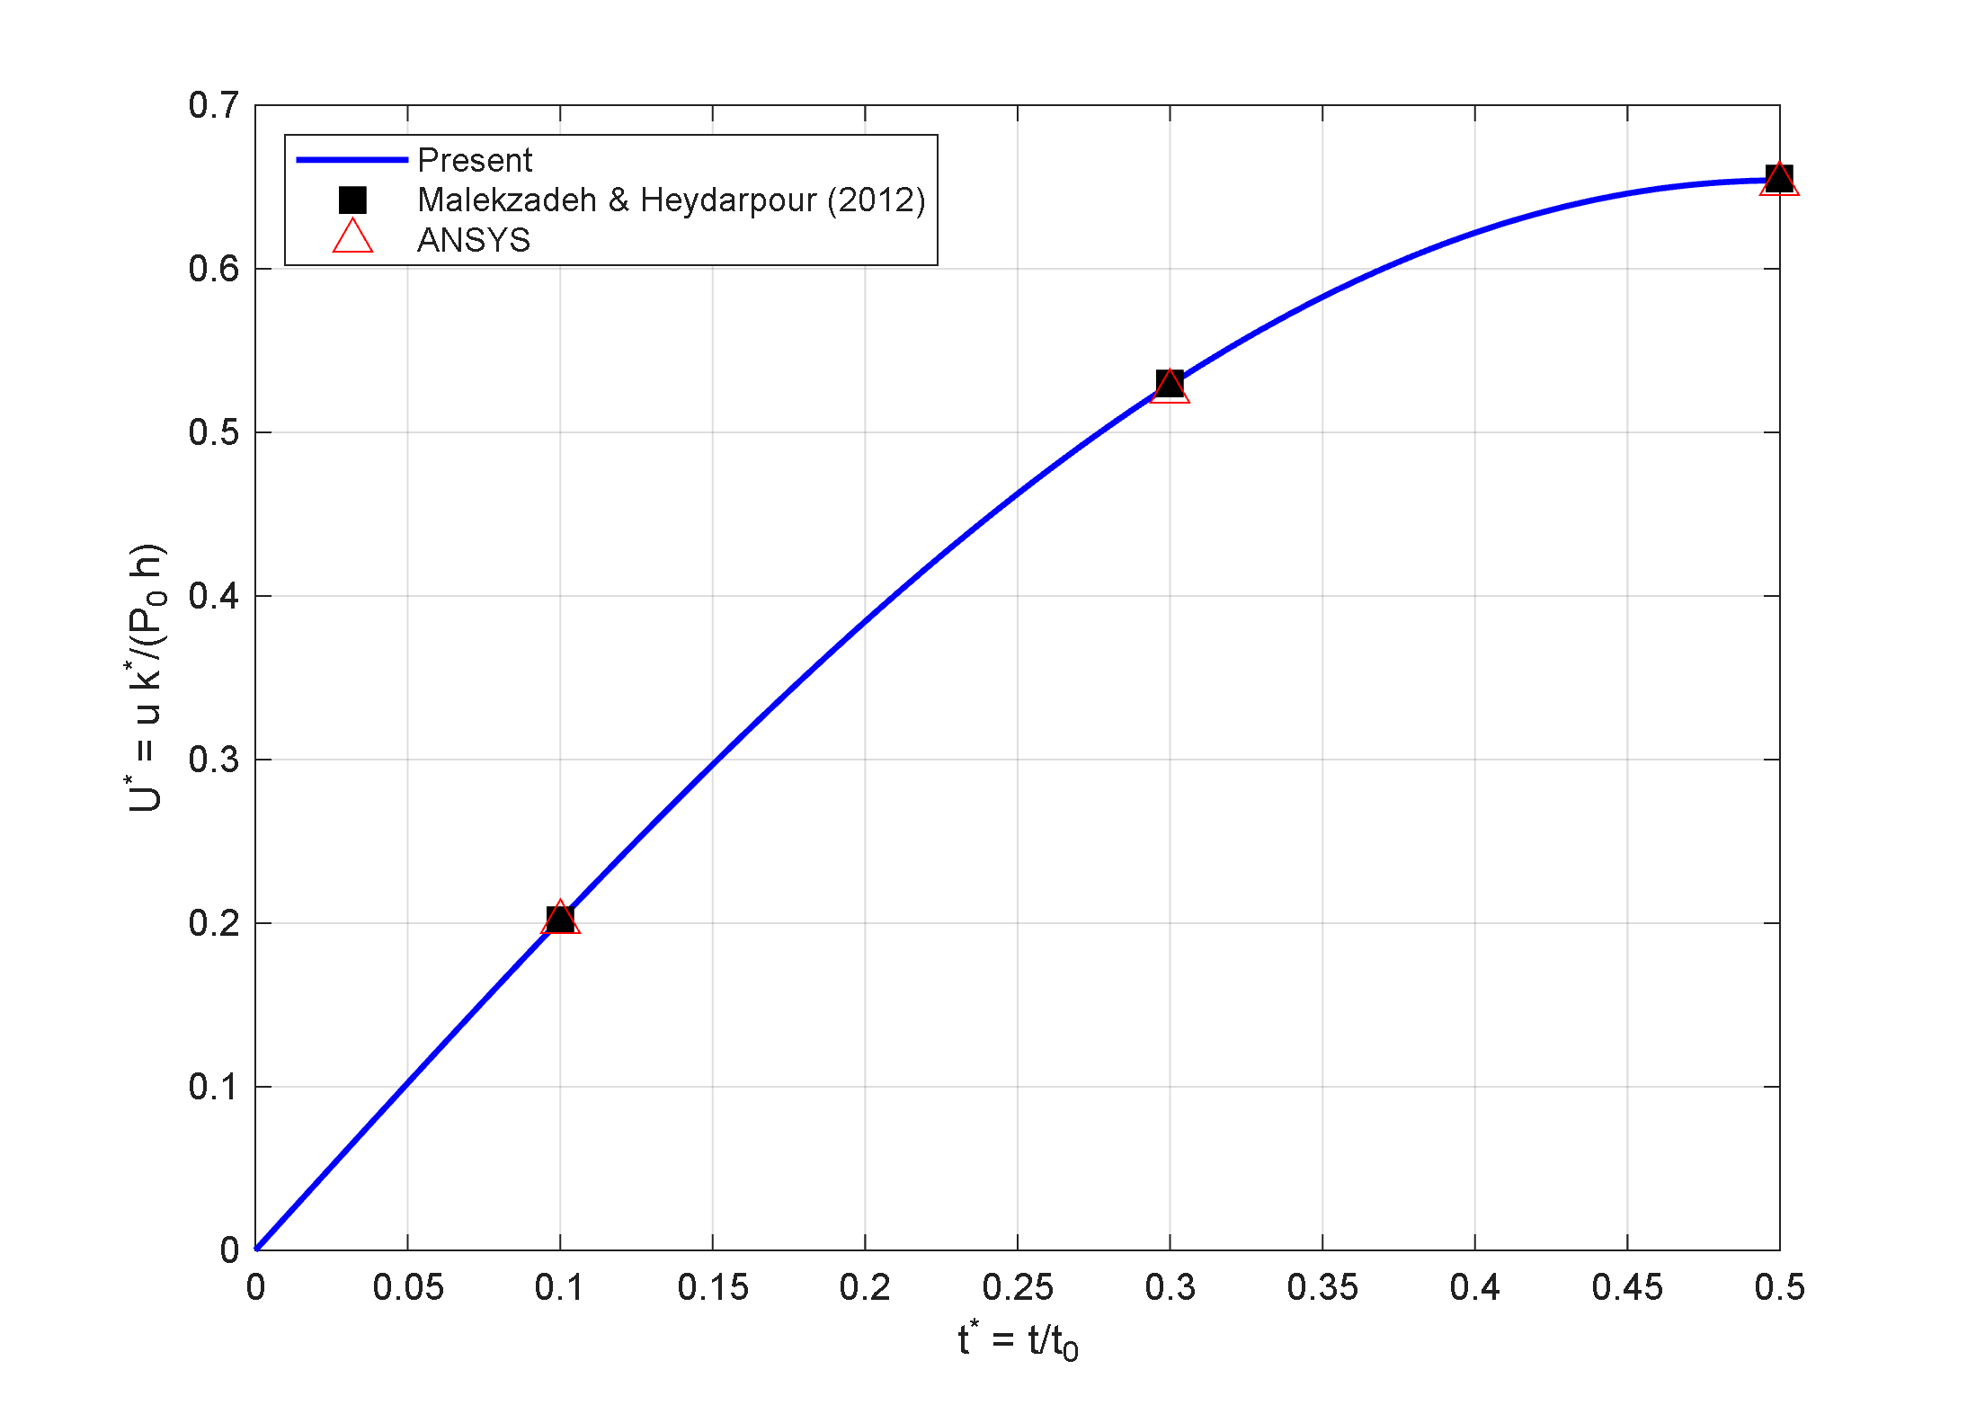
Figure 4-6. Test 2 — dimensionless inner-surface radial displacement at mid-span against dimensionless time: the present solution compared with the published values of reference [31] and the ANSYS solution.

4-4-3. Test 3 — transient heat conduction
The transient conduction problem is checked against the exact Bessel-series solution. The dimensionless temperature distribution at several times lies on the exact curve, with a relative error between 10⁻⁵ and 10⁻⁷; that is, the differential quadrature spatial discretization reproduces the transient thermal field to several significant digits.
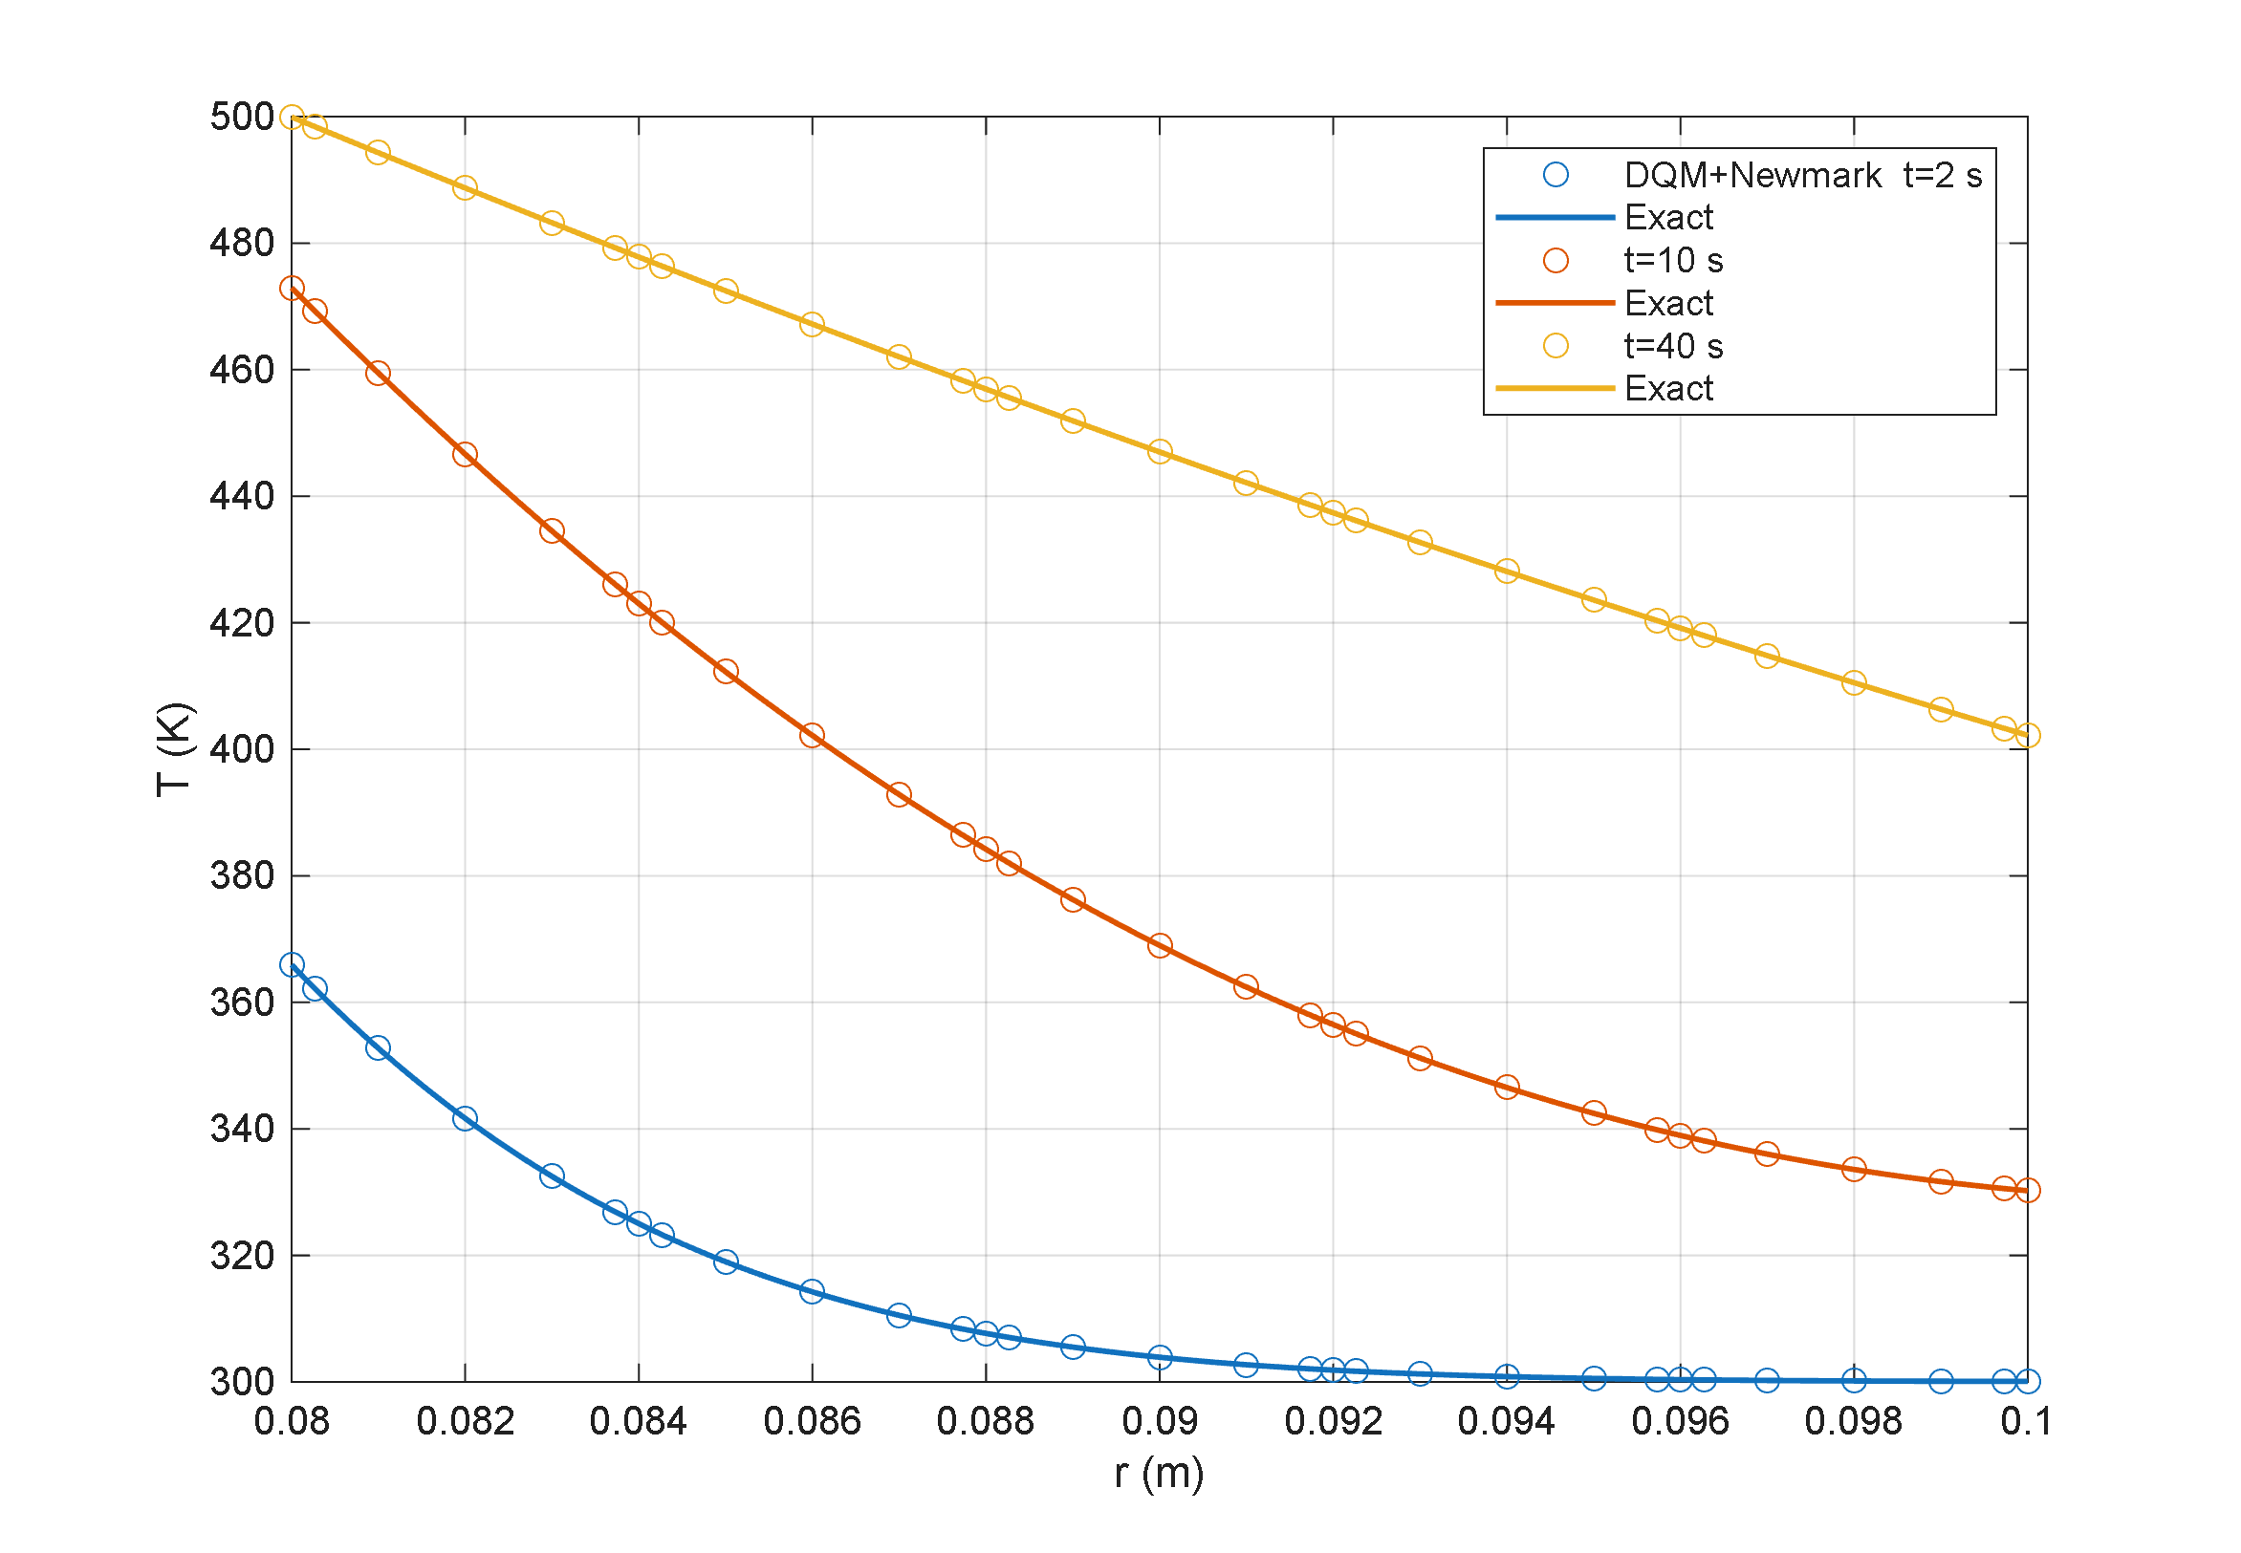
Figure 4-7. Test 3 — radial temperature profiles at several times: the present solution (markers) against the exact Bessel-series solution (solid line).

4-4-4. Test 4 — time-integration scheme
The Newmark scheme is checked against MATLAB’s adaptive stiff solver on the same spatial system. Figure 4-8 shows all three curves — the exact solution, Newmark, and the adaptive solver — coinciding over the whole time interval. The quantitative size of the difference between the two schemes is given in Table 4-8: the maximum Newmark error is about one order of magnitude larger than that of the adaptive solver, but its computational cost is roughly one tenth. It is this accuracy-to-cost ratio that justifies the choice of Newmark for all production runs.
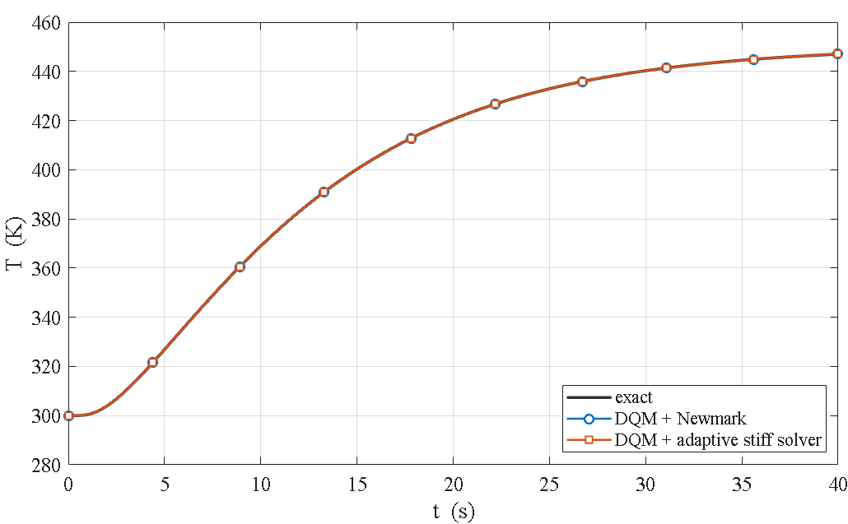
Figure 4-8. Test 4 — mid-point temperature history for the exact solution, the Newmark scheme and the adaptive stiff solver; all three curves coincide.
Table 4-8. Test 4 — comparison of time integrators on the identical spatial system.
method | max error vs exact (K) | CPU time (s)
differential quadrature + Newmark | 0.00319 | 0.18
differential quadrature + adaptive stiff solver | 0.00026 | 1.74
difference between Newmark and the adaptive solver | 0.00337 | —

4-4-5. Test 5 — the Lord–Shulman second-sound wave
The wave-propagation behaviour is checked against an exact Fourier–Bessel solution derived for the solver’s own geometry. That reference was itself verified independently before use: the steady-state limit to 1.9×10⁻¹⁶, strict hyperbolic causality ahead of the front to 4×10⁻⁶, and the front-jump ratios against the analytic ray law to 0.16 percent. The present solver matches it with a maximum pointwise error of 0.32 percent and an L₂ error of 0.065 percent on the finest mesh, and according to Table 4-9 the error falls monotonically under mesh refinement. That monotone decrease simultaneously establishes that the oscillations trailing the sharp front are a Gibbs effect of the spectral discretization and not a numerical instability.
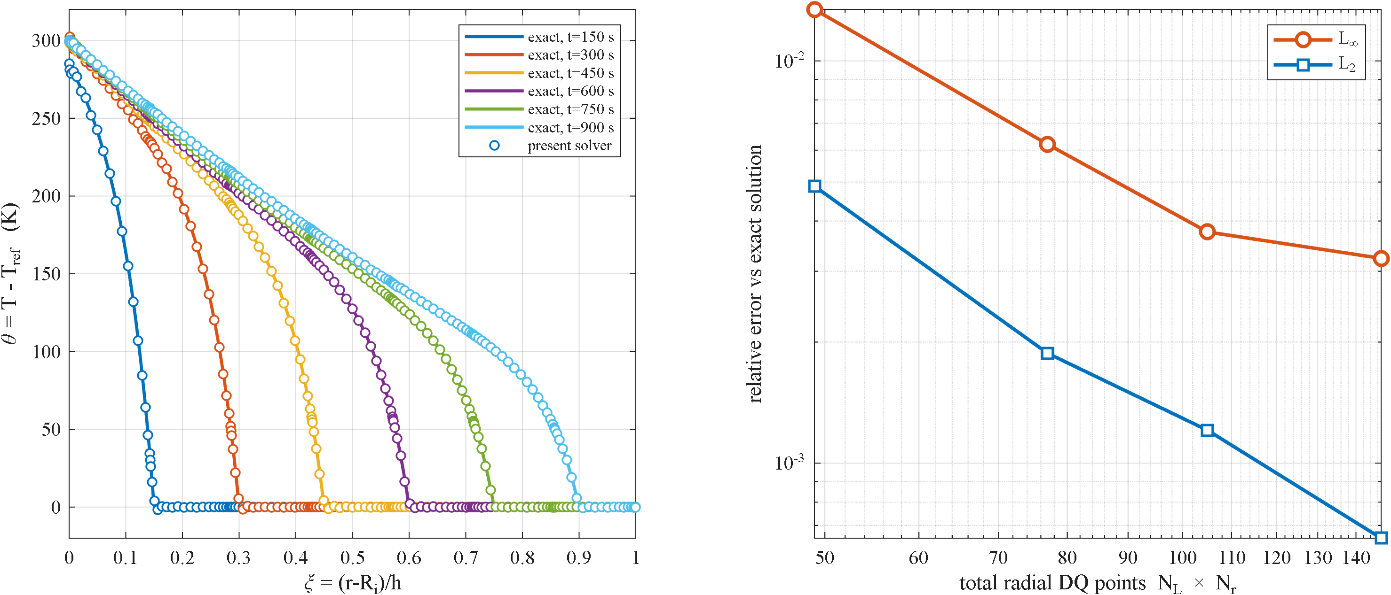
Figure 4-9. Test 5 — radial temperature profiles at several times: the present solver against the exact Fourier–Bessel second-sound solution, with the sharp wave front present in both.
Table 4-9. Test 5 — mesh convergence against the exact Fourier–Bessel solution.
N_r | radial points | L∞ relative error | L₂ relative error
7 | 49 | 1.343×10⁻² | 4.881×10⁻³
11 | 77 | 6.204×10⁻³ | 1.876×10⁻³
15 | 105 | 3.756×10⁻³ | 1.207×10⁻³
21 | 147 | 3.230×10⁻³ | 6.507×10⁻⁴

4-4-6. Summary
Taken together, these five checks confirm the validity of the present solution in both the static and the transient regimes and in the coupled and uncoupled cases: test 1 covers the system assembly, tests 2 and 3 the mechanical and thermal parts separately, test 4 the time-marching scheme, and test 5 the Lord–Shulman wave phenomenon itself, which is the central novelty of this research.

Implementation notes (not part of the thesis text)
- End condition in test 1. The comparison uses free ends, as recorded in the original documentation. Running the same comparison with simply supported ends gives a relative difference of about 8.0×10⁻², because the two codes do not impose the axial simple-support condition identically; that discrepancy is a genuine physical difference, not an assembly error. The new data were produced with Static_Baseline_R3 (the free-end revision) and LSTE_solver_R11.
- Change relative to the previous summary table. Row 5 previously cited Bagri and Eslami as the reference and “wave speeds and reflections matched” as the result, i.e. a qualitative comparison. Following the addition of the exact Fourier–Bessel solution, that row is now quantitative. Row 4 has likewise been updated to the measured difference between Newmark and the adaptive solver (0.0034 K).
- Figure and table numbering. The numbers 4-5 to 4-9 for figures and 4-7 to 4-9 for tables are provisional and must be reconciled with the chapter’s global numbering at final assembly; the summary table keeps its existing number 4-6.
- Image paths. The image paths are written relative to the claude/ folder (the CHAPTER3_formulation convention), so pandoc must be run from that folder to build the docx — running it elsewhere drops the images silently. Black-and-white versions of the two new figures exist in the same folder with the _bw suffix.

