Chapter 4: Research Findings

4-1. Introduction
This chapter presents and discusses the numerical findings of the research for the multilayer porous GPL-reinforced hollow cylinder under thermo-mechanical loading, based on the governing equations and solution method described in Chapter 3. First, the reference problem and the dimensionless quantities are introduced and the numerical solver is verified against six independent tests. The main parametric studies follow: the GPL distribution pattern, the porosity pattern and level, the GPL weight fraction, the relaxation time, the end supports, the internal pressure, the interaction of the distribution patterns, the coupling of the equations, the convection coefficient, the wall thickness, the number of layers, and a Gaussian thermal shock. Finally, three extension studies that go beyond comparable previous works [6] — a comparison of time- integration methods, a comparison of spatial discretization methods, and a comparison of generalized thermoelasticity theories — are reported, and the chapter is summarized.

4-2. Reference problem and dimensionless quantities
The problem under study is a thick-walled hollow cylinder with inner radius R_i = 0.1 m, outer radius R_o = 0.2 m (R_o/R_i = 2, wall thickness l = 0.1 m), length h = 0.5 m and N_L = 5 layers. In the reference case the GPL distribution across the thickness is uniform (UD) with total weight fraction W_GPL = 4 %, the porosity distribution is uniform (UD) with mass coefficient e_m3 = 0.8980, the Lord-Shulman theory [4] with relaxation time τ0 = 50 s is used in fully coupled form, and both ends are simply supported (S). The loading is as follows: the inner-surface temperature rises from the initial 300 K to 600 K according to the smooth ramp T_in(t) = 300 + 300(1 − e^(−t/t0)) with time constant t0 = 0.5 s, while an internal pressure P_i = 1 MPa acts on the inner surface; the outer surface exchanges heat with the 300 K environment through the convection coefficient h_c = 10 W/m²K. The discretization uses N_r = 9 points per layer and N_z = 11 axial points (layerwise differential quadrature, Chapter 3) with the time step Δt = 0.1 s up to 100 s. The Newmark parameters are δ = 1/2 and β = 1/4 (no numerical damping); accordingly, the small oscillations visible behind sharp wave fronts are the well-known Gibbs effect of the spectral discretization and are deliberately left unfiltered so that the results are reported without manipulation.
For generality, all results are presented in dimensionless form. The reference thermal diffusivity ᾱ = k̄/(ρ̄c̄) = 3.50×10⁻⁴ m²/s belongs to the homogenized reference material, and the definitions are collected in Table 4-1. The Lord-Shulman thermal wave speed of the reference material is v = √(ᾱ/τ0) = 2.65×10⁻³ m/s; crossing half the wall thickness therefore takes about 19 s (Fo ≈ 0.17), which — as will be seen — is exactly where the first wave arrival appears in the time histories.
Table 4-1: Dimensionless quantities used in this chapter.
quantity | definition | value/range
Fourier number (dimensionless time) | Fo = ᾱ t / R_o² | Fo(100 s) = 0.875
dimensionless relaxation time | τ* = ᾱ τ0 / R_o² | 0.44 (reference)
dimensionless temperature | T* = (T − T∞)/(T_in − T∞) | 0 … ≈1.4
dimensionless radial coordinate | ξ = (r − R_i)/l | 0 … 1
dimensionless radial displacement | u* = u(λ̄+2μ̄)/(β̄ ΔT l) | O(1)
dimensionless stress | σ* = σ/(β̄ ΔT) | O(0.1)

4-3. Verification
Before presenting the findings, the correctness of the developed solver was established by six independent tests, summarized in Table 4-2. First, the assembled spatial operator was compared with an independent static solver, agreeing to machine level (2×10⁻¹¹). Second, the dynamic mechanical response was compared with Table 6 of reference [31] (Malekzadeh et al.) and with ANSYS finite-element results: the dimensionless displacement error is 0.1–0.2 % and the inner-surface radial stress equals the analytical value −1.000 exactly. Third, the transient conduction solution was compared with the exact Bessel-series solution (relative error 10⁻⁵–10⁻⁷). Fourth, the Newmark time integration was compared with MATLAB's independent ode15s solver (maximum difference 0.003 K). Fifth, the coupled Lord-Shulman wave propagation was verified against the benchmark of Bagri and Eslami [7], reproducing both wave speeds and the reflection times. Sixth, layer-refinement convergence (N_L = 5/10/20) was examined, showing monotone convergence onto published values. Together these six tests support the validity of all results reported in this chapter.
Table 4-2: Summary of the solver verification tests.
# | test | reference | result
1 | static spatial assembly | independent static solver | agreement 2×10⁻¹¹
2 | dynamic mechanical response | reference [31] + ANSYS | error 0.1–0.2 %; σ_rr exact
3 | transient conduction | exact Bessel-series solution | rel. error 10⁻⁵–10⁻⁷
4 | time integration | ode15s (independent) | max difference 0.003 K
5 | coupled Lord-Shulman waves | Bagri & Eslami [7] | speeds and reflections matched
6 | layer convergence | N_L = 5/10/20 | monotone convergence

4-4. Effect of the GPL distribution pattern
In the first parametric study, the effect of five GPL distribution patterns across the thickness (UD, O, X, V and A) is examined with all other parameters held at their reference values. Figure 4-1 shows the time histories of the dimensionless temperature and radial displacement of the mid-thickness point at the mid-length section (panels a and b) and the radial profiles of the temperature and hoop stress at the final time (panels c and d).
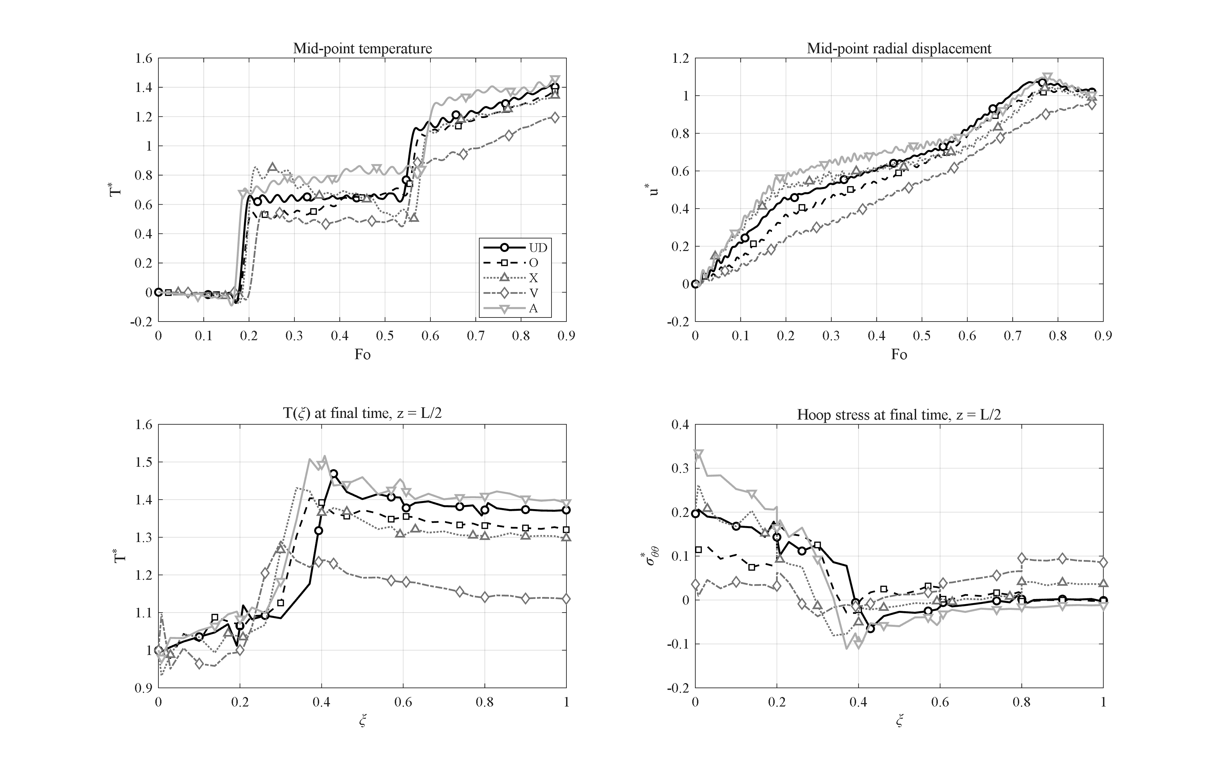
Figure 4-1: Effect of the GPL distribution pattern (UD, O, X, V, A): (a) mid-point temperature history; (b) mid-point radial displacement history; (c) radial temperature profile and (d) hoop-stress profile at the final time (z = h/2).
As observed, the peak mid-point temperature for patterns UD, O, X, V and A is 1.41, 1.37, 1.34, 1.19 and 1.46, respectively. Pattern V, in which the GPLs are concentrated at the inner surface, shows the most favorable behavior: the highly conductive inner region spreads the incoming heat rapidly through the thickness, so its peak temperature is about 16 % lower than UD. At the same time its final inner-surface hoop stress is σ*_θθ = 0.036, which is about 5.5 times smaller than UD (0.196) and 8.8 times smaller than pattern A (0.313). Conversely, pattern A — whose inner surface consists of the low-conductivity epoxy-rich material — experiences both the highest temperature and the highest stress. The radial displacement follows the same ordering (u*_max from 0.95 for V to 1.11 for A). Physically, placing the stiff, conductive phase where the temperature gradient is steepest — the heated inner wall — both moderates the thermal gradient and reinforces the critical hoop-stress region; pattern V is therefore recommended for cylinders under internal thermal shock.

4-5. Effect of the porosity pattern and porosity level
This section examines the effect of the porosity distribution pattern (Figure 4-2) and of the overall porosity level (Figure 4-3); in both cases the GPL distribution is kept uniform (UD).
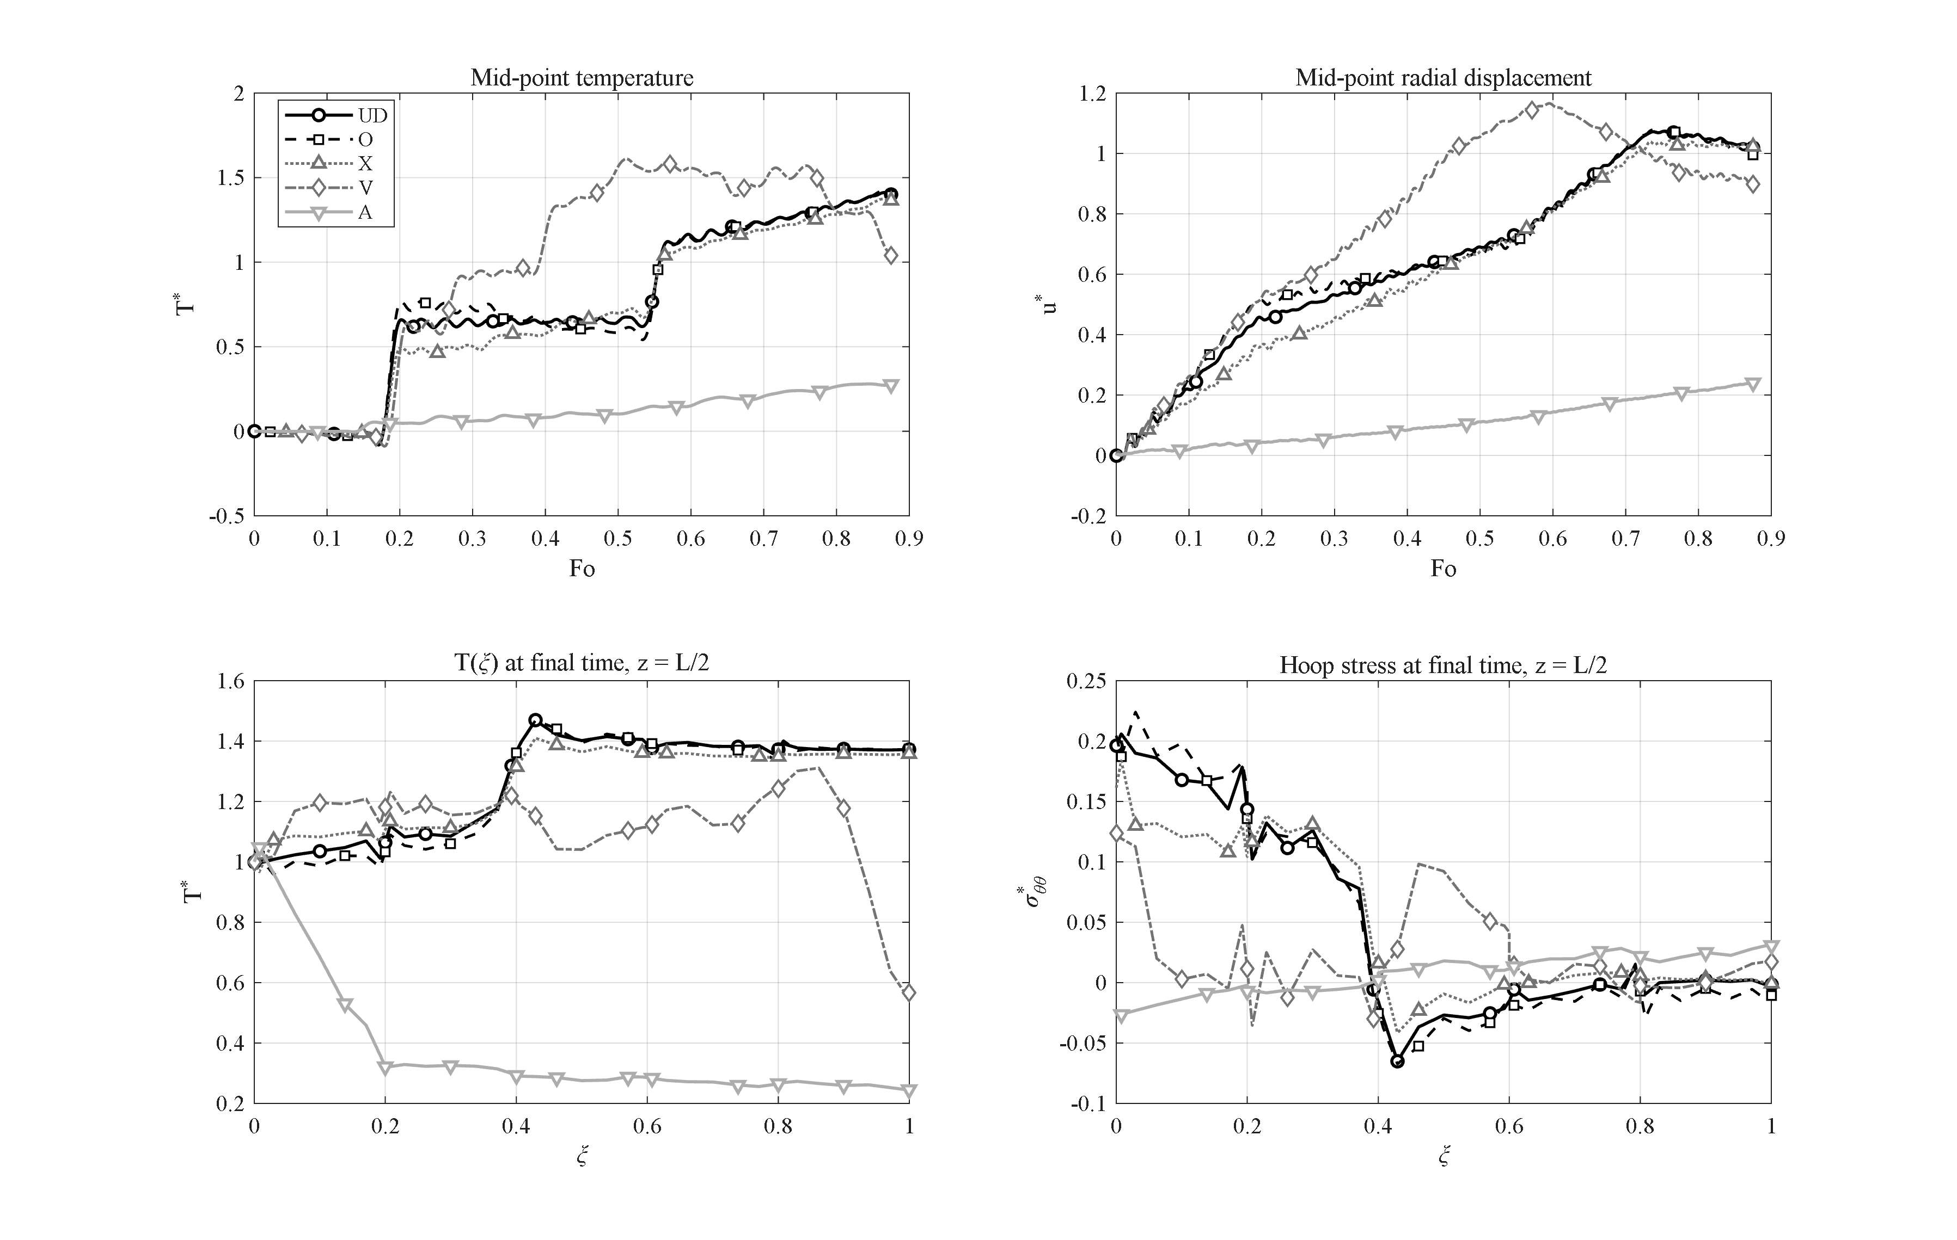
Figure 4-2: Effect of the porosity distribution pattern (UD, O, X, V, A) at uniform GPL distribution; pattern A acts as a thermal barrier and pattern V shows the largest transient trapping peak.
The porosity pattern acts essentially through the conduction path. Patterns UD, O and X behave similarly (peak temperatures 1.41, 1.42 and 1.37), whereas the two asymmetric patterns V and A represent complete opposites. In pattern V, with the pores concentrated at the inner surface, the heat is initially trapped next to the cylinder cavity and the mid-point experiences the largest transient peak of this group (T*_max = 1.61 at Fo = 0.51); subsequently the same porous inner band throttles further heat inflow, so that by the end of the interval the mid-point temperature returns to 1.04 and the outer surface to 0.57. Pattern A, concentrating the pores at the outer surface, acts as a genuine thermal barrier: the outer porous band with its negligible conductivity blocks the heat path to the environment, so that the mid-point temperature never exceeds T* = 0.28 and the outer surface remains at 0.25 — a 5.6-fold reduction with respect to the value 1.37 of pattern UD. The price of this thermal performance is paid on the mechanical side: the displacements collapse to u*_max = 0.24 and the final inner-surface hoop stress even changes sign (−0.025), a behavior that must be accounted for in design.
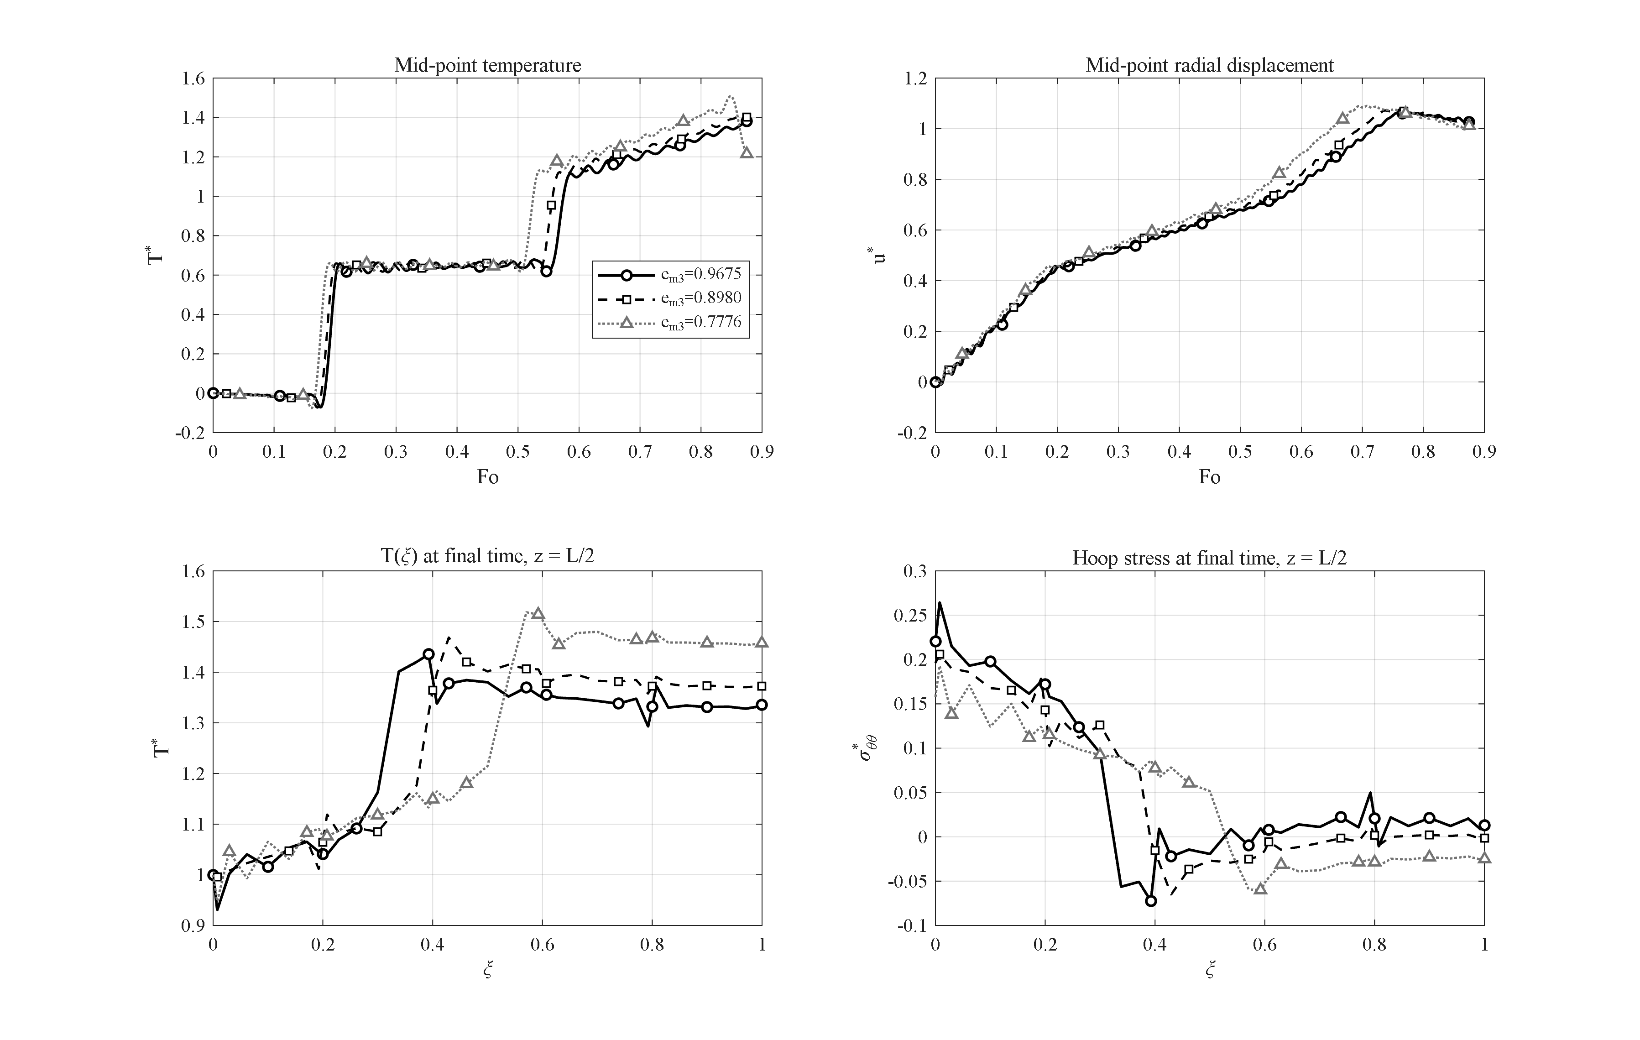
Figure 4-3: Effect of the porosity level (e_m3 = 0.9675, 0.8980, 0.7776) on the transient thermoelastic response.
Figure 4-3 shows the effect of the overall porosity level for the three mass coefficients e_m3 = 0.9675, 0.8980 and 0.7776 (light, moderate and heavy porosity, respectively). Increasing the porosity reduces the conductivity and the stiffness simultaneously; consequently the peak temperature grows mildly (from 1.38 to 1.41 and 1.51) while the diffusion process slows down, so that the final mid-point value for the heavy porosity drops to 1.21 — at the end of the time window the wall is still filling with heat.

4-6. Effect of the GPL weight fraction
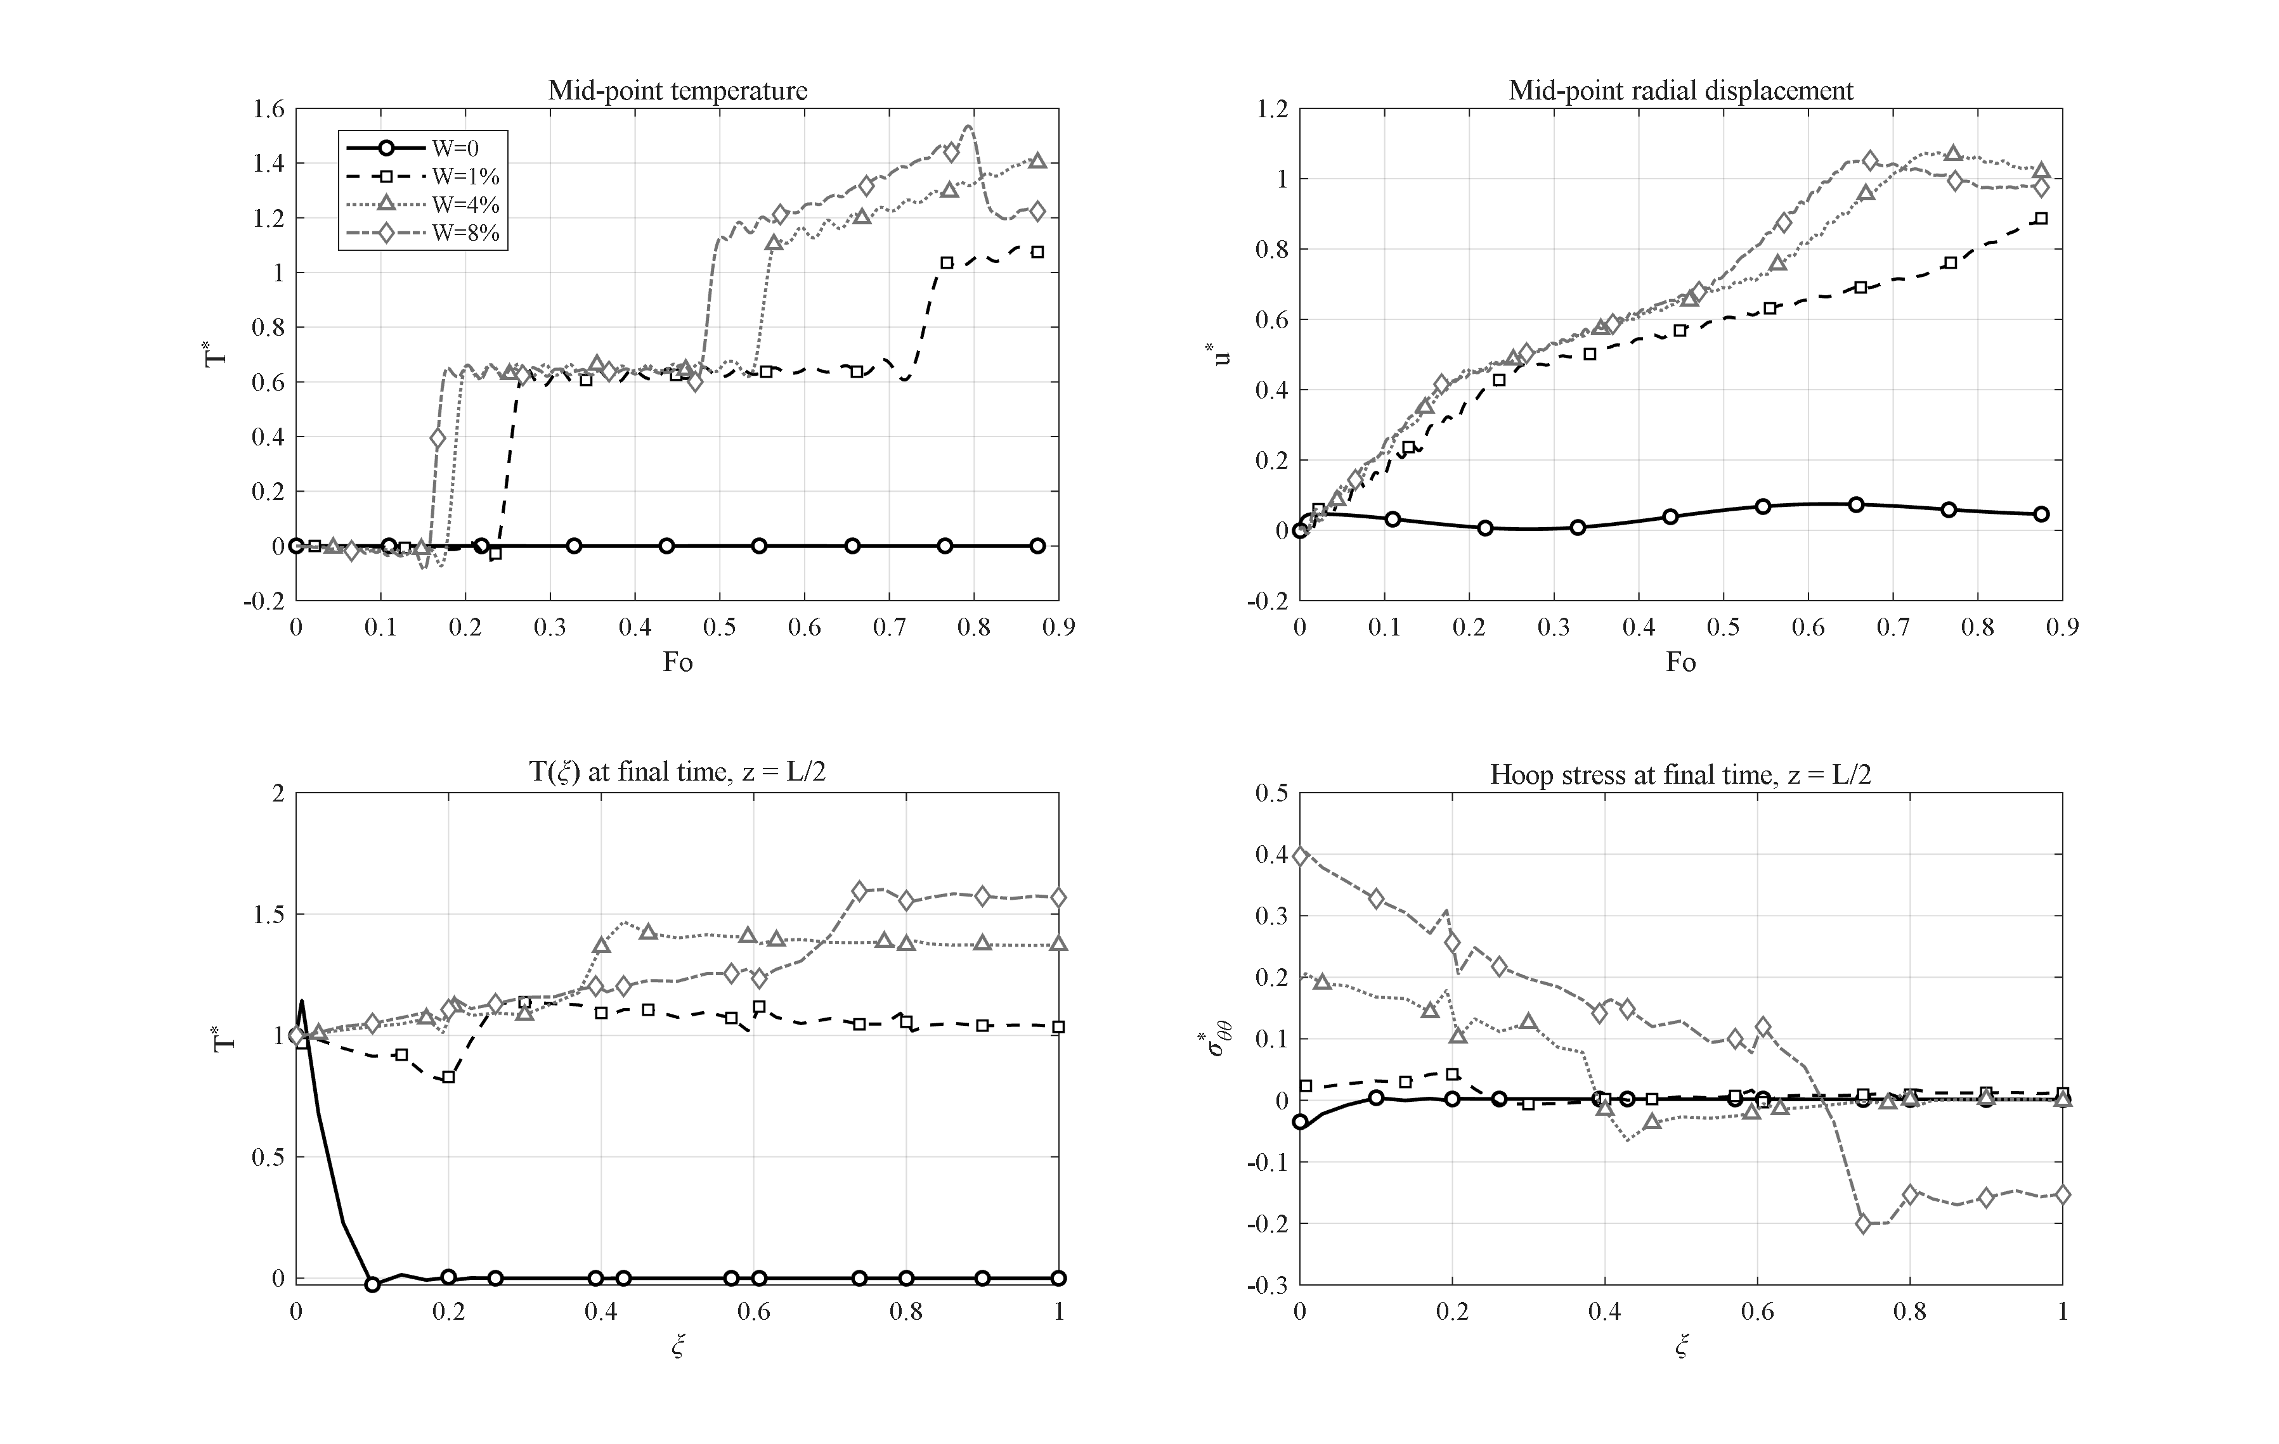
Figure 4-4: Effect of the GPL weight fraction (W = 0, 1 %, 4 %, 8 %): the percolated GPL network switches the wall from thermally insulating to conducting behavior.
The percolation character of the thermal-conductivity model (Chapter 3) makes the GPL weight fraction the strongest material lever of the problem. According to Figure 4-4, without GPLs (W = 0) the wall is pure porous epoxy with k ≈ 0.25 W/mK and ᾱ ≈ 1.9×10⁻⁷ m²/s: within the whole 100-second window the thermal wave does not even reach the mid-thickness (T* ≈ 0 throughout), and the small observed displacement (u* = 0.075) is merely the response to the internal pressure. Adding only 1 % of GPLs by weight, the percolated graphene network raises the thermal conductivity by about three orders of magnitude and the familiar transient behavior is established (T*_max = 1.09). Increasing the weight fraction to 4 % (reference) and 8 % raises the peak temperature to 1.41 and 1.54, respectively; at the same time, however, the wall stiffness increases strongly and the final inner-surface hoop stress doubles (0.397 versus 0.196). The practical conclusion of this study is that a small GPL weight fraction suffices to switch the structure from a "thermal insulator" to a "thermal conductor", and adding graphene beyond that mainly raises the thermal stresses.

4-7. Effect of the relaxation time; Lord-Shulman versus Fourier
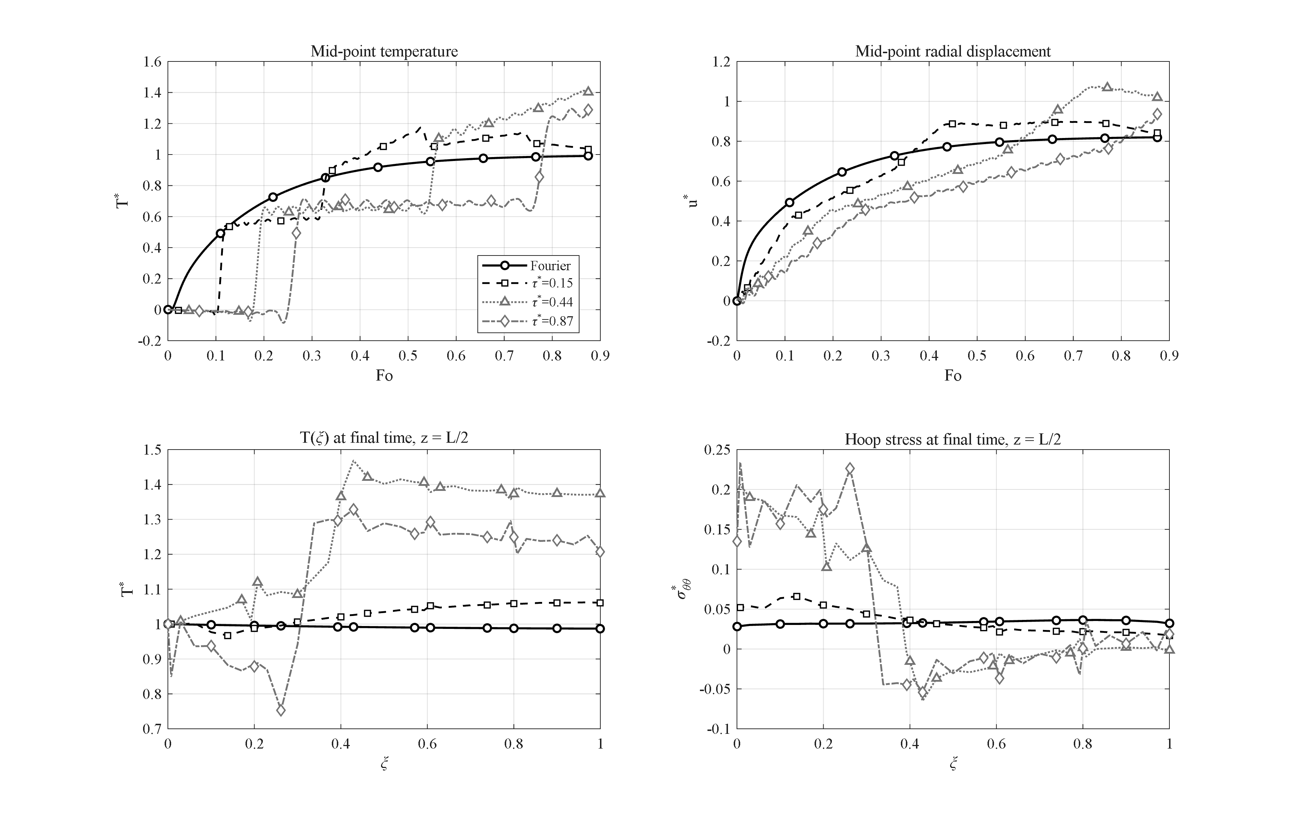
Figure 4-5: Effect of the dimensionless relaxation time (Fourier and τ* = 0.15, 0.44, 0.87): wave arrivals at Fo ≈ 0.17 and 0.55 and the hyperbolic overshoot T* > 1; the mild oscillations behind the fronts are the unfiltered Gibbs effect (δ = 1/2).
Figure 4-5 compares the response for Fourier conduction (τ* = 0) and for three values of the dimensionless relaxation time, τ* = 0.15, 0.44 and 0.87. Under Fourier conduction the mid-point temperature increases monotonically and never exceeds the driving value (T*_max = 0.99), since classical diffusion, with its unbounded propagation speed, cannot produce any overshoot. With the relaxation time active in the Lord-Shulman theory, the heat propagates as a wave with the finite speed √(ᾱ/τ0): the first wave arrival at the mid-thickness for τ* = 0.44 is clearly visible at Fo ≈ 0.17, followed by a second front — the reflection from the outer surface — at Fo ≈ 0.55. Remarkably, owing to the cylindrical geometry and the superposition of the reflected wave, the temperature overshoots even the inner-surface value; a purely hyperbolic phenomenon impossible in the parabolic Fourier theory. The peak temperatures are 1.17 for τ* = 0.15, 1.41 for τ* = 0.44 and 1.30 for τ* = 0.87 (at the end of the interval and still rising — the slower wave has completed fewer passes within the window). The relaxation time thus controls both the wave arrival times and the overshoot amplitude, and its clear signature in the temperature histories is the central physical argument for employing generalized thermoelasticity in short-time analyses of such structures [3].

4-8. Effect of the end supports
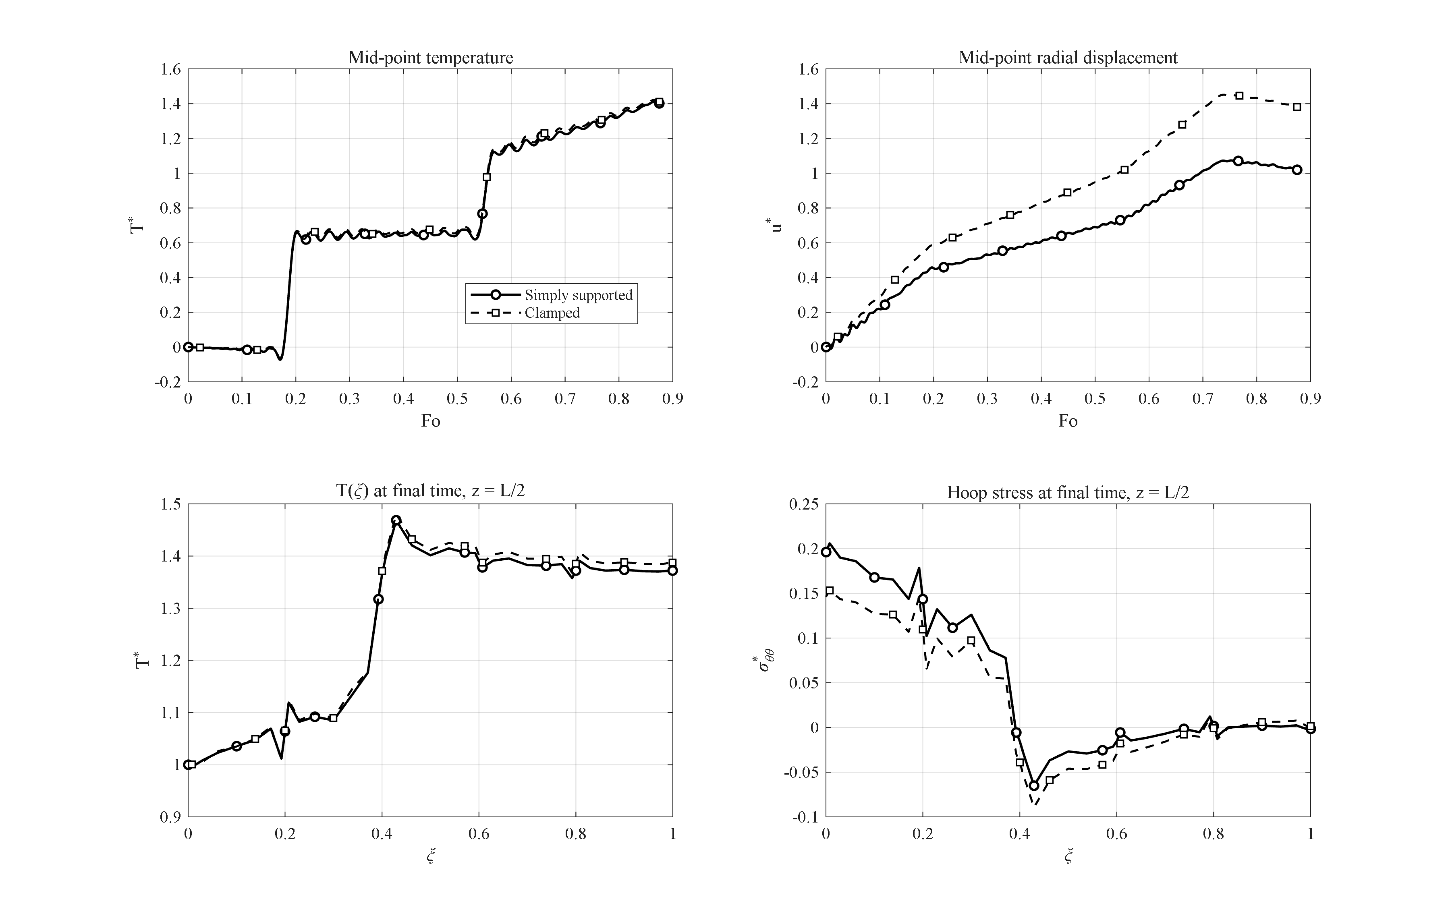
Figure 4-6: Effect of the end supports (simply supported S vs clamped C): the temperature field is unchanged while the blocked axial expansion raises the mid-length radial displacement by about 35 %.
Figure 4-6 compares the response for simply supported (S) and clamped (C) conditions at the two ends z = 0 and z = h. The temperature field is observed to be practically independent of the mechanical support (the peak temperature changes by only 0.8 %). The mechanical response, however, changes character: with clamped ends the axial thermal expansion of the wall is blocked and, by the Poisson effect, the blocked axial strain is redirected radially — the mid-length radial displacement increases by about 35 % (u*_max = 1.45 versus 1.07). Conversely, the final inner-surface hoop stress *decreases* from 0.196 to 0.146, since part of the load is transferred to the end constraints. It is worth noting that the disturbances caused by either support decay within a distance of roughly one wall thickness from the ends; the mid-length responses are therefore support-independent to within a few percent, which justifies reporting mid-length quantities as the characteristic response of the structure.

4-9. Effect of the step and harmonic internal pressure
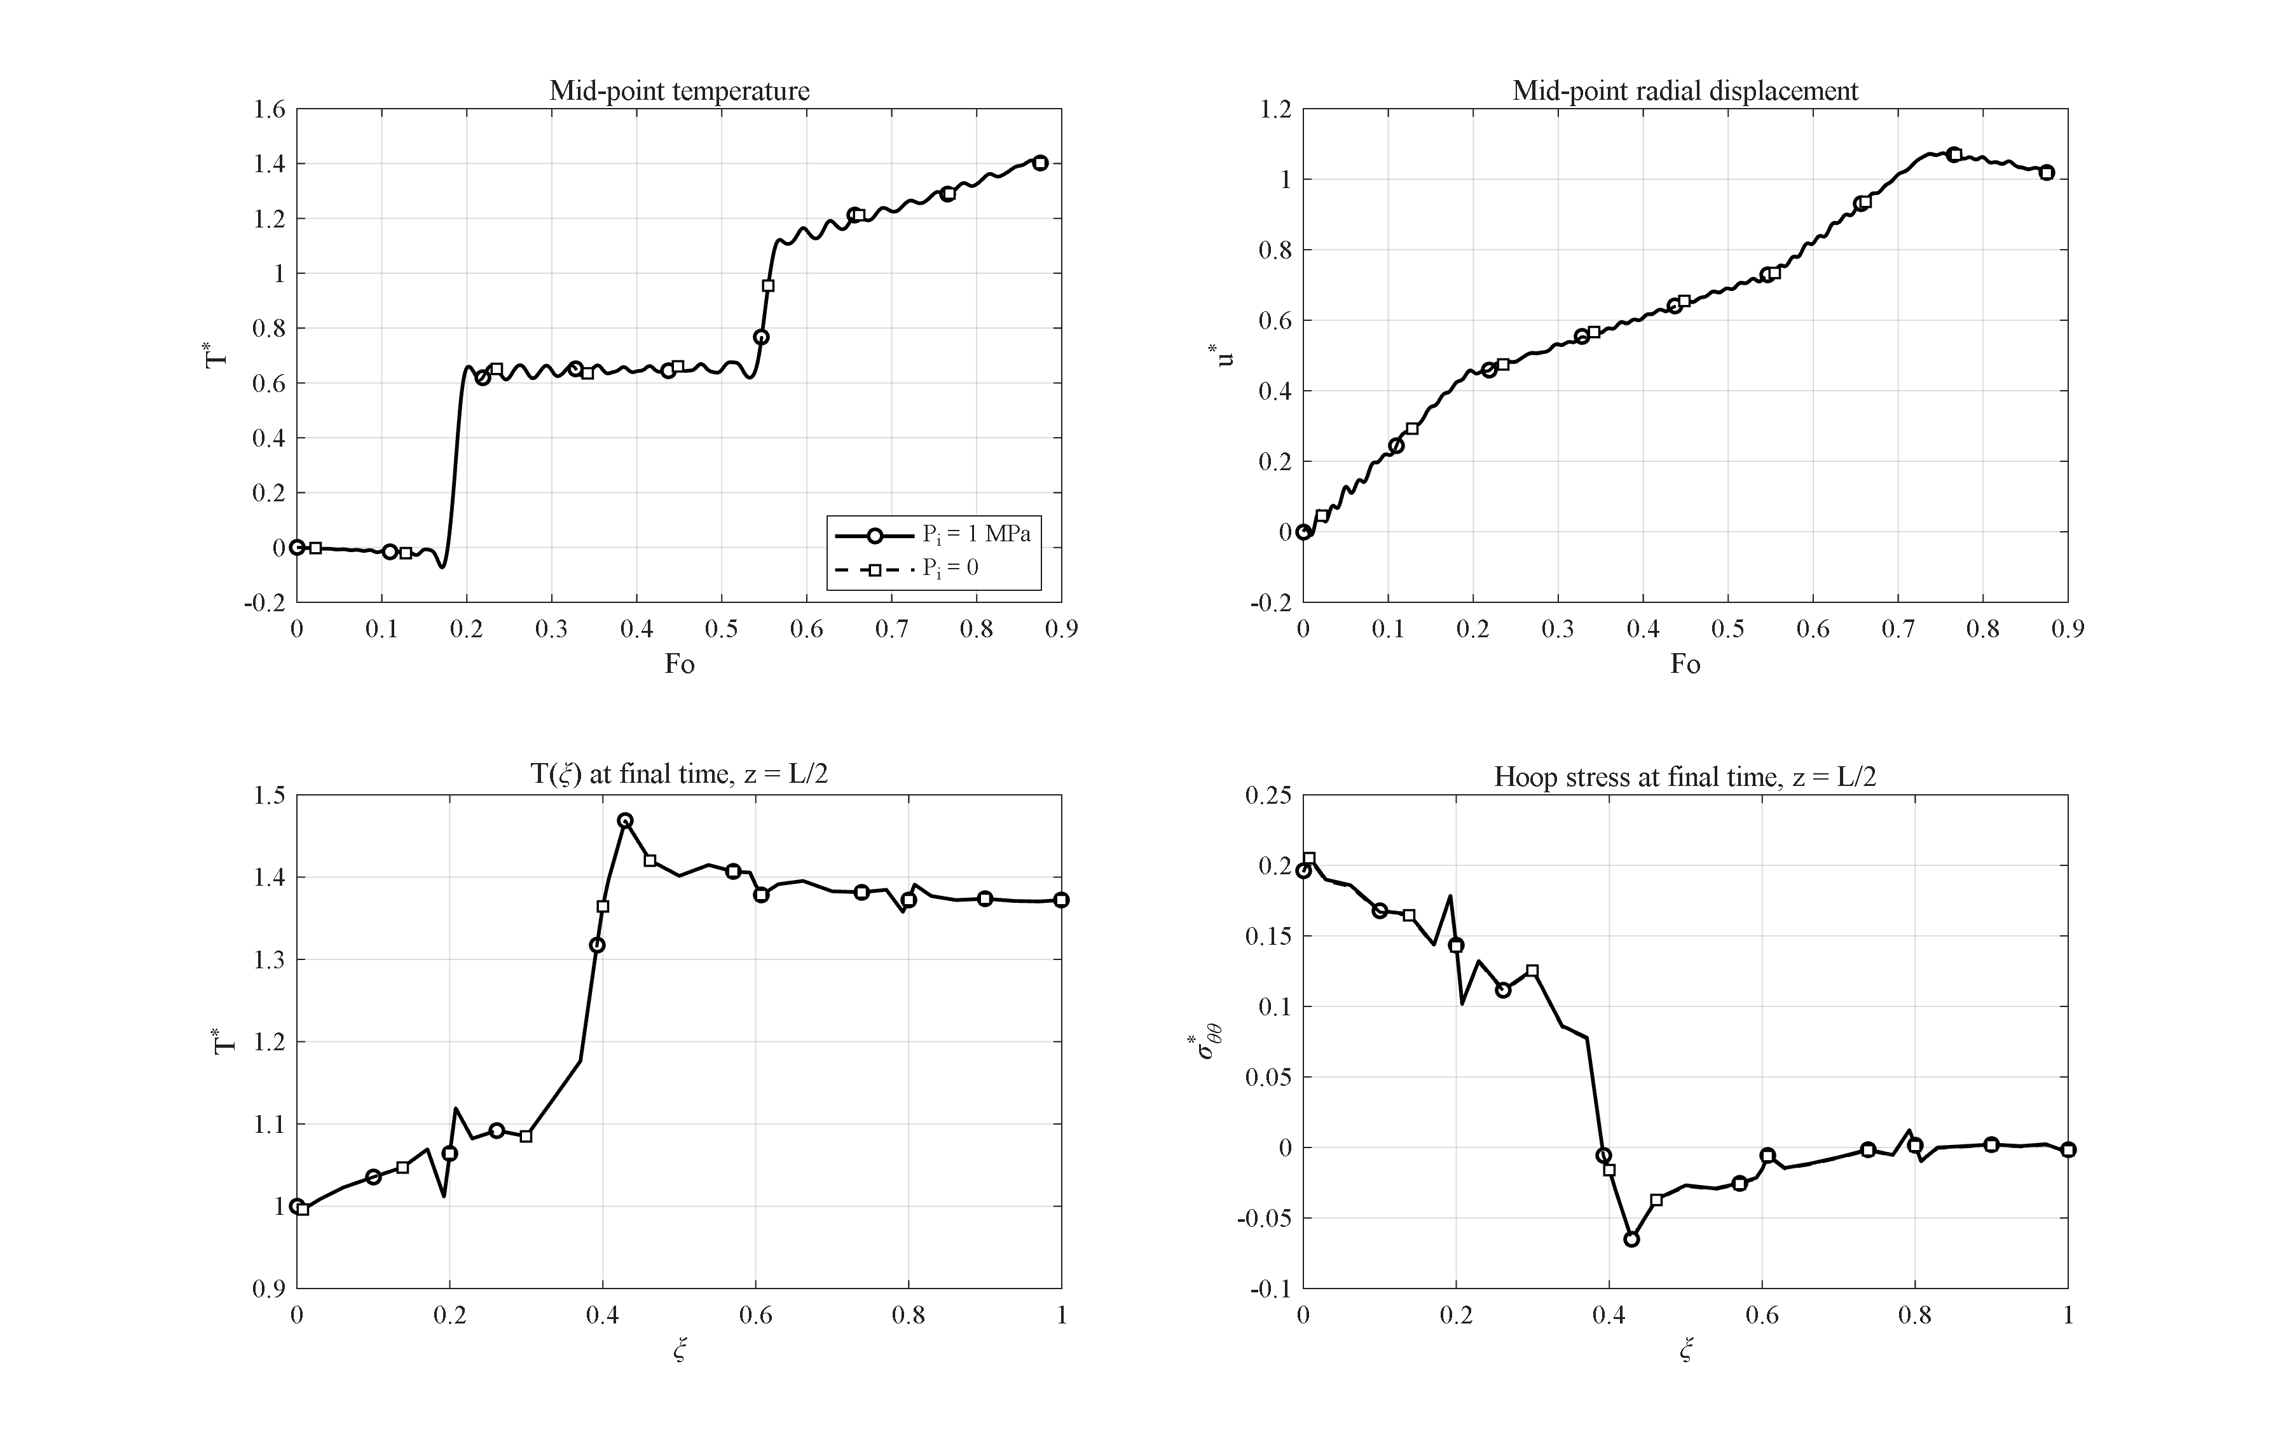
Figure 4-7: Effect of removing the internal pressure (P_i = 1 MPa vs 0): the thermally dominated response changes by less than 1 %.
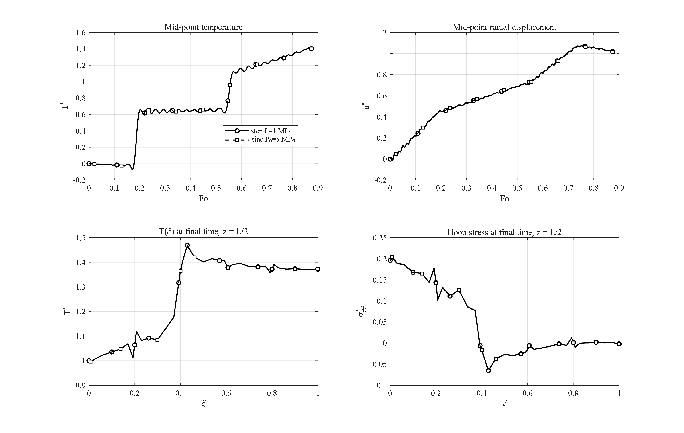
Figure 4-8: Effect of a harmonic internal pressure (amplitude 5 MPa) versus the step pressure: a small ripple on the displacement history without change of the thermal solution.
Figures 4-7 and 4-8 examine the effect of the internal pressure. According to Figure 4-7, removing the 1 MPa internal pressure entirely changes the displacement and stress histories by far less than 1 % (for instance u*_max from 1.0735 to 1.0721); the reason is that the thermal stress scale β̄ΔT in this problem is about two orders of magnitude larger than the applied pressure, so the response is thermally dominated. According to Figure 4-8, even a harmonic pressure with 5 MPa amplitude merely superposes a small ripple on the displacement history without any change of the thermal solution (the peak-temperature difference from the reference case is of order 10⁻⁵). The engineering conclusion is that in rapid heating events of this magnitude the pressure term is a second-order correction — a result that also justifies the common literature practice of studying the thermal shock alone.

4-10. Interaction of the GPL and porosity distribution patterns
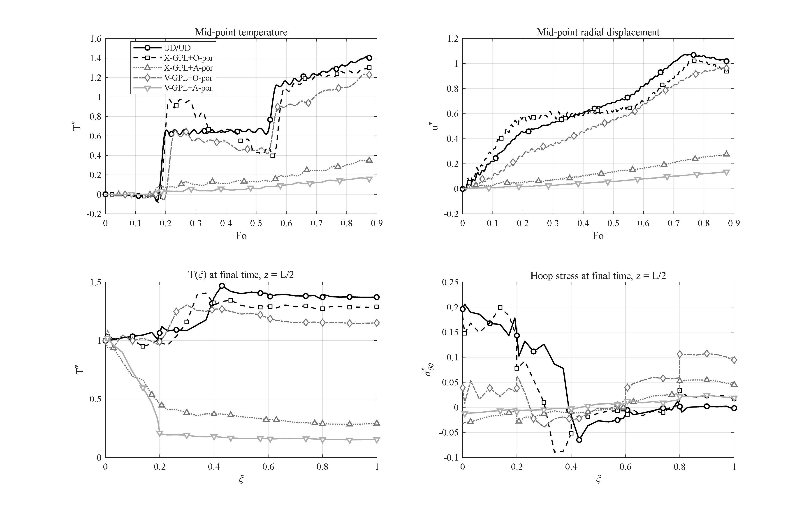
Figure 4-9: Interaction of the GPL and porosity patterns (UD/UD, X+O, X+A, V+O, V+A): the V-GPL + A-porosity combination reduces the outer-surface temperature 9-fold at benign stress levels.
The studies of Sections 4-4 and 4-5 showed that pattern V for the GPLs and pattern A for the porosity are individually the most favorable thermally. In this section their interaction is examined for the four combinations X-GPL+O-por, X-GPL+A-por, V-GPL+O-por and V-GPL+A-por alongside the UD/UD reference (Figure 4-9). The results show that the two mechanisms are synergetic, with the porosity barrier playing the dominant role: with the X distribution of graphene, switching the porosity pattern from O to A lowers the mid-point peak from 1.30 to 0.35, and with the V distribution from 1.23 to 0.17. The best combination, V-GPL together with A-porosity, holds the outer-surface temperature at T* = 0.15 — a 9.0-fold reduction with respect to the reference case (1.37) — while its stress state remains benign (|σ*_θθ| ≤ 0.024). This combination — conductive GPLs facing the heat source and insulating pores facing the environment — is the design recommendation of this thesis for thermal-protection applications, and the interaction study that identified it has no counterpart in comparable previous research [6].

4-11. Effect of the coupling of the equations
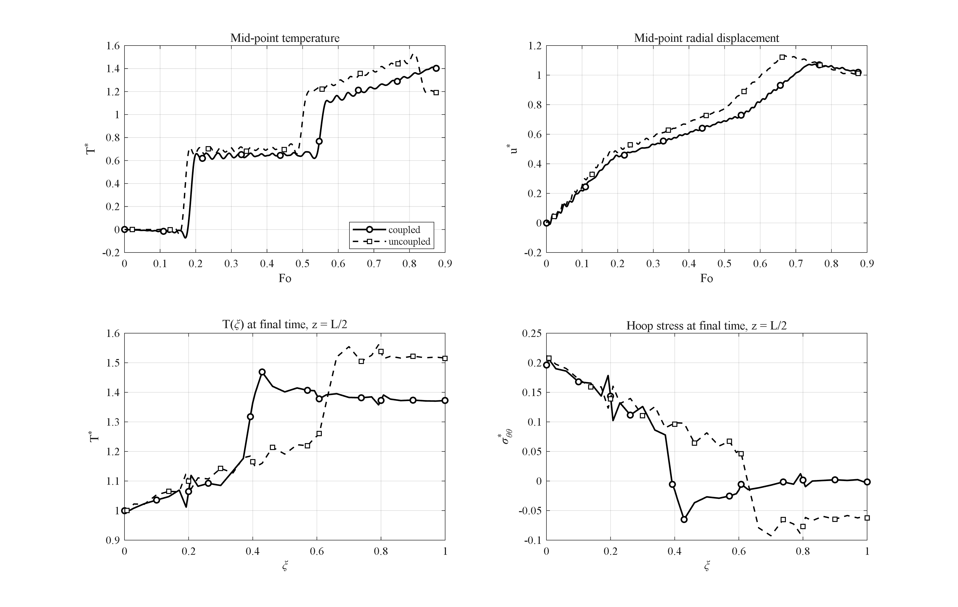
Figure 4-10: Effect of the thermo-mechanical coupling: the uncoupled model overestimates the temperature peak by 8.4 % (absence of the thermoelastic damping of the wave).
Figure 4-10 compares the fully coupled model with the uncoupled one (the dilatation-rate term removed from the energy conservation equation). The uncoupled model overestimates the peak temperature by 8.4 % (1.53 versus 1.41) and the peak displacement by 5.5 %. The reason is that in the coupled model a part of the thermal energy is continuously converted into mechanical work — a mechanism that may be called the thermoelastic damping of the thermal wave. The largest difference between the two models occurs exactly at the wave fronts, i.e. in the very quantities that matter in short-time analyses. This result demonstrates the necessity of solving the fully coupled system despite its higher computational cost.

4-12. Effect of the outer-surface convection coefficient
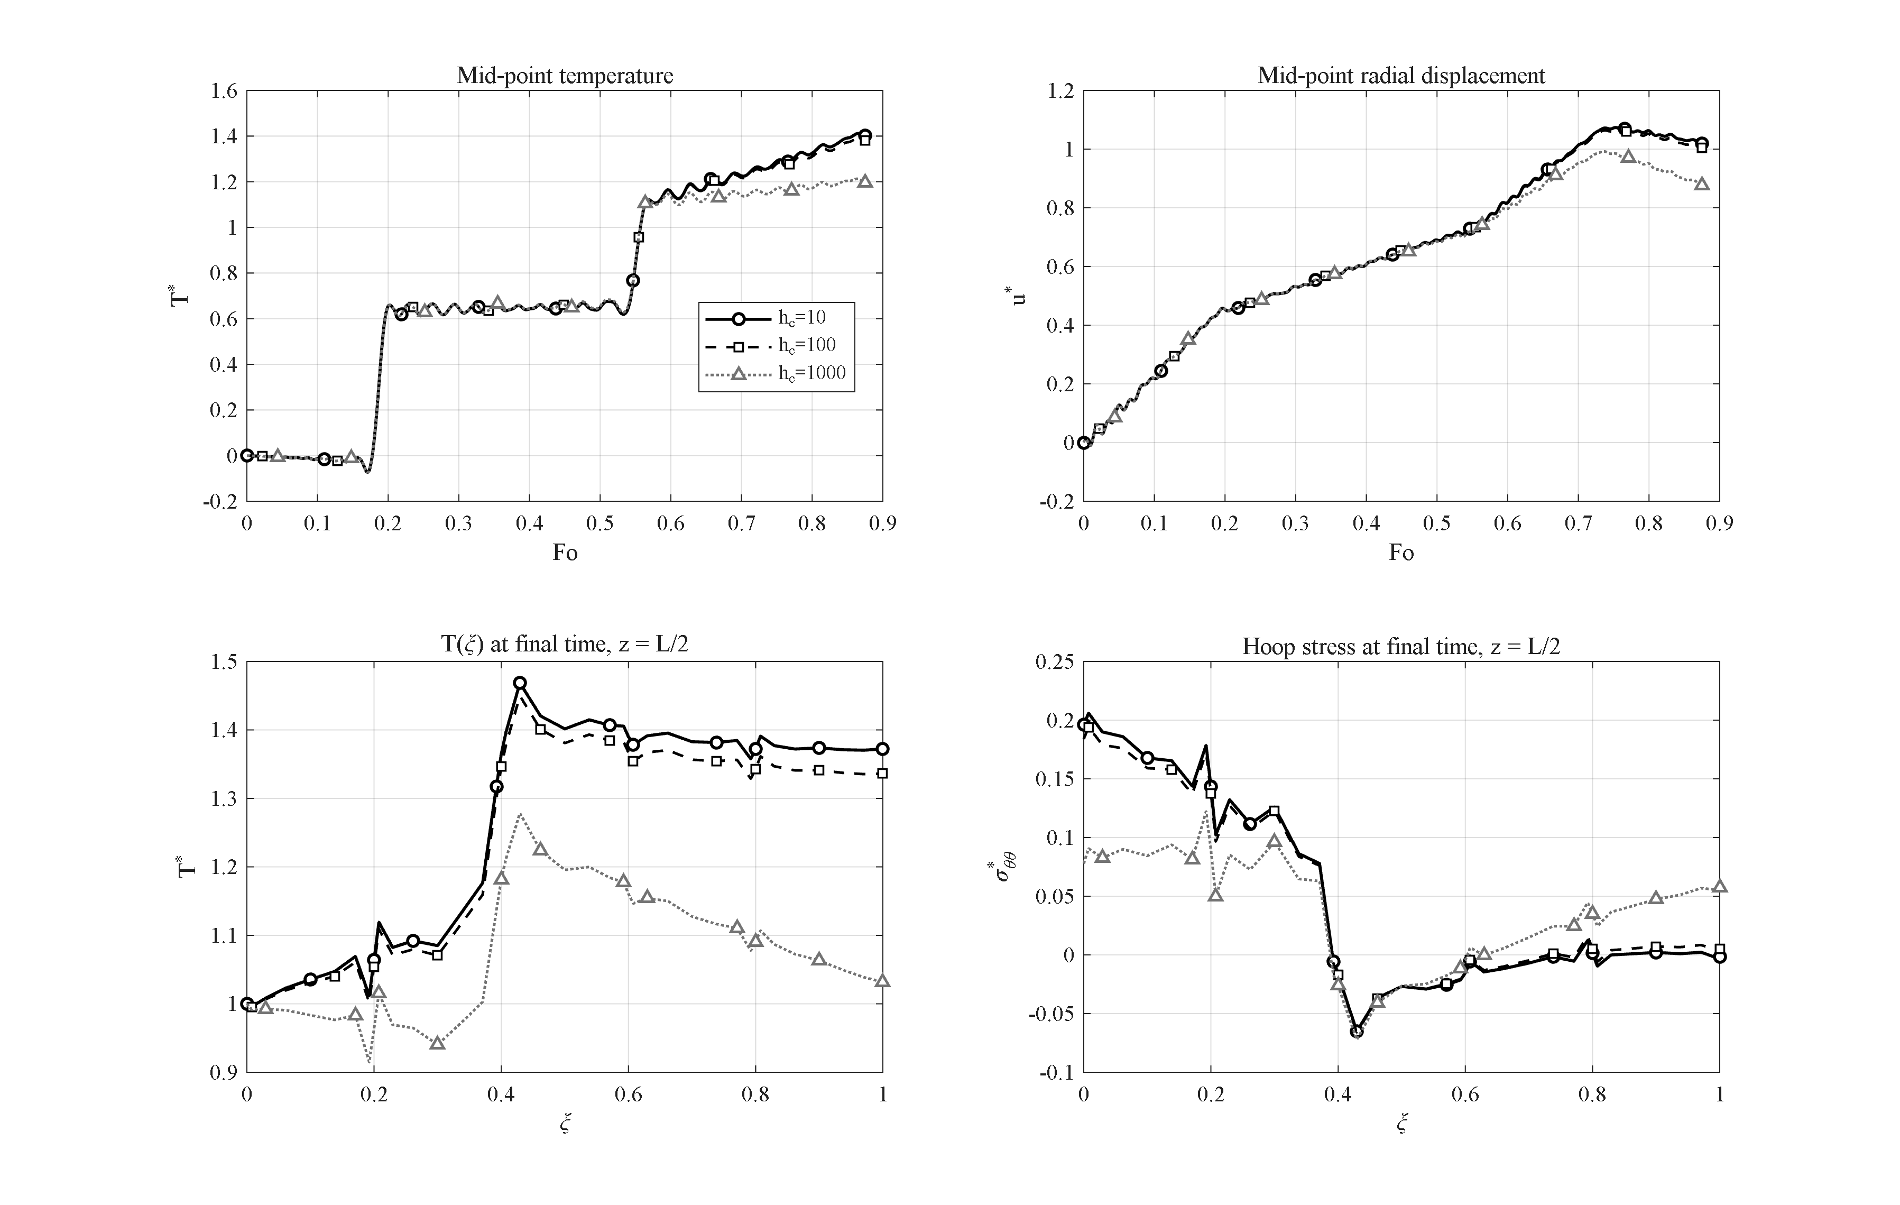
Figure 4-11: Effect of the outer-surface convection coefficient (h_c = 10, 100, 1000 W/m²K; Bi ≈ 0.004–0.4) on the transient response.
Figure 4-11 examines the effect of the outer-surface convection coefficient for h_c = 10, 100 and 1000 W/m²K, corresponding to Biot numbers Bi = h_c l/k̄ ≈ 0.004 to 0.4. With increasing h_c the outer surface turns from nearly adiabatic into an effective heat sink: the final outer-surface temperature drops from T* = 1.37 to 1.34 and 1.03, the mid-point peak from 1.41 to 1.39 and 1.21, and the final inner-surface hoop stress relaxes from 0.196 to 0.078 — because what determines the thermal stress is the through-wall temperature difference, not the absolute temperature level. The results show that the response is insensitive to convection for Bi below about 10⁻² and strongly convection-controlled for Bi above about 0.1 — two regimes that must be distinguished in design.

4-13. Effect of the wall thickness
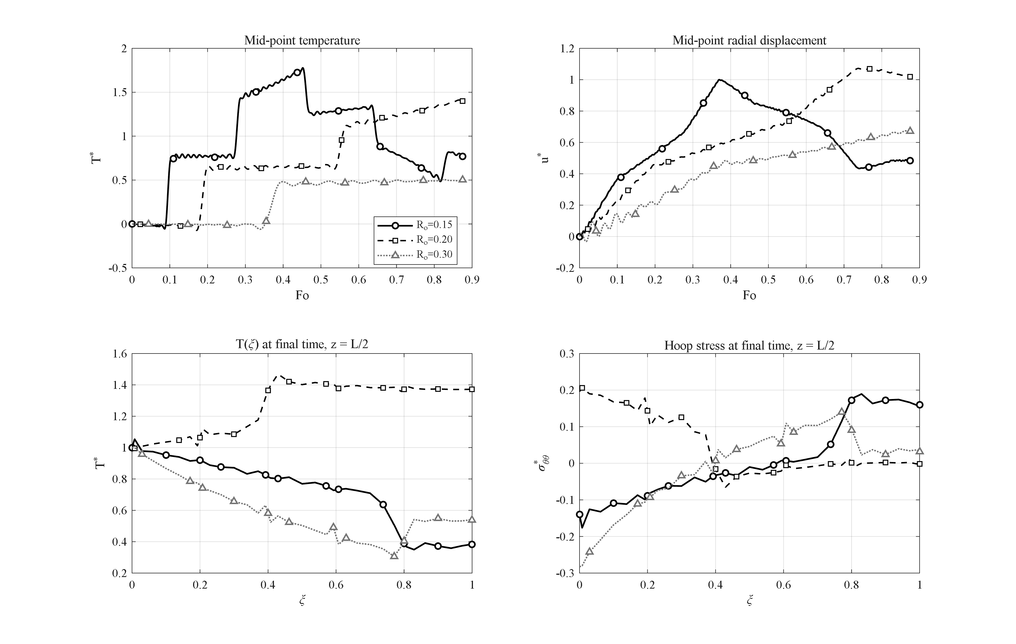
Figure 4-12: Effect of the wall thickness (l = 0.05, 0.10, 0.20 m at fixed R_i = 0.1 m): the thin wall maximizes the wave overshoot and the thick wall the compressive inner hoop stress.
Figure 4-12 compares three cylinders with wall thicknesses l = 0.05, 0.10 and 0.20 m (R_i = 0.1 m fixed); for comparability the time scale of all cases is nondimensionalized with the reference R_o = 0.2 m. The thin wall is crossed quickly and repeatedly by the thermal wave, and its mid-point experiences the largest overshoot of all studies in this chapter (T*_max = 1.78 at Fo = 0.45); equally quickly, however, it drains (final temperature 0.77). The thick wall behaves oppositely: within the examined window the wave does not even complete one full crossing (T*_max = 0.51) and the outer region stays cold; instead, the inner-surface hoop stress becomes strongly compressive (σ*_θθ,min = −0.28), since the heated inner band pushes against the cold, stiff outer mass. The wall thickness is therefore the geometric lever trading "temperature overshoot in thin walls" against "stress severity in thick walls".

4-14. Effect of the number of layers
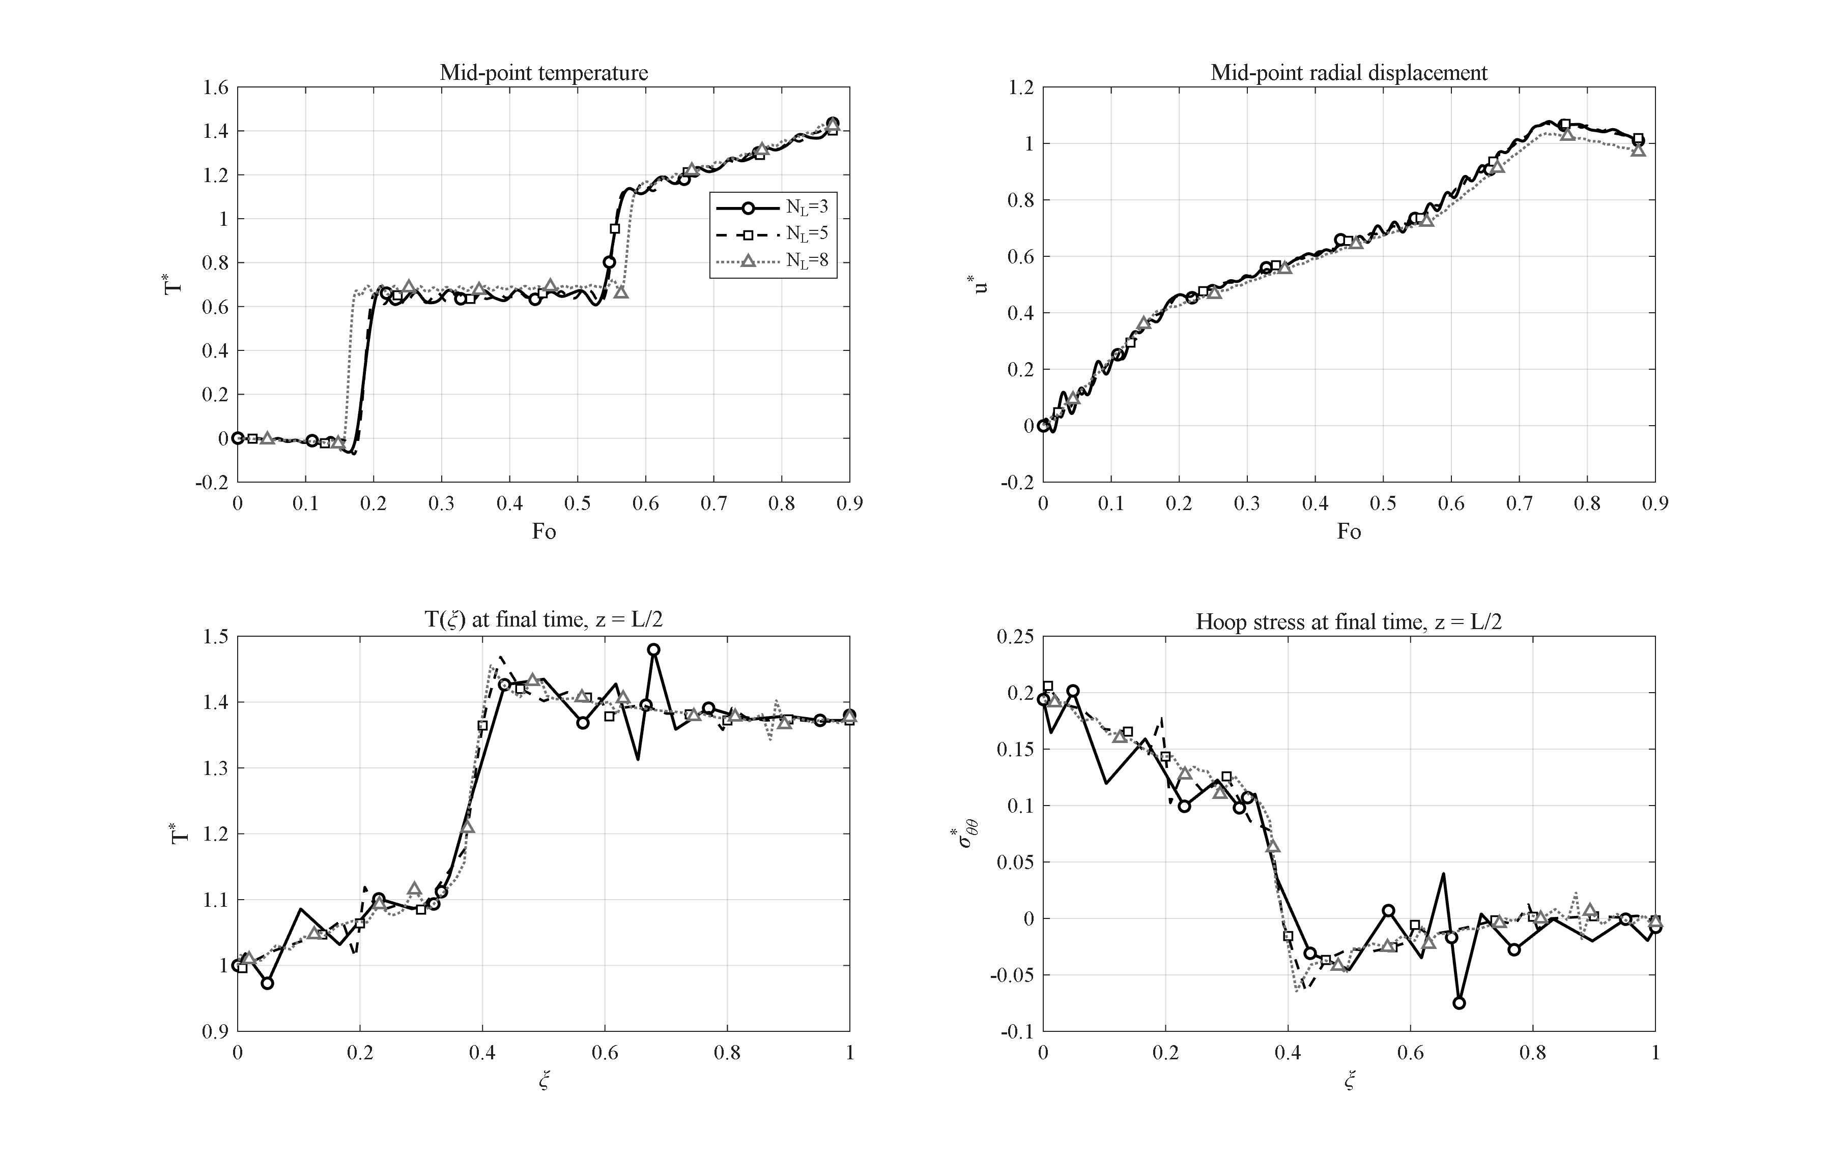
Figure 4-13: Effect of the number of layers (N_L = 3, 5, 8): global histories are converged (≤1.6 % change); the layer count refines the interface staircase of the stress profile.
Figure 4-13 shows the effect of the number of layers building up the wall (N_L = 3, 5 and 8) while the global distribution functions are kept fixed. The peak mid-point temperature changes by at most 1.6 % (1.435, 1.412 and 1.428) and the time histories are practically indistinguishable; the main effect of the layer count is a refinement of the staircase pattern of the hoop-stress profile at the layer interfaces, which is the natural signature of the layerwise property model. On this basis N_L = 5 is used throughout this chapter as the standard compromise between fidelity to the continuous distribution and computational cost — a choice consistent with the convergence study of the verification section.

4-15. Response to a Gaussian thermal shock
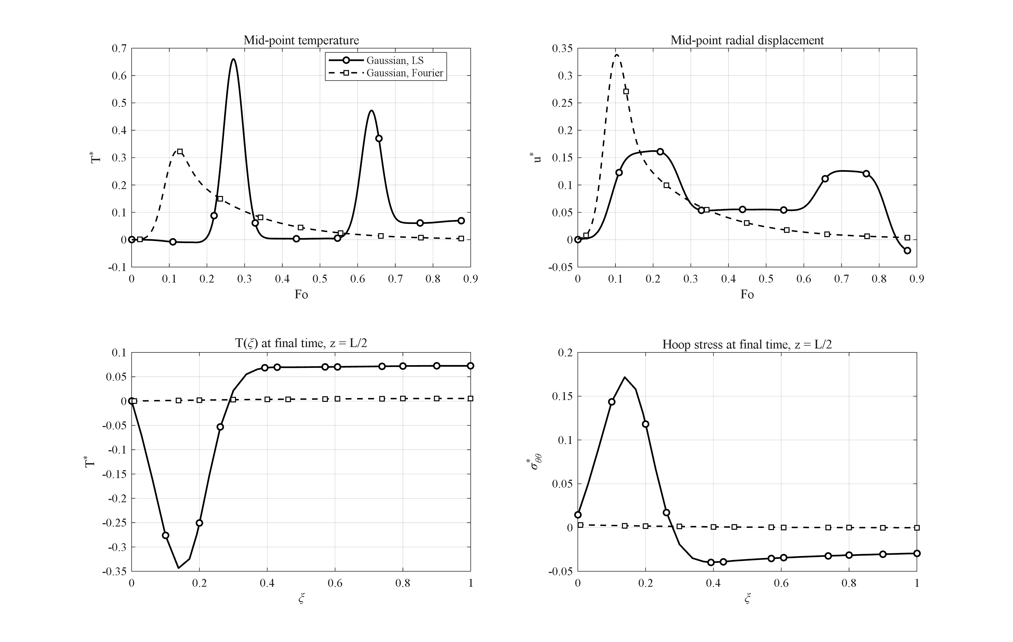
Figure 4-14: Response to a Gaussian thermal pulse under the Lord-Shulman and Fourier theories: the LS wave packet arrives later and twice as strong, with a ~50× larger hoop-stress excursion.
In this study the sustained ramp is replaced by a short Gaussian pulse of the inner-surface temperature, and the response is compared under the Lord-Shulman and Fourier theories (Figure 4-14). This loading exposes the essential difference between wave-like and diffusive transport: under Fourier conduction the pulse arrives at the mid-thickness smeared and weak (T*_max = 0.33 at Fo = 0.12) and has practically vanished by the end of the interval (T* = 0.004). Under the Lord-Shulman theory the pulse travels as a coherent wave packet: it arrives later (Fo = 0.27), about twice as strong (T*_max = 0.66), and leaves persistent oscillations behind (final temperature 0.070). The difference in the stress response is even more striking: the hoop-stress excursion under Lord-Shulman (from −0.040 to +0.172) is about 50 times that of Fourier conduction. In other words, under impulsive loads the classical theory underestimates the mechanical consequences of the shock by more than an order of magnitude — the strongest single argument of this thesis in favor of the generalized theory.

4-16. Comparison of time-integration methods
To position the Newmark scheme used in this thesis, five alternative time integrators were run on the identical benchmark problem (transient conduction with known exact solution; error measure: maximum temperature error at t = 10 s). The results are summarized in Table 4-3.
Table 4-3: Comparison of time-integration methods on the same spatial system.
method | max error (K) | CPU time (s)
Newmark (δ=½, β=¼) | 0.0032 | 0.33
Wilson-θ (θ=1.4) | 0.0164 | 0.19
Houbolt | 0.0025 | 0.24
HHT-α (α=−0.1) | 0.0033 | 0.29
ode15s (adaptive BDF) | 0.0003 | 2.57
Laplace-Durbin (thermal subsystem) | 0.137 | 193

Newmark, Houbolt and HHT-α are practically equally accurate at equal time step; Wilson-θ accepts a roughly 5-fold larger error due to its extra numerical dissipation; the adaptive stiff solver ode15s is about 10 times more accurate but 8 times more expensive; and the Laplace-transform route with Durbin's numerical inversion is three orders of magnitude slower. In addition, a methodological result emerged from this study: the Laplace transform cannot be applied to the full coupled system of this problem, because the undamped elastic poles of the coupled operator lie exactly on the inversion contour — which is why transform methods are applied in the literature to thermal subsystems only. This measured comparison justifies the choice of the Newmark method for all production runs of this thesis.

4-17. Comparison of spatial discretization methods
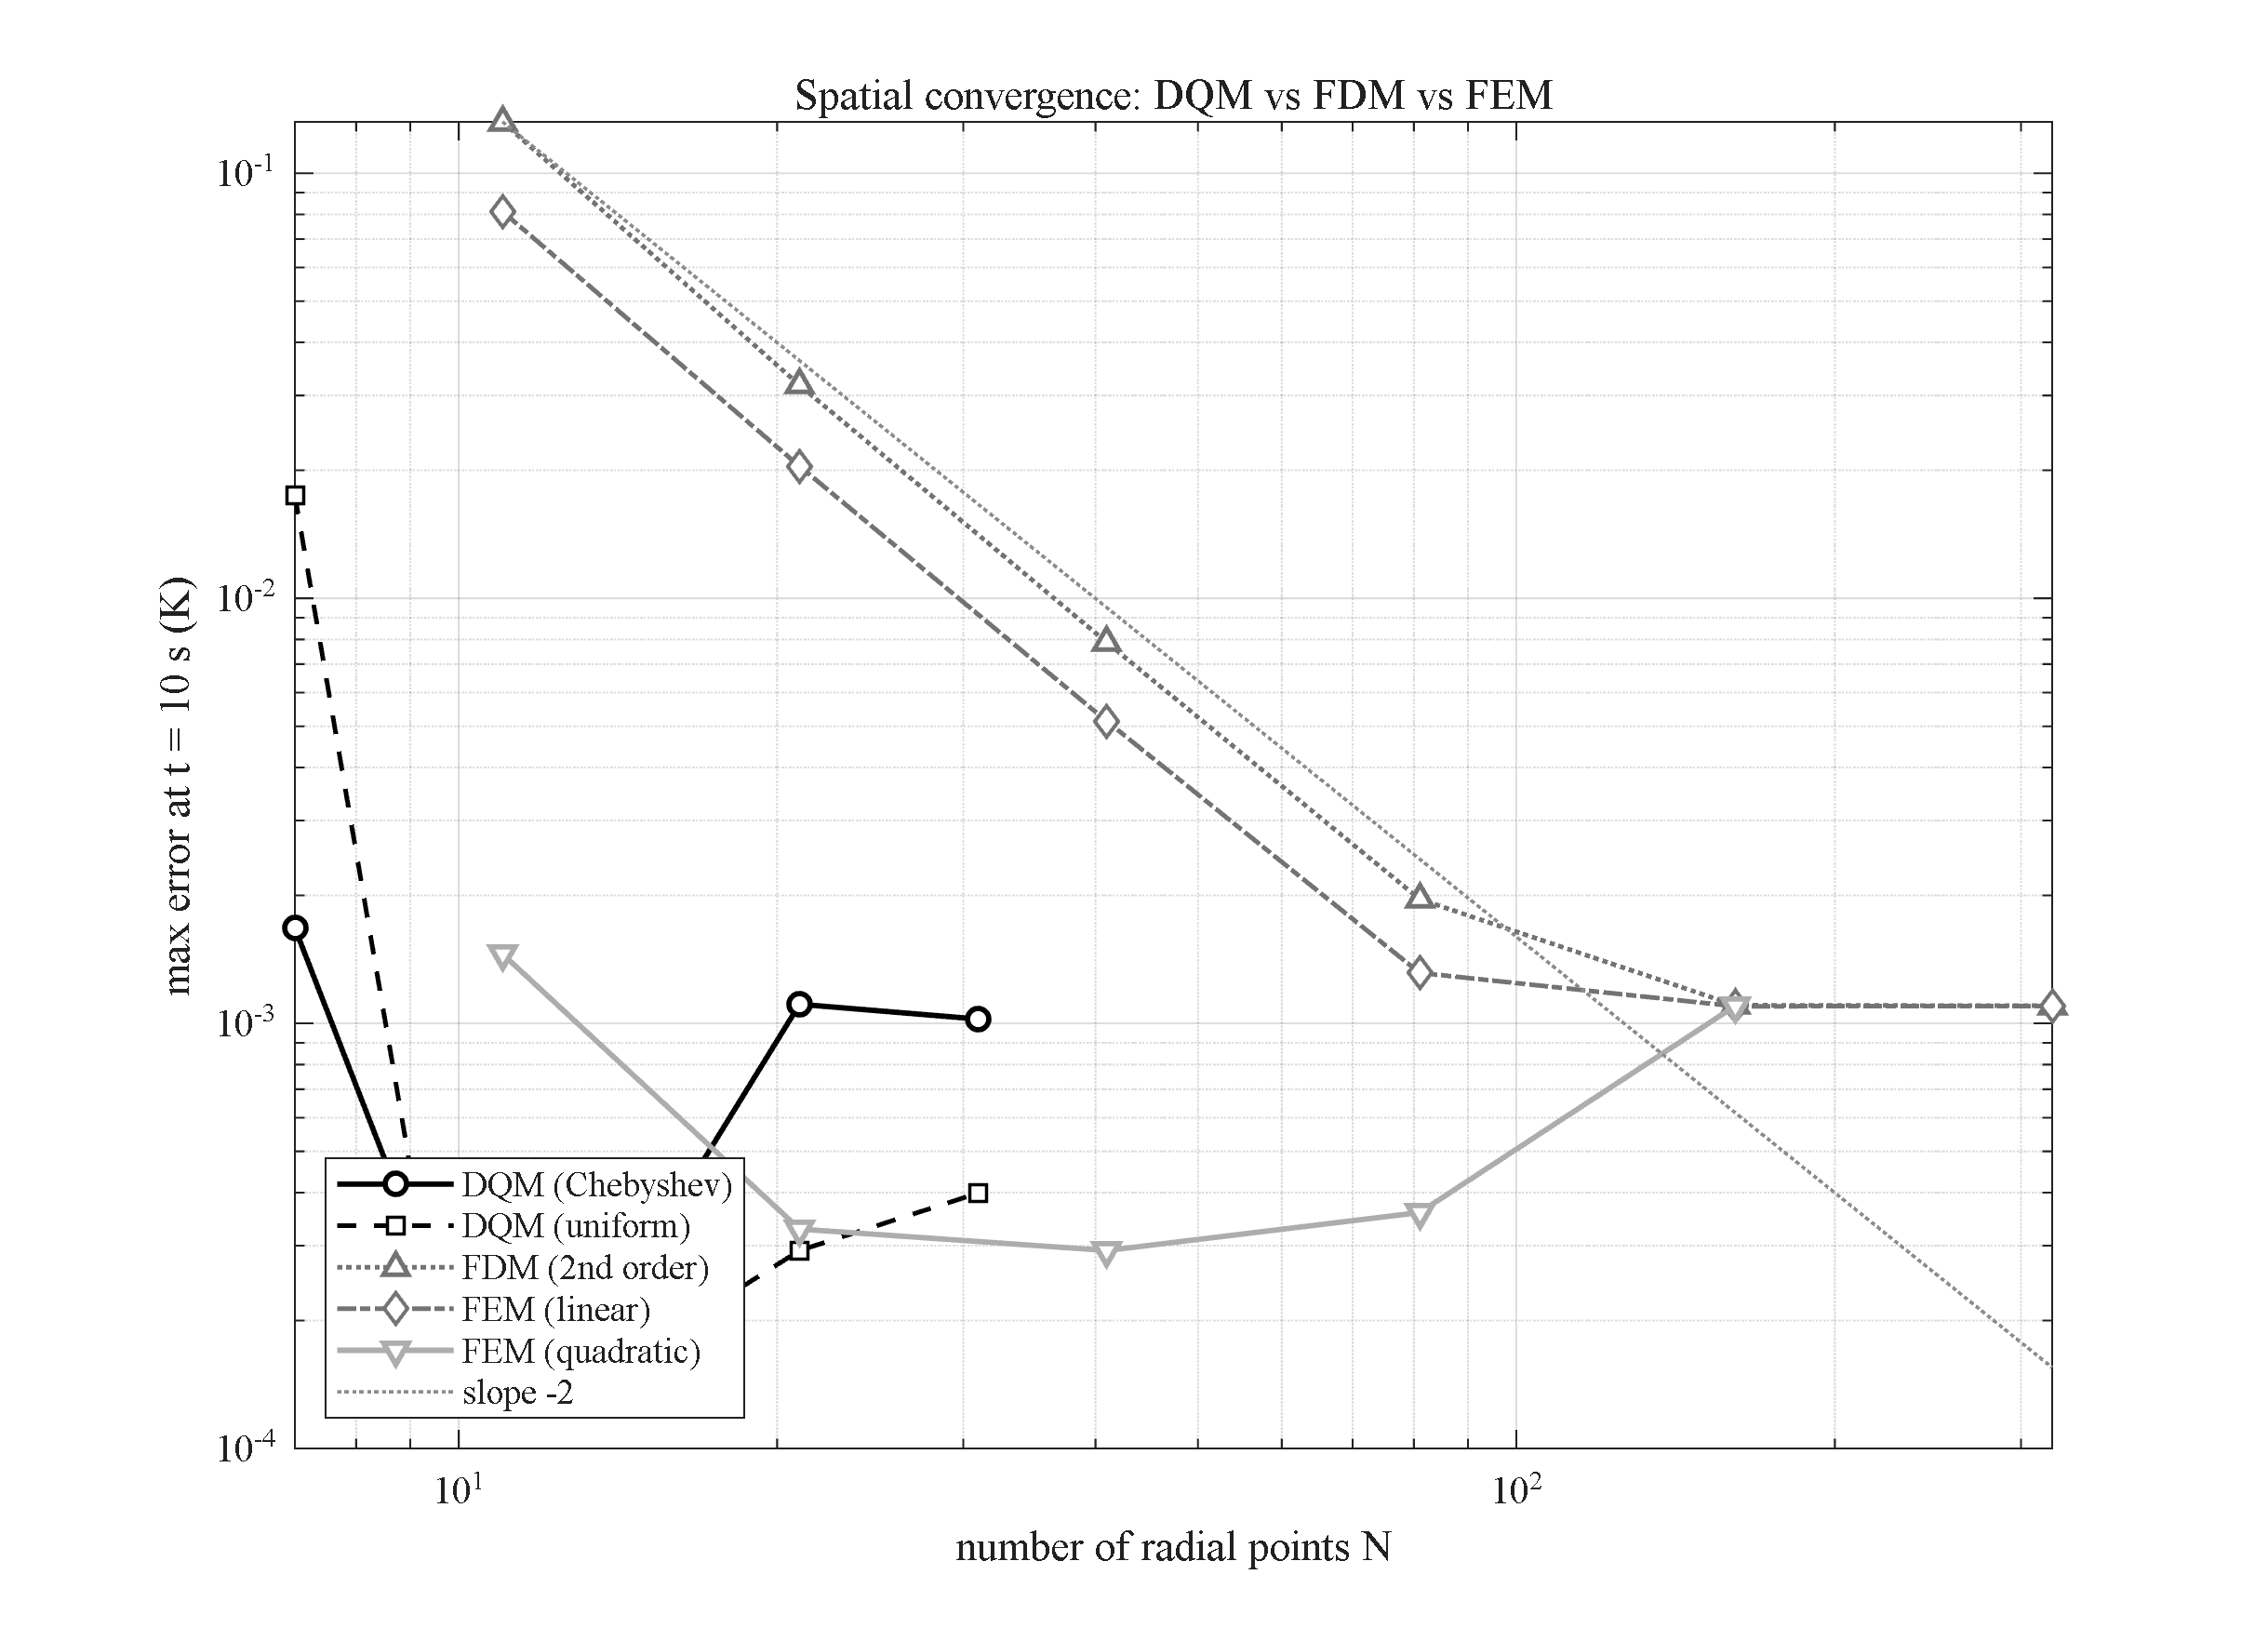
Figure 4-15: Spatial convergence of DQM (Chebyshev/uniform), 2nd-order FDM and FEM (linear/quadratic) on the transient-conduction benchmark: points needed to reach the time-step error floor are N ≈ 9–11 (DQM), 21 (quadratic FEM) and 161 (linear FEM/FDM).
In this extension study four spatial discretizations — the differential quadrature method with Chebyshev and with uniform grids, the second-order finite difference method, and the finite element method with linear and quadratic elements (Galerkin formulation with consistent matrices) — are compared on the transient-conduction problem with the exact Bessel-series solution, using the identical Newmark time march. Figure 4-15 shows the error convergence versus the number of radial points. The number of points required to reach the time-step error floor is: N ≈ 9–11 for differential quadrature, N ≈ 21 for quadratic finite elements, and N ≈ 161 for linear finite elements and finite differences. The linear-FEM and FDM curves coincide at slope −2; quadratic FEM gains roughly one order of magnitude per refinement step; and the DQM error falls quasi-exponentially until the temporal floor. At equal accuracy the DQM equation system is about 15 times smaller per direction — squared in the (r,z) plane — which is the quantitative justification for the layerwise differential quadrature choice of this thesis.

4-18. Comparison of the generalized thermoelasticity theories
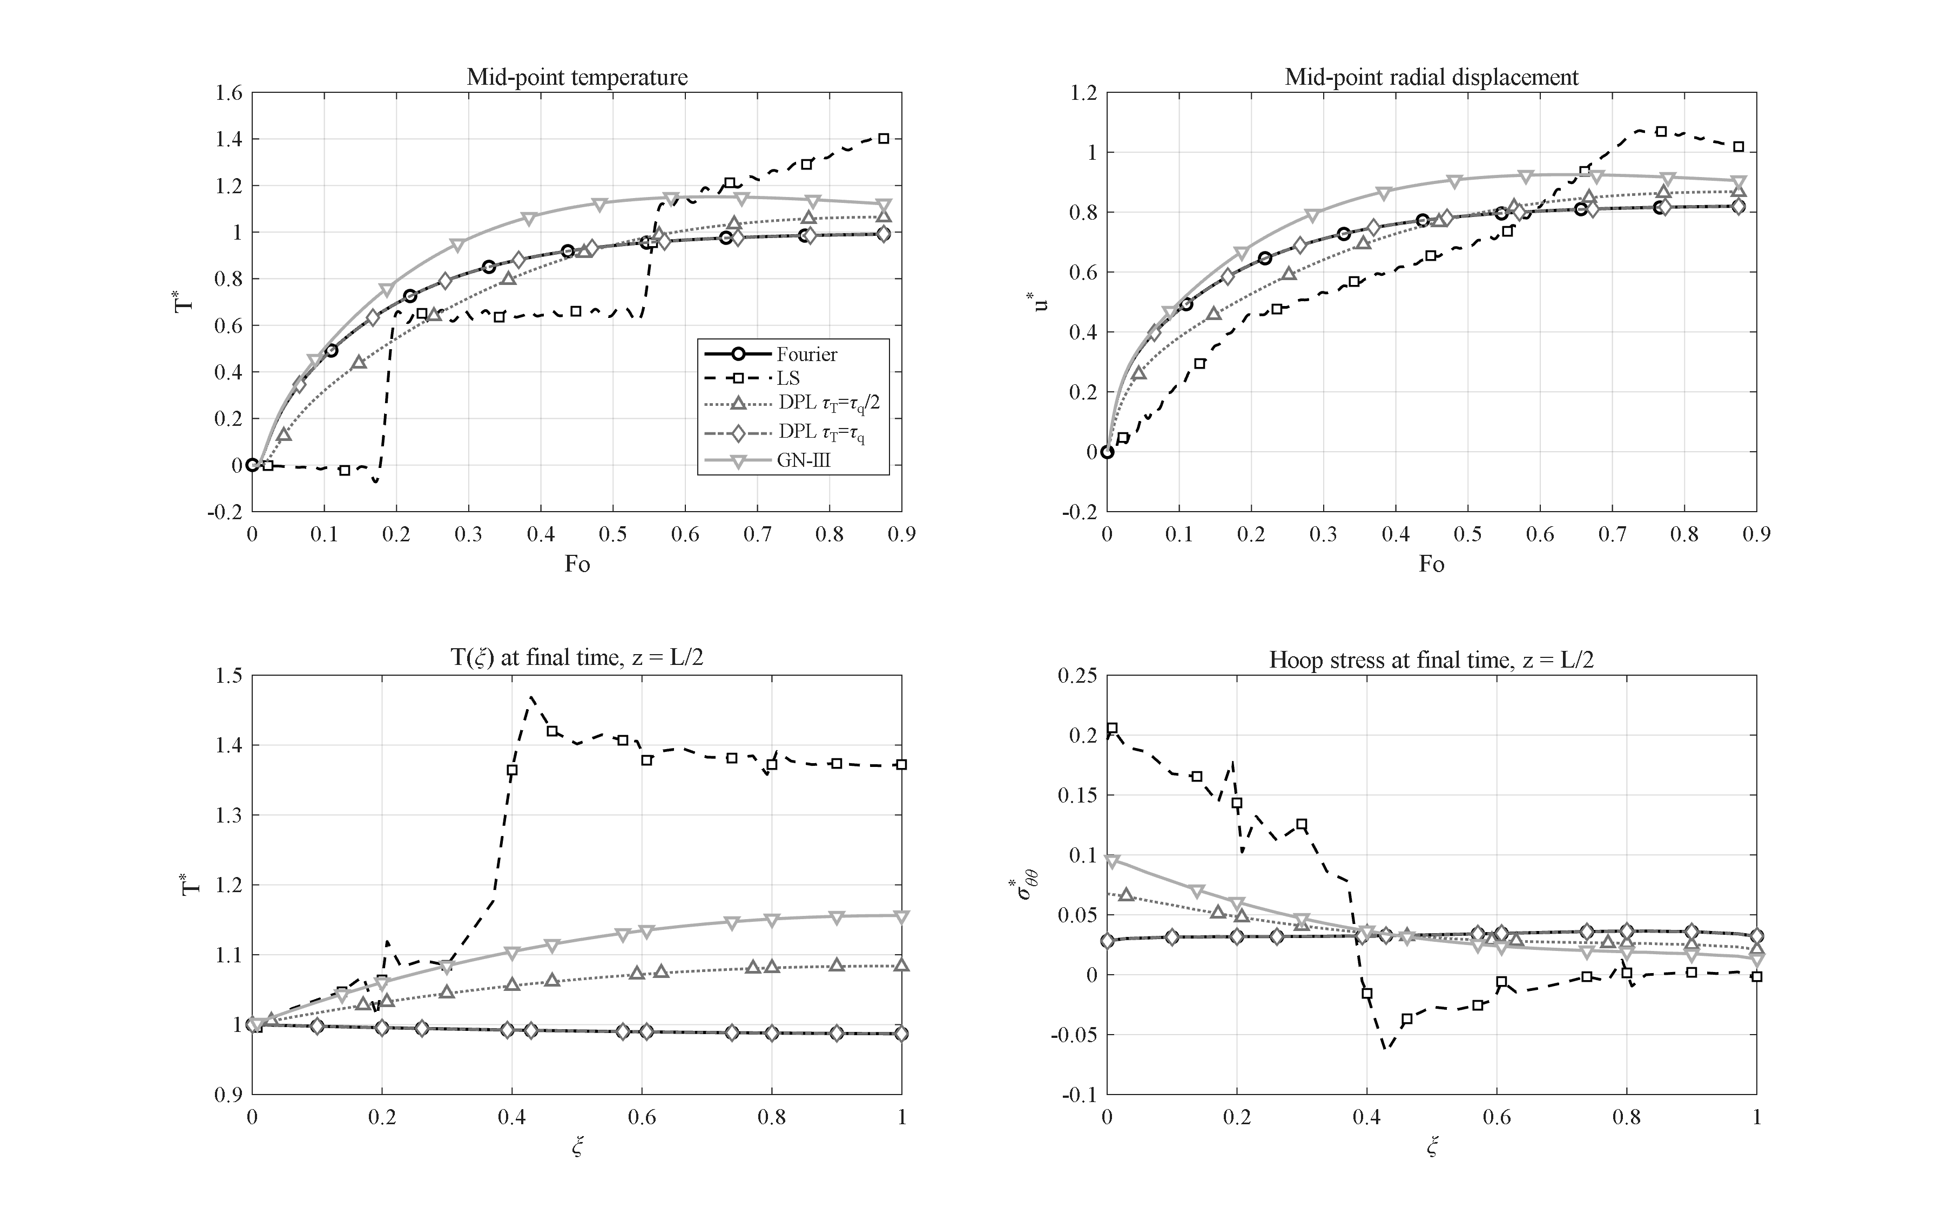
Figure 4-16: Comparison of the thermoelasticity theories (Fourier, Lord-Shulman, DPL with τ_T = τ_q/2 and τ_T = τ_q, Green-Naghdi III) with matched parameters: DPL(τ_T=τ_q) collapses onto Fourier; GN-III shows a persistent overshoot; LS carries the strongest wave.
In the final extension study the reference problem is solved under four thermoelasticity theories with matched parameters: the classical coupled Fourier theory, the Lord-Shulman theory [4], the dual-phase-lag (DPL) theory [74] with τ_q = τ0 and the two values τ_T = τ_q/2 and τ_T = τ_q, and the Green-Naghdi type-III theory [67] with k* = k/τ0 (so that its wave speed equals the Lord-Shulman one). According to Figure 4-16, the peak mid-point temperatures order as: Fourier 0.991 = DPL(τ_T=τ_q) 0.991 < DPL(τ_T=τ_q/2) 1.065 < Green-Naghdi 1.151 < Lord-Shulman 1.412. The two main observations are the following. First, for τ_T = τ_q the DPL solution collapses onto the Fourier solution to nine significant digits — the numerical confirmation of the known analytical degeneracy of this theory — showing that DPL is meaningful only for τ_T < τ_q, in which case it interpolates between Fourier and Lord-Shulman. Second, the Green-Naghdi theory exhibits an earlier but weaker front (peak at Fo ≈ 0.64) and a persistent overshoot (T* = 1.12 at the end of the interval), because its energy equation lacks a dissipative mechanism to damp the thermal wave; its long-time behavior is therefore qualitatively different. Such a four-theory map for porous GPL-reinforced cylinders does not exist in the literature and constitutes one of the contributions of this research.

4-19. Chapter summary
The main findings of this chapter can be summarized as follows:
1. The Lord-Shulman thermal wave produces mid-wall temperature overshoot up to T* = 1.41 (reference case) and 1.78 (thin wall) — impossible under Fourier conduction and decisive for short-time design.
2. Placing the GPLs at the heated surface (pattern V) and the pores at the cooled surface (pattern A) is synergetic: a 9.0-fold reduction of the outer-surface temperature at benign stress levels — the design recommendation of this thesis.
3. A percolation threshold near 1 % weight fraction switches the wall from an insulator to a conductor; graphene beyond that mainly raises the thermal stresses.
4. Full coupling damps the thermal wave (about 8 % peak reduction); uncoupled models are non-conservative exactly at the wave fronts.
5. Internal pressure of engineering magnitude is a second-order effect compared with the thermal stress scale β̄ΔT.
6. Clamped ends convert the blocked axial expansion into a ~35 % increase of the mid-length radial displacement; support effects remain localized at the ends.
7. Under impulsive (Gaussian) heating the classical theory underestimates the stress response by a factor of about 50.
8. Methodologically: Newmark offers the best accuracy-to-cost ratio of the six tested integrators; differential quadrature needs about 15 times fewer points per direction than finite differences or linear finite elements; and the four-theory map (Fourier / Lord-Shulman / DPL / Green-Naghdi) charts where the theories diverge for this class of structures.

