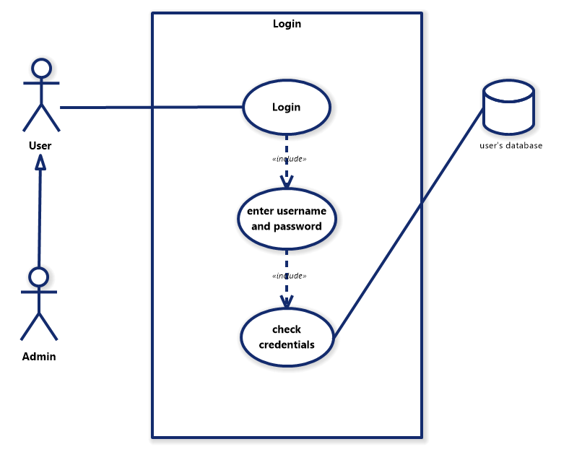

طراح: علی دست رنج
Check credentials | Enter username and password | Login | Field / Use cases
UC-03 | UC-02 | UC-01 | Id
Check credentials | Enter username and password | Login | Use case name
User | User | User/Admin | Actor
User has entered his/her credentials | User has initiated 'Login’ process | User is not already logged in | Precondition
Username and password check out and user is validated | User has entered their password and username correctly | User’s credentials are correct and is successfully logged in | Postcondition
1. System validates credentials (username and password)  2. if credentials don’t check out, an error message is displayed  3. otherwise user is permitted access to the system | 1. System displays login form  2. User enters username  3. User enters password  4. User Clicks Submit | 1. User selects 'Login  2. includes a form that contains username and password fields  3. User Procerds to entering login credentials | Main Flow
None. | None. | None. | Extend/Alt Flow

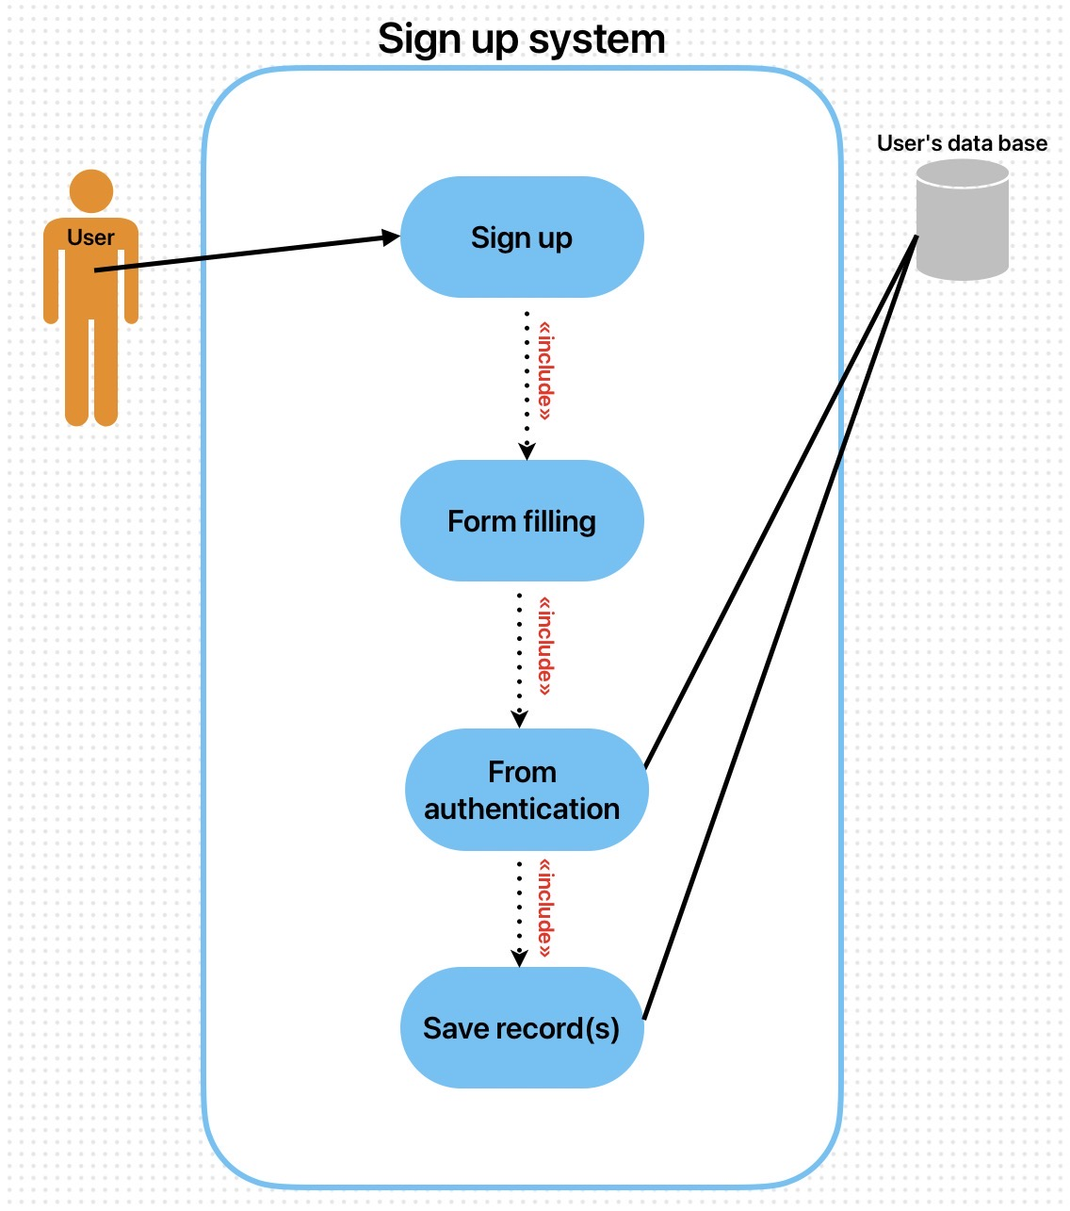

طراح: علی خواجوئی
Save record(s) | Form authentication | From filling | Sign up | Field / Use cases
UC-04 | UC-03 | UC-02 | UC-01 | Id
Save record(s) | Form authentication | From filling | Sign up | Use case name
user | user | user | user | Actor
Authentication is passed successfully. | Form is filled by the user. | User has initiated 'Sign up' process. | User is not registered in the system. | Precondition
User's record(s) are stored in the User's database. | Input data is validated and is ready to be saved. | User has entered all required information. | User is successfully registered and their record is saved. | Postcondition
1. System sends final validated data to 'User's data base'.  2. Database stores the record(s) and returns confirmation. | 1. System validates input data (e.g. email format, password).  2. If valid, System includes 'Save record(s)'.  3. If invalid, System shows error. | 1. System displays registration form.  2. User enters information.  3. System includes 'Form authentication'. | 1. User selects 'Sign up'.  2. System includes 'Form filling'.  3. System completes sign up. | Main Flow
None. | None. | None. | None. | Extend/Alt Flow
نویسنده: علی خواجوئی
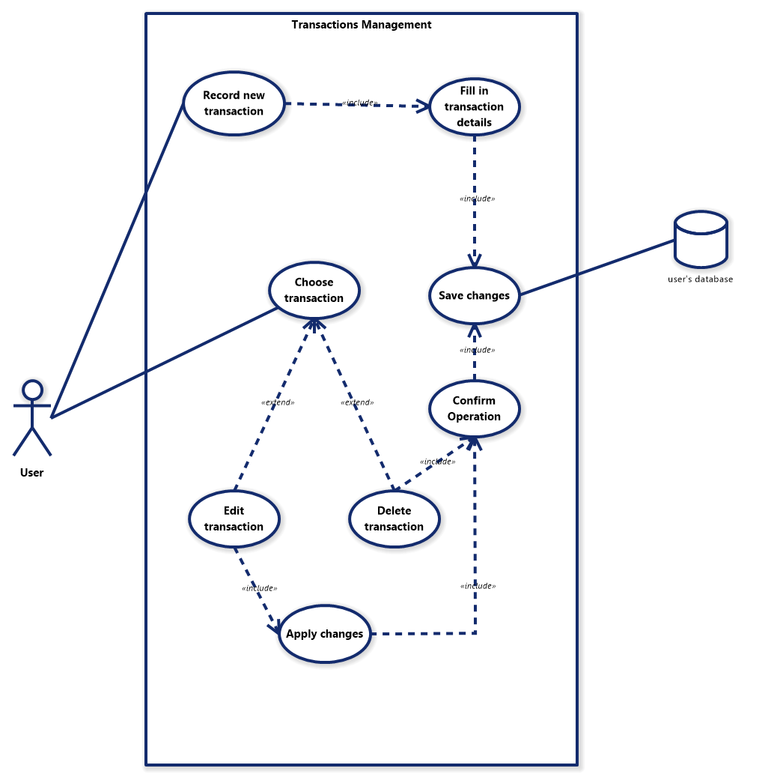

طراح: علی دست رنج

Save changes | Confirm operation | Delete transaction | Edit transaction | Choose transaction | Fill in transaction details | Record new transaction | Field / Use cases
UC-07 | UC-06 | UC-05 | UC-04 | UC-03 | UC-02 | UC-01 | Id
Save changes | Confirm operation | Delete transaction | Edit transaction | Choose transaction | Fill in transaction details | Record new transaction | Use case name
User | User | User | User | User | User | User | Actor
Wants to save the changes made | User has made the desired changes | Wants to delete records of a transaction | Wants to edit an existing transaction | Wants to change existing transaction | User has transaction details | User has a new transaction to record | Precondition
Changes are saved in the database and operation is complete | User is displayed a confirm message that needs to be confirmed | A transaction is chosen for permanent deletion | A form is displayed that will contain details for the edited transaction | A transaction is selected for either a change or deletion | A form is displayed that will contain details for the new transaction | User enters a flow to add a new transaction | Postcondition
Database makes the specified changes to its tables and fields | User has to confirm the changes he/she wishes to make | The chosen transaction will be deleted upon confirmation | User enters details for this transaction and resumes with the flow | User chooses a transaction from the existing transaction for either edition or deletion | User enters details regarding the new transaction. Details include date, amount, additional notes | User chooses to add a new transaction and a form is displayed for details of new transaction | Main Flow
None. | None. | An extension of choose transaction. Is triggered after that flow optionally | An extension of choose transaction. Is triggered after that flow optionally | Edit transaction or delete transaction can be triggered after this flow | None. | None. | Extend/Alt Flow

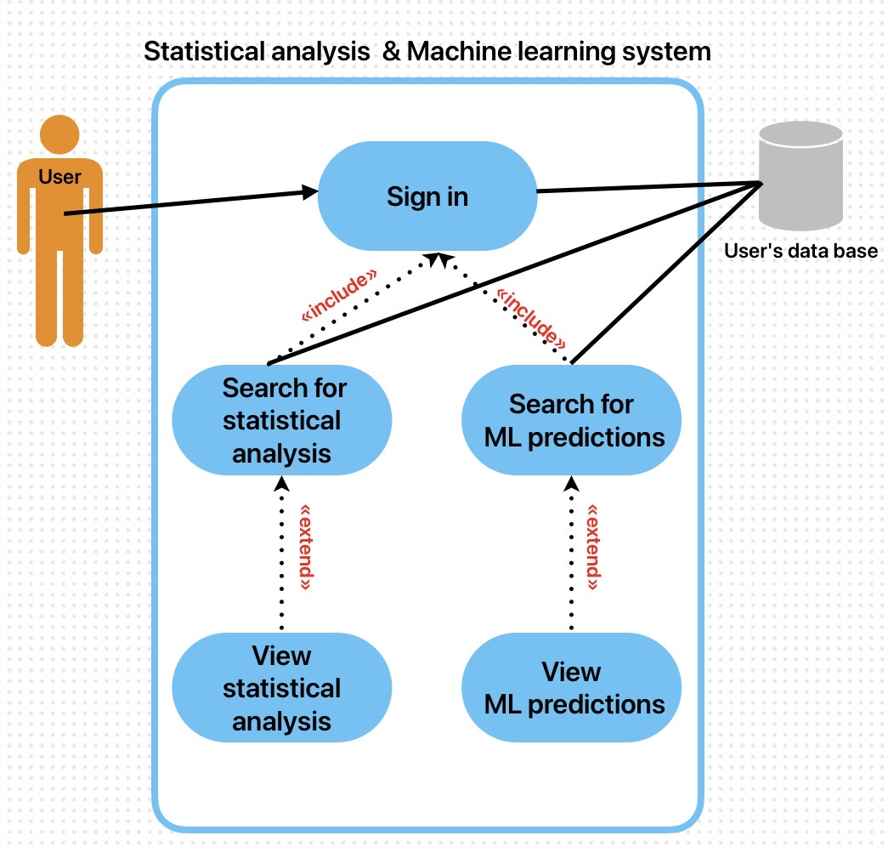

طراح: علی خواجوئی
View ML predictions | Search for ML predictions | View statistical analysis | Search for statistical analysis | Sign in | Field / Use cases
UC-05 | UC-04 | UC-03 | UC-02 | UC-01 | ID
View ML predictions | Search for ML predictions | View statistical analysis | Search for statistical analysis | Sign in | Use case name
User | User | User | User | User | Actor
'Search for ML predictions' is executed. | User is successfully signed in (UC-01 completed). | 'Search for statistical analysis' is executed. | User is successfully signed in (UC-01 completed). | User has a valid account. | Precondition
Detailed output of the ML models (confidence, predicted values) are displayed. | ML prediction results are retrieved. | Full charts and detailed reports of analysis are displayed. | Analysis results related to search parameters are retrieved. | User is logged into the system and can access search features. | Postcondition
1. User selects the "View prediction details" option.  2. System displays detailed ML outputs (e.g. confidence scores, predicted values).  (Note: This extends 'Search for ML predictions') | 1. User specifies parameters for the ML model.  2. System runs the ML model using 'User's data base'.  3. Prediction results are retrieved and presented. | 1. User selects the "View full details" option.  2. System loads and displays advanced statistical charts and tables.  (Note: This extends 'Search for statistical analysis') | 1. User enters search parameters (e.g., date range).  2. System queries 'User's data base'.  3. Analysis data is retrieved and presented. | 1. User enters username and password.  2. System verifies credentials with 'User's data base'.  3. Upon success, System includes 'Search for statistical analysis' and 'Search for ML predictions'. | Main Flow
(Extension point for Search for ML predictions) | Extend: 'View ML predictions' can be triggered optionally after this flow. | (Extension point for Search for statistical analysis) | Extend: 'View statistical analysis' can be triggered optionally after this flow. | None. | Extend/Alt Flow
نویسنده: علی خواجوئی

