Warehouse Inventory Visualization Tool
Project Summary Report

Overview
This project began as a practical response to a real operational problem: a warehouse with no consistent way to track where inventory physically sits on the shelves, leading to wasted time searching for items and unused (“dead”) space going unnoticed. The tool was built in two phases — first as a 2D web application to prove out the core data model and workflow, and then, once that was validated, rebuilt as a fully interactive, rotatable 3D warehouse floor plan based on direct user feedback that a flat view wasn't enough to reason about real shelf space.

Phase 1 — 2D Prototype
The first version focused on getting the underlying logic right before investing in a more advanced visual layer:
- Configurable racks: each rack's width, depth, height, and number of levels can be defined independently, with two level types — “Small Box” (4 subdivided bins per level) and “Skid” (one full-width slot per level).
- Real dimensions, not guesses: instead of an abstract fill percentage, users enter each box's actual width × height × depth, and the tool calculates exact dead space on every axis.
- Multi-item bins with stacking direction: a single bin can hold several boxes, each explicitly marked as stacked “on top” (height) or “behind” (depth), with manual reordering and per-item color coding.
- Overflow prevention: the tool blocks adding or saving a box that physically doesn't fit, with a clear explanation of which dimension is the problem.
- Removal history: every removed box records who removed it and when, so the bin's history stays visible even after the item is gone.
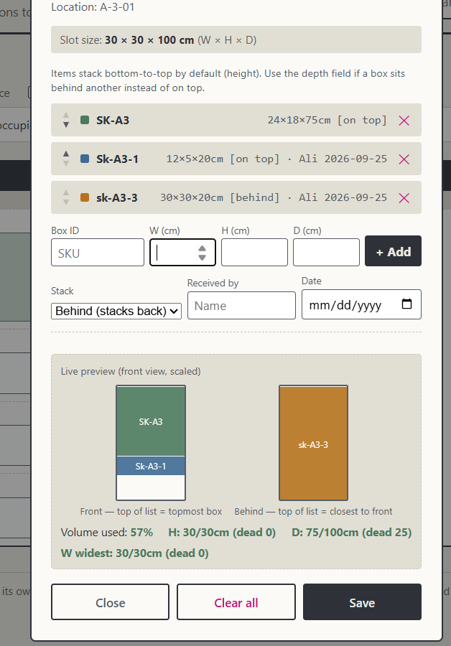
Figure 1 — The detailed bin-editing panel: multiple boxes stacked with independent “front” (on top) and “behind” (depth) positioning, live dead-space stats per axis.
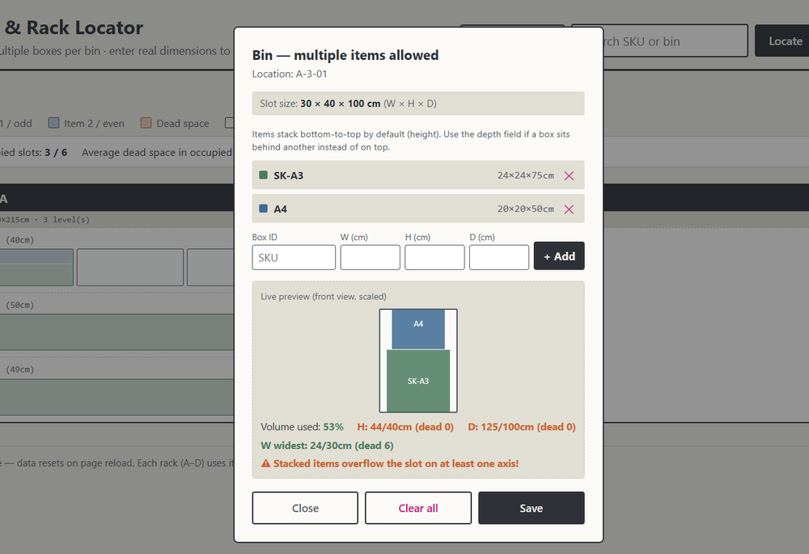
Figure 2 — A bin being edited with the surrounding rack grid and live occupancy summary visible in the background.

Why We Moved to 3D
Once the 2D tool was working, a clear limitation showed up in practice: a flat, top-down or front-view representation couldn't capture how racks, aisles, and shelf depth actually relate to each other in a physical room. The request for a 3D view came directly from hands-on use — including a hand-drawn sketch (below) showing how the warehouse should be visualized: an isometric room with racks placed in it, each rack's shelves and boxes visible in proper spatial relation to one another.
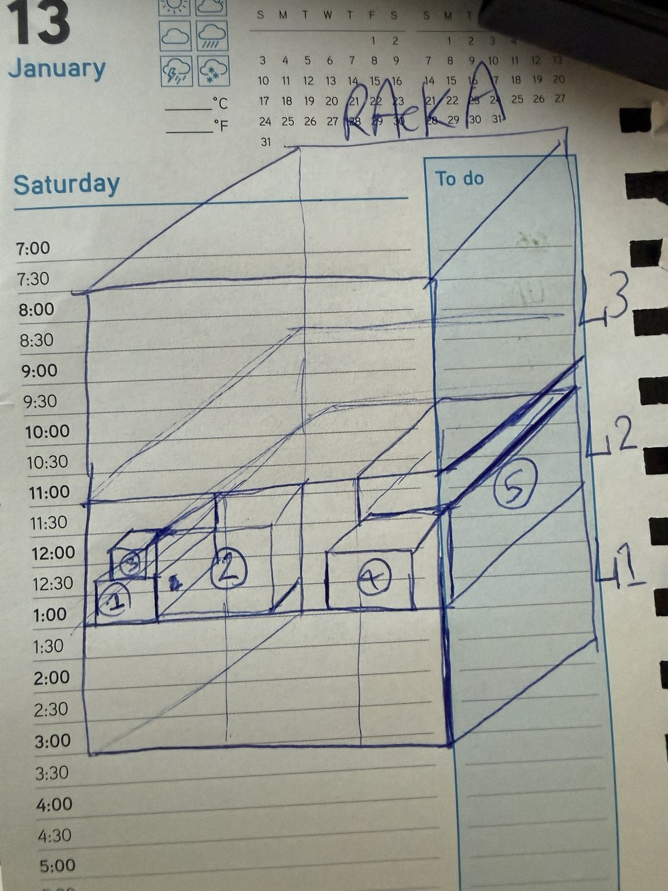
Figure 3 — The original hand-drawn concept that defined the target: a rotatable, isometric warehouse layout rather than a flat grid.

Phase 2 — 3D Floor Plan
The second phase rebuilt the visualization layer on top of the same data model, using a real 3D engine (Three.js) rather than a flat-image trick:
- A true 3D room: an empty floor that racks are added into one at a time, each positioned and rotated freely within the space.
- Full camera control: drag to orbit around the room, scroll to zoom, right-click drag to pan — so any angle or aisle can be inspected.
- Each rack rendered to scale: levels, bin subdivisions, and real box dimensions are all drawn proportionally in 3D, using the same stacking (on top / behind) logic as the 2D tool.
- Clicking any bin opens the same detailed editing panel from Phase 1 — the two tools share one underlying data model, just with a different front end.
- Hover tooltips on individual boxes surface their full record: SKU, dimensions, who received it, and when — effectively an “ID card” for each item without leaving the 3D view.
- A consolidated Removal Archive lists every item ever removed across every rack and bin, with who removed it and the date, in one place.
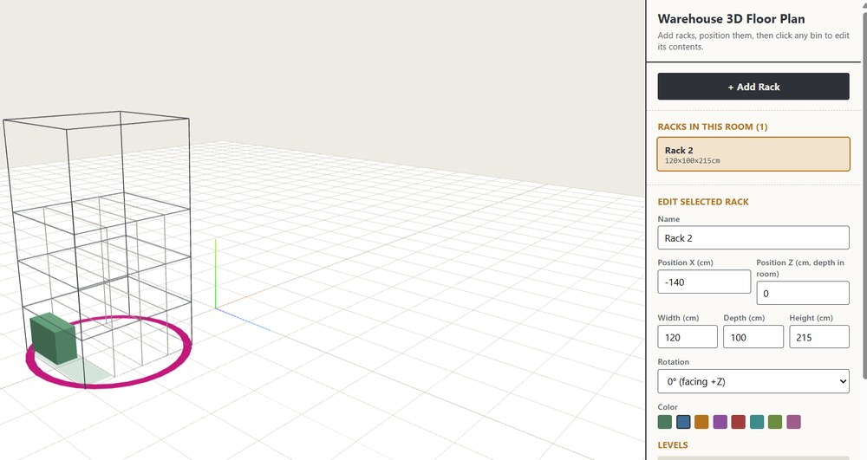
Figure 4 — The deployed 3D tool: a rack selected in the room, its levels and current contents visible, with full rotate/zoom/pan navigation.

Outcome
The result is a single tool with two complementary views built on one shared data model: the 2D version remains useful for quick, detailed editing, while the 3D version gives an intuitive, spatial sense of the whole warehouse — how full it is, where dead space is accumulating, and where a specific box actually sits. Development moved in the right order: validate the data and workflow first in 2D, then invest in the more complex 3D visualization once the underlying model had already proven itself.

