

**»Data Mining course«**

**Project 1 - Football**

**Dr.Farahani , Dr.Kheradpisheh**

**Ashkan Safavi Sohi**

**98422096**

**About dataset**

This dataset includes **42,082** results of international football matches starting from the very first official match in 1972 up to 2019. The matches range from FIFA World Cup to FIFI Wild Cup to regular friendly matches. The matches are strictly men's full internationals and the data does not include Olympic Games or matches where at least one of the teams was the nation's B-team, U-23 or a league select team.

**Analyze and Questions**

* **Who is the best team of all time    
    
  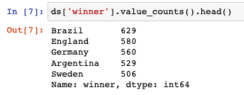**

As can be seen, Brazil has won the most matches

* **Check the number of equal games during this period .**

**/var/folders/5m/xytwqt8d5r73pdwzg17wc7xm0000gn/T/TemporaryItems/(A Document Being Saved By screencaptureui 2)/Screen Shot 2021-04-16 at 3.57.50 PM.png**

* **Which team has been the worst in terms of performance?**

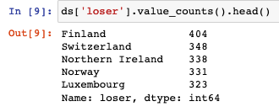

* **How much does hosting a tournament help a team stand a chance of winning?**

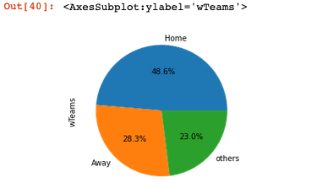

* **Can we say anything about geopolitics from football fixtures - how has the number of countries changed, which teams like to play each other**

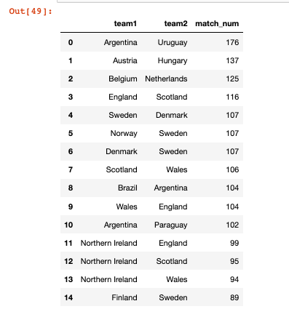

According to the table above, the teams that have played the most games together are also neighbors

* **Which countries host the most matches where they themselves are not participating in  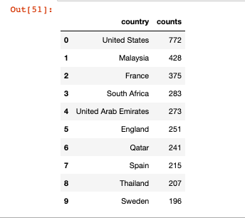**
* **Which teams are the most active in playing friendlies and friendly tournaments - does it help or hurt them**

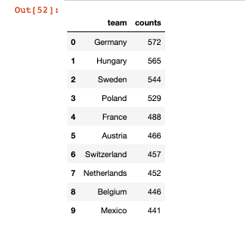

According to the table above, it can be concluded that friendly games have been useful