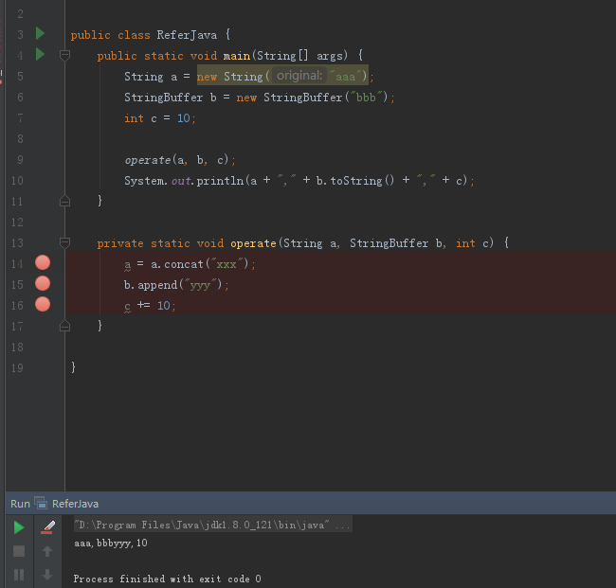

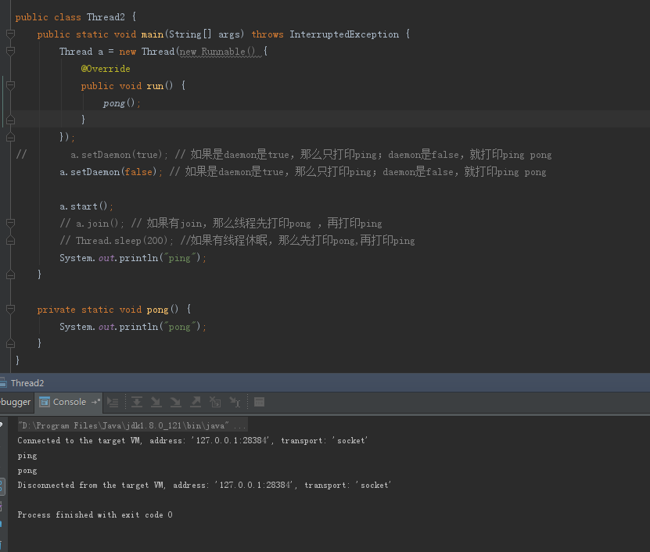

public class Printer1 {  
 static int *flag* = 1;  
 static int *num* = 1;  
 static Object *object* = new Object();  
  
 public static void main(String[] args) {  
 // 打印奇数  
 Thread printer1 = new Thread(() -> {  
 while (*num* < 100) {  
 synchronized (*object*) {  
 while (*flag* == 2) {  
 try {  
 *object*.wait();  
 } catch (InterruptedException e) {  
 e.printStackTrace();  
 }  
 }  
 System.*out*.println(*num*);  
 *num*++;  
 *flag* = 2;  
 *object*.notify();  
 }  
 }  
  
 });  
  
 // 打印偶数  
 Thread printer2 = new Thread(() -> {  
 while (*num* <= 100) {  
 synchronized (*object*) {  
 while (*flag* == 1) {  
 try {  
 *object*.wait();  
 } catch (InterruptedException e) {  
 e.printStackTrace();  
 }  
 }  
 System.*out*.println(*num*);  
 *num*++;  
 *flag* = 1;  
 *object*.notify();  
 }  
 }  
  
 });  
 printer1.start();  
 printer2.start();  
 }  
}

