redis cluster

jedis 通讯原理

socket

public void connect() {

if (!isConnected()) {

try {

socket = new Socket();

// ->@wjw_add

socket.setReuseAddress(true);

socket.setKeepAlive(true); // Will monitor the TCP connection is

// valid

socket.setTcpNoDelay(true); // Socket buffer Whetherclosed, to

// ensure timely delivery of data

socket.setSoLinger(true, 0); // Control calls close () method,

// the underlying socket is closed

// immediately

// <-@wjw_add

socket.connect(new InetSocketAddress(host, port), connectionTimeout);

socket.setSoTimeout(soTimeout);

通过代码serverSocket来监听6379端口的发出

和fiddler一致

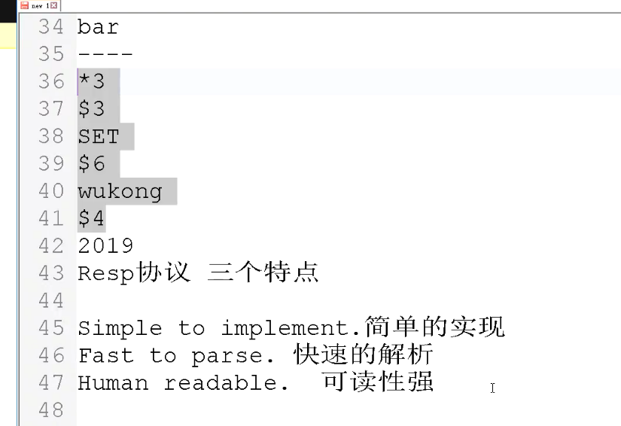

public static final byte *DOLLAR_BYTE* = '$';  
public static final byte *ASTERISK_BYTE* = '*';  
public static final byte *PLUS_BYTE* = '+';  
public static final byte *MINUS_BYTE* = '-';  
public static final byte *COLON_BYTE* = ':';

telnet 试试socket连接通不通

telnet host port

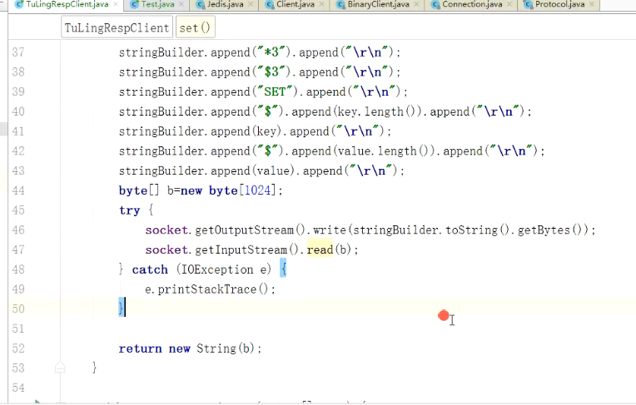

持久化

Aof resp写入的命令放入文件中

Rdb redis database