Boruta-Driven Explainable Machine Learning for Identifying Gene Signatures in Laser-Captured Dopamine Neurons of Parkinson’s Disease
Ali Sareminia
Abstract
Background. Expression studies of the substantia nigra in Parkinson’s disease (PD) are confounded by the loss of the very cells they measure. Laser-capture microdissection (LCM) isolates dopamine neurons before sequencing, but each LCM study is small, and a panel selected in one is rarely tested anywhere else.
Methods. Four LCM datasets were merged at one profile per person (63 donors, 30 control, 33 PD; 5,622 genes measured and expressed in all four). A Random Forest on within-person gene ranks was evaluated by repeated cross-validation, leave-one-study-out and label permutation, and Boruta selected a 30-gene panel. Both models were then frozen and applied without refitting to eight public bulk nigra cohorts (158 donors, 72 control, 86 PD, after 14 shared brains were removed). We scored each donor’s dopamine-neuron content, estimated the CALB1-versus-SOX6 subtype mix from published single-nucleus markers, and repeated the whole analysis with that mix regressed out of every gene.
Results. Nine of the 30 panel genes replicated in the independent bulk donors with the same direction of effect and a Benjamini–Hochberg $q<0.05$ before any adjustment for neuron content (RBM4B, USP12, SOX6, ADGRB3, SH3GL3, DNAJB1, CNTN4, ZMYND8 and SSTR1), and once each donor’s dopamine-neuron content was removed from every gene 23 of the 30 effects still agreed in sign with the laser-captured neurons ($P=0.003$). The classifier that selected them reached an area under the ROC curve (AUC) of 0.73 (SD 0.03) across donors and 0.68 with a whole study held out (label shuffles $P=0.005$). In bulk tissue the frozen classifier pooled 0.70 (95% CI 0.62–0.78) and the panel forest 0.84 (0.77–0.90), but eight dopamine-neuron markers alone reached 0.86. Removing neuron content left the panel at 0.76 and the classifier at 0.62. Genes lower in PD are markers of SOX6 dopamine neurons and genes higher are markers of CALB1 neurons ($P=0.0012$; $P=0.004$ against gene sets matched on effect size), the split that single-nucleus work reports for selective vulnerability. Over-representation analysis against the measured background returned four synapse and calcium-binding terms. When each donor’s estimated subtype mix was regressed out of every gene, out-of-fold AUC fell from 0.76 to 0.67 ($P=0.009$) yet stayed above chance, and 23 of 30 genes kept at least half of their effect.
Conclusions. The panel is a reproducible set of candidate genes rather than a diagnostic score: nine of its members survive a test in independent tissue, while most of what the classifier itself uses is a shift in which dopamine neurons remain rather than a change inside surviving neurons. Reports of nigral expression signatures in PD should state how much survives an explicit composition adjustment.
Keywords: Parkinson’s disease; substantia nigra; laser-capture microdissection; external validation; cell composition; Boruta; SHAP; dopamine-neuron subtypes

Introduction
Parkinson’s disease is the fastest-growing neurological cause of disability worldwide (GBD 2021 Nervous System Disorders Collaborators 2024), and its prevalence keeps rising as populations age (Ben-Shlomo et al. 2024; Bloem et al. 2021). The motor syndrome follows the loss of neuromelanin-containing dopamine neurons of the substantia nigra pars compacta (Kordower et al. 2013). Why those neurons go first is still argued over, with $α$-synuclein aggregation, mitochondrial and lysosomal failure and the metabolic cost of pacemaking all proposed (Morris et al. 2024; Surmeier et al. 2017). Single-nucleus sequencing sharpened the question by showing that vulnerability differs between dopamine neuron subtypes: the SOX6_AGTR1 population is depleted in PD while several CALB1 populations are relatively spared (Kamath et al. 2022). Molecular taxonomies of midbrain dopamine neurons agree on that broad SOX6–CALB1 division (Poulin et al. 2020).
This is a problem for expression studies of nigral tissue. When neurons die the tissue that remains contains proportionally more glia, and in PD brain much of what looked like disease biology turns out to be a change in cell composition (Nido et al. 2020). Laser-capture microdissection removes part of the problem by collecting the neurons themselves before sequencing (Nichterwitz et al. 2016), and several LCM datasets of human nigral dopamine neurons are public (Zheng et al. 2010; Tiklová et al. 2021; Zaccaria et al. 2021). None of them holds more than 22 people.
Small cohorts and tens of thousands of genes are an easy way to overfit. Selecting genes on all samples before cross-validation biases the error estimate (Ambroise and McLachlan 2002), as does tuning a model on the data used to score it (Varma and Simon 2006); both remain common in genomics and in machine-learning-based science more broadly (Whalen et al. 2021; Kapoor and Narayanan 2023). Repeated measurements from one donor are not independent (Hurlbert 1984; Lazic 2010), and treating pools or cells as the unit of analysis inflates false discoveries in transcriptomics (Squair et al. 2021; Zimmerman et al. 2021). The most informative test holds out whole studies (Bernau et al. 2014), because platform and batch effects can exceed the biology (Leek et al. 2010).
In earlier work we merged four LCM cohorts at one row per person and used Boruta (Kursa and Rudnicki 2010; Breiman 2001) with SHAP (Lundberg et al. 2020) to select and explain a gene panel. Two questions were left open. First, whether the panel carries across to data the model has never seen, which for nigral expression means bulk tissue, where most public cohorts live. Second, whether what the panel measures is a change inside dopamine neurons or a change in which dopamine neurons are left to measure. Here we fix both models before touching any external data, test them in eight public bulk cohorts after removing brains shared with the discovery studies, and then ask how much of the signal survives an explicit adjustment for each donor’s estimated dopamine-neuron subtype mix.

Methods

Discovery cohort
All expression data came from the Gene Expression Omnibus (Barrett et al. 2012). Four LCM studies of nigral dopamine neurons were merged at one profile per person (Table 1): GSE182622, RNA sequencing of pools of neuromelanin-positive neurons (Tiklová et al. 2021); GSE20141 and GSE24378, Affymetrix HG-U133 Plus 2.0 and HG-U133 X3P profiles (Zheng et al. 2010); and GSE169755, RNA sequencing of two libraries per brain (Zaccaria et al. 2021). Replicate pools and libraries from one donor were averaged, so that 192 pools became 22 donors in GSE182622 and 12 libraries became 6 brains in GSE169755. Of 28,180 genes, 10,164 were measured on all four platforms and 5,622 were expressed in every study. Each study was standardised on its own without reference to diagnosis. A classifier trained to name each donor’s study placed every donor correctly before that step and 1% afterwards, against a 25% chance rate (Fig. 1).
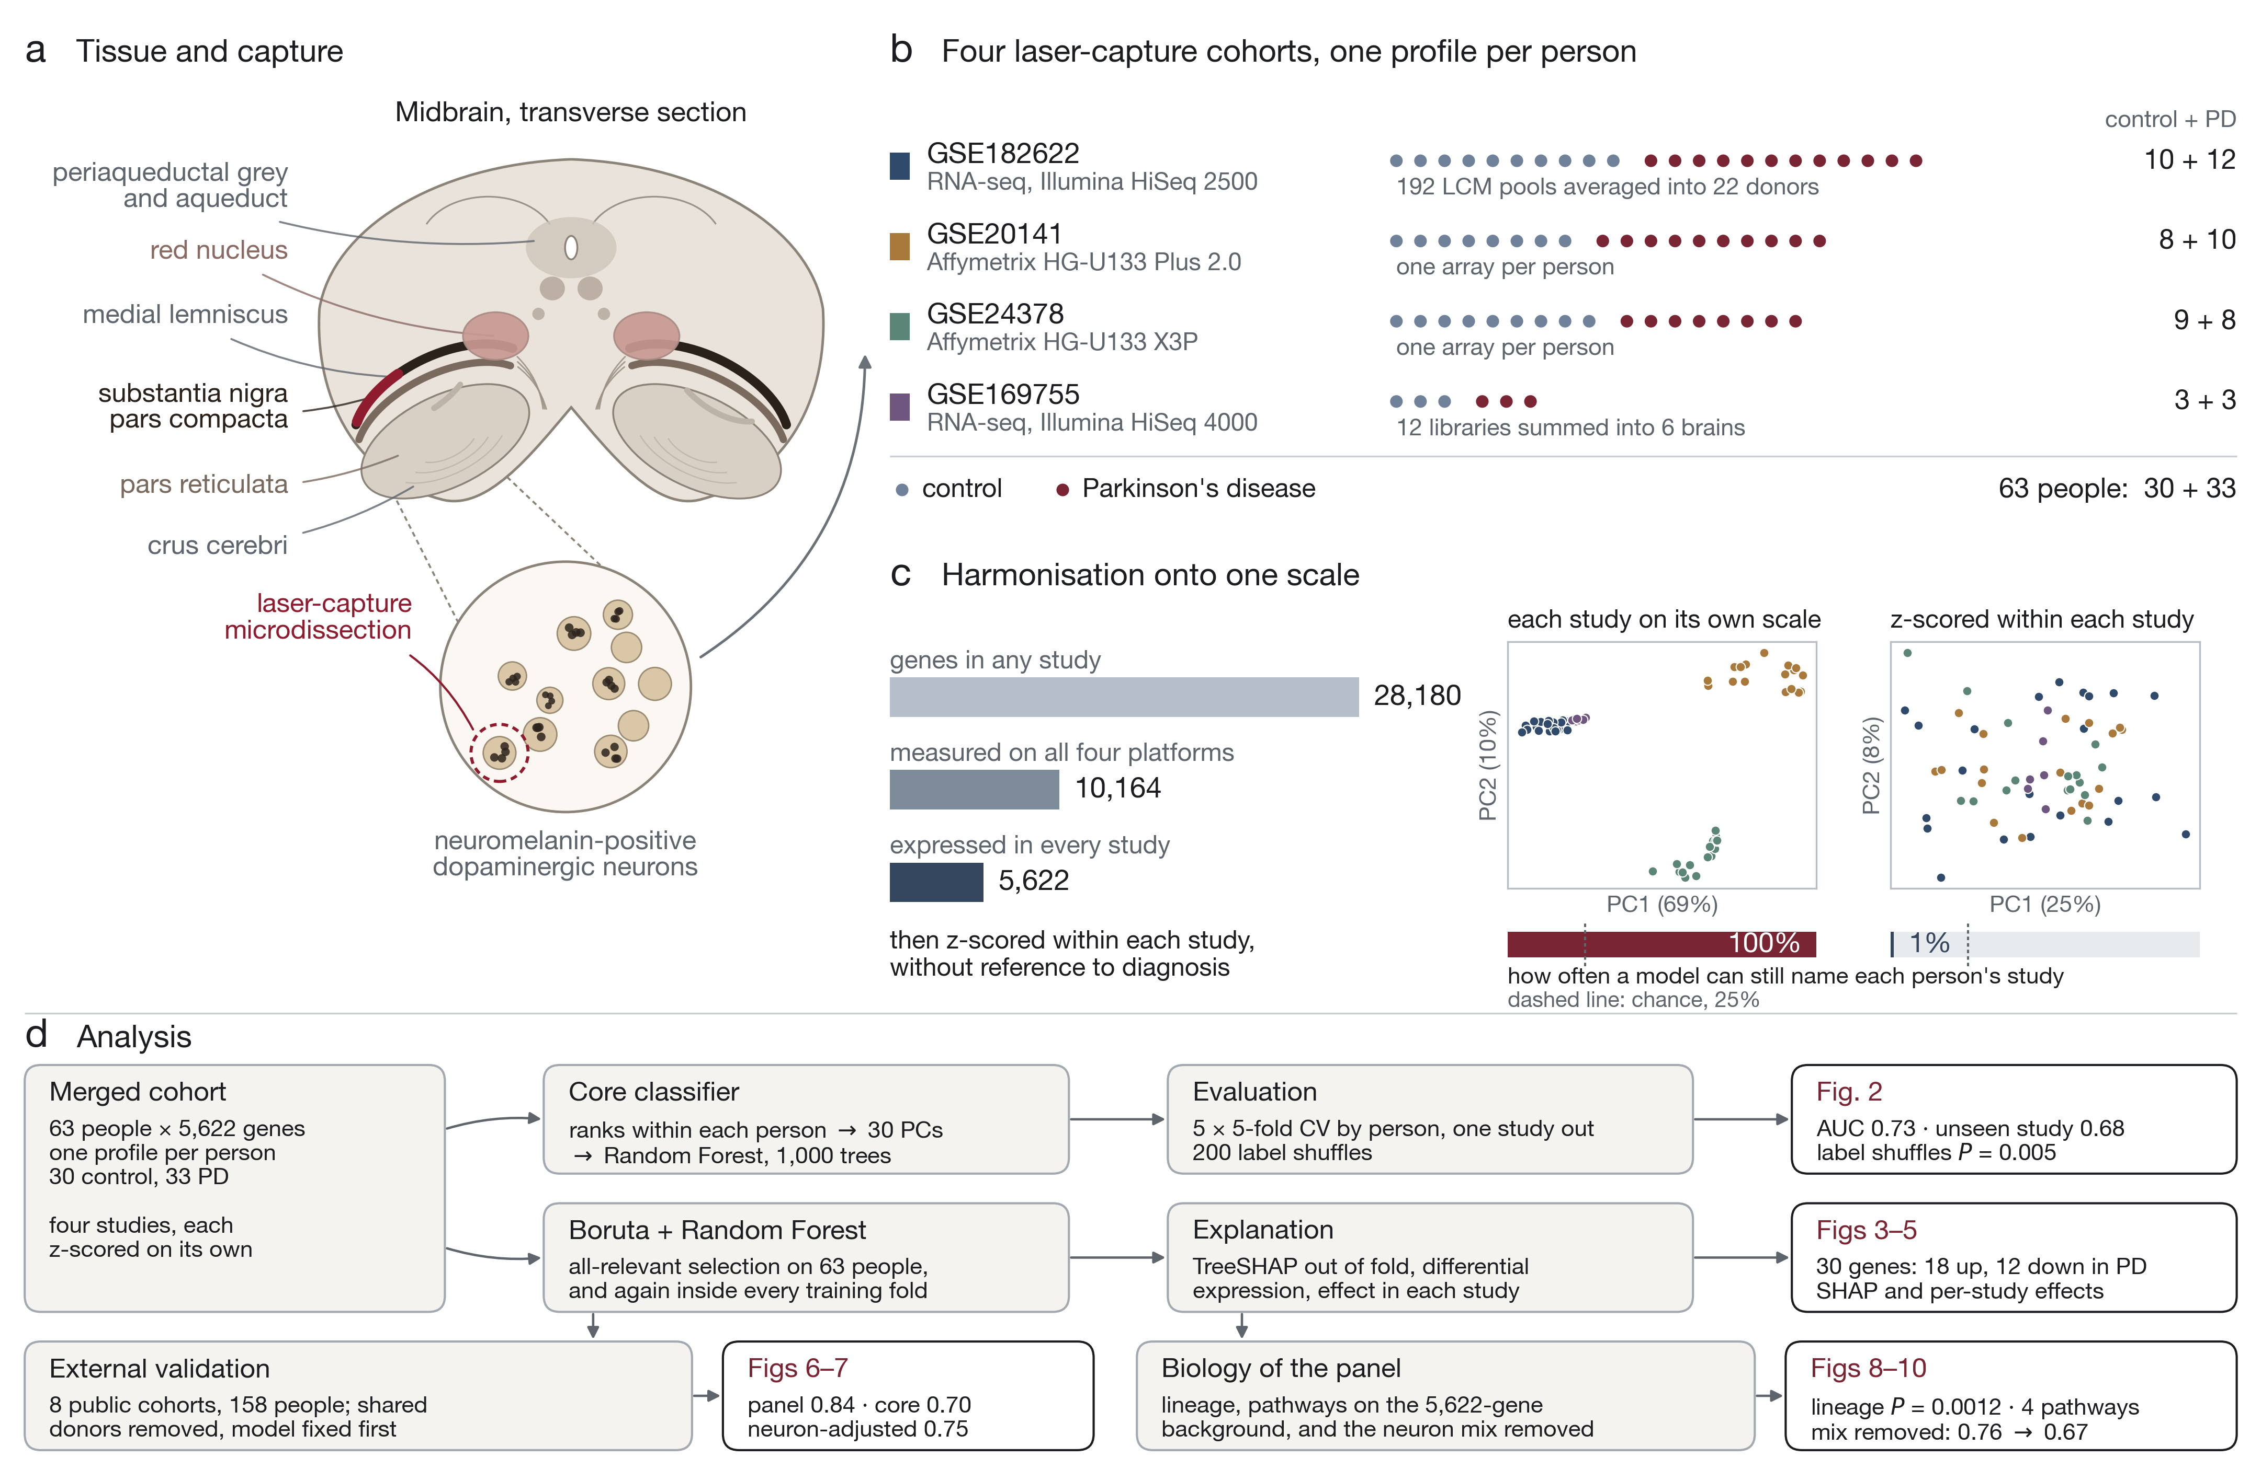
Study design. (a) Nigral dopamine neurons were isolated by laser-capture microdissection in each study. (b) Four cohorts, 63 people, one profile per person after replicate pools and libraries were averaged. (c) Harmonisation: 28,180 genes reduce to 5,622 measured and expressed in every study, and standardising within study removes study identity, which a classifier could otherwise recover perfectly. (d) The analysis in five stages, with the figure each one produces.
The four laser-capture discovery cohorts, one profile per person.
Dataset | Platform | Control | PD | Units merged | Source
GSE182622 | RNA-seq (HiSeq 2500) | 10 | 12 | 192 | Tǐklová et al. (Tiklová et al. 2021)
GSE20141 | Affymetrix U133 Plus 2.0 | 8 | 10 | 18 | Zheng et al. (Zheng et al. 2010)
GSE24378 | Affymetrix U133 X3P | 9 | 8 | 17 | Zheng et al. (Zheng et al. 2010)
GSE169755 | RNA-seq (HiSeq 4000) | 3 | 3 | 12 | Zaccaria et al. (Zaccaria et al. 2021)
Total |  | 30 | 33 | 239

The core classifier
Three steps make up the model, and each answers a specific problem with merging studies. First, genes are ranked within each person, so a profile enters the model as the order of its genes rather than as platform-dependent intensities; a rank transform of this kind is the usual defence when arrays and sequencing are combined (Leek et al. 2010). Second, the 5,622 ranks are reduced to 30 principal components fitted on the training donors only, which keeps the dimensionality below the sample size and keeps test donors out of the projection (Ambroise and McLachlan 2002). Third, a Random Forest (Breiman 2001) is fitted on those components with 1,000 trees, max_features 0.5, one sample per leaf and balanced class weights, using scikit-learn (Pedregosa et al. 2011). A forest suits this setting because it assumes no distribution, tolerates correlated predictors, and reports an out-of-bag error from the samples each tree did not see (Breiman 2001). Performance was estimated by five repeats of five-fold cross-validation split by person (seeds 1000–1004), by leave-one-study-out, and against 200 permutations of the diagnosis labels within each study. The model configuration was chosen inside the folds among 97 Random Forest variants, so that the reported estimate is not the maximum over the comparison (Varma and Simon 2006).

The 30-gene panel
Boruta is the selection step this paper depends on, so we state it as the test it is (Kursa and Rudnicki 2010). Let $X∈R^{n×p}$ hold the $p=5,622$ genes of $n=63$ donors and let $y$ be the diagnosis. At iteration $t$ every column is copied and shuffled,
$${\tilde{X}}_{⋅j}^{(t)}=X_{π_{j}^{(t)}(⋅), j}, π_{j}^{(t)}∼\text{Unif}(S_{n}),$$
which destroys any relation to $y$ while keeping each gene’s own distribution; these are the shadow features. A Random Forest is fitted to $[X,{\tilde{X}}^{(t)}]$ and gives importances $Z_{j}^{(t)}$. A gene scores a hit when it beats the shadow columns of that same run,
$$h_{j}^{(t)}=1​\left\{Z_{j}^{(t)}>Q_{0.99}​\left(Z_{\tilde{1}}^{(t)},…,Z_{\tilde{p}}^{(t)}\right)\right\}, H_{j}=\sum_{t=1}^{T}{h_{j}^{(t)}},$$
and under the null that the gene carries nothing, $H_{j}∼\text{Binomial}(T,1/2)$. Genes are confirmed or rejected by a two-sided binomial test on $H_{j}$ with a Bonferroni correction over the $p$ genes; rejected genes are dropped from later iterations, and whatever is still undecided when $t$ reaches $T$ stays tentative. Using $Q_{0.99}$ of the shadow importances instead of their maximum is the stricter variant, which suits a 63-donor cohort.
Boruta is all-relevant rather than minimal-optimal: it keeps every gene that carries signal instead of the smallest set that predicts, which is what one wants when the aim is interpretation (Kursa and Rudnicki 2010; Degenhardt et al. 2017). We used $T=100$ iterations and a 500-tree forest, run on all 63 donors and again inside every training fold, so Table [tab:genes] reports how often each gene is reselected rather than assuming the selection is stable (Degenhardt et al. 2017). The panel holds 30 genes, 18 higher and 12 lower in PD.
TreeSHAP values (Lundberg et al. 2020) were computed out of fold. Differential expression used the two-sided Wilcoxon rank-sum test (Mann and Whitney 1947) with Benjamini-Hochberg control (Benjamini and Hochberg 1995), and per-study effects were combined as Hedges’ $g$ (Hedges 1981) in a random-effects meta-analysis (DerSimonian and Laird 1986).

Model locking and external cohorts
Both models, the core classifier and a forest restricted to the 30 panel genes, were fitted on all 63 discovery donors and stored before any external cohort was downloaded. Nothing was refitted, re-selected or re-tuned afterwards. Eight public bulk substantia nigra cohorts were then scored: GSE7621 (Lesnick et al. 2007), GSE8397 (Moran et al. 2006), GSE20163 and GSE20164 (Zheng et al. 2010), GSE20292 (Zhang et al. 2005), GSE49036 (Dijkstra et al. 2015), GSE114517 (Simchovitz et al. 2020) and GSE168496 (Tranchevent et al. 2023). Probe sets were mapped to gene symbols through the g:Profiler conversion service (Kolberg et al. 2023); HG-U133A arrays were mapped through the Plus 2.0 namespace, which recovers 4,584 of the 5,622 discovery genes. Each cohort was standardised within itself and then ranked within each person, exactly as in discovery. Four panel genes are absent from that older array design: SOX6, CNTN4, ELOVL7 and C11orf54 are not represented on HG-U133A, so GSE8397, GSE20163, GSE20164 and GSE20292 contribute 26 of the 30 panel genes and the per-gene meta-analysis of those four rests on the other four cohorts. Rather than drop those cohorts or refit the frozen models, a missing gene was given the cohort mean, that is a standardised value of zero, so that it moves no donor’s score in either direction; the external estimates for the four genes therefore come only from the cohorts that measure them.
Donor identifiers were compared with the discovery studies. GSE20292 shares 12 brains with GSE20141 and GSE20163 shares 2, identified by matching donor numbers; those donors were removed, leaving 158 people (72 control, 86 PD). Because shared brain banks can leak in ways identifiers do not show, every cohort was also scored by strictly independent models retrained without any discovery study from the same bank. Significance came from 10,000 permutations of diagnosis within cohorts; confidence intervals from 4,000 donor bootstraps (Efron 1979). Cohort AUCs were pooled with weights equal to the number of PD–control pairs, and ROC curves were averaged vertically with the same weights so that the drawn curve has the pooled area (Hanley and McNeil 1982).
The dependence of the external result on the less stable members of the panel was measured by repeating the whole frozen-panel procedure with the panel restricted by fold frequency, at every threshold from 0 to 100% in steps of 4%, and by comparing each panel with 200 random panels of the same size drawn from the 5,622 measured genes and put through the identical steps. Fold frequencies come from the discovery donors alone and were fixed when the panel was selected.
Each panel gene was also tested on its own in the external donors. Cohort-level standardised effects were combined by inverse-variance meta-analysis, tested two-sided against the standard normal and corrected by the Benjamini–Hochberg procedure over the 30 genes of the panel, before and after the neuron-content adjustment described next. Agreement of sign with the discovery effect was tested by a two-sided binomial test against one half.

Dopamine-neuron content and subtype mix
Two adjustments were made, and they answer different questions. The first asks whether a score merely tracks how much dopamine-neuron material a bulk sample contains: eight canonical dopamine-neuron markers (TH, SLC6A3, SLC18A2, DDC, KCNJ6, ALDH1A1, NR4A2 and EN1) were standardised within each cohort and averaged into a neuron score, and each model score was residualised on it within each cohort. All eight are measured in every external cohort. The second asks which dopamine neurons remain. Marker $z$ scores for every dopamine-neuron subtype were taken from Supplementary Table 8 of Kamath et al. (2022); a lineage score was defined for each gene as its mean marker strength over the six CALB1 subtypes minus its mean over the four SOX6 subtypes. The 50 strongest markers on each side, with panel genes excluded, gave a per-donor composition score, standardised within study. That score was then regressed out of every one of the 5,622 genes, and the whole discovery pipeline was run again on the adjusted data with the same folds and the same model. Sensitivity runs used 25, 100 and 200 markers, SOX6_AGTR1 markers alone, and composition together with overall dopamine purity.
Because that neuron score is our own construction, it was checked against reference-based deconvolution. The reference is the single-nucleus midbrain atlas of Smajić et al. (2021) (GSE157783): 41,434 nuclei from six controls and five people with Parkinson’s disease, carrying the authors’ own cell-type labels. Each cell type was summarised once per reference donor as counts per million, the per-donor profiles were averaged, and a signature matrix of 1,626 genes was built by keeping, for each cell type, the genes with the largest fold change over the remaining types (condition number 24.0). Every external donor was then deconvolved three ways: non-negative least squares; $ν$ support-vector regression, the estimator behind CIBERSORT (Newman et al. 2015); and non-negative least squares weighted by the inverse across-donor variance of each gene, the idea behind MuSiC (Wang et al. 2019). Between 799 and 1,567 signature genes were measured per cohort. The deconvolved dopamine-neuron proportion was compared with the eight-marker score, and the external scores were residualised on it in place of that score. This analysis uses all 173 external donors, without the donor-overlap removal, so its absolute AUCs sit below those of Table 2; the three adjustments are computed on the same donors and are therefore comparable with each other.

Pathway analysis
Over-representation was tested with g:GOSt (Kolberg et al. 2023) using the 5,622 measured genes as the background and Benjamini-Hochberg correction across all 3,547 terms (Benjamini and Hochberg 1995), against GO, Reactome (Milacic et al. 2023), KEGG (Kanehisa et al. 2022) and WikiPathways (Agrawal et al. 2023). Because a gene list of this size can return terms by chance, the same settings were applied to 100 random gene lists of each size drawn from the same background, and to lists matched on differential-expression rank; the calibrated $P$ value is the share of those lists reaching a smaller adjusted $P$ than the panel. A ranking-based analysis was also run for completeness: gene set enrichment analysis (Subramanian et al. 2005) over all 5,622 genes against 1,967 sets from Hallmark (Liberzon et al. 2015), Reactome, KEGG and GO, with the null built by shuffling donor diagnoses within study rather than genes, and single-sample scores per donor (Barbie et al. 2009). Gene set definitions came from Enrichr’s libraries (Kuleshov et al. 2016).

Gene-level annotation
Table [tab:genes] collects what is known about each panel gene, and every cell in it is either measured here or taken from a named public resource at a stated release. Protein names and functions are from UniProt (The UniProt Consortium 2024), with the accession given so each statement can be checked. Association scores with Parkinson disease, the tractability evidence and the count of drug or clinical candidates are from the Open Targets Platform (Buniello et al. 2024). Dopamine-neuron subtype identity is the lineage score described above (Kamath et al. 2022).
Published links to the disease were found with one protocol applied to every gene, so that the absence of a link is as checkable as its presence. We searched Europe PMC (Rosonovski et al. 2023) for the gene symbol, its approved name and every HGNC alias, in the title or abstract, together with Parkinson, parkinsonism, Lewy, synuclein, LRRK2, PINK1, parkin, glucocerebrosidase, dopaminergic neuron, substantia nigra, MPTP, rotenone, 6-hydroxydopamine or paraquat; for open-access papers we also read the full text sentence by sentence. A paper was kept only when one sentence reports a finding about the gene itself in that setting. Reviews, acronym collisions (FUS returns focused ultrasound, SCAI a cardiology society) and retracted papers were excluded, and every citation was checked against Crossref for retractions and corrections. The complete search, with each hit and its disposition, is Supplementary Table S1.

Reproducibility
Every analysis ran in public Kaggle notebooks, each writing the tables the figures read; no figure recomputes a result. Random seeds are fixed and reported in the notebooks.

Results

One profile per person, and a classifier that works at donor level
The merged cohort holds 63 people from four studies (Table 1), one profile each, on 5,622 genes. Standardising within study removed study identity almost completely (Fig. 1c).
On these donors the classifier reached an AUC of 0.725 (SD 0.032) and an accuracy of 0.692 across 25 person-level folds, with sensitivity 0.56 and specificity 0.83 (Fig. 2). Holding out a whole study gave 0.678, ranging from 1.00 in the six-brain GSE169755 to 0.55 in GSE20141. Against 200 label permutations the observed AUC of 0.707 sat above a null centred on 0.498 ($P=0.005$), and choosing the model inside the folds rather than once on all data gave 0.741, so the estimate is not an artefact of the comparison (Varma and Simon 2006). A forest on all 5,622 genes without the rank and component steps reached 0.66.
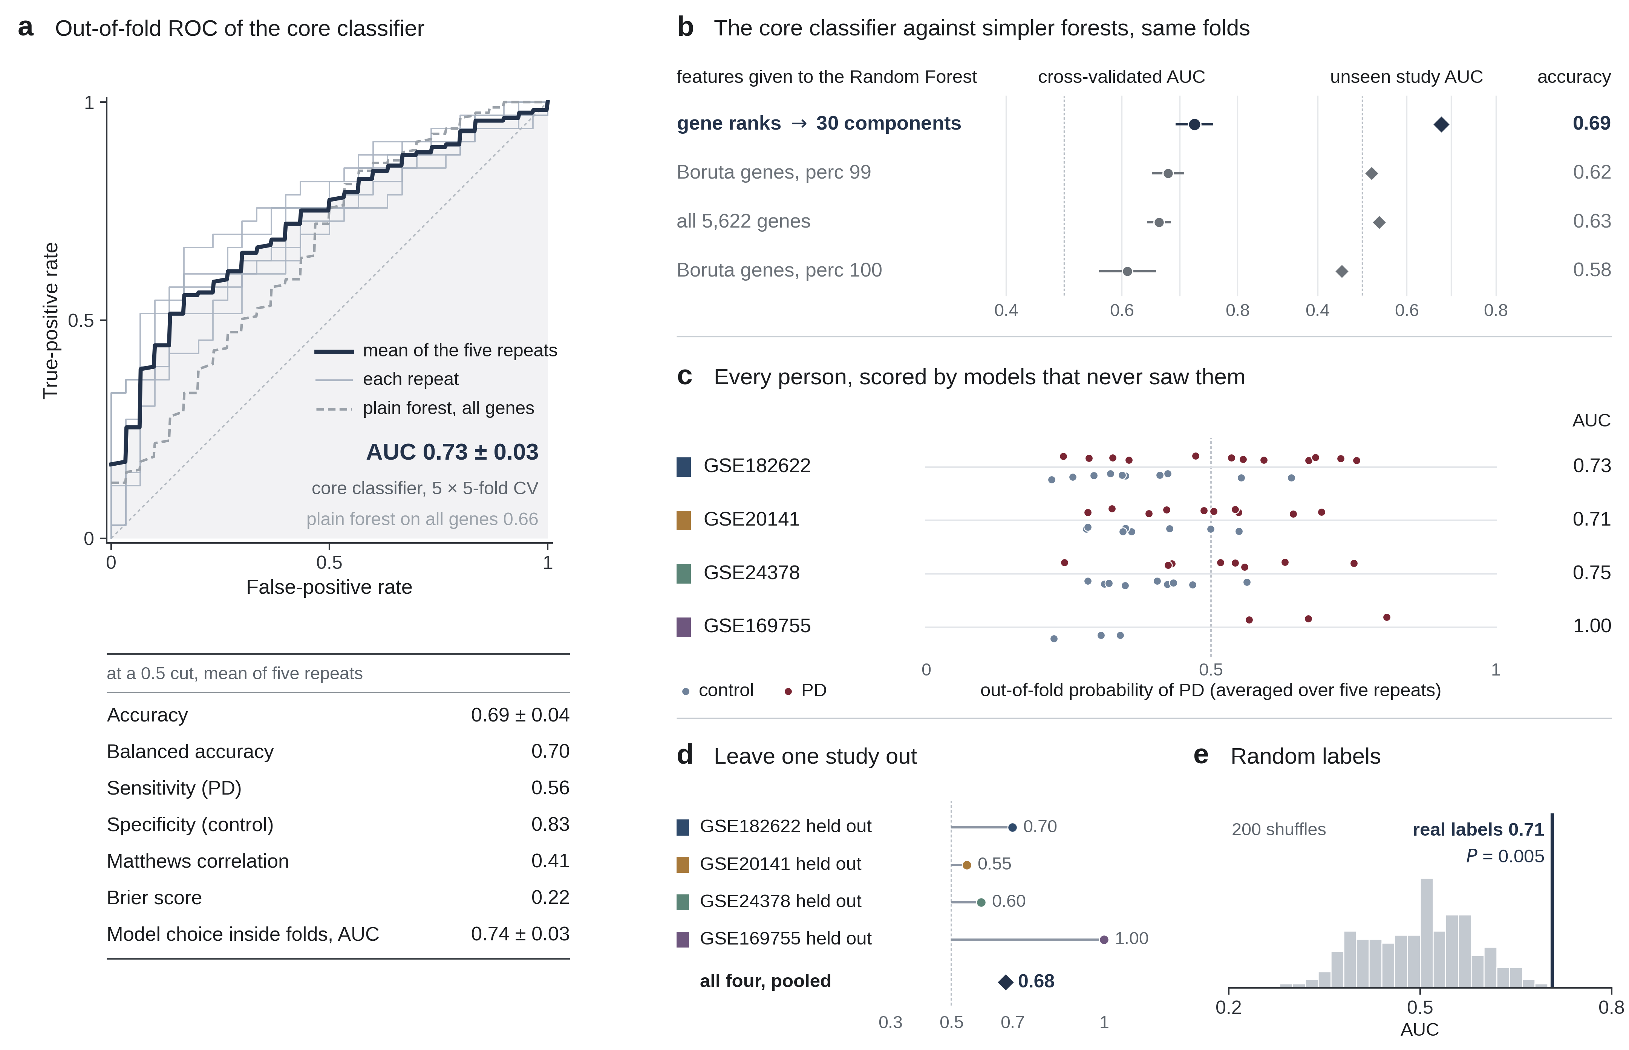
The core classifier. (a) Out-of-fold ROC over 25 person-level folds. (b) The same folds for simpler forests. (c) Every donor’s out-of-fold score. (d) Leave-one-study-out. (e) 200 permutations of the diagnosis labels within study.

What the model uses
Boruta confirmed 30 genes, 18 higher and 12 lower in PD. RBM4B, PLXNC1 and GPNMB lead the SHAP ranking and were kept in 100%, 96% and 92% of training folds; single genes reach AUCs of 0.63–0.78 on their own (Fig. 3, Fig. 4).
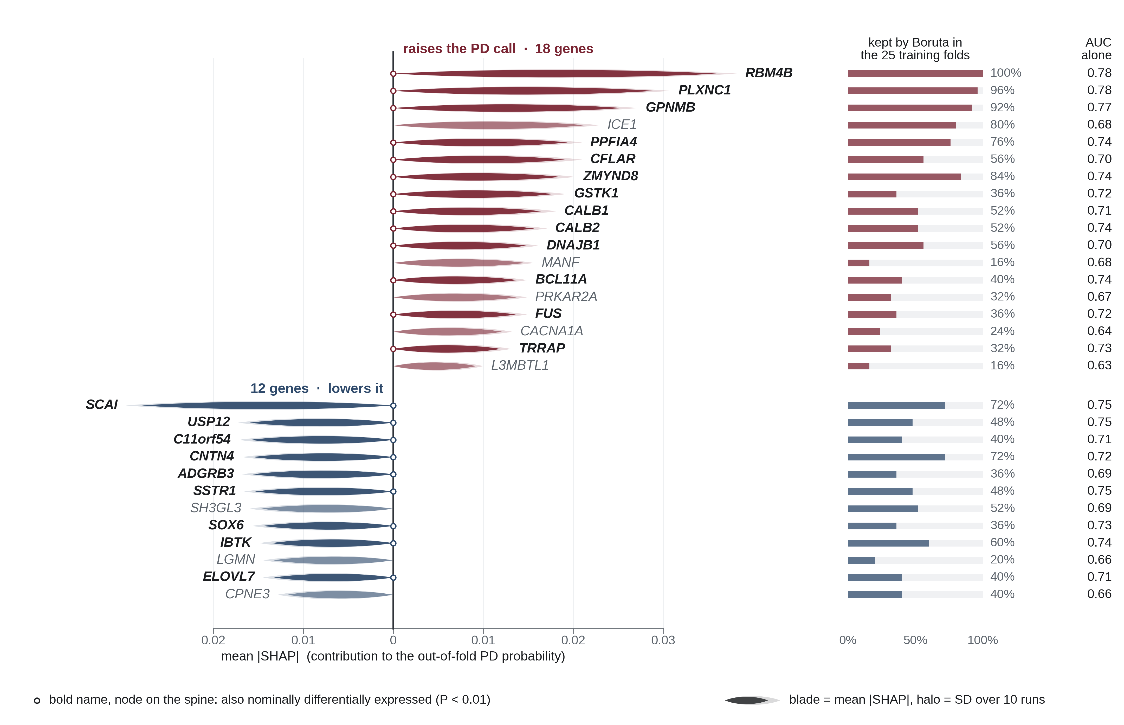
The 30 Boruta genes ranked by mean absolute SHAP contribution to the out-of-fold PD probability, split by direction, with the share of training folds that reselected each gene and the AUC of each gene alone. Bold names are also nominally differentially expressed.
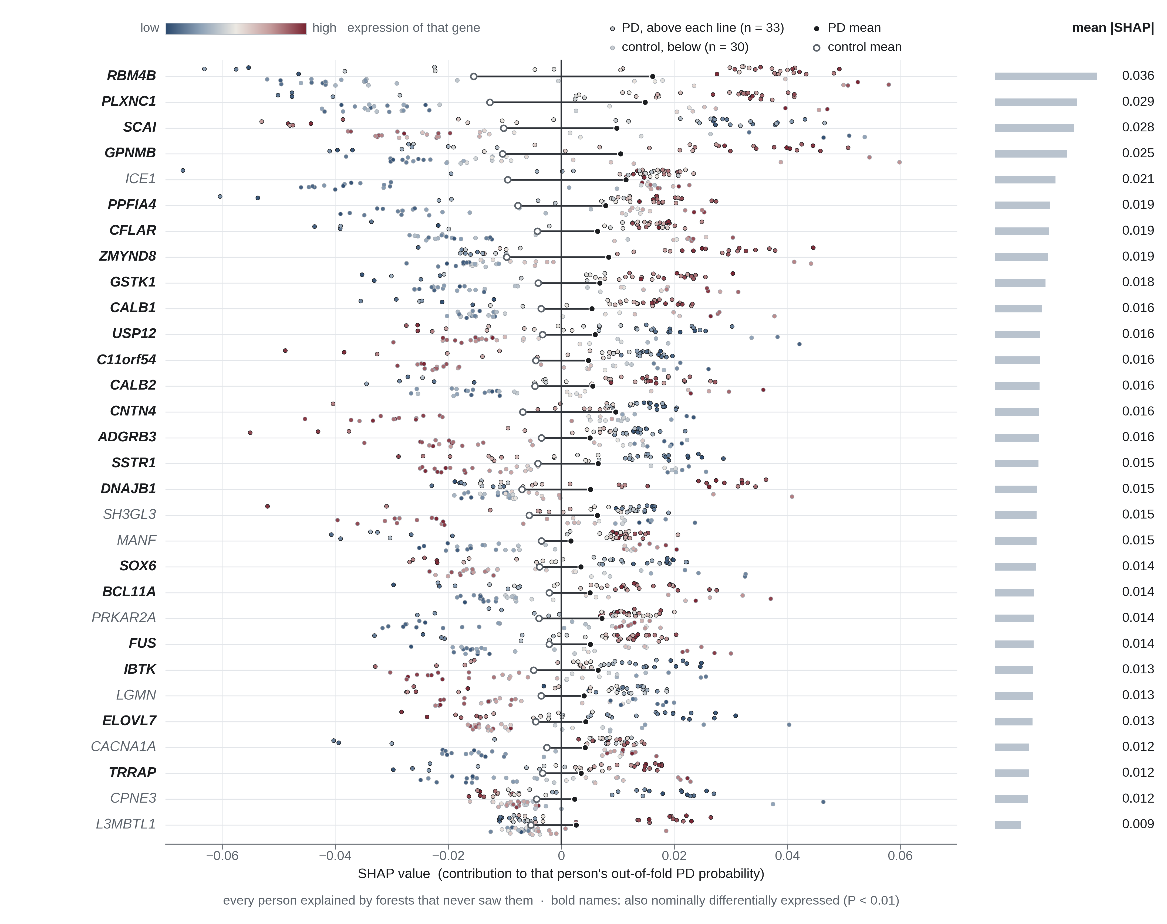
SHAP values of every donor for every panel gene, coloured by that donor’s expression rank.
Twenty-two of the 30 are also nominally differentially expressed at $P<0.01$, an overlap 79 times larger than chance would give (hypergeometric $P=6×{10}^{−41}$; Fig. 5). No gene survives a 5% false-discovery rate in the 63 donors, which is the expected outcome at this sample size rather than evidence of absence (Benjamini and Hochberg 1995).
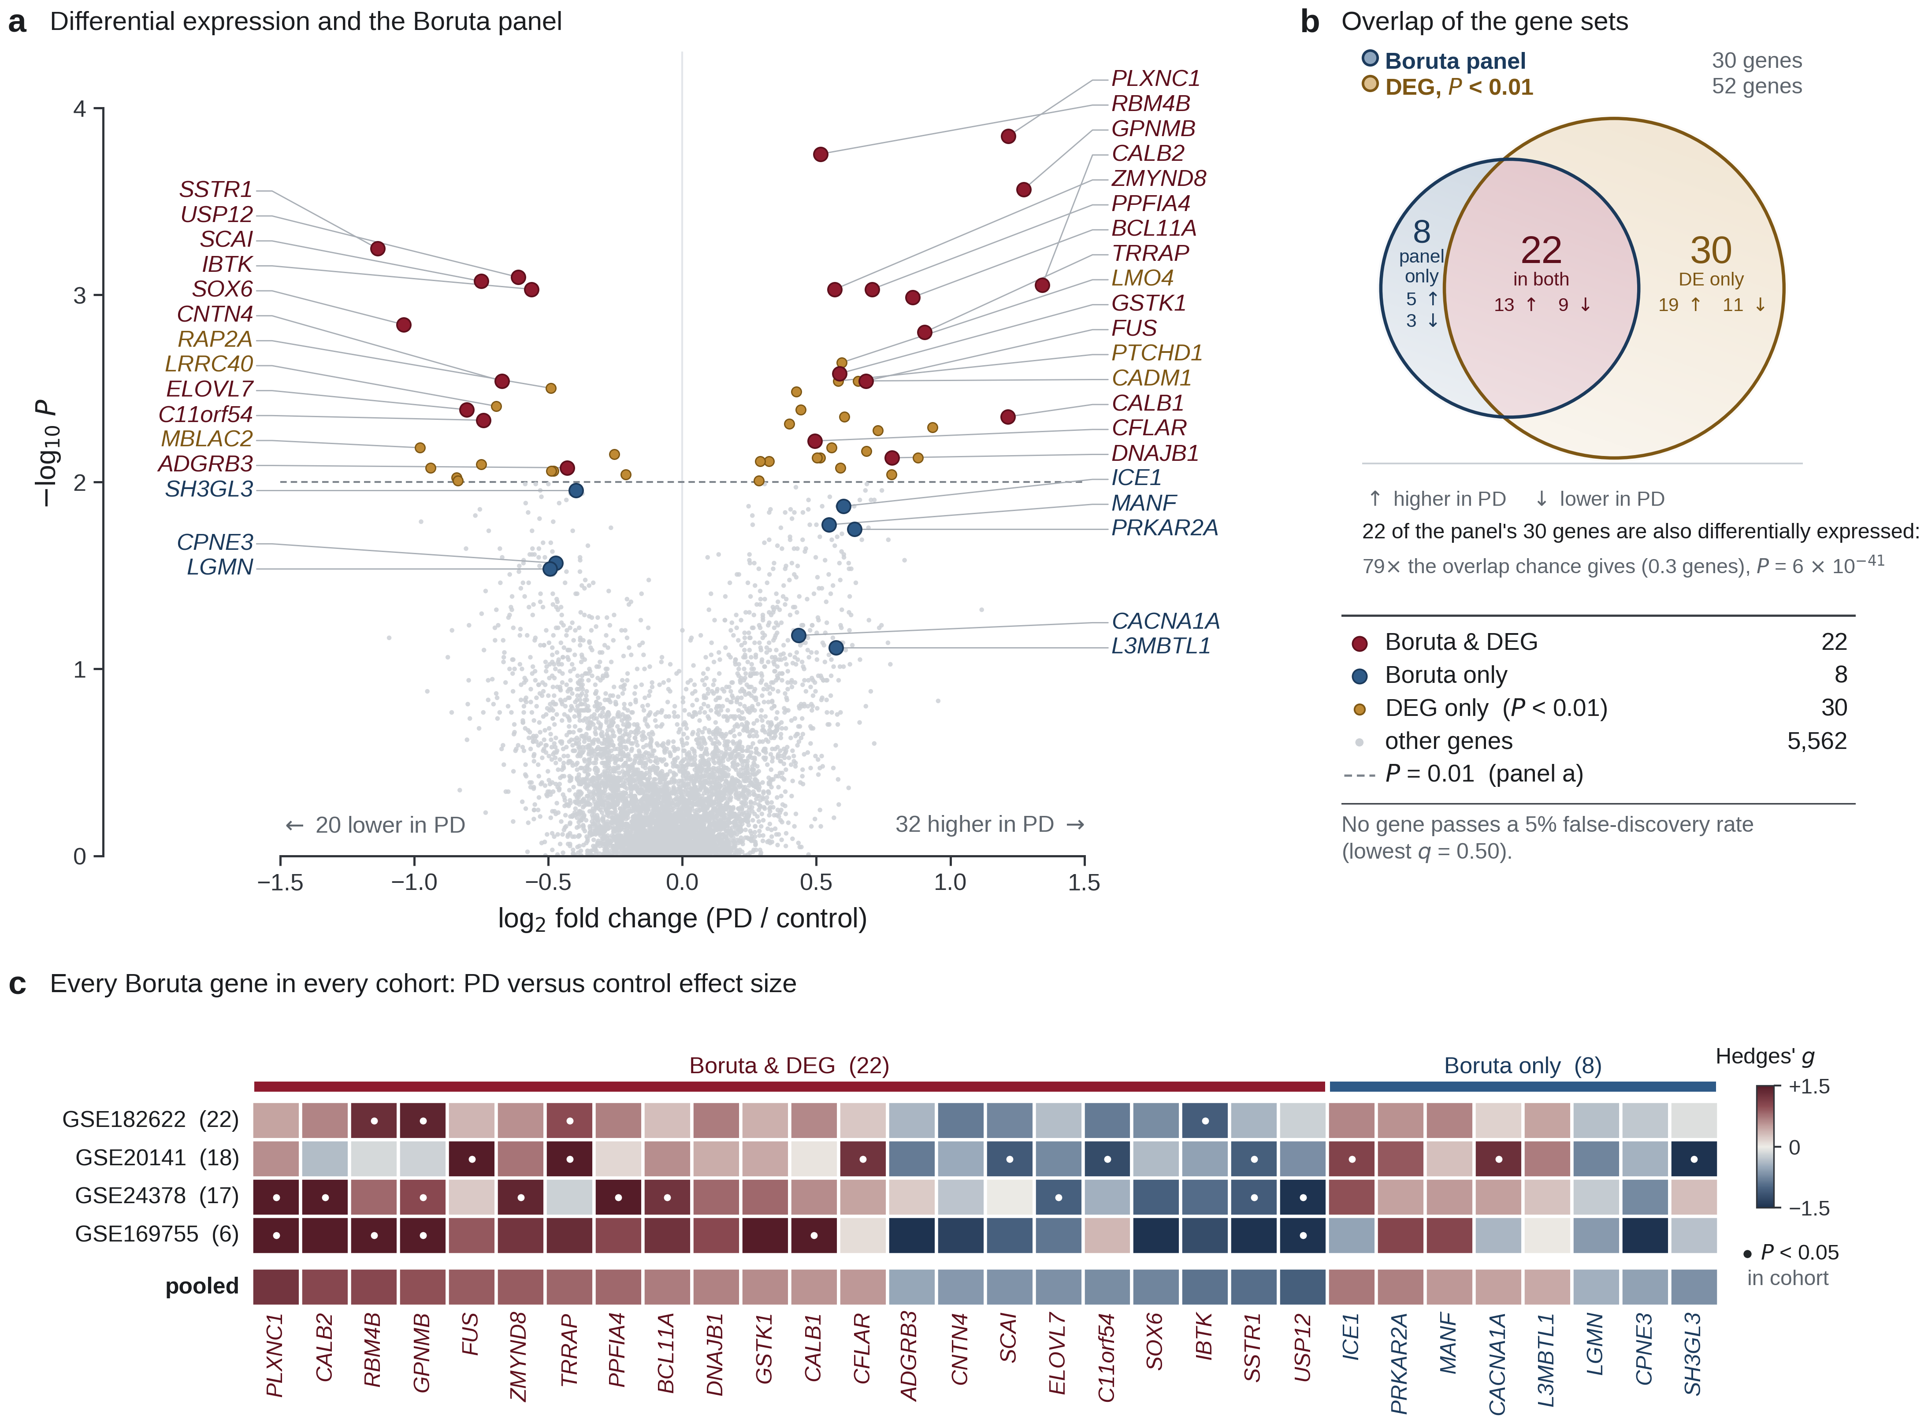
Differential expression and the panel. (a) Volcano of all 5,622 genes. (b) Overlap of the Boruta panel with genes at $P<0.01$: 22 of 30, with the up and down split of each region; the overlap is 79 times what chance gives. (c) Effect of every panel gene in every discovery cohort.

The frozen models in eight bulk cohorts
Both models were fixed before the external data were touched. Applied without refitting to 158 donors in eight bulk nigra cohorts, the core classifier pooled an AUC of 0.70 (95% CI 0.62–0.78) and the panel forest 0.84 (0.77–0.90), both far from chance under within-cohort label permutation ($P<0.001$; Fig. 6a, Table 2). At a cut-off fixed before testing the panel called 72% of donors correctly, with sensitivity 0.76 and specificity 0.68 (Fig. 7b). Per-cohort AUCs of the panel ranged from 0.43 in the 15-donor GSE20163 to 0.98 in GSE168496 (Fig. 7a). Retraining without any discovery study from the same brain bank changed little: 0.80 for the panel and 0.73 for the classifier. Dropping GSE7621, the cohort most similar to the discovery arrays, left the panel at 0.82.
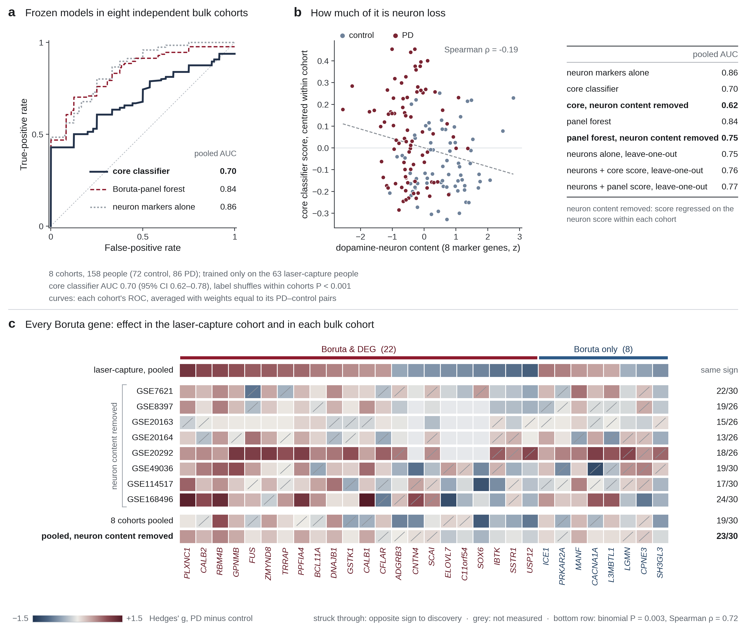
External validation in eight bulk cohorts, 158 donors, both models frozen beforehand. (a) Weighted average ROC of the classifier, the panel forest and a dopamine-neuron marker score. (b) Classifier score against neuron content, with pooled AUCs after that content is removed. (c) Each panel gene’s effect in discovery and in bulk tissue, before and after the neuron adjustment.
Chance is the wrong comparison here. Eight dopamine-neuron markers, averaged into a single score with no model behind them, reached 0.86 in the same donors, better than either model. Removing that neuron component from the scores within each cohort dropped the panel to 0.76 and the classifier to 0.62 (Table 2). Gene by gene is the test that matters for a panel offered as a set of candidates rather than as a score. Twelve of the 30 genes reached $q<0.05$ in the bulk donors on their unadjusted effect, after Benjamini–Hochberg correction over the panel, and nine of those twelve carried the same direction of effect as in the laser-captured neurons: RBM4B, USP12, SOX6, ADGRB3, SH3GL3, DNAJB1, CNTN4, ZMYND8 and SSTR1. The other three, GSTK1, PRKAR2A and CALB1, were significant with the opposite sign, which is what a marker of the spared population looks like once whole tissue rather than isolated neurons is measured. Across all 30, 19 effects had the same sign in bulk as in the laser-captured neurons, which is not more than chance ($P=0.10$); after the neuron score is removed from every gene, 23 of 30 agree ($P=0.003$, Spearman $ρ=0.72$; Fig. 6c), and two genes, RBM4B and PLXNC1, are still significant on their own at $q<0.05$ once that adjustment is made. Table [tab:genes] reports the adjusted effect and its $q$ value for every gene, so the bulk row of that table is the conservative version of the comparison made here. So the panel does say something about bulk nigra beyond counting neurons. Counting neurons still does the job at least as well.
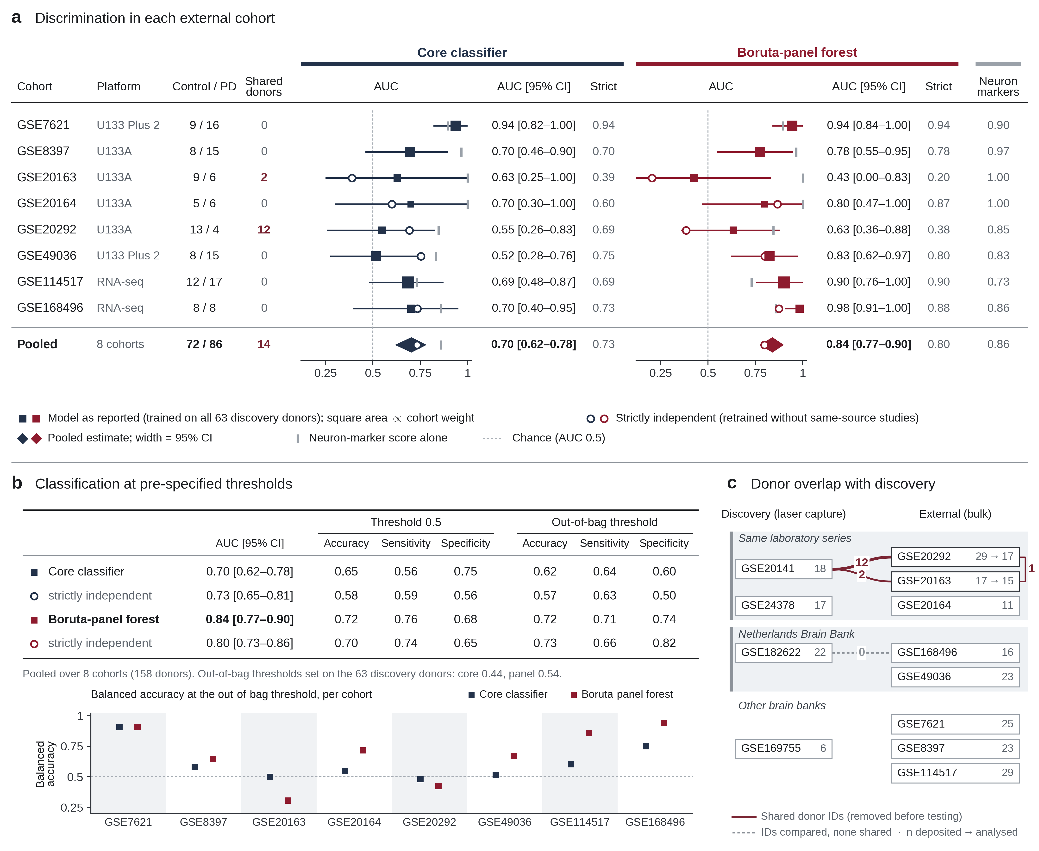
The frozen models cohort by cohort. (a) AUC of each cohort with bootstrap intervals and the pooled estimate. (b) Calls at cut-offs fixed before testing. (c) Brains shared with the discovery studies, found by donor identifier and removed.
Pooled performance in the eight external bulk-tissue cohorts (158 people, 72 control, 86 PD). Strictly independent models were retrained without any discovery study from the same brain bank. Neuron score removed residualises each donor’s score on eight dopamine-neuron markers. Confidence intervals are 4,000 donor bootstraps.
Model | AUC [95% CI] | Neuron score removed | Label shuffles
Core classifier, fixed | 0.70 [0.62–0.78] | 0.62 [0.53–0.71] | $<0.001$​
Core classifier, strictly independent | 0.73 [0.65–0.81] | 0.67 [0.58–0.76] | –
30-gene panel forest | 0.84 [0.77–0.90] | 0.75 [0.67–0.83] | $<0.001$​
30-gene panel, strictly independent | 0.80 [0.73–0.86] | 0.70 [0.61–0.78] | –
Dopamine-neuron markers alone | 0.86 [0.79–0.92] | – | –
Boruta reselected the panel genes at very different rates across the training folds, from RBM4B in every fold to MANF and L3MBTL1 in four of twenty-five, so the panel was restricted by fold frequency and retested. Keeping only the genes reselected in more than half of the folds leaves 14, and more than 70% leaves 8. Neither smaller panel does better. Pooled over the same donors the reported 30 genes reach 0.772, the 14 stable genes 0.752 and the 8 most stable 0.725; every threshold between those points lands in the same band. The tail of unstable genes is therefore contributing, not diluting, and the panel is not improved by trimming it.
The comparison that decides how much of this is the panel rather than the method is 200 random panels of each size, put through the identical procedure. All three panels beat their own null ( $P=0.015$, $0.015$ and $0.030$), but the null itself is high: a random 30-gene panel reaches a median pooled AUC of 0.63, and one in twenty reaches 0.73. Any set of genes carries some of the neuron loss with it. The selection adds to that, and the margin it adds is modest. These figures use all 173 external donors without the donor-overlap removal, so they sit below the values in Table 2 and are comparable with each other rather than with that table.

The panel tracks a dopamine-neuron lineage
Three quarters of the panel genes appear in the Kamath single-nucleus marker table (Kamath et al. 2022), and they fall apart cleanly by direction. Genes lower in PD are markers of SOX6 dopamine neurons; genes higher are markers of CALB1 neurons (difference in lineage score $P=0.0012$; each side also differs from the measured background, $P=0.0066$ and $P=0.0038$; all two-sided Wilcoxon rank-sum tests; Fig. 8). Because effect size and lineage could be correlated through expression level, the same test was run against gene sets matched on differential expression rank, and the split survived ($P=0.004$, one-sided by construction: the null is the proportion of matched sets that separate at least as well). SOX6 itself is in the panel, lower in PD, as is ADGRB3; CALB1 and CALB2 are higher. This is the direction single-nucleus work reports for selective vulnerability (Kamath et al. 2022), recovered here from four bulk-processed LCM studies that never saw a single-cell library.
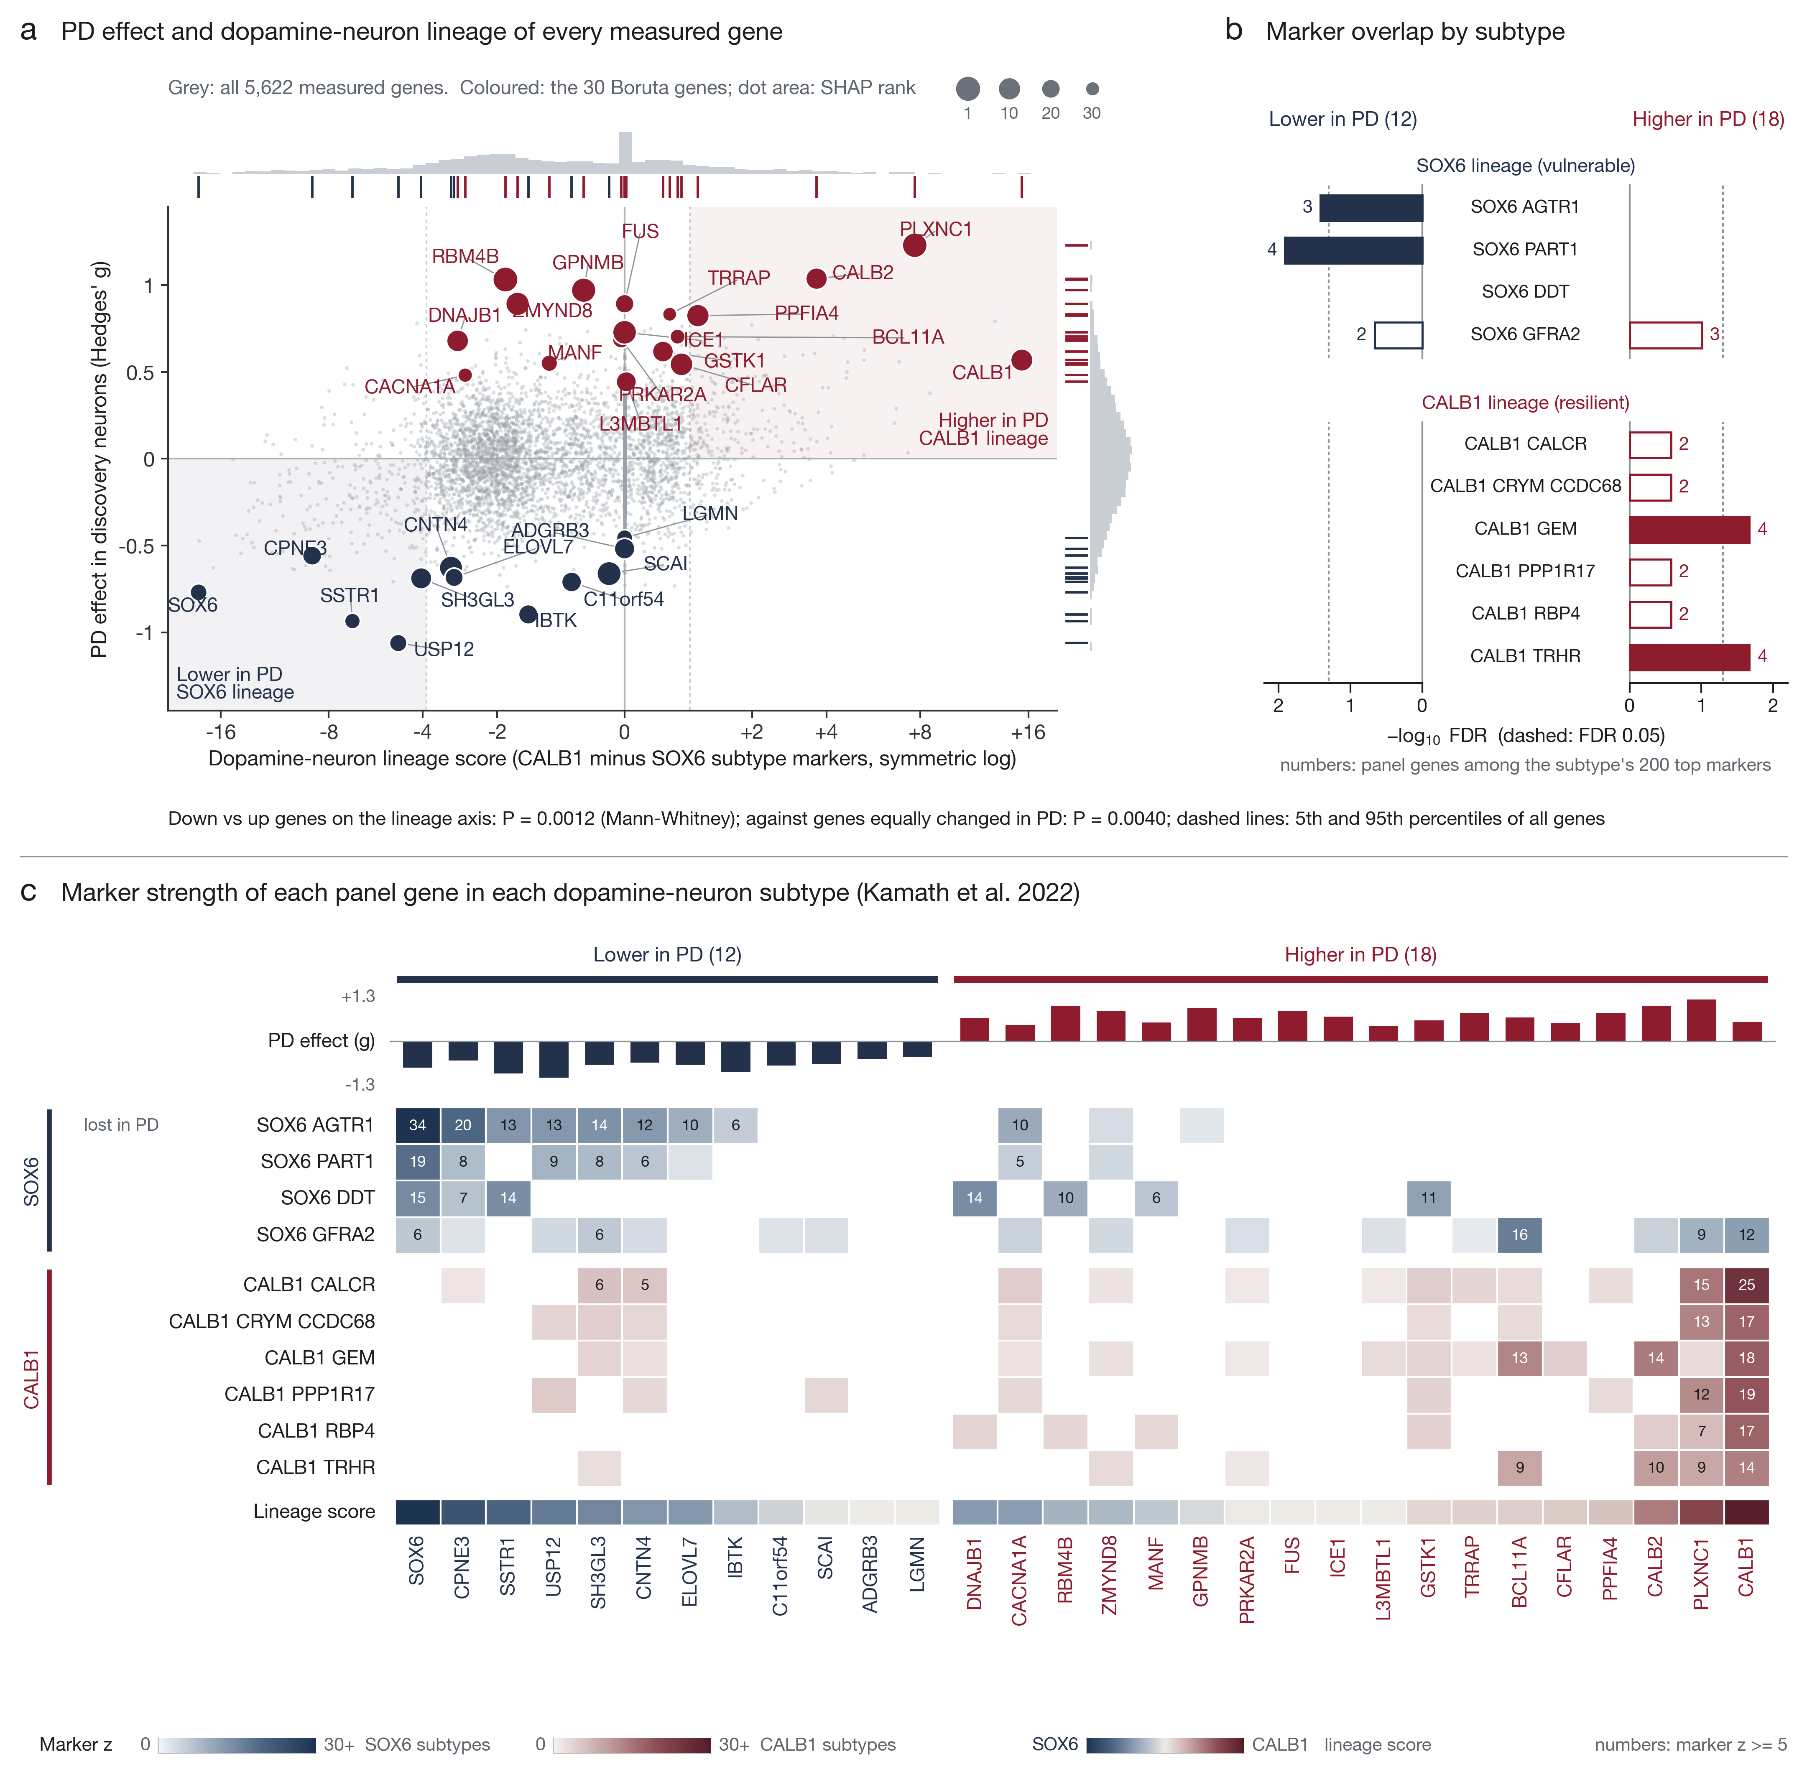
The panel against dopamine-neuron subtypes (Kamath et al. 2022). (a) PD effect and lineage score of every measured gene, with the panel marked. (b) Marker overlap by subtype. (c) Marker strength of each panel gene in each subtype: genes lower in PD are SOX6 markers, genes higher are CALB1 markers.

Pathways, with an honest background
Using the 5,622 measured genes as the background and correcting across all 3,547 terms, the 30-gene panel returns four significant terms: calcium ion binding involved in regulation of presynaptic cytosolic calcium (FDR 0.005), excitatory synapse (0.016), a GO term labelled after cerebellar climbing-fibre synapses that covers the same excitatory synaptic genes (0.018), and regulation of synapse pruning (0.028; Fig. 9). Four terms is more than most random lists of the same size return: 32% of random lists return at least one, 10% return four or more, and the panel’s strongest term beats 98% of them. The enrichment is real and modest. The terms rest on five genes: CALB1, CALB2, ADGRB3, PLXNC1 and PPFIA4. Four of those five are also lineage markers, so this is close to the result of the previous section in different words.
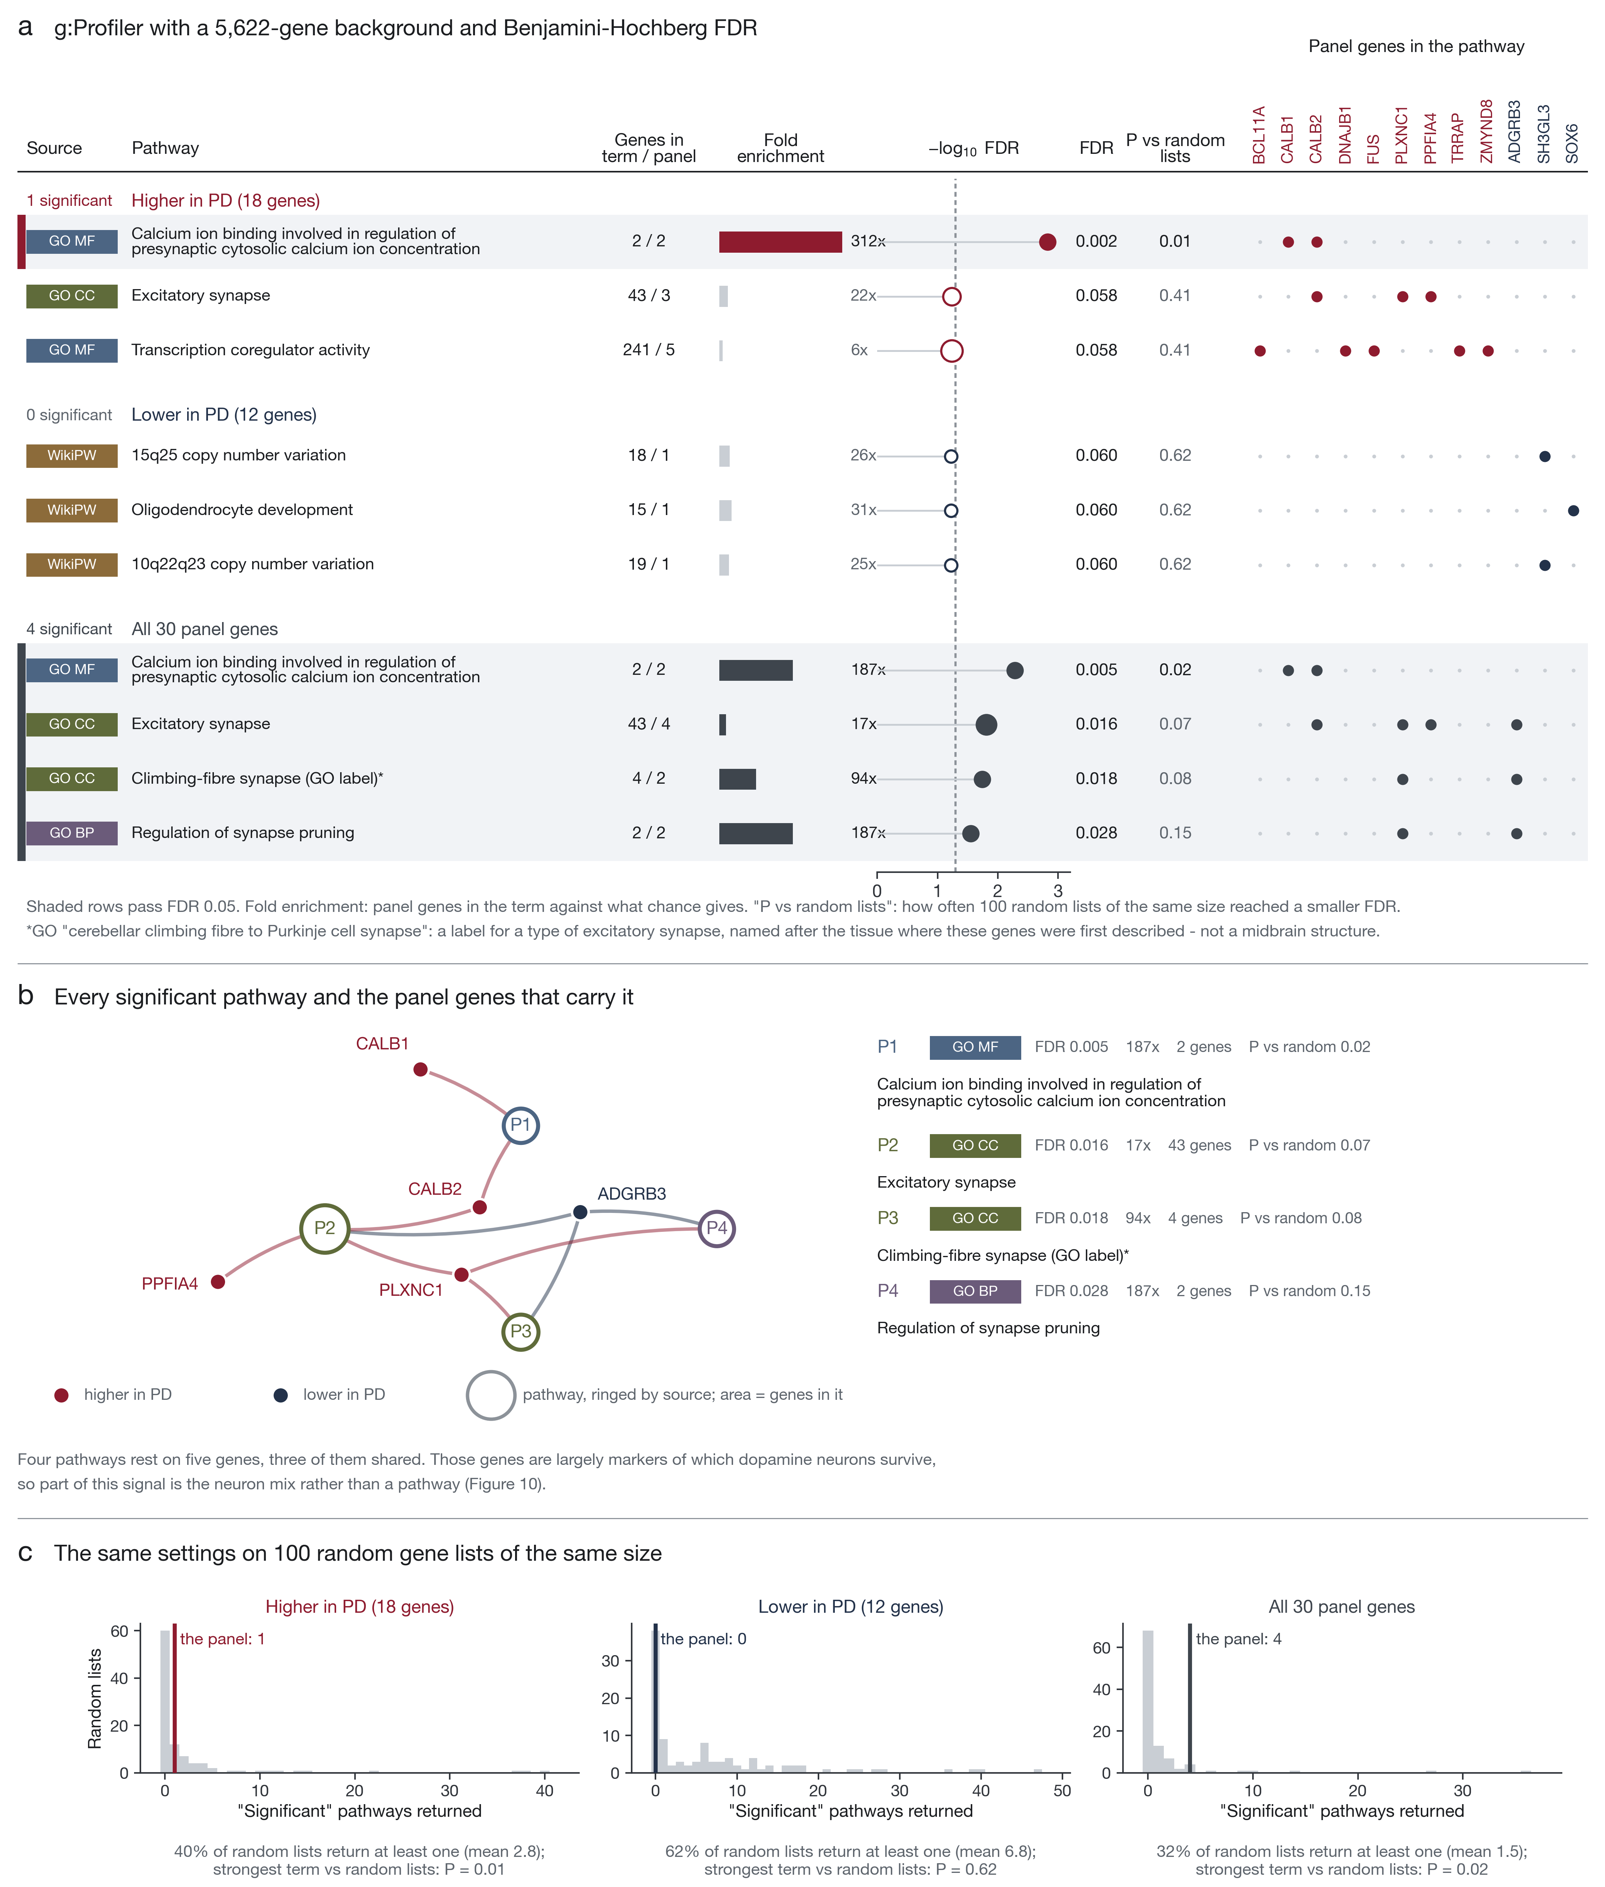
Over-representation with the 5,622 measured genes as background and Benjamini-Hochberg correction. (a) Terms for the lower, higher and full panel. (b) The four significant terms and the five genes that carry them. (c) The same settings applied to 100 random gene lists of each size.
A ranking-based analysis adds nothing that survives a strict null. Across 1,967 gene sets, none reaches significance when the null is built by shuffling donor diagnoses within study; 20 pass the conventional gene-permutation FDR of 0.25, of which 12 carry a panel gene in the leading edge, and single-sample scores separate PD from control at $P<0.05$ for 147 sets but none after correction. We report those as exploratory, not as findings (Subramanian et al. 2005).

How much of it is the neuron mix
Each donor’s dopamine-neuron subtype mix was estimated from the Kamath markers, with panel genes excluded. PD donors are more CALB1-like than controls (AUC 0.73, Mann-Whitney $P=0.0003$), and the classifier’s out-of-fold score follows that mix ($ρ=0.51$ overall, 0.60 among controls alone), which is the correlation one expects if the model is partly reading composition (Fig. 10a,b).
Reference-based deconvolution says the same thing as the marker score, which is the point of running it. Against the Smajić et al. (2021) midbrain atlas, the estimated dopamine-neuron proportion tracks the eight-marker score in every cohort (Spearman $ρ$ 0.57 to 0.99, all $P≤0.002$) and across the pooled donors ($ρ=0.79$, $P=9×{10}^{−39}$ for the variance-weighted estimator; 0.64 for $ν$-SVR and 0.43 for plain non-negative least squares, all $P<{10}^{−8}$). The deconvolution also recovers the disease itself without being told about it: the dopamine-neuron fraction is the cell type that separates PD from control most strongly and in the expected direction (median 6.2% in controls against 0.0% in PD, AUC 0.16, that is 0.84 for loss), while microglia, pericytes and oligodendrocyte precursors are higher in PD (AUC 0.65, 0.74 and 0.69). Residualising the external scores on the deconvolved proportion rather than on the marker score costs the panel slightly more, not less: 0.77 to 0.67 against 0.77 to 0.73 on the same donors. The composition explanation is therefore not an artefact of how we measured composition, and if anything the marker score understates it.
Regressing the mix out of every gene and re-running the same folds with the same model is the test that separates the two explanations. Out-of-fold AUC falls from 0.765 to 0.674, a drop that is well outside the fold-to-fold variation, and the adjusted model still beats its own label permutations ($P=0.009$; Fig. 10c). Adding the classifier score to a model built on composition alone improves it (leave-one-out AUC 0.68 to 0.72, likelihood-ratio $P=0.006$). Sensitivity runs with 25, 100 or 200 markers, with SOX6_AGTR1 markers alone, or with dopamine purity added, land between 0.64 and 0.76. Gene by gene, 23 of 30 keep at least half of their effect, with a median of 68% kept (Fig. 10d, Table [tab:genes]).
So the signal is both things at once. A large part of what the classifier reads is which dopamine neurons survive; a smaller part is a difference in the neurons that remain.
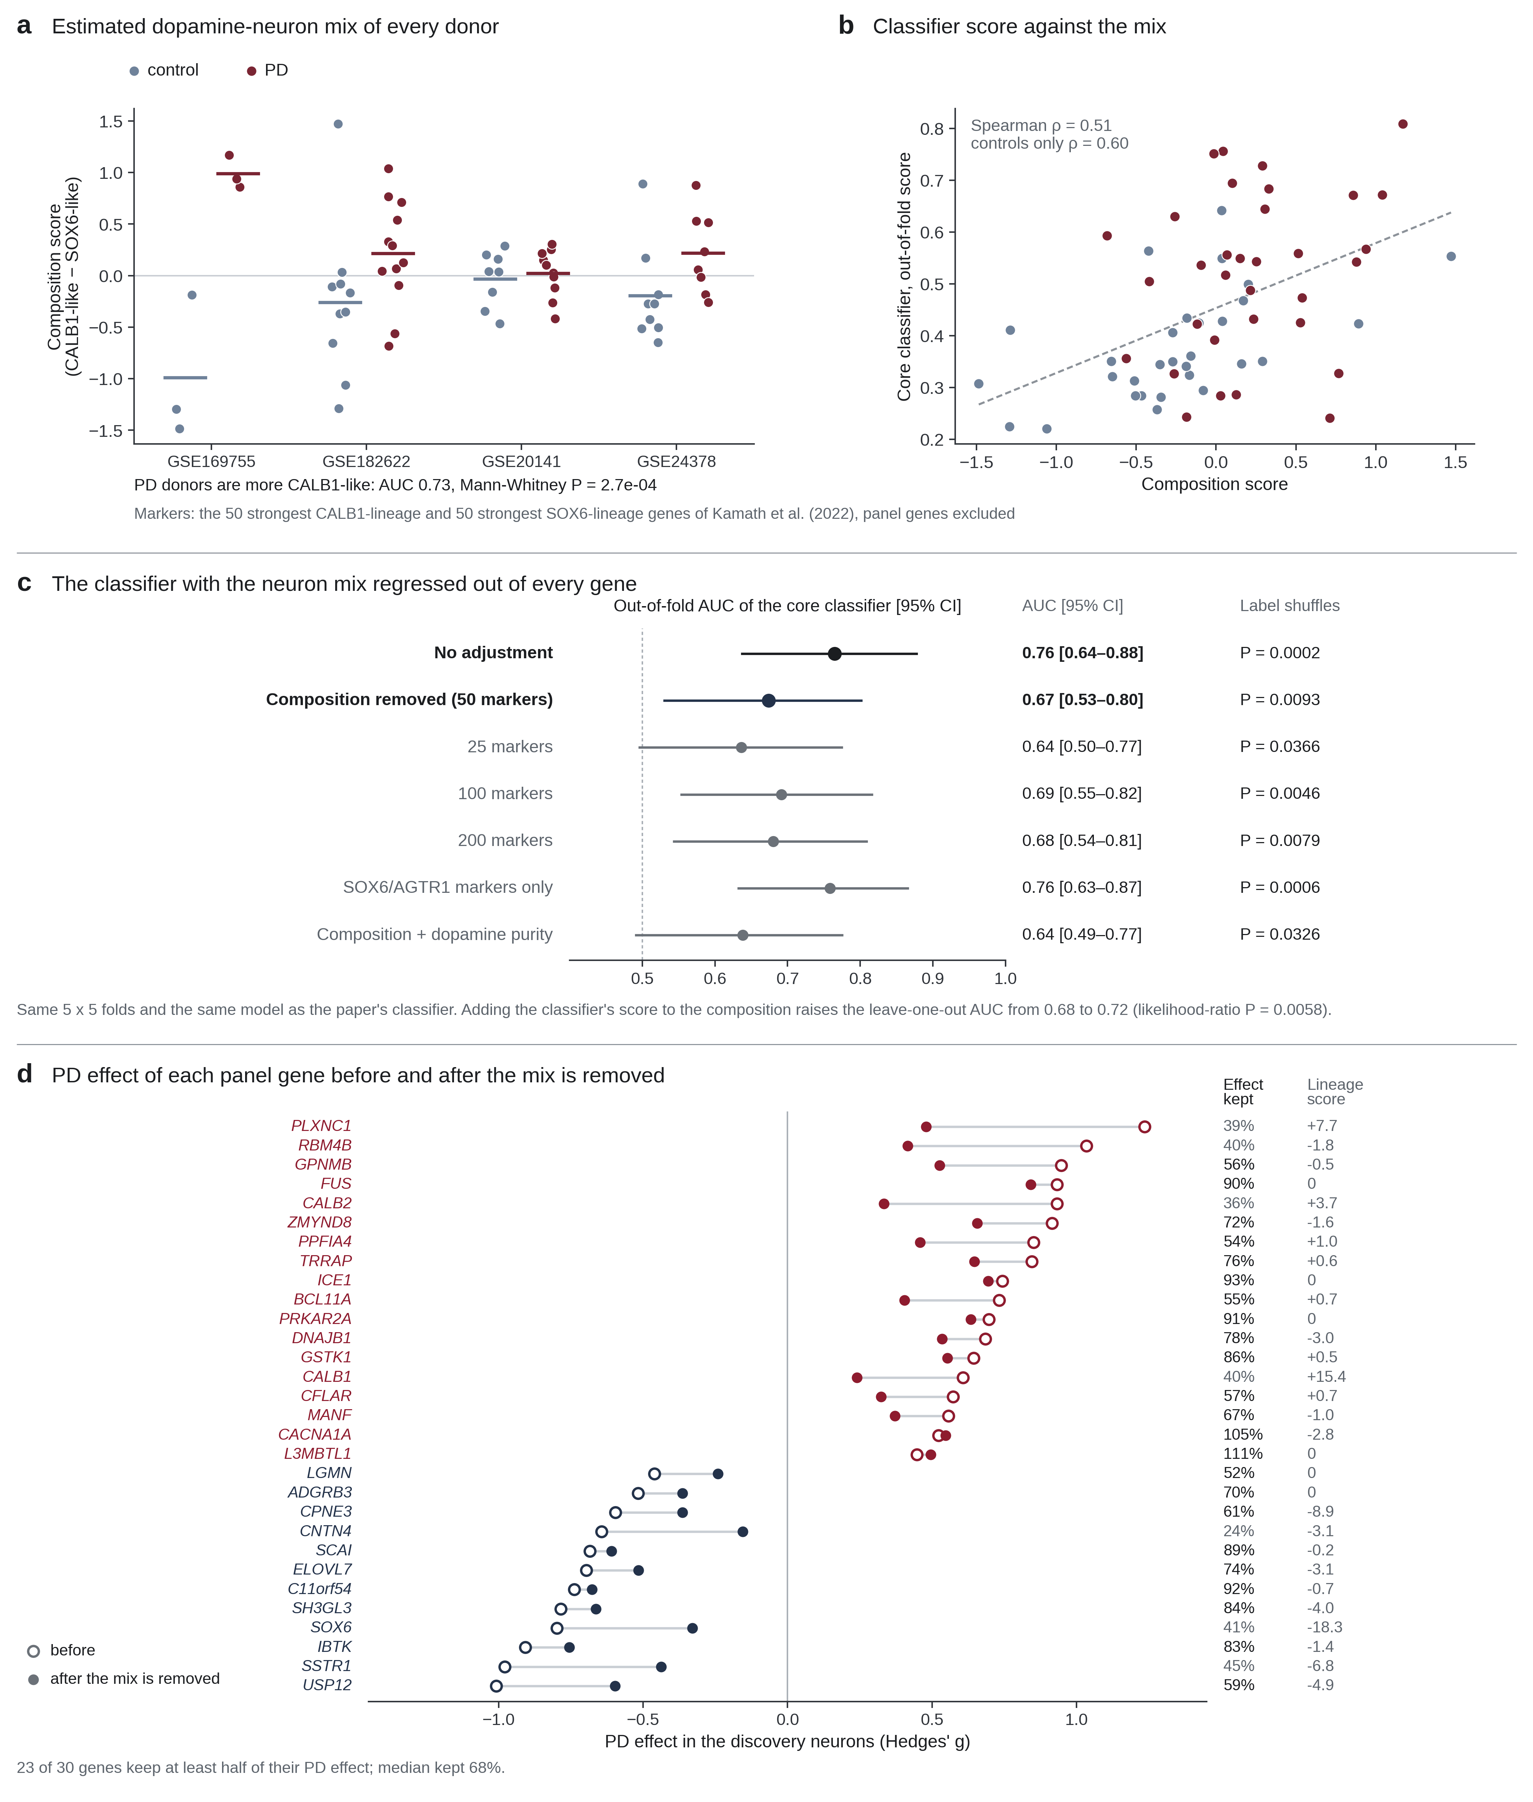
How much of the signal is the neuron mix. (a) Estimated CALB1-versus-SOX6 mix of every donor. (b) The classifier’s out-of-fold score against that mix. (c) Out-of-fold AUC with the mix regressed out of every gene, across marker counts and variants. (d) Each panel gene’s effect before and after the adjustment.

The genes themselves
Table [tab:genes] gives all 30 genes: the four measurements above, the dopamine-neuron subtype each one marks, its Open Targets association with Parkinson disease, what is tractable about it, and any published study tying it to the disease or to dopamine neurons.
Thirteen of the 30 carry such a study. Two of them, GPNMB and ELOVL7, sit at genetic risk loci (Open Targets genetic association 0.78 and 0.51) (Buniello et al. 2024; Blauwendraat et al. 2020). SOX6 and CALB1 are the markers of the vulnerable and the spared dopamine populations (Kamath et al. 2022; Damier et al. 1999), and CALB2 is the third calcium-binding protein in that group: in human PD midbrain its neurons were selectively preserved (Mouatt-Prigent et al. 1994). LGMN encodes legumain, which cleaves $α$-synuclein at N103 and also truncates SOX6 in vulnerable neurons (Zhang et al. 2017; Nie et al. 2024). DNAJB1 clears $α$-synuclein through the Hsp70 system (Huang et al. 2025), MANF restores nigrostriatal function after a 6-hydroxydopamine lesion (Voutilainen et al. 2009), and BCL11A marks a nigral subset that is especially vulnerable to $α$-synuclein overexpression (Tolve et al. 2021). That a wrapper algorithm with no knowledge of any of this recovered thirteen such genes is the strongest evidence that the selection is not noise.
The other seventeen have no published tie to the disease, which is what makes them candidates rather than confirmations. Which of them to follow depends on the composition adjustment rather than on the literature: FUS and DNAJB1 keep 90% and 78% of their effect once the neuron mix is removed, while CNTN4 and CALB2 keep about a third, which is what a subtype marker looks like.

Discussion
A classifier trained on 63 laser-captured donors transfers to bulk nigra it has never seen: 0.70 for the model, 0.84 for the 30-gene panel. The panel’s directions match the SOX6–CALB1 split that single-nucleus sequencing reports for selective vulnerability (Kamath et al. 2022). When each donor’s estimated subtype mix is regressed out of every gene, the classifier loses about half of its margin over chance and keeps the rest.
The external result has to be read against the neuron-marker comparison. Eight markers with no model behind them reach 0.86 in the same cohorts, above both trained models, and removing that component costs the panel 0.08 of AUC and the classifier 0.08 more. Composition explaining much of what looks like differential expression is the rule in nigral tissue, not the exception (Nido et al. 2020). The panel is not reducible to it: after the neuron score is removed, 23 of 30 gene effects still agree in direction between laser-captured neurons and bulk tissue ($P=0.003$), which a pure composition marker would not do. But any claim that a nigral expression signature is diagnostic has to clear this bar first, and most published signatures have never been asked to.
One number deserves more weight than its size suggests. Random 30-gene panels, selected without reference to the disease and put through the same frozen procedure, reach a median pooled AUC of 0.63 in these cohorts, and the best one in twenty reaches 0.73. A nigral expression panel therefore starts from a high floor, because almost any gene set inherits some of the neuron loss. Read against that floor the panel is ahead but not far ahead, and the honest description of the external result is a real effect of modest size rather than a diagnostic. We report the null because a signature that has never been compared with a random one of equal size has not been tested in the way that matters.
The two models do not transfer equally well, and the gap is informative. The panel forest reaches 0.84 in bulk tissue while the core classifier reaches 0.70, although the core classifier is the better model in discovery. The difference follows from what each one carries across. The core classifier’s thirty components are fitted to the total variance of 5,622 genes in laser-captured neurons, and a component is a weighted sum of all of them; in bulk nigra the largest sources of variance are not the ones it was fitted on but platform, processing batch and the ratio of glia to neurons, which behave differently in whole tissue than in a captured population (Leek et al. 2010; Nido et al. 2020). A direction defined in one variance structure is only partly a direction in the other, so the projection arrives distorted. The panel forest has no such projection: it reads thirty genes that were each standardised within the receiving cohort, so a platform difference that shifts every gene equally cancels, and only those thirty genes’ behaviour is exposed. Narrow signatures transferring across platforms better than dimension-reduced whole-transcriptome representations is the usual finding of cross-study validation work (Bernau et al. 2014), and it is the practical argument for reporting a gene list rather than a fitted projection.
We did not expect the subtype result to hold. Boruta (Kursa and Rudnicki 2010) knows nothing about cell types, the four studies predate the single-nucleus atlas, and the genes still sort by lineage at $P=0.0012$, and $P=0.004$ against sets matched on effect size. That an unsupervised selection recovered an axis established independently (Kamath et al. 2022; Poulin et al. 2020) is reassuring about the method. It is also the least comfortable finding here, because a panel that reports which dopamine neurons are left is measuring a consequence of the disease rather than a mechanism inside the cells.
What survives the adjustment is a smaller signal, not an absent one. FUS, DNAJB1, TRRAP and ZMYND8 keep the largest share of their effect, and they are chaperone, RNA-binding and chromatin genes rather than subtype markers. DNAJB1 belongs to the HSP40 chaperone family, whose members differ in how well they suppress seeded $α$-synuclein aggregation (Deshayes et al. 2019), and FUS is an RNA-binding protein central to work on RNA processing in neurodegeneration (Lagier-Tourenne et al. 2010). Neither is a PD mechanism on this evidence. They are where we would look next, because their signal does not dissolve when composition is removed.
Cause and consequence stay entangled here. All the tissue is post-mortem, and PD donors have already lost most of the neurons the study is about (Kordower et al. 2013).
The adjustment deserves more scepticism than it usually receives, including ours. Regressing a lineage score out of every gene removes whatever part of that gene is linearly predictable from the score, and the score is itself a contrast between CALB1 and SOX6 marker sets (Kamath et al. 2022). Calcium buffering, synaptic vesicle handling and the other processes most likely to fail in a stressed dopamine neuron are also the processes that distinguish those two populations in the first place (Surmeier et al. 2017; Poulin et al. 2020). A gene whose disease response runs along that axis is therefore partly removed as composition even when the change is real and intrinsic, and no amount of care in fitting the regression can separate two effects that are collinear in the data at hand. The adjusted figure of 0.67 is best read as a lower bound on what survives inside surviving neurons, and the unadjusted 0.76 as an upper bound.
Two further limits of the procedure point in opposite directions, which is why we report the bracket rather than a point estimate. The regression is linear and assumes the composition effect is additive on the z scale; a non-linear relation would leave residual composition behind. Against that, the covariate is estimated with error rather than measured, and regression on a covariate that carries measurement error is attenuated, so the correction applied is smaller than the one intended (Frost and Thompson 2000). Three observations argue that the adjustment has not simply erased the biology: 23 of 30 genes keep at least half of their effect, agreement of sign between laser-captured neurons and bulk tissue rises after the adjustment rather than falling (19 of 30 to 23 of 30, $P=0.003$), and an independent deconvolution against a single-nucleus atlas reaches the same composition estimate (Smajić et al. 2021; Newman et al. 2015; Wang et al. 2019). The sensitivity runs point the same way: the result holds between 25 and 200 markers, with SOX6_AGTR1 markers alone, and with dopamine purity added. What would settle the question is not a better regression but better measurement, that is subtype proportions counted directly in the same donors, by single-nucleus or spatial profiling, rather than inferred from bulk expression.

Limitations
The discovery cohort is 63 people, which is large for laser-capture nigra and small for machine learning; no gene passes a genome-wide false-discovery threshold, and the panel should be read as a stable selection, not a list of established PD genes. The external cohorts are bulk tissue, so the transfer is across both study and tissue type, and cohort sizes run from 11 to 29 donors, which makes individual cohort AUCs unstable. Boruta selection is itself unstable at this sample size: rerun on the donors that remain after a whole brain bank is withheld, it returns panels sharing 5 of 30 and 15 of 32 genes with the reported one, so the panel is one of several near-equivalent all-relevant sets that these data support, and the nine genes that replicate externally carry more weight than membership of the list. Restricting the panel to its stable core does not repair this: the 14 genes reselected in more than half of the folds, and the 8 reselected in more than 70%, transfer slightly worse than the full 30, so the instability cannot be removed by trimming. Donor overlap could only be excluded where identifiers allowed it; the strictly independent models are the guard against what identifiers missed. Subtype mixtures are estimated from marker averages, not measured, and the Kamath markers come from a different cohort and technology (Kamath et al. 2022). Finally, clinical detail is thin in the public metadata: we could not test disease duration, medication or Braak stage systematically, though the early-stage cohort GSE49036 (Dijkstra et al. 2015) scored no differently from the rest.

Data and code availability
Every dataset used here is public in the Gene Expression Omnibus (Barrett et al. 2012). The discovery cohort is four laser-capture studies of nigral dopamine neurons: GSE182622 (Tiklová et al. 2021), GSE20141 and GSE24378 (Zheng et al. 2010), and GSE169755 (Zaccaria et al. 2021). The models were then tested in eight bulk substantia nigra cohorts: GSE7621 (Lesnick et al. 2007), GSE8397 (Moran et al. 2006), GSE20163 and GSE20164 (Zheng et al. 2010), GSE20292 (Zhang et al. 2005), GSE49036 (Dijkstra et al. 2015), GSE114517 (Simchovitz et al. 2020) and GSE168496 (Tranchevent et al. 2023). Dopamine-neuron subtype markers are Supplementary Table 8 of Kamath et al. (2022). Gene annotation came from UniProt (The UniProt Consortium 2024), target information from the Open Targets Platform (Buniello et al. 2024), and the literature search from Europe PMC (Rosonovski et al. 2023).
All code is public at https://github.com/Alisareminia/pd-lcm-boruta: the seventeen notebooks as they were run, the scripts that generate them, the tables behind every figure, and the figures themselves. Each notebook reads the outputs of the ones before it, so any figure can be redrawn without repeating the analysis. The record of the literature search, with every hit and whether it was kept, is Supplementary Table S1.

Gene | Type and main role | This study | DA-neuron subtype | Open Targets | Druggability | Published link to Parkinson’s disease or dopamine neurons
Gene | Type and main role | This study | DA-neuron subtype | Open Targets | Druggability | Published link to Parkinson’s disease or dopamine neurons
RBM4B $↑$  11q13.2  SHAP rank 1 | RNA-binding protein 4B  RNA-binding protein that activates translation of the clock gene PER1. (The UniProt Consortium 2024) [Q9BQ04] | $g$ +1.03, $q$ 0.003  100% of folds  $g$ +0.66, $q$ 0.004  $g$ +0.42, $q$ 0.154 | SOX6 DDT | — | — | —
PLXNC1 $↑$  12q22  SHAP rank 2 | Plexin-C1  Receptor for semaphorin 7A; its signalling rearranges the cytoskeleton. (The UniProt Consortium 2024) [O60486]  excitatory synapse, climbing-fibre synapse, synapse pruning | $g$ +1.23, $q$ 0.003  96% of folds  $g$ +0.56, $q$ 0.015  $g$ +0.48, $q$ 0.107 | +7.7  CALB1 CALCR |  | small molecule: high-quality pocket  antibody: surface/secreted (high confidence) | Mouse development: semaphorin 7A–PLXNC1 signalling separates the nigrostriatal from the mesolimbic dopamine pathway (Chabrat et al. 2017)
GPNMB $↑$  7p15.3  SHAP rank 3 | Transmembrane glycoprotein NMB  Transmembrane glycoprotein, annotated as a possible melanogenic enzyme. (The UniProt Consortium 2024) [Q14956] | $g$ +0.97, $q$ 0.003  92% of folds  $g$ +0.43, $q$ 0.070  $g$ +0.53, $q$ 0.086 | SOX6 AGTR1 | genetic 0.782 | antibody: advanced clinical  1 drug or clinical candidate | Human GWAS: risk locus, the risk allele raising GPNMB; cell and mouse models: GPNMB binds $α$-synuclein and promotes its neuronal uptake (Diaz-Ortiz et al. 2022)  Plasma: raised in Parkinson’s disease across 731 patient and 59 control samples, tracking severity (Diaz-Ortiz et al. 2022)
SCAI $↓$  9q33.3  SHAP rank 4 | Protein SCAI  Suppressor of MRTF-A-driven SRF transcription that regulates cell migration. (The UniProt Consortium 2024) [Q8N9R8] | $g$ -0.66, $q$ 0.003  72% of folds  $g$ +0.13, $q$ 0.699  $g$ -0.61, $q$ 0.061 | CALB1 PPP1R17 | — | antibody: signal peptide or transmembrane | —
ICE1 $↑$  5p15.32  SHAP rank 5 | Little elongation complex subunit 1  Scaffold of the little elongation complex, which drives small nuclear RNA transcription. (The UniProt Consortium 2024) [Q9Y2F5] | $g$ +0.73, $q$ 0.017  80% of folds  $g$ +0.14, $q$ 0.699  $g$ +0.69, $q$ 0.053 | +0.0 | — | — | —
ZMYND8 $↑$  20q13.12  SHAP rank 6 | MYND-type zinc finger-containing chromatin reader ZMYND8  Chromatin reader that recognises combined histone methylation and acetylation marks. (The UniProt Consortium 2024) [Q9ULU4] | $g$ +0.89, $q$ 0.003  84% of folds  $g$ +0.29, $q$ 0.258  $g$ +0.66, $q$ 0.053 | SOX6 GFRA2 |  | — | —
CNTN4 $↓$  3p26.3-p26.2  SHAP rank 7 | Contactin-4  Cell-surface adhesion molecule of nervous-system development that promotes neurite outgrowth. (The UniProt Consortium 2024) [Q8IWV2] | $g$ -0.63, $q$ 0.005  72% of folds  $g$ +0.10, $q$ 0.752  $g$ -0.16, $q$ 0.539 | SOX6 AGTR1 |  | antibody: surface/secreted (high confidence) | Patient iPSC dopamine neurons, two brothers with the same PRKN mutations: CNTN4 was among the most down-regulated genes in the more severely affected brother (Cukier et al. 2022)  Cerebrospinal fluid: measured across dementias, including Parkinson’s disease dementia and dementia with Lewy bodies (Muqaku et al. 2024)
CFLAR $↑$  2q33.1  SHAP rank 8 | CASP8 and FADD-like apoptosis regulator  Apoptosis regulator that inhibits death-receptor-mediated cell death. (The UniProt Consortium 2024) [O15519] | $g$ +0.54, $q$ 0.009  56% of folds  $g$ -0.11, $q$ 0.752  $g$ +0.32, $q$ 0.225 | +0.7  CALB1 GEM |  | small molecule: structure with ligand  antibody: surface/secreted (HPA) | —
PPFIA4 $↑$  1q32.1  SHAP rank 9 | Liprin-alpha-4  Scaffold that may regulate focal-adhesion turnover and position receptor tyrosine phosphatases. (The UniProt Consortium 2024) [O75335]  excitatory synapse | $g$ +0.82, $q$ 0.003  76% of folds  $g$ +0.46, $q$ 0.057  $g$ +0.46, $q$ 0.122 | +1.0  CALB1 PPP1R17 |  | antibody: surface/secreted (medium confidence) | —
CALB1 $↑$  8q21.3  SHAP rank 10 | Calbindin  Calcium-binding protein that buffers cytosolic calcium. (The UniProt Consortium 2024) [P05937]  presynaptic Ca$​^{2+}$ binding | $g$ +0.57, $q$ 0.007  52% of folds  $g$ +0.45, $q$ 0.057  $g$ +0.24, $q$ 0.355 | +15.4  CALB1 CALCR |  | — | Human post-mortem nigra: calbindin-rich compartments lose fewer dopamine neurons (Damier et al. 1999)
DNAJB1 $↑$  19p13.12  SHAP rank 11 | DnaJ homolog subfamily B member 1  HSP40 co-chaperone that stimulates HSP70 in protein folding. (The UniProt Consortium 2024) [P25685] | $g$ +0.68, $q$ 0.011  56% of folds  $g$ +0.37, $q$ 0.129  $g$ +0.53, $q$ 0.086 | SOX6 DDT |  | small molecule: structure with ligand | Cell model: DNAJB1 clears $α$-synuclein through the Hsp70 system, and its phosphorylation by EGFR suppresses aggregation (Huang et al. 2025)  In vitro: DNAJB1 binds $α$-synuclein fibrils and recruits Hsc70 to take them apart (Monistrol et al. 2025)
CALB2 $↑$  16q22.2  SHAP rank 12 | Calretinin  Calcium-binding protein that buffers intracellular calcium in specific neuronal populations. (The UniProt Consortium 2024) [P22676]  presynaptic Ca$​^{2+}$ binding, excitatory synapse | $g$ +1.04, $q$ 0.003  52% of folds  $g$ +0.35, $q$ 0.135  $g$ +0.33, $q$ 0.224 | +3.7  CALB1 GEM |  | — | Human post-mortem midbrain, 4 patients and 3 controls: calretinin-positive dopamine neurons of the substantia nigra were selectively preserved (Mouatt-Prigent et al. 1994)  Rat culture: calretinin-containing dopamine neurons were spared from levodopa toxicity (Isaacs et al. 1997)  Plasma: among the proteins most reduced in Parkinson’s disease compared with controls, by nucleic acid-linked immunoassay (Vijiaratnam et al. 2026)
SH3GL3 $↓$  15q25.2  SHAP rank 13 | Endophilin-A3  Endophilin that binds curved membranes and takes part in endocytosis. (The UniProt Consortium 2024) [Q99963] | $g$ -0.69, $q$ 0.014  52% of folds  $g$ -0.15, $q$ 0.699  $g$ -0.66, $q$ 0.053 | SOX6 AGTR1 |  | antibody: surface/secreted (medium confidence) | —
GSTK1 $↑$  7q34  SHAP rank 14 | Glutathione S-transferase kappa 1  Glutathione S-transferase that conjugates glutathione to foreign and endogenous compounds. (The UniProt Consortium 2024) [Q9Y2Q3] | $g$ +0.62, $q$ 0.005  36% of folds  $g$ +0.04, $q$ 0.821  $g$ +0.55, $q$ 0.083 | +0.5  SOX6 DDT |  | small molecule: structure with ligand | —
ADGRB3 $↓$  6q12-q13  SHAP rank 15 | Adhesion G protein-coupled receptor B3  Adhesion G protein-coupled receptor that regulates synapse and dendritic-spine formation. (The UniProt Consortium 2024) [O60242]  excitatory synapse, climbing-fibre synapse, synapse pruning | $g$ -0.52, $q$ 0.011  36% of folds  $g$ +0.00, $q$ 0.993  $g$ -0.36, $q$ 0.191 | +0.0 | — | small molecule: structure with ligand  antibody: surface/secreted (high confidence) | —
L3MBTL1 $↑$  20q13.12  SHAP rank 16 | Lethal(3)malignant brain tumor-like protein 1  Polycomb-group reader of methylated lysines that keeps genes repressed. (The UniProt Consortium 2024) [Q9Y468] | $g$ +0.44, $q$ 0.077  16% of folds  $g$ +0.10, $q$ 0.752  $g$ +0.50, $q$ 0.099 | +0.0  CALB1 GEM | — | small molecule: structure with ligand | —
C11orf54 $↓$  11q21  SHAP rank 17 | Beta-keto L-gulonate decarboxylase  Decarboxylase of the pentose pathway that also regulates HIF1A degradation. (The UniProt Consortium 2024) [Q9H0W9] | $g$ -0.71, $q$ 0.007  40% of folds  $g$ -0.15, $q$ 0.725  $g$ -0.68, $q$ 0.053 | SOX6 GFRA2 | — | — | —
IBTK $↓$  6q14.1  SHAP rank 18 | Inhibitor of Bruton tyrosine kinase  Inhibitor of Bruton tyrosine kinase in B-cell development. (The UniProt Consortium 2024) [Q9P2D0] | $g$ -0.90, $q$ 0.003  60% of folds  $g$ -0.13, $q$ 0.699  $g$ -0.76, $q$ 0.053 | SOX6 AGTR1 | — | antibody: surface/secreted (medium confidence) | —
CPNE3 $↓$  8q21.3  SHAP rank 19 | Copine-3  Calcium-dependent phospholipid-binding protein involved in cell migration. (The UniProt Consortium 2024) [O75131] | $g$ -0.56, $q$ 0.030  40% of folds  $g$ +0.23, $q$ 0.461  $g$ -0.36, $q$ 0.191 | SOX6 AGTR1 | — | antibody: surface/secreted (high confidence) | —
FUS $↑$  16p11.2  SHAP rank 20 | RNA-binding protein FUS  DNA/RNA-binding protein acting in transcription, splicing, RNA transport and DNA repair. (The UniProt Consortium 2024) [P35637] | $g$ +0.89, $q$ 0.005  36% of folds  $g$ +0.07, $q$ 0.752  $g$ +0.84, $q$ 0.042 | +0.0 |  | small molecule: structure with ligand | —
ELOVL7 $↓$  5q12.1  SHAP rank 21 | Very long chain fatty acid elongase 7  Rate-limiting elongase of long- and very-long-chain fatty acids in the endoplasmic reticulum. (The UniProt Consortium 2024) [A1L3X0] | $g$ -0.68, $q$ 0.007  40% of folds  $g$ -0.29, $q$ 0.461  $g$ -0.52, $q$ 0.088 | SOX6 AGTR1 | genetic 0.507 | small molecule: structure with ligand  antibody: signal peptide or transmembrane | Human case-control study: variant associated with Parkinson’s disease (Li et al. 2018)
PRKAR2A $↑$  3p21.31  SHAP rank 22 | cAMP-dependent protein kinase type II-alpha regulatory subunit  Regulatory subunit of cAMP-dependent protein kinase that anchors it to membranes. (The UniProt Consortium 2024) [P13861] | $g$ +0.69, $q$ 0.021  32% of folds  $g$ -0.08, $q$ 0.752  $g$ +0.63, $q$ 0.053 | SOX6 GFRA2 |  | small molecule: structure with ligand  antibody: surface/secreted (high confidence) | Human Lewy body disease brain and mice: $α$-synuclein sequesters DNMT1 from the nucleus, hypomethylating CpG islands upstream of PRKAR2A (Desplats et al. 2011)
USP12 $↓$  13q12.13  SHAP rank 23 | Ubiquitin carboxyl-terminal hydrolase 12  Deubiquitinating enzyme that regulates immune and inflammatory signalling. (The UniProt Consortium 2024) [O75317] | $g$ -1.06, $q$ 0.003  48% of folds  $g$ -0.21, $q$ 0.480  $g$ -0.60, $q$ 0.061 | SOX6 AGTR1 |  | small molecule: structure with ligand  antibody: surface/secreted (high confidence) | —
SOX6 $↓$  11p15.2  SHAP rank 24 | Transcription factor SOX-6  Transcription factor in neurogenesis and cartilage development. (The UniProt Consortium 2024) [P35712] | $g$ -0.77, $q$ 0.004  36% of folds  $g$ -0.41, $q$ 0.210  $g$ -0.33, $q$ 0.224 | SOX6 AGTR1 |  | — | Human single-nucleus nigra: marks the dopamine population depleted in Parkinson’s disease (Kamath et al. 2022)  Mouse: legumain cleaves SOX6 in vulnerable dopamine neurons, and the fragment speeds degeneration in A53T $α$-synuclein mice (Nie et al. 2024)
MANF $↑$  3p21.2  SHAP rank 25 | Mesencephalic astrocyte-derived neurotrophic factor  Secreted factor that selectively promotes survival of ventral midbrain dopamine neurons. (The UniProt Consortium 2024) [P55145] | $g$ +0.55, $q$ 0.020  16% of folds  $g$ +0.39, $q$ 0.103  $g$ +0.37, $q$ 0.191 | SOX6 DDT |  | antibody: surface/secreted (high confidence) | Rat 6-hydroxydopamine model: MANF restores nigrostriatal function (Voutilainen et al. 2009)
LGMN $↓$  14q32.12  SHAP rank 26 | Legumain  Lysosomal protease that cleaves proteins after asparagine residues. (The UniProt Consortium 2024) [Q99538] | $g$ -0.46, $q$ 0.031  20% of folds  $g$ +0.13, $q$ 0.699  $g$ -0.24, $q$ 0.355 | +0.0 |  | small molecule: structure with ligand  antibody: surface/secreted (high confidence) | Cell, mouse and human brain: legumain cleaves $α$-synuclein at N103, and the fragment aggregates and is toxic to dopamine neurons (Zhang et al. 2017)  Mouse: it cleaves $α$-synuclein and tau and drives their spread from gut to brain (Ahn et al. 2019)
SSTR1 $↓$  14q21.1  SHAP rank 27 | Somatostatin receptor type 1  Somatostatin receptor that inhibits adenylyl cyclase through G proteins. (The UniProt Consortium 2024) [P30872] | $g$ -0.93, $q$ 0.003  48% of folds  $g$ -0.07, $q$ 0.752  $g$ -0.44, $q$ 0.136 | SOX6 DDT |  | small molecule: structure with ligand  antibody: surface/secreted (high confidence)  8 drug or clinical candidates | —
BCL11A $↑$  2p16.1  SHAP rank 28 | BCL11 transcription factor A  Transcription factor associated with the BAF chromatin-remodelling complex. (The UniProt Consortium 2024) [Q9H165] | $g$ +0.70, $q$ 0.003  40% of folds  $g$ +0.16, $q$ 0.699  $g$ +0.40, $q$ 0.161 | +0.7  SOX6 GFRA2 |  | 1 drug or clinical candidate | Mouse: marks a subset of nigral dopamine neurons that is especially vulnerable to $α$-synuclein overexpression and oxidative stress (Tolve et al. 2021)
CACNA1A $↑$  19p13.13  SHAP rank 29 | Voltage-dependent P/Q-type calcium channel subunit alpha-1A  Pore-forming subunit of P/Q-type voltage-gated calcium channels. (The UniProt Consortium 2024) [O00555] | $g$ +0.48, $q$ 0.068  24% of folds  $g$ +0.08, $q$ 0.752  $g$ +0.55, $q$ 0.083 | SOX6 AGTR1 |  | small molecule: approved drug  antibody: surface/secreted (high confidence)  11 drug or clinical candidates | Cell model: the Parkinson’s kinase LRRK2 regulates the Ca$​_{V}$2.1 channel (Bedford et al. 2016)
TRRAP $↑$  7q22.1  SHAP rank 30 | Transformation/transcription domain-associated protein  Adapter of histone acetyltransferase complexes that mark chromatin for transcription. (The UniProt Consortium 2024) [Q9Y4A5] | $g$ +0.83, $q$ 0.004  32% of folds  $g$ +0.06, $q$ 0.772  $g$ +0.65, $q$ 0.053 | +0.6  CALB1 CALCR |  | small molecule: structure with ligand | —
Notes to Table 3. Type and main role: the UniProt protein name and its function, summarised in one sentence (The UniProt Consortium 2024); bold names are pathway terms that pass Benjamini-Hochberg correction against the measured background. This study: four measurements, each bar scaled to the largest value among the 30 genes. effect is Hedges’ $g$ between 33 PD and 30 control donors; folds is the share of training folds in which Boruta reselected the gene; bulk is the inverse-variance pooled $g$ in eight external bulk cohorts after dopamine-neuron content is regressed out (grey bar: sign opposite to discovery); kept is $g$ after each donor’s CALB1/SOX6 composition is regressed out of every gene, the bar showing the share of the original effect that remains. Each $q$ is a Benjamini-Hochberg value across the 30 genes within its own family of tests: the Wilcoxon rank-sum test for the discovery effect, and $z$ tests on the pooled or adjusted effect against its standard error for the other two. DA-neuron subtype: CALB1 minus SOX6 lineage score and the subtype in which the gene is the strongest marker, from single-nucleus profiling of human nigra (Kamath et al. 2022). Open Targets: the overall association score with Parkinson disease, and beneath it the genetic-association component, which integrates GWAS and rare-variant evidence, where it is non-zero (Buniello et al. 2024). Druggability: Open Targets tractability evidence by modality and the number of drug or clinical candidates; for each modality only the strongest tier in Open Targets’ own hierarchy is shown. Published link: primary studies tying the gene to Parkinson’s disease or dopamine-neuron biology, study type first, and any measurement of the gene in patients’ blood or cerebrospinal fluid. They were found with one protocol for every gene (Methods): Europe PMC (Rosonovski et al. 2023), searched for the gene symbol, its protein name and every HGNC alias together with Parkinson’s-disease and dopamine-neuron terms, in titles, abstracts and open-access full text; each hit was read and kept only when it reports a finding about the gene itself, and reviews, acronym collisions and retracted papers were excluded. The whole search, every hit and whether it was kept, is Supplementary Table S1. An em dash (—) means the resource holds no entry for that gene. The literature search ran on 2026-09-21; Open Targets release 26.06 was accessed on 2026-09-21; $↑$ higher and $↓$ lower in Parkinson’s disease; loci are GRCh38.
Agrawal, Ayushi, Hasan Balcı, Kristina Hanspers, et al. 2023. “WikiPathways 2024: next generation pathway database.” Nucleic Acids Research 52 (D1): D679–89. https://doi.org/10.1093/nar/gkad960.
Ahn, Eun Hee, Seong Su Kang, Xia Liu, et al. 2019. “Initiation of Parkinson’s disease from gut to brain by $δ$-secretase.” Cell Research 30 (1): 70–87. https://doi.org/10.1038/s41422-019-0241-9.
Ambroise, Christophe, and Geoffrey J. McLachlan. 2002. “Selection bias in gene extraction on the basis of microarray gene-expression data.” Proceedings of the National Academy of Sciences 99 (10): 6562–66. https://doi.org/10.1073/pnas.102102699.
Barbie, David A., Pablo Tamayo, Jesse S. Boehm, et al. 2009. “Systematic RNA interference reveals that oncogenic KRAS-driven cancers require TBK1.” Nature 462 (7269): 108–12. https://doi.org/10.1038/nature08460.
Barrett, Tanya, Stephen E. Wilhite, Pierre Ledoux, et al. 2012. “NCBI GEO: archive for functional genomics data sets—update.” Nucleic Acids Research 41 (D1): D991–95. https://doi.org/10.1093/nar/gks1193.
Bedford, Cade, Catherine Sears, Maria Perez-Carrion, Giovanni Piccoli, and Steven B. Condliffe. 2016. “LRRK2 Regulates Voltage-Gated Calcium Channel Function.” Frontiers in Molecular Neuroscience 9. https://doi.org/10.3389/fnmol.2016.00035.
Benjamini, Yoav, and Yosef Hochberg. 1995. “Controlling the False Discovery Rate: A Practical and Powerful Approach to Multiple Testing.” Journal of the Royal Statistical Society Series B: Statistical Methodology 57 (1): 289–300. https://doi.org/10.1111/j.2517-6161.1995.tb02031.x.
Ben-Shlomo, Yoav, Sirwan Darweesh, Jorge Llibre-Guerra, Connie Marras, Marta San Luciano, and Caroline Tanner. 2024. “The epidemiology of Parkinson’s disease.” The Lancet 403 (10423): 283–92. https://doi.org/10.1016/s0140-6736(23)01419-8.
Bernau, Christoph, Markus Riester, Anne-Laure Boulesteix, et al. 2014. “Cross-study validation for the assessment of prediction algorithms.” Bioinformatics 30 (12): i105–12. https://doi.org/10.1093/bioinformatics/btu279.
Blauwendraat, Cornelis, Mike A Nalls, and Andrew B Singleton. 2020. “The genetic architecture of Parkinson’s disease.” The Lancet Neurology 19 (2): 170–78. https://doi.org/10.1016/s1474-4422(19)30287-x.
Bloem, Bastiaan R, Michael S Okun, and Christine Klein. 2021. “Parkinson’s disease.” The Lancet 397 (10291): 2284–303. https://doi.org/10.1016/s0140-6736(21)00218-x.
Breiman, Leo. 2001. “Random Forests.” Machine Learning 45 (1): 5–32. https://doi.org/10.1023/a:1010933404324.
Buniello, Annalisa, Daniel Suveges, Carlos Cruz-Castillo, et al. 2024. “Open Targets Platform: facilitating therapeutic hypotheses building in drug discovery.” Nucleic Acids Research 53 (D1): D1467–75. https://doi.org/10.1093/nar/gkae1128.
Chabrat, A., G. Brisson, H. Doucet-Beaupré, et al. 2017. “Transcriptional repression of Plxnc1 by Lmx1a and Lmx1b directs topographic dopaminergic circuit formation.” Nature Communications 8: 933. https://doi.org/10.1038/s41467-017-01042-0.
Cukier, Holly N., Hyunjin Kim, Anthony J. Griswold, et al. 2022. “Genomic, transcriptomic, and metabolomic profiles of hiPSC-derived dopamine neurons from clinically discordant brothers with identical PRKN deletions.” Npj Parkinson’s Disease 8 (1): 84. https://doi.org/10.1038/s41531-022-00346-3.
Damier, P., E. C. Hirsch, Y. Agid, and A. M. Graybiel. 1999. “The substantia nigra of the human brain.” Brain 122: 1437–48. https://doi.org/10.1093/brain/122.8.1437.
Degenhardt, Frauke, Stephan Seifert, and Silke Szymczak. 2017. “Evaluation of variable selection methods for random forests and omics data sets.” Briefings in Bioinformatics 20 (2): 492–503. https://doi.org/10.1093/bib/bbx124.
DerSimonian, Rebecca, and Nan Laird. 1986. “Meta-analysis in clinical trials.” Controlled Clinical Trials 7 (3): 177–88. https://doi.org/10.1016/0197-2456(86)90046-2.
Deshayes, N., S. Arkan, and C. Hansen. 2019. “The Molecular Chaperone DNAJB6, but Not DNAJB1, Suppresses the Seeded Aggregation of Alpha-Synuclein in Cells.” International Journal of Molecular Sciences 20: E4495. https://doi.org/10.3390/ijms20184495.
Desplats, Paula, Brian Spencer, Elizabeth Coffee, et al. 2011. “$α$-Synuclein Sequesters Dnmt1 from the Nucleus.” Journal of Biological Chemistry 286 (11): 9031–37. https://doi.org/10.1074/jbc.c110.212589.
Diaz-Ortiz, Maria E., Yunji Seo, Marijan Posavi, et al. 2022. “GPNMB Confers Risk for Parkinson’s Disease Through Interaction with $α$-Synuclein.” Science 377 (6608). https://doi.org/10.1126/science.abk0637.
Dijkstra, Anke A., Angela Ingrassia, Renee X. de Menezes, et al. 2015. “Evidence for Immune Response, Axonal Dysfunction and Reduced Endocytosis in the Substantia Nigra in Early Stage Parkinson’s Disease.” PLOS ONE 10 (6): e0128651. https://doi.org/10.1371/journal.pone.0128651.
Efron, B. 1979. “Bootstrap Methods: Another Look at the Jackknife.” The Annals of Statistics 7 (1). https://doi.org/10.1214/aos/1176344552.
Frost, Chris, and Simon G. Thompson. 2000. “Correcting for Regression Dilution Bias: Comparison of Methods for a Single Predictor Variable.” Journal of the Royal Statistical Society Series A: Statistics in Society 163 (2): 173–89. https://doi.org/10.1111/1467-985x.00164.
GBD 2021 Nervous System Disorders Collaborators. 2024. “Global, regional, and national burden of disorders affecting the nervous system, 1990–2021: a systematic analysis for the Global Burden of Disease Study 2021.” The Lancet Neurology 23 (4): 344–81. https://doi.org/10.1016/s1474-4422(24)00038-3.
Hanley, J A, and B J McNeil. 1982. “The meaning and use of the area under a receiver operating characteristic (ROC) curve.” Radiology 143 (1): 29–36. https://doi.org/10.1148/radiology.143.1.7063747.
Hedges, Larry V. 1981. “Distribution Theory for Glass’s Estimator of Effect size and Related Estimators.” Journal of Educational Statistics 6 (2): 107–28. https://doi.org/10.3102/10769986006002107.
Huang, Yun-Yu, Sue-Jane Lin, Wei-Yu Chiang, et al. 2025. “EGFR phosphorylates DNAJB1 to suppress $α$-synuclein aggregation in Parkinson’s disease.” Npj Parkinson’s Disease 11 (1): 157. https://doi.org/10.1038/s41531-025-01006-y.
Hurlbert, Stuart H. 1984. “Pseudoreplication and the Design of Ecological Field Experiments.” Ecological Monographs 54 (2): 187–211. https://doi.org/10.2307/1942661.
Isaacs, Krystyna R., Matthew E. Wolpoe, and David M. Jacobowitz. 1997. “Calretinin-Immunoreactive Dopaminergic Neurons from Embryonic Rat Mesencephalon Are Resistant to Levodopa-Induced Neurotoxicity.” Experimental Neurology 146 (1): 25–32. https://doi.org/10.1006/exnr.1997.6530.
Kamath, Tushar, Abdulraouf Abdulraouf, S. J. Burris, et al. 2022. “Single-cell genomic profiling of human dopamine neurons identifies a population that selectively degenerates in Parkinson’s disease.” Nature Neuroscience 25 (5): 588–95. https://doi.org/10.1038/s41593-022-01061-1.
Kanehisa, Minoru, Miho Furumichi, Yoko Sato, Masayuki Kawashima, and Mari Ishiguro-Watanabe. 2022. “KEGG for taxonomy-based analysis of pathways and genomes.” Nucleic Acids Research 51 (D1): D587–92. https://doi.org/10.1093/nar/gkac963.
Kapoor, Sayash, and Arvind Narayanan. 2023. “Leakage and the reproducibility crisis in machine-learning-based science.” Patterns 4 (9): 100804. https://doi.org/10.1016/j.patter.2023.100804.
Kolberg, Liis, Uku Raudvere, Ivan Kuzmin, Priit Adler, Jaak Vilo, and Hedi Peterson. 2023. “g:Profiler—interoperable web service for functional enrichment analysis and gene identifier mapping (2023 update).” Nucleic Acids Research 51 (W1): W207–12. https://doi.org/10.1093/nar/gkad347.
Kordower, Jeffrey H., C. Warren Olanow, Hemraj B. Dodiya, et al. 2013. “Disease duration and the integrity of the nigrostriatal system in Parkinson’s disease.” Brain 136 (8): 2419–31. https://doi.org/10.1093/brain/awt192.
Kuleshov, Maxim V., Matthew R. Jones, Andrew D. Rouillard, et al. 2016. “Enrichr: a comprehensive gene set enrichment analysis web server 2016 update.” Nucleic Acids Research 44 (W1): W90–97. https://doi.org/10.1093/nar/gkw377.
Kursa, Miron B., and Witold R. Rudnicki. 2010. “Feature Selection with the Boruta Package.” Journal of Statistical Software 36 (11). https://doi.org/10.18637/jss.v036.i11.
Lagier-Tourenne, C., M. Polymenidou, and D. W. Cleveland. 2010. “TDP-43 and FUS/TLS: emerging roles in RNA processing and neurodegeneration.” Human Molecular Genetics 19: R46–64. https://doi.org/10.1093/hmg/ddq137.
Lazic, Stanley E. 2010. “The problem of pseudoreplication in neuroscientific studies: is it affecting your analysis?” BMC Neuroscience 11 (1). https://doi.org/10.1186/1471-2202-11-5.
Leek, Jeffrey T., Robert B. Scharpf, Héctor Corrada Bravo, et al. 2010. “Tackling the widespread and critical impact of batch effects in high-throughput data.” Nature Reviews Genetics 11 (10): 733–39. https://doi.org/10.1038/nrg2825.
Lesnick, Timothy G, Spiridon Papapetropoulos, Deborah C Mash, et al. 2007. “A Genomic Pathway Approach to a Complex Disease: Axon Guidance and Parkinson Disease.” PLoS Genetics 3 (6): e98. https://doi.org/10.1371/journal.pgen.0030098.
Li, G., S. Cui, J. Du, et al. 2018. “Association of GALC, ZNF184, IL1R2 and ELOVL7 With Parkinson’s Disease in Southern Chinese.” Frontiers in Aging Neuroscience 10: 402. https://doi.org/10.3389/fnagi.2018.00402.
Liberzon, Arthur, Chet Birger, Helga Thorvaldsdóttir, Mahmoud Ghandi, Jill P. Mesirov, and Pablo Tamayo. 2015. “The Molecular Signatures Database Hallmark Gene Set Collection.” Cell Systems 1 (6): 417–25. https://doi.org/10.1016/j.cels.2015.12.004.
Lundberg, Scott M., Gabriel Erion, Hugh Chen, et al. 2020. “From local explanations to global understanding with explainable AI for trees.” Nature Machine Intelligence 2 (1): 56–67. https://doi.org/10.1038/s42256-019-0138-9.
Mann, H. B., and D. R. Whitney. 1947. “On a Test of Whether one of Two Random Variables is Stochastically Larger than the Other.” The Annals of Mathematical Statistics 18 (1): 50–60. https://doi.org/10.1214/aoms/1177730491.
Milacic, Marija, Deidre Beavers, Patrick Conley, et al. 2023. “The Reactome Pathway Knowledgebase 2024.” Nucleic Acids Research 52 (D1): D672–78. https://doi.org/10.1093/nar/gkad1025.
Monistrol, Jim, Joseph G. Beton, Erin C. Johnston, Thi Lieu Dang, Bernd Bukau, and Helen R. Saibil. 2025. “Stepwise recruitment of chaperone Hsc70 by DNAJB1 produces ordered arrays primed for bursts of amyloid fibril disassembly.” Communications Biology 8 (1): 522. https://doi.org/10.1038/s42003-025-07906-2.
Moran, L. B., D. C. Duke, M. Deprez, D. T. Dexter, R. K. B. Pearce, and M. B. Graeber. 2006. “Whole genome expression profiling of the medial and lateral substantia nigra in Parkinson’s disease.” Neurogenetics 7 (1): 1–11. https://doi.org/10.1007/s10048-005-0020-2.
Morris, Huw R, Maria Grazia Spillantini, Carolyn M Sue, and Caroline H Williams-Gray. 2024. “The pathogenesis of Parkinson’s disease.” The Lancet 403 (10423): 293–304. https://doi.org/10.1016/s0140-6736(23)01478-2.
Mouatt-Prigent, Annick, Yves Agid, and Etienne C. Hirsch. 1994. “Does the calcium binding protein calretinin protect dopaminergic neurons against degeneration in Parkinson’s disease?” Brain Research 668 (1-2): 62–70. https://doi.org/10.1016/0006-8993(94)90511-8.
Muqaku, B., S. Anderl-Straub, L. Werner, et al. 2024. “Contactin proteins in cerebrospinal fluid show different alterations in dementias.” Journal of Neurology, ahead of print. https://doi.org/10.1007/s00415-024-12694-6.
Newman, Aaron M., Chih Long Liu, Michael R. Green, et al. 2015. “Robust enumeration of cell subsets from tissue expression profiles.” Nature Methods 12 (5): 453–57. https://doi.org/10.1038/nmeth.3337.
Nichterwitz, Susanne, Geng Chen, Julio Aguila Benitez, et al. 2016. “Laser capture microscopy coupled with Smart-seq2 for precise spatial transcriptomic profiling.” Nature Communications 7 (1). https://doi.org/10.1038/ncomms12139.
Nido, Gonzalo S., Fiona Dick, Lilah Toker, et al. 2020. “Common gene expression signatures in Parkinson’s disease are driven by changes in cell composition.” Acta Neuropathologica Communications 8 (1). https://doi.org/10.1186/s40478-020-00932-7.
Nie, Shuke, Bowei Li, Mengmeng Wang, et al. 2024. “Sox6 and ALDH1A1 Truncation by Asparagine Endopeptidase Defines Selective Neuronal Vulnerability in Parkinson’s Disease.” Advanced Science 12 (2): 2409477. https://doi.org/10.1002/advs.202409477.
Pedregosa, Fabian, Gaël Varoquaux, Alexandre Gramfort, et al. 2011. “Scikit-Learn: Machine Learning in Python.” Journal of Machine Learning Research 12: 2825–30.
Poulin, Jean-Francois, Zachary Gaertner, Oscar Andrés Moreno-Ramos, and Rajeshwar Awatramani. 2020. “Classification of Midbrain Dopamine Neurons Using Single-Cell Gene Expression Profiling Approaches.” Trends in Neurosciences 43 (3): 155–69. https://doi.org/10.1016/j.tins.2020.01.004.
Rosonovski, Summer, Maria Levchenko, Rajat Bhatnagar, et al. 2023. “Europe PMC in 2023.” Nucleic Acids Research 52 (D1): D1668–76. https://doi.org/10.1093/nar/gkad1085.
Simchovitz, Alon, Mor Hanan, Nadav Yayon, et al. 2020. “A lncRNA survey finds increases in neuroprotective LINC‐PINT in Parkinson’s disease <i>substantia nigra</i>.” Aging Cell 19 (3). https://doi.org/10.1111/acel.13115.
Smajić, Semra, Cesar A. Prada-Medina, Zied Landoulsi, et al. 2021. “Single-cell sequencing of human midbrain reveals glial activation and a Parkinson-specific neuronal state.” Brain 145 (3): 964–78. https://doi.org/10.1093/brain/awab446.
Squair, Jordan W., Matthieu Gautier, Claudia Kathe, et al. 2021. “Confronting false discoveries in single-cell differential expression.” Nature Communications 12 (1). https://doi.org/10.1038/s41467-021-25960-2.
Subramanian, Aravind, Pablo Tamayo, Vamsi K. Mootha, et al. 2005. “Gene set enrichment analysis: A knowledge-based approach for interpreting genome-wide expression profiles.” Proceedings of the National Academy of Sciences 102 (43): 15545–50. https://doi.org/10.1073/pnas.0506580102.
Surmeier, D. James, José A. Obeso, and Glenda M. Halliday. 2017. “Selective neuronal vulnerability in Parkinson disease.” Nature Reviews Neuroscience 18 (2): 101–13. https://doi.org/10.1038/nrn.2016.178.
The UniProt Consortium. 2024. “UniProt: the Universal Protein Knowledgebase in 2025.” Nucleic Acids Research 53 (D1): D609–17. https://doi.org/10.1093/nar/gkae1010.
Tiklová, Katarína, Linda Gillberg, Nikolaos Volakakis, et al. 2021. “Disease Duration Influences Gene Expression in Neuromelanin-Positive Cells From Parkinson’s Disease Patients.” Frontiers in Molecular Neuroscience 14 (November). https://doi.org/10.3389/fnmol.2021.763777.
Tolve, Marianna, Ayse Ulusoy, Nikolaos Patikas, et al. 2021. “The transcription factor BCL11A defines distinct subsets of midbrain dopaminergic neurons.” Cell Reports 36 (11): 109697. https://doi.org/10.1016/j.celrep.2021.109697.
Tranchevent, Léon-Charles, Rashi Halder, and Enrico Glaab. 2023. “Systems level analysis of sex-dependent gene expression changes in Parkinson’s disease.” Npj Parkinson’s Disease 9 (1). https://doi.org/10.1038/s41531-023-00446-8.
Varma, Sudhir, and Richard Simon. 2006. “Bias in error estimation when using cross-validation for model selection.” BMC Bioinformatics 7 (1). https://doi.org/10.1186/1471-2105-7-91.
Vijiaratnam, Nirosen, Christine Girges, Arthur Mitchell, et al. 2026. “Peripheral and CSF protein quantification in Parkinson’s disease and multiple system atrophy—the nucleic acid-linked immuno-sandwich assay.” Brain Communications 8 (2): fcag035. https://doi.org/10.1093/braincomms/fcag035.
Voutilainen, Merja H., Susanne Bäck, Eeva Pörsti, et al. 2009. “Mesencephalic Astrocyte-Derived Neurotrophic Factor Is Neurorestorative in Rat Model of Parkinson’s Disease.” The Journal of Neuroscience 29: 9651–59. https://doi.org/10.1523/jneurosci.0833-09.2009.
Wang, Xuran, Jihwan Park, Katalin Susztak, Nancy R. Zhang, and Mingyao Li. 2019. “Bulk tissue cell type deconvolution with multi-subject single-cell expression reference.” Nature Communications 10 (1): 380. https://doi.org/10.1038/s41467-018-08023-x.
Whalen, Sean, Jacob Schreiber, William S. Noble, and Katherine S. Pollard. 2021. “Navigating the pitfalls of applying machine learning in genomics.” Nature Reviews Genetics 23 (3): 169–81. https://doi.org/10.1038/s41576-021-00434-9.
Zaccaria, Affif, Paola Antinori, Virginie Licker, Enikö Kövari, Johannes A. Lobrinus, and Pierre R. Burkhard. 2021. “Multiomic Analyses of Dopaminergic Neurons Isolated from Human Substantia Nigra in Parkinson’s Disease: A Descriptive and Exploratory Study.” Cellular and Molecular Neurobiology 42 (8): 2805–18. https://doi.org/10.1007/s10571-021-01146-8.
Zhang, Yanli, Michael James, Frank A. Middleton, and Richard L. Davis. 2005. “Transcriptional analysis of multiple brain regions in Parkinson’s disease supports the involvement of specific protein processing, energy metabolism, and signaling pathways, and suggests novel disease mechanisms.” American Journal of Medical Genetics Part B: Neuropsychiatric Genetics 137B (1): 5–16. https://doi.org/10.1002/ajmg.b.30195.
Zhang, Zhentao, Seong Su Kang, Xia Liu, et al. 2017. “Asparagine endopeptidase cleaves $α$-synuclein and mediates pathologic activities in Parkinson’s disease.” Nature Structural and Molecular Biology 24: 632–42. https://doi.org/10.1038/nsmb.3433.
Zheng, Bin, Zhixiang Liao, Joseph J. Locascio, et al. 2010. “PGC-1$α$, a potential therapeutic target for early intervention in Parkinson’s disease.” Science Translational Medicine 2 (52). https://doi.org/10.1126/scitranslmed.3001059.
Zimmerman, Kip D., Mark A. Espeland, and Carl D. Langefeld. 2021. “A practical solution to pseudoreplication bias in single-cell studies.” Nature Communications 12 (1). https://doi.org/10.1038/s41467-021-21038-1.

