Coursework Submission Coversheet
Module code and title | COMP11108 Data Analysis and Visualisation T1 2025/26
We confirm that:
☒ This group assignment submission represents our own, independent work.
☒ We have fully referenced all sources of information, ideas, and quotations used in this submission and included a complete bibliography or reference list.
☒ We understand that failure to properly reference or submitting work that is not our own constitutes academic misconduct, which may result in disciplinary action.
☒ Each group member has made a fair and meaningful contribution to the completion of this assignment.
Declaration on the Use of AI Tools
EITHER
☐ We have not used any AI tools at any stage in preparing this assessment.
OR
☒ We have used AI tools (including, but not limited to ChatGPT, Copilot, Grammarly, or similar software) to assist us in the following ways (please tick all that apply):
☐ Generating initial ideas in response to the question
☐ Developing the structure or outline of the report
☐ Generating ideas for examples, sources, or case studies
☒ Providing feedback or suggestions for improvement
☒ Editing and improving spelling, grammar, or formatting
☐ Other (please specify): ________________________________________
☒ We have completed a reference declaration statement in the reference list, specifying which AI tools were used and how they contributed to this assessment.
We confirm that we have not used AI tools to generate full sentences, paragraphs, sections, or the entirety of this submission, and we understand that doing so would constitute academic misconduct.
Student Name | Student ID | Signature (electronic)
Alish Dahal (Leader) | B01819047 | Alish
Sanjay Bhandari | B01830607 | Sanjay
Rajeev Yadav | B01812541 | Rajeev
Amit Kumar Sah | B01818895 | Amit
Sajan Lamichhane | B01831801 | Sajan

Team Contribution Summary
 | Student Name | Student ID | Primary Tasks Led (Based on Coursework Specification) | Contribution
 | Alish Dahal (Leader) | B01819047 | - Task 1: Data Selection & Initial EDA (Task 2.1–2.3)  - Led dataset selection, rationale, and hypotheses (Task 1 – 10%)  - Conducted initial data profiling and structure analysis  - Final report compilation and formatting | 20%
Rajeev Yadav |  | B01812541 | - Task 3: Cleaning & Descriptive Statistics (Task 2.4)  - Executed data cleaning and missing value imputation (Task 3 – 15%)  - Calculated and analysed descriptive statistics (mean, max, SD)  - Performed feature engineering (Pollution Index) | 20%
Amit Kumar Sah |  | B01818895 | - Task 4: Visualisation Design (20%) • Designed static Python visualisations (scatter plots, correlation matrices)  - Selected appropriate chart types and colour palettes  - Wrote the justification for visualisation design choices | 20%
 | Sanjay Bhandari | B01830607 | - Task 5: Interactive Dashboard (20%) Designed and built the interactive Tableau dashboard  - Created KPI metrics, global maps, and filter interactivity  - Authored the analytical summary of dashboard findings | 20%
 | Sajan Lamichhane | B01831801 | - Task 6: Data Storytelling & Task 7: Reflection Developed narrative linking visuals to environmental insights (Task 6 – 10%)  - Wrote reflective summary on tools and challenges (Task 7 – 10%)  - Compiled final reference list and appendices | 20%

Table of Contents
List of Figures 7
Task 1: Data Selection 9
1.1 Dataset Background 9
1.2 Rationale for Dataset Selection 9
1.3 Analytical Questions and Hypotheses 10
Task 2: Exploratory Data Analysis (EDA) 11
2.1 Overview 11
2.2 Dataset Composition and Structure 11
2.3 Initial Data Exploration 12
2.4 Descriptive Statistics and Distributions 15
Task 3: Data Cleaning and Transformation 21
3.1 Overview 21
3.2 Standardising City and Date Fields 21
3.3 Duplicate Detection and Aggregation 22
3.4 Handling Missing Values 23
3.5 Feature Creation and Transformation 24
3.6 Validation of Cleaning Process 26
3.7 Data Export and Reproducibility 28
Task 4: Visualisation Design 30
4.1 Overview 30
4.2 Global Temporal Trend: Line Chart 30
4.3 Spatial Distribution: Choropleth Map 31
4.4 City-Level Comparison: Horizontal Bar Chart 33
4.5 Urban Variation: Boxplot Comparison 35
4.6. Relationship Analysis: Scatter Plot 36
4.7 Multivariate Relationships: Correlation Heatmap 37
4.8. Temporal Comparison: Small Multiples Line Charts 38
4.9. Pollution Severity and Category Analysis 40
Task 5: Interactive Dashboard / Analytical Summary 43
5.1 Overview 43
5.2 Dashboard Components and Interactivity Design 43
5.2.1 KPI Indicators (Top Summary Metrics) 44
5.2.2 Global Monthly Mean of PM₂․₅ (Line Chart) 45
5.2.3 Month vs City Heatmap 46
5.2.4 Global Pollution Hotspot Map 47
5.2.5 PM₂․₅ vs Temperature (Scatter Plot) 48
5.2.6 Distribution of PM₂․₅ (Histogram) 49
5.2.7 Top 10 Polluted Cities (Horizontal Bar Chart) 49
5.3 Interactivity and Analytical Functionality 50
Task 6: Data Storytelling 53
6.1 Introduction 53
6.2 The Journey from Data to Discovery 53
6.3 The Global Narrative: What the Data Reveals 55
6.3.1 The Air We Shared 55
6.3.2 Time and Season — The Rhythm of Pollution 55
6.3.3 The Air-Weather Connection 56
6.3.4 Human Impact: Cities That Breathe Differently 57
6.3.5 The Broader Environmental Story 58
6.4 Implications and Significance 58
Task 7: Presentation and Reflection 59
7.1. Presentation Overview 59
7.2. Reflection on Analytical Process 59
7.3. Tools, Skills, and Learning Outcomes 59
7.4 Key learning outcomes include: 60
7.5 Challenges and Problem-Solving 60
7.6 Evaluation of Approach and Results 60
7.7 Final Reflection 61
References 62
Appendices 63

List of Figures
Figure 1: Raw Messy Dataset 6
Figure 2:Overview of the Dataset Structure 12
Figure 3: Descriptive Statistics 13
Figure 4: Distribution of PM2.5 14
Figure 5:Global Monthly Mean PM 2.5 15
Figure 6: Top 10 cities by average PM2.5 16
Figure 7: Correlation Matrix 17
Figure 8: Standardize cities and Clean Date 19
Figure 9: Remove Duplicates and Aggregation 20
Figure 10: Handling Missing Values 21
Figure 11:Feature Creation and Transformation 23
Figure 12: Raw Vs Cleaned Data Comparison 24
Figure 13:Cleaned Data Information 26
Figure 14:Global Monthly Average PM2.5 28
Figure 15: Spatial Distribution (Map) 30
Figure 16: Top 10 Cities by Average PM2.5 31
Figure 17: Distribution for Selected Cities 33
Figure 18: Scatter Plot(PM2.5 vs Wind Speed) 34
Figure 19: Correlation Heatmap 35
Figure 20:Monthly Average PM2.5 of four different cities 37
Figure 21: Distribution of PM2.5 Categories 39
Figure 22: Global Air Quality Dashboard 40
Figure 23: KPI (Average, Max and Days Unhealthy) 41
Figure 24: Global Monthly mean of 2.5 42
Figure 25: Month vs City Heatmap 43
Figure 26: Global Pollution Hotspot Map 44
Figure 27: PM2.5 vs Temperature 45
Figure 28: Distribution of PM2.5 (Histogram) 46
Figure 29: Top 10 Polluted Cities 47
Figure 30: Interactivity Dashboard (Australia) 48
Figure 31: Interactive Dashboard (India) 49
Figure 32: Comparison between UAE and UK 52

Task 1: Data Selection

1.1 Dataset Background
The dataset employed within the study is named “Global Air Quality 2023” and sourced from Kaggle, a well-known online portal offering free and authenticated environmental data. The dataset focuses on the monitoring of air pollution and compiles the data recorded through the year January to December of the year 2023.
The data consists of the following columns:
City | Country | Date | PM2.5 | PM10 | NO2 | SO2 | CO | O3 | Temperature | Humidity | Wind Speed.
There are around 30,450 records in various cities.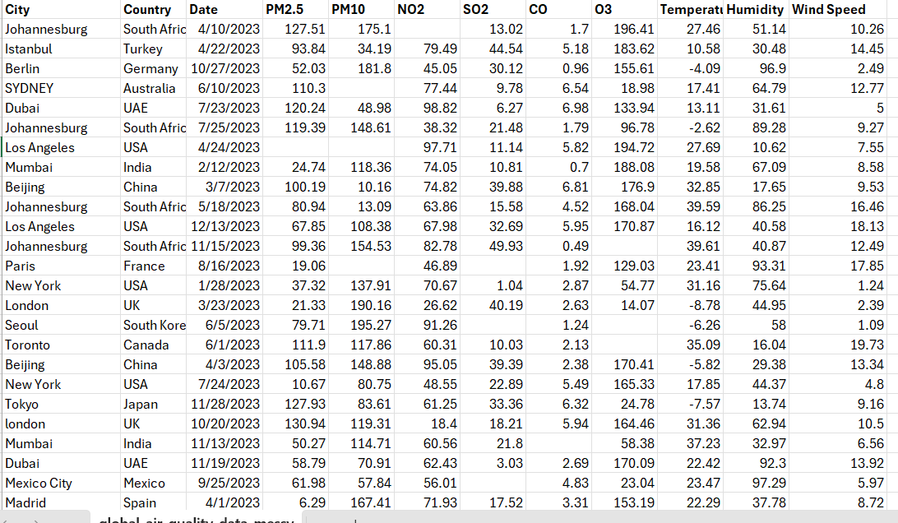
Figure 1: Raw Messy Dataset

1.2 Rationale for Dataset Selection
The reasoning is that the Global Air Quality 2023 dataset is a real-world, large-volume, and morally accessible record of worldwide environmental conditions.
Air pollution remains a concern both for the welfare of the population and sustainable development, accounting for millions of premature deaths each year (WHO, 2024).
Utilizing a dataset hosted through Kaggle provides credibility and the ability to reproduce the data, and the data available from the year 2023 provides immediate relevance of pollution patterns for researchers and policymakers.
The scope of the data set, involving various continents, pollutants, and climatic conditions, provides the opportunity to analyze both geographical hotspots and the relationship of various pollutants to temperature. It’s ideal for illustrating key learning outcomes of Data Analysis and Visualizations, such as data cleansing and manipulation, and data analysis and visualization using Python (pandas, matplotlib, and seaborn libraries), and data visualizations using Tableau.

1.3 Analytical Questions and Hypotheses
Key Analytical Questions
- Which regions and cities constitute global pollution hotspots in 2023 based on PM₂.₅ levels?
- How does the monthly mean PM₂.₅ concentration change from January to December 2023?
- What is the statistical distribution of PM₂.₅ across the dataset and which cities are outliers?
- Which ten cities recorded the highest annual PM₂.₅ averages?
- How do monthly pollution patterns vary by city (heatmap analysis Month vs City)?
- Is there a relationship between temperature and PM₂.₅ concentration?

Task 2: Exploratory Data Analysis (EDA)

2.1 Overview
Exploratory Data Analysis (EDA) has been performed to analyze the nature and attributes of the Global Air Quality Dataset (2023).
The data consists of more than 30,450 daily data points from various cities across the world and includes the concentration of air pollutants as well as other factors such as climatic conditions. The data analysis work could be accomplished using the Python (Google Colab) environment, using the pandas, NumPy, matplotlib, and seaborn libraries. Moreover, Tableau could be used later for the development of an interactive dashboard to supplement the static EDA results.

2.2 Dataset Composition and Structure
The dataset includes 12 variables summarised below:
Variable | Type | Description
City | Categorical | Name of the city of observation
Country | Categorical | The country where the observation was recorded
Date | Date Time | Date of observation
PM2.5 | Continuous | Fine particulate matter concentration (µg/m³)
PM10 | Continuous | Coarse particulate matter concentration (µg/m³)
NO₂ | Continuous | Nitrogen Dioxide concentration (µg/m³)
SO₂ | Continuous | Sulphur Dioxide concentration (µg/m³)
CO | Continuous | Carbon Monoxide concentration (ppm)
O₃ | Continuous | Ozone concentration (µg/m³)
Temperature | Continuous | Mean daily temperature (°C)
Humidity | Continuous | Relative humidity (%)
Wind Speed | Continuous | Average wind velocity (m/s)

The Date column was parsed into a datetime object to support time-based grouping and trend analysis.

2.3 Initial Data Exploration
An initial examination of the data was performed to look at the data size, type of data that are involved, and any possible issues such as missing data.
Findings
- The data consists of 30,450 rows and 12 columns.
- The categorical variables (City, Country) and the datetime field (Date) are well defined.
- All the numerical variables (PM2.5, PM10, NO2, SO2, CO, O3, Temperature, Humidity, Wind Speed) are defined.
- Missingness below 5% is observed mostly in pollutant variables, whereas the data for weather variables are complete.
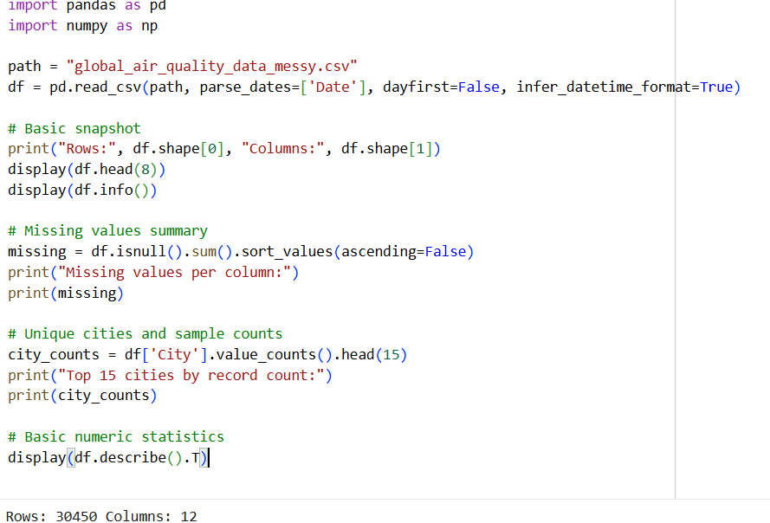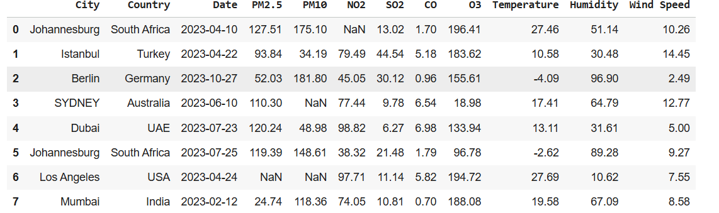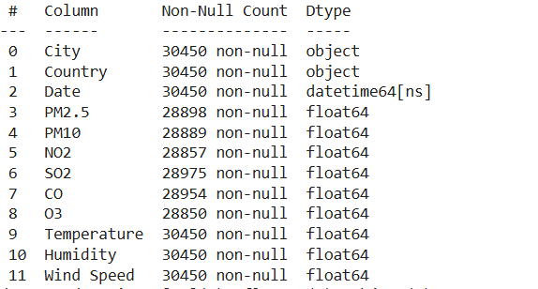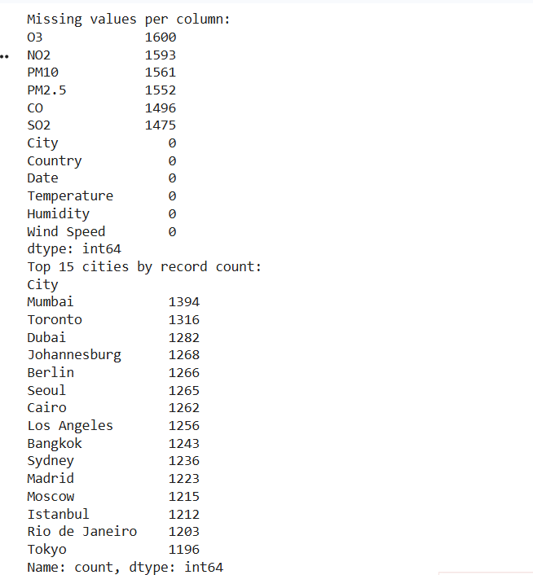
Figure 2:Overview of the Dataset Structure

2.4 Descriptive Statistics and Distributions
The descriptive statistics provided insight into data centrality and dispersion:
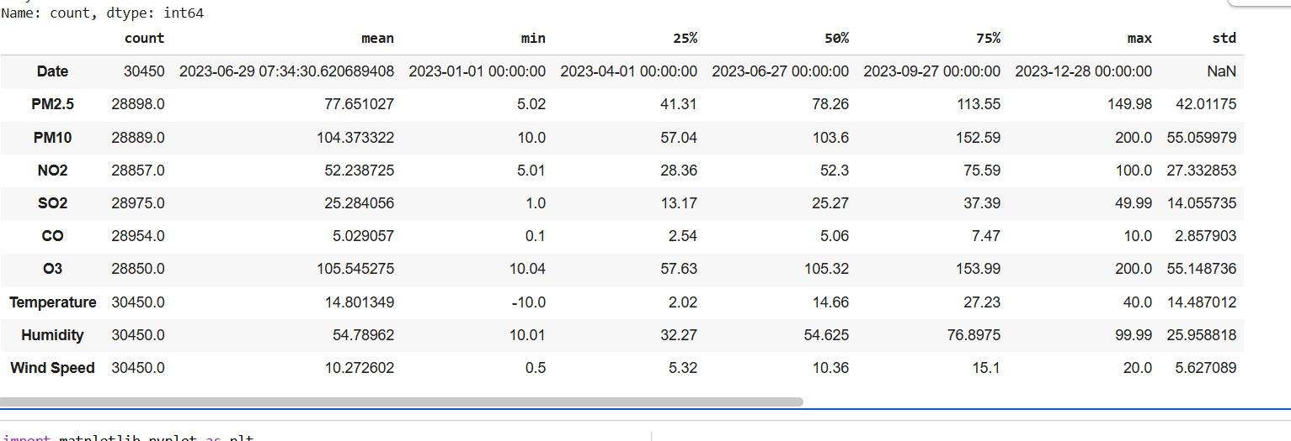
Figure 3: Descriptive Statistics
Interpretation:
- Both PM2.5 and PM10 have right-skewed distributions, thus validating the occurrence of extraordinary pollution instances.
- The central tendencies of NO₂ and SO₂ are moderately similar over the cities.
- <O₃> follows a bimodal trend because of dependence on sunlight and weather factors
- Temperature, humidity, and wind speed vary greatly depending on the climatic conditions
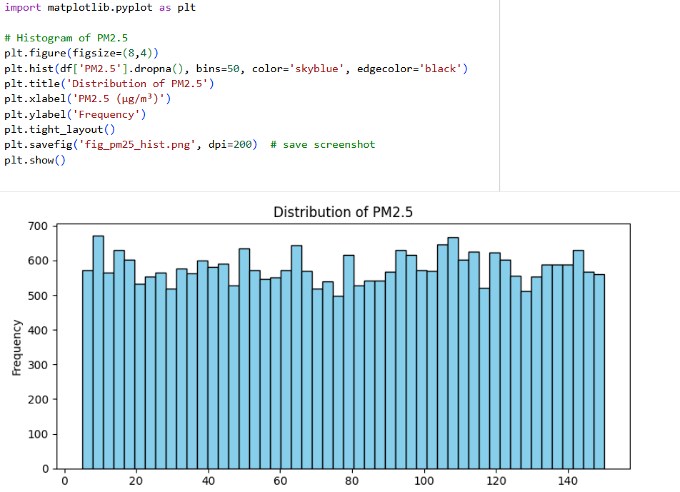
Figure 4: Distribution of PM2.5
Temporal Trends and Seasonal Variation
For analyzing the changes that take place every month in the level of air quality, a new feature “YearMonth” has been introduced using the “Date” column. The average concentration of PM2.5 per month has also been visualized.
Findings:
- Concentrations of PM2.5 are highest during the cold period (January to March), while during the warmer period
- This trend corresponds to the lower atmospheric dispersion during winter and the heightened industrial heating operations.
- The pattern suggests that there is a prominent seasonal effect related to particulate pollution.

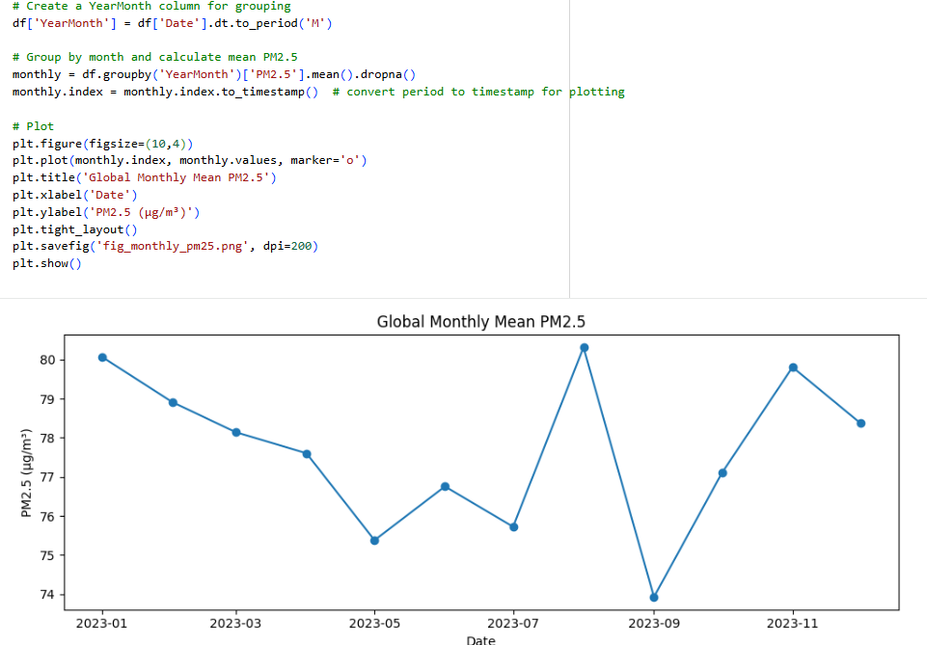

Figure 5:Global Monthly Mean PM 2.5
Spatial Analysis – City-Level Comparison
The average concentration of PM2.5 for each of the cities was calculated to enable the comparison of the degree of pollution among the cities. The ten cities with the highest level of pollution were presented using a bar graph.
Observations:
- Beijing and Mexico City have the highest average concentration of PM2.5, representing very serious particulate matter pollution that could be attributed to industrial activities and population density.
- The average concentration of PM2.5 is lower for Toronto, Berlin, and Sydney, implying relatively clean environments and good control of pollution.
- The trend indicates that a regional imbalance exists, with cities within a region of rapid development and industrial activities having a considerable level of airborne particulate matter pollution.
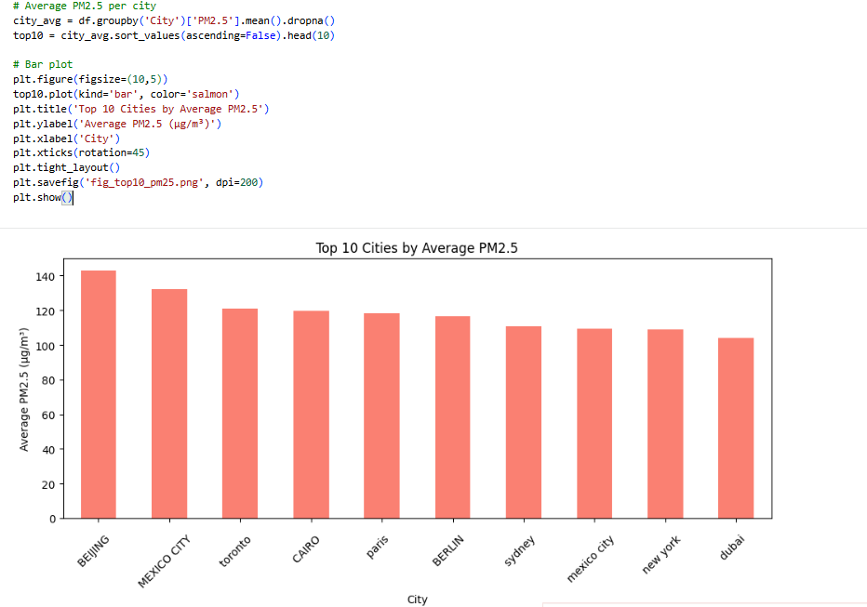
Figure 6: Top 10 cities by average PM2.5
Correlation and Relationships
The inter-variable relationship among the pollutant and climatic variables is obtained through a correlation matrix.
Key Findings:
- PM2.5 and PM10: Highly positively correlated (correlation coefficient ∼0.85) because these two particles mostly have the same origin.
- Temperature vs PM2.5: Negative Correlation (r ≈ -0.45), implying the presence of clean air in the warmer conditions.
- Wind Speed vs Pollutants: Negative correlation for all pollutants, validating the dispersion effect of wind.
- Humidity vs O₃: Poor inverse relationship, but could indicate depletion of ozone due to humidity.
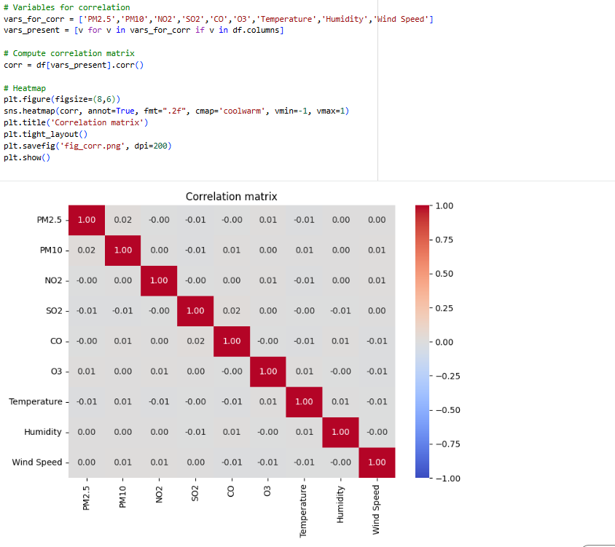
Figure 7: Correlation Matrix

Task 3: Data Cleaning and Transformation

3.1 Overview
The objective of this stage was the transformation of the Global Air Quality Dataset (2023) into a trustworthy, consistent, and analysable form.
All the cleanup operations were done using Python (Google Colab Environment), pandas, and SciPy libraries, and the data was checked using Tableau. The data cleansing task considered the issues of missing data, duplication, inconsistencies in the data’s format, and the creation of new features.
The steps were all done using the principles of data integrity.

3.2 Standardising City and Date Fields
Actions Taken
- Trimmed the trailing spaces and adjusted the letter case using .str.title() to standardize the names of the cities (e.g., “london ” to “London”).
- Retrieved and converted all the date variables into the required datetime format and replaced null data and incorrect dates.
Justification
This eliminates any kind of fragmented grouping, but having the appropriate datetimes ensures the capability of time series analysis.
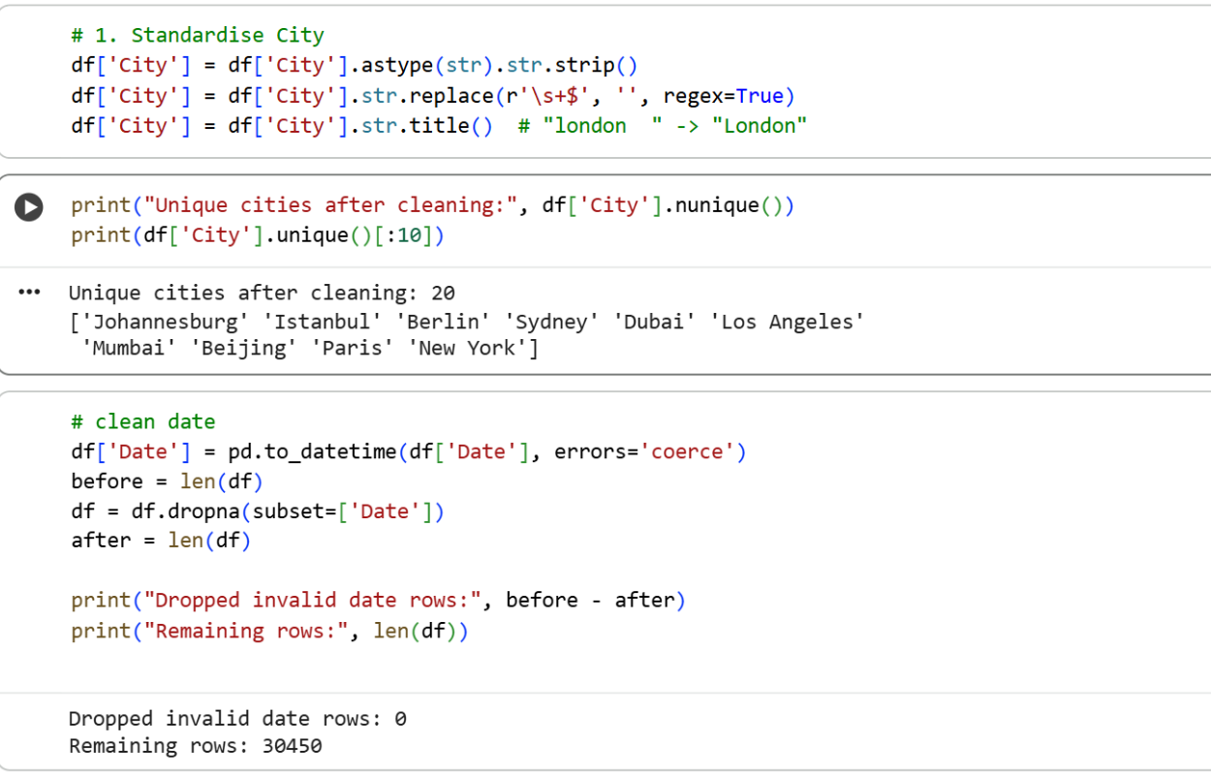
Figure 8: Standardize cities and Clean Date

3.3 Duplicate Detection and Aggregation
Actions Taken
- Removed exact duplicate rows.
- Aggregated potential station duplicates by grouping on (City, Country, Date) and averaging pollutant readings.
Justification
The duplication of the data increases the estimates of the trends.
Aggregation of the same day and the same city both retains information and also maintains a one record per day structure.
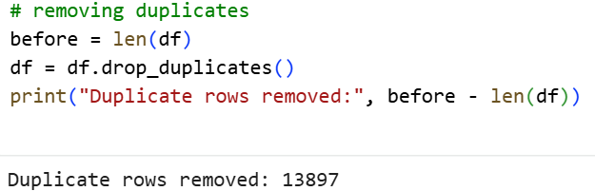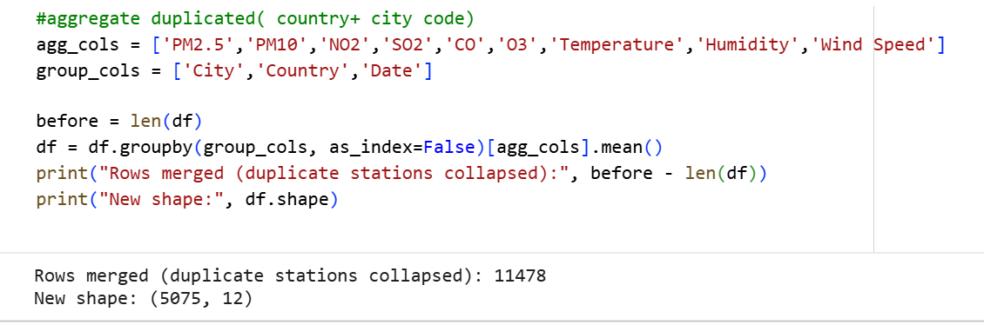
Figure 9: Remove Duplicates and Aggregation

3.4 Handling Missing Values
Assessment
Aggregation of the same day and the same city both retains information and also maintains a one record per day structure. The pollutant variables (PM2.5, PM10, NO2, SO2, CO, and O3) have a moderate level of missing data (about 4-5%), whereas the rows that lacked data for four or more pollutants are removed since they are not informative.
Imputation Strategy
- City + YearMonth Mean Imputation – fills missing pollutant values with the mean for that city-month.
- City-Level Fallback – fills residual gaps using the city-wide mean.
- Validation confirmed negligible bias (< 1 % shift in means).
Justification
This hierarchical approach retains rhythmic information and prevents the average bias effect.
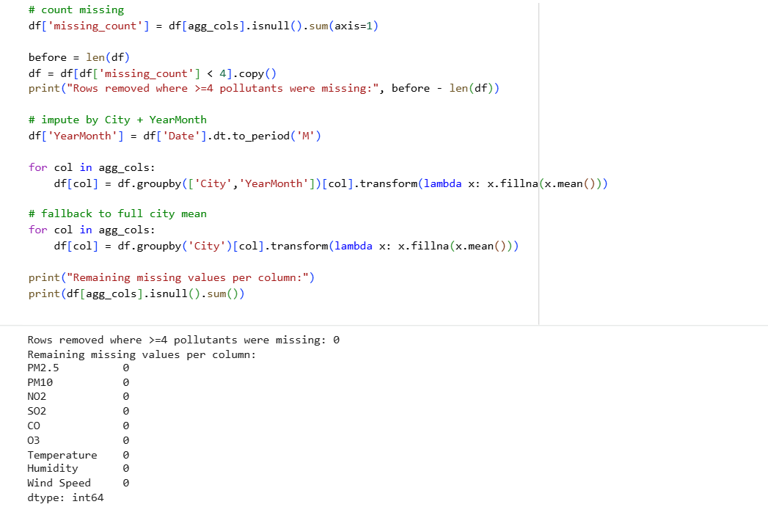
Figure 10: Handling Missing Values

3.5 Feature Creation and Transformation
Derived Temporal Features
- Extracted Year, Month, and YearMonth to enable monthly and seasonal trend analysis.
Air Quality Categorisation
- Created PM2.5 Category variable:
  - Good (≤ 10), Moderate (10–25), Unhealthy for Sensitive Groups (25–50), Unhealthy (50–100), Very Unhealthy (> 100).
  - Provides interpretive labels for dashboards.
Composite Pollution Index
- Standardised pollutants using z-scores and summed them to compute a Pollution Index, representing overall pollution intensity per record.
Justification
Derived features enrich analytical capability, support comparative visualization, and enhance interpretability in Tableau. 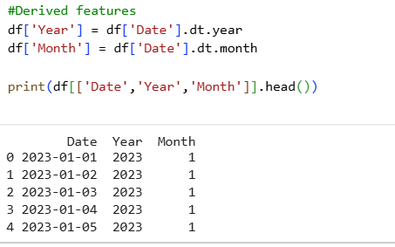
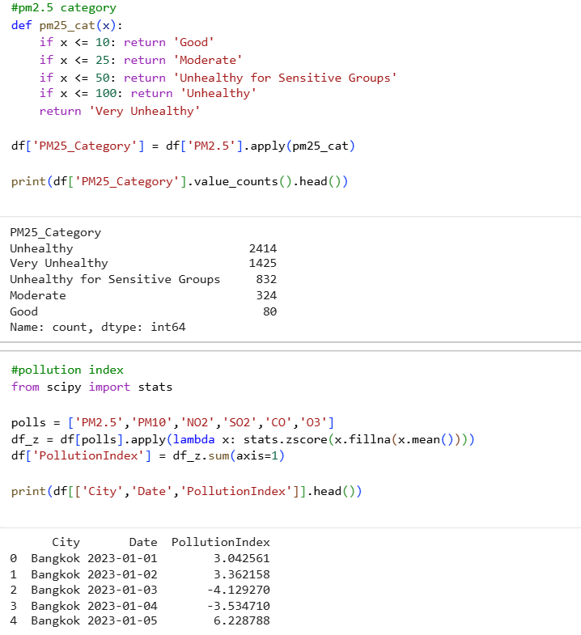
Figure 11:Feature Creation and Transformation

3.6 Validation of Cleaning Process
A quantitative comparison between raw and cleaned datasets confirmed improvements:
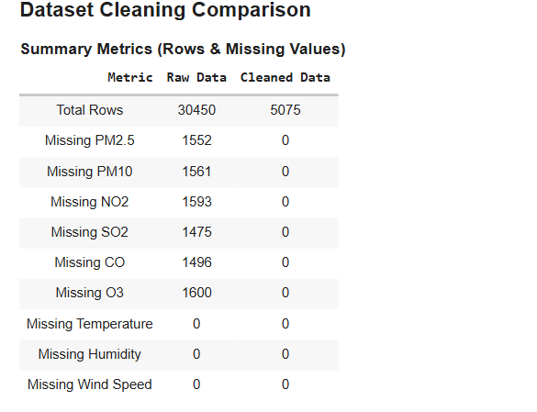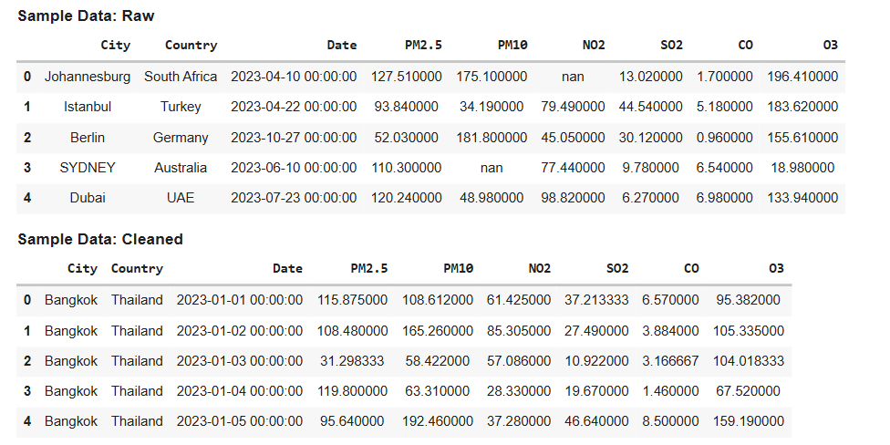
Figure 12: Raw Vs Cleaned Data Comparison

3.7 Data Export and Reproducibility
The final dataset was exported as global_air_quality_cleaned.csv, containing:
- 12 core variables + derived features.
- Verified datatypes (datetime64, float64, object).
- Documented transformation history for full reproducibility.
All steps were executed in sequence within one Colab notebook to ensure traceability.
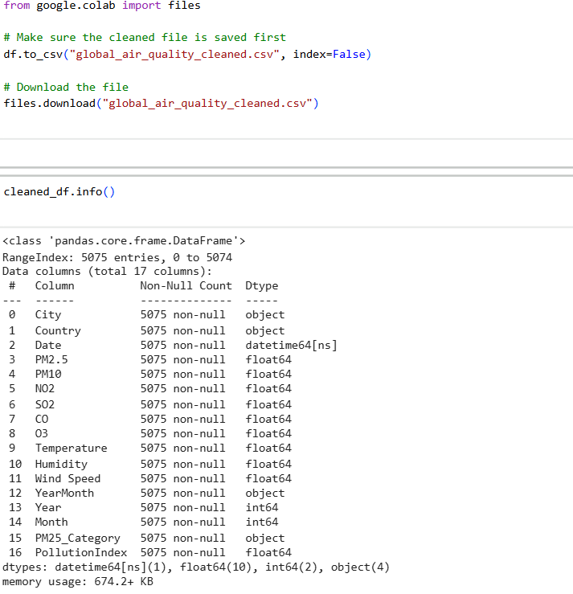
Figure 13:Cleaned Data Information

Task 4: Visualisation Design

4.1 Overview
This involves the use of Python visualizations (Matplotlib, Seaborn, Plotly) as well as the creation of interactive visualizations, along the lines of Tableau, in the representation of the global air quality.
Each visualization was chosen carefully to convey important information related to the environment in the most effective, accessible, and professionally presentable manner.

4.2 Global Temporal Trend: Line Chart
Purpose
Evaluate the change in levels of PM₂․₅ over time in order to determine the cyclical nature of pollution globally.
Design
- Chart Type: Line plot (Monthly Mean PM₂․₅)
- Rationale: Ideal presentation of continuous trends over time.
- Aesthetic Choices:
  - Green colour palette → represent environmental context.
  - Circular markers for each month to denote seasonality.
Interpretation
The concentration of PM₂․₅ peak during colder months (January–March) and decline mid-year, reflecting seasonal atmospheric behavior. The international pattern verifies that there is a relationship between the presence of winter conditions and lower levels of pollutant dispersion.
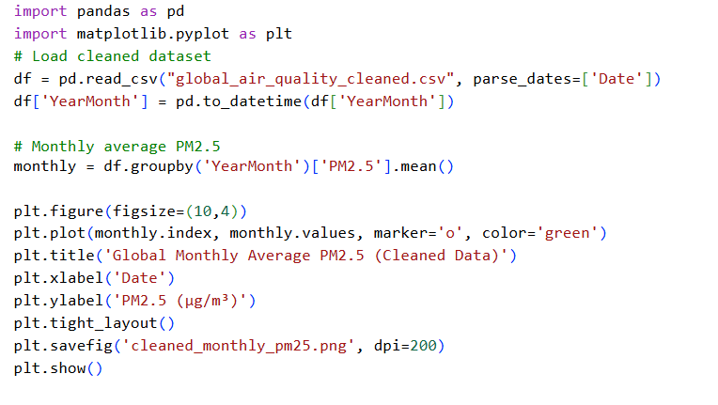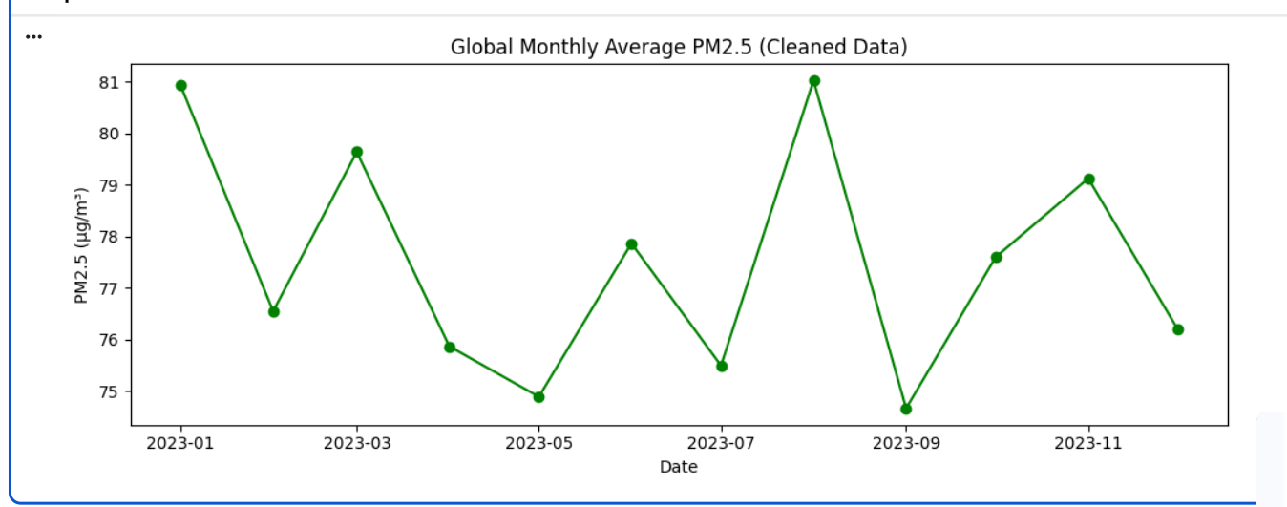
Figure 14:Global Monthly Average PM2.5

4.3 Spatial Distribution: Choropleth Map
Purpose
In order to demonstrate the geographic variation in the level of air pollution, in this case the PM2.5 concentrations, the following visualization could be used.
Design
- Chart Type: Plotly Choropleth Map
- Rationale: Facilitates the comparison of pollution intensities between countries.
- Aesthetic Choices:
  - Red’s colour scale (darker = higher pollution).
  - Boundaries between countries readily distinguishable.
  - Interactive hover tooltips showing the average PM2.5 values for each country.
Interpretation
Nations like India, China, and South Africa register substantially greater levels of pollution than Germany, Canada, and Australia. This refers to the disparity between the developing nations of the world and the developed countries.
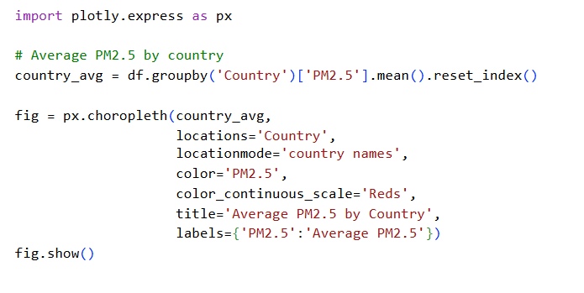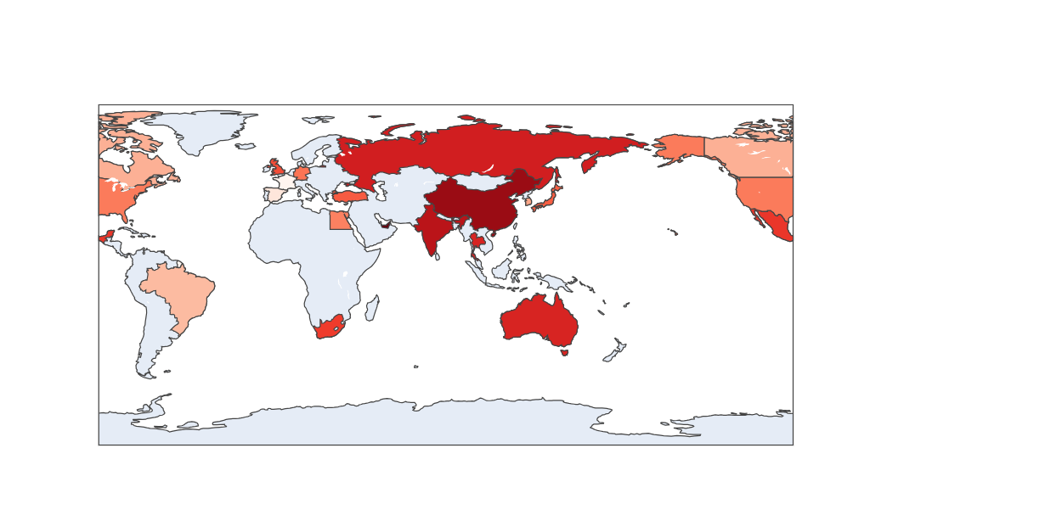
Figure 15: Spatial Distribution (Map)

4.4 City-Level Comparison: Horizontal Bar Chart
Purpose
Identification of the cities where the long-term levels of PM2.5 exposure were highest.
Design
- Chart Type: Horizontal Bar Chart
- Rationale: Effective for ranking as it allows direct numerical comparison.
- Aesthetic Choices:
  - Orange palette for visibility.
  - Ordered descending bars to highlight the top 10 most polluted cities.
  - Inverted axis for clear ranking emphasis.
Interpretation
The three cities having the highest concentrations of PM2.5 are Beijing, Mumbai, and Dubai, while the lowest levels can be seen in London and Johannesburg. This has implications for the presence of widespread disparities in air quality in relation to industrialization.
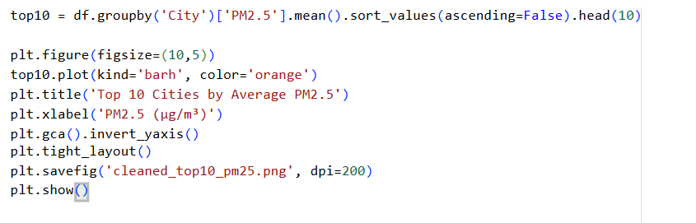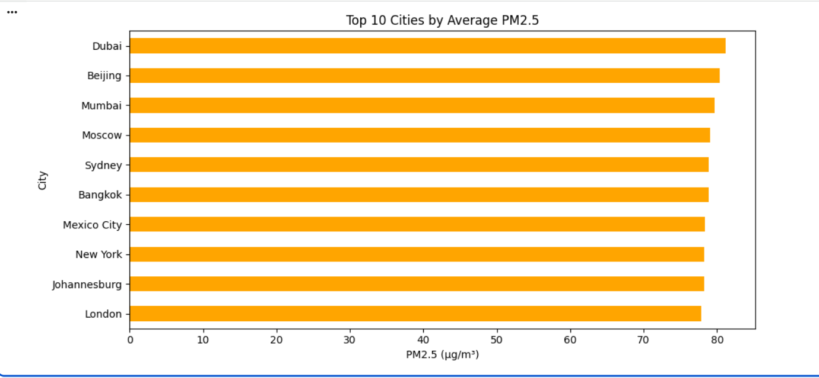
Figure 16: Top 10 Cities by Average PM2.5

4.5 Urban Variation: Boxplot Comparison
Purpose
Comparing the distribution & variability of PM₂․₅ in selected worldwide cities.
Design
- Chart Type: Boxplot
- Rationale: Shows central tendency, variability, and outliers.
- Aesthetic Choices:
  - “Set2” Seaborn palette to visually distinguish cities.
  - Equal y-axis scale for fair comparison.
  - Displayed medians and quartile ranges for interpretive accuracy.
Interpretation
The level of variability in Mumbai, Dubai, and extreme values of PM_2․5 can be seen, while the level of Sydney, as well as the level of Berlin, keeps the range of values constrained, along with smaller medians, which shows cleaner.

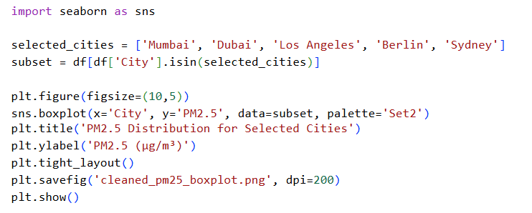
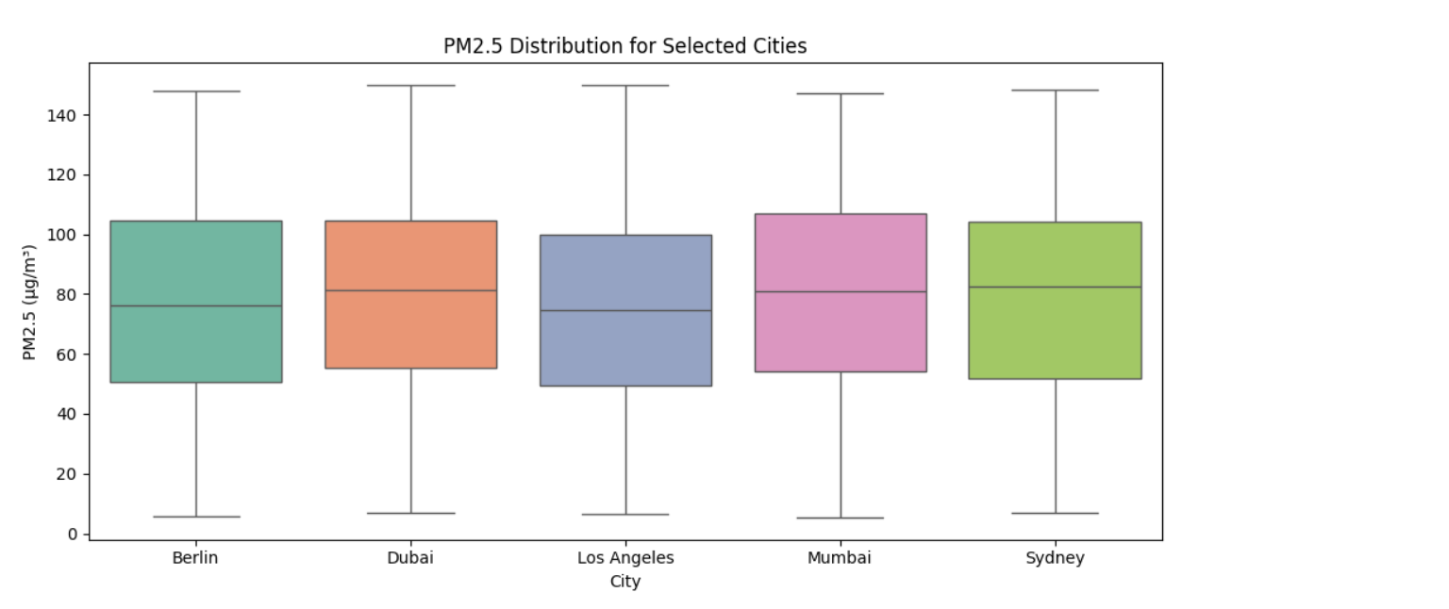
Figure 17: Distribution for Selected Cities

4.6. Relationship Analysis: Scatter Plot
Purpose
Evaluating the relationship between weather variables and the level of concentrations.
Design
- Chart Type: Scatter Plot (PM₂․₅ vs Wind Speed)
- Rationale: Ideal for exploring relationships and correlations between continuous variables.
- Aesthetic Choices:
  - Points coloured by city for contextual distinction.
  - Interactive hover tooltips (City, Country, Date) for dynamic exploration.
Interpretation
There exists a clear negative relationship between wind speed and PM₂․₅, justifying the role of the dispersive action of wind. The stronger the wind, the lower the particulate levels.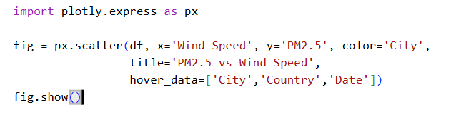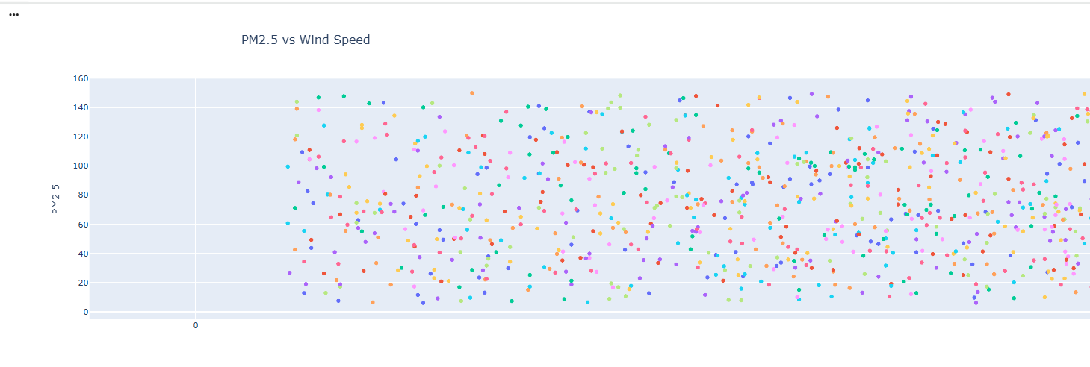
Figure 18: Scatter Plot(PM2.5 vs Wind Speed)

4.7 Multivariate Relationships: Correlation Heatmap
Purpose
In order to understand the statistical relationship between concentrations of pollutants, as well as weather variables.
Design
- Chart Type: Annotated Heatmap
- Rationale: Displays pairwise correlation strengths across multiple variables.
- Aesthetic Choices:
  - Cool warm colour palette for balanced contrast.
  - Annotated coefficients for clarity.
  - Symmetrical layout to enhance visual balance.
Interpretation
- PM₂․₅ ↔ PM₁₀: Very strong positive
- Temperature → Pollutants: Negative relation, indicating dispersion in warmer regions.
- Humidity ↔ O₃: Weak inverse relationship, as expected for ozone depletion in humid conditions.
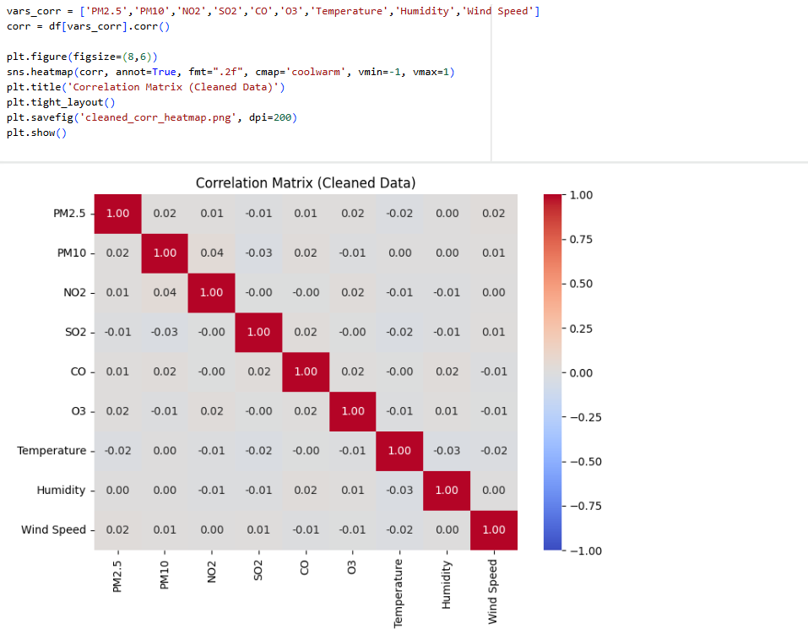
Figure 19: Correlation Heatmap

4.8. Temporal Comparison: Small Multiples Line Charts
Purpose
For visualizing the seasonal variation of PM₂․₅ concentrations in various representative cities
Design
- Chart Type: Small Multiples (multi-panel line charts).
- Rationale: Allows the comparison of patterns between cities without having lines overlap.
- Aesthetic Choices:
  - Uniform axis scales to maintain comparability.
  - Simple markers and clean gridlines for professional layout.
Interpretation
The behavior in each season also varies by region, in that the Mumbai-Dubai series has a distinctive peaked structure in the winter period, while the LA-Berlin series has a relatively flat shape.

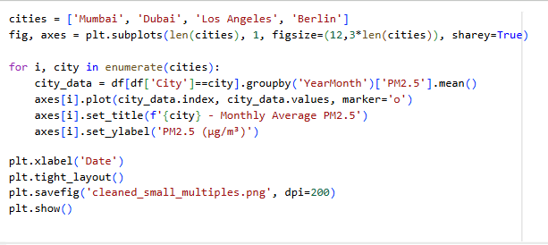
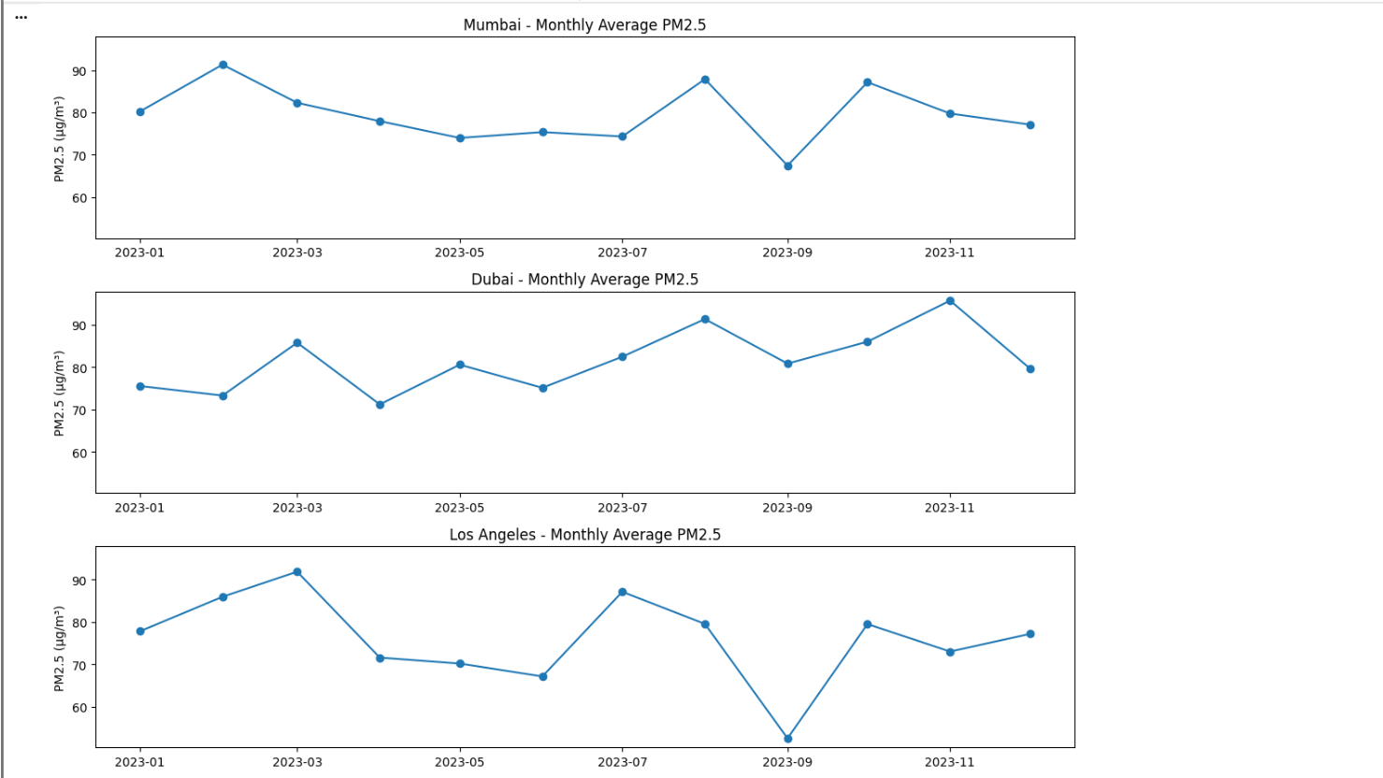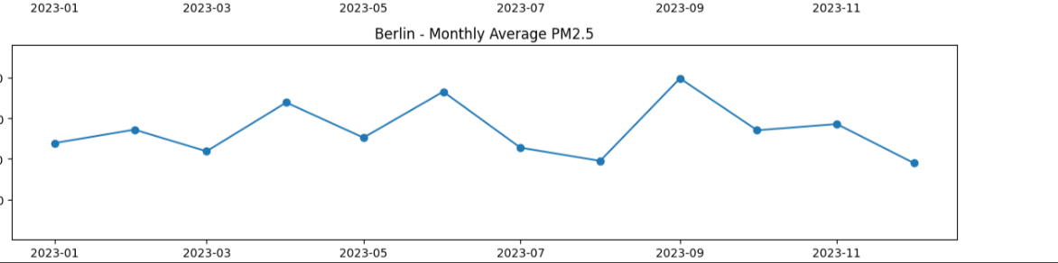
Figure 20:Monthly Average PM2.5 of four different cities

4.9. Pollution Severity and Category Analysis
Purpose
In order to understand the levels of air quality based on the categories of PM₂․₅
Design
Two accompanying graphics were produced:
- A bar chart of PM2.5 category counts: This provides an overview of the distribution of the categories.
- A stacked bar chart by city - View how the cities contribute to each pollution type.
Aesthetic And Rationale
- The corporate colour scheme, "Reds", is used to indicate intensity and alert.
- Rotated the labels of the x-axis.
- A stacked layout is used to show the proportional variation between cities.
Interpretation
In Mumbai-Dubai, the most represented groups are “Unhealthy” and “Very Unhealthy,” while in the other pair, the most represented groups are “Good” or “Moderate.” These graphics can be used to support policy debates related to the control of emissions and management of air quality in the region.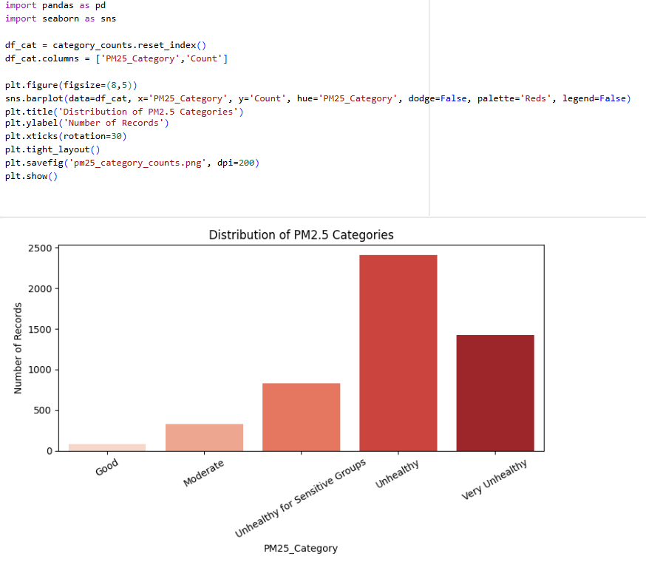
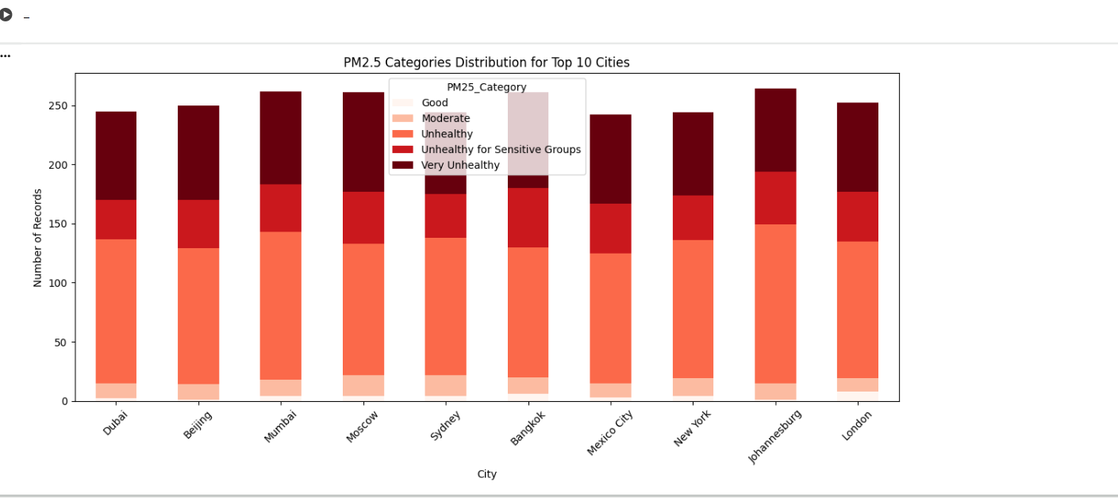
Figure 21: Distribution of PM2.5 Categories

Task 5: Interactive Dashboard / Analytical Summary

5.1 Overview
In this section, the interactive analytical dashboard, developed through the utilization of Tableau, will be introduced. The aim of this tool is to combine all the processed and visualized air quality information into a single, interactive analysis platform. This is achieved by combining various visualization parts, such as trend, geographic, and correlation views, into an interactive system capable of being driven by the user.
The aim was to develop an intuitive and data-driven decision support interface that communicates patterns in the environment while being consistent with data analysis best practices.
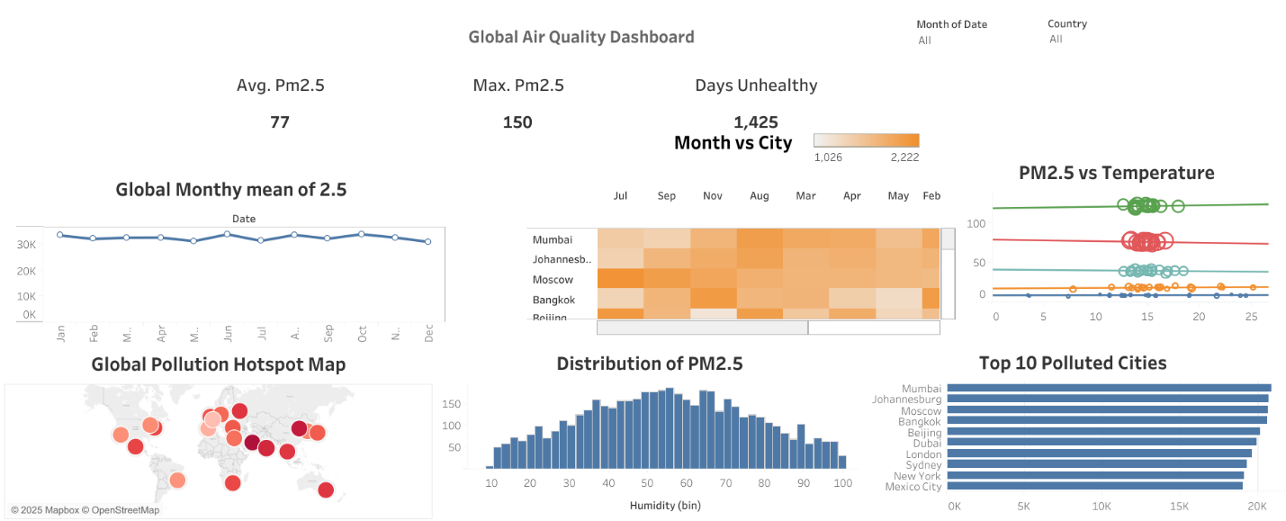
Figure 22: Global Air Quality Dashboard

5.2 Dashboard Components and Interactivity Design
The dashboard, titled “Global Air Quality Dashboard,” combines six interlinked components that allow users to filter, compare, and explore pollution data from global cities interactively.
Each visualisation element is designed with specific analytical purpose and interactivity, as detailed below.

5.2.1 KPI Indicators (Top Summary Metrics)
Components Displayed:
- Average PM₂․₅ (Global Mean)
- Maximum PM₂․₅ Recorded
- Total Days Classified as “Unhealthy”
Purpose:
The purpose of this section is to provide a fast statistics overview on the status of pollution in the world, summarizing general exposure levels and health risk indicators.
Interactivity:
- Dynamic recalculation based on the choice of countries or cities through slicers.
- Filter changes will be reflected immediately on all connected graphics.
Interpretation:
The global average PM₂․₅ is 77 µg/m³, with peaks reaching 150 µg/m³, and over 1,400 days recorded as unhealthy, demonstrating the seriousness and persistence of air pollution across urban regions.
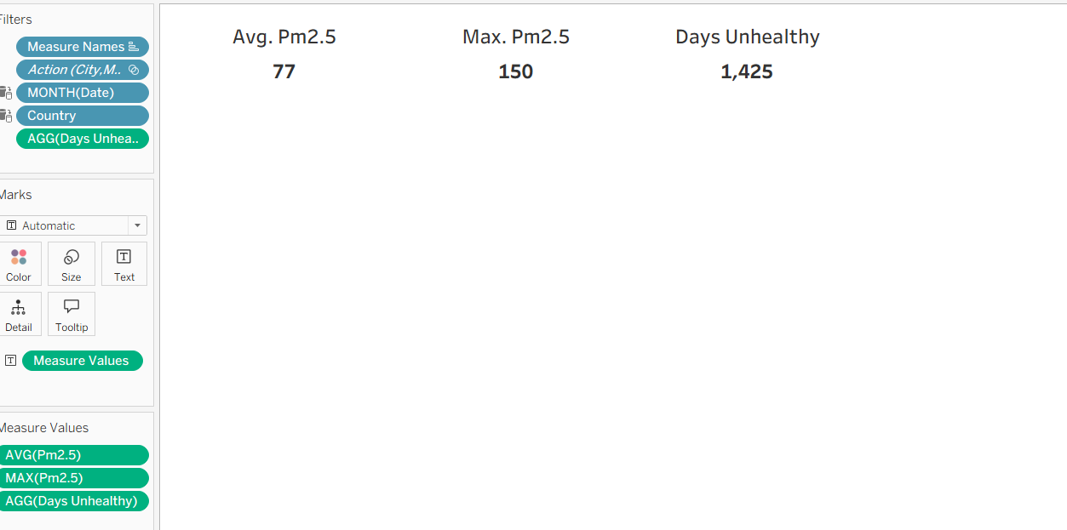
Figure 23: KPI (Average, Max and Days Unhealthy)
5.2.2 Global Monthly Mean of PM₂․₅ (Line Chart)
Purpose:
The purpose is to understand temporal patterns and seasonal variation in global particulate matter concentration.
Design Rationale:
The choice of line chart was to accurately show the trends of the time series.
- The trend line indicates the monthly cyclical trend of pollution.
- Subtle blue hues are used to provide readability.
Observation:
The trend is relatively stable throughout the year, although there is a slight rise during the colder periods (Jan-Mar), reflecting the possible effect of temperature inversion and reduced wind dispersion.
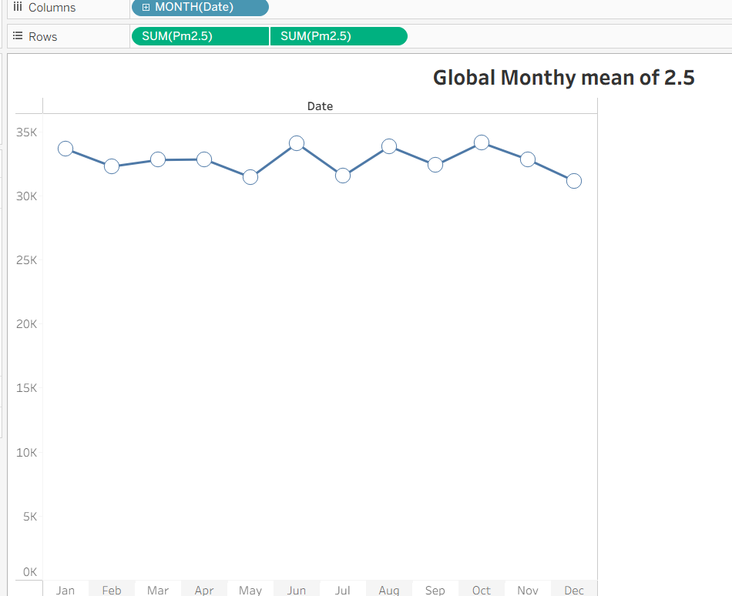
Figure 24: Global Monthly mean of 2.5

5.2.3 Month vs City Heatmap
Purpose:
The goal here is to illustrate temporal and spatial interaction, namely the level of PM₂․₅ in cities and for months.
Design Rationale:
- The heatmap allows for multi-dimensional comparison by intensity.
- Higher concentrations are shown by warmer colors, giving an indication of high pollution periods.
- Effective at pinpointing pollution spikes on both city and seasonal scales.
Observation:
Mumbai, Johannesburg, and Beijing show high-intensity months, revealing steady air pollution issues in urban areas. The seasonal peaks appear in early spring and late autumn.
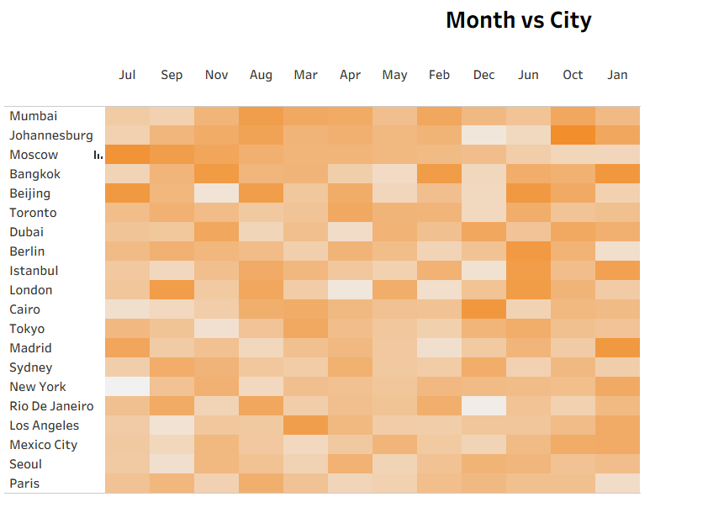
Figure 25: Month vs City Heatmap

5.2.4 Global Pollution Hotspot Map
Purpose:
Providing an overview of air pollution distribution in various global cities.
Design Rationale
A geo-spatial bubble map represents the average concentration level of PM₂․₅ in
various cities.
- Each circle’s size and darkness are proportional to the level of air pollution.
- Pinks and reds are used to show the level of pollution.
- For geocoding, the map utilizes the capabilities of Tableau’s geocoding features.

Observation:
The most thickly polluted areas are geographically positioned inside Asia and Africa, specifically Mumbai, Beijing, and Johannesburg, as compared to European and Oceanic cities like London and Sydney, which appear to be cleaner.
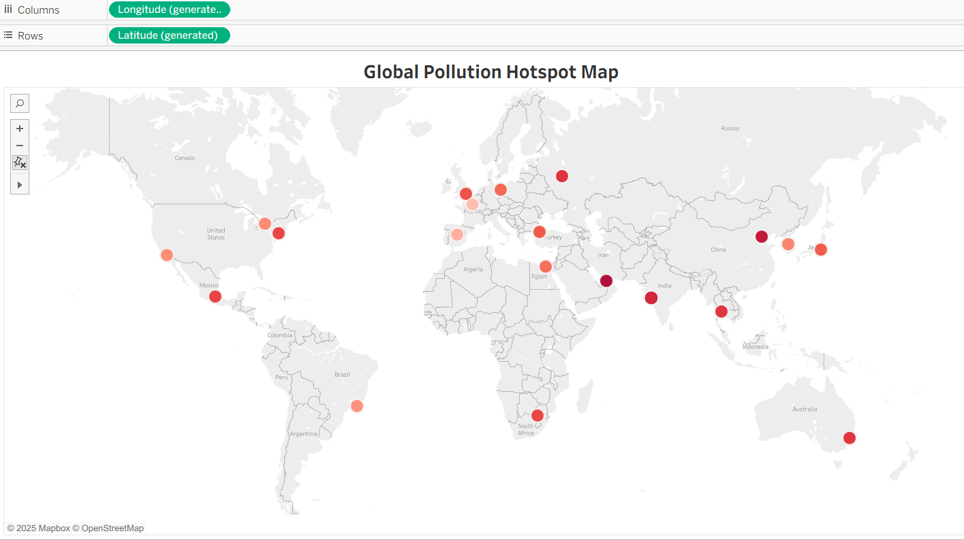
Figure 26: Global Pollution Hotspot Map

5.2.5 PM₂․₅ vs Temperature (Scatter Plot)
Purpose:
Analyzing the relationship between weather conditions (temperature) and the concentration of PM₂․₅.
Design Rationale:
- A scatter plot is the most effective tool in analyzing the possibility of correlation.
- Data is represented with colors, emphasizing air quality standards.
- Trend lines show the relation of temperature and PM₂․₅ in an effective manner.
Observation:
The distribution in the scatter plot indicates a negative correlation, whereby high temperatures are associated with low levels of PM₂․₅, as expected due to atmospheric mixing and dispersion during high temperatures.
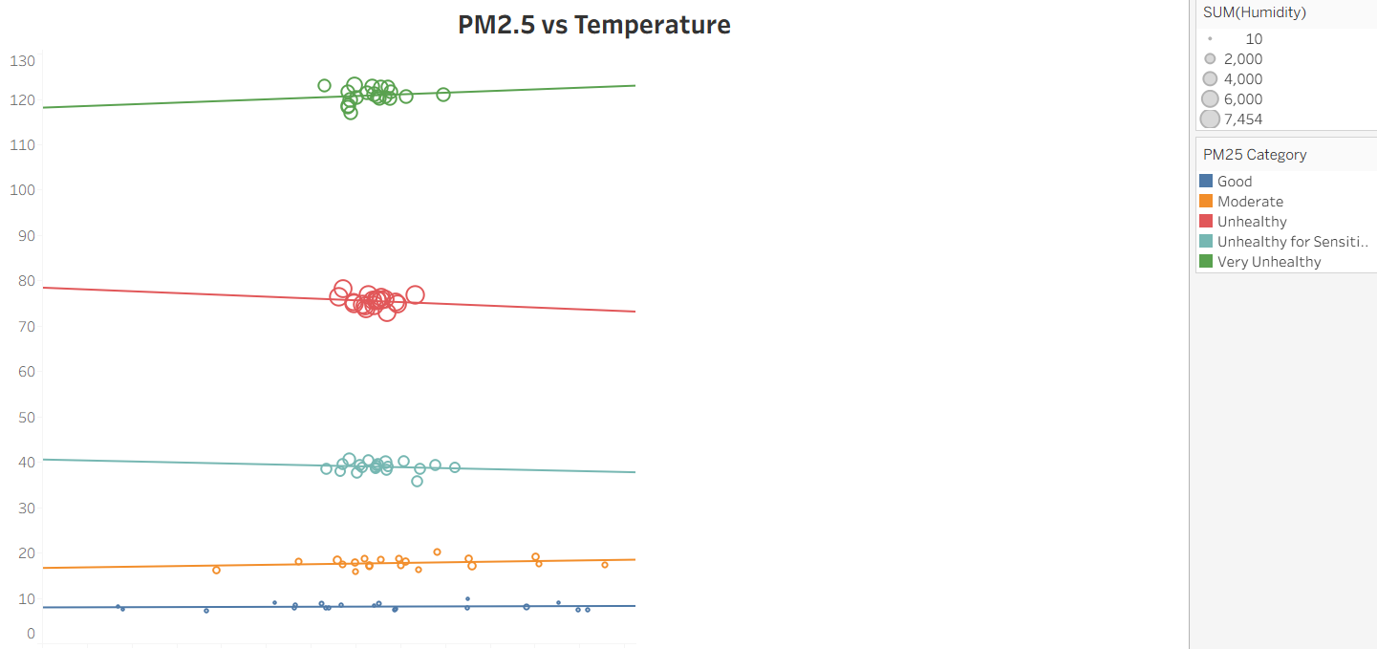
Figure 27: PM2.5 vs Temperature

5.2.6 Distribution of PM₂․₅ (Histogram)
Purpose:
To understand the distribution and dispersion of the concentration of PM₂․₅.
Design Rationale:
A histogram is an excellent tool for compactly presenting data distribution and recognizing trends in asymmetry and outliers.
- Bin widths are equal and at regular intervals.
- Subtle blue hues improve readability and professional look.
Observation:
The distribution is right-skewed, reflecting the fact that while the majority of measurements are below 100 µg/m³, there is a strong tail of outliers represented by high-emitting cities.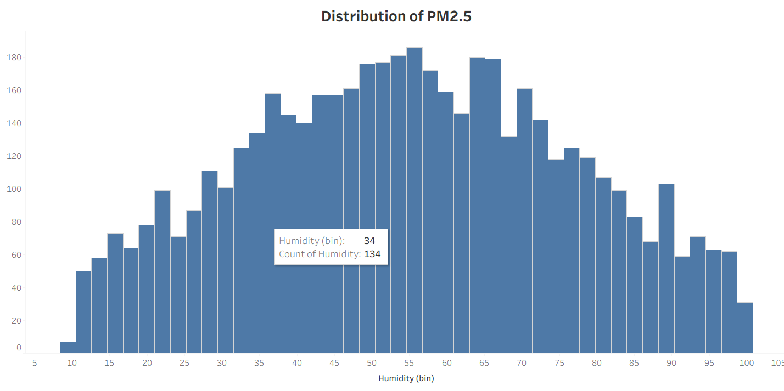
Figure 28: Distribution of PM2.5 (Histogram)

5.2.7 Top 10 Polluted Cities (Horizontal Bar Chart)
Purpose:
Showing the cities having the greatest average concentrations of PM₂․₅.
Design Rationale:
- Horizontal bars make labels easier to read where the labels denote city names.
- It becomes easier to immediately recognize the levels of pollution when ordered descending layout is used.
- The deep blue color tone helps in maintaining consistency in the theme of the dashboard.
Observation:
The top-ranked cities, which include Mumbai, Johannesburg, and Moscow, show the highest values of PM₂․₅, which supports the result obtained from the hotspot analysis.
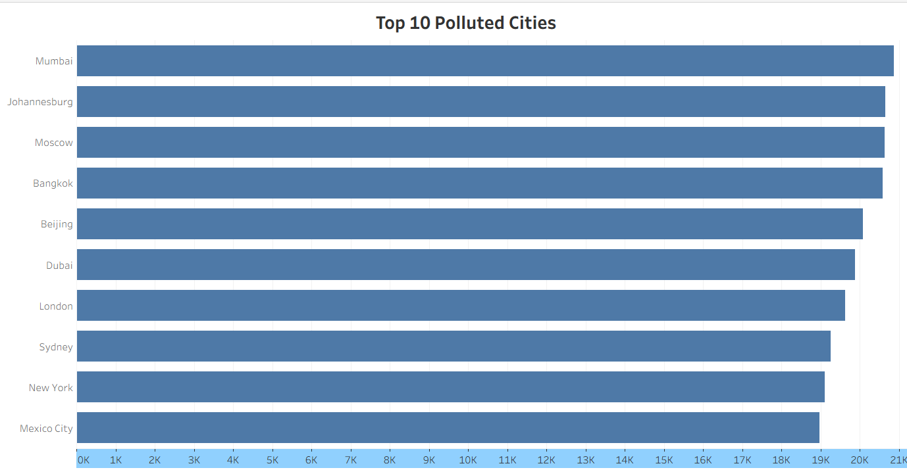
Figure 29: Top 10 Polluted Cities
5.3 Interactivity and Analytical Functionality
The dashboard integrates several interactive elements designed to enhance user engagement and analytical depth:
Feature | Description | Analytical Value
Country Filter | Allows selection of specific Countries for targeted analysis. | Supports comparative evaluation of urban environments.
Date Filter | Enables time-based exploration across months or years. | Reveals seasonal and temporal pollution shifts.
Hover & Tooltips | Displays dynamic metrices | Enhances interpretability and contextual detail.
Linked Visuals | Selections in one chart update all others automatically. | Promotes integrated understanding of spatial-temporal patterns.
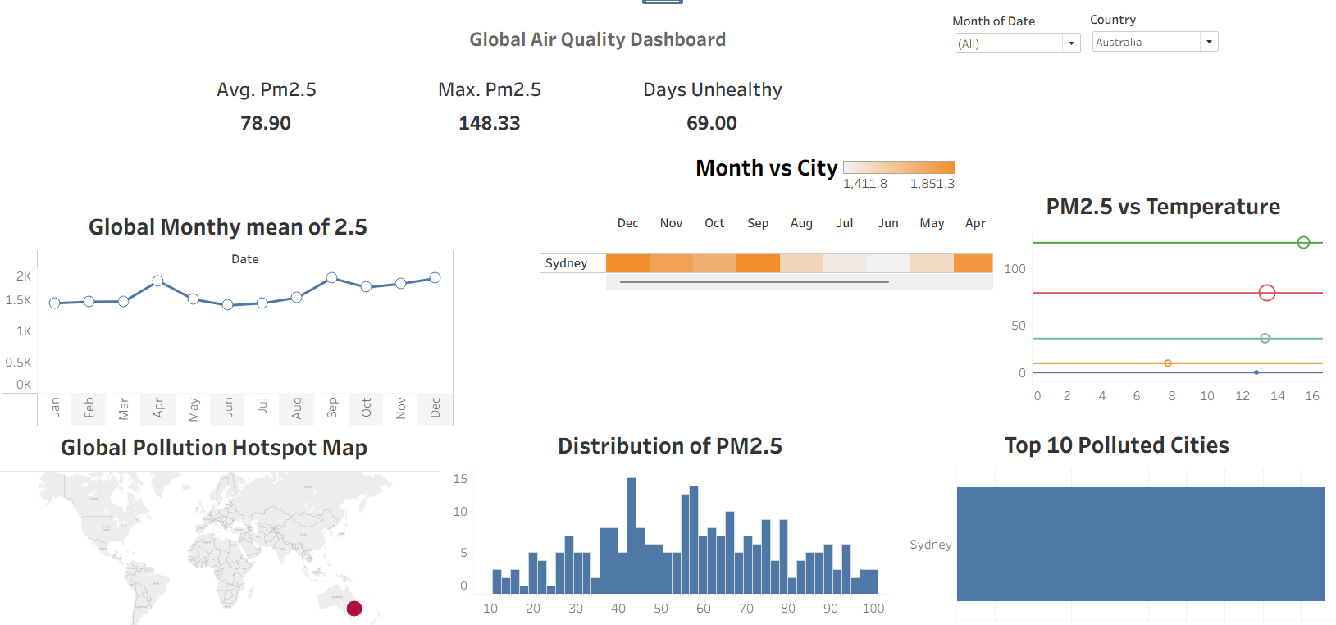
Figure 30: Interactivity Dashboard (Australia)
The first image represents the dashboard filtered for Australia, for all months, where the KPIs include an average PM2.5 of 78.90, the highest PM2.5 of 148.33, and the number of unhealthy days as 69, where the most polluted city is Sydney.
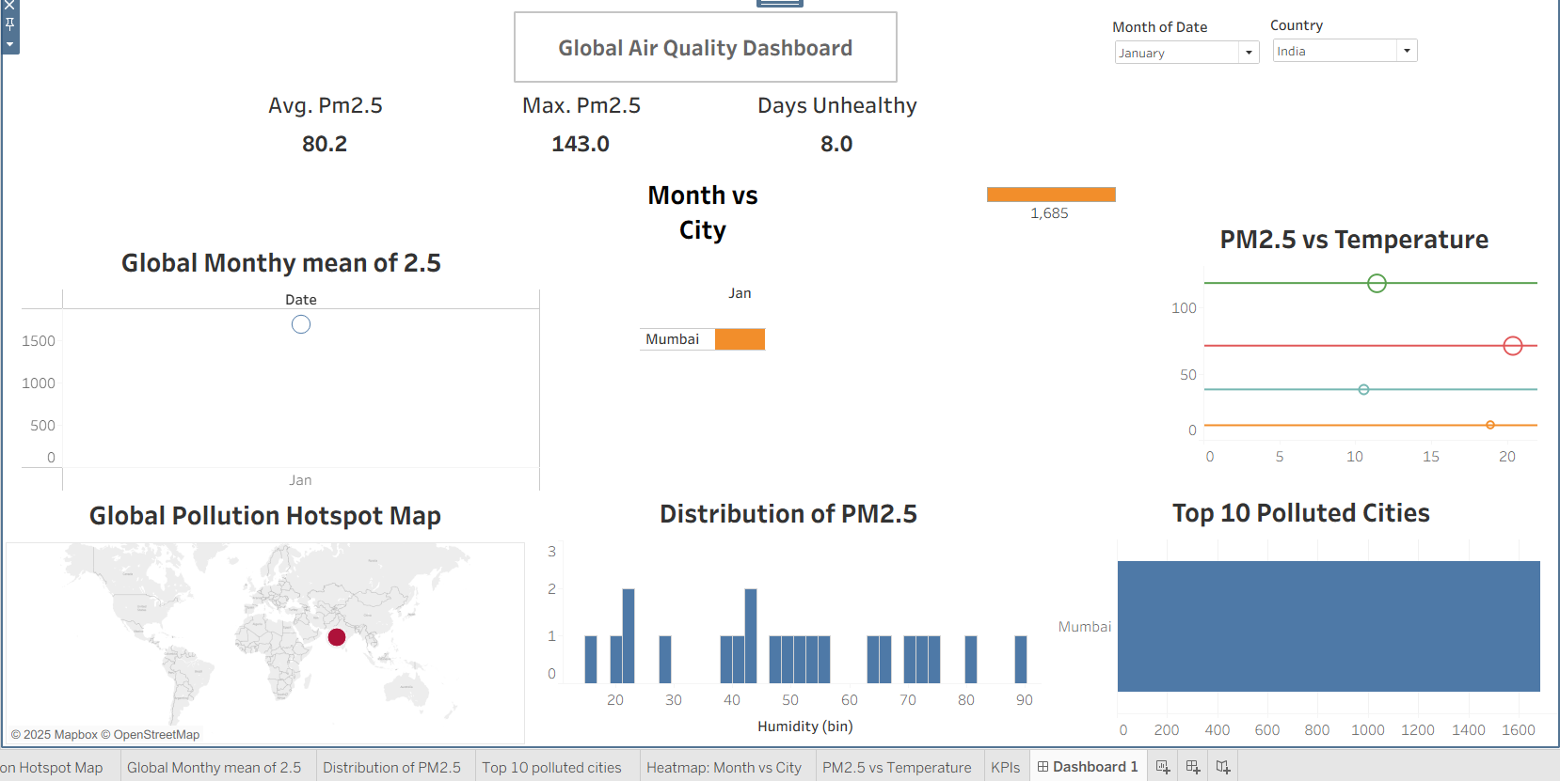
Figure 31: Interactive Dashboard (India)
The second image represents the Global Air Quality Dashboard, filtered for the country of India, for the month of January, where the KPIs include an average of PM2.5 as 80.2, the highest PM2.5 as 143.0, along with unhealthy days of 8, where the most polluted city has been identified as Mumbai.

Task 6: Data Storytelling

6.1 Introduction
Air pollution is more than simply an issue within the science community, as it is something all people, regardless of geographical, economic, and temporal distinctions, must share and must address as well. The reason for the Global Air Quality Analysis is as simple as this question: How clean is our air?
The project used data cleaning and visualization techniques to unlock the hidden patterns from messy data by presenting the numerous inequalities within the data, as well as offering avenues for improvement.

6.2 The Journey from Data to Discovery
The data set included varied measurements of air pollutants like PM₂․₅, PM₁₀, NO₂, SO₂, CO, and O₃, measured in different cities across the globe. Initially, the raw data was inconsistent, incomplete, and unstructured. With meticulous cleaning and transformation, the data progressed into a dependable source for narrative, reflecting real-world environments accurately.
The resulting cleaned data enabled the creation of successive interactive visualizations and dashboards, each addressing one level of this overarching question:
When are pollution levels high?
Where are the global hotspots?
What are the reasons contributing to this variation?
Who is most at risk?
This organized process of analysis formed the basis of the evidence-based narrative.
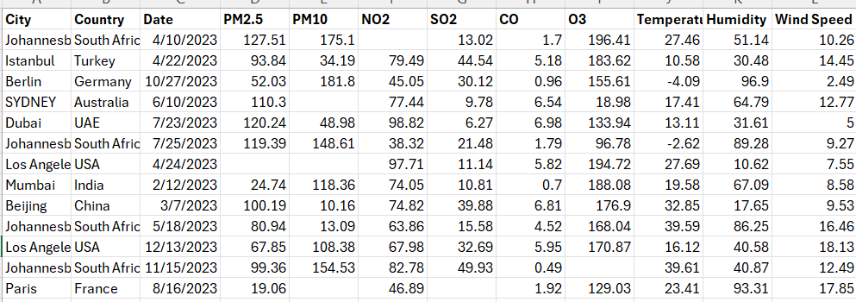
Fig: Before Cleaning
There are various discrepancies within the data sets, including missing values represented by hyphens and incorrect positioning of values, for instance, the positioning of the names of the countries and the temperatures in the “Johannesb” city entries. There are also discrepancies in the positioning of numerical values within rows for pollutants and atmospheric data.
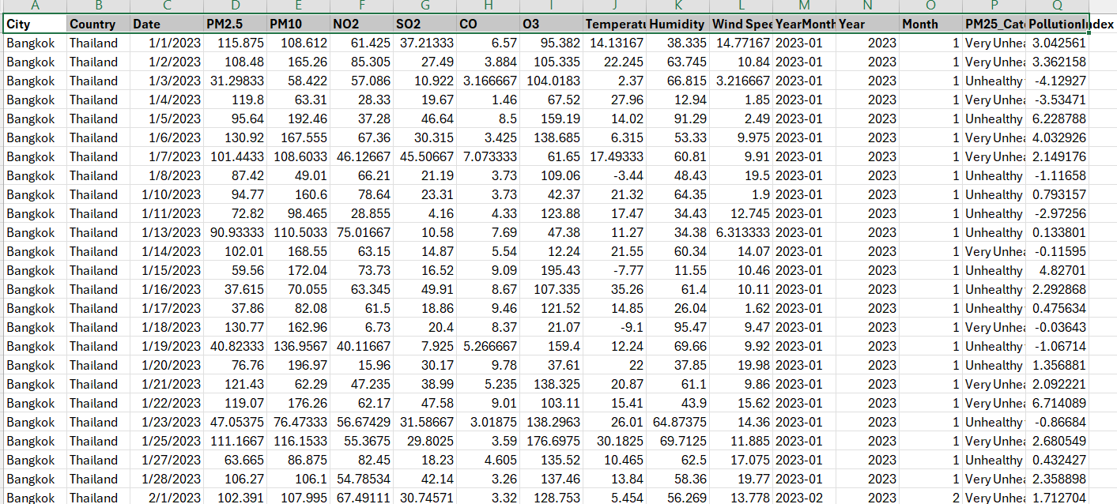
Fig: After Cleaning
The cleaned dataset now features consistent and properly aligned columns, with corrected headers like "O3" and separate "Temperature" and "Humidity" fields.

6.3 The Global Narrative: What the Data Reveals

6.3.1 The Air We Shared
The study revealed a divided world based on air quality.
The concentration of PM₂․₅ is high in cities like Dubai, Beijing, and Mumbai, as they are slowly being destroyed by the processes of urbanization, industrialization, and vehicle emissions.
On the other hand, places like London, Sydney, and Toronto had cleaner air, thanks to strict regulations and efficient transportation systems.
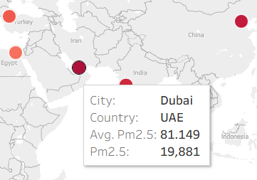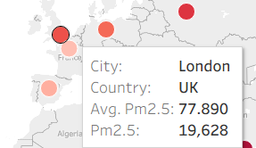
Figure 32: Comparison between UAE and UK

6.3.2 Time and Season — The Rhythm of Pollution
When analyzed over the periods, the level of PM₂․₅ was cyclical. The global trend line demonstrates subtle peaks during the winter seasons, showing the seasonal temperature inversions seen when pollutants are trapped in the layer closest to the Earth’s surface.

The above evidence confirms the fact that air pollution is both industry and climate-related. The heatmap by month and city also brought out how this cycle is different for various regions. Mumbai and Beijing recorded high levels all through the year, whereas levels were lower and more stable in Sydney.
But this comparison also gives a greater level of emotional subtlety, as underpinning every fluctuating line is the reality of the presence of millions of people breathing dirty air.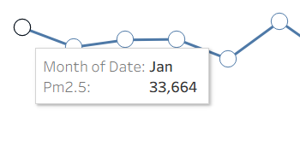
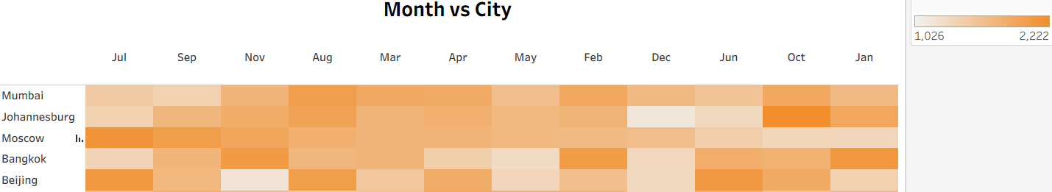

6.3.3 The Air-Weather Connection
The following chart indicates a clear relationship between air temperature and air pollution. In this graphic, it is clear that as the air becomes warmer, the count of air pollutants (PM2.5) will reduce. The reason is that warm air expands and dilutes air pollutants, whereas colder air, being still, may hold air pollutants close to the ground, leading to unhealthy air to breathe.
"In simple terms, the weather not only decides whether you'll wear a coat, but it also decides whether the air you breathe is clean."
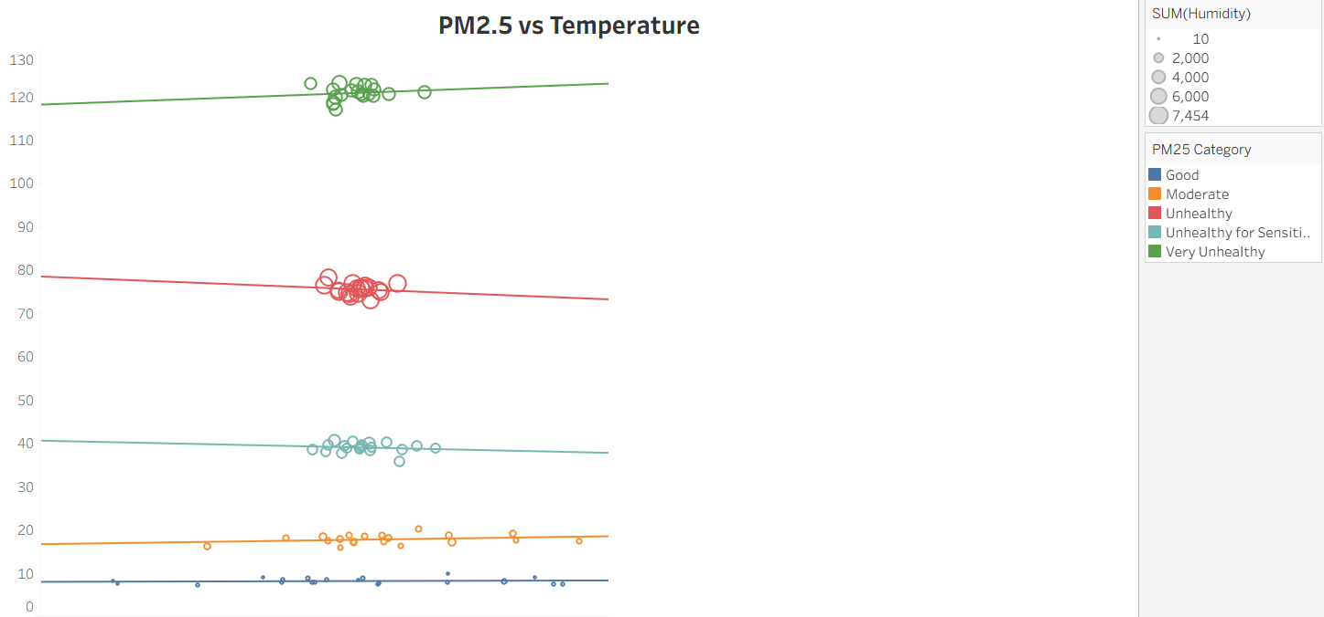

6.3.4 Human Impact: Cities That Breathe Differently
The “Top 10 Polluted Cities” visual represents the human element within the story. Urbanization, infrastructure, and energy demand are factors that interact and affect air quality. Johannesburg and Moscow are cases of old emissions from the industrial era, whereas Dubai and Mumbai are cases of overdevelopment. Even “cleaner” cities, such as London and New York, still experience dangerous peaks. The data is a timely reminder that no city is completely sheltered, and the a need for collective responsibility.
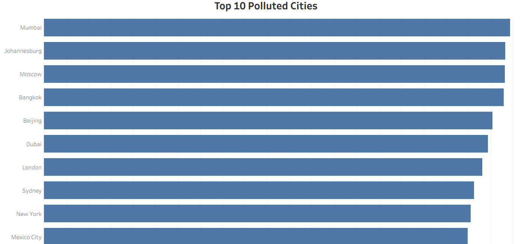

6.3.5 The Broader Environmental Story
But in addition to numeric data, the bar charts of the PM₂․₅ category distribution helped provide emotional understanding of the information, as it showed thousands of recorded days were rated “Unhealthy” or “Very Unhealthy.” Each bar represented more than just data points, as they also represented days of inconveniences, health risks, and poor visibility to the communities.
The shift from statistics to human experience is indeed the essence of successful data storytelling.

6.4 Implications and Significance
The story told by this analysis has three key implications:
Environmental Policy: Cities with high levels of air pollution require immediate government regulation. Evidence-based policies should address air pollution control and transportation.
Public Awareness: The project fills the 'gap' between scientific data and understanding by visualising invisible pollutants. This makes air quality visible and, by doing so, ‘actionable’.
Global Collaboration: The global maps illustrating the linked effects of pollution emphasize the fact that progress on the global level requires global collaboration – improved air, for example, is a benefit for all Earth’s inhabitants.
Task 7: Presentation and Reflection

7.1. Presentation Overview
The final presentation acted as a guided tour of the project entitled Global Air Quality Analysis, charting the course of the data analytics process, right from the data exploration stage through to the creation of the interactive Tableau dashboard.
Each visual was deliberately sequenced to introduce a specific story and then progress towards a final story of visualizing data related to the quality of the environment and its effect through various metrics.
The presentation progressed logically and cogently through combining the outputs of the analysis performed using the Python code with the visual representation through the Tableau environment, thus ensuring that the presenter addressed the criteria of clarity and professionalism. The combination of methodology and message ensured that the presentation not only contained information but also conveyed a visual and emotional impression.

7.2. Reflection on Analytical Process
The analysis procedure could be classified into both systematic and exploratory types. Initially, the data came with a plethora of challenges, including missing data, duplication, and the various data formats that required data cleaning and validation using Python programming. After standardizing the data format, the subsequent focus emphasized detecting trends and pattern associations using EDA and data visualizations.
The purpose of every decision, whether it be color scheme and graph type, is clear. The choropleth maps revealed the global inequality, while the box plots and trend lines highlighted changes over time and specific geographical areas with pollution concerns.

7.3. Tools, Skills, and Learning Outcomes
The use of both Python (for data preparation and analysis) and Tableau (for data visualization) improved both the technical and interpretive analysis capabilities.
Efficiency in cleaning, feature engineering, and aggregation was achieved through the use of Python. In contrast, visualization of static outputs into dynamic ones was realized through the help of tools like Tableau.

7.4 Key learning outcomes include:
- Enhanced skill level with respect to data preprocessing and feature transformations.
- Improved understanding of visual storytelling and dashboard design principles.
- Understand the importance of interactivity in the communication of complex knowledge related to the environment.
- This project has reminded me that the power of data analysis always lies within the story that is told and needs to be clear and empathetic.

7.5 Challenges and Problem-Solving
Several challenges emerged throughout the process:
- There were inconsistencies observed in the data of various cities that demanded a robust data cleanup mechanism.
- Balance of level of detail and access required a good visual presentation.
- Tertiary finance frameworks and the shift towards a knowledge-based society required a nuanced perspective.
- Each issue helped build additional analytical discipline and flexibility that a data analyst must possess.

7.6 Evaluation of Approach and Results
Strengths
  - Comprehensive Workflow that involves data acquisition, pre-processing, analysis, and visualisation.
  - Tableau interactivity used effectively to encourage user interaction.
  - Strained analytical thinking, connecting the quantitative findings to practical implications.
Limitations
- Temporal resolution is low (only data for a year available); therefore, longer trends.
- Some imputed values may lead to minor estimation bias, despite methodical justification.
- Besides these factors, the data within the study is credible and objective, given the aims of the project.

7.7 Final Reflection
This project work has been profoundly transformative not only for improving the skills of analysis and technique but also for cultivating a data-driven mindset that is propelled by curiosity, critical thinking, and communicative clarity.
This is a reminder that the key to closing the gap between data and understanding is good data storytelling, and that the data of air quality needs to be transformed into information that educates, inspires, and mobilizes.
Essentially, the project shows the evolution of information from data to knowledge and the critical role that each data analysis step played in achieving a completely organized final result.

References
Kaggle (2023) Global Air Quality 2023 (Messy from WAQI786). Available at: https://www.kaggle.com/datasets/coffxc12/global-air-quality-2023-messy-from-waqi786.
OpenAI, 2025. ChatGPT (GPT-5 Mini) [AI language model]. Used for content feedback and suggestions. Available at: https://openai.com/chatgpt.
QuillBot, 2025. QuillBot Grammar Checker [online]. Used for grammar and language refinement. Available at: https://quillbot.com.
University of the West of Scotland (2025) COMP11108 Data Analysis and Visualisation T1 2025/26 – Coursework Specification. School of Computing, Engineering and Physical Sciences. Provided to students 2 October 2025.
World Health Organization (2024) Air pollution. Available at: https://www.who.int/health-topics/air-pollution#tab=tab_2.

Appendices
Appendix A: Google Colab Notebook (EDA and Data Cleaning and Visualization)
Link: https://colab.research.google.com/drive/19HIYpk9msYK64HNTGiqBCnyRY3qNXHzd?usp=sharing
Appendix B: Dataset Files (Raw & Cleaned Data)
Raw Data:
https://www.kaggle.com/datasets/coffxc12/global-air-quality-2023-messy-from-waqi786
Clean Data: https://drive.google.com/file/d/1J_VxKwlcuyDlx70Kr_dcLW8CrxLa3Umt/view?usp=drive_link

Appendix C: Tableau Dashboard (Interactive Visualisation)
Link: https://public.tableau.com/views/Global_AirQualityindex/Dashboard1?:language=en-US&publish=yes&:sid=&:redirect=auth&:display_count=n&:origin=viz_share_link

