Table of Contents

Introduction 1

What is the significance of digitalization? 2

Digital Transformation Technologies. 2

Artificial Intelligence and Machine Learning 2

Internet of Things 3

Virtual Reality: 3

Big Data and Real-Time Analytics 3

Future trends 3

Enterprise System Used by Organizations 4

Business Intelligence (BI) 4

Business Process Management (BPM) 4

Digital Transformation Success Stories 4

NIKE 5

Key takeaways 6

AUDI 6

Failure Stories 6

KODAK 6

Decision-Making with Digital Technologies 7

Conclusion 7

References 8

# Introduction

Digital transformation is the process of making something new or recreating, converting conventional to contemporary like challenges in business, tradition, or customers’ demands in the market. All can be done with the help of technology. Digital transformation is the incorporation of technology into all kinds of business.

Now the mode of doing business has changed as it moves from paper to hand-sized gadgets, so we have to think about how we introduce our customers to modern technologies. With the help of digital technology, they can convert their conventional business system from advertising to production or sales and customer service. They can secure their business from upcoming obstacles. Planning businesses with digital strategies can give you flexibility and help you grow readily.

Full digital transformation (DX)uses on-screen data, and this transformation can only be understood by using it. So, DX will require businesses to take some brave decisions and to handle upcoming pros and cons. Adapting new digital ways instead of the convenient traditional way might be difficult. But to stand in the market digital transformation is crucial.

# What is the significance of digitalization?

* **Boosts productivity while lowering labor expenses**

Employees and businesses may eliminate monotonous tasks and better manage their time using various digital technologies, enhancing productivity. These devices aid in reducing human error and increasing operational efficiency.

* **Enhance the customer experience**

Companies are enhancing client interactions and delivering better support by utilizing digital technology such as mobile applications, live chat, and social media.

* **Encourages innovation, allowing you to stay ahead of the competition**

Business digitalization has a huge impact on innovation. As technology advances, companies are simply forced to act and innovate.

# Digital Transformation Technologies.

Businesses can benefit from a variety of digital transformation technologies.

## Artificial Intelligence and Machine Learning

Artificial intelligence (AI) is a technology that allows computers to mimic human cognitive processes. Machine learning models make up AI. After sufficient training, this model may accurately forecast or analyze the problem. The accuracy of these models improves as the number of inputs to train increases. Artificial intelligence may provide insights and data to businesses, allowing them to make better decisions. (Gwo-Jen Hwang, n.d.)

## Internet of Things

The Internet of Things is made up of physical devices that include sensors and software that are connected to the internet. These interconnected gadgets share data for purposes such as automation and analytics. Smart manufacturing, connected assets, smart digital supply chains, smart power grids, smart cities, connected logistics, preventative, and predictive maintenance, and so on are all possible with IoT. (Sachin Kumar, 2019)

## Virtual Reality:

Virtual Reality, or VR, is a computer-based simulation environment that immerses the user in a computer-generated environment. This simulation world may be explored in 360 degrees. In contrast to traditional interfaces, virtual reality immerses the user in the virtual environment. A user using a VR headset may explore the virtual environment. The user may move around and interact with the environment. VR is useful in a variety of fields, including education, marketing, gaming, and entertainment. (Nor Farhah Saidin, n.d.)

## Big Data and Real-Time Analytics

Big data analytics is a technique for analyzing data sets that are extremely large and diversified. These data are inaccessible to traditional analytics tools. Data might also be organized or fully unstructured. Big data is mostly derived from real-time sensors, videos and audios, logs, and banking transactions, among other sources. These data are unusable with traditional analytics tools; however, Big Data Analytics allows for data analysis, allowing business users to make better and faster decisions.

Many approaches are used in big data analytics, including data mining, machine learning, predictive analysis, and text analytics. (Elragal, n.d.)

## Future trends

According to recent data, more people started using smart wearables like smartwatches, smart headsets, and some other IoT-based devices. These devices can provide accurate analytics of one’s health and well-being preventing some major illnesses.

Once this IOT based devices will adopt AI and ML models they will be much more accurate and will diagnose some illnesses and medical conditions. With the 5g, internet connectivity latency of these devices will reduce providing a better exchange of data.

Users can also connect gadgets to the cloud via an IoT platform. The cloud-based IoT acts as a middleman. It is used to design and deliver applications. IoT is a self-management technology. Users can use it to manage smart gadgets. (Anon., n.d.)

It collects data via a remote device configuration. It also sends out real-time notifications to help troubleshoot. Because of its great performance to interact and connecting, IoT is a cloud computing trend.

# Enterprise System Used by Organizations

There are many types of Enterprise systems that Businesses use like Customer Relationship Management (CRM), Enterprise Resource Planning (ERP), Supply Chain Management (SCM), Business Intelligence (BI), Product Lifecycle Management (PLM), etc.

## Business Intelligence (BI)

Business intelligence, or BI, is a set of tools, procedures, and services that assist businesses in turning raw data into actionable information. Raw data is inaccessible and useless, but well-structured information may aid in gaining insights into the business. This data can assist organizations in making lucrative decisions. (Rouhani, n.d.)

BI assists businesses in making decisions based on fact-based historical data rather than assumptions. Businesses may use BI Tools to analyze data and then show it in reports, graphs, and charts.

## Business Process Management (BPM)

BPM, or business process management, is a collection of techniques and disciplines that aid in the administration of a company's daily activities and goals. Processes are critical to every company, according to BPM. This BPM software assists businesses in setting precise business task requirements and assigning appropriate business goals. (Jeston, n.d.)

This software analyzes, enhances, and establishes business processes, as well as collects the data required for these processes. As a result, organizations become more efficient and transparent, and some of these operations may be automated.

# Digital Transformation Success Stories

## NIKE

Nike is a well-known footwear firm that employs technology in its field by using electrical devices. The company has created an app for users that uses a leg scan to assist them to choose the best-fitting, most comfortable shoes. By combining 13 data points, a map of an individual's feet can be created. This app is also useful for obtaining valuable assets for future projects.

Nike Plus is a crucial endeavor for the firm because it recognizes the most engaged users of the program. It had a positive impact on sales in Japan, where it was first introduced. (Anon., n.d.)

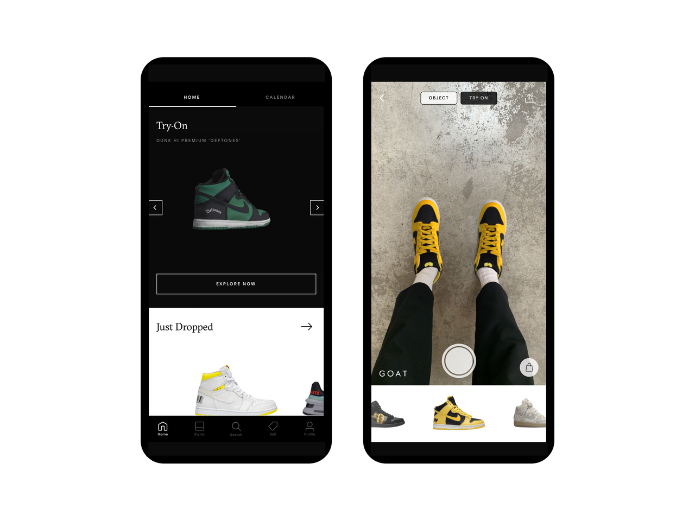

Figure 1 NIKE AR (NIKE FIT) (Anon., n.d.)

The NIKE SNKRS app became well-known, increasing demand for sneakers and thus sales. NIKE's digital transformation innovation aids in the modification of the company's assets. Workers at the company put in long hours digitizing 6000 pairs of shoes. Overall, it aids in the increase of sales and marketing.

The business has developed an e-commerce strategy that incorporates analytical data and improved marketing strategies. The company was able to establish concept stores thanks to the usage of online data, as well as provide more members and better customer service to gain their trust in the site and app. With this analytical data, the organization has seen significant changes in manufacturing and marketing, as well as improved customer response. In just two years, its economy grew from $52 to roughly $88.

### Key takeaways

1. Trust the analytical data gathered to improve the client experience and make sound decisions.
2. Don't rely on the old methods; use technology to better understand market strategy, even in the retail industry.

## AUDI

Car manufacturing equipment needs a lot of maintenance as well and keeping track of it is not easy. All tools wear out eventually. To avoid any kind of downtime and predict when certain machines will need maintenance, Audi started a big project called Predictive Maintenance.

Audi used Big data to analyze cases when unexpected equipment failures can occur. Surprisingly, this project culminated in the creation of an app named “I-Maintenance”. People in charge of factory equipment maintenance use this app to predict when maintenance is required and what type of labor each machine requires. (Neckarsulm, n.d.)

This predictive maintenance Project helped Audi to Reduce Manufacturing breakdowns and helped the company in on-time car deliveries.

# Failure Stories

## KODAK

Kodak was once the world’s biggest film corporation because of its inability to adapt to digitalization and fear of losing its best product line.

The firm's marketing, equipment, and design leaders had a lot of opportunities to steer the company in a lucrative direction, but they couldn't since they didn't know how to follow digitalization. For example, Kodak has invested billions of dollars in research and technology for taking images with cell phones and other mobile devices. It has declined to develop digital cameras for the market due to concerns about losing its lucrative film industry. (Taneja, n.d.)

Canon, a Japanese firm, seized the opportunity and overtook Goliath. Another example is Kodak's acquisition of Ofoto in 2001, which is a photo-sharing website. On the other hand, rather than competing with Instagram, Kodak used Ofoto to encourage people to print digital photos. Kodak declared bankruptcy in 2012 and recovered a little amount in 2013 by focusing on customer service.

# Decision-Making with Digital Technologies

A Business decision-making process is a sequence of processes they take to identify the best option or course of action to maximize their profits.

Businesses must make critical decisions regarding their future procedures and visions. Well-supported data is required to make sound decisions. Digital enterprise solutions such as Business Intelligence assist businesses in making informed decisions by offering well-presented reports based on current and historical company performance, predicted demand, future trends, and much more.

By processing enormous amounts of data, artificial intelligence-based models assist businesses in gaining relevant business insights. Humans have decision fatigue from time to time, while AI models do not have these restrictions, making decision-making easier and more effective.

# Conclusion

The benefits of digital transformation are self-evident. Digital transformation benefits both small and large businesses, and it is unavoidable for businesses seeking to survive the next decade on the market. Product managers are in an ideal position to lead these initiatives and create products and solutions that can help others achieve their revolutionary goals.

By definition, digital transformation is challenging and threatens the existing quo, but it also offers enormous opportunities in practically every business.

Adapting Digital transformation technology can assist businesses in achieving their goals. With correct analysis and theories, an appropriate Enterprise system may assist businesses in making decisions. Companies that do not adapt will struggle to survive.

# References

Anon., n.d. *Cloud Computing and IoT.* [Online]   
Available at: https://stonefly.com/blog/role-cloud-computing-internet-things

Anon., n.d. *NIKE Research and Development.* [Online]   
Available at: https://news.nike.com/r-d

Elragal, N. E. &. A., n.d. Big Data Analytics: A Literature Review Paper. *LNAI.*

Gwo-Jen Hwang, H. X., n.d. Computers and Education: Artificial Intelligence.

Jeston, J., n.d. What is Business Process Management?. In: *Business Process Management.* s.l.:s.n.

Neckarsulm, n.d. *Predictive Maintenance: Audi Maintenance uses data to predict the future.* [Online]   
Available at: https://www.audi-mediacenter.com/en/press-releases/predictive-maintenance-audi-maintenance-uses-data-to-predict-the-future-12971

Nor Farhah Saidin, N. D. A. h., n.d. A Review of Research on Virtual and Augmented Reality in Education: Advantages and Applications. *International Education Studies.*

Rouhani, S., n.d. Review Study: Business Intelligence Concepts and Approaches. *Business Intelligence Evaluation.*

Sachin Kumar, P. T. &. M. Z., 2019. Internet of Things is a revolutionary approach for future technology enhancement: a review. *Journal of Big Data,* Issue 6.

Taneja, Y., n.d. *Why Did Kodak Fail? | Kodak Bankruptcy Case Study.* [Online]   
Available at: Neckarsulm