Entrepreneurship

Group 30

Table of Contents

Executive summary 2

Introduction 2

Discussion 3

1. Empathize 3

2. Define 3

3. Ideate 3

4. Prototype 3

5. Test 3

Workflow 3

Analysis 5

Empathize 5

Define 5

Ideate 5

• Prototype 1 6

• Test 1 6

• Prototype 2 6

• Test 2 6

Conclusion 6

Executive summary

Agriculture has been a practice that has been followed for thousands of years to produce required food crops. The Australian aboriginals had been involved in hunting, fish-trapping, and crop growing for food. The Australian landscape had been very new to the aboriginals since it had very different climatic conditions. Their tools and methods were not suited for the harsh and barren lands. The Australian aboriginals used native plants as crops for agriculture. The practices followed by them were completely different from traditional farming. They had developed unique agricultural practices like Firestick farming for cultivating the isolated lands of Australia. Also, the change in climatic and uneven weather conditions impacted in great loss to the aboriginal farmers as most of the field crops was directly dependent on weather.

We are developing a tool for the aboriginals to predict the weather conditions based on the previous year’s data and soil conditions. The tool would help the aboriginal farmers in recommending which crop would help them in getting better yields from the field. The input system takes the basic details of the farmers, their location, and the soil quality report, analyses the data, and predicts the weather conditions. It also gives a rating on a scale of 1 to 10 as to which crop is best suited for the given field. In rating 1 would be the lowest and 10 would be the highest rate. Any rating below 5 will not be considered for growing the crop and the cropping rate on the scale of 8-10 would be highly recommended the tool would also suggest to the farmers which fertilizers and ingredients would be better for the given soil details. This would help them in getting better yields from cultivating the given land.

# Introduction

Agriculture being the backbone of society plays an important role in the development of the economy. Employment opportunity is also generated for a large percentage of people through agriculture. The main purpose of agriculture is to provide food for the use of people and fodder for domestic animals. Development in the field of agriculture is very crucial since it impacts the entire social and economic system. With the increasing rate of adverse climatic conditions, there has been an immense need to develop agriculture production while reducing the environmental impacts and land use. About 70% of people are directly dependent on agriculture for their livelihood.

In Australian cultivation, there has been an enormous loss of local biodiversity and high rates of species extinction due to improper methods of cultivation and a lack of measures on flora and fauna. The aboriginals used the burning method to clear the land and attract the animals to the field by growing new grass in its place. This made them easily hunt the animals but resulted in losing the soil potential.

# Discussion

In the current agricultural practices, which are followed by the aboriginals there are many reasons for crop failure like improper crop selection, adverse climatic conditions, weather changes, and so on. To overcome these problems, we need to create innovative solutions and try to implement them using design thinking processes. We can create iterative solutions, refine the existing skills, and cope with the rapid developments of the user’s environment. Design thinking can be used to understand people’s problems and challenges and create technological solutions to prototype and test them.

The different phases of Design thinking related to the given problem are as follows:

## Empathize

Researching the existing problems in the agricultural practices followed by the aboriginals. From this, we can understand the actual need and gain real insights into the problems faced by aboriginals.

## Define

Stating the different agricultural needs of aboriginals and accumulating them from the empathizing phase. After this analysis is made on the observations and synthesized to find the actual core problem.

## Ideate

Finding alternative ways to investigate the agricultural problem of aboriginals and creating innovative solutions. The background knowledge from the first two phases would help in coming up with new solutions.

## Prototype

Developing the best possible solution which can be implemented to overcome the problems of aboriginals. This is just an experimental phase and provides a glimpse of how the problem can be solved.

## Test

Rigorously testing the developed prototypes. Though this is the final stage in design thinking we can return to the previous stages and make suitable changes and prepare alternatives to develop the best possible solution.

Workflow

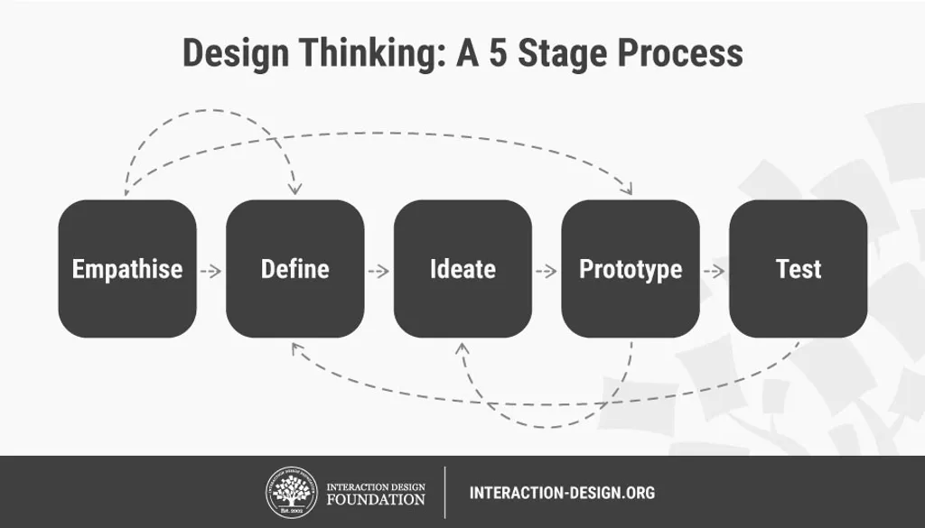

Figure 1 Stages of Design thinking (Dam, n.d.)

At the beginning phase of the given task, we emphasize understanding the various problems and challenges faced by the aboriginals while cultivating the land. Insights are made into the aboriginal people’s emotions and aspirations to provide designers with more detailed directions. Researching the backgrounds and collecting the details from different stakeholders helps to analyze the actual need and the barriers in agriculture. If this phase is carried out correctly then it ensures the smooth functioning of other phases and helps to achieve success.

In the next phase, we define the problem to all the members so that everyone brings out a creative idea. The different problems defined in this phase are weather unpredictability, Improper and old techniques, lack of technological knowledge, and following the traditional approach.

In the third phase, we ideate the given problem by using all the data collected in the previous phase and understandably frame the situation so that it would be easier to solve the problem.

In the fourth phase, we prototype the ideas to build the artifacts and encounter various ways of solving the problem efficiently.

In the final phase, we test the developed solution rigorously to discover the ideal solution. This is done to ensure that the system is performing accurately, and the required outcome is achieved. After the testing is completed, feedback is taken from the users and stakeholders on what features can be added and how further improvements can be made to the tool.

After getting the feedback the process is revisited. The testing showed that further improvements can be made to the tool by increasing the accuracy and adding new features like weather prediction and crop selection. Hence the process is iterated again to re-define the problem and ideate new solutions for the improvement of the system.

The tool is re-developed by adding the new features and testing accordingly.

# Analysis

We implement the design thinking practices to solve the agricultural problems of the aboriginals. The aboriginals follow their traditional way of doing agriculture and most often they end up in loss. To improve the agricultural practices, we develop a tool that uses the farmers’ details and soil conditions and provides the outcome so that the aboriginals improve in the field of agriculture. The design thinking practices are imbibed into the solution to build the best solution and achieve greater efficiency.

The step-by-step illustration of the design thinking practices is illustrated below:

Empathize

This is the beginning phase of design thinking and emphasizes knowing the actual needs of the aboriginal farmers. All the stakeholders like the farmers, Government agencies, testing authorities, and development centers are involved in this stage. Proper investigation is made to find what are the different practices followed by the aboriginals and their impact on society. A large amount of data is collected to develop the best solution. Different measures affecting the growth of crops are researched. Needs and concerns from different perspectives of all the stakeholders are considered and the doubts of the farmers regarding the digital technologies are answered. Also, the different barriers and facilitators that influence the aboriginals in using the newly developed tool are explored. Different questions like what the needs of the aboriginals are and how they expect the tool to help them in getting better outcomes are determined. The main concept of this phase is that the problems of the users must be empathized with by the designers using the various design solutions that meet their needs.

Define

The define phase aims to explore all the views of the stakeholders, find out the core problem that needs to be solved is decided and reframe the challenges reflected by the stakeholders. Proper understanding of different patterns is made and the findings from empathizing phase are collated into questions like what are the current difficulties that the indigenous farmers are undergoing, what is the core user problem that needs to be solved. Some of the challenges faced in this phase are older farmers not interested in using the new tool, gaining the trust, promoting the farmers to use the new tool, overcoming the internet issues in remote areas, designing user-friendly interfaces, and so on.

## Ideate

The results obtained from previous phases are validated and ideas are refined accordingly. Creative ideas are generated to increase the potential of the project, unexpected areas are explored, and solutions are generated beyond the traditional approach. A simple and friendly login page with colorful visuals is created to provide easy access, smooth navigations, and interactive screens to the aboriginals. Assistance for all the actions with clear instructions and action items is developed to provide user-friendly support. A secure log-in page is done to avoid unauthorized access to the system. Also, to develop the trust and encourage the aboriginals for using the tool a dedicated helpline center is built to have a positive user experience.

## Prototype 1

The prototype of the system is developed using the Machine learning models for predicting the data based on the given data set. The system is trained with the past 10 years of data and the accuracy of the system is tested. The system took the authentication details from the user to the login page to avoid unauthorized access to the system. Later farmer details, land details, and soil details are entered. The system uses this data and based on the trained dataset it predicts the outcome. It provides a rating on a scale of 1 to 10 recommending the type of crop to be selected for crop cultivation.

## Test 1

While developing the tool, the farmer was the only end-user but different people like farmers’ family members, Inspection agencies, farming organizations, Government Departments, and councils all turned out to be users of the tool. The tool could also be used to predict the weather forecasts, provide some useful tips to the farmers, and help them in getting better yields. The accuracy of the system could also be increased considerably by training the system with more data sets. Also, there are challenges in getting internet access in remote areas.

## Prototype 2

After obtaining the suggestions and feedback from the stakeholders, the earlier phases are revisited, and modifications were made to the system to enhance the user experience and have a higher accuracy rate. The system was trained with the past years’ data and a more than 90% accuracy rate was observed. Further training resulted in overtraining the system and did not increase the accuracy rate. Further enhancements to the tool were made by adding features like predicting the weather forecasts, suggesting the farmer alternate ways like crop rotation to enrich the soil contents, suggesting the different ingredients and fertilizers, and have efficient growth. The internet connectivity issue is being solved by making the tool offline by any offline technologies like service workers for webpages. The tool can now be used in offline mode and quarterly updates are being provided to enhance the system features.

## Test 2

The system can be used in distant areas, due to the offline version and there is no difficulty in using it in any remote areas. It worked with more accuracy after adding the new features and helped the farmers in selecting the crops and fertilizers. It is not supporting aboriginal languages as the aboriginal had their languages like Warlipi, Tiwi, and Murrinh-pathe it is difficult for them to connect with the tool.

## Prototype 3

The system is redesigned after considering the feedback obtained from the peers and a new feature is added to the tool for supporting Multilanguage. The help center is also supported by the aboriginal languages so that it would be easy for them to communicate and use the tool.

## Test 3

The system worked with more accuracy after adding the new features and helped the farmers in selecting the crops and fertilizers. Along with agricultural needs further improvements can be made in the field of dairy farming, poultry farming, and sheep farming to reduce the number of inspections and help in keeping track and automating the process.

# Challenges

While implementing this tool majorly two challenges need to be addressed. The first challenge is developing the trust among the aboriginals so that they start using the developed tool and the other challenge is to capture the current market.

## Solution

* The trust among the aboriginals can be developed by giving them basic knowledge on how this tool will help them in growing their crops more efficiently and giving them free trials for the first time and making them realize how they can increase the production of crops by using the developed tool. Also providing them free soil reports for the first three months so that the aboriginals get used to the system.
* The other challenge of capturing the market can be resolved by reaching out to the organizations that are connected with the well-being of the aboriginals and letting them know about the tool and how this tool can result in their well-being.

Conclusion

There has always been a need to educate the aboriginals on innovative farming practices and develop them on the latest tools and techniques. The aboriginals have been using the traditional approach of cultivating the land and must be encouraged to use the new tools and techniques to increase their yield. By implementing the given tool, the aboriginals can expect a high yield as it would direct them on selecting the crops, fertilizers, and ingredients and help them with predicting the weather conditions. The design thinking process supported the stakeholders to grow effectively and overcome the agricultural challenges.

# References

Dam, R. F., n.d. *5 Stages in the Design Thinking Process.* [Online]   
Available at: https://www.interaction-design.org/literature/article/5-stages-in-the-design-thinking-process