# Executive Summary

Any successful business must have a strong focus on innovation. Problems can be created by innovation, but it can also lead to solutions. Success and inventive ideas are inextricably linked. It will assist You in taking the lead in a competitive market. Without innovation, a company will be unable to compete in the market and will eventually fail. It aids in the expansion of profit as well as the comprehension of market strategy and client desires. Tesla's technology and unique ideas have been highlighted in this scenario, such as how it came up with the idea of an electric vehicle without sacrificing other benefits.

Tesla is now a well-known vehicle company. It offers superior technology, speed, safety features, and luxury, among other things. Tesla has now created a future of mobility that is both fuel-free and safer. Tesla owns roughly 361 patents in diverse sectors such as electric vehicles and vehicle design, which have helped the firm significantly to outperform its competitors.

# Introduction

Tesla intends to provide battery electric vehicles with compelling qualities such as improved range, performance, and customer compliance, as well as cheap cost and, most importantly, energy efficiency. The company is primarily focused on the development of electric sports cars. The electric engine, which consists of powerful motors, a control center, and lithium batteries, will be used instead of a combustion engine.

Innovation has numerous benefits, the most important of which is that it aids in profit generation. Innovation is a synthesis of the past and the future. It has the potential to enhance client requirements and services. Tesla only made it to the top of the EV car manufacturing rankings because of its innovation.

# Finding and Analysis

## The core business activity and role of innovation

The company's major business goal is to produce environmentally-friendly electric vehicles, as well as sustainable energy generation and efficient storage. The corporation has sold over 2 million electric automobiles and operates a network of over 20,000 electric vehicle charging stations. In addition, the corporation is a major supplier of energy storage solutions.

The role of innovation set out by Tesla is to accelerate the transition of the world to more sustainable energy. The company is leading in the Artificial inelegance domain which helps its Autopilot model to achieve a great level of accuracy. Which will help road transport safer and secure preventing human mistakes and negligence. The company has many patents for many sustainable processes which helps climate. Thus, it is safer to say that Innovation is one of the leading factors which helped tesla gain the top spot.

## The way innovation is making a difference

One of the main reasons for Tesla’s massive success is innovation and improvement. Tesla leads in the innovation of the automobile industry ranging from Aerodynamic designs to Fully automated self-driving cars. Due to innovative ideas and Tesla was able to report $18.76 billion in revenue in the first quarter of 2022. Moreover, Tesla is Leading in Autonomous Car Sector. Tesla needs to collect the necessary data to train its algorithms and feed its AIs in order to make cars fully autonomous. More training data will inevitably lead to improved performance, and Tesla shines in this area.

This method is referred to as "imitation learning" by Tesla. The algorithms used by the company are based on the decisions, reactions, and movements of millions of real-world drivers all around the world. All of those miles add up to super-smart self-driving automobiles.

The company also applied for a new patent for the lithium extraction process, due to which extraction cost cuts by more than 30%. It is a sulfate-free process that skips the intermediate processes. This process is environmentally friendly moreover results in a considerable reduction in lithium cost.

The company’s many innovations like these help in reducing raw material costs and improving sales of the products.

## Research and development and its relationship with organization innovation

In the innovation process, research and development is crucial. It's essentially a bet on future skills and technology that's turned into new products, processes, and services.

Tesla's breakthroughs haven't always come from the top down. To obtain an advantage over larger competitors, the company chose adaptability over a traditional corporate hierarchy. When a management style is adopted that eliminates communication barriers, "everyone can talk to anyone." As a result, Tesla employees have unrestricted access to the firm's senior team, allowing for a free exchange of ideas that could improve the company. The company promotes its culture to encourage and empower its people to think creatively and develop ideas that will help the company to continuously grow and differentiate itself from competitors in areas such as automotive, storage, and energy generation.

The organization has established a culture and management structure aimed at assisting employees in developing behaviors that allow them to think creatively and innovatively on their own. Because it is these characteristics that will contribute to and preserve the company's ability to give the market with things that others have yet to consider, let alone offer. These habits are credited with Tesla's capacity to remain competitive.

Employee motivation is emphasized in order to provide answers to present and emerging problems. Tesla, for example, has been able to constantly progress the vehicles it brings to market because of a focus on producing electric vehicles that will restrict cars' deteriorating environmental effects.

Tesla is the only carmaker that spends more money on research and development (R&D). According to StockApps.com, the company spends $2984 for each car manufactured on research and development. That's more than three times the industry average of about $1,000 per car, and more than the combined R&D budgets of Ford, GM, and Chrysler.

**R&D spent per car** sold (In US Dollars)

* **Tesla**  $2,984
* **Ford** $1,186
* **Toyota** $1,063
* **General** **Motors** $878
* **Chrysler** $784

## Factors affecting innovation success

Mechanical complexities and production risk factors will increase as the level of innovation rises. During the launch of its new automobiles and other goods, Tesla has experienced constant launch, manufacturing, and production ramp delays. When Tesla was about to introduce the Model X, for example, they experienced ongoing manufacturing issues, which resulted in constant distribution delays. Similarly, the business ran into major issues at Gigafactory while building the battery module assembly line for the Model X.

Tesla may suffer an uneven supply and demand as a result of its extensive testing and complicated procedures, rendering it unable to achieve the production ramp in the future.

Tesla has released a number of autopilot vehicles, but not all of them have proven to be safe in the event of an accident. Lawsuits and claims have been filed against the corporation due to technical failures in its goods. If these liability lawsuits persist, Tesla may face even more financial difficulties.

Tesla's battery packs are made up of lithium-ion cells. Because lithium is a highly reactive and explosive element, its products have a higher danger factor. Tesla has had a couple of incidents where their cars have caught fire and emitted smoke, which has severely tarnished the firm.

## Firms Innovation category

Building new innovative and more sustainable products are Tesla’s main strategy. The company has introduced many game-changing innovations like Powerwall, Solar roof, and Megapack. Giga factory. The company’s whole innovative ecosystem has helped the company to achieve a height of success. The company employs a large number of highly talented workers who conduct research and develop new technologies and concepts, which they then incorporate into their goods to set them apart from their competition.

## S-curve of Organization technology

The S-curve depicts innovation from its modest beginnings as a technology or process is established, to an acceleration phase (a steeper line) as it matures, and eventually to its stabilization over time (the flattening curve), with commensurate improvements in the item or organization that uses it.

Tesla grew by 109 percent in the first quarter, shipping roughly 185,000 vehicles, above Wall Street's expectations. Loup Ventures believes that the company is currently entering the slope of its growth S-Curve, as evidenced by Tesla's rapid expansion.

Tesla’s autopilot model is in the early beginnings of innovation but once trained with a vast amount of data it will acquire the required amount of accuracy which will correspond to an increment in performance and optimization

## The success of the Firm in using innovation

When it came to creating technologies, making prototypes, and scaling manufacturing, the company had a lot of challenges at first. Despite considerable setbacks, the firm is on track to deliver its one-millionth car in March 2020.

Tesla currently delivers over 200,000 vehicles every quarter, with plans to considerably increase manufacturing in the future. In June 2021, it became the first electric vehicle in the world to sell one million units. More than any other electric vehicle producer on the planet. Tesla has produced a total of 1.91 million automobiles since 2009. Tesla employs 70,757 people worldwide.

Innovation helped the company to achieve such a massive success.

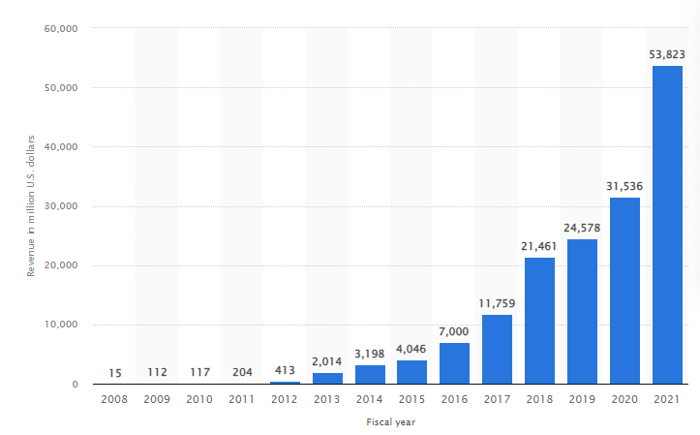

Figure Tesla's revenue 2008-2021 (Anon., n.d.)

# Conclusion

According to the findings of the study, innovations inevitably lead to bigger and better ideas, which may one day become revolutionary. Innovation has the potential to provide significant benefits. It is one of the most basic requirements for any firm to progress. It can assist businesses in resolving issues, generating profit, increasing market share, and edging out competitors. Innovations have helped Tesla to position itself as one of the successful independent automakers and a pioneer in the electric car market.

# Recommendation

Nowadays electric car sales are growing rapidly. Tesla being a supplier and pioneer of electric car manufacturing, the company should lead the Automobile industry. One of the major challenges is there are little to no charging stations all around the globe also in some countries there is very low awareness regarding electric vehicles. The company should work on raising EV awareness and expanding its charging station network. The company should also work on diversifying its product catalog to a wide range of consumers, especially middle-class people.