Wipro Capstone Project Documentation

1. Selenium Automation Testing Project

Project Title
Nykaa Makeup Module Selenium Automation Testing Framework

Project Description

This is an automated project created with the Selenium WebDriver technique and Python language using the Pytest framework, which is used to test the Nykaa.com website. Makeup module was selected for testing and sub-module was Lipstick. The design pattern is based on Page Object Model (POM).

Test Strategy
- Functional Testing
- Regression Testing
- Smoke Testing
- End-to-End Testing
- Page Object Model (POM) Framework
- Reusable utility functions
- Screenshot capture on failures
- Logging and report generation

Selenium Test Scenarios
TC01 - Verify Lipstick Category Page
- Step 1: Open Nykaa website
- Step 2: Navigate to Makeup module
- Step 3: Click on Lipstick category
- Step 4: Verify Lipstick page loads successfully
TC02 - Verify Product Display
- Step 1: Open Lipstick category
- Step 2: Verify products are displayed
- Step 3: Validate product names and prices

TC03 - Verify Filter and Sort Functionality
- Step 1: Apply brand filter
- Step 2: Apply sorting option
- Step 3: Verify filtered products are displayed
TC04 - Verify Lipstick Search Functionality
- Step 1: Search for lipstick product
- Step 2: Verify relevant products appear
TC05 - Verify Invalid Search
- Step 1: Search invalid keyword
- Step 2: Verify no result message appears
TC06 - Verify Invalid Product URL
- Step 1: Open invalid product URL
- Step 2: Verify error page appears

End-to-End Selenium Test Flow
- TC-E2E-01: Homepage validation
- TC-E2E-02: Makeup category navigation
- TC-E2E-03: Lipstick category validation
- TC-E2E-04: Product search validation
- TC-E2E-05: Product detail page validation
- TC-E2E-06: Add to Bag validation
- TC-E2E-07: Cart validation
- TC-E2E-08: Proceed to Buy validation
- TC-E2E-09: Payment/Login page validation

Test Environment
Component | Details
Operating System | Windows 11
Programming Language | Python
Automation Tool | Selenium WebDriver
Testing Framework | Pytest
IDE | VS Code
Browser | Google Chrome
Reporting Tool | Allure Report
Version Control | Git & GitHub

Test Execution
Command Used:
pytest -v
For Allure Report:
pytest --alluredir=allure-results
allure serve allure-results
For HTML Report:
pytest --html=reports/report.html --self-contained-html

Test Output
- Browser launch
- Lipstick category validation
- Search functionality execution
- Product addition to bag
- Cart validation
- Console logs generation
- Automatic screenshot capture on failures

Test Reports
- Allure Reports
- HTML Reports
- Execution Logs
- Failure Screenshots
- Execution Timeline
- Pass/Fail Summary

Allure Reports

This project was designed to combine both Selenium and BDD frameworks with Allure Report to create a good execution report at the end of every automated test case.
The report includes:
- Test execution summary
- Pass and fail statistics
- Step-by-step test execution details
- Execution timeline
- Screenshots on failure
- Environment details
- Test duration information
- Scenario-wise execution status

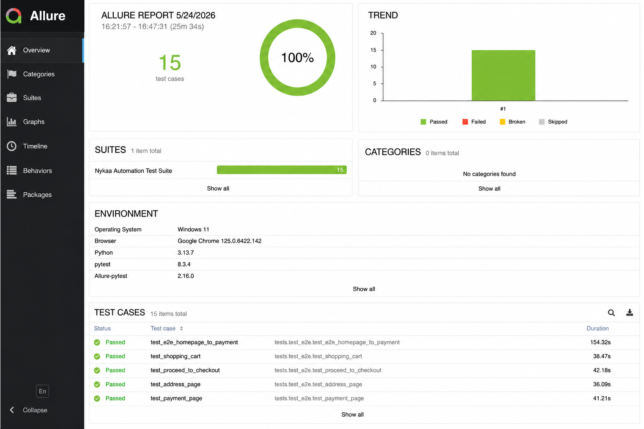

HTML Report
For this project, HTML reports were generated with the Pytest HTML plugin in both the Selenium and the BDD automation frameworks. The report can be used for analysing execution results without having to manually check console logs.
The HTML report contains:
- Total executed test cases
- Passed and failed test count
- Execution time
- Test execution status
- Error and exception details
- Environment information

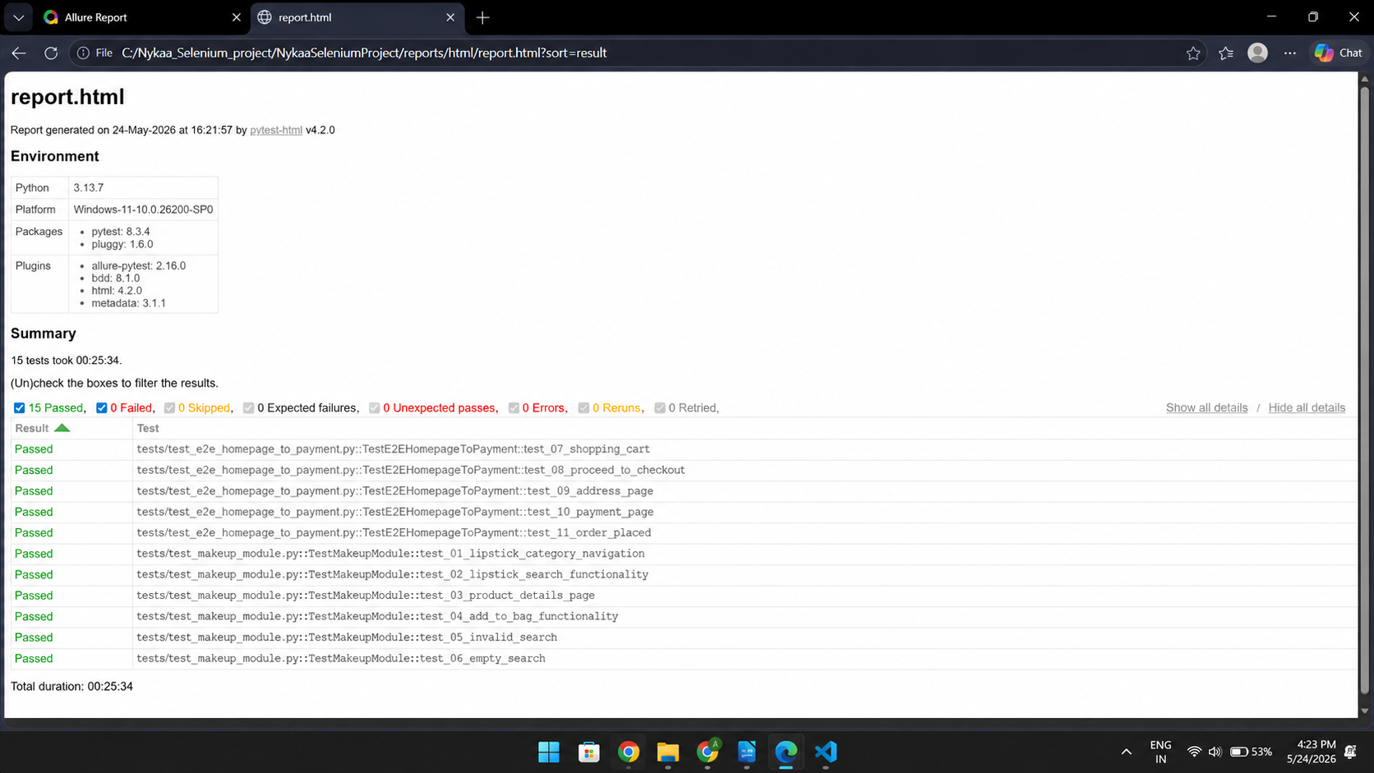

2. BDD Automation Testing Project

Project Title
Nykaa Makeup Module BDD Automation Framework using Pytest-BDD

Project Description

Selenium automation framework as well as BDD automation framework were successfully created to check the Nykaa Makeup module. Projects showed Selenium WebDriver Automation, BDD implementation, Page Object Model design pattern, Allure reporting, capturing screenshots, and End-to-End workflow testing.

BDD Test Strategy
- Scenario-Based Testing
- Functional Testing
- Regression Testing
- End-to-End Testing
- Feature File Implementation
- Reusable Step Definitions
- Hooks implementation
- Allure reporting integration

BDD Feature Scenarios
Scenario: Verify Lipstick Category Page
- Given user launches Nykaa website
- When user navigates to Makeup module
- And user clicks on Lipstick category
- Then Lipstick page should open successfully
Scenario: Verify Product Display
- Given user is on Lipstick page
- When products are loaded
- Then product names should be visible
- And product prices should be visible
Scenario: Verify Filter and Sort Functionality
- Given user is on Lipstick page
- When user applies brand filter
- And user applies sorting option
- Then filtered products should be displayed

Scenario: Verify Lipstick Search
- Given user launches Nykaa website
- When user searches for lipstick
- Then relevant products should be displayed
Scenario: Verify Invalid Search
- Given user launches Nykaa website
- When user searches invalid product
- Then no result message should appear
Scenario: Verify Invalid Product URL
- Given user enters invalid URL
- Then error page should appear

BDD End-to-End Flow
- TC-E2E-01: Homepage validation
- TC-E2E-02: Makeup module navigation
- TC-E2E-03: Lipstick category validation
- TC-E2E-04: Search result validation
- TC-E2E-05: Product detail validation
- TC-E2E-06: Add to Bag validation
- TC-E2E-07: Shopping cart validation
- TC-E2E-08: Proceed to Buy validation
- TC-E2E-09: Payment/Login page validation

BDD Test Environment
Component | Details
Operating System | Windows 11
Programming Language | Python
Automation Tool | Selenium WebDriver
BDD Framework | Pytest-BDD
IDE | VS Code
Browser | Google Chrome
Reporting Tool | Allure Report
Version Control | Git & GitHub

BDD Test Execution
Command Used:
pytest -v
For Allure Report:
pytest --alluredir=allure-results
allure serve allure-results

BDD Test Output
- BDD scenario execution
- Step-by-step execution logs
- Feature execution summary
- Screenshot generation on failures
- Console logs
- Scenario pass/fail summary

BDD Test Reports
- Allure Dashboard
- Scenario Execution Reports
- Failure Screenshots
- Execution Timeline
- HTML Reports
- Execution Logs

Allure Report

In this project, Allure Report was integrated with both Selenium and BDD frameworks to generate professional execution reports after running automated test cases.
The report includes:
- Total executed test cases
- Passed and failed test statistics
- Step-by-step execution details
- Screenshots attached on failures
- Execution timeline
- Environment information
- Scenario-wise and test-wise results

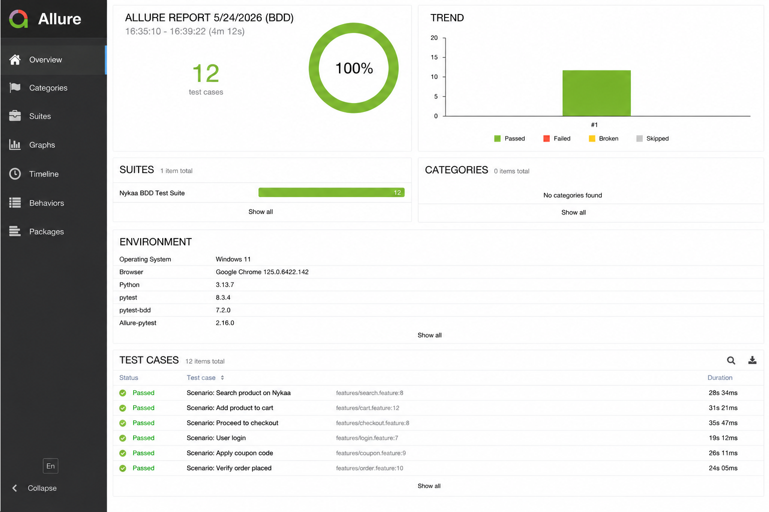
HTML Report

In this project, HTML reports were generated using the Pytest HTML plugin for both Selenium and BDD automation frameworks. The report helps in analyzing execution results without checking console logs manually.
The HTML report contains:
- Total executed test cases
- Passed and failed test count
- Execution duration
- Environment details
- Test execution summary
- Error and exception details
- Scenario-wise execution results

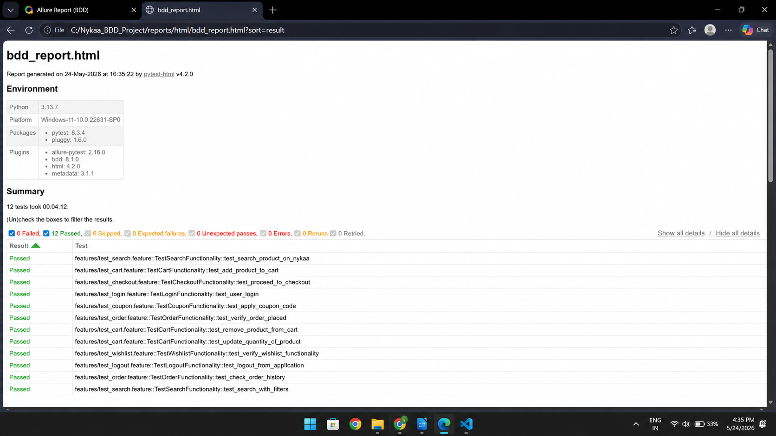

Conclusion
Both Selenium and BDD automation frameworks were successfully developed for testing the Nykaa Makeup module. The projects demonstrated Selenium WebDriver automation, BDD framework implementation, Page Object Model design pattern, Allure reporting, screenshot capturing, and End-to-End workflow testing.

