RESPONSE FOR THE COMMAND “AT”

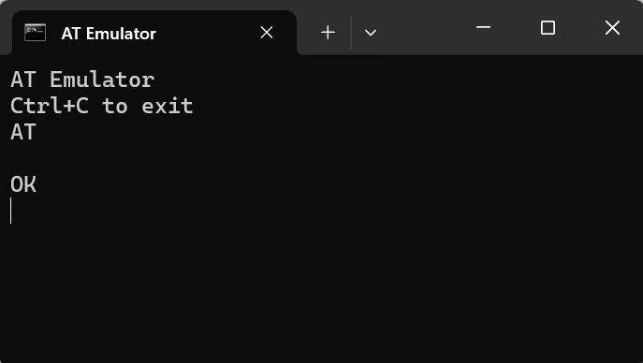

RESPONSE FOR THE COMMAND “ATI”

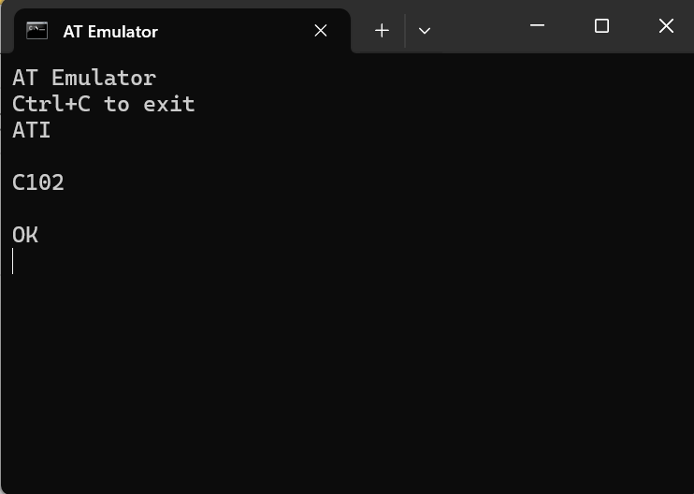

REPONSE FOR THE COMMAND “ATZ”

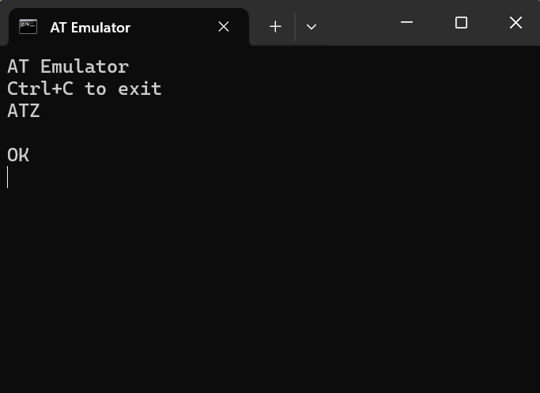

COMMAND LOG TABLE

|  |  |  |  |
| --- | --- | --- | --- |
| **COMMAND** | **EXPECTED RESPONSE** | **ACTUAL RESPONSE** | **NOTES** |
| AT | OK | OK | SUCCESS |
| ATI | Manufacturer or Model Information | C102 | SUCCESS |
| ATZ | OK | OK | RESETS SETTINGS |

SUMMARY:

AT: Basic test Command. Responds with OK if Communication is working.

ATI: Displays module information, useful for device identification.

ATZ: Resets the modem to default settings.