**Final Evaluation**

**Command Sequence Executed:**

1. AT – Basic connectivity check
2. AT+CSQ – Signal quality check
3. AT+CMGF=1 – Set SMS mode to text
4. AT+CMGS – (Attempted, emulator returned ERROR due to unsupported command)
5. AT+CMGR – (Attempted, emulator returned ERROR)

|  |  |  |  |  |
| --- | --- | --- | --- | --- |
| **Step** | **Command** | **Expected Response** | **Actual Response** | **Result** |
| 1 | AT | OK | OK | Success |
| 2 | AT+CSQ | +CSQ: <rssi>,<ber> | +CSQ:21,0 | Success |
| 3 | AT+CMGF=1 | OK | OK | Success |
| 4 | AT+CMGS | Wait for message input,send,get OK | ERROR  (unsupported) | Failed |
| 5 | AT+CMGR | Display received message | ERROR  (unsupported) | Failed |

**Command Sequence:**

AT🡪AT+CSQ🡪AT+CMGF🡪AT+CMGS🡪AT+CMGR

**Flowchart:**

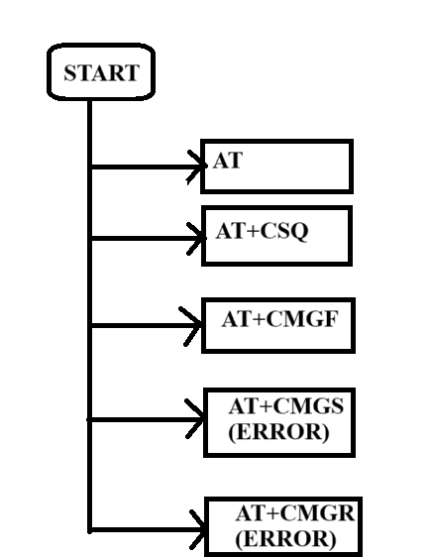

In this evaluation, a full AT command sequence was executed in the CelerSMS AT Emulator. The basic GSM commands (AT, ATI, AT+CSQ, AT+CMGF=1) worked as expected. SMS sending and reading (AT+CMGS, AT+CMGR) failed due to emulator limitations. Screenshots of each step were captured as proof of execution. This final sequence demonstrated understanding of AT command flow and emulator response handling.