RESPONSE FOR THE COMMAND “AT+CSQ”

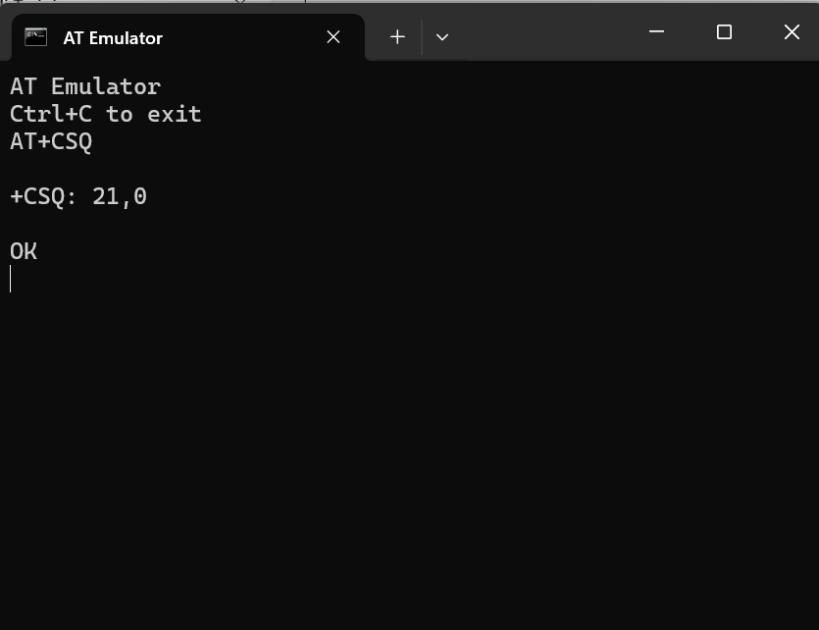

AT+CSQ checks signal quality

The response is +CSQ: 21,0 which means the RSSI(Received Signal Strength Indicator) is 21 and the BER(Bit Error Rate) is 0.

RSSI= 21 (equals -**71dBm manually)** indicates good signal strength and BER=0 indicates that there are no bit errors

RESPONSE FOR THE COMMAND “AT+CPIN?”

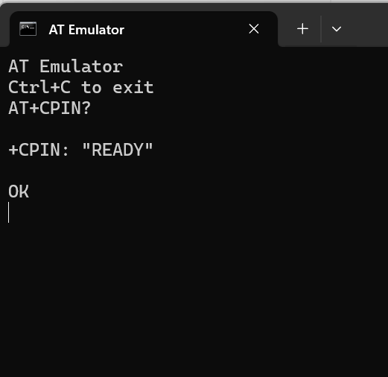

The Command AT+CPIN? checks if the SIM card is present and the PIN code has been entered.

The Response ‘READY’ indicates that

The SIM is detected.

The PIN has already been entered or no PIN is required.

The module is ready to register to the network.

RESPONSE FOR THE COMMAND “AT+COPS”

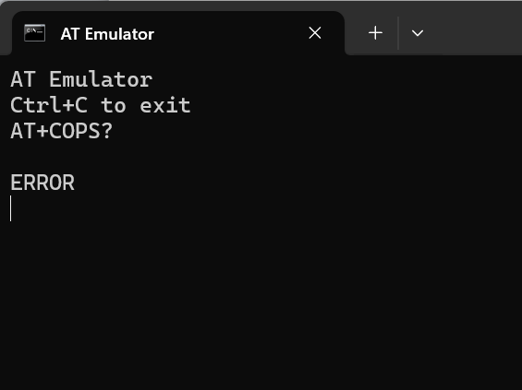

Expected Output:

+COPS: <mode>,<format>,<operator>,<access technology>

OK

Actual Output: ERROR because AT Emulator does not support this command