**Five supported AT Commands:**

AT - Basic Test Command

ATI - Module Info

ATZ - Reset

AT+CSQ - Signal Quality

AT+CPIN? - SIM PIN Check

AT+CMGF=? - SMS mode query/set

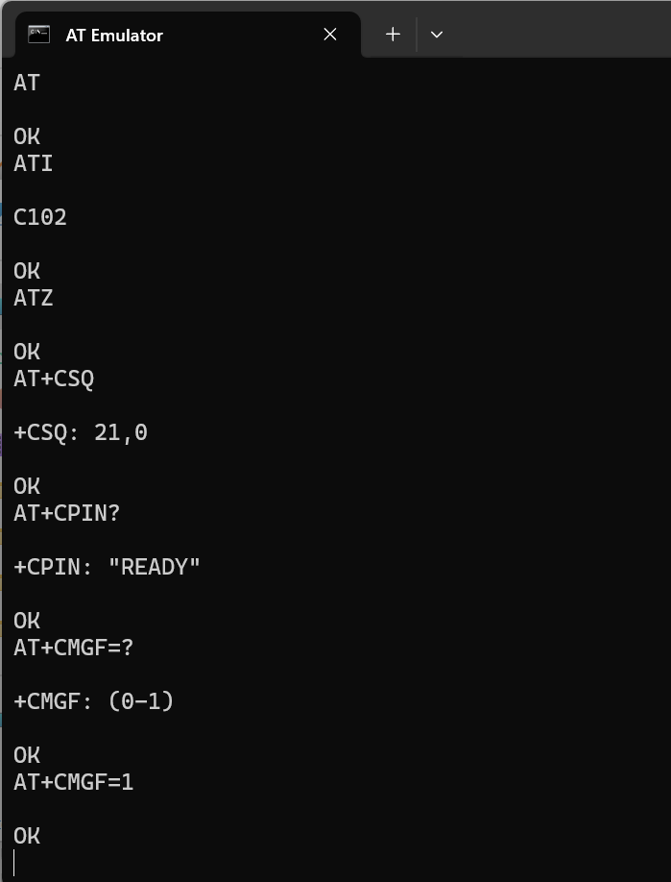

**Command Syntax Types**:

AT+CMD – Execute

AT+CMD? – Read

AT+CMD=? – Test

AT+CMD=<value> - Write

|  |  |  |  |  |
| --- | --- | --- | --- | --- |
| **COMMAND** | **Execute**  **AT+CMD** | **Read**  **AT+CMD?** | **Test**  **AT+CMD=?** | **Write**  **AT+CMD=<value>** |
| AT | OK | N/A | N/A | N/A |
| ATI | Module Info  C102 | N/A | N/A | N/A |
| AT+CSQ | +CSQ: 21,0 | N/A | N/A | N/A |
| AT+CPIN? | N/A | +CPIN: “READY” | N/A | N/A |
| AT+CMGF | N/A | N/A | Eg: AT+CMGF=?  +CMGF: (0,1) | Eg: AT+CMGF=1  OK |