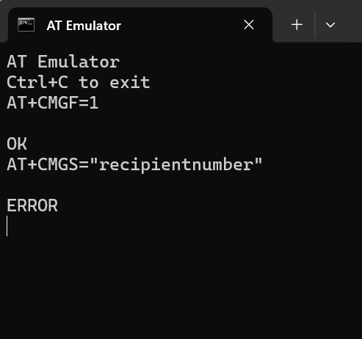

AT+CMGS is **not fully supported in this emulator**, and entering the command results in ERROR after attempting to input recipient number

SMS mode simulation was performed using AT commands. First, the command AT+CMGF=1 was used to set the SMS mode to text. The expected response for this command is simply OK, which confirms that the modem has successfully switched to text mode.

Next, the command AT+CMGS="recipientnumber" was used to initiate the process of sending an SMS to the specified recipient. After entering this command, the modem is expected to display a prompt (usually represented as a greater-than symbol >), indicating that it is waiting for the message content to be typed. After entering the message text, pressing **Ctrl+Z** should submit the message for sending. Upon successful submission, the expected response is +CMGS: <message_reference_number> followed by OK, which indicates that the message was sent successfully. For example, the modem might respond with +CMGS: 25 followed by OK.

Finally, to read the received SMS, the command AT+CMGR=1 can be used, where 1 refers to the message index. The expected response from this command is in the format: +CMGR: "REC READ","+recipientnumber","","message_content", followed by OK. This response confirms that the stored message has been read successfully.