AT+CMEE=2 is not supported by AT Emulator.

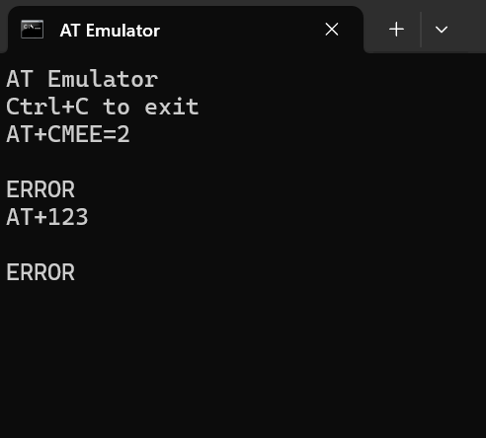

**Expected Result:**

**Enable Verbose Error Reporting**

* Command: AT+CMEE=2
* Purpose: Enables detailed (verbose) error messages instead of just “ERROR”.
* Expected Response is OK

### ****Send Unsupported or Incorrect Commands****

* After entering AT+CMEE=2, try entering incorrect commands, for example:

AT+ABC=123

* With **AT+CMEE=2** enabled, instead of just showing ERROR, the emulator should give detailed error messages like:

+CME ERROR: operation not supported

or

+CME ERROR: invalid parameter

**+CME ERROR: operation not supported** — The command is not recognized by the module.

**+CME ERROR: invalid parameter** — The command format is correct, but parameters are wrong.

**Plain ERROR** — General failure; either invalid command or unsupported.