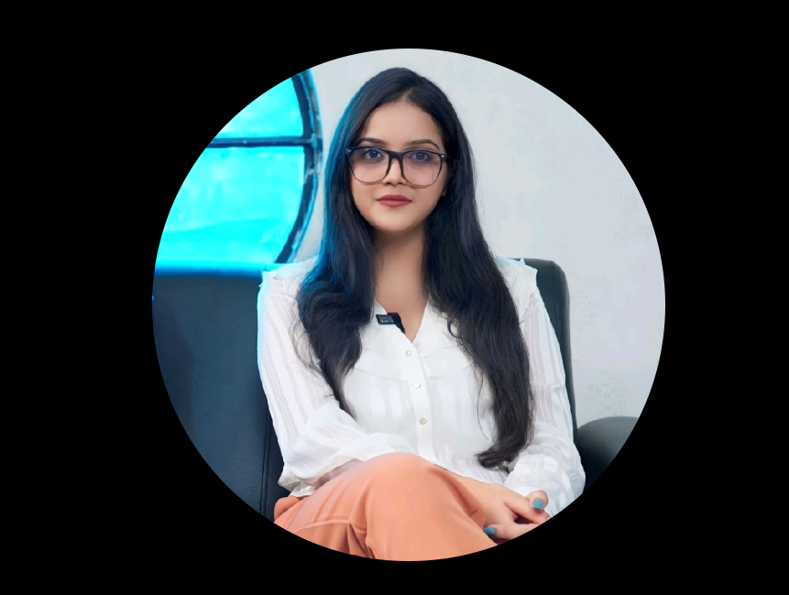

**[Tejaswee Tripathy](https://www.linkedin.com/in/tejaswee-tripathy/overlay/about-this-profile/)**

 ( Career Coach )

Chief Human Resource Officer (CHRO)- Finocontrol | LinkedIn Top Voice | Incharge- Corporate Relations | Aligning Disruptive Talent with Opportunities | Content Strategist - Helping Brands Grow

LinkedIn –

<https://www.linkedin.com/in/tejaswee-tripathy/>

Work email –

[tejaswee.tripathy@finocontrol.com](mailto:tejaswee.tripathy@finocontrol.com)

------------------------------------------------------------------------------------------------------------------------------------------

**[Disha Vaghela](https://www.linkedin.com/in/disha-vaghela-0a171a72/overlay/about-this-profile/)**

Techerudite

Human Resource professional | Recruitment specialist

<https://www.linkedin.com/in/disha-vaghela-0a171a72/>

[dishavaghela2012@gmail.com](mailto:dishavaghela2012@gmail.com)

**[Jesica Logioco](https://www.linkedin.com/in/jesicalogioco-safarigrouphr/overlay/about-this-profile/)**

Safari Group HR

[jesicalogioco@safari-group.com](mailto:jesicalogioco@safari-group.com)

+5491131221328

<https://www.linkedin.com/in/jesicalogioco-safarigrouphr/>

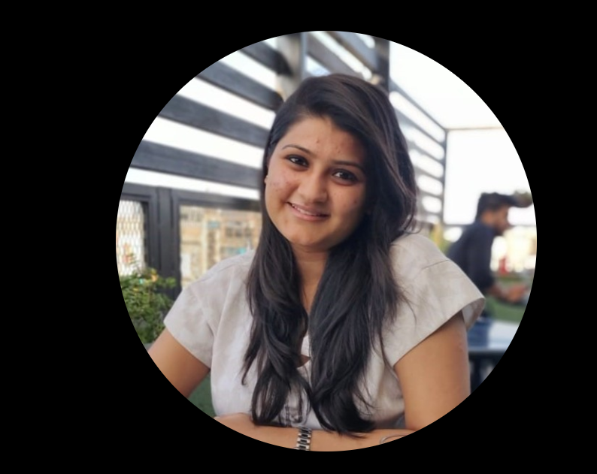

**[Vasudha Goel](https://www.linkedin.com/in/vasudha-goel-05b3a7145/overlay/about-this-profile/)**

HR Talent Acquisition at EY | Technology Consulting | Data and Analytics | DEI Enthusiast

[vasudhagoel@ymail.com](mailto:vasudhagoel@ymail.com)

[vasudha.goel@in.ey.com](mailto:vasudha.goel@in.ey.com)

[vasudha.goel@ey.com](mailto:vasudha.goel@ey.com)

+15167102313

<https://www.linkedin.com/in/vasudha-goel-05b3a7145/>

**[soni singh](https://www.linkedin.com/in/soni-singh-218988b8/overlay/about-this-profile/)**

Genpact

Talent Acquisition Specialist

[soni.singh@genpact.com](mailto:soni.singh@genpact.com)

<https://www.linkedin.com/in/soni-singh-218988b8/>

**[Pooja Chouhan](https://www.linkedin.com/in/pooja-chouhan-290bb018a/overlay/about-this-profile/)**

Samosys Technologies Pvt. Ltd. HR Generalist

[pooja.chouhan@samosys.com](mailto:pooja.chouhan@samosys.com)

<https://www.linkedin.com/in/pooja-chouhan-290bb018a/>

**[Iswenda Ishak](https://www.linkedin.com/in/iswenda-ishak-114355175/overlay/about-this-profile/)**

**[Human Resources ConsultantHuman Resources Consultant](https://www.linkedin.com/company/14383281/" \t "_self)**

[Confidential · Freelance](https://www.linkedin.com/company/14383281/" \t "_self)

<https://www.linkedin.com/in/iswenda-ishak-114355175/>

**Zoho Corporation**

* **Location**: Chennai, Tamil Nadu, India
* **Industry**: Software Development, SaaS
* **HR Contact**:
  + **Name**: Sivaramakrishnan Iswaran
  + **Role**: Director of Human Resources
  + **LinkedIn**: [linkedin.com/in/sivaramakrishnaniswaran](https://www.linkedin.com/in/sivaramakrishnaniswaran/)

[**sivaramakrishnaniswaran@gmail.com**](mailto:sivaramakrishnaniswaran@gmail.com)

**2. Uniphore**

* **Location**: Chennai, Tamil Nadu, India & Palo Alto, California, USA
* **Industry**: Conversational AI, Speech Analytics
* **HR Contact**:
  + **Name**: Kavitha Raj
  + **Role**: Senior Manager - Talent Acquisition
  + **LinkedIn**: [linkedin.com/in/kavitharaj](https://www.linkedin.com/in/kavitharaj/)
  + **Email**: Not publicly available