DNS Project Run:

1. DNS Proxy server listening on port 3053



1. Lookup query sent for getting IP address of domain name : [www.google.com](http://www.google.com) to DNS proxy server



1. Proxy Server getting the request from the stub solver/ client.

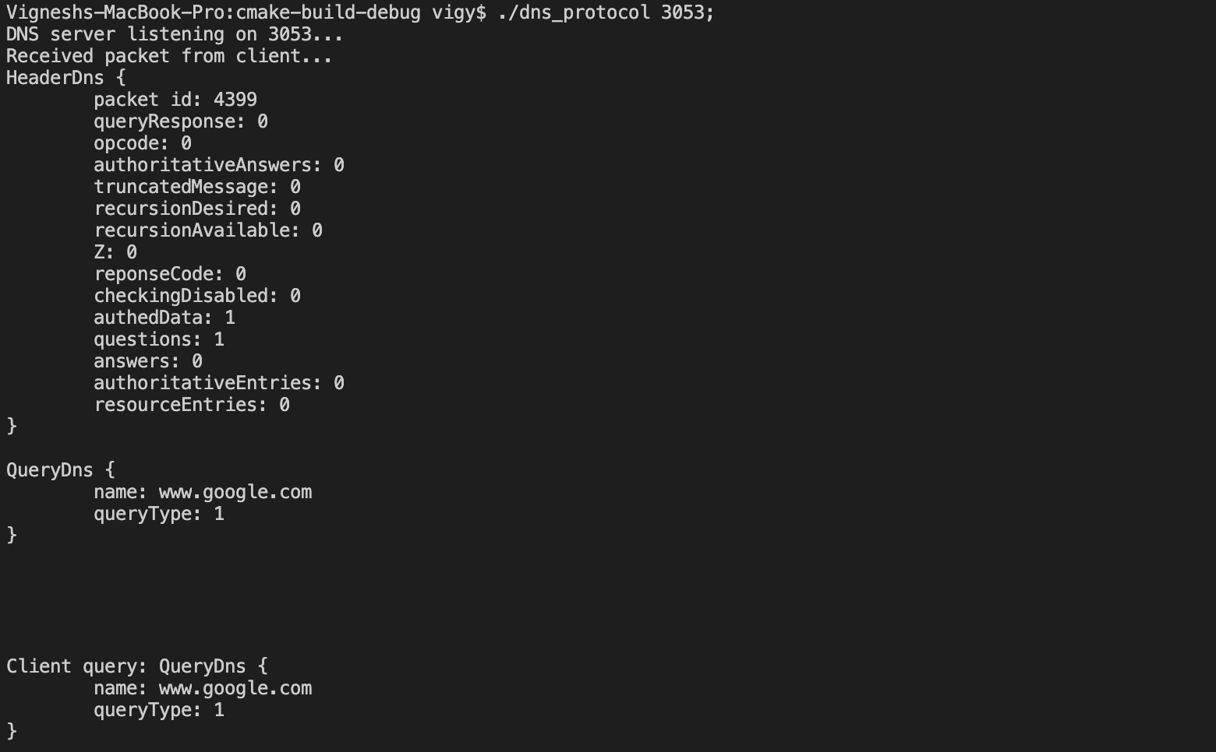

4. Proxy server forwards the request to DNS resolver 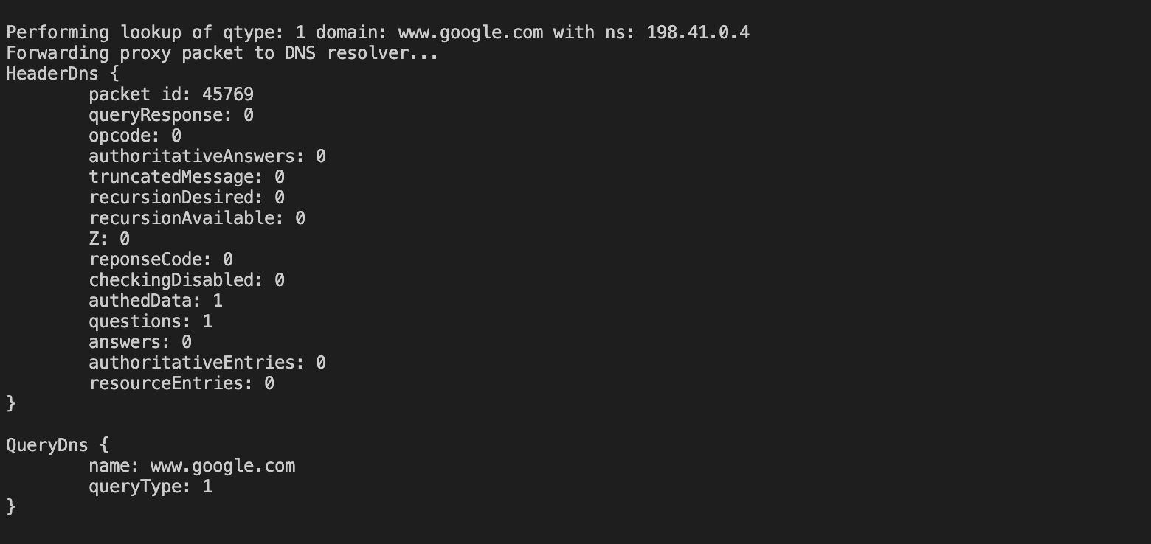

5. proxy server receiving response from DNS resolver 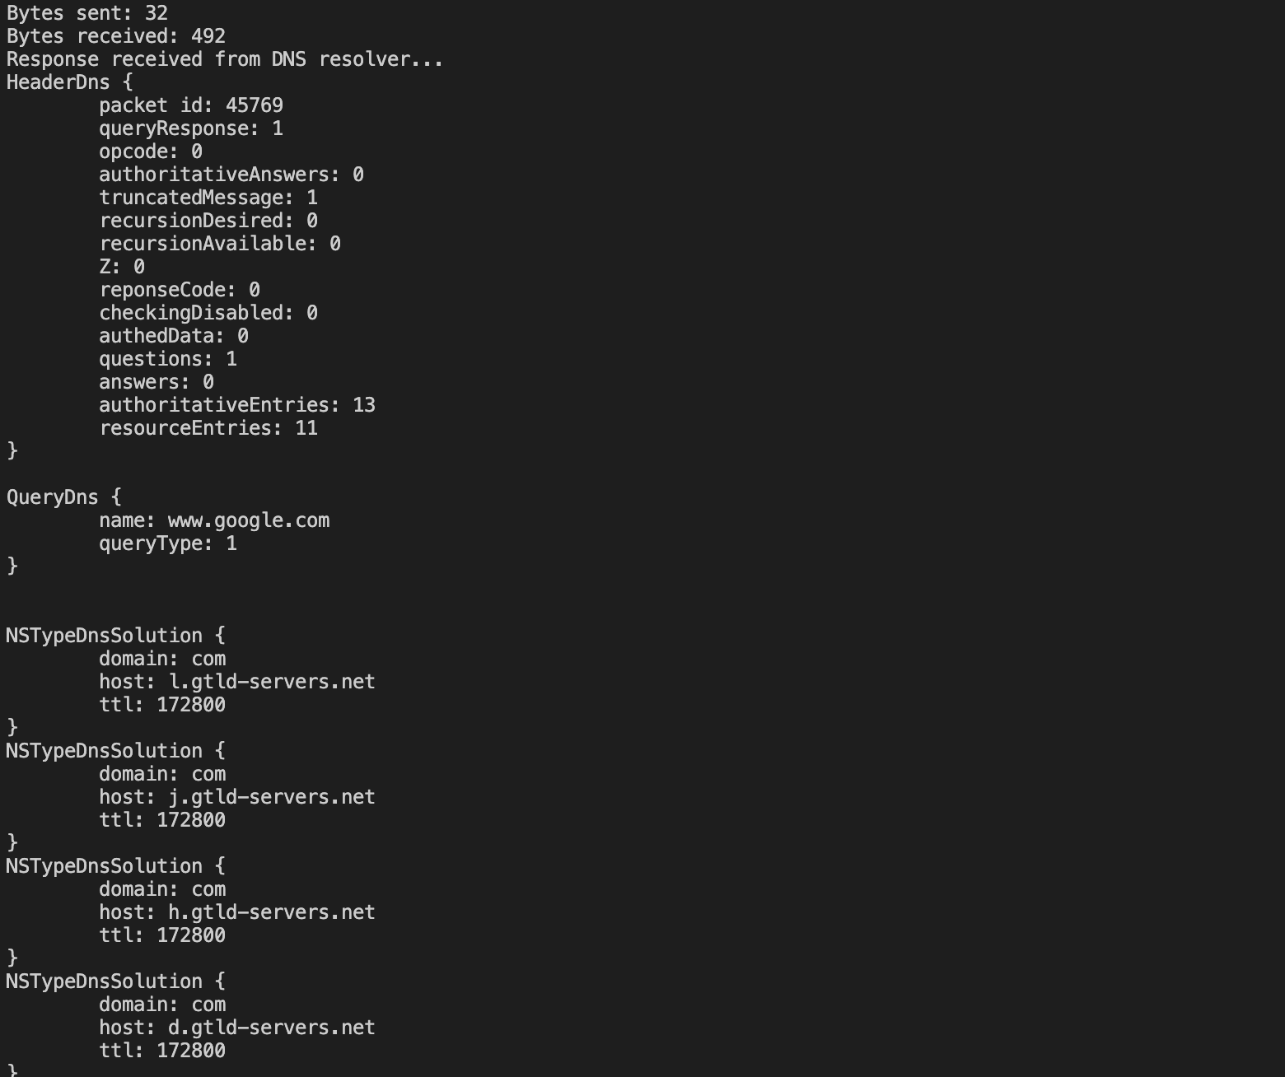6. Proxy server forwards response to client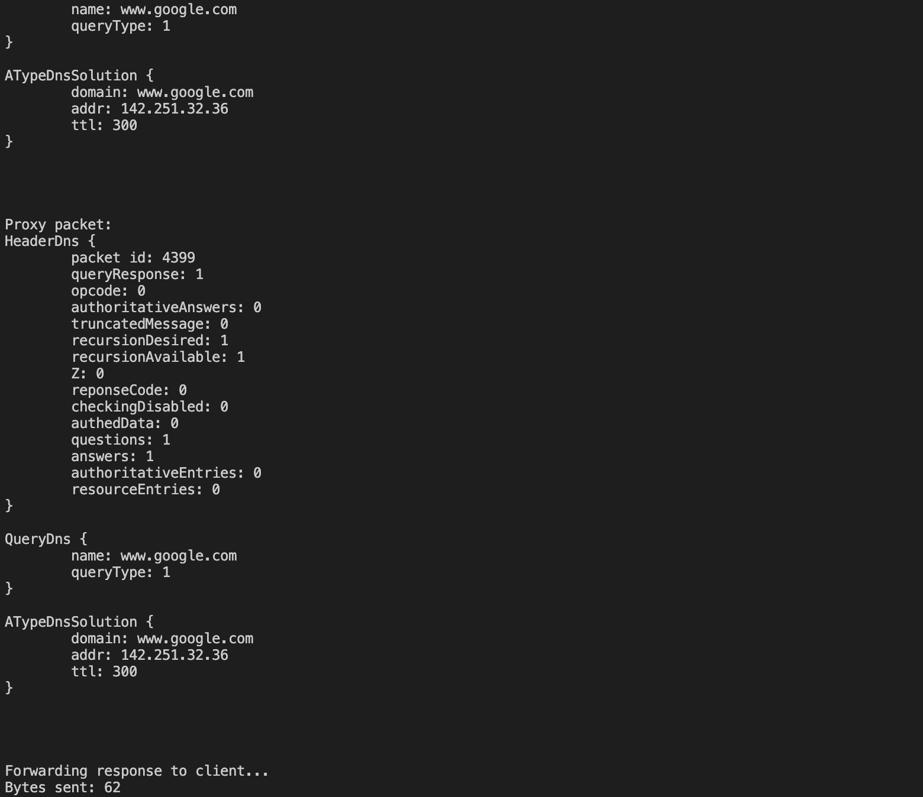

7. DNS client receives response from Proxy Server

