Final Assignment

Passenger Aircraft Loading and Take-Off Performance

Dataset
You are given a clean CSV file called aircraft_loading_clean.csv. Each row represents one flight. The data file contains no missing values and no invalid numbers.
Column name | Meaning
flight_number | A unique number for each flight
occupied_seats | Number of occupied passenger seats
luggage_weight_kg | Total luggage weight in kilograms
fuel_loaded_kg | Fuel loaded before take-off, in kilograms
outside_temperature_C | Outside air temperature in degrees Celsius
runway_distance_before_liftoff_m | Distance travelled along the runway before the aircraft leaves the ground, in metres
height_30s_after_takeoff_m | Height reached 30 seconds after take-off, in metres
Simplifying assumption. Assume that each occupied seat corresponds to an average passenger mass of 75 kg.
total_loaded_weight_kg = 75 × occupied_seats + luggage_weight_kg + fuel_loaded_kg

Tasks

Task 1: Data Loading and Initial Inspection [2 marks]
- Load the CSV file into a pandas DataFrame.
- Use a try-except block to handle the case where the file is missing or cannot be opened.
- Display the first seven rows of the DataFrame.
- Report the shape of the DataFrame and list the column names.

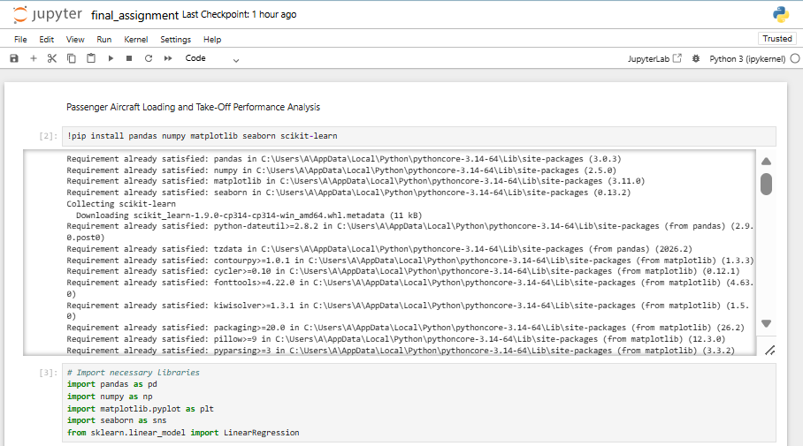
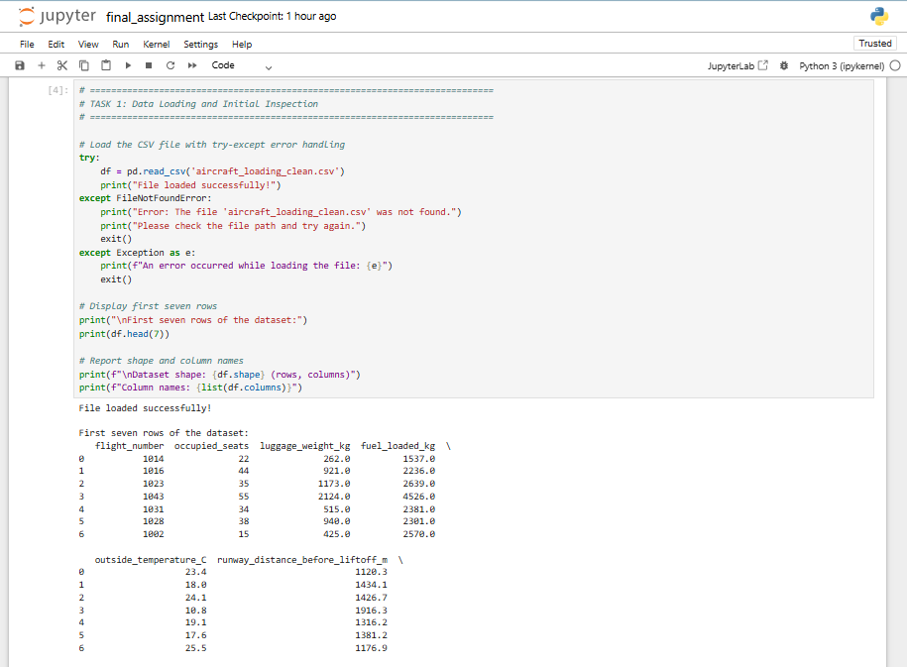
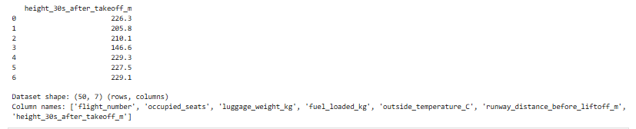

Task 2: Basic Calculations and Code Structure [2 marks]
- Calculate total_loaded_weight_kg for each row and add the results in a new column with this name.
- Find and print the average, smallest value, and largest value for runway_distance_before_liftoff_m and height_30s_after_takeoff_m. Print your answers to 2 decimal places using f-strings.
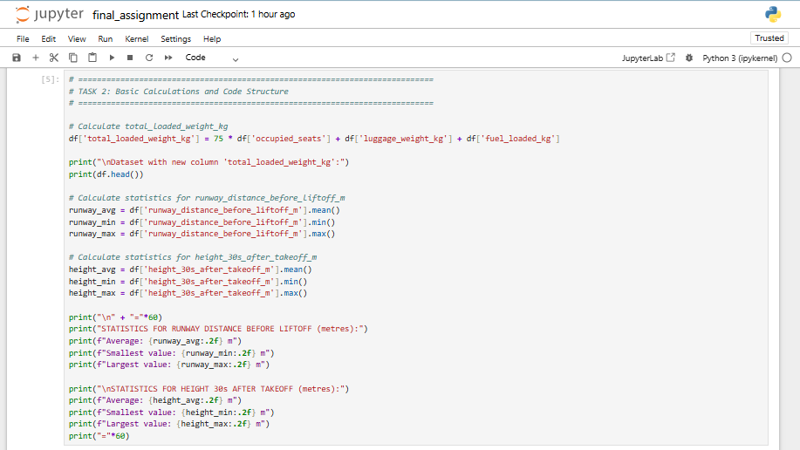
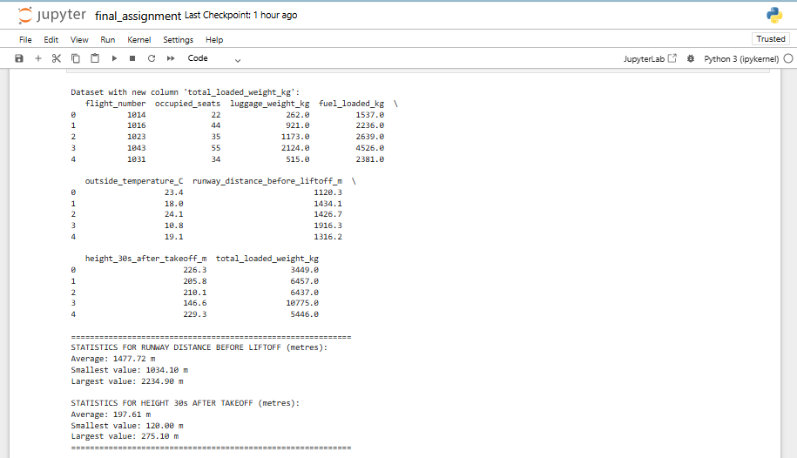

Task 3: Classification based on load and temperature [5 marks]
Classify each flight according to its total loaded weight. Create a new column called loading_class using the following rules:
- Light: total_loaded_weight_kg < 4500
- Medium: 4500 ≤ total_loaded_weight_kg ≤ 6500
- Heavy: total_loaded_weight_kg > 6500
Then report how many flights belong to each class. Also write code to save these counts in a text file called ‘loading_class_counts.txt’.

Also create a new column called temperature_group using the following rules:
- Cool: outside_temperature_C < 15
- Mild: 15 ≤ outside_temperature_C ≤ 25
- Warm: outside_temperature_C > 25
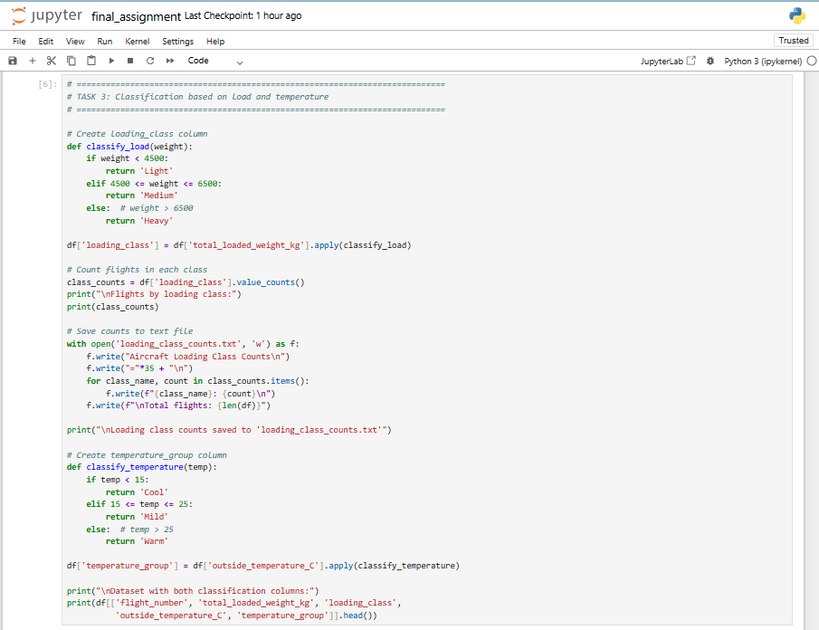
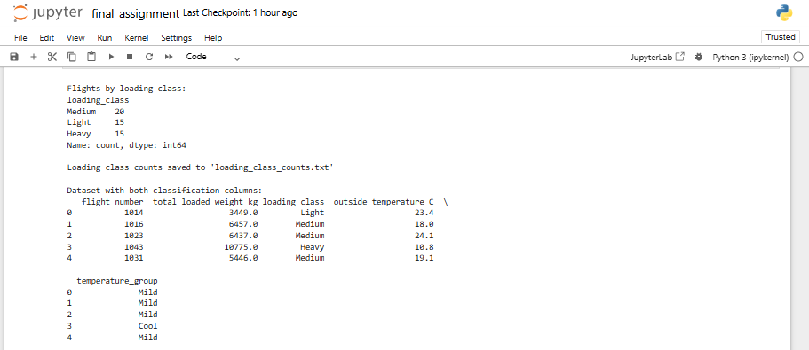

Task 4: Visualisation [5 marks]
Produce four plots as described below.
Using matplotlib, create a figure with two subplots:
- A scatter plot of runway_distance_before_liftoff_m (y-axis) against total_loaded_weight_kg (x-axis)
- A scatter plot of height_30s_after_takeoff_m (y-axis) against total_loaded_weight_kg (x-axis)
Also write code to save this figure in a file called ‘matplotlib_subplots.png’.

Using seaborn, create:
- A count plot of loading_class.
- A pairplot, using temperature_group as hue.
All plots must include a clear title, axis labels, and units where appropriate.
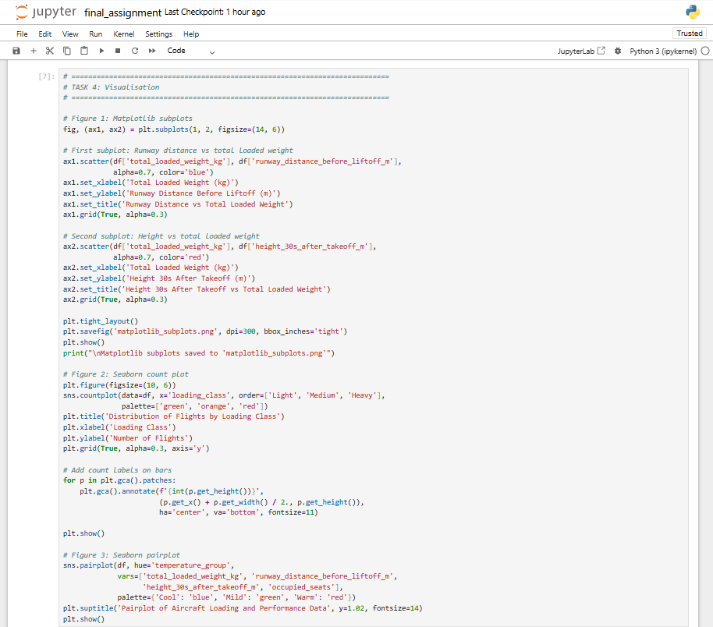
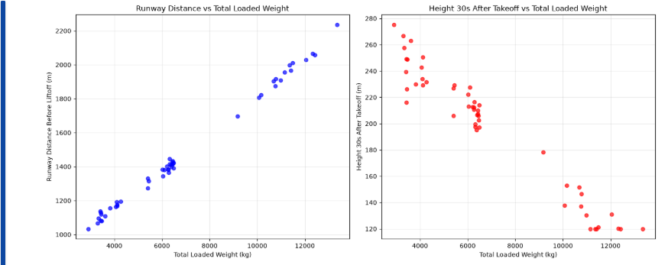
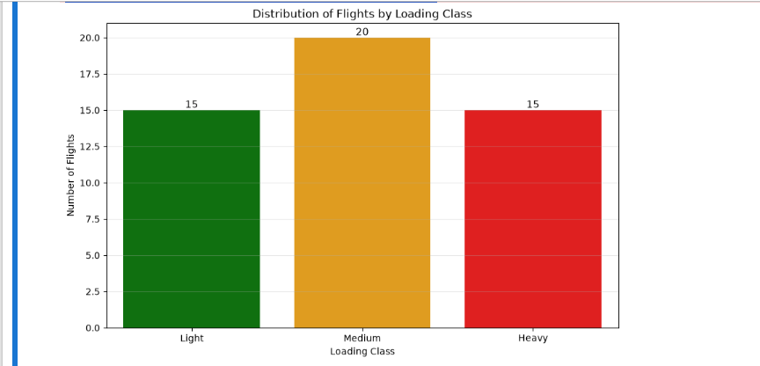
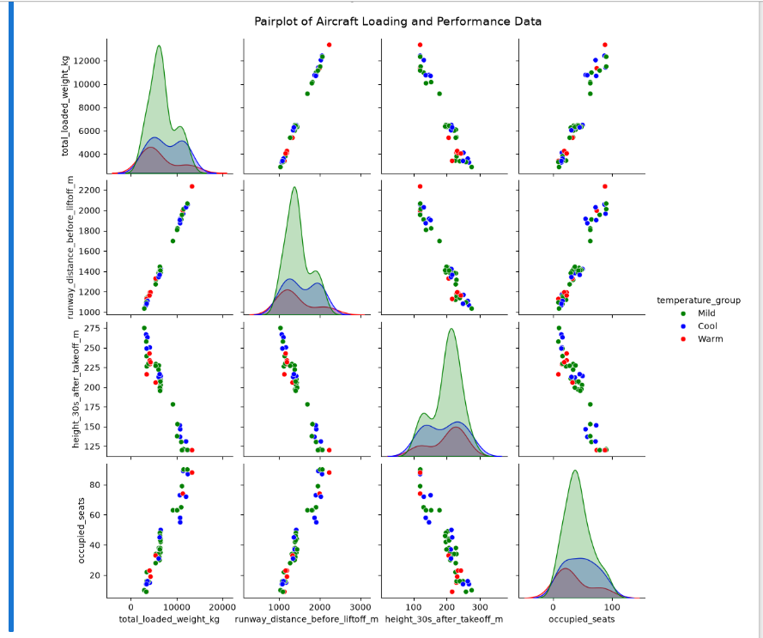
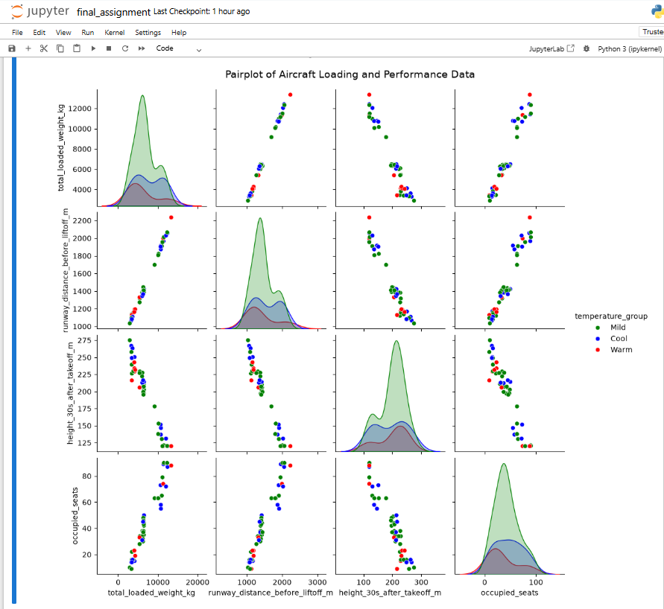

Task 5: Simple Mathematical Modelling [6 marks]
- Fit a linear regression model to predict runway_distance_before_liftoff_m from total_loaded_weight_kg.
- Report the equation of the fitted straight line.
- Use the above to estimate the runway distance before liftoff when total_loaded_weight_kg = 6000 kg.
